Weilin Lu

Assign-10

Naive Bayes

Q1



Q2

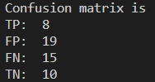

Q3



Q4

The first year is short,I want use short portion for the second year. But according to the predict, the long position trading strategy is better strategy