Weilin Lu

Assign10

Student-T

Q1

Accuracy 0.5 : 100%



Accuracy 1 : 96.15%



Accuracy 5 : 86.54%



Q2

Confusion Matrix for 0.5:

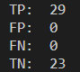

Confusion Matrix for 1:

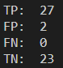

Confusion Matrix for 05:

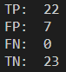

Q3

df=0.5



df=1



df=5



Q4

According to the accuracy, the best value is df=1

Q5

The long position strategy