Weilin Lu

Assign11

Tips

Q1

Lunch:16%

Dinner:15%



Q2

Thursday: 16%

Friday: 16%

Saturday:15%

Sunday:15%

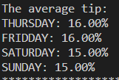

Q3

The highest tip is at dinner time,Saturday:10



Q4



Q5

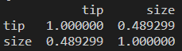

Q6

Smoking people:36%



Q7



Q8

Smoking:0.62

Non-Smoking:1.12

