Weilin Lu

Assign 11

Decision Tree

Q1

Accuracy: 100%



Q2

TP:27; FP:0; FN:0; TN:25

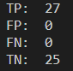

Q3

TPR:1

TNR:1



Q4

For second year, the long position strategy is a better way to get more amount money at the end of the year