Weilin Lu

Assign11

Random Forest

Q1

N=2

D=2



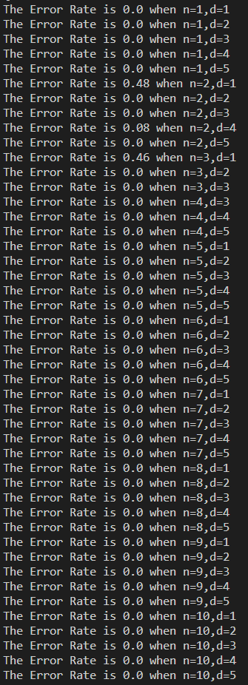

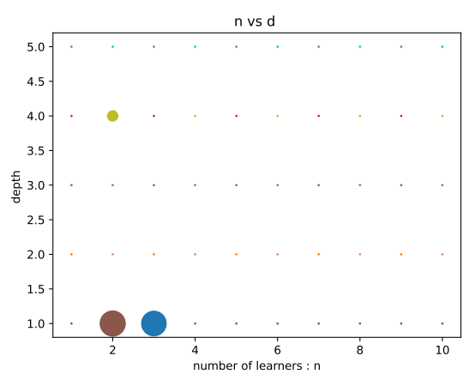

Q2

TP:29; FP:0; FN:0; TN:23

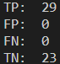

Q3

TPR:1.0

TNR:1.0



Q4

For second year, the long position strategy is a better way to get more amount money at the end of the year