Weilin Lu

Assign12-Kmeans

Q1

The best k is 3

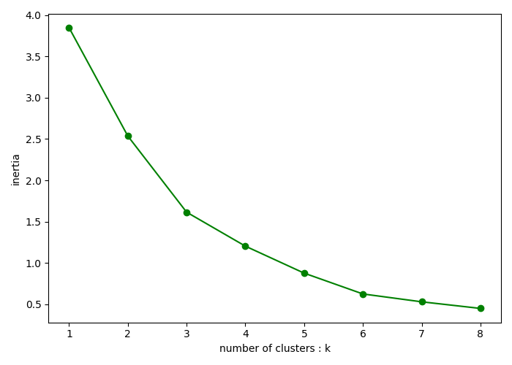

Q2

0=green 1=red

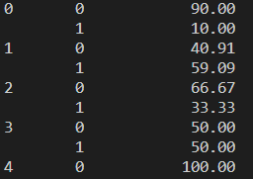

Q3

Cluster 1 and 4