Weilin Lu

Assign12-SVM

Q1&Q2&Q3&Q4&Q5

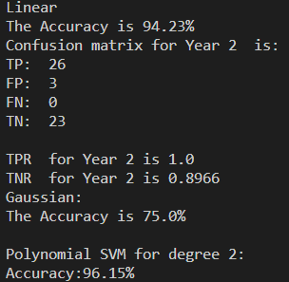

Gaussian SVM is worst than linear SVM

Polynomial SVM is better than linear SVM

Q6

Long position strategy