Weilin Lu

Assign12-seed

Q1

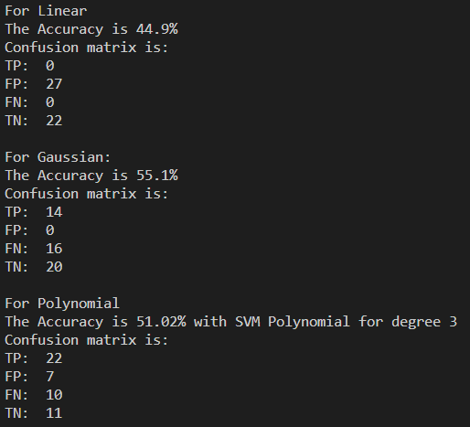

1

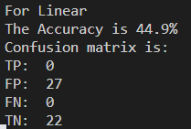

2

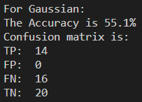

3

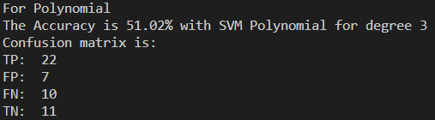

Q2

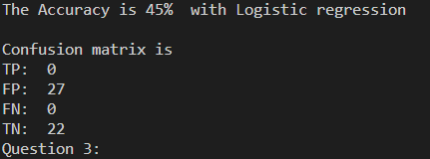

|  |  |  |  |  |  |  |  |
| --- | --- | --- | --- | --- | --- | --- | --- |
| Model | TP | FP | FN | TN | accuracy | TPR | TNR |
| linear SVM | 0 | 27 | 22 | 0 | 44.9% | 1 | 0 |
| Gaussian SVM | 14 | 0 | 16 | 20 | 55.1% | 0.56 | 1 |
| polynomial SVM | 22 | 7 | 10 | 11 | 51.02% | 0.52 | 0.76 |
| Logistic Regression | 0 | 27 | 0 | 22 | 45% | 1 | 0 |

Q3

1

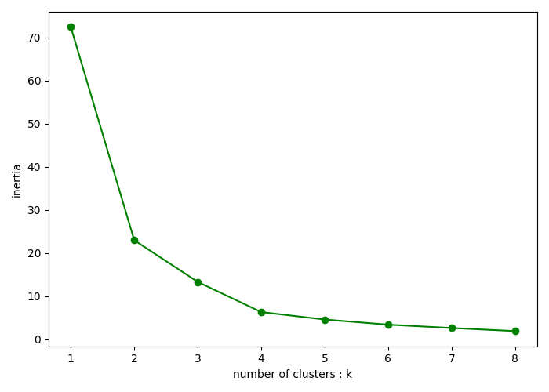

The best kmeans=2

2

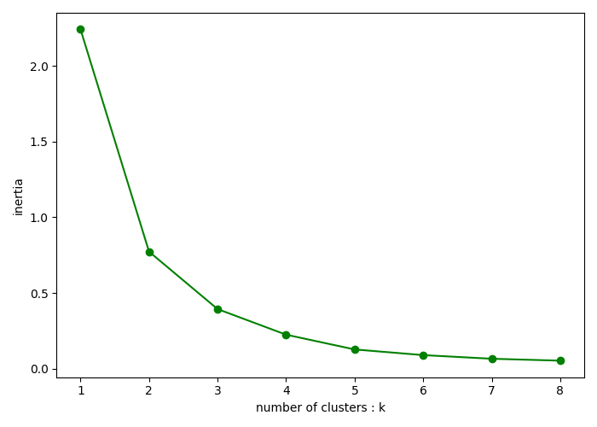

The best kmeans=2