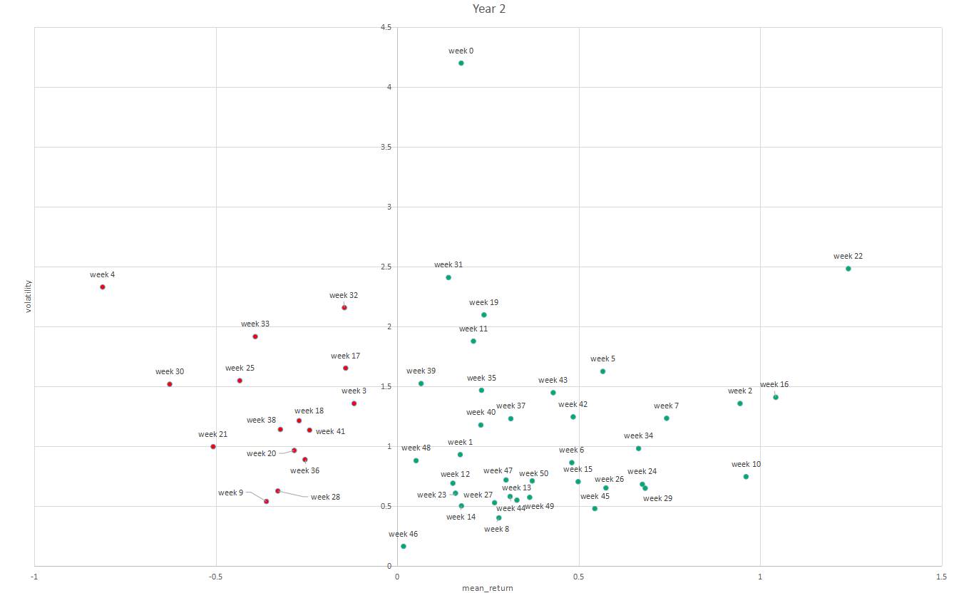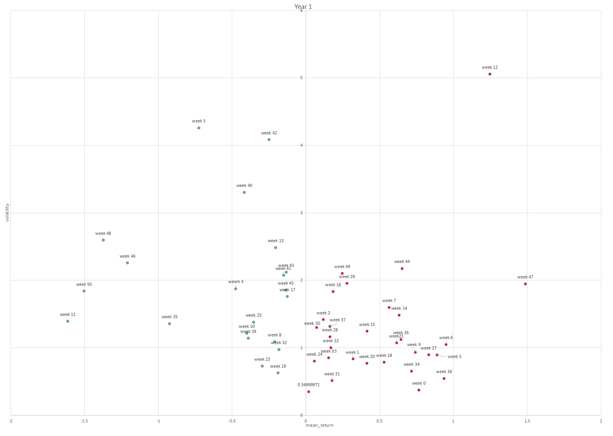

1: For the year one, no. But for the year two,yes.

2:Yes,same color point close to each other.

3:No, they are not repeat.

4:No, because two years has a lot of difference.