All solution were calculated after delete all none value

1

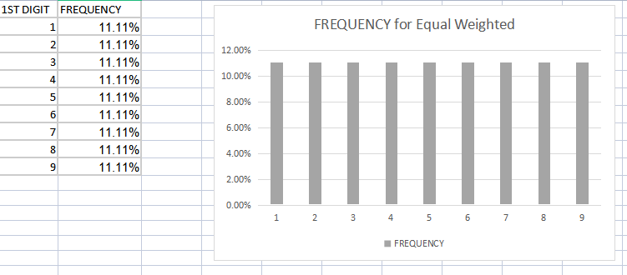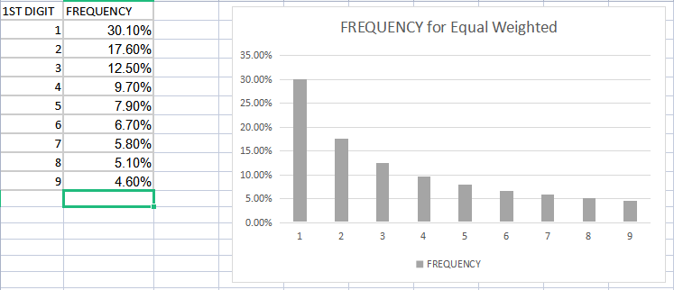

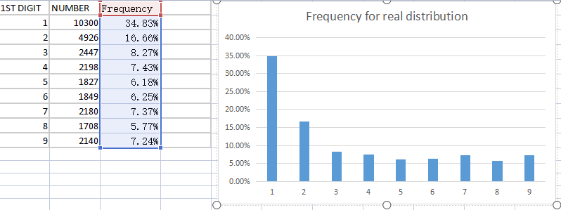

2

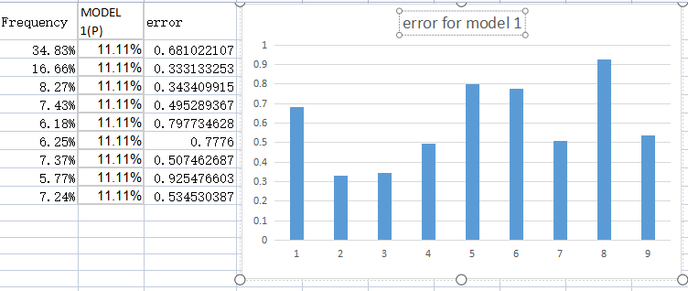

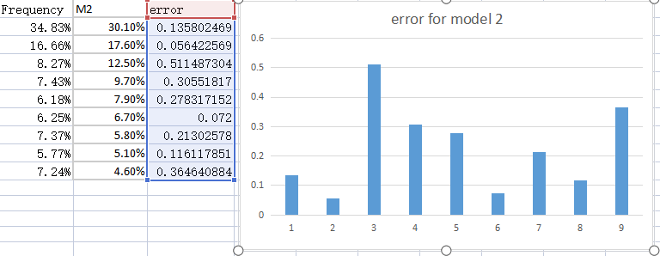

3

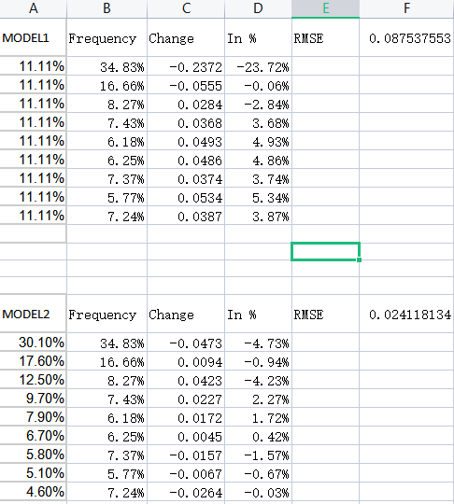

Model 2 is closer to the real distribution

4:

All F values are Frequency value

All P values are Model 1 Value

All Pi values are Model 2 Value

Footwomen

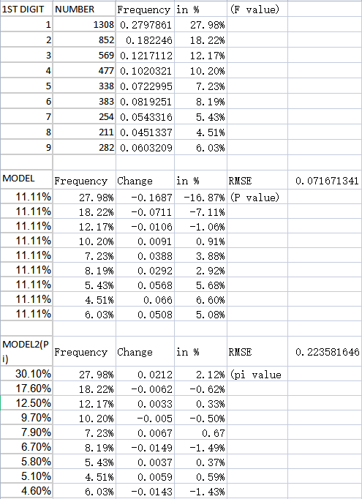

Watcheswomen

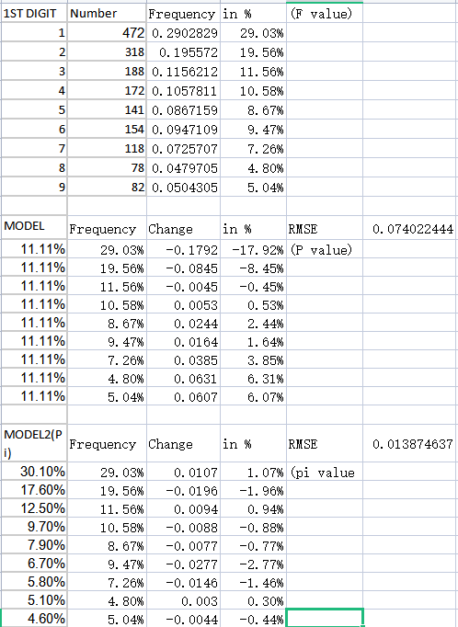

Jewellery

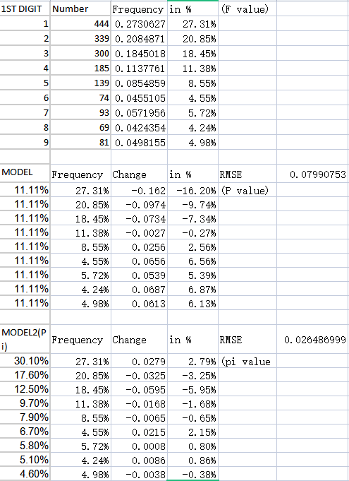

According to these 3 categories and calculate their RMSE, the footwear women closet to the equal weight P

5

For each categories, we can see that model 2 is always closer to the real distribution than model 1. And also, if a categories list is long enough, it will close to the real distribution than other categories.