Weilin Lu

1

SPY:from 2018-1-1 to 2018-12-31

The average nightly profit: -0.94

BILI:from 2019-1-1 to 2019-12-31

The average nightly profit: 0.23%

2

SPY

Long position profit: -14.15$

Short position profit: -8.52$

Long position has more profit

BILI

Long position profit: 37.82$

Short position profit:-32.21$

Long position has more profit

3

Spy

If x goes larger, the average profit goes larger, the x value should be 10%

BILI

If x goes larger, the average profit goes larger, the x value should be 10%

4

SPY

BILI

For both of my stock and SPY, we can find long position always has higher profit the short position. Ans also for short position, we always lose money

5

SPY graph with buy and hold

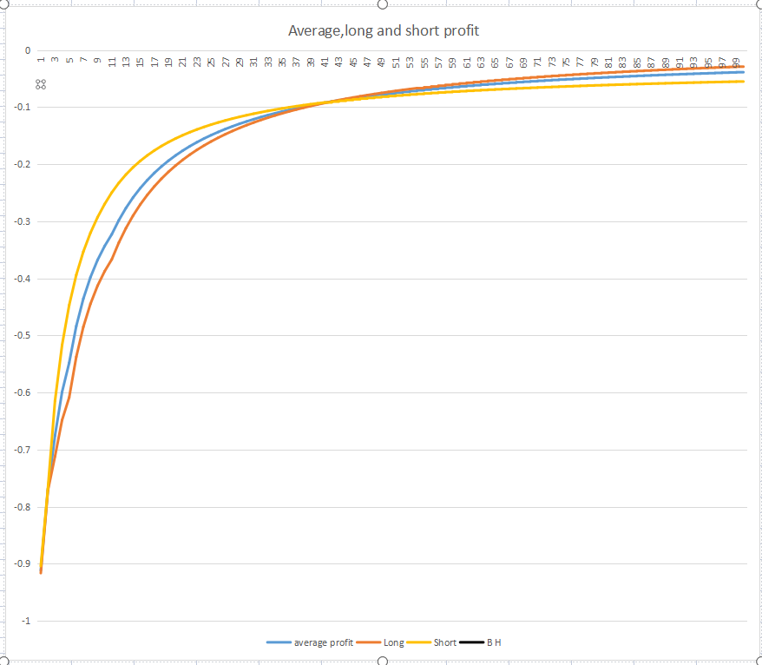

BILI graph with buy and Hold

