HW 5

Q1

2:

Statistic

|  |  |  |  |  |  |  |
| --- | --- | --- | --- | --- | --- | --- |
| Feature | μ0 | σ0 | μ1 | σ1 | μ all | σ all |
| Sepal Length | 5.936 | 0.516 | 6.588 | 0.636 | 6.262 | 0.663 |
| Sepal Width | 2.77 | 0.314 | 2.974 | 0.322 | 2.872 | 0.333 |
| Petal Length | 4.26 | 0.470 | 5.552 | 0.552 | 4.906 | 0.826 |
| Petal Width | 1.326 | 0.198 | 2.026 | 0.275 | 1.676 | 0.425 |

3:

For Setosa

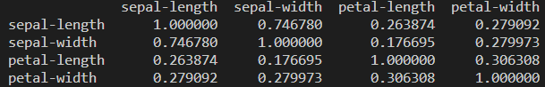

Sepal-width and sepal-length highest correlations is :0.746780

Sepal-width and petal-width lowest correlations is :0.176695

For Versicolor

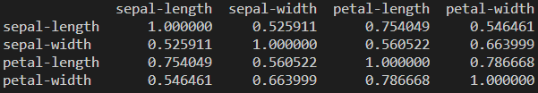

Petal-width and petal-length highest correlations is :0.786668

Sepal-length and sepal-width lowest correlations is :0.525911

For Virginica

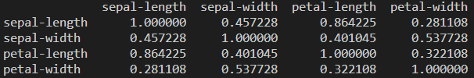

Petal-length and sepal-length highest correlations is :0.864225

Petal-width and sepal-length lowest correlations is :0.281108

4:

Virginica has Petal-length and sepal-length highest correlations is :0.864225

Setosa Sepal-width and petal-width lowest correlations is :0.176695

Q2

1:

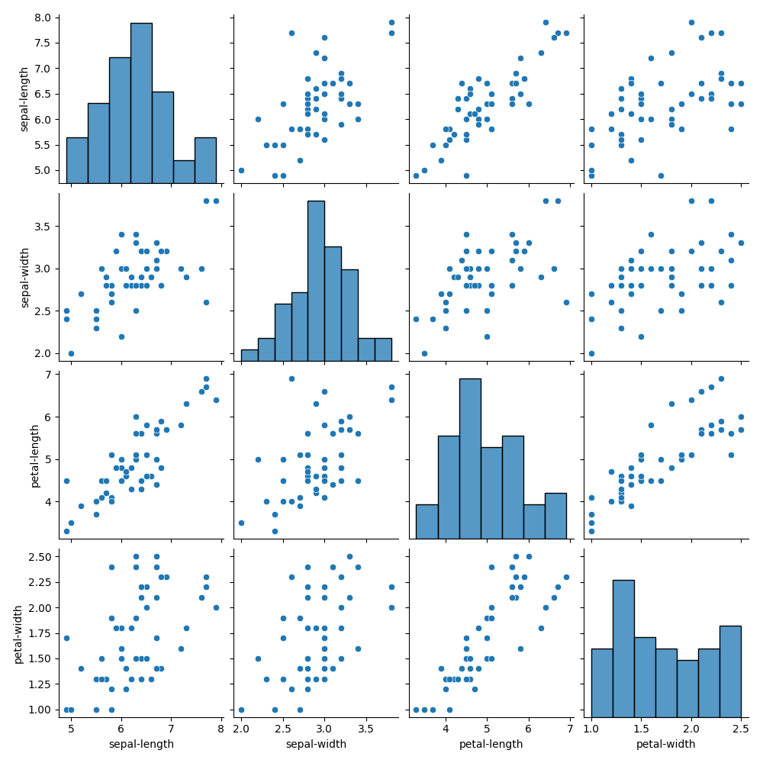

2:

Classifier for sepal-length:

If >6 ; label = 0, else = 1

Classifier for sepal-width:

If >2 ; label = 0, else = 1

Classifier for petal-length:

If >5 ; label = 0, else = 1

Classifier for petal-width:

If >1; label = 0, else = 1

|  |  |  |  |  |  |
| --- | --- | --- | --- | --- | --- |
| Classifier | TP | TN | FP | FN | Accuracy |
| 1:sepal-length | 14 | 20 | 6 | 10 | 68% |
| 2:sepal-width | 1 | 26 | 0 | 23 | 54% |
| 3:petal-length | 24 | 21 | 5 | 0 | 90% |
| 4:petal-width | 4 | 26 | 0 | 20 | 60% |

3: Sepal width has the most Confusion Matrix

Q3

1:

Ensembles of weak learners

|  |  |  |  |  |  |
| --- | --- | --- | --- | --- | --- |
| Classifier | TP | TN | FP | FN | Accuracy |
| 1,2,3 Sepal-length | 14 | 20 | 6 | 10 | 68% |
| 1,2,4 Sepal-width | 24 | 0 | 26 | 0 | 48% |
| 1,3,4 Petal-length | 24 | 5 | 21 | 0 | 57% |
| 2,3,4 petal-width | 24 | 0 | 26 | 0 | 48% |

2: Sepal-width and petal-width have the most Confusion Matrix

3: The ensemble results are easier than the weak learners which influenced by certain conditions which has certain values

Q4

1:

Sepal length: If p0 >= p1, 0, else 1

Sepal width:If p0 <= p1, 0, else 1

Petal length:If (p0- p1)>=0, 0, else 1

Petal width:If (p0-p1)<=1, 0, else 1

Density based weak learners

|  |  |  |  |  |  |
| --- | --- | --- | --- | --- | --- |
| Classifier | TP | TN | FP | FN | Accuracy |
| 1:sepal-length | 7 | 7 | 19 | 17 | 28% |
| 2:sepal-width | 3 | 17 | 9 | 21 | 40% |
| 3:petal-length | 0 | 21 | 5 | 24 | 42% |
| 4:petal-width | 0 | 26 | 0 | 24 | 52% |

2: Petal-width has the most Confusion Matrix

Q5:

1

Density-based Ensembles

|  |  |  |  |  |  |
| --- | --- | --- | --- | --- | --- |
| Classifier | TP | TN | FP | FN | Accuracy |
| 1,2,3 Sepal-length | 24 | 0 | 26 | 0 | 48% |
| 1,2,4 Sepal-width | 24 | 0 | 26 | 0 | 48% |
| 1,3,4 Petal-length | 24 | 0 | 26 | 0 | 48% |
| 2,3,4 petal-width | 24 | 0 | 26 | 0 | 48% |

2: They have the same Confusion Matrix

3:Compared with the weak learner, the ensemble result has some conflicting conditions that lead to an error in the confusion matrix

Q6

1:Compared with the weak learner, the ensemble result has some conflicting conditions that lead to an error in the confusion matrix