Weilin Lu

Q1

1

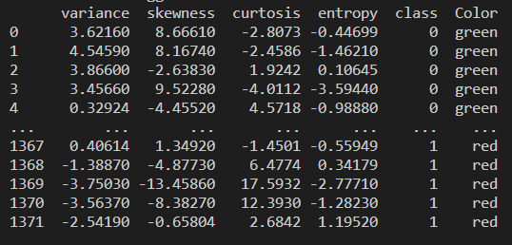

2

|  |  |  |  |  |  |  |  |  |
| --- | --- | --- | --- | --- | --- | --- | --- | --- |
| class | Mean(f1) | STD(f1) | Mean(f2) | STD(f2) | Mean(f3) | STD(f3) | Mean(f4) | STD(f4) |
| 0 | 2.28 | 2.02 | 4.26 | 5.14 | 0.8 | 3.24 | -1.15 | 2.13 |
| 1 | 2.28 | 2.02 | 4.26 | 5.14 | 0.8 | 3.24 | -1.15 | 2.13 |
| all | 0.43 | 2.84 | 1.92 | 5.87 | 1.4 | 4.13 | -1.19 | 0.5 |

3

From this label, we can see if we divide the table into two parts, the mean and STD of these two parts are the same value and their STD is less than the STD of all values(except f4)

Q2

2&3

Please see the excel file:Weilin_Lu_Assign6_Simple.xlsx

4&5

|  |  |  |  |  |  |  |
| --- | --- | --- | --- | --- | --- | --- |
| TP | FP | TN | FN | Accuracy | TPR | TNR |
| 14 | 25 | 1 | 10 | 78% | 0.583 | 0.962 |

Q3

2

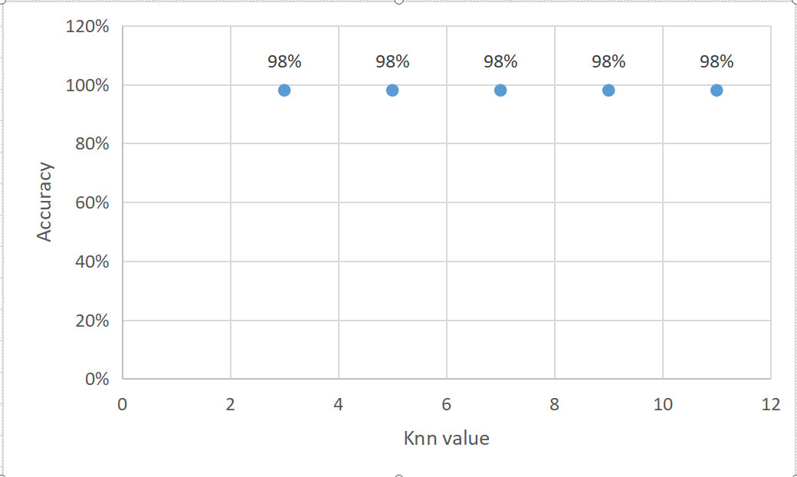

For more detail please see excel file:Weilin_Lu_Assign6_Knn.xlsx

3

|  |  |  |  |  |  |  |
| --- | --- | --- | --- | --- | --- | --- |
| TP | FP | TN | FN | Accuracy | TPR | TNR |
| 27 | 22 | 0 | 1 | 98% | 0.9643 | 1 |

4

Yes,it is better

5

Knn predict

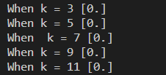

Simple classifier

0