Weilin Lu

Assign7

Stock knn

Q1

Q2 & 3& 4

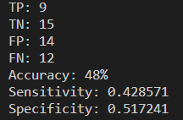

Q5

Buy and hold will cause more amount