Weilin Lu

Assign7

Logistic

Q1

Y=e^([0.27642045]-0.03570352878588806x) /(1+e^( [0.27642045]-0.03570352878588806x))

Q2&3

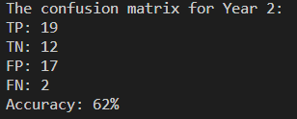

Q4



Q5

Buy and hold still cause more amount at the end of the year