Weilin Lu

Assign-9

Linear-Regression

Q1

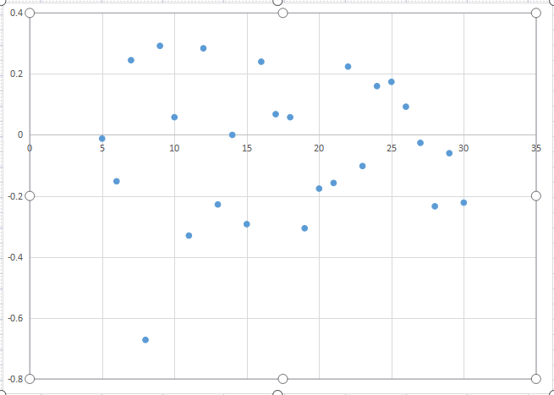

Week\*=9

Q2

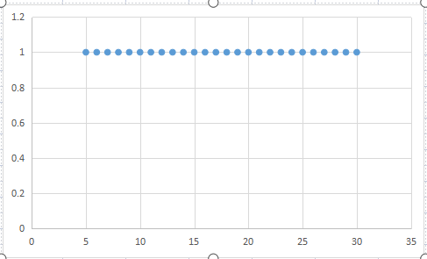

The average r^2=1.0

According to r^2,we can say the price change is very similar to year 1

Q3

The number of long position transaction for year 2: 131

The number of short position transaction for year 2: 118

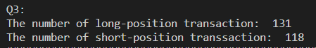

Because the average price in the second year is higher than that in the first year, it is suitable for long-term holding

Q4

The average P/L for long position:0.213

The average P/L for short position:-0.988



Q5

The average days of long position: 5

The average days of short position: 5



Q6

No,they have a little bit of difference of the W\* from first year