Weilin Lu
Assign7
Bank Notes
Q4
1
Just f1 miss

Just f2 miss
Just f3 miss
Just f4 miss
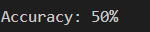
2
No,as the result from last week, the best k value is 3 and the accuracy is 98%

3
If F1 miss, it will has the lowest accuracy

4
If F4 miss, it will has the highest accuracy

Q5
2
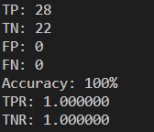
TP | FP | TN | FN | Accuracy | TPR | TNR
28 | 0 | 0 | 22 | 100% | 1 | 1

3
Yes, it is
4
Yes,it is
5
It is the same label as it predicted by knn
Q6
1
F1 miss

F2 miss
F3 miss
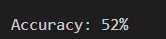
F4 miss
2
No, as show before, it decrease a lot
3
If F1 miss, it will has the lowest accuracy
4
If F3 miss, it will has the highest accuracy

5
For the result, it seems like it obtained using k-nn

