HW-3

Weilin-Lu

Q1

1:

(152-13)/3=46.33

So,bin interval are[0.,59.33),[59.33,105.66),[105.66,152]

Bin 1: 13,38,41,44,45

Bin 2: 81,83,88,90,95,103

Bin 3: 125,129,137,152

Smoothing by bin means

Bin 1: 36.2,36.2,36.2,36.2,36.2

Bin 2: 90,90,90,90,90

Bin 3: 135.75,135.75,135.75,135.75

Smoothing by bin median

Bin 1: 41,41,41,41,41

Bin 2: 89,89,89,89,89

Bin 3: 133,133,133,133

Smoothing by bin boundaries

Bin 1: 13,45,45,45,45

Bin 2: 81,103,103,103,103,103

Bin 3: 125,125,125,152

2:

Partition into equal depth bin

Bin 1: 13,38,41,44,45

Bin 2: 81,83,88,90,95

Bin 3: 103,125,129,137,152

Smoothing by mean

Bin 1: 36.2,36.2,36.2,36.2,36.2

Bin 2: 87.4,87.4,87.4,87.4,87.4

Bin 3: 129.2,129.2,129.2,129.2

Smoothing by median

Bin 1: 41,41,41,41,41

Bin 2: 88,88,88,88,88

Bin 3: 129,129,129,129,129

Smoothing by bin boundaries

Bin 1: 13,13,13,13,45

Bin 2: 81,81,95,95,95

Bin 3: 103,103,103,152

3:

V”=new_min+{(v-min)/(max-min)}*(new_max-new_min)

=0+{(125-13)/(152-13)}*10

= 8.0576

4:

Standard deviation

Mean = 84.27

Std=41.24

v’=(v-mean)/std

=(125-84.27)/41.24

=0.99

5

Absolute standard deviation

S=(|13-84.27|+|38-84.27|+|41-84.27|+|44-84.27|+|45-84.27|+|81-84.27|+|83-84.27|+|88-84.27|+|90-84.27|+|95-84.27|+|103-84.27|+|125-84.27|+|129-84.27|+|137-84.27|+|152-84.27|)/15=32.649

v’=(v-mean)/ab std=(125-84.27)/32.649=1.28

Q2

Correlation between *Cement* and *Concrete_compressive_strength*

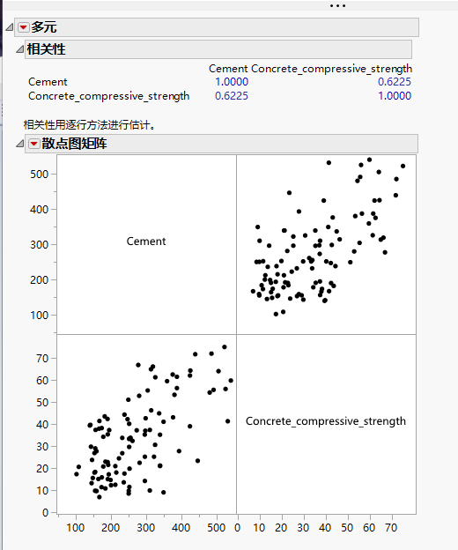

0.6225

Correlation between *Blast_Furnace_Slag* and *Concrete_compressive_strength*

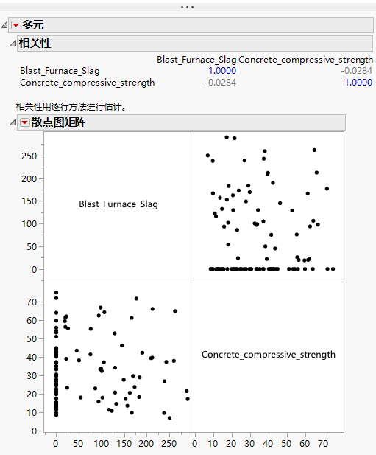

-0.0284

Correlation between *Fly_Ash* and *Concrete_compressive_strength*

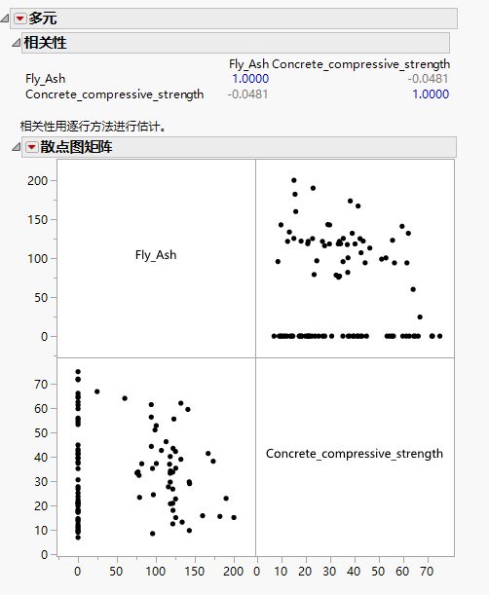

-0.0481

Correlation between *Water* and *Concrete_compressive_strength*

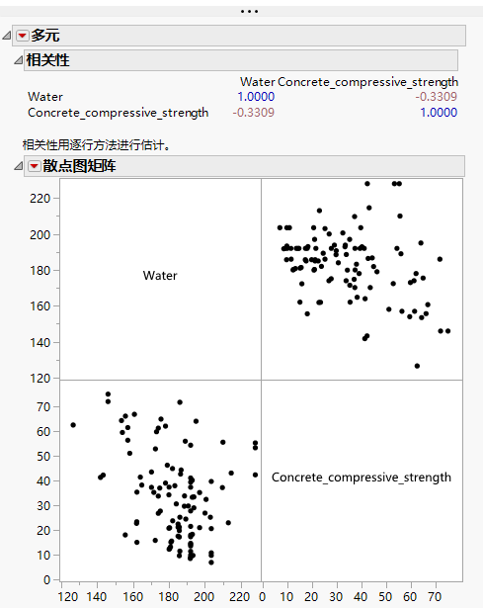

-0.3309

According to the previous picture and data, Cement has the strongest correlation with Concrete_compressive_strength

Q3

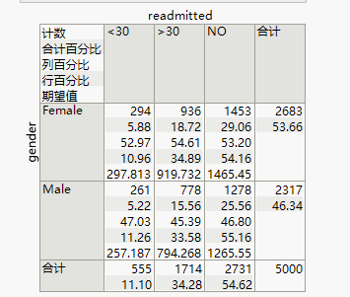

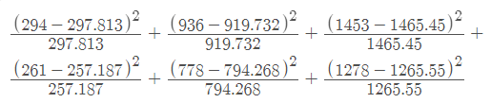

=0.9545

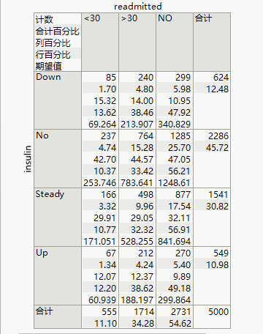

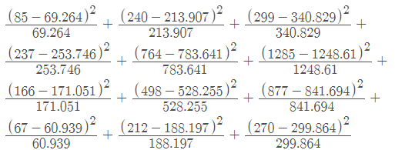

=24.5003