Q1

Without percentage split 66%

|  |  |  |  |
| --- | --- | --- | --- |
|  | Alone | Bagging | AdaboostM1 |
| Naive Bayes | 91.8367% | 92.8571% | 100% |
| Logistic | 100% | 98.9796% | 100% |
| MultiayerPerceptron | 100% | 100% | 100% |
| J48 | 97.9595% | 97.9592% | 100% |
| Random Forest | 100% | 98.9796 | 100% |
| IBK | 100% | 98.9796% | 100% |

Alone













Bagging













AdaboostM1













With Percentage split 66%

|  |  |  |  |
| --- | --- | --- | --- |
|  | Alone | Bagging | AdaboostM1 |
| Naive Bayes | 87.8788% | 87.8788% | 90.9091% |
| Logistic | 93.9394% | 100% | 93.9394% |
| MultiayerPerceptron | 90.9091% | 96.9697% | 90.9091% |
| J48 | 78.7879% | 78.7879% | 90.9091% |
| Random Forest | 75.7576% | 72.7273% | 72.7273% |
| IBK | 84.8485% | 81.8182% | 84.8485% |



Alone













Bagging













AdaboostM1













Q2



Q3

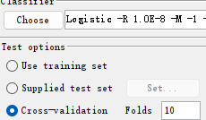

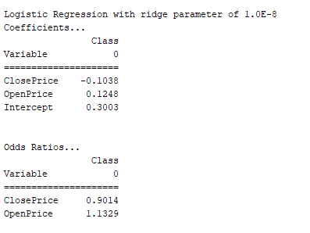

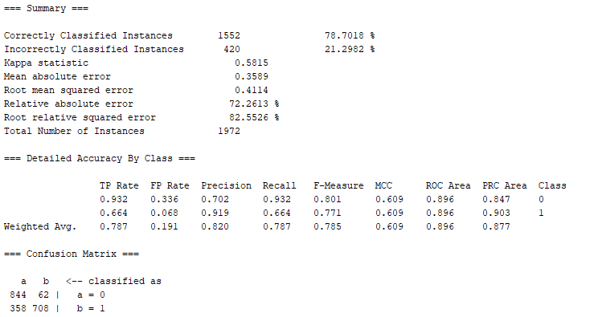

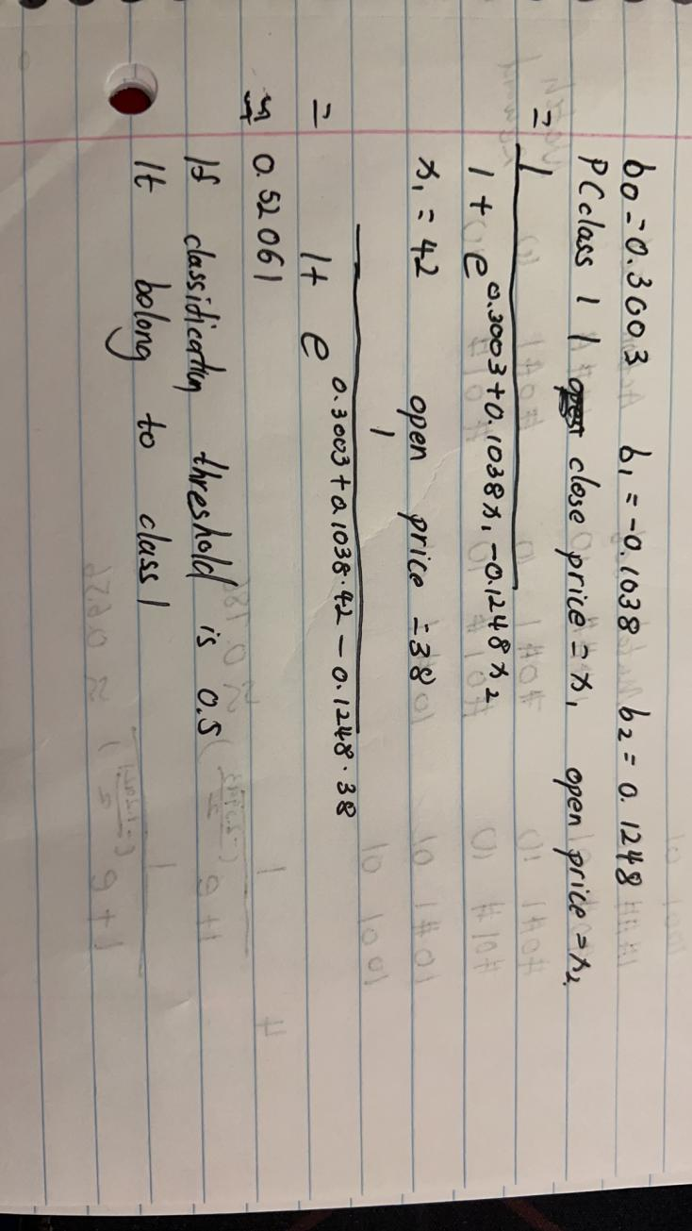

Q4

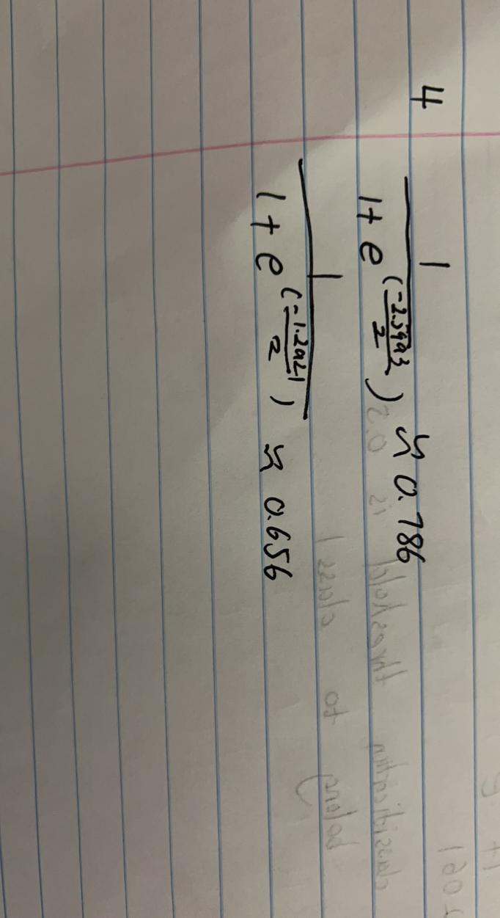

Q5

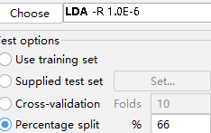

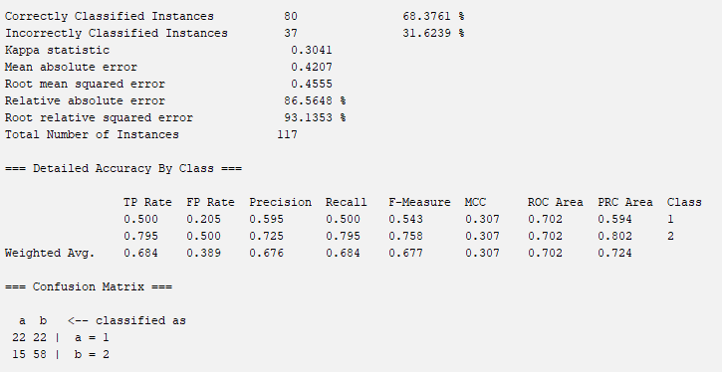

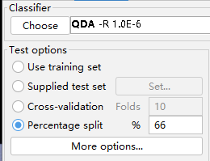

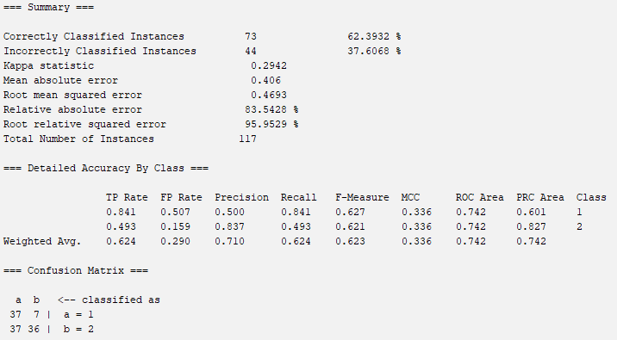

I will choose LDA because it has higher correctly classified instances percentage.