Q1

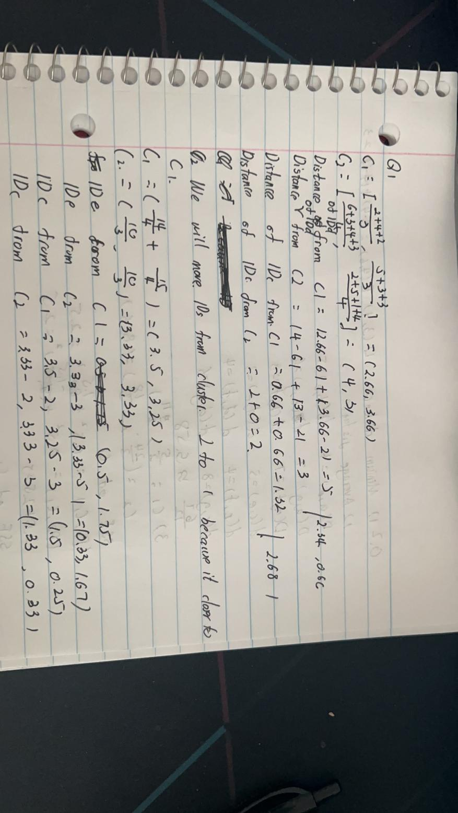

Q2

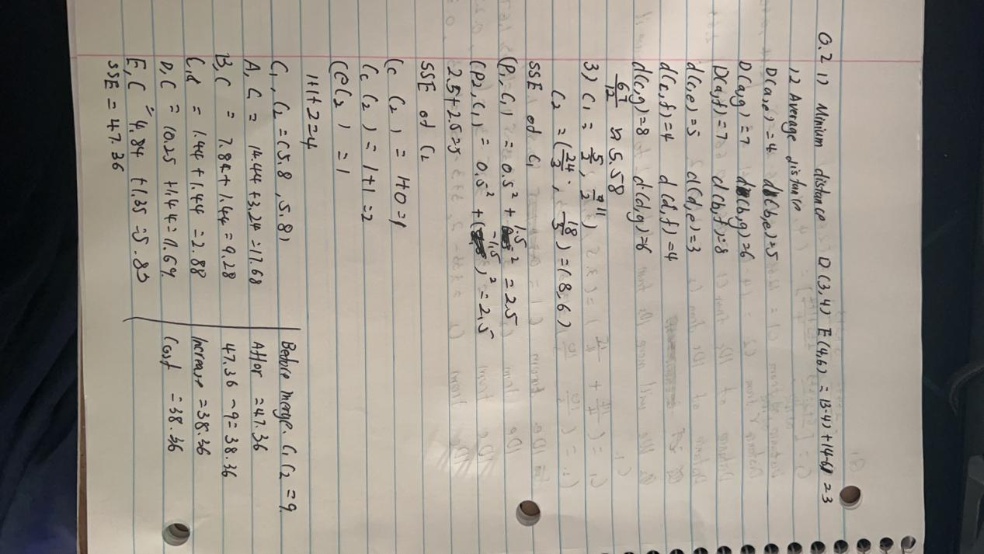

Q3

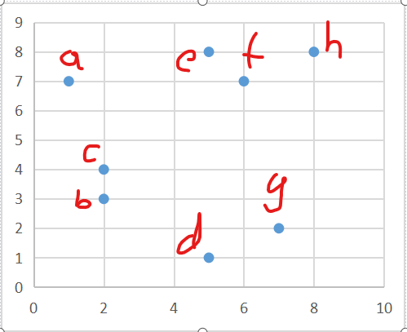

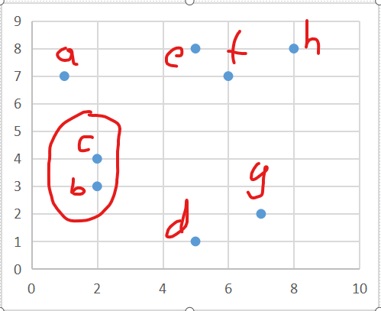

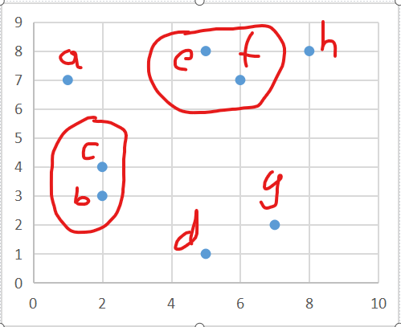

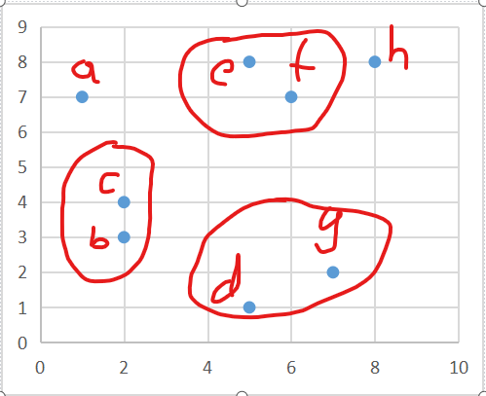

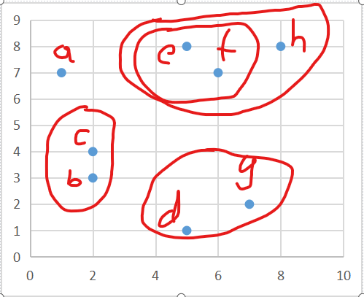

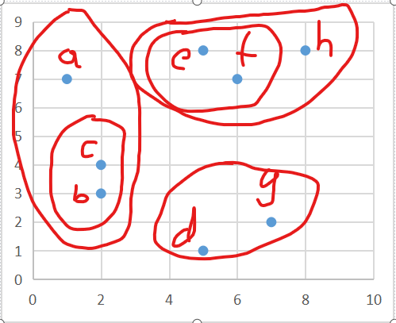

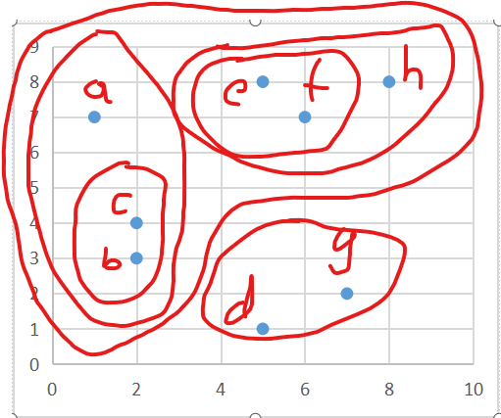

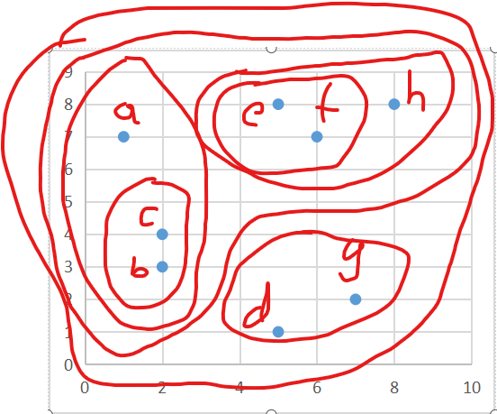

(a)(b)(c)(d)(e)(f)(g)(h)

(a)(b,c)(d)(e)(f)(g)(h)

(a)(b,c)(d)(e,f)(g)(h)

(a)(b,c)(d,g)(e,f)(h)

(a)(b,c)(d,g)(e,f,h)

(a,b,c)(d,g)(e,f,h)

Q4

(1)

K=2

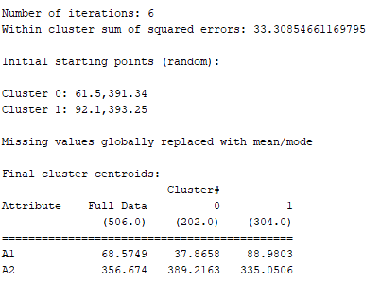

K=3

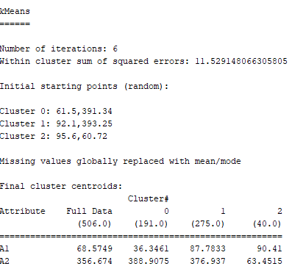

K=4

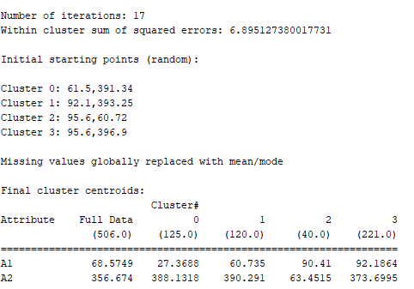

K=5

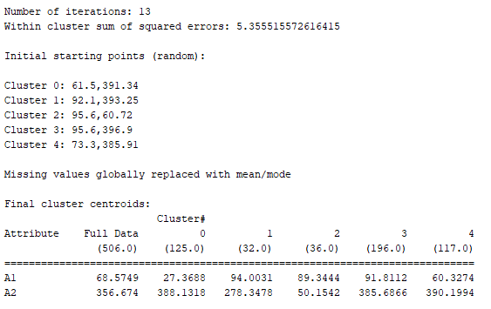

K=6

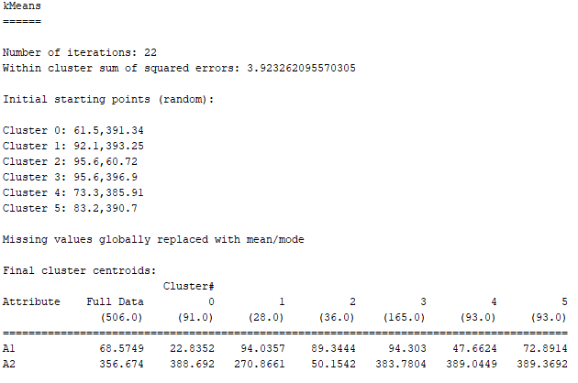

K=7

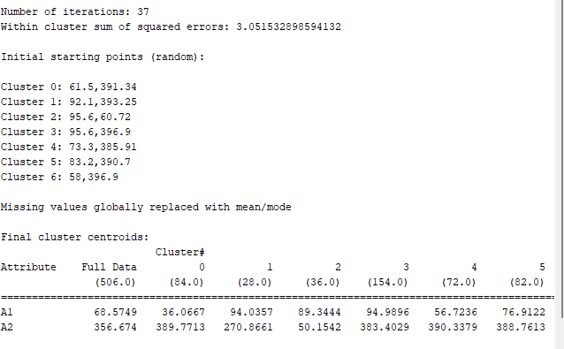

optimal number of clusters:k=2

(2)

|  |  |  |  |  |
| --- | --- | --- | --- | --- |
|  | 1 | 2 | 3 | 4 |
| Calories Mean | 156.5629 | 214.8264 | 171.026 | 167.5224 |
| STD | +/-11.1385 | +/-15.5421 | +/-18.191 | +/-8.2984 |
| MAX | 211.073064 | 196.0569717 | 211.073064 | 24.10206 |
| Min | 135.9771213 | 135.9771213 | 166.0206963 | 135.9771213 |
| Fiber Mean | 3.9537 | 7.2813 | 24.8333 | 0.225 |
| STD | +/-4.3567 | +/-4.3536 | +/-6.3456 | +/-1.0665 |
| MAX | 24.5 | 24.5 | 8.5 | 35.5 |
| Min | -0.5 | -0.5 | -0.5 | -0.5 |
| Sugars Mean | 10.9923 | 26.7789 | 26.0188 | 30.7703 |
| STD | +/-4.2619 | +/-7.5774 | +/-10.1438 | +/-6.3388 |
| MAX | 38.97474109 | 38.97474109 | 28.27701184 | 42.97815422 |
| Min | 7.150685103 | 11.95246912 | 14.32746912 | 7.150685103 |
| Potassium Mean | 81.2963 | 146.875 | 206.6667 | 46.75 |
| STD | +/-32.1233 | +/-44.7962 | +/-36.697 | +/-24.4559 |
| MAX | 230 | 190 | 100 | 260 |
| Min | 20 | 30 | 35 | 35 |

So,cluster 1 has the healthiest cereals

Q5

(1)

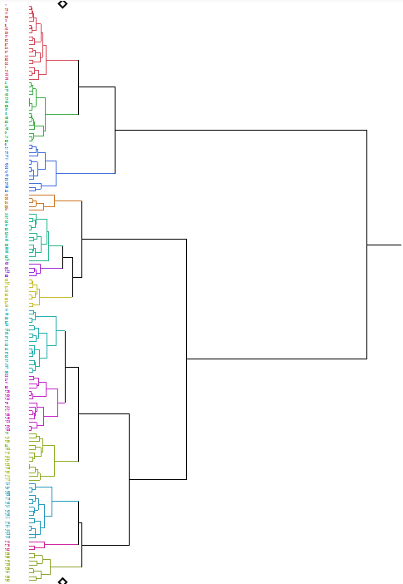

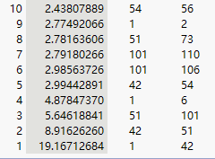

I will chose No.4 because since No.4, the distance has a huge change

(2)

