Q1

According to the graph, this is a increasing trend. Ans it is a annual seasonality

So:

Does the time series have a trend? Yes

Does it have seasonality? Yes

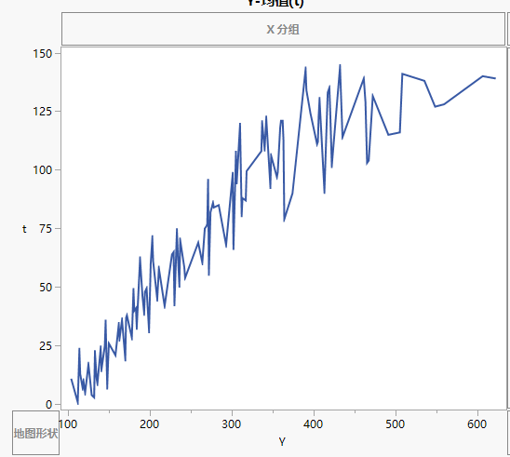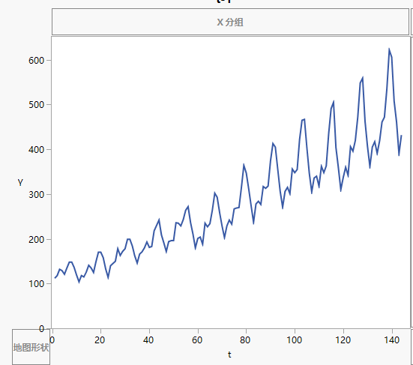

Q2

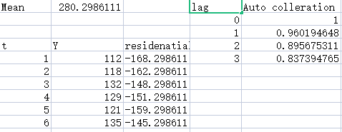

Picture is not in Full. The excel file will come with the submission

Lag 3 = 0.837394765

Q3

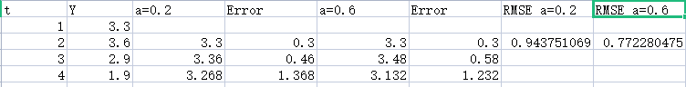

Picture is not in Full. The excel file will come with the submission

α = 0.6 is better