**Narvatri**

Navratri, in Hinduism, major festival held in honour of the divine feminine. Navratri occurs over 9 days during the month of Ashvin, or Ashvina . It often ends with the Dussehra celebration on the 10th day. In some parts of India, Dussehra is considered a focal point of the festival, making

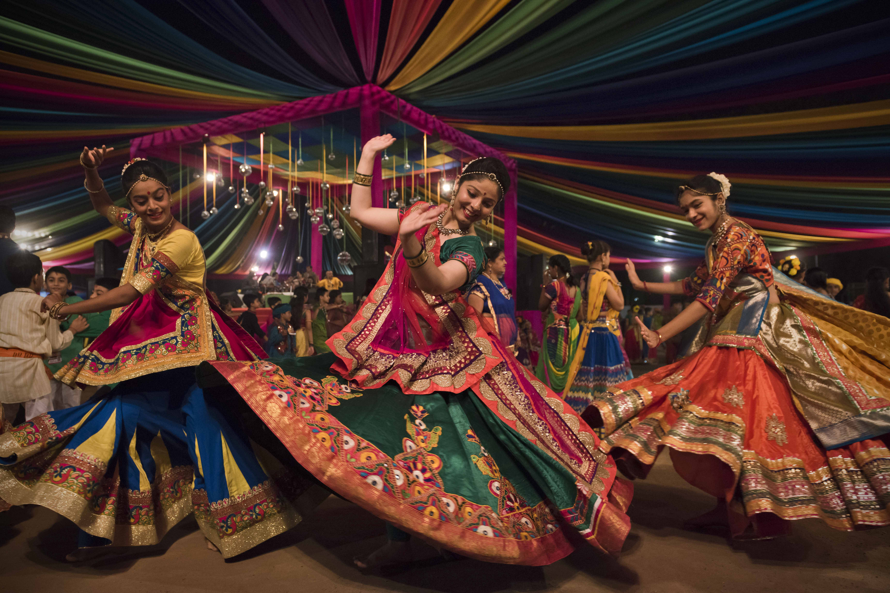it effectively span 10 days instead of 9. For many people it is a time of religious reflection and fasting, while for others it is a time for dancing and feasting. Among fasting customs are observing a strict vegetarian diet and abstaining from alcohol and certain spices. Dances performed include garba, especially in Gujarat. Typically, the festival’s nine nights are dedicated

to different aspects of the divine feminine principle, or shakti. Special images of Durga commemorating her victory over the buffalo-headed demon Mahishasura are worshipped daily, and on the 10th day they are taken in jubilant processions to nearby rivers or reservoirs for immersion in water. In addition to family observances, the puja, or ritual, days are also celebrated with public concerts, recitations, plays, and fairs.

In some regions, Dussehra is collected into Navratri, and the entire 10-day celebration is known by that name.