**Milad-un-Nabi**

**What is Milad-un-Nabi?**

Also known as Mawlid, Mawlid un Nabi Sharif, and Eid Milad, Milad-un-Nabi is the auspicious occasion of Prophet Muhammad Saheb’s birthday. The literal meaning of the word Mawlid is to give birth, which comes from the Arabic language. The contemporary usage however refers to the birth of the Prophet specifically.-Milad-un-Nabi dates.The celebrations of Milad un-Nabi will begin from evening of 27th September 2023 and will end by the evening of 28th September 2023.

**-What is the month of Rabi ul-Awwal?**

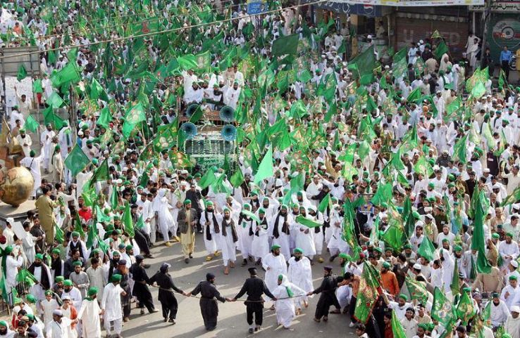The third month in Islmaic Calendar, Rabi Al Awwal falls after the holy month of Muharram and Safar. The literal meaning of Rabi Al Awwal can be derived from two words Rabi meaning the spring and Al Awwal meaning the first. As a result, Rabi al Awwal is translated to the first spring of the year. However, the meaning has no significance in the modern day as Islamic Calendar is a lunar Calendar and seasons may differ from month. The month in today’s world maintains the metaphorical sense of spring that is the blossom of hope and joy. The month also marks key events such as the birth of the beloved Prophet Muhammad (PBUH). Hence, the month is significant for the Muslims around the world. The month is widely celebrated for the 12th of Mawlid or Milad-un-Nabi

**-What is 12 Rabi ul-Awwal?**

Mawlid is observed on 12 Rabi ul-Awwal every year. Since Islamic calendar is a lunar calendar, the date as per the English calendar varies year to year. The date for Milad-un-Nabi 2023 is September 27th. It starts on the evening of 27th September and ends on the evening of the next day, which is the 28th.-Eid Milad-un-Nabi History.The history of Eid Milad revolves around the time when Prophet Muhammad (peace and blessings be upon him) was born in Makkah in 570 CE. However, the popularity of Eid-e-Milad began during the 8th century after the Prophet’s house was converted to a prayer hall. This was done by the then Caliph, Harun-al-Rashid’s mother, Al-Khizuran.Also, at that time, the day was observed very differently from the way it is observed today. Going back to the 11th century, Mawlid was only celebrated in Egypt by the leading clan. Later in the day, people used to recite and offer prayers and then people from the ruling clan gave speeches and verses from the Holy Quran. It was only in the 12th century, that other Muslim countries such as Syria, Turkey, Morocco, and Spain started to celebrate this day.-Eid Milad-un-Nabi Significance Prophet Muhammad (peace and blessings be upon him) is the last messenger of Allah Almighty, and a man of wise words, honesty, and mercy on all human beings. The entire humanity has been blessed by the birth of Prophet Muhammad and therefore any day related to his life is of great significance for Muslims irrespective of geographical boundaries. On this day, the believers greet his birthday to show their love and devotion to the Prophet (PBUH). This festival is all about remembering and regarding the teachings of the Holy Prophet.

**How is Milad un-Nabi celebrated?**

Eid Milad-un-Nabi is celebrated differently across different locations. In countries like India and Pakistan, Eid Milad is marked by grand processions, colorful decorations, and public gatherings. Buildings and streets are often illuminated with lights and candles. Special naat (poetry praising the Prophet) competitions and recitations are common. In Egypt and other North African countries, the focus is on religious lectures, Quranic recitations, and scholarly discussions about the life and teachings of the Prophet. In many Arab countries, Eid Milad is observed as a religious occasion with prayers and Quran recitations. In some Arab cultures, there is a tendency to avoid elaborate celebrations and focus on spiritual aspects. Countries like Indonesia and Malaysia may hold public festivals, including parades and cultural events, to celebrate Eid Milad. Streets and buildings are often decorated with banners and Islamic calligraphy. Some Middle Eastern countries place a strong emphasis on religious gatherings, where scholars discuss the life and teachings of the Prophet. In Western countries with Muslim populations, the celebration of Eid Milad varies, influenced by local customs and the diversity of Muslim communities.