**The Passover Story**

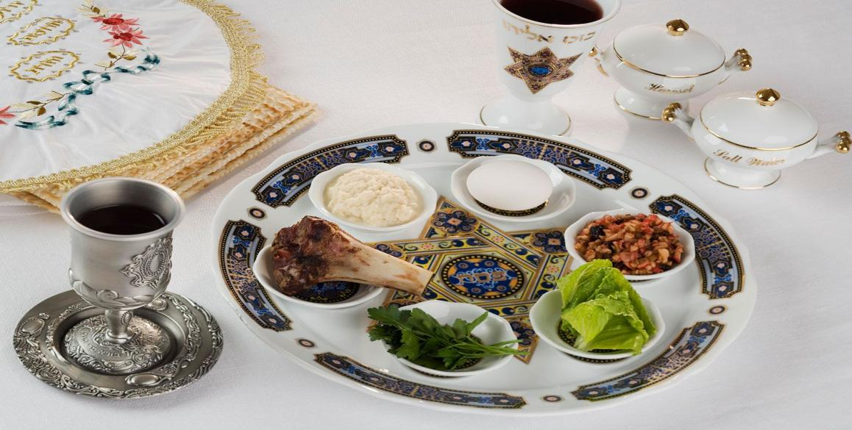According to the Hebrew Bible, Jewish settlement in ancient Egypt first occurs when Joseph, a son of the patriarch Jacob and founder of one of the 12 tribes of Israel, moves his family there during a severe famine in their homeland of Canaan.For many years the Israelites live in harmony in the province of Goshen, but as their population grows the Egyptians begin to see them as a threat. After the death of Joseph and his brothers, the story goes, a particularly hostile pharaoh orders their enslavement and the systematic drowning of their firstborn sons in the Nile.-

Passover Seder Meaning-On the first two nights of Passover, families and friends gather for a religious feast known as a seder for the Jewish holiday.-During the meal, the story of the exodus from Egypt is read aloud from a special text called the Haggadah (Hebrew for “telling”), and rituals corresponding to various aspects of the narrative are performed. For example, vegetables are dipped into salt water representing the tears Jews shed during their time as slaves, and bitter herbs (usually horseradish) symbolizing the unpleasant years of their bondage are eaten.-A seder plate at the center of the table contains Passover foods with particular significance to the exodus story, including matzo, bitter herbs, a lamb shankbone and a mixture of fruit, nuts and wine known as charoset, which represents the mortar Jews used while bonding bricks as slaves in Egypt.-Other typical menu items include matzo kugel (a pudding made from matzo and apples), poached fish patties called gefilte fish and chicken soup with matzo balls.