DBS201 Lab 1 (revised Winter 2017)

Purpose:
- to become familiar with the signing on process for the IBMi.
- to learn how to change your password.
- to learn how to print on the line printer.
- to enter a SQL statement
- compare Schemas Libraries and Collections

You will need a userid and password from your instructor before starting this lab.

- Signing On:

Click on the IBMi folder on your desktop and sign in with the profile provided to you by your instructor using either the white or green screen Client Access.

Read the guidelines for use of computer accounts and press enter. Read the second screen and press enter. Now you will be prompted for your name and student number. Enter your first name, then TAB and enter your last name, then TAB and enter your student number. Once you have entered all three, then press ENTER!

Read the confirmation screen. If the information is correct press enter. If something needs to be changed, enter an N (and press enter) to go back and make corrections.

Once you have confirmed your information, you will be at a Menu screen. This signon is using Client Access. This is sometimes referred to as the Green Screen.

Type the following command at the command line prompt:

=> GO DBS201LIB/SQLTERMS

This terminology is something you will have mastered by the end of this subject. You are not expected to know it now, but you are encouraged to take a brief look by pressing the appropriate number for a term. After you have browsed the definition, press F3 to return to the menu.

Remember you are not expected to know any of these definitions in the first week.

Press F23 (done by pressing Shift + F11). This should ensure that anytime you start a session in Client Access, the definitions will be easily accessible. This will always be the first screen you will see when signing on.

In order for your name to show at the bottom of the printout, you need to remember to always run the following command from the command line:

==>CALL STRJOB .

After you have run that command, hold down the <Control> key and press the Pause key (upper right of keyboard). This causes a printout of the screen to be created. In the bottom left-hand corner of the screen you will see a message telling you that the print operation is complete. You will also see a red X. You must press the (ESC) key before you can key in anything else. Press Escape now. Print the screen again (just in case!). (you will find these printouts later!!)

Type the following command at the command line prompt:

=> STRSQL

This places you into a friendly SQL environment where you can enter SQL statements interactively.

Type CREATE at the SQL command prompt and press the F4 function key.

Type SQL statement, press Enter
Current connection is to relational database S10A04C2

===> CREATE (F4)

Select option 2 (Collection)

For the Library prompt, provide a name that is similar to your ID. If your id is DT201B39 use DT201B39SQ

What feedback is provided for the execution of this SQL statement:
Schema DM201H25SQ created

Press F3 which will take you to the Exit Interactive SQL screen.

Exit Interactive SQL

Type choice, press Enter.

Option . . . . . . . . . 1 1=Save and exit session
2=Exit without saving session
3=Resume session
4=Save session in source file

Always keep the default of 1 to Save and exit session. You do not ever want to lose the SQL statement history.

Press enter to obtain a menu screen. Below the menu options is a command line where your cursor should be.

3. Changing Your password:

On the command line, type the command CHGPWD and press F4. You should now see the Change Password screen and your cursor is on the line which says Current password. Enter your current password (which you received on the sticky label), then press the TAB key to go to the next input field. Enter your new password (it may not begin with a number), then TAB and enter the new password again. Finally press enter to execute the Change Password command. The system will return you to the menu screen and you should see the message "Password changed successfully" at the bottom of the screen.

4. Sending messages:

On the command line, enter the following command: (the iSeries is not case sensitive)
SNDMSG MSG(‘Hi, how are you?’) TOUSR( DJ201C11)
(Note: Use your own userid).
Press enter. (you will find this message later!)

5. Do not close this connection.

6. Using the GUI:

Find and double click the iSeries Navigator icon on the desktop. This starts the GUI interface to the iSeries. You may have to search programs if the icon is not on the desktop. If you do not find iSeries Navigator look for System i Navigator which is another name used for this product.

On the left hand pane, double click on Zeus.senecac.on.ca.

Now you will see a signon window. Enter the userid you have been given by your instructor and your changed password and click OK.

Notice all the components of iSeries Navigator in the left hand pane.

Double click Basic Operations (left pane). What options do you see?

Double click on messages. Do you have any messages? You may double click the message itself to see more details. Right click on the message to delete it. Press DELETE button now.

Right click on Messages. Select “Send message”. Enter your userid, enter a message in the message area (like “Hello World”), then click send and close. Does your message appear in the right hand pane?

Click View and then select Refresh. Now do you see it? Delete the message.

7. Printer Output:

Double click on Printer Output. How many files appear in the right pane? What are the names of the files? Double click the first output file. (You may have to sign on again.) Does this look familiar? Close the View window.

To print this output on an i-Series printer:
- Right click the output file and select Properties.
- Click on the Printer/Queue tab.
- Locate the line that says output queue (an output queue is where output waits to be printed or deleted). Which output queue is listed?
- Click the MOVE button, then click on Output Queue radio button and type in PRT01 (that’s prt followed by a zero and 1),
- Choose “Use Library list” (default option), then click OK.
- Click OK on the Properties window.
Notice the status of your printer output now. Has the status changed?
Refresh the screen. Do you remember how to do that? Another way is to press F5. Is the output still there? No, it has been printed!!

To print this output on a PC printer (you can try this at home), click File, then Print.

Delete the second printout (and any others you may have listed there) the same way you deleted a message before.

8. Databases:

Back on the left hand pane, double click on Databases. What options do you see?

Double click on Schemas. On the iSeries a Schema is similar to a Library.
(A Library on the i-Series is like a directory where files and other objects are stored.) When you are using interactive SQL on this system you create Schemas to store objects like tables and special database objects to help you manage a database are included. When you are using the native interface you create Librarys to store objects like files and no extra special database objects are included. What do you see listed?

A Library has been created for you to use this semester. The Library has the same name as your userid (like DT201B39) and is accessible by clicking on Schema

To add this Schema/Library to the list:
- right click on Schemas
- choose "select schemas to display" (do not choose "new schema" as this is used to actually create a new one).
- In the "select schemas to display" window, enter your schema name
(like DT201B39)
- Click add.
- Enter your previously created collection name as well (in this case DT201B39SQ)
- Click OK to exit the window.
- Do you see your schemas listed now?

Adding Schemas
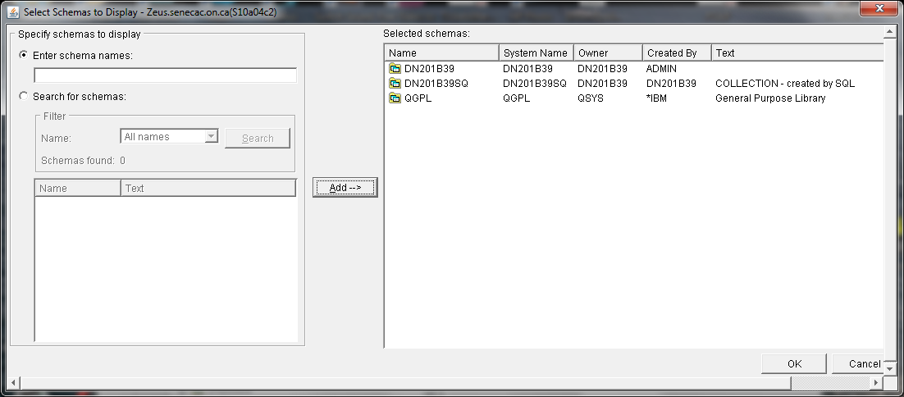

Note: If your schema is already displayed when you double click on Schema object, you can still do these steps, just for the practice

After you have added Schemas/Librarys this list will be stored on the server and whenever you log on to the system using Navigator, the list will include the new Library/Schema additions.

Double click on your schemas. (This will be where you will store some of the files you create this semester.) In the right hand pane you will see the list of database objects stored in your library. How many are there? Once you have created some database objects you will find them here.

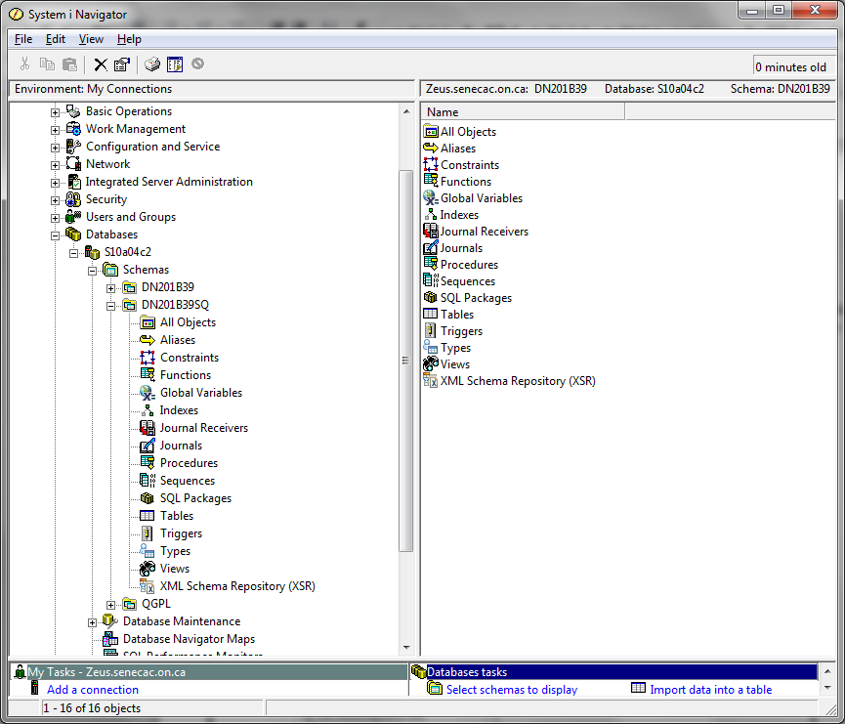

Write down all the objects in both of your Libraries/Schemas. You can access this information by clicking on the All Objects prompt underneath the Schema you want to investigate.

Important note: It appears that the system has a configuration problem and clicking on all Objects at the lab machines causes an error to occur. To see all the objects in your collection and in your library do the following:

In Client Access type the following commands:

WRKOBJPDM collectionname

WRKOBJPDM libraryname

DT201B39 ???????? DT201B39SQ ????????SQ
(Schema created for you) (Schema created by you)

____________________________ _______________________________

____________________________ _______________________________

____________________________ _______________________________

____________________________ _______________________________

____________________________ _______________________________

____________________________ _______________________________

____________________________ _______________________________

____________________________ _______________________________

____________________________ _______________________________

____________________________ _______________________________

____________________________ _______________________________

____________________________ _______________________________

____________________________ _______________________________

____________________________ _______________________________

____________________________ _______________________________

____________________________ _______________________________

____________________________ _______________________________

____________________________ _______________________________

____________________________ _______________________________

____________________________ _______________________________

____________________________ _______________________________

Although Library and Schema are similar on the system, which name of the two names that you listed stored objects is more like a Library and which is more like a Schema?

DM201H25 – Library, DM201H25SQ - Schema

You were introduced to another name that is similar to Library and Schema in this lab. It is

COLLECTION

In the next lab, we will spend some time looking at some database objects.

9. Signing off:

Close the iSeries Navigator window. This signs you off and ensures that no one else has access to your account!

In Client Access you need to type in SIGNOFF at the command line. Do that.

You should always make sure you are signed off when you are not using the computer.

Hand in:

Your lists entered on page 7

Pick up your printout in room 2113. On the banner page of the printout and on page 7 write:

- Your name: Sang Jun Park
- Your Section: DBS201SHHL
- Lab Number: 1

Make sure you get the printout that has your name and id at the bottom. You will not have a name or id showing if you did not run the CALL STRJOB command as instructed.

