**LAB 4 : JOINS and VIEWS**

**\*\*\*\*\*\*\*\*\*\*\*\*\*\*\*\*\*\*\*\*\*\*\*\*\*\*\*\*\*\*\*\*\*\*\*\*\*\*\*\*\*\*\*\*\*\*\*\*\*\*\*\*\*\*\*\*\*\*\*\*\*\*\*\*\*\*\*\*\*\*\*\*\*\*\*\*\*\*\*\*\*\*\*\*\*\*\*\*\*\*\*\*\*\*\*\*\*\*\*\*\*\*\*\***

Purpose - In this lab you will learn how to:

A. use a **JOIN** for reports that needs data from more than 1 table.

B. create a **VIEW**

- a VIEW contains no data

- the VIEW appears to the user as a table.

- the VIEW runs a “SELECT” to create a temporary table.

- the user can use this temporary table to produce reports or anything else that a table can be used

for.

C. copy data from one table to another.

D. use calculated fields that are derived from two or more attributes

.*\*\*\*\*\*\*\*\*\*\*\*\*\*\*\*\*\*\*\*\*\*\*\*\*\*\*\*\*\*\*\*\*\*\*\*\*\*\*\*\*\*\*\*\*\*\*\*\*\*\*\*\*\*\*\*\*\*\*\*\*\*\*\*\*\*\*\*\*\*\*\*\*\*\*\*\*\*\*\*\*\*\*\*\*\*\*\*\*\*\*\*\*\*\*\*\*\*\*\*\*\*\*\*\**

**PART A:** What if we want to produce a report that contains data from CUSTOMER and SALESREP?

Fields: Customer_Number

CUSTOMER.First_Name

CUSTOMER.Last_Name

SALESREP.First_Name

SALESREP.Last_Name

Tables: PREMIERE.CUSTOMER, PREMIERE.SALESREP

The Salesrep data would be the customer’s corresponding Salesrep.   
  
- We will use the common column Sales_Rep_Number.

- It is used in both the CUSTOMER and the SALESREP tables.

- The Sales_Rep_Number is the primary key in the SALESREP table

- The Sales_Rep_Number is the foreign key in the Customer table.

- When we put a row of the CUSTOMER table together with the corresponding row of the SALESREP table we get a temporary table called a **join.**

We can JOIN CUSTOMER with SALESREP with a SELECT statement:

SELECT c.CUSTOMER_NUMBER, c.FIRST_NAME, c.LAST_NAME,

s.FIRST_NAME, s.LAST_NAME

FROM PREMIERE.CUSTOMER c, PREMIERE.SALESREP s

WHERE c.SALES_REP_NUMBER = s.SALES_REP_NUMBER

ORDER BY c.CUSTOMER_NUMBER

NOTE:

The characters c and s are aliases.

c stands for PREMIERE.CUSTOMER

s stands for PREMIERE.SALESREP

Let's create this report. In Client Access, type in the SELECT exactly as previously provided

.

You should obtain the following display.

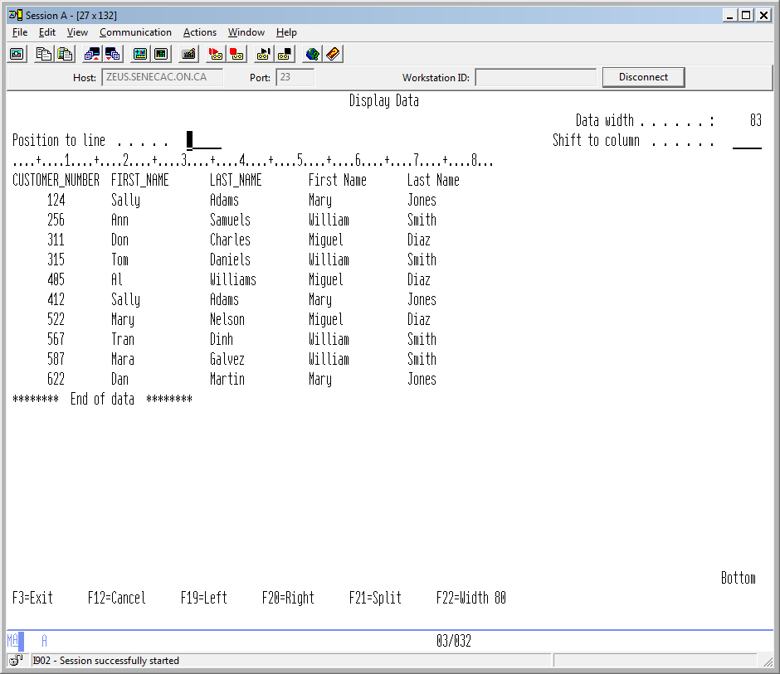

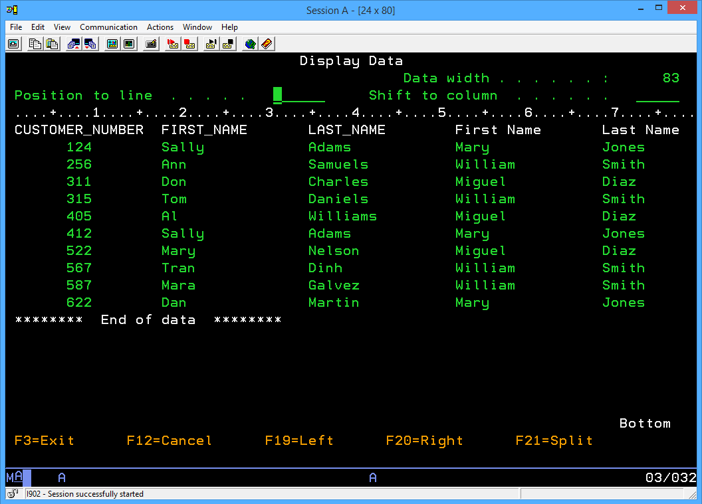

What is the problem with this report? By looking at the report we cannot tell which is the Customer Name and which is the Sales Rep Name

We can fix this. The **concatenation** operator joins two character strings together.

It is || (“||” is the pipe key “|” pressed twice).

For example, ‘ABC’ || ‘/’ || ‘def’ will produce a result of ‘ABC/def’.  
Retrieve the previous command (F9) and change it as follows:

SELECT c.CUSTOMER_NUMBER,

c.FIRST_NAME || c.LAST_NAME as CUST_NAME,

s.FIRST_NAME || s.LAST_NAME as REP_NAME

FROM PREMIERE.CUSTOMER c, PREMIERE.SALESREP s

WHERE c.SALES_REP_NUMBER = s.SALES_REP_NUMBER

ORDER BY c.CUSTOMER_NUMBER

You should get the following display:

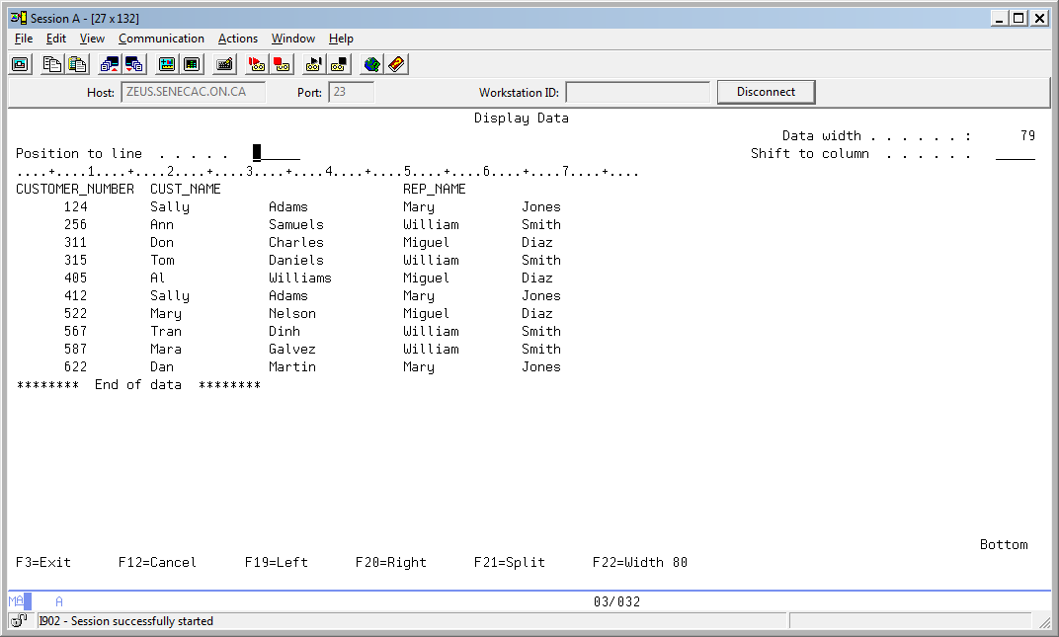

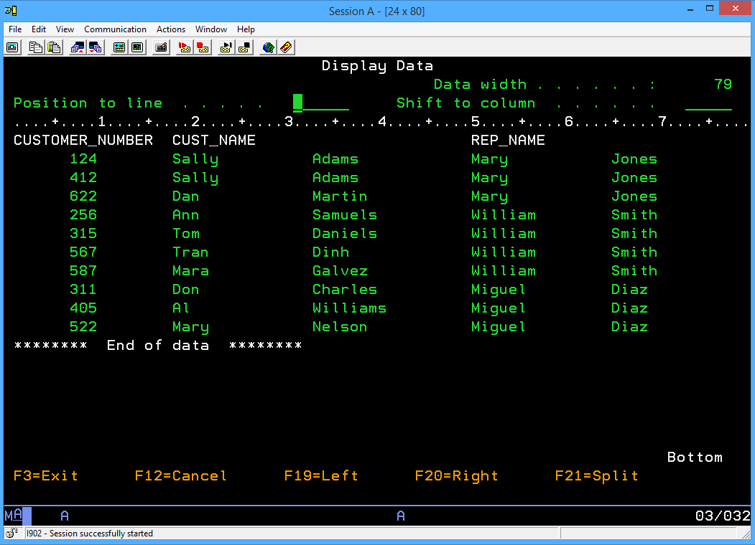

**Much Better!**

**Let’s get rid of the wasted space between first and last names.**

**Use the TRIM function to provide the following output:**

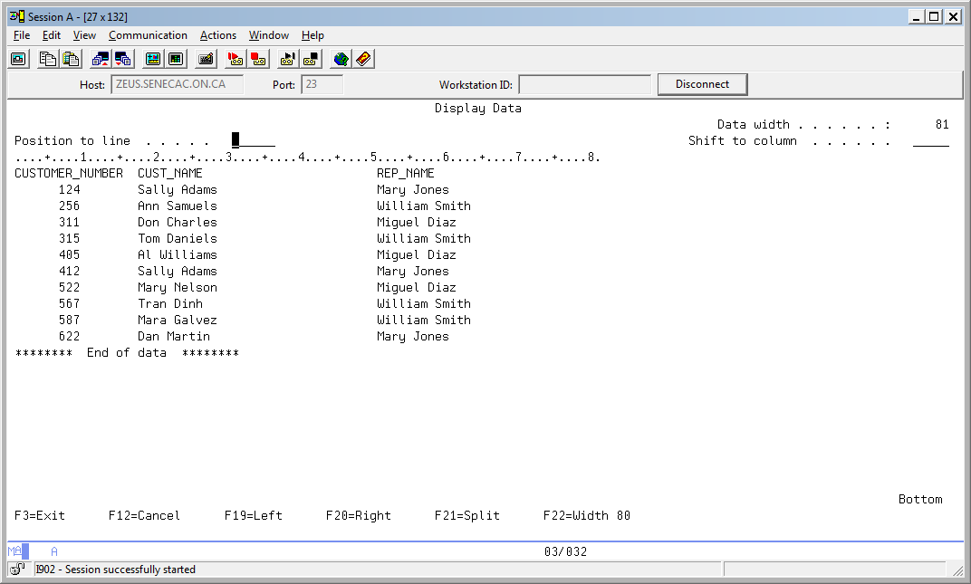

**(you will retrieve most of this statement and write all this down later when creating the view)**

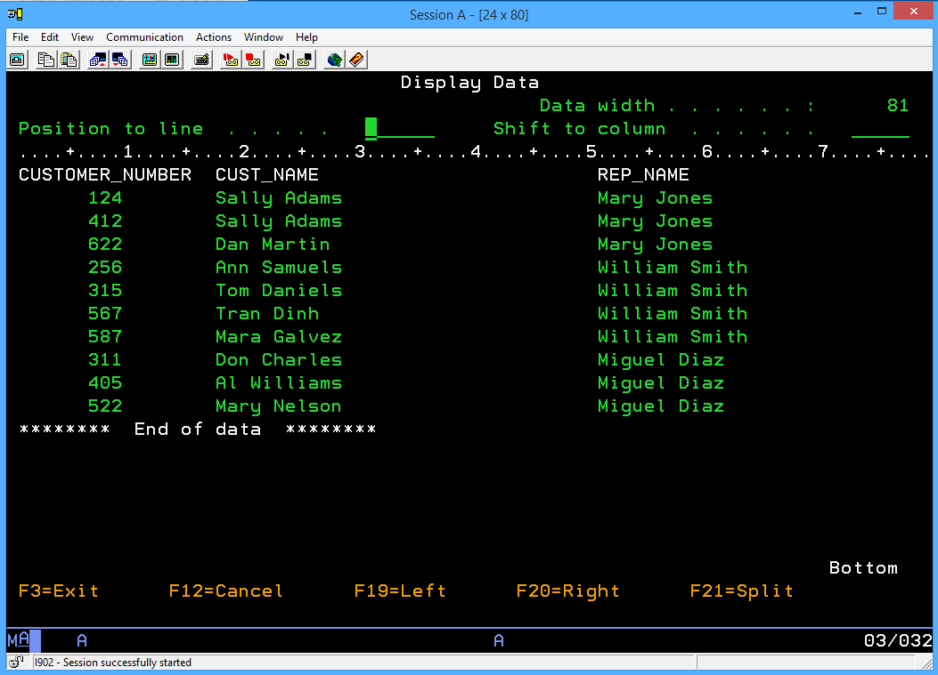

**PART B: Creating a View**

In the previous section, we went to a lot of trouble to generate a report using multiple files, concatenation, and a change of column titles. What if this SELECT were required many, many times? It is possible to save that select statement as a *View*.

The general syntax to create a view is:  
  
 **CREATE VIEW *viewname AS***

**(SELECT …..[ insert your select statement here] ).**

Find and retrieve the SELECT that you used to create the previous report. With your cursor at the beginning of the command, press F15 (Split line). This should insert a new line at the beginning of the command. Now we can enter our CREATE VIEW AS command before the SELECT statement and save having to re-enter the whole thing!

An ORDER BY clause is not allowed when creating a view, so you will have to remove that clause when creating the view.

Provide the full statement to produce the CUST_REP view where names show as “Sally Adams” for the customer and “Mary Jones” for the sales rep. Assume the Set schema command was not run and refer to PREMIER??? in the appropriate areas. This view will be created in your collection and be based on the tables in your collection.

Make sure your written statement is readable; it will be part of the submission for this lab.

===>  **Enter SQL Statements**

CREATE VIEW CUST_REP AS

SELECT c.CUSTOMER_NUMBER,

TRIM (C.FIRST_NAME)||' '||(C.LAST_NAME) AS CUST_NAME,

TRIM (S.FIRST_NAME)||' '||(S.LAST_NAME) AS REP_NAME

FROM PREMIERE.CUSTOMER c, PREMIERE.SALESREP s

WHERE c.SALES_REP_NUMBER = s.SALES_REP_NUMBER

Press enter to execute the command. You should receive the following message:

**View CUST_REP created in PREMIERxxx.**

Once a VIEW is created, it can be used in much the same way as a TABLE. You can use SELECT statements to see the data. Run the SELECT statement to look at all the data in the view. (SELECT * FROM PREMIER???.CUST_REP.) Your report should look the same as before.

A VIEW can be thought of as a virtual table. It is virtual in the sense that it is not an actual table that stores data, but rather it is a way of presenting data from other tables to you in table format.

You can also think of it as a way of "saving" a complicated select statement so you don't have to re-enter it every time you want to run that query.

**PART B: Copying data from one table to another**

Remove all the data in the SalesRep table

==>DELETE FROM SALESREP

You should get a message above your delete statement preventing the delete from being executed like the following:

Delete prevented by referential constraint CUSTOMER_FK in PREMIERB45

(You may not see this message if lab 3 was not done properly)

This error message is a good thing. Why?

Delete prevented by referential constraint SALES_REP_NUMBER_FK in PR

Because SALES_REP_NUMBER table was connected with COUSTOMER table by foreign key.

So, you need to remove all the rows from Customer first, than remove all the rows from SalesRep next.

Do this (ask for help if you are not sure)

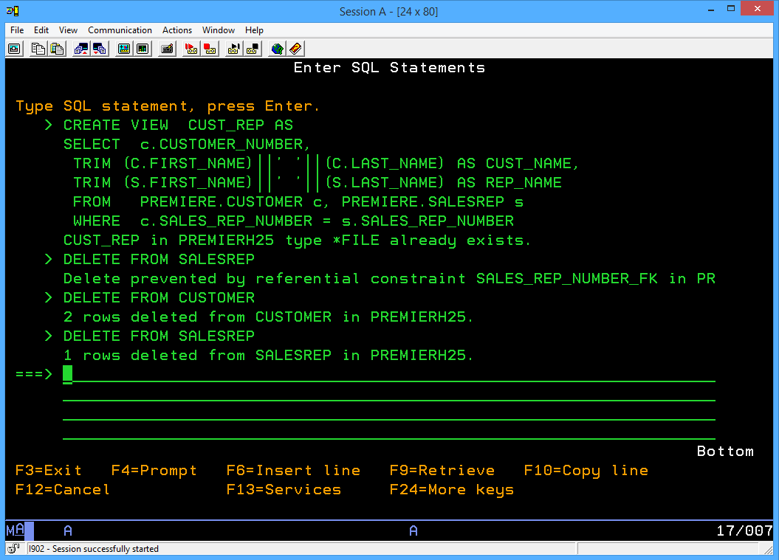

Now that our tables are empty, let’s get the data from Premiere.Customer and the data from Premiere.SalesRep.

The statement to do this is similar to the following:

INSERT INTO PREMIER???.CUSTOMER SELECT * FROM PREMIERE.CUSTOMER

Note that this statement is not referring to the column names in either table. That is because the column names were specified in the same order with the CREATE TABLE statement for both tables. Also the columns for both tables agree in type and size. If Customer_number was defined as a character type with a length of 3 in the first table, it should also be a character type with a length of 3 in the second table.

if you did not create the tables in the previous lab the way you were guided to and are having problems with this step, see if you can run a more sophisticated version of the insert into statement with prompting. Instead of using an asterisk you will have to match up the column names. A lab aid or instructor can also help here.

We needed to run the Delete Statements in a certain order, do we have to follow a certain order when loading your Customer and SaleRep tables with data from the PREMIERE collection tables? If so, what is the order?

Provide the statements here:

If columns are not specified then the order matters.

Why does the order matter?

In customer table, there is foreign key. Customer table uses information written in the salesrep table. So, if I want to delete information in tables, I need to delete customer table first. But if I want to insert information into tables, I have to do reverse.

Insert one row into the SalesRep table with your instructors name and one row in the customer table with your name. Use ‘99’ for the sales rep number for both tables. Your instructor should show up as your SalesRep in the following report.

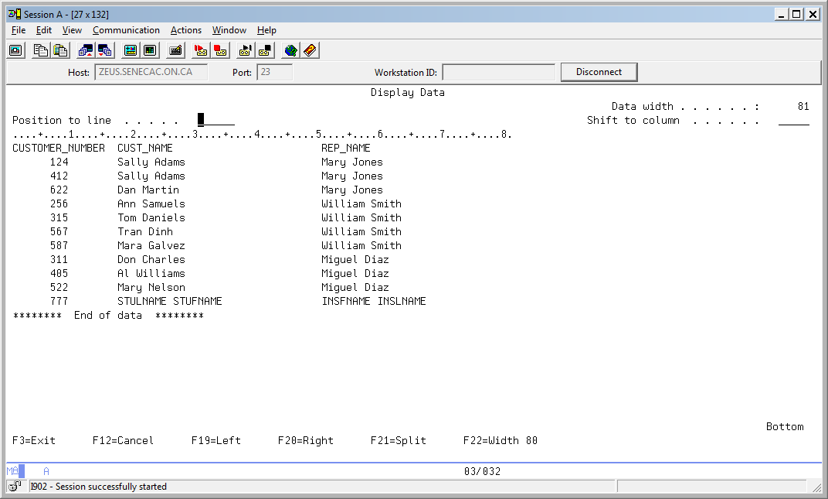

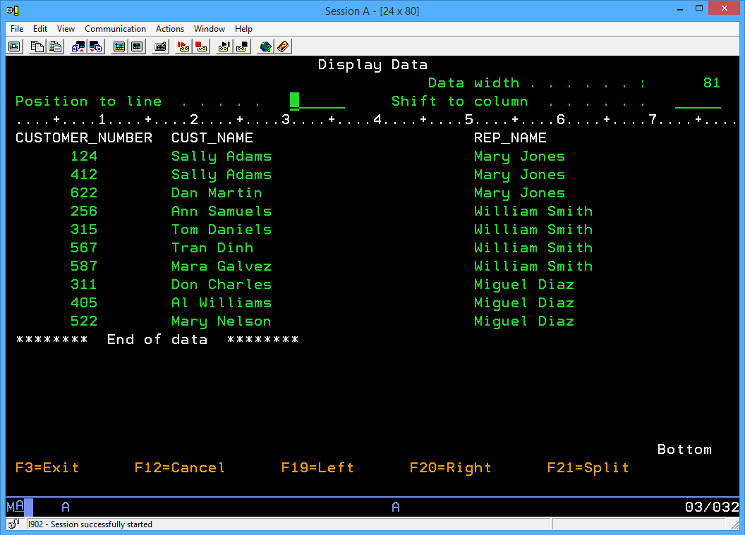

**PART D: Using calculated fields that are derived from two or more attributes**

**These are the tables available in PREMIERE**

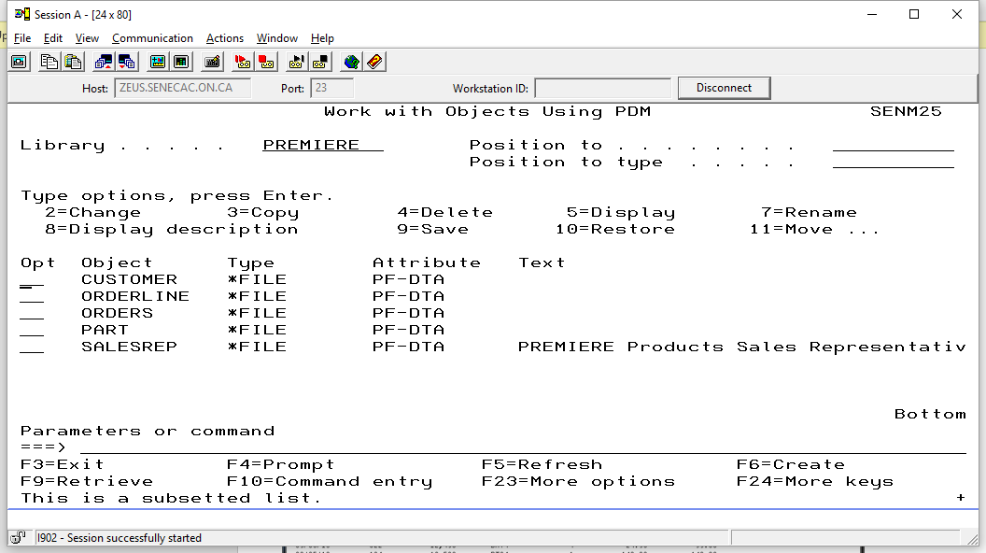

You should have a copy of ORDERS, ORDERLINE and PART in your PREMIER??? Collection. The following command should be used. It cannot be prompted, it must be typed out.

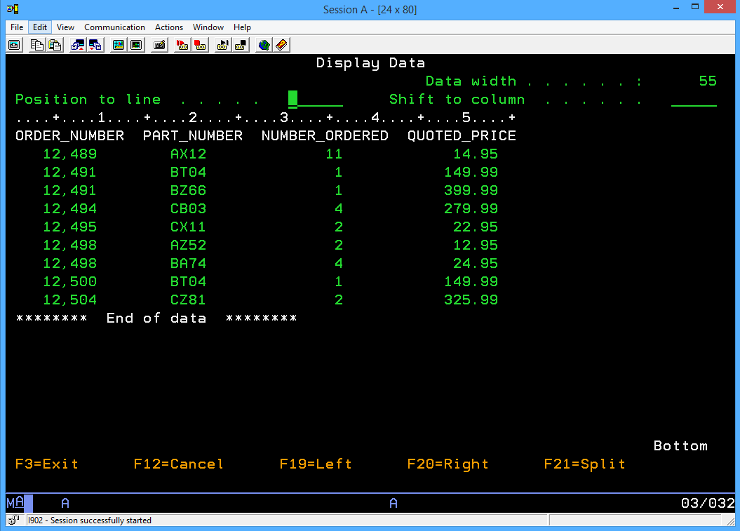

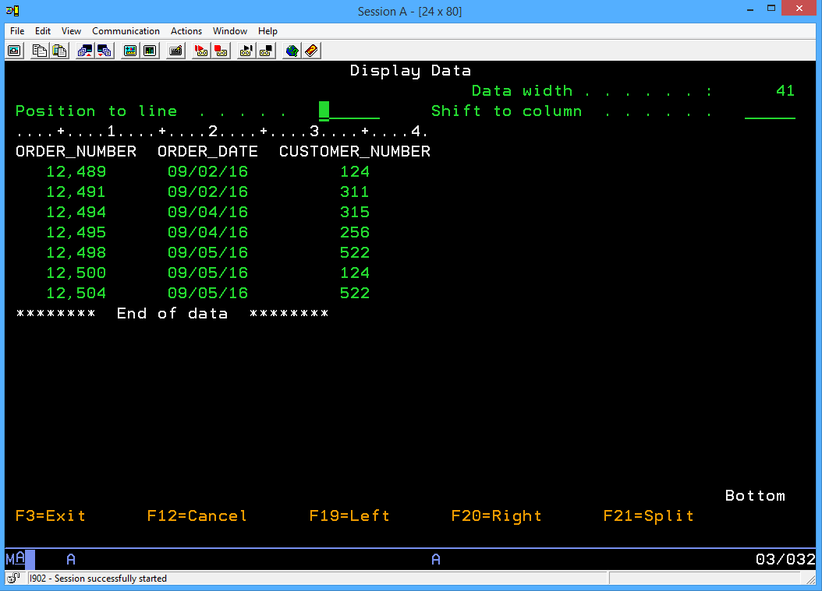

**CREATE TABLE ORDERS as (SELECT * FROM PREMIERE.ORDERS) with data**

Be careful that your tables are created in your collection rather than your student library.

You are looking for a completion message like the following:

**Table ORDERS created in PREMIERB45**

You do not want to see the following:

**Table ORDERS created in DB201B45**

After you have copied the tables with data, develop a report on the latest sales.

An ORDER_INFO report should look like this

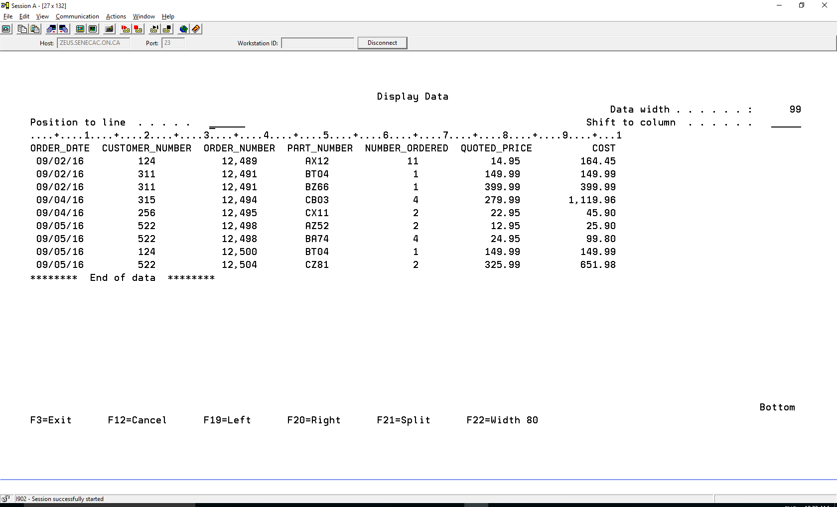

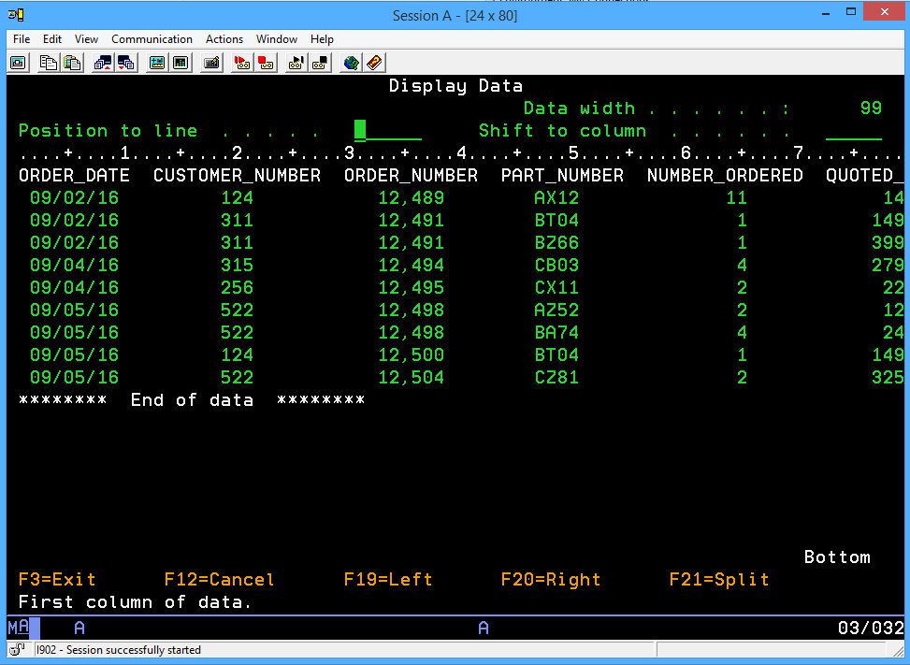

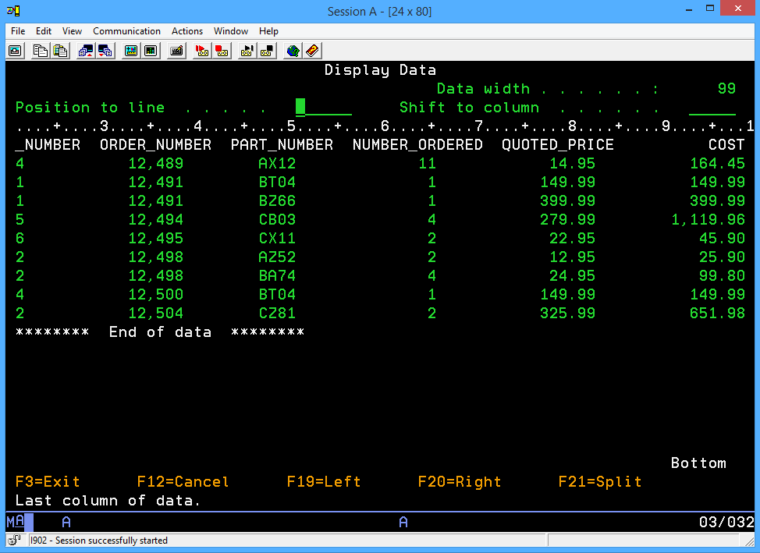

To Hand In:  
There are 5 items to hand in.

1. A printout of the Sales Rep report showing above with your name as a Customer, your instructors name as the SalesRep and the data from the PREMIERE Customer and SalesRep tables in your versions of these tables.

2. The formatted **written** SQL statement used to create the Cust_Rep view (entered on page 4)

3. Create a view in your PREMIERxxx collection and produce a report.

The view should be called ORDER_INFO. This view will use tables in the PREMIERE database and will be stored in your library (DR201???). The VIEW should contain the Order Date, Customer Number and the Order Number from the ORDERS table and the Part Number, Number Ordered and Quoted Price from the ORDERLINE table. The TotalCost column is a virtual field determined by the Number Ordered and the Quoted Price.

Provide the formatted **written** SQL statement that you used to create the ORDER_INFO view.

4. Employ a SELECT statement that uses the ORDER_INFO view to produce a report that displays all

fields in the view. Hand in that report. A sample report shows on the previous page.

5. Hand in a report that shows the ORDER_INFO view in Total Cost order.

**REMEMBER: when you select columns from more than 1 table, you must tell the database which column to match on using the "WHERE" clause.**

Reports from the system printer should include your ID page and the report on the next page