Purpose - In this lab you will learn how to:

1. Use the RUNSQLSTM statement at the command line to execute a number of DDL SQL statements.
2. Experience the differences between a referential constraint that uses one of three options: ON DELETE RESTRICT

ON DELETE CASCADE

ON DELETE SET DEFAULT

In Client Access create a container (Source Physical File) for your members (they will contain a number of SQL statements to be executed) that will test out the three possible ON DELETE clauses used with a foreign key.

**==>CRTSRCPF LAB6**

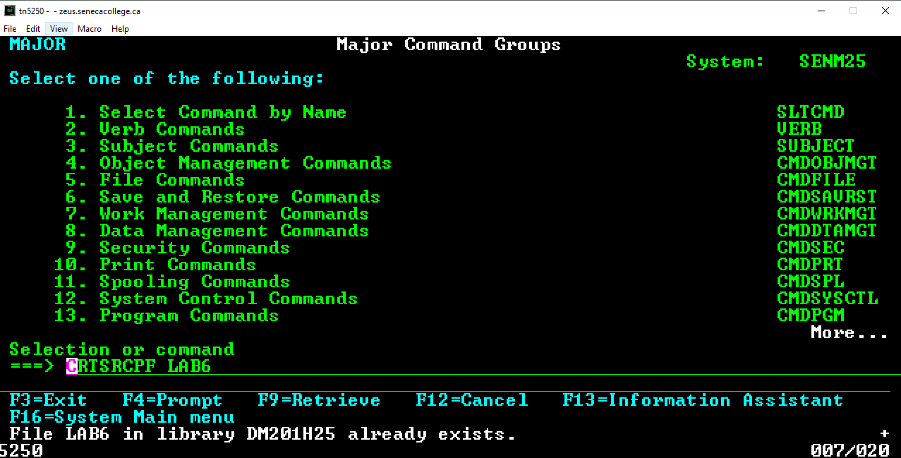

Eventually you will have three members to set up testing of the three ON DELETE clauses.

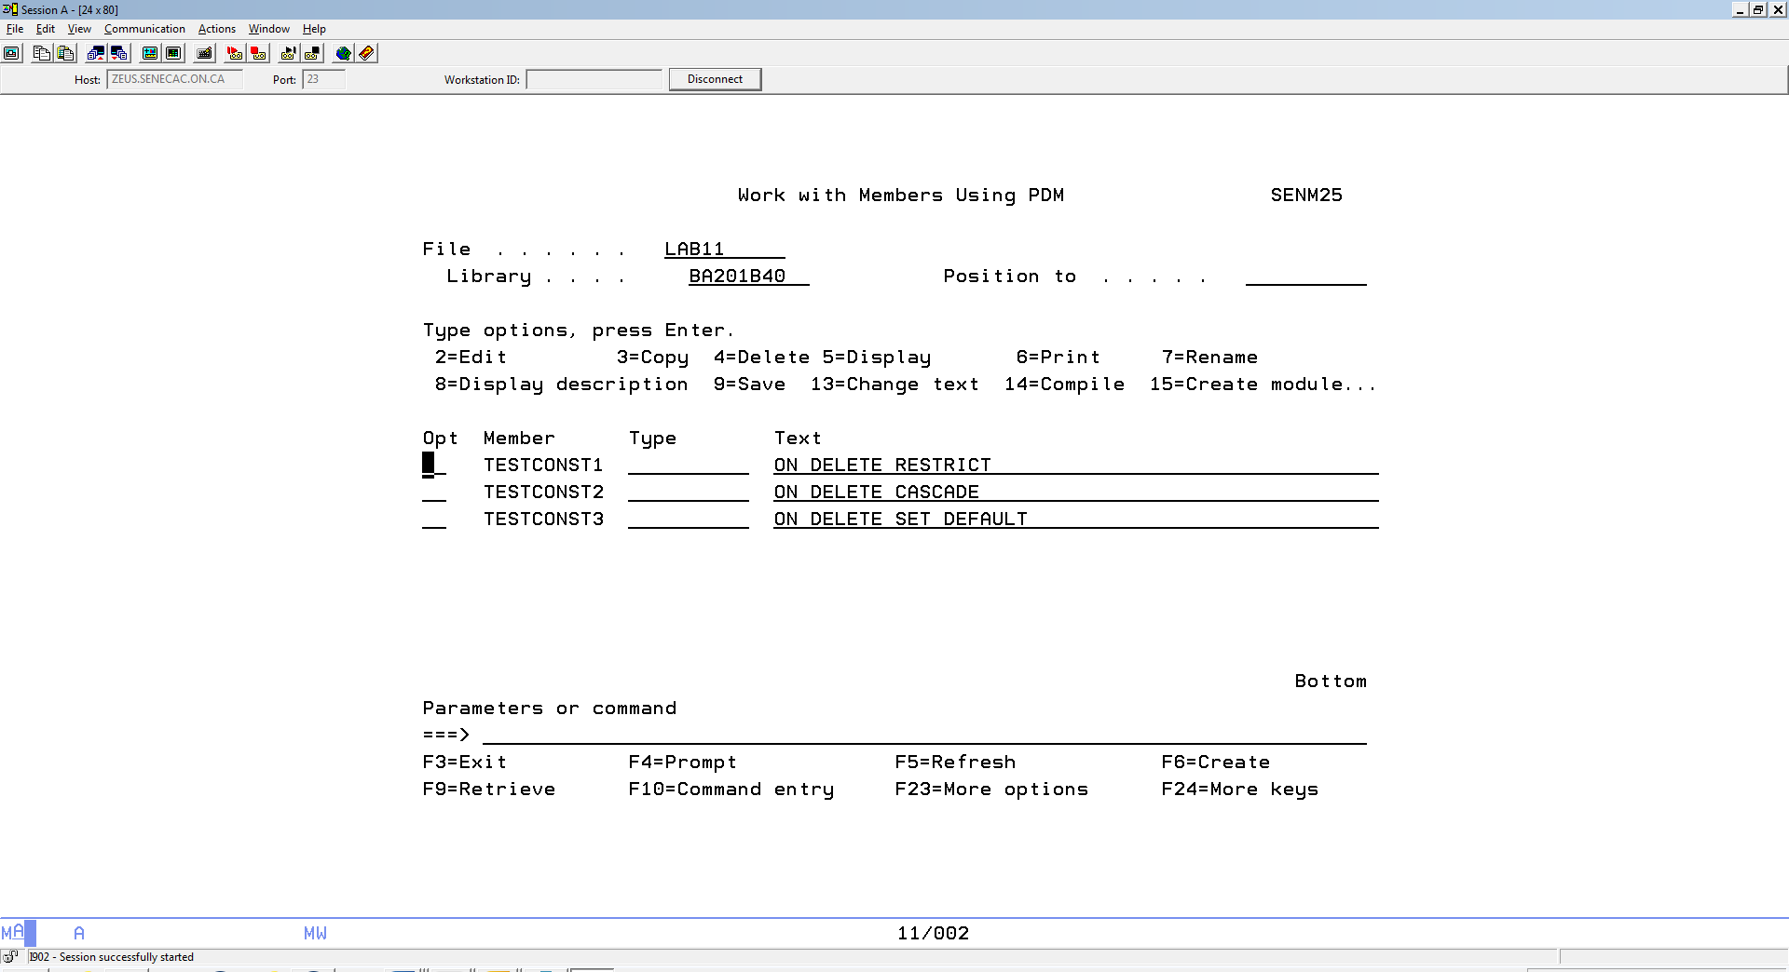

Objective: Test out the three possibilities for the On Delete clause when setting up a referential constraint with a Foreign Key:

On Delete Restrict (default)

On Delete Cascade

On Delete Set Default

**Requirements:**

**Successfully demonstrate the ON DELETE CASCADE and the ON DELETE SET DEFAULT actions**

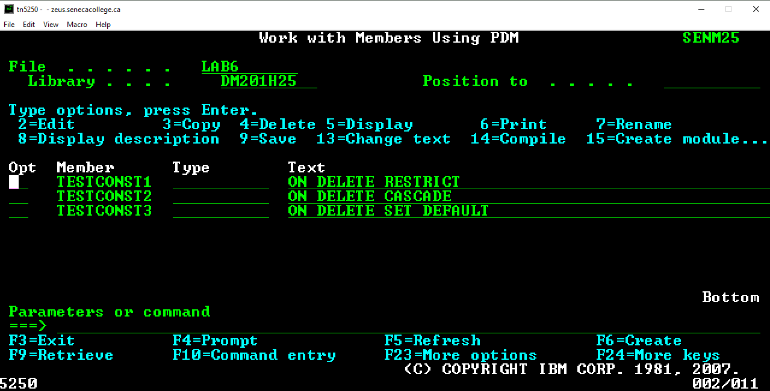

Copy TESTCONST1 from DBS201LIB/LAB6

At the command line type ==> **WRKMBRPDM DBS201LIB/LAB6**

Use option 3 to copy this member to your source physical file called LAB6

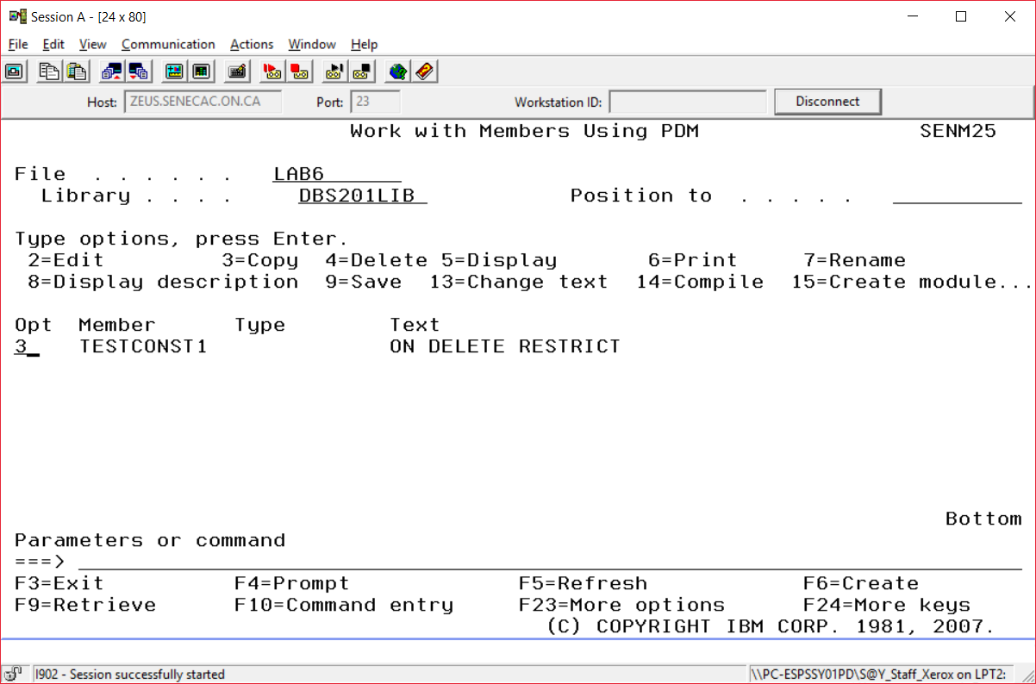

**The To File Library is your library**

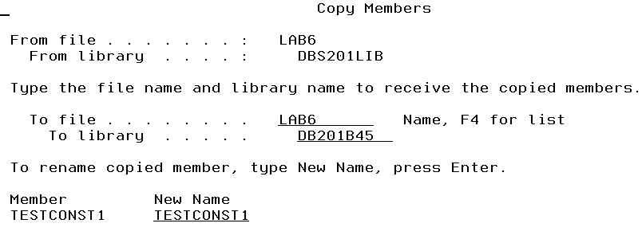

After copying the LAB6 member, use option 2 to edit it.

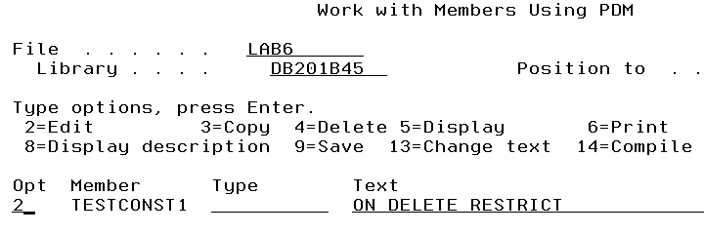We all cannot use the same collection names, so change the first two statements to reflect your id.

**(Use your id in place of B45. DB201A01 would refer to LAB6A01)**

CREATE SCHEMA LAB6B45;

SET SCHEMA LAB6B45;

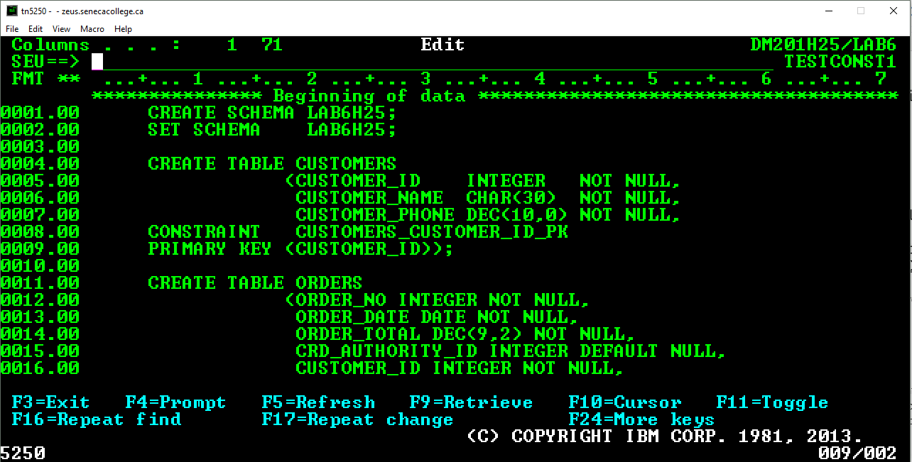

The majority of the SQL has been done for you. In order to place data into your tables (Customers and Orders) you need to copy the data from RUSSDBS. The tables use the same names and this action requires you adding two extra statements to the TESTCONST1 member. With the referential constrai3nts in place, you need to decide which table needs to be loaded first. Remember each SQL statement ends with a semicolon.

Have the SQL statements run with RUNSQLSTM at the command line. You can prompt this - RUNSQLSTM (F4)

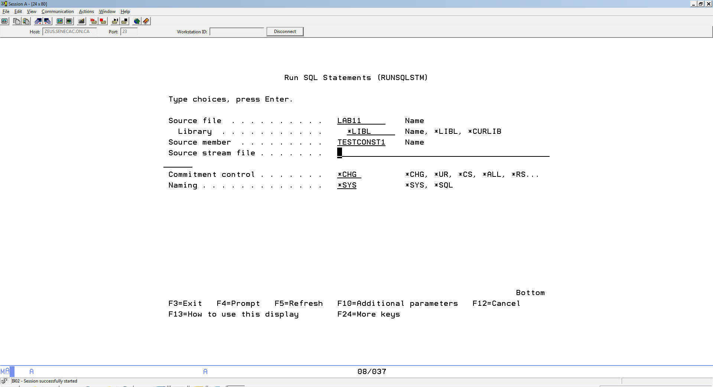

Pressing F9 shows we ran the following statement

===> RUNSQLSTM SRCFILE(LAB6) SRCMBR(TESTCONST1)

Using STRSQL we can look the tables and then try and delete Customer #1.

===>SET SCHEMA LAB6B45

===>SELECT * FROM CUSTOMERS

===>DELETE FROM CUSTOMERS WHERE CUSTOMER_ID = 1

Delete prevented by referential constraint ORDERS_CUSTOMER_ID_FK in

=> delete from customers where customer_id = 1

We expected that outcome.

We will re run those SQL statements with a different outcome. The collection needs to be deleted. What do you say in interactive SQL?

DORP COLLECTION

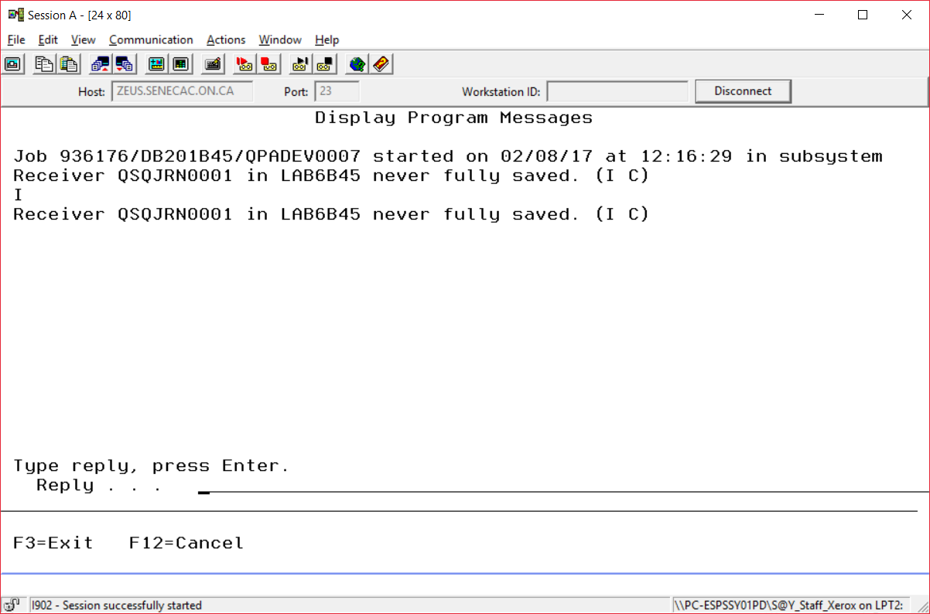

The journal and journal receiver are used for recording before and after images when table rows are changed, added or deleted and the user profile doing the changes. Type I for ignore. We do not need the journal receiver to be backed up.

Copy TESTCONST1 to a TESTCONST2 in the same source physical file called LAB6. (use option 3)

Work with Members Using PDM SENM25

File . . . . . . LAB6

Library . . . . DB201B45 Position to . . . . .

Type options, press Enter.

2=Edit 3=Copy 4=Delete 5=Display 6=Print 7=Rename

8=Display description 9=Save 13=Change text 14=Compile 15=Create module...

Opt Member Type Text

3 TESTCONST1 ON DELETE RESTRICT

Your new member name will be TESTCONST2 and Text should be ON DELETE CASCADE

The only change required here is with the statement that sets up the foreign key for ORDERS. The default clause of ON DELETE RESTRICT was not specified after the ON UPDATE RESTRICT clause. Remove the semicolon after ON UPDATE RESTRICT and add a new clause – ON DELETE CASCADE; (with the semicolon)

ON UPDATE RESTRICT

ON DELETE CASCADE;

After you RUSQLSTM with TESTCONST2 you should find that the deletion of Customer_ID 1 is allowed. The solution to ensuring no references to a nonexistent customer, was to remove all rows that have that reference.

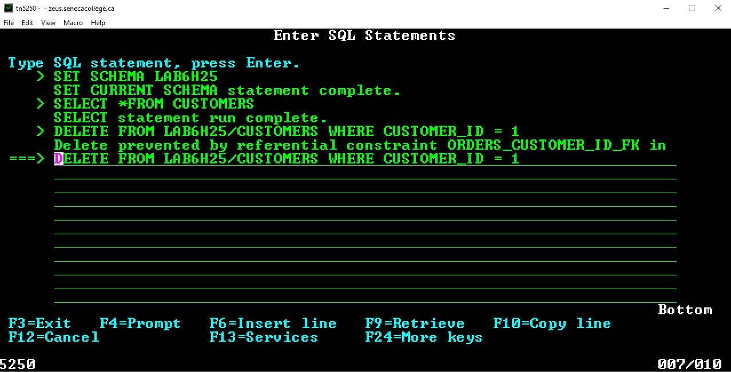

You should be able to delete customer number 1 with the new setup.

BEFORE:

CUSTOMER_ID CUSTOMER_NAME CUSTOMER_PHONE

1 Russ Pangborn 4,164,915,050

2 Jean Chretien 6,074,556,070

3 Stephen Harper 6,079,923,433

4 Paul Martin 6,078,823,432

ORDER_NO ORDER_DATE ORDER_TOTAL CRD_AUTHORITY_ID CUSTOMER_ID

3 07/01/13 665.44 5 3

4 07/01/13 456.77 6 4

2 07/01/13 433.22 1 1

6 07/02/13 544.55 9 1

7 07/03/13 777.77 7 1

8 07/04/13 656.77 88 3

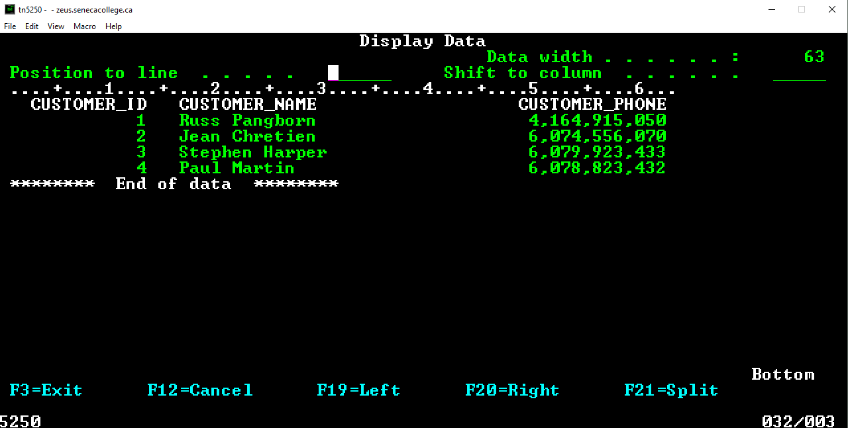

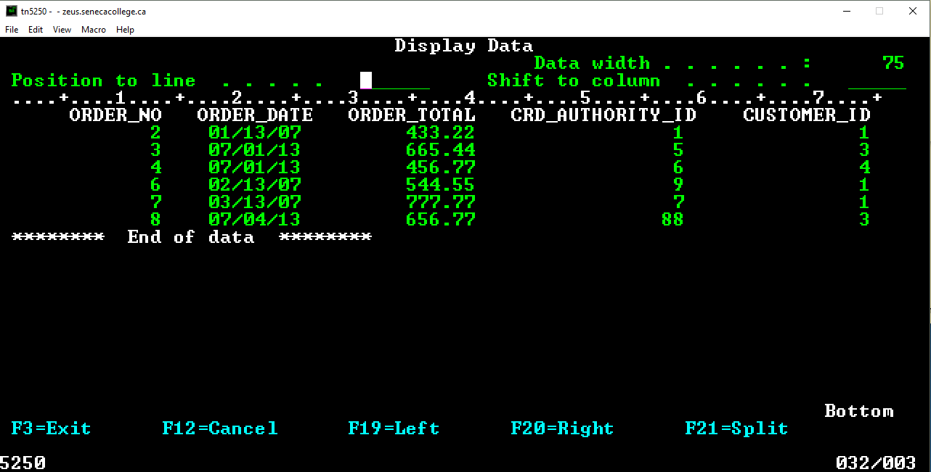

DELETE FROM LAB6B45/CUSTOMERS WHERE CUSTOMER_ID = 1

1 rows deleted from CUSTOMERS in LAB6B45.

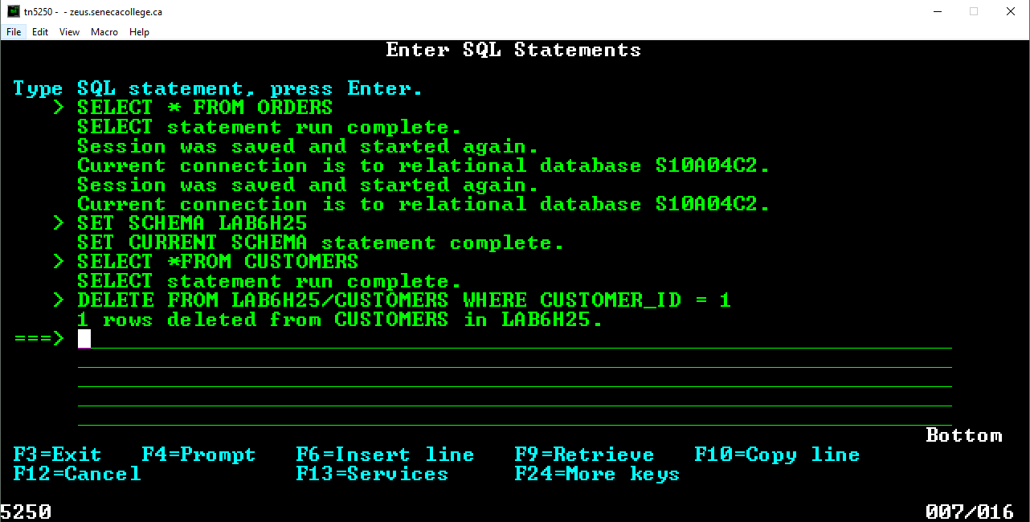

AFTER:

CUSTOMER_ID CUSTOMER_NAME CUSTOMER_PHONE

2 Jean Chretien 6,074,556,070

3 Stephen Harper 6,079,923,433

4 Paul Martin 6,078,823,432

ORDER_NO ORDER_DATE ORDER_TOTAL CRD_AUTHORITY_ID CUSTOMER_ID

3 07/01/13 665.44 5 3

4 07/01/13 456.77 6 4

8 07/04/13 656.77 88 3

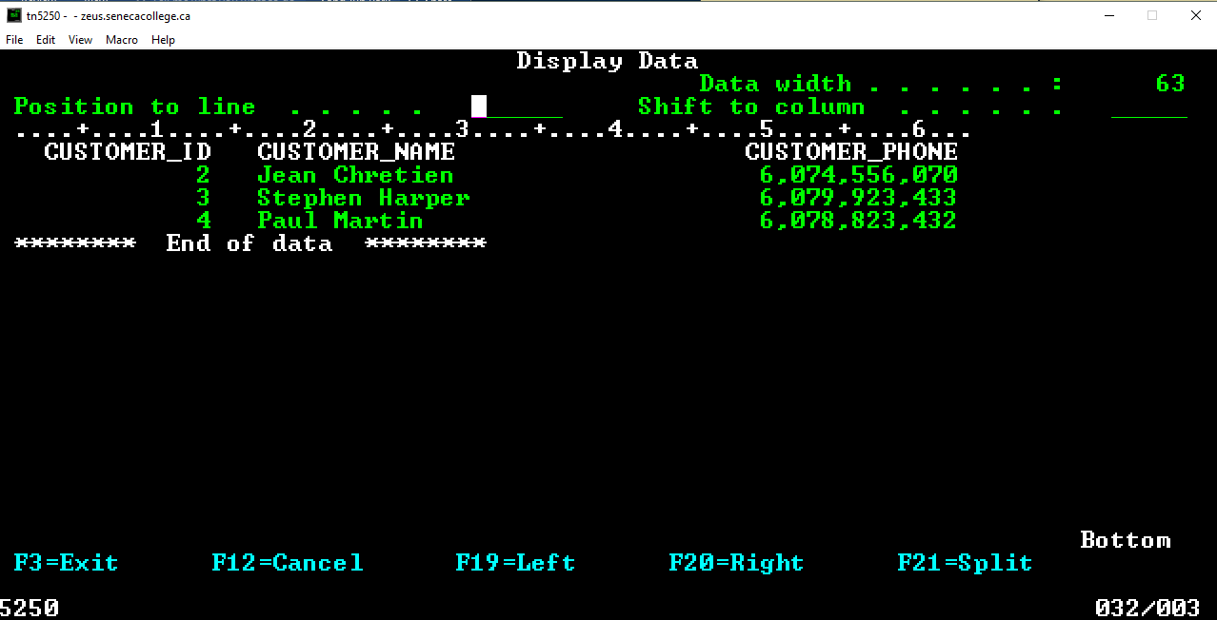

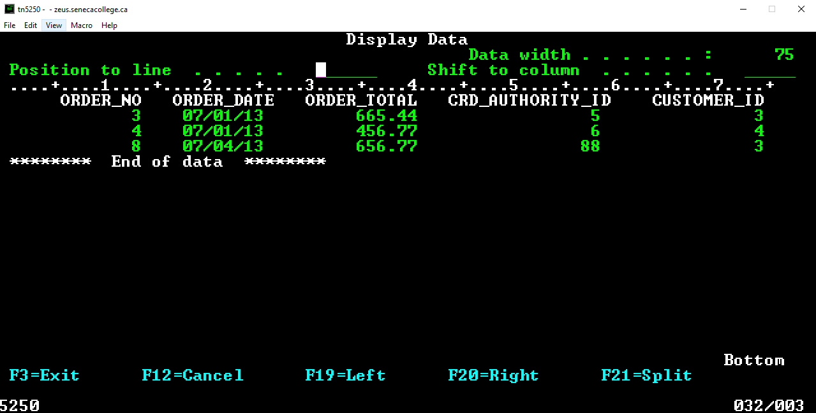

We have successfully tested out the ON DELETE CASCADE clause. Remove the library either using interactive SQL substituting your id where appropriate.

DROP COLLECTION LAB6???

Or after exiting interactive SQL with

DLTLIB LAB6???

You should be able to demonstrate the above occurring with TESTCONST2

Delete the collection and do the same with TESTCCONST3 in order to show a default value was set for the Customer Id in the ORDERS table when customer number 1 was removed from the CUSTOMERS table.

ORDER_NO ORDER_DATE ORDER_TOTAL CRD_AUTHORITY_ID CUSTOMER_ID

3 07/01/13 665.44 5 3

4 07/01/13 456.77 6 4

2 07/01/13 433.22 1 0

6 07/02/13 544.55 9 0

7 07/03/13 777.77 7 0

8 07/04/13 656.77 88 3

In order for TESTCONST3 to work, you will need an extra step for CUSTOMERS.

You need to insert a row with a customer ID of 0.

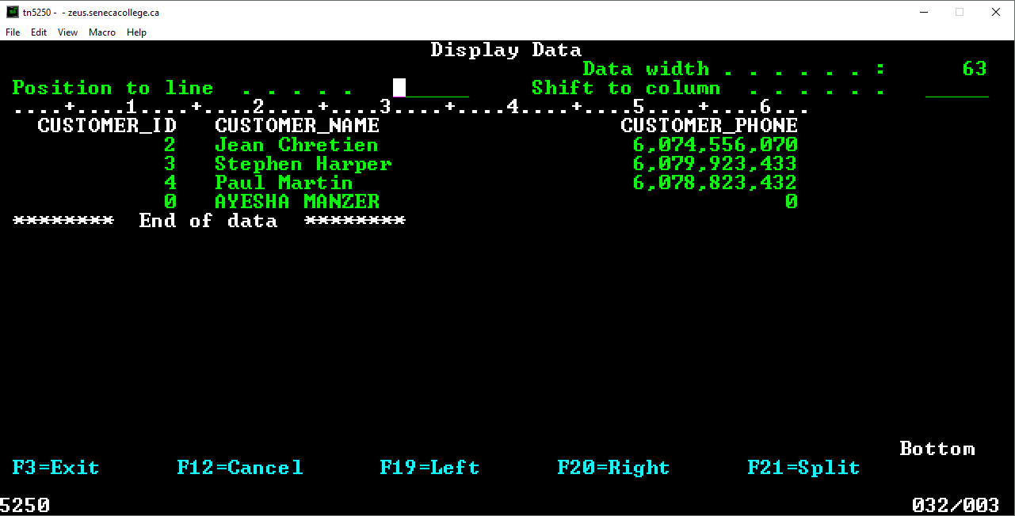

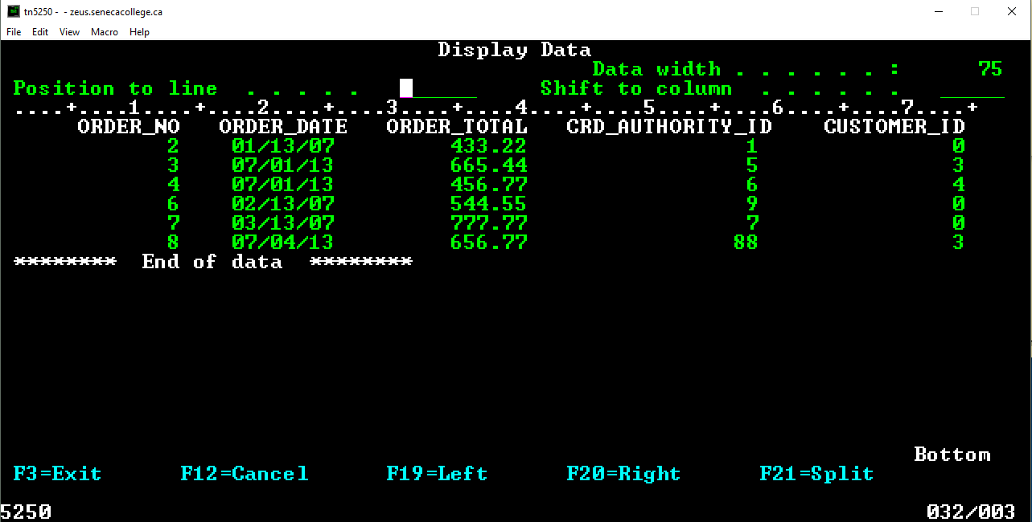

You should be able to demonstrate the above occurring with TESTCONST3 after Customer number 1 is removed from the CUSTOMERS table.

Your teacher may ask for

1. Screenshots of TESTCONST1, TESTCONST2 and TESTCONST3 or
2. Screenshots of the three scenarios at your terminal using F9 to access three versions of the RUNSQLSTM (with TESTCONST1, TESTCONST2 and TESTCONST3) and using F9 to access your SQL statements showing what CUSTOMER and ORDERS look like before your delete and what they look like after the delete.
3. A screenshot of the following produced by using SQL:

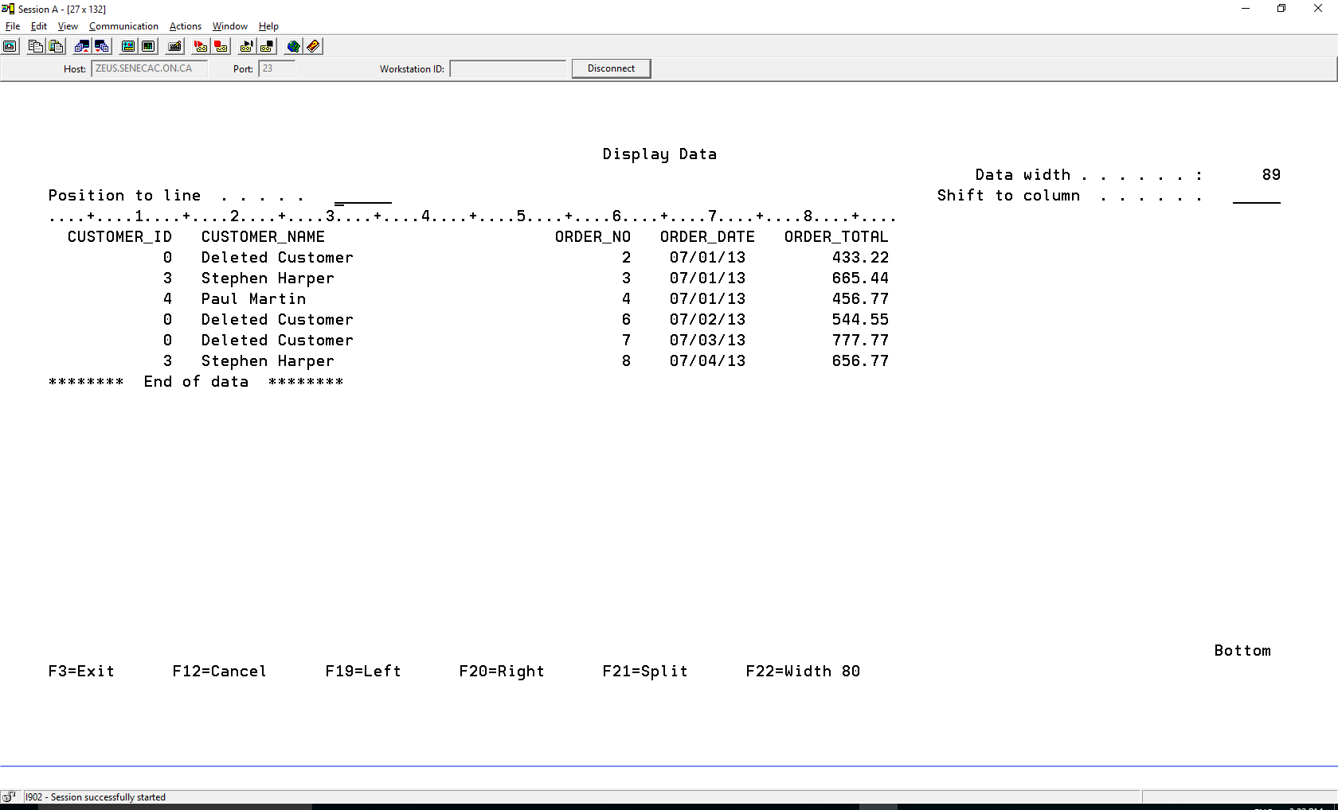

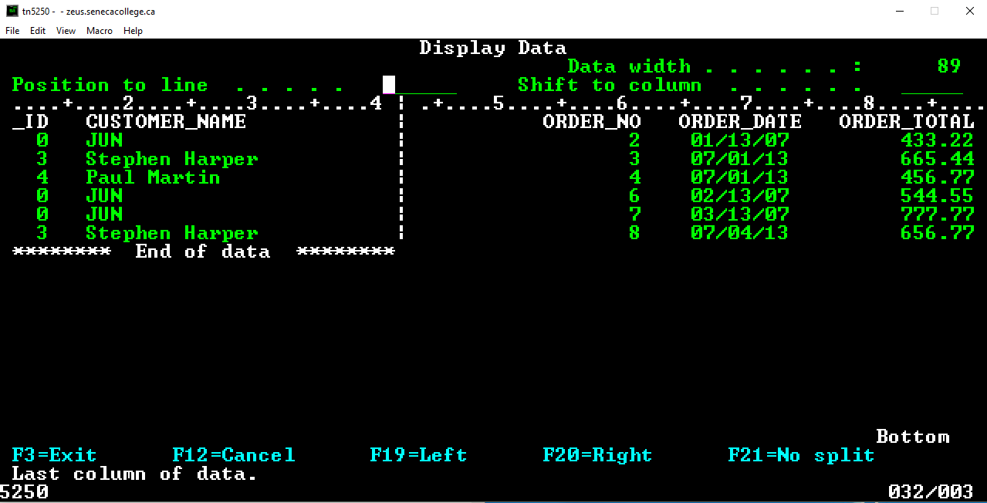

Errors in RUNSQLSTM

ERROR1

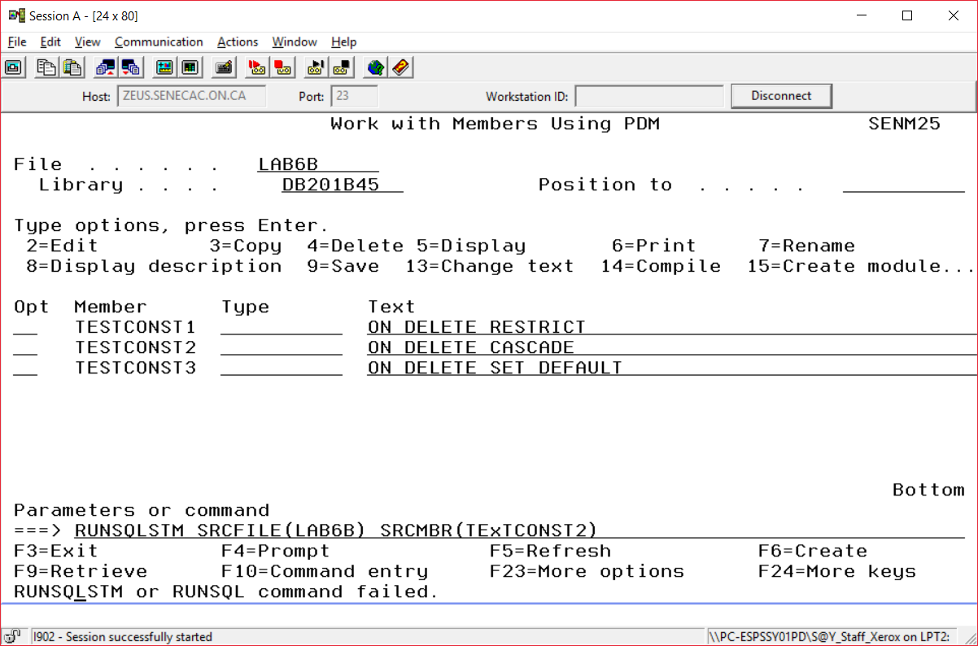

You can put your cursor on the error message, press F1 and then press F10 to look a the job log.

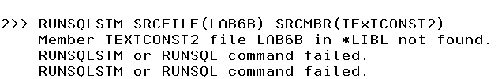

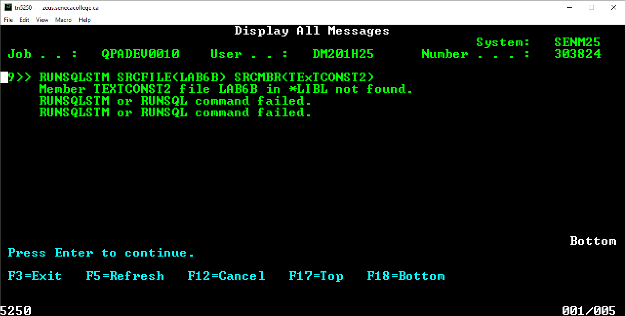

The SRCMBR was called TExTCONST2 instead of TESTCONST2

If there isn’t a naming problem, you may need to look at the spooled file

WRKSPLF (Use option 5 to display the spooled file)

Opt File User

5 TESTCONST2 DB201B45

The spooled file is showing us that the error occurred on line 4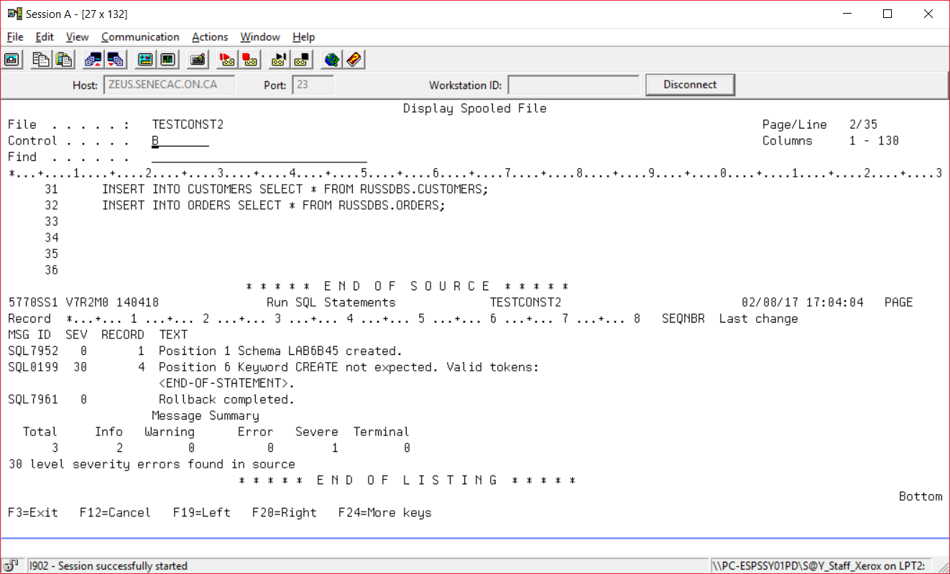

**CAN YOU SPOT THE ERROR?**

