**Meets Specications**

**Your Own Instagram on AWS :**

1. **Setup Node Environment**

Initialize a new project: “*npm i*”

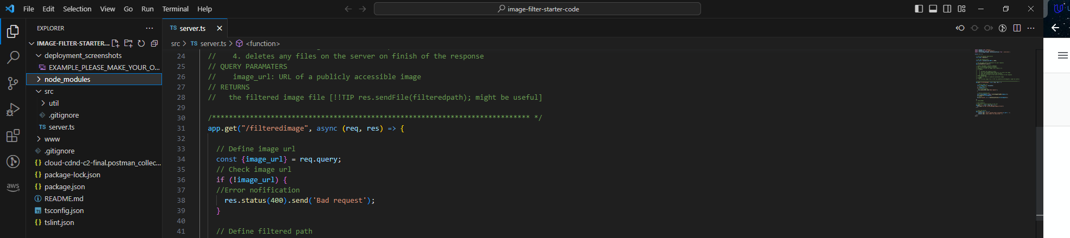

Run the development server : “*npm run dev*”

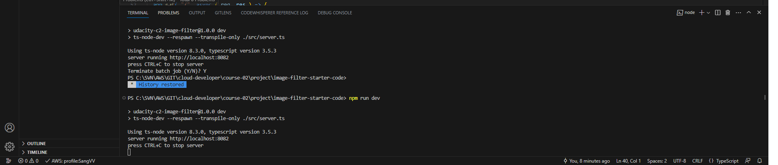

1. **Create a new endpoint in the server.ts file**

The starter code has a task for you to complete an endpoint in “./src/server.ts “

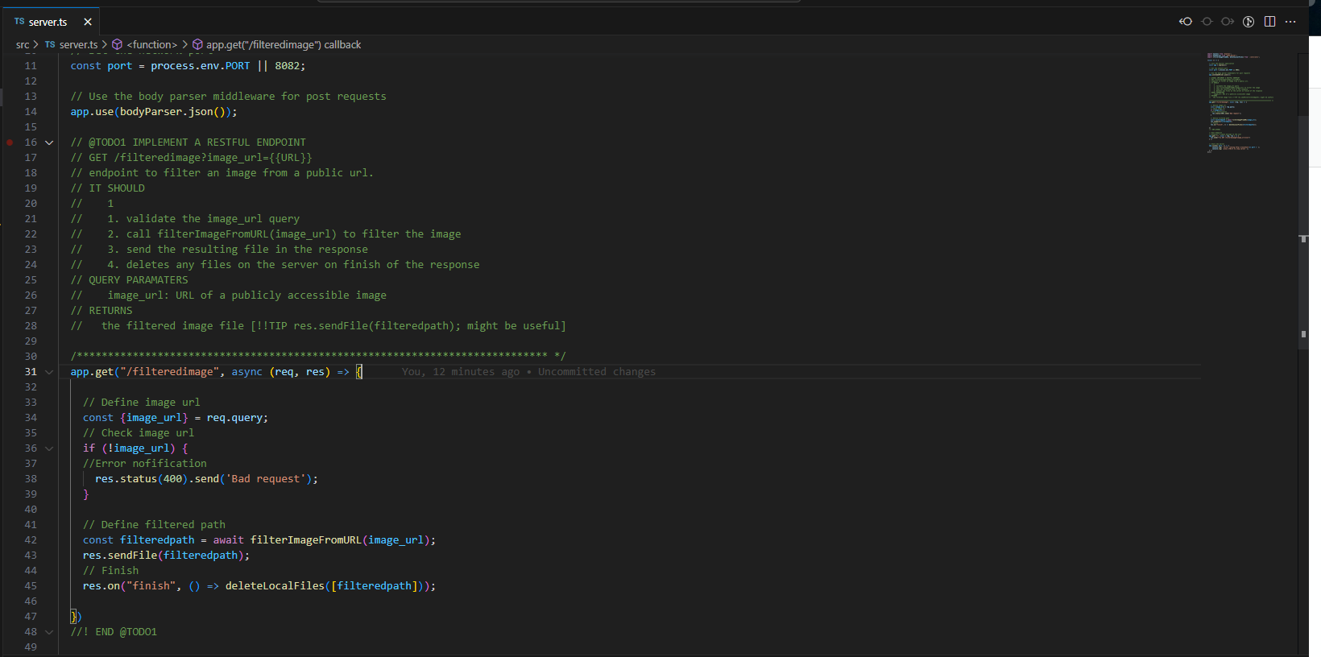

1. **Deploying your system**

Follow the process described in the course to “*eb init*” : a new application

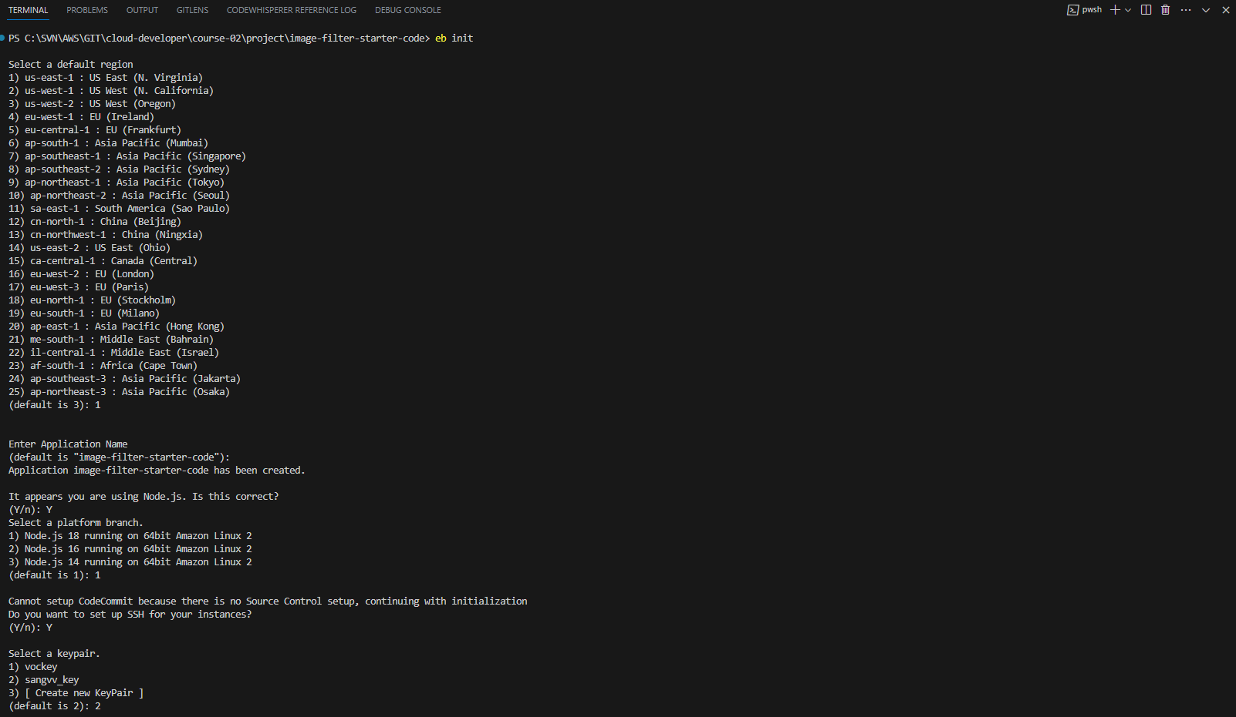

A new environment to deploy your image-filter service : “*eb create*”

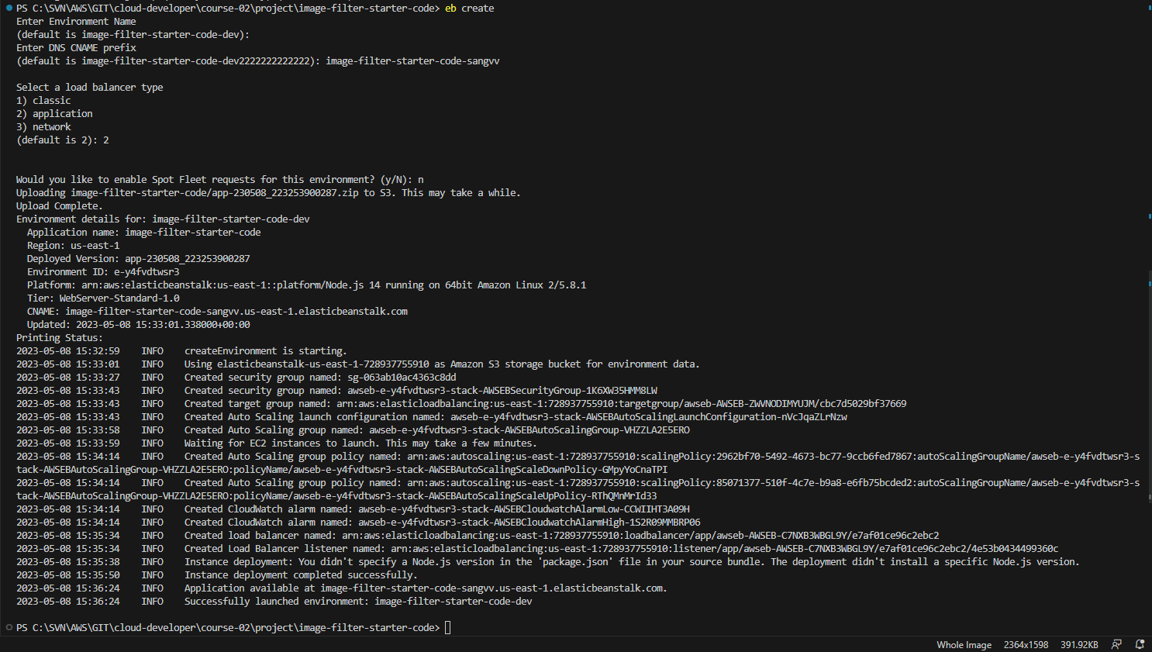

Command “eb deploy”



1. **Host**

The project demonstrates an understanding of RESTFUL design

[http://localhost:{{PORT}}/filteredimage?image_url=https://upload.wikimedia.org/wikipedia/commons/b/bd/Golden_tabby_and_white_kitten_n01.jpg](http://localhost:%7b%7bPORT%7d%7d/filteredimage?image_url=https://upload.wikimedia.org/wikipedia/commons/b/bd/Golden_tabby_and_white_kitten_n01.jpg)

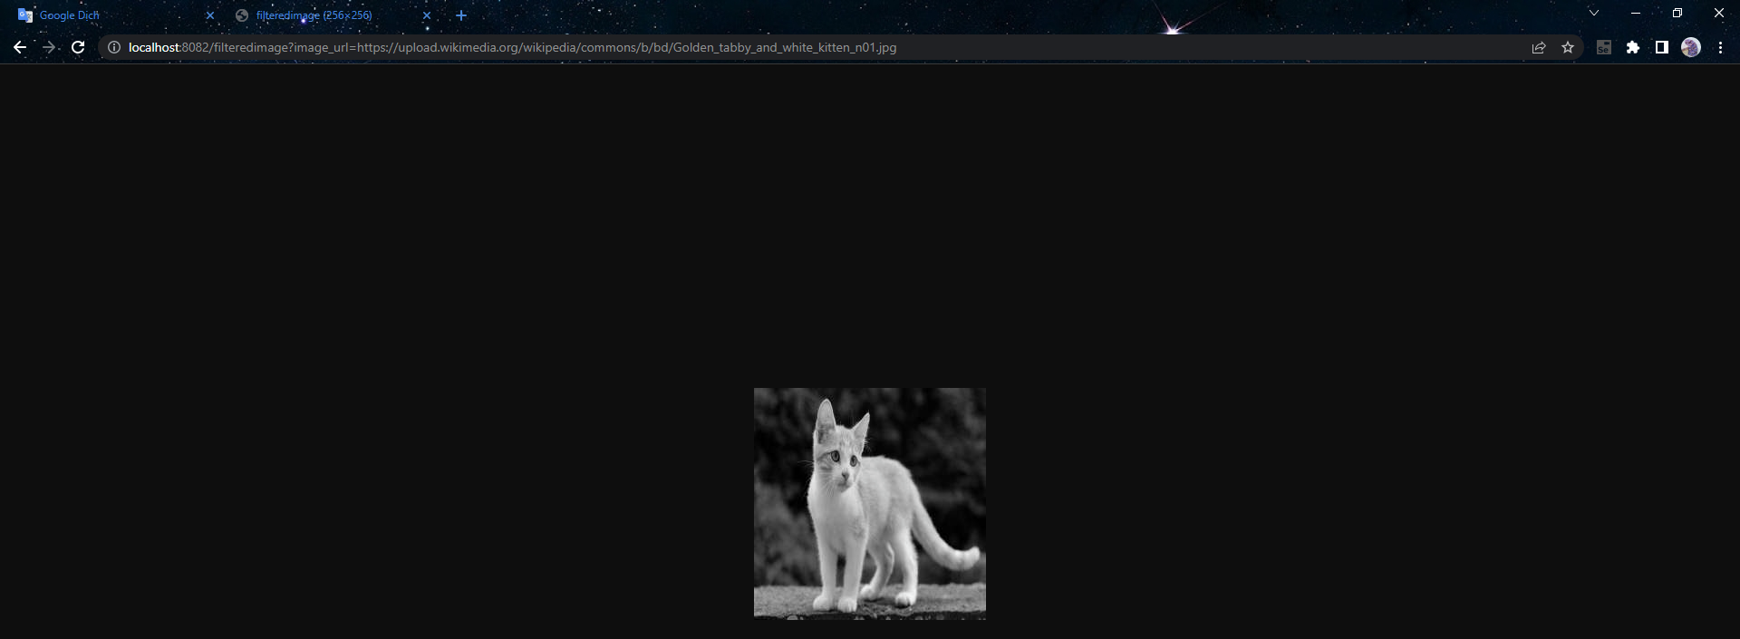

The project demonstrates the ability to create functional cloud deployments

http://image-filter-starter-code-sangvv.us-east-1.elasticbeanstalk.com/filteredimage?image_url=https://upload.wikimedia.org/wikipedia/commons/b/bd/Golden_tabby_and_white_kitten_n01.jpg

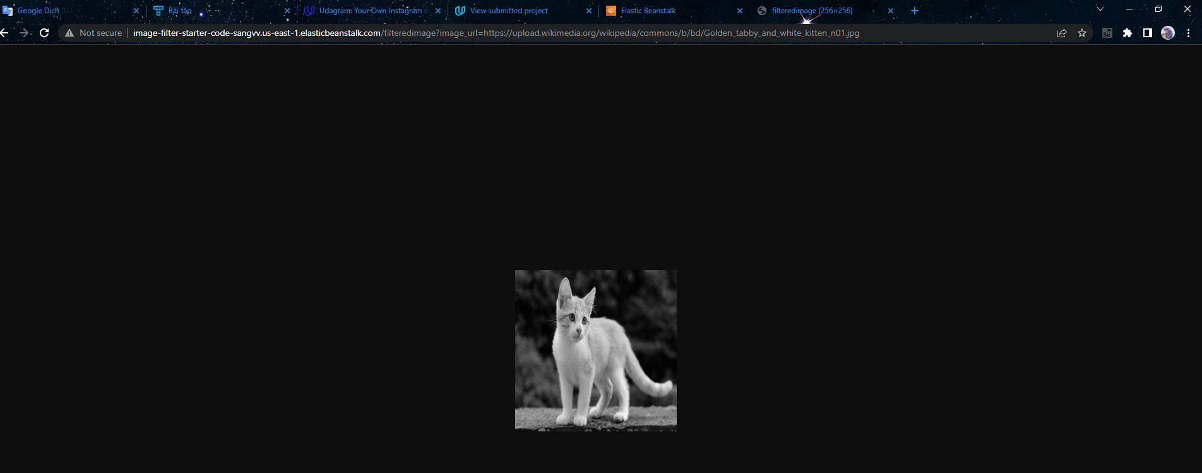

1. **Link :**

Elastic Beanstalk Url :

<http://image-filter-starter-code-sangvv.us-east-1.elasticbeanstalk.com>

http://image-filter-starter-code-sangvv.us-east-1.elasticbeanstalk.com/filteredimage?image_url=https://upload.wikimedia.org/wikipedia/commons/b/bd/Golden_tabby_and_white_kitten_n01.jpg

Git Url :

https://github.com/SangSungSuong/YourOwnInstagram.git

-------------------------------------------------------------------------------------------------------------------------------

Thanks you