**Project: DataFlowSync**

**Week 5 Assignment - Data Engineering**

**Tasks Completed**

**1. Extracted data from SQLite database to CSV, Parquet, and JSON.**

**2. Implemented scheduled (every 5 minutes) and event-based (database change) triggers.**

**3. Copied entire database to `backup_company.db`.**

**4. Performed selective table/column extraction.**

**1-python data_extractor.py**

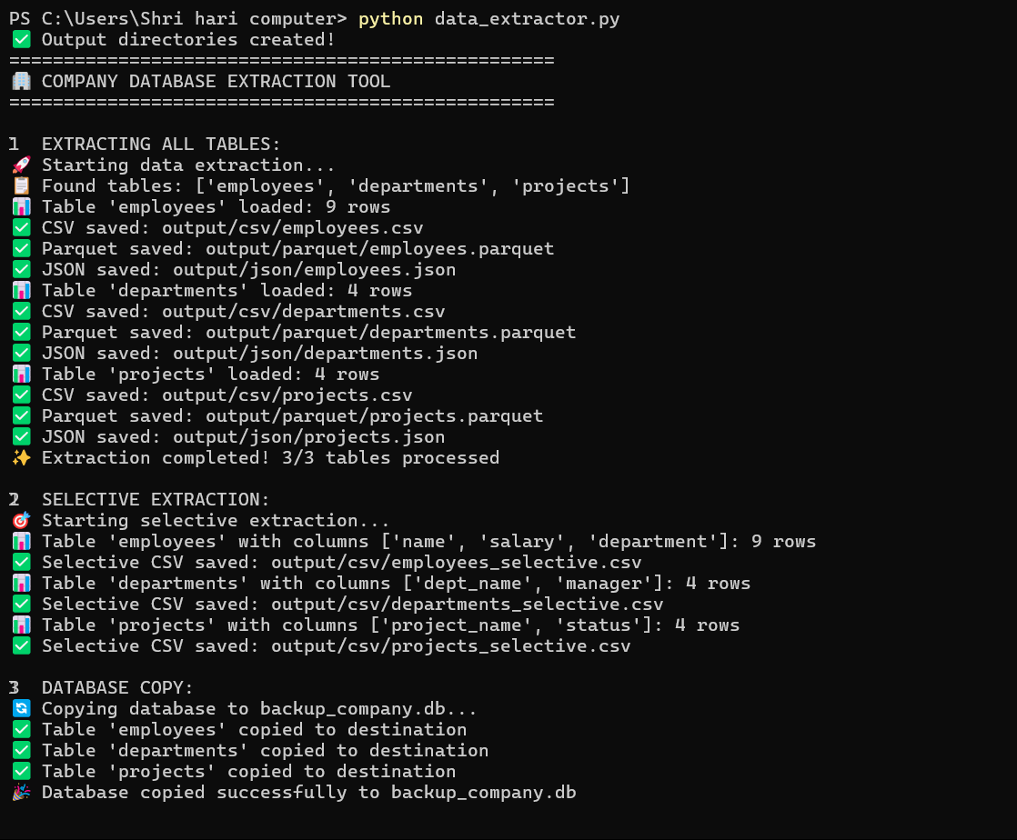

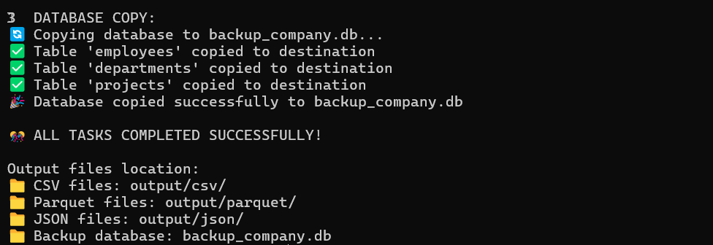

**2-Check Generated Files:**

1. **dir output\csv**

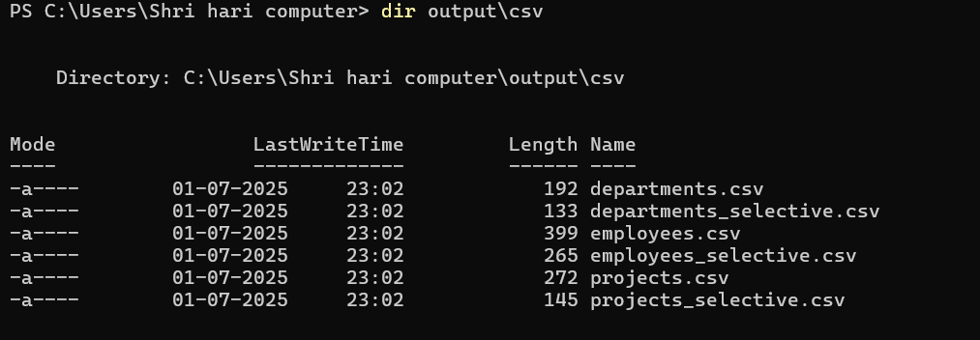

1. **dir output\parquet**

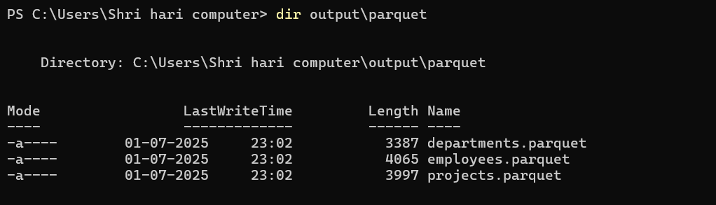

**iii-dir output\json**

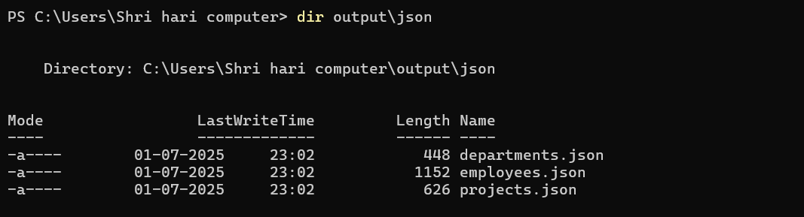

**iv-dir *.db**

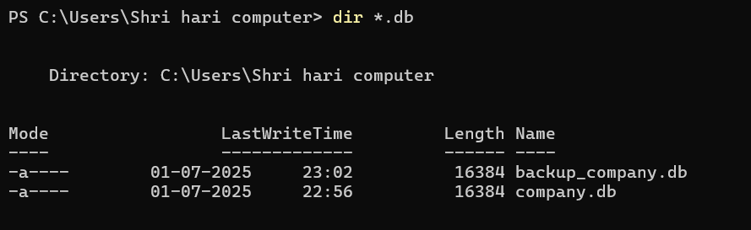

**3-python automation_scheduler.py**

**It will run every 5 minutes and when company.db changes.**

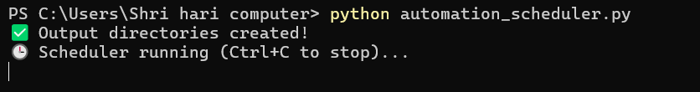

**To test event trigger:**

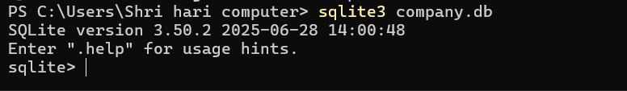

**SQLite Data**

