Secure Multi-Application Deployment using AWS ALB & Nginx Reverse Proxy

(Scalable Port-Based Routing Architecture)

📌Project Overview:
Deploying multiple web applications on a private EC2 instance using Nginx, with traffic securely routed through an AWS Application Load Balancer based on port configuration (80 and 8080).
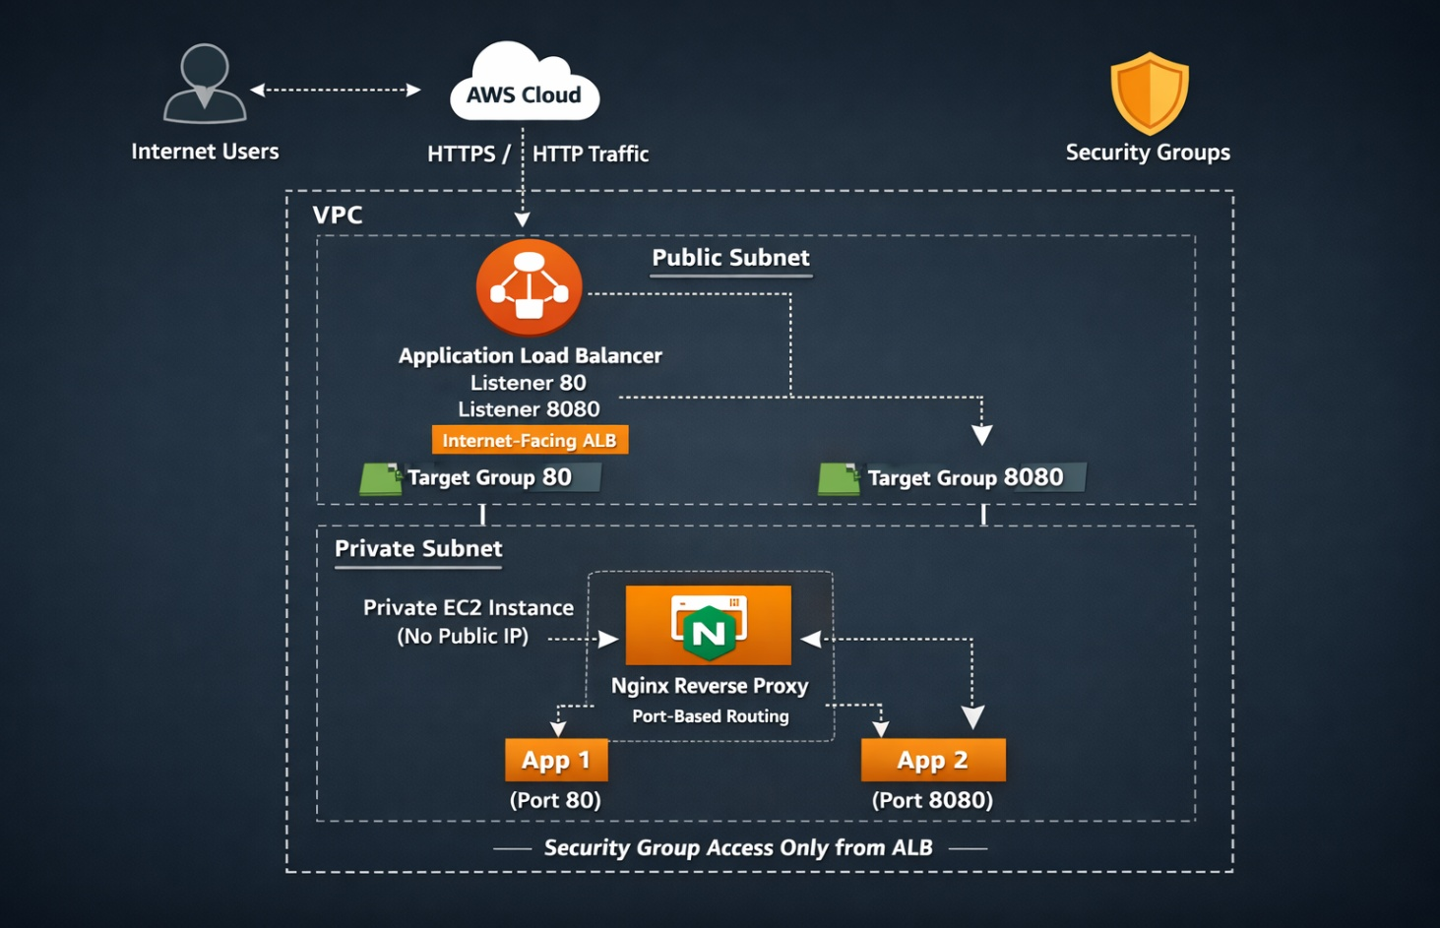
⚠️ Problem Statement
- Direct EC2 exposure increases attack surface
- Port conflicts when running multiple apps
- Lack of centralized traffic management
- No Layer 7 routing
🎯The Objective
To implement a Secure Reverse Proxy Layer that:
- Standardizes entry points via an Internet-Facing ALB (Public Subnet)
- Uses Nginx to perform intelligent port-based routing inside a private subnet.
- Enforces a Zero-Trust security model where backend apps have no public IP addresses.

🔎How the Traffic Flows??
Internet → ALB → Private EC2 → Nginx → App1 / App2
• The Entry:
- User Action: Hits your URL/DNS from the public internet. USER Hit : your URL/DNS from the public internet
• The Listeners (Security Guard):
- ALB Action: Monitors Port 80 and Port 8080 for incoming requests.
• Target Forwarding (Sorting):
- If Port 80: Traffic is handed to Target Group 80.
- If Port 8080: Traffic is handed to Target Group 8080.
• The Secret Proxy (Private Hand-off):
- ALB to VPC: Traffic moves from the public subnet to the Private Subnet.
- EC2 Security: Hits the Nginx Proxy on a Private EC2 with no public IP, making it invisible to hackers.
• Final Delivery:
- Nginx Logic: Inspects the port and drops the request directly into the lap of App 1 (via Port 80) or App 2 (via Port 8080).
🌐1.Network Setup Details
VPC creation Public & Private subnets Internet Gateway NAT GatewayRoute Tables Security Groups (ALB SG & EC2 SG referencing)

VPC
── Public Subnet 1
└── Application Load Balancer
── Public Subnet 2
└── Application Load Balancer
└── Private Subnet
└──EC2 Instance
└── Nginx APP-1(Port 80)
APP-2 (Port 8080)

Create VPC
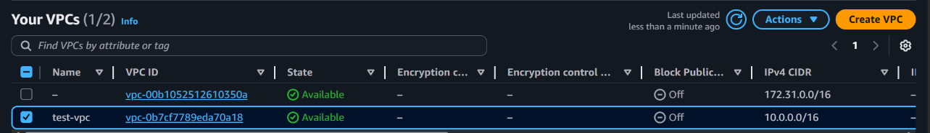
Create 3 Subnets: 2 public and one private
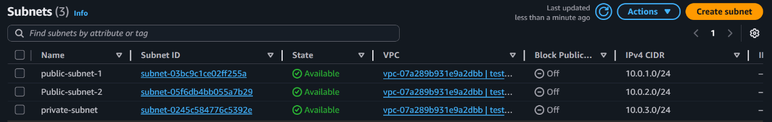
Create Internet gateway and attach to VPC
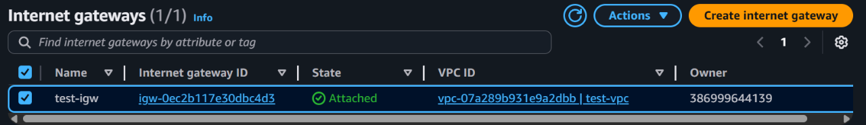
Create NAT gateways
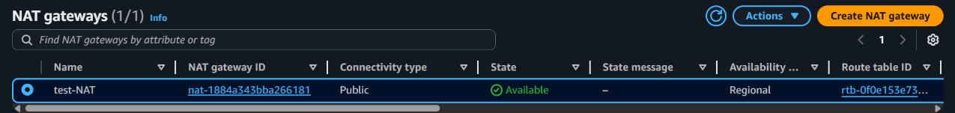
Create 2 Route Table :Public & Private RT
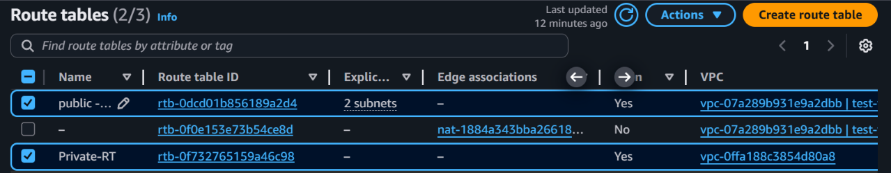
Add IGW in inbound rule of public rout table 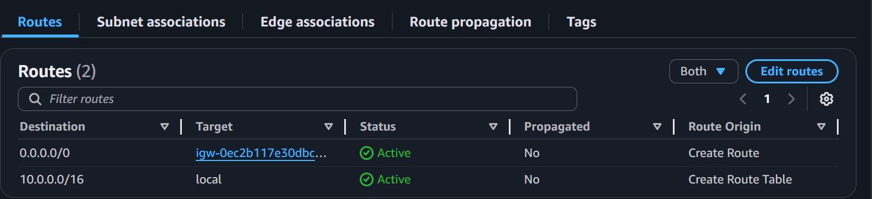 Add NAT in inbound rule of private rout table
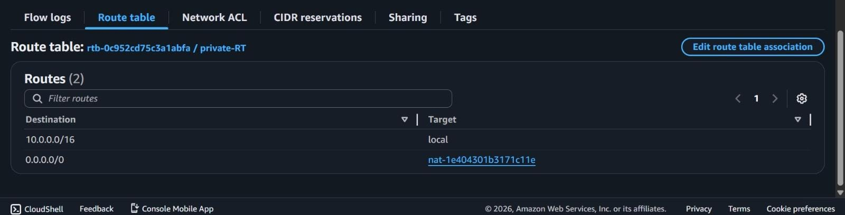
🖥️2.Create Private EC2 instance
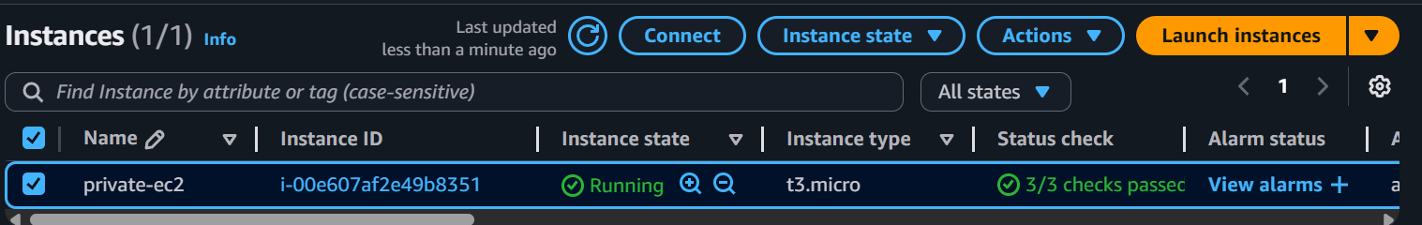
Add SG of ALB in inbound rule:
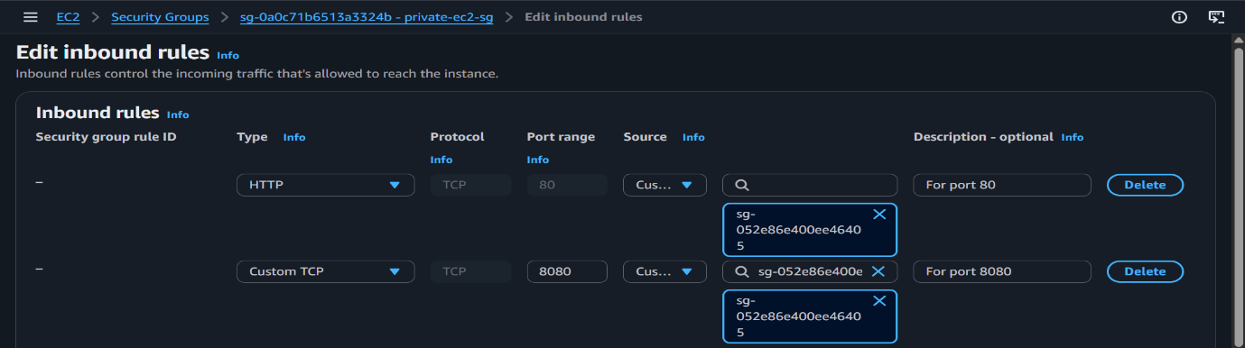
To connect via SSM, modify IAM Role
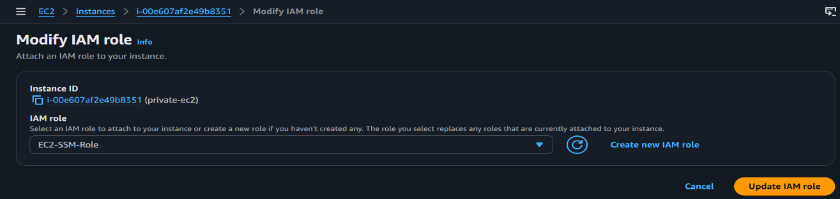
Connect via SSM Manager
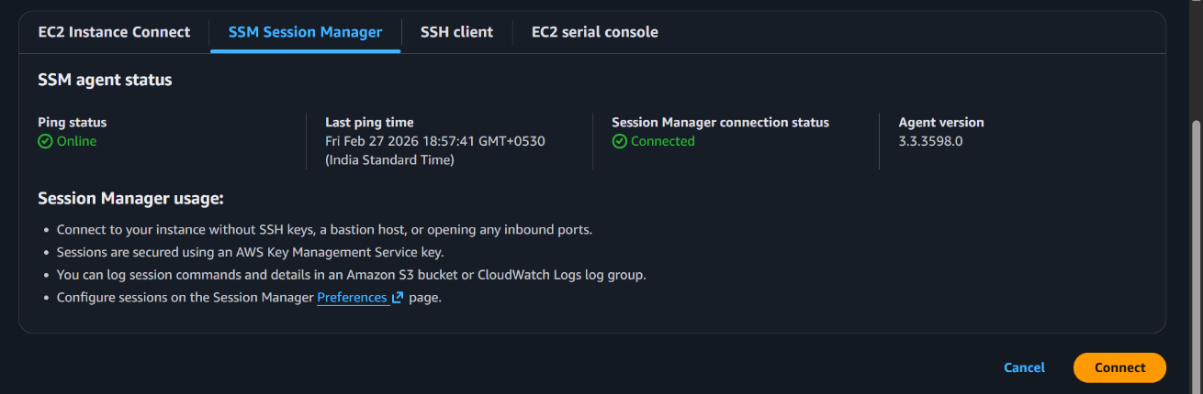

⚖️3.Load Balancer Configuration
- Listener configuration (80 & 8080) and target group configuration
- Health check configuration and Target registration

ALB in Public Subnet
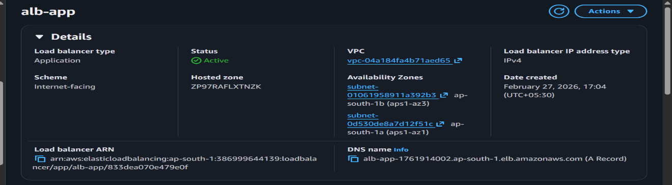
Create 2 Target groups: For port 80 and 8080
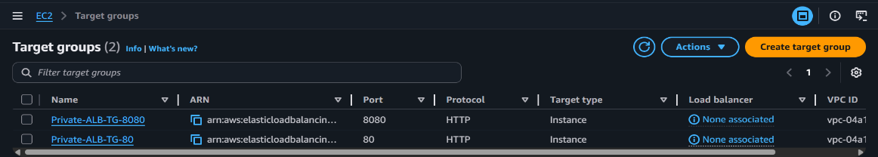
Add Listeners and target forward to respective ports
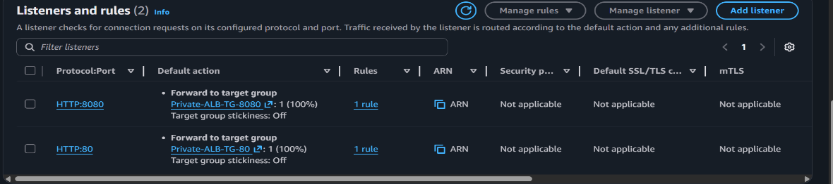
⚙️4.Nginx Configuration
- Reverse proxy setup: Nginx forwards client requests to backend applications.
- Server blocks: Separate configurations to host multiple applications or domains.
- Port configuration: Nginx listens on different ports i.e 80, 8080 to serve different apps.
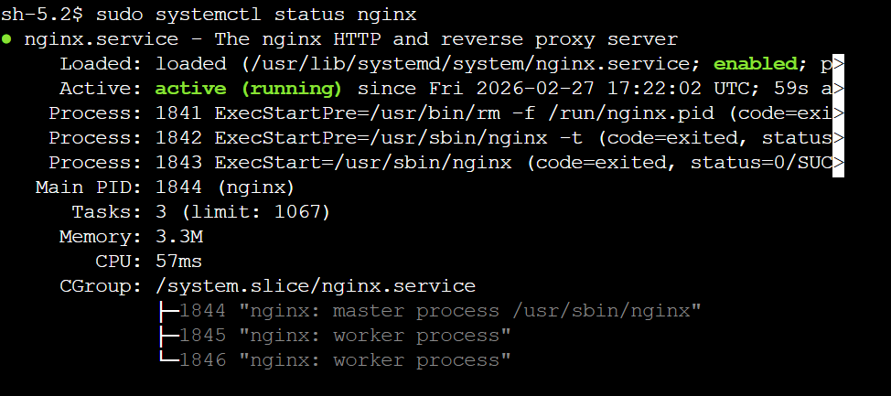

🎉Host the Ngnix server inside the private EC2
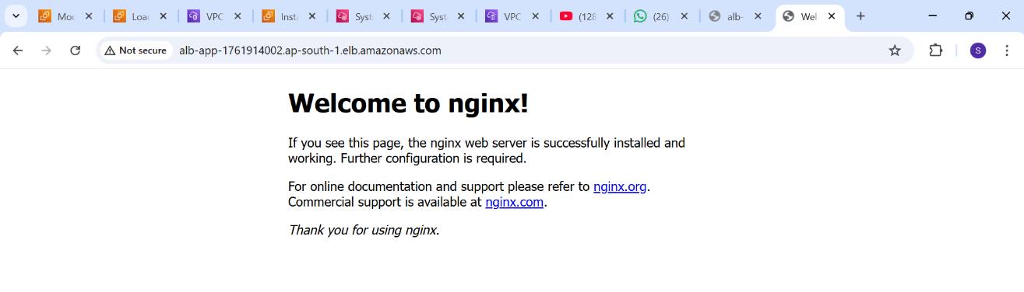
🔄Request Flow:
User Request → ALB Listener → Target Group → Private EC2 → Nginx → Application Page

Application - 1 (Port 80)
- User enters the ALB DNS URL in the browser.
- ALB (port 80) receives the request and forwards it to the Target Group.
- The request reaches the private EC2 instance.
- Nginx serves the page from:
/usr/share/nginx/html/index.html
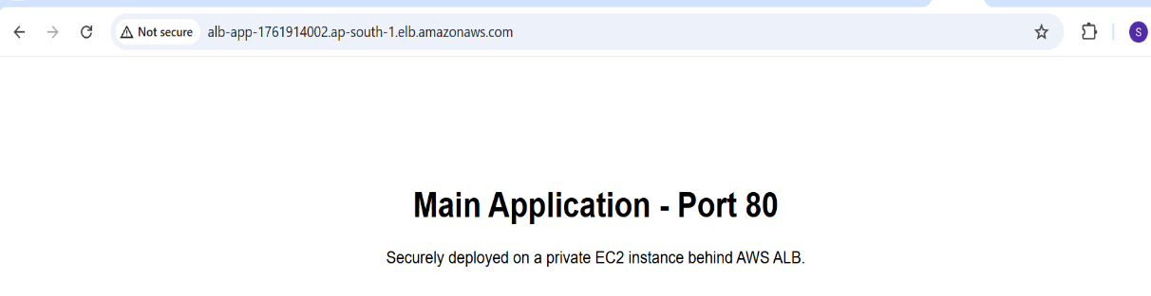

(User → ALB (Port 80) → Target Group (80) → Private EC2 → Nginx → Application-1 )

Application - 2(Port 8080)
- User enters the ALB DNS with port 8080 in the browser.
- ALB (port 8080) receives the request and forwards it to the Target Group (8080).
- The request reaches the private EC2 instance.
- Nginx serves the page from:
/var/www/app2.html

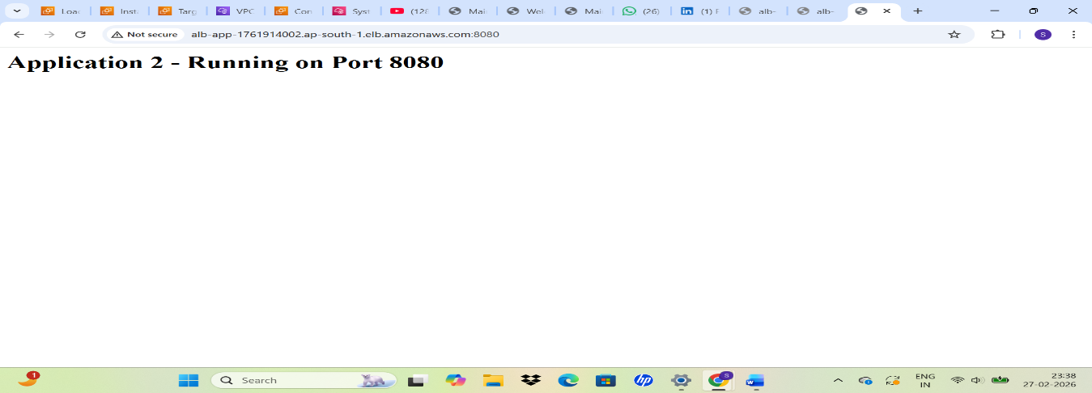
(User → ALB (Port 8080) → Target Group (8080) → Private EC2 → Nginx → Applicatio)

⚙️ss -tulnp: to check which services are listening on which ports
