**CHAPTER 1:**

**COMPANY PROFILE**

Introduction:

EZ Trainings and Technologies Pvt. Ltd. is a dynamic and innovative organization dedicated to providing comprehensive training solutions and expert development services. Established with a vision to bridge the gap between academic learning and industry requirements, we specialize in college trainings for students, focusing on preparing them for successful placements. Additionally, we excel in undertaking development projects, leveraging cutting-edge technologies to bring ideas to life.

Mission:

Our mission is to empower the next generation of professionals by imparting relevant skills and knowledge through specialized training programs. We strive to be a catalyst in the career growth of students and contribute to the technological advancement of businesses through our development projects. Services: College Trainings:

• Tailored training programs designed to enhance the employability of students.

• Industry-aligned curriculum covering technical and soft skills.

• Placement assistance and career guidance. Development Projects:

• End-to-end development services, from ideation to execution.

• Expertise in diverse technologies and frameworks.

• Custom solutions to meet specific business needs. Locations: Hyderabad | Delhi NCR At EZ Trainings and Technologies Pvt. Ltd., we believe in transforming potential into excellence.

**CHAPTER 2:**

**DAY TO DAY ACTIVITIES**

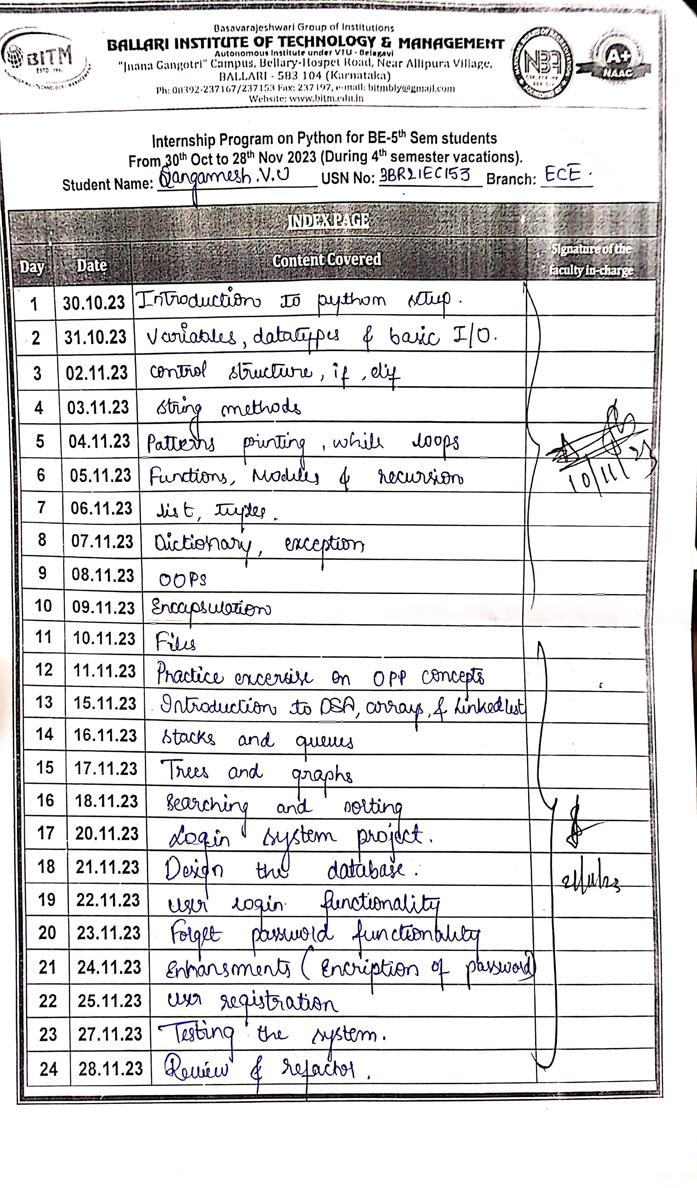

**CHAPTER 3:**

**ABSTRACT:**

In the contemporary landscape of technological advancements, the integration of virtual assistants has emerged as a pivotal facet in human-computer interaction. These intelligent entities, capable of comprehending and executing user commands, epitomize the synergy between cutting-edge technologies and user convenience. The project "Optimus Prime" stands as a testament to this evolution, presenting a Python-based virtual assistant that not only responds to voice commands but also leverages a spectrum of functionalities through seamless integration of libraries, APIs, and graphical user interface components.

Optimus Prime transcends the traditional boundaries of virtual assistants by encapsulating an amalgamation of speech recognition, natural language processing, and external API utilization. It endeavors to provide users with a multifaceted experience, ranging from entertainment features like playing music on YouTube to practical applications such as fetching real-time information and controlling system functions. The interface design, implemented using PyQt5, ensures a visually engaging and user-friendly interaction, augmenting the overall appeal of the virtual assistant.

This project serves not only as a demonstration of technical prowess but also as a foray into the realm of enhancing user accessibility and productivity. The documentation that follows delves into the intricacies of the project, elucidating the modules, algorithms, and design principles that underpin the creation and functionality of Optimus Prime. As technology continues its inexorable march forward, this project contributes to the ongoing narrative of creating intelligent, user-centric applications that seamlessly integrate into the fabric of our daily lives.

**CHAPTER 4:**

**INTRODUCTION**

In the ever-evolving landscape of technology, virtual assistants have emerged as transformative agents, bridging the gap between human interactions and computational capabilities. These intelligent entities, capable of understanding natural language and executing tasks, represent a paradigm shift in how we interact with machines. The project "Optimus Prime" encapsulates the essence of this paradigm, presenting a Python-based virtual assistant that not only responds to voice commands but also integrates seamlessly with a diverse array of functionalities.

In an era where technology is increasingly becoming an integral part of our daily lives, the need for intuitive and responsive interfaces is more pronounced than ever. Optimus Prime addresses this need by offering a holistic user experience, fusing together speech recognition, natural language processing, and graphical user interface elements. Beyond being a mere tool for task automation, this virtual assistant aspires to become a personalized, interactive companion for users, adapting to their preferences and simplifying complex interactions.

The design philosophy behind Optimus Prime extends beyond its technical intricacies. The graphical user interface, crafted with PyQt5, not only ensures functionality but also endeavors to create an aesthetically pleasing and user-friendly environment. This blend of technical sophistication and user-centric design aims to redefine the user's relationship with technology, fostering a sense of seamless integration and accessibility.

As we embark on this exploration of Optimus Prime, the subsequent sections of this documentation will delve into the modules, algorithms, and design principles that collectively breathe life into this virtual assistant. It stands not just as a testament to technological capabilities but as a realization of the symbiotic relationship between humans and machines in the digital age.

**CHAPTER 5:**

**MODULE DESCRIPTION**

2.1. GUI (Graphical User Interface):

The GUI is built using PyQt5, a Python library for creating desktop applications. It includes a main window with an animation and buttons to initiate tasks or exit the application.

2.2. Speech Recognition and Text-to-Speech:

The project utilizes the speech_recognition library to recognize voice commands from the user. The pyttsx3 library is employed for text-to-speech functionality, allowing the assistant to respond audibly to the user's queries.

2.3. External APIs and Libraries:

Web Interaction: The assistant can interact with the web using the webbrowser library, opening specified websites based on user commands.

Information Retrieval: The assistant fetches information from Wikipedia using the wikipedia library.

Weather Information: Current weather information is obtained using the OpenWeatherMap API.

Camera Integration: The assistant can open the camera using OpenCV.

2.4. Task Execution:

The assistant executes tasks based on voice commands provided by the user. It handles a variety of commands, including playing music, providing the current time, answering questions about individuals, opening websites, telling jokes, checking the weather, and more.

**CHAPTER 6:**

**ALGORITHM:**

3.1. Initialization:

Import Libraries:

Import necessary libraries, including PyQt5 for the GUI, speech_recognition for recognizing voice commands, pyttsx3 for text-to-speech, and other relevant libraries.

Initialize GUI:

Set up the main window using PyQt5, incorporating buttons for task initiation and an animated GIF for visual appeal.

Initialize Speech Recognition and Text-to-Speech:

Set up the speech recognition engine to capture voice commands.

Initialize the pyttsx3 engine for converting text to speech.

3.2. Task Execution Loop:

Start Task Button:

Define a method (startTask) that gets triggered when the user clicks the "Start Task" button.

Set a flag (listening_flag) to indicate that the assistant is active.

Run Optimus Method:

The run_Optimus method is invoked to initiate a separate thread for continuous execution of the assistant.

3.3. Voice Command Handling:

Handle Command Method:

The handle_command method listens for user commands using the speech recognition engine.

Recognize Voice Command:

Capture the user's voice input and attempt to recognize the command using Google's speech recognition service.

Command Processing:

Based on the recognized command, execute the corresponding task or provide a relevant response.

3.4. Task-Specific Methods:

Play Music, Get Time, Fetch Information:

Implement methods to handle specific tasks like playing music on YouTube, providing the current time, fetching information from Wikipedia, etc.

Web Interaction:

Open specified websites based on user commands using the webbrowser library.

Weather Information:

Use OpenWeatherMap API to fetch and relay current weather information for a user-specified city.

Camera Integration:

Open the camera using OpenCV and display the video feed in the GUI.

3.5. Exit and Close:

Exit Command:

If the user issues an "exit" command, gracefully stop the assistant, thanking the user.

3.6. Additional Features:

Search Engine Activation, Volume Control, Calls, Information about current battery percentage of the device, Messages:

Implement methods for activating a search engine, controlling volume, making calls using Twilio, and sending messages via Twilio.

Conclusion of Task:

After executing the requested task, the assistant loops back to the handle_command method, awaiting the next user command.

**CHAPTER 6:**

**RESULTS**

Visual representation of the assistant:



Message sample: Call sample:

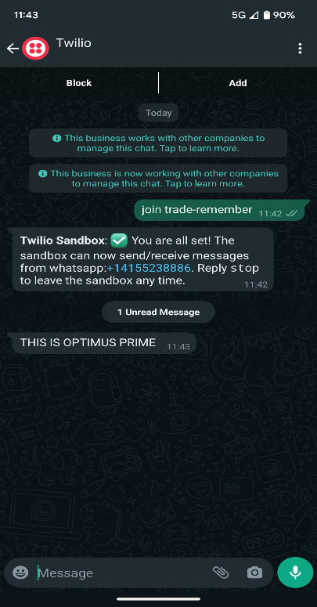 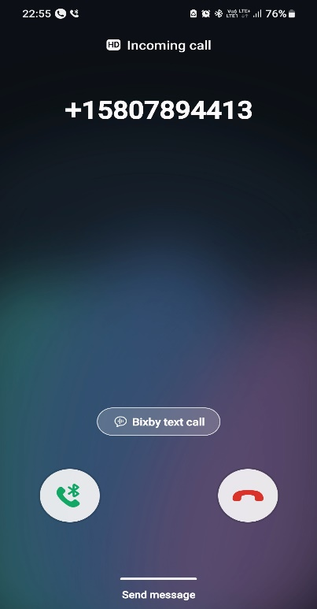

Playing from Youtube:

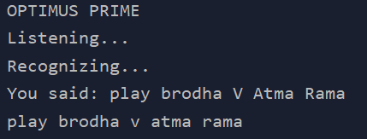

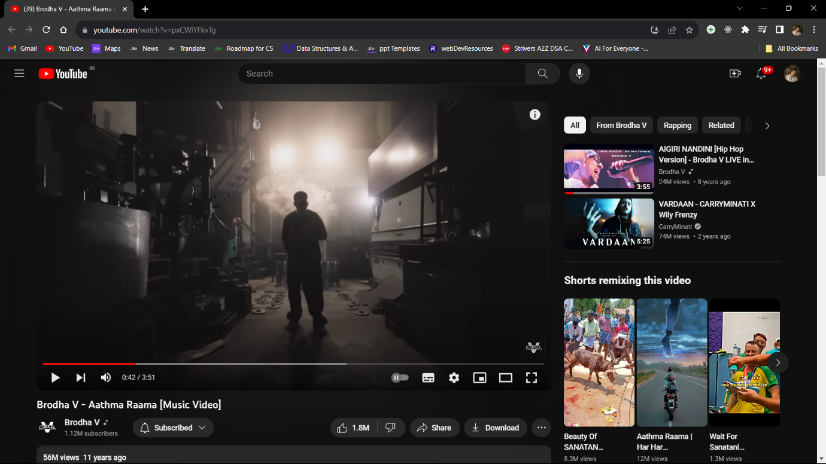

Opening websites:

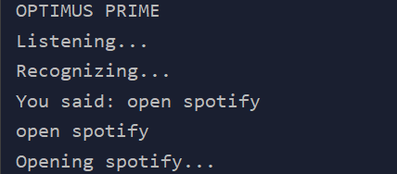

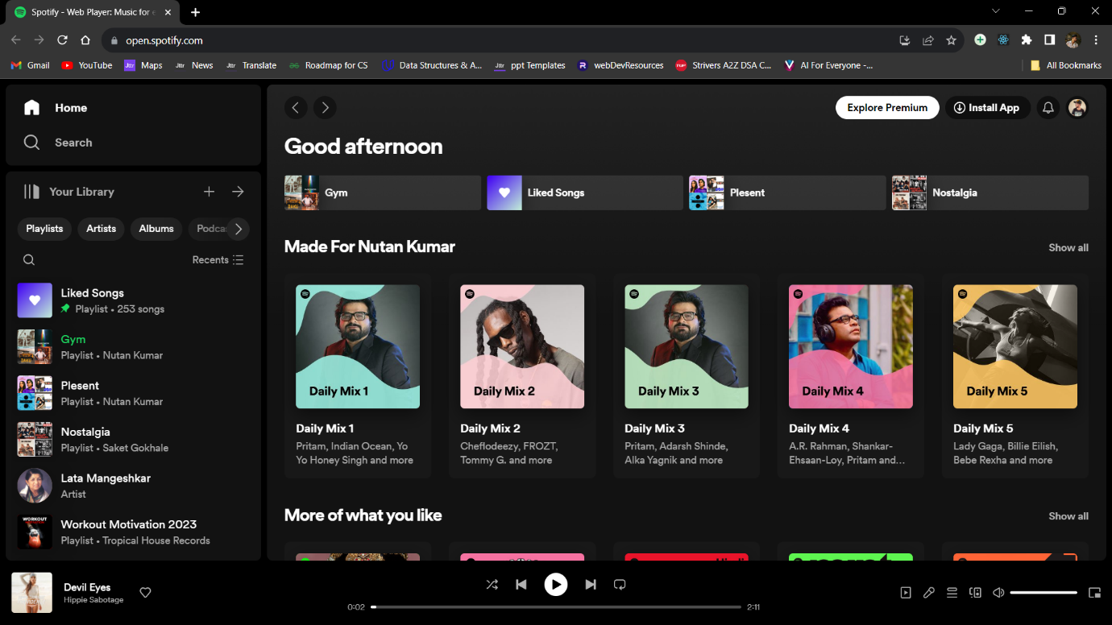

Search engine activation:

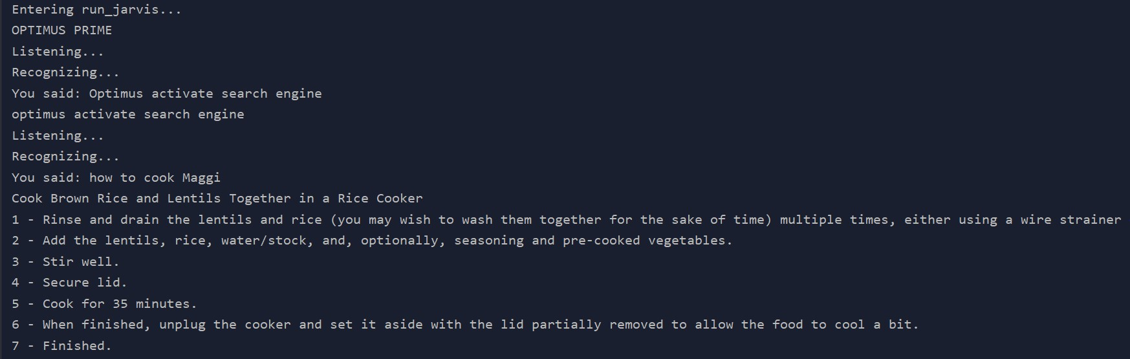

**CHAPTER 7:**

**CONCLUSION:**

The Optimus Prime virtual assistant project showcases the integration of various Python libraries to create a functional and interactive voice-controlled application. It provides a foundation for further development and customization, opening possibilities for expanding its capabilities and enhancing the user experience. The project serves as a hands-on exploration of speech recognition, natural language processing, and API integration in Python.

**REFERENCE:**

Official Python Docs: <https://docs.python.org/3/>

Calling feature: <https://www.twilio.com/docs/phone-numbers>

pyQT5: [https://doc.qt.io/qtforpython-5/contents.html#](https://doc.qt.io/qtforpython-5/contents.html)

Weather reference: <https://openweathermap.org/guide>