**implementing TestNG listeners becomes very useful for the following reasons:**

1. Centralized Reporting and Logging

* You can capture and log extra information automatically when a test starts, passes, fails, or gets skipped.
* Example: On test failure, you might want to capture the request/response logs or screenshots (for UI tests) automatically.
* You can also push this data into Allure reports, making the report much richer.
* ✅ Listeners help you consistently gather all this without writing code in every test method.

1. Enhanced Failure Handling (Retries, Screenshots, Debug Info)

* With listeners like IRetryAnalyzer, you can automatically retry flaky tests without modifying the test case itself.
* In onTestFailure(), you can implement code to capture diagnostic info (API response body, headers, etc.) on test failure.
* ✅ Makes your test suite more robust and easier to debug.

1. Custom Test Flow Management

* Sometimes you want to perform custom actions before/after:
  + A single test
  + A class
  + A full suite
* Examples:
  + Setting up API tokens dynamically.
  + Cleaning up databases after test classes run.
  + Modifying test names dynamically for parameterized tests.
* ✅ Listeners give you those hooks.

1. Integration with Allure Reports
   * Allure can hook into TestNG Listeners to automatically generate better reports.
   * For example:
     1. @Attachment annotations can be placed when a listener triggers.
     2. You can attach request and response details dynamically when a test fails.
   * ✅ This creates beautiful and useful reports without cluttering your test methods.
2. Real-World Example for API Testing
   * Suppose your test fails because the API response time exceeded 2 seconds.
     1. With listeners, you can automatically log:
        1. Request body
        2. Response body
        3. Headers
        4. API endpoint URL
        5. Test parameters
        6. Environment info
     2. Attach all of this to Allure automatically.
   * ✅ Makes debugging much easier for the team.

**How TestNG Listeners are Implemented in a Complex Project**

1. ITestListener
   1. Area
      1. Test Execution Monitoring
   2. Use Case
      1. Track test start, success, failure, skipped, etc.
   3. How It Helps
      1. Attach logs, API requests/responses, screenshots
2. Retry Failed Tests
   1. Area
      1. Retry Failed Tests
   2. Use Case
      1. Automatically retry flaky tests
   3. How It Helps
      1. Increase test suite stability
3. IAnnotationTransformer
   1. Area
      1. Dynamic Test Behavior
   2. Use Case
      1. Add retries dynamically, modify test priorities/groups
   3. How It Helps
      1. Central control over tests
4. ISuiteListenerArea
   1. Area
      1. Suite Level Setup/Teardown
   2. Use Case
      1. Actions before/after the full test suite
   3. How It Helps
      1. Global setup, DB connections, environment checks
5. IClassListener
   1. Area
      1. Class Level Setup/Teardown
   2. Use Case
      1. Actions before/after a test class runs
   3. How It Helps
      1. Class-specific setup or resource cleanup
6. IConfigurable and IConfigurationListener
   1. Area
      1. Configuration Monitoring
   2. Use Case
      1. Listen to @BeforeMethod/@AfterMethod failures
   3. How It Helps
      1. Catch failures in setup/teardown methods
7. Custom Listener + TestNG parallel settings
   1. Area
      1. Parallel Execution Management
   2. Use Case
      1. Manage threads, API token synchronization
   3. How It Helps
      1. Prevent race conditions during multi-thread API testing
8. IInvokedMethodListener
   1. Area
      1. Dependency Handling
   2. Use Case
      1. Before/after every method execution (test or config)
   3. How It Helps
      1. Advanced logging or dynamic skipping
9. Custom Reporter with Allure + IReporter
   1. Area
      1. Reporting Enhancements
   2. Use Case
      1. Generate beautiful structured reports
   3. How It Helps
      1. Detailed, interactive reports
10. Custom ITestListener + Logger (like SLF4J/Log4j)
    1. Area
       1. Custom Logging & Audit Trail
    2. Use Case
       1. Log every step/test action in external files
    3. How It Helps
       1. Create audit logs for compliance
11. IInvokedMethodListener or ITestListener
    1. Area
       1. Dynamic Data Capture
    2. Use Case
       1. Capture dynamic data (request, response, headers) for each API call
    3. How It Helps
       1. Attach into Allure automatically

|  |
| --- |
|  |

🎯 **Deep Examples for Each Listener Type**

1. ITestListener
   1. On test failure, log REST Assured request/response and attach to Allure
2. IRetryAnalyzer
   1. Retry test 2 times if a 502 Bad Gateway is returned
3. IAnnotationTransformer
   1. Automatically apply retry logic to all tests without coding it inside each test
4. ISuiteListener
   1. Connect to the database before all tests start; disconnect after
5. IClassListener
   1. Reset API stubs or mocks before each test class
6. IInvokedMethodListener
   1. Capture execution time for each API call method
7. IReporter
   1. Generate custom JSON summary reports post execution
8. IConfigurationListener
   1. If @BeforeMethod fails (like login failed), mark tests as skipped properly

🧠 **Pro Industry Tips:**

1. Global Retry Setup:
   1. Using IAnnotationTransformer and IRetryAnalyzer together for zero manual retry code.
2. Failure Context Capturing:
   1. Automatically attach Allure attachments at listener level — no need inside tests.
3. Thread-Safe Logging:
   1. When running parallel tests, use ThreadLocal variables inside listeners.
4. Fail Early Strategy:
   1. Implement ISuiteListener to validate that the environment (e.g., API base URL is reachable) before starting tests.
5. Soft Assertions + Listeners:
   1. Capture all soft assertion failures in one test instead of failing fast.

{{{{ More ADD}}

⚡ **Full Listener Classes Typically in Big Projects**

1. Test Listener
   1. TestListener.java
      1. Logs events, attaches Allure details
2. Retry Logic
   1. RetryAnalyzer.java
      1. Retries failed cases
3. Retry Setup
   1. AnnotationTransformer.java A
      1. Applies RetryAnalyzer dynamically
4. Suite Listener
   1. SuiteListener.java
      1. Setup/teardown at suite level
5. Method Invocation
   1. MethodInvocationListener.java
      1. Advanced method-level monitoring
6. Configuration Listener
   1. ConfigListener.java
      1. Listen to @BeforeMethod and @AfterMethod
7. Reporter
   1. CustomAllureReporter.java
      1. Customizes report generation

🚀 **Priority-Ordered TestNG Listeners Implementation Plan**

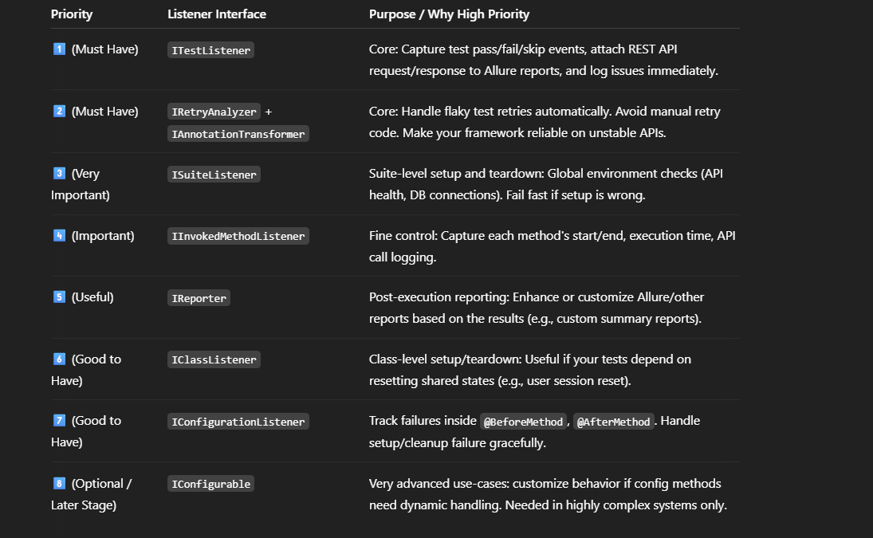

🛠️ **Implementation Plan for You**

**Phase 1: Core Foundation** (Essential for stability and reporting)

* ✅ ITestListener → Attach request/response to Allure on failure.
* ✅ IRetryAnalyzer + IAnnotationTransformer → Setup auto retry.

**Phase 2: Suite Management**

* ✅ ISuiteListener → Pre-check APIs, token generation, DB connection.

**Phase 3: Method and Class Fine Control**

* ✅ IInvokedMethodListener → Log execution time, API stats.
* ✅ IClassListener → Reset stubs/mocks/class-specific data.

**Phase 4: Richer Reporting**

* ✅ IReporter → Custom summary reports if needed.

**Phase 5: Advanced Monitoring**

* ✅ IConfigurationListener, IConfigurable → If your framework grows very large (over 1000+ API tests).

🎯 **Why This Order?**

* You first stabilize execution and reporting.
* Then add environment checks and preconditions.
* Then enhance debugging and reporting.
* Finally, fine-tune the behavior if your framework needs it.

✍️ **Quick Visual Summary:**

Core Stability

⬇️

Retry & Resilience

⬇️

Suite Setup & Global Checks

⬇️

Logging Each Method + Class Level Control

⬇️

Better Custom Reports

⬇️

Advanced Listeners (optional in very big projects)

📚 **Full Deep Explanation of Listener (in TestNG)**

1. What is Listener?
2. Why is Listener Useful?
3. Where is Listener Used in a Project?
4. How is Listener Used?
5. Key Methods of Listener
6. How to Use Listener (with Code)
7. Real-World Example Use Cases of Listener
8. Simple Architecture Diagram
9. Extra Pro Information
10. Advantages of Using Listener
11. Summary: **Big Picture**
12. Final Tip:

Each listener each doc