**ITestListener**

1. What is ITestListener?
   1. ITestListener is an interface provided by TestNG that lets you listen to important events during the execution of test methods.
   2. “Observer” for your test cases — you get notified automatically when tests start, succeed, fail, or get skipped.
2. Why is ITestListener Useful?
   1. **Centralized control for:**
      1. Handling test success, failure, skipped events.
      2. Logging, taking screenshots, attaching API logs, etc.
      3. Creating custom behaviors on test results without touching the test code.
      4. Automatically improving reports like Allure, ExtentReports, etc.
      5. Making tests more maintainable and DRY (Don't Repeat Yourself).
3. Where is ITestListener Used in a Project?
   1. Typically used in:
      1. Base Framework Layer (utilities, setup)
      2. Custom Reporting (Allure, Extent, HTML Reports)
      3. Failure Handling (taking screenshots, logs)
      4. Retry Handling (combine with IRetryAnalyzer)
      5. Test Lifecycle Management (when you want hooks on test events)
4. How is ITestListener Used?
   1. Step-by-Step:
      1. Implement the Interface in a class.
      2. Override methods like onTestSuccess(), onTestFailure(), etc.
      3. Register the Listener either:
      4. Using @Listeners annotation in your test classes.
      5. Or globally in testng.xml.
5. Key Methods of ITestListener
   1. onTestStart(ITestResult result)
      1. When a test method starts
   2. onTestSuccess(ITestResult result)
      1. When a test method passes
   3. onTestFailure(ITestResult result)
      1. When a test method fails
   4. onTestSkipped(ITestResult result)
      1. When a test is skipped
   5. onStart(ITestContext context)
      1. Before any test method in a test <test> tag starts
   6. onFinish(ITestContext context)
      1. After all test methods in a test <test> tag finish

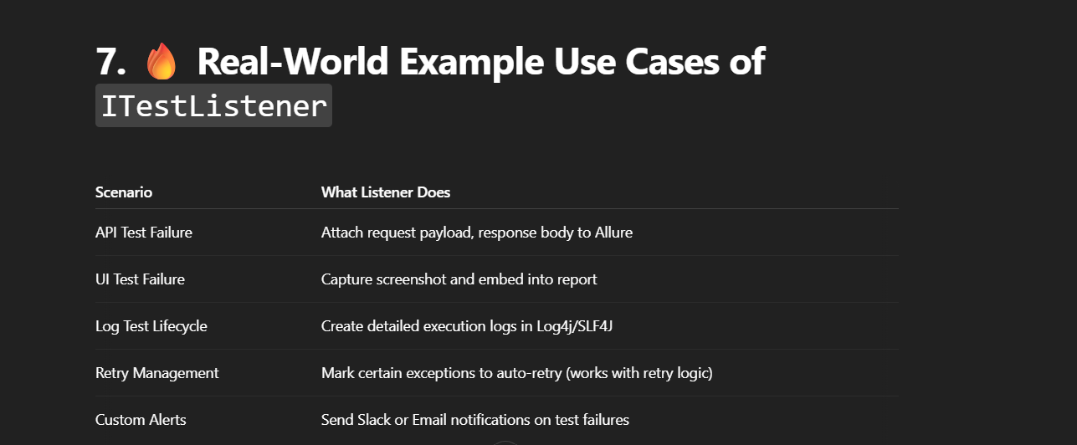

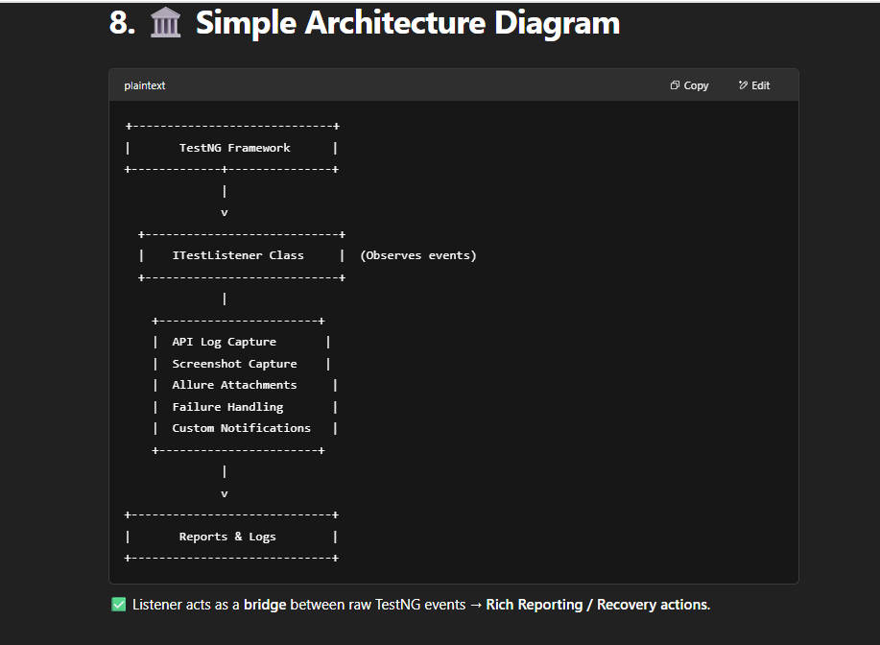

10. 📈 Advantages of Using ITestListener

* No need to put repetitive log/screenshot/attach code inside every test.
* Cleaner, maintainable codebase.
* Makes Allure/Extent reports automatically richer.
* Easier debugging for failures — logs and API traces are already captured.

🚀 Summary: Big Picture

| **Key Concept** | **Summary** |
| --- | --- |
| What | Observer for your test cases |
| Why | Centralize logging, reporting, retries |
| Where | Framework core utilities |
| How | Implement, override methods, register listener |
| Real Use | API failure logs, retry on network glitches, Allure attachments |