ctr -n k8s.io images pull mcr.microsoft.com/playwright:v1.61.1-jammy

Phase 1 – Project Setup

Goal
- Create the project structure for storing Playwright test artifacts using Kubernetes Persistent Volumes and understand the storage architecture.

Step 1 – Create the Project Directory

mkdir -p ~/k8s-playwright-persistent-results/{tests,k8s}
cd ~/k8s-playwright-persistent-results

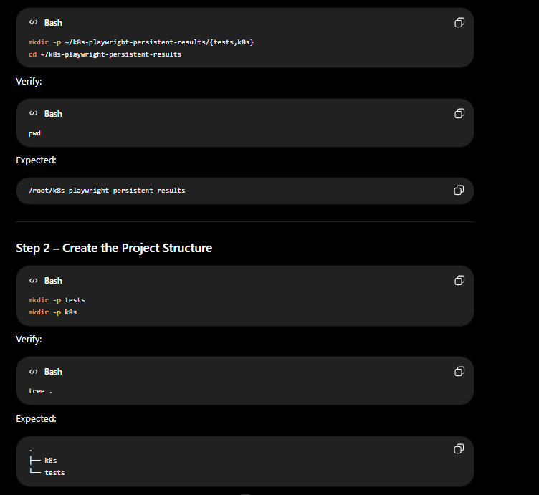

Step 2 – Initialize the Playwright Project

apt install npm
npm init -y

npm install -D @playwright/test

npx playwright install

npx playwright install-deps

apt install tree

Phase 2 – Build Playwright Test Suite

Step 1 – Create the Test File
cat <<'EOF' > tests/sample.spec.ts
import { test, expect } from '@playwright/test';

test('Verify Playwright homepage', async ({ page }) => {

await page.goto('https://playwright.dev');

await expect(page).toHaveTitle(/Playwright/);

await expect(
page.getByRole('link', { name: 'Get started' })
).toBeVisible();

});
EOF

cat <<'EOF' > playwright.config.ts
import { defineConfig } from '@playwright/test';

export default defineConfig({

testDir: './tests',

timeout: 30000,

reporter: [
['list'],
[
'html',
{
outputFolder: 'artifacts/playwright-report',
open: 'never'
}
]
],

outputDir: 'artifacts/test-results',

use: {

headless: true,

screenshot: 'on',

video: 'on',

trace: 'on'

}

});
EOF

Phase 3 – Configure Playwright for Persistent Artifacts

Step 1 – Update the Playwright Configuration

cat <<'EOF' > playwright.config.ts
import { defineConfig } from '@playwright/test';

export default defineConfig({

testDir: './tests',

timeout: 30000,

reporter: [
['list'],
[
'html',
{
outputFolder: 'artifacts/playwright-report',
open: 'never'
}
]
],

outputDir: 'artifacts/test-results',

use: {

headless: true,

screenshot: 'on',

video: 'on',

trace: 'on'

}

});
EOF

Step 2 – Run the Playwright Tests

npx playwright test

Step 3 – Verify the Generated Artifacts
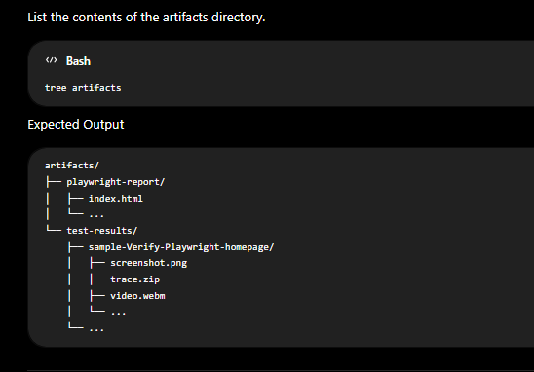

Step 4 – View the HTML Report
npx playwright show-report artifacts/playwright-report

Phase 4 – Create StorageClass

- Goal
  - Create a Kubernetes StorageClass that defines how storage is managed for the Playwright artifacts. In this project, the StorageClass uses the kubernetes.io/no-provisioner provisioner because the storage will be backed by a manually created hostPath PersistentVolume.

Step 1 – Create the StorageClass Manifest

cat <<'EOF' > k8s/storageclass.yaml
apiVersion: storage.k8s.io/v1
kind: StorageClass
metadata:
name: playwright-storage

provisioner: kubernetes.io/no-provisioner

volumeBindingMode: WaitForFirstConsumer

allowVolumeExpansion: false

reclaimPolicy: Retain
EOF

Step 2 – Apply the StorageClass

kubectl apply -f k8s/storageclass.yaml

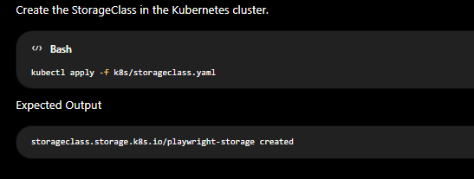

Step 3 – Verify the StorageClass
kubectl get storageclass
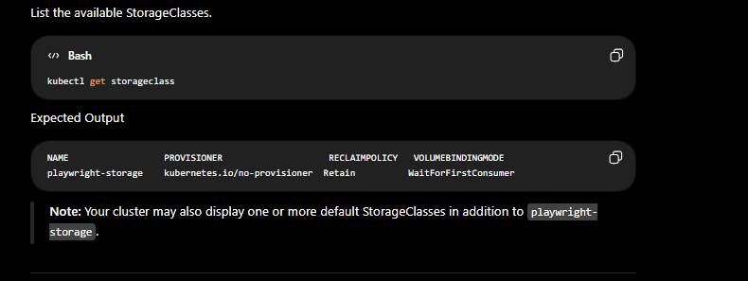

Phase 5 – Create PersistentVolume

Goal
Create a PersistentVolume (PV) that provides persistent storage for Playwright artifacts. This storage will later be claimed by a PersistentVolumeClaim (PVC) and mounted into the Kubernetes Job.

Step 1 – Create a Directory for the PersistentVolume

sudo mkdir -p /mnt/playwright-results
sudo chmod 777 /mnt/playwright-results

Verify
ls -ld /mnt/playwright-results

Step 2 – Create the PersistentVolume Manifest
cat <<'EOF' > k8s/pv.yaml
apiVersion: v1
kind: PersistentVolume
metadata:
name: playwright-pv

spec:
capacity:
storage: 2Gi

accessModes:
- ReadWriteOnce

storageClassName: playwright-storage

persistentVolumeReclaimPolicy: Retain

hostPath:
path: /mnt/playwright-results
EOF

Step 3 – Apply the PersistentVolume
kubectl apply -f k8s/pv.yaml

Step 4 – Verify the PersistentVolume
kubectl get pv

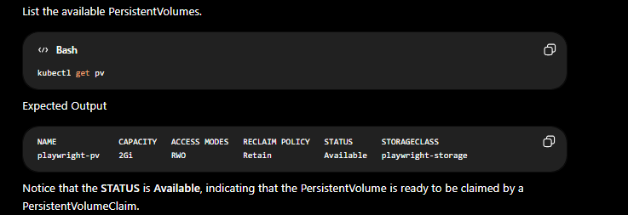

Phase 6 – Create PersistentVolumeClaim

Goal
Create a PersistentVolumeClaim (PVC) that requests persistent storage from Kubernetes. The PVC will bind to the previously created PersistentVolume (PV) and will later be mounted into the Playwright Job for storing test artifacts.

Step 1 – Create the PersistentVolumeClaim Manifest

cat <<'EOF' > k8s/pvc.yaml
apiVersion: v1
kind: PersistentVolumeClaim
metadata:
name: playwright-results-pvc

spec:
accessModes:
- ReadWriteOnce

storageClassName: playwright-storage

resources:
requests:
storage: 2Gi
EOF

Command
kubectl apply -f k8s/pvc.yaml
kubectl get pvc
kubectl get pv

Phase 7 – Create Kubernetes Job

Create a Kubernetes Job that mounts the PersistentVolumeClaim (PVC) so that Playwright artifacts can be stored in persistent storage.
Note: This phase focuses on the Kubernetes Job configuration and PVC mounting. We use the official Playwright container image for demonstration purposes and do not build a custom Docker image.

Step 1 – Create the Job Manifest

cat <<'EOF' > k8s/job.yaml
apiVersion: batch/v1
kind: Job
metadata:
name: playwright-job

spec:
backoffLimit: 2
activeDeadlineSeconds: 600

template:
spec:
restartPolicy: Never

containers:
- name: playwright
image: mcr.microsoft.com/playwright:v1.61.1-jammy
imagePullPolicy: IfNotPresent

command:
- sh
- -c
- |
echo "Playwright Job Started"
echo "Mounted Artifacts Directory:"
ls -la /artifacts
echo "Playwright Job Completed"

volumeMounts:
- name: playwright-artifacts
mountPath: /artifacts

volumes:
- name: playwright-artifacts
persistentVolumeClaim:
claimName: playwright-results-pvc
EOF

Step 2 – Create the Job
kubectl apply -f k8s/job.yaml

Step 3 – Verify the Job
kubectl get jobs

Step 3 – Watch the Pod
kubectl get pods -w

Step 4 – View Job Logs
kubectl logs job/playwright-job

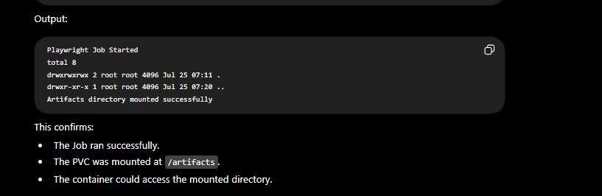

Step 5 – Verify the PersistentVolumeClaim
kubectl get pvc

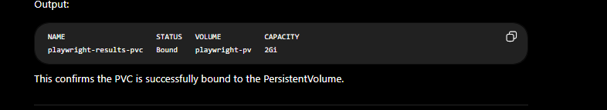

Step 6 – Verify the PersistentVolume
kubectl get pv
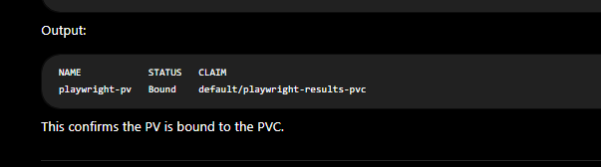

Step 7 – Verify the Mounted Storage
kubectl run pvc-debug \
--image=busybox \
--restart=Never \
--overrides='
{
"spec": {
"containers": [{
"name": "debug",
"image": "busybox",
"command": ["sh", "-c", "sleep 3600"],
"volumeMounts": [{
"name": "artifacts",
"mountPath": "/artifacts"
}]
}],
"volumes": [{
"name": "artifacts",
"persistentVolumeClaim": {
"claimName": "playwright-results-pvc"
}
}]
}
}'

kubectl exec -it pvc-debug -- sh

ls -la /artifacts

exit

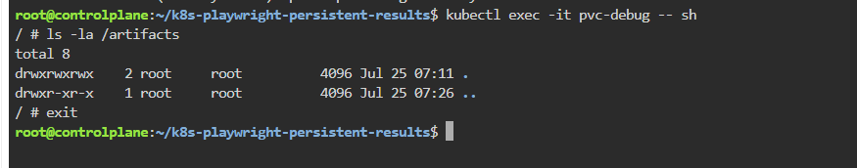

kubectl delete pod pvc-debug

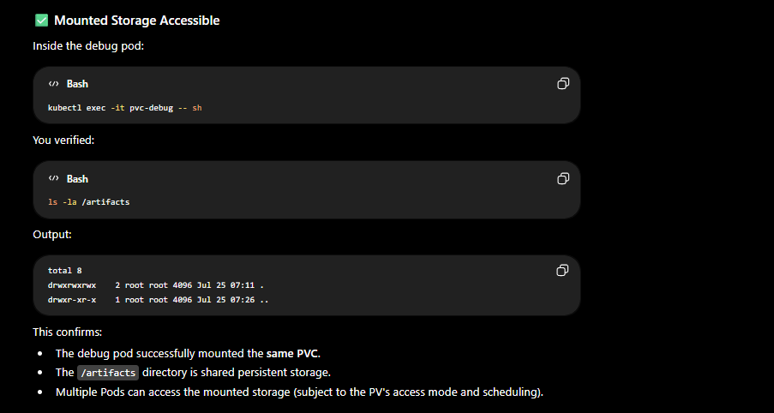

Phase 8 – Verify Persistent Storage

Goal
Verify that the PersistentVolume (PV) and PersistentVolumeClaim (PVC) remain available after the Kubernetes Job completes, demonstrating that data stored on the volume survives the Pod lifecycle.

Step 1 – Verify the Job Status
kubectl get jobs

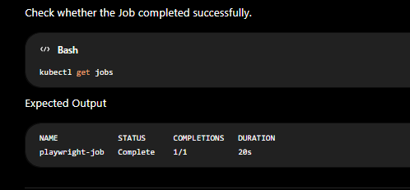

Step 2 – Verify the Pod Status
kubectl get pods

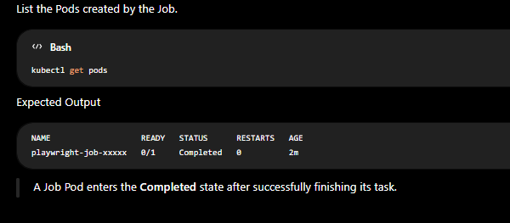

Step 3 – Verify the PersistentVolumeClaim
kubectl get pvc

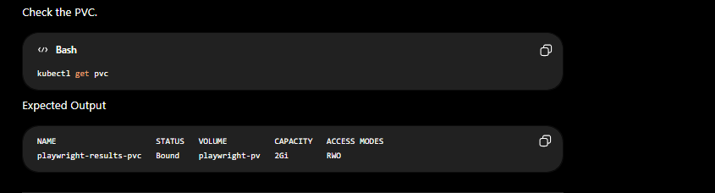

Step 4 – Verify the PersistentVolume
kubectl get pv

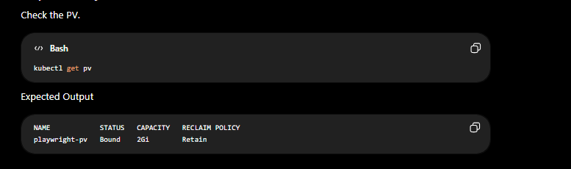

Step 5 – Delete the Completed Job

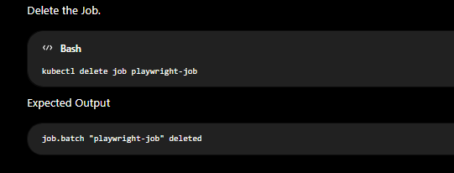
Step 6 – Verify the PVC Still Exists
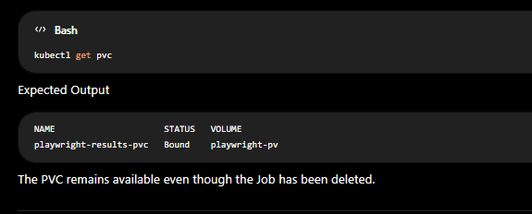

Step 7 – Verify the PV Still Exists
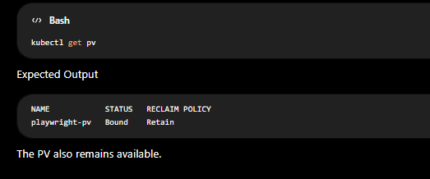

Step 8 – Verify the Mounted Storage
kubectl run pvc-debug \
--image=busybox \
--restart=Never \
--overrides='
{
"spec": {
"containers": [{
"name": "debug",
"image": "busybox",
"command": ["sh", "-c", "sleep 3600"],
"volumeMounts": [{
"name": "artifacts",
"mountPath": "/artifacts"
}]
}],
"volumes": [{
"name": "artifacts",
"persistentVolumeClaim": {
"claimName": "playwright-results-pvc"
}
}]
}
}'

Step 9 – Access the Storage
kubectl exec -it pvc-debug -- sh
ls -la /artifacts
exit
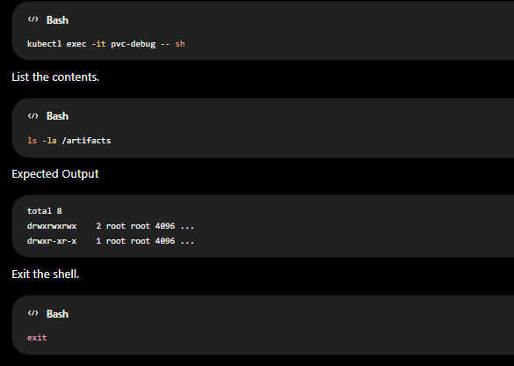

Step 10 – Delete the Temporary Pod

kubectl delete pod pvc-debug

Phase 9 – Retrieve Persistent Artifacts

Goal
Learn different methods to access Playwright artifacts stored in the PersistentVolumeClaim (PVC) after the Job has completed.

Step 1 – Create a Debug Pod
cat <<'EOF' > k8s/debug-pod.yaml
apiVersion: v1
kind: Pod
metadata:
name: pvc-debug

spec:
restartPolicy: Never

containers:
- name: debug
image: busybox
command:
- sh
- -c
- sleep 3600

volumeMounts:
- name: playwright-artifacts
mountPath: /artifacts

volumes:
- name: playwright-artifacts
persistentVolumeClaim:
claimName: playwright-results-pvc
EOF

Step 2 – Deploy the Debug Pod
kubectl apply -f k8s/debug-pod.yaml

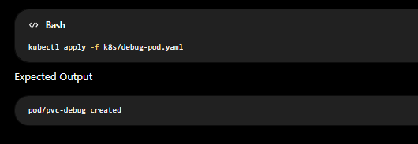

Step 3 – Verify the Pod
kubectl get pods

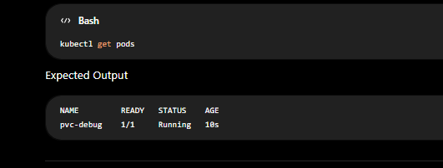

Step 4 – Open a Shell

kubectl exec -it pvc-debug -- sh

Step 5 – Browse the Mounted Volume

ls -la /artifacts

ls -R /artifacts

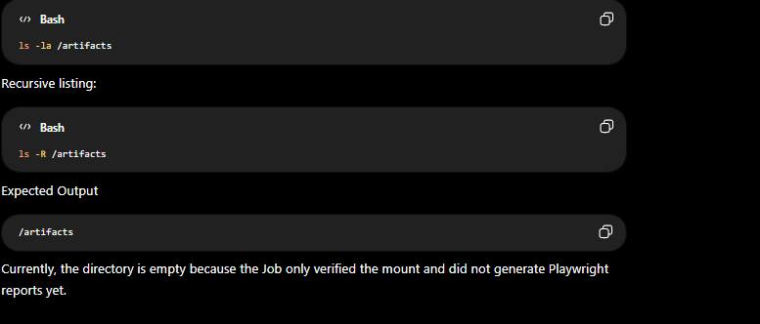

Step 6 – Exit the Container

exit

Step 7 – Delete the Debug Pod
