Manager Level

1. Application Run - Option display

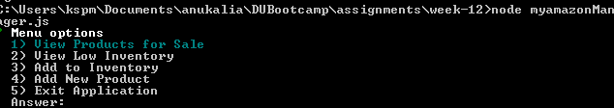

Pic:1

1. Option choice:2 (View low inventory)

Displays products which are lower than inputted quantity

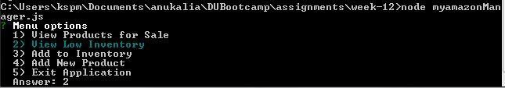

Pic: 2

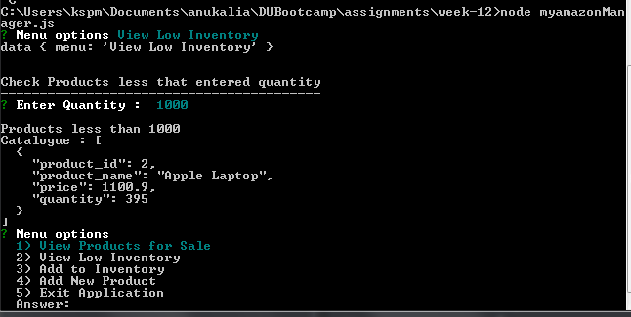

Pic: 3

After Displaying Items which are less than 1000, Returns to application Main Menu

1. Option Add to Inventory(3rd option)

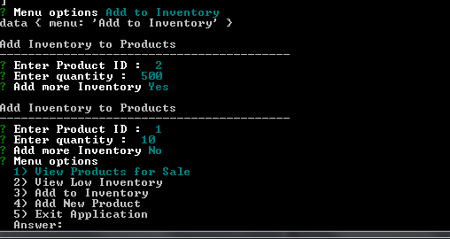

Pic:4

The 3rd Option ask for Product Id, and the quantity to be added to the inventory. The Ask for whether any Inventory has to be added, if yes lets more additions to the inventory. If no, goes to application main menu

1. Option to ‘Add New Products’ - (4th option)

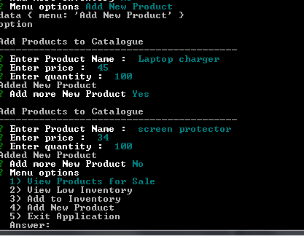

Pic:5

Ask for the Product name, price and quantity. Adds to the database. Ask whether more new products need to be added. If yes, lets the add more products. If No, goes to Main menu.

1. Option ‘View Products for Sale’ (option 1)

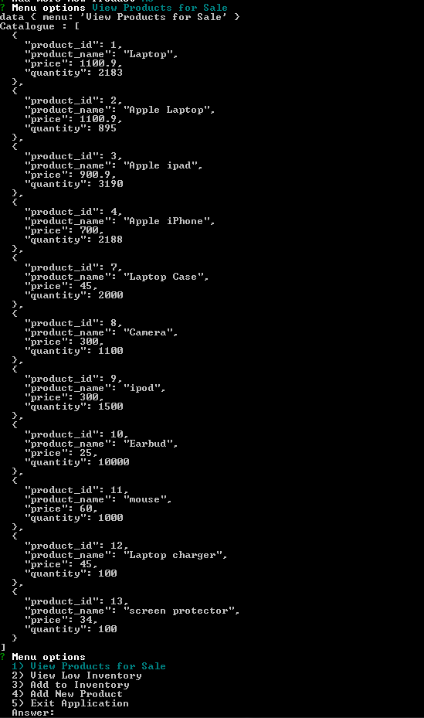

Pic:6

We can verify the Product:2 (Apple Laptop) Inventory is 895

{ ( Low Inventory screen: Pic3, Shows 395)(Add Inventory Pic:4, we add 500)}

We can also see the New Products added “Laptop charger”,”Screen protector”.

{Pic:5  -- for adding new products}

-----------------------------------------------