**Step:1** node myamzonsuperior.js

The application displays 3 options – See Report of Sales for all products, See Sales for a specific report, Exit Application

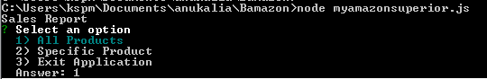

**Step:2** Choose Option All products sales are displayed.

The Order_products and master_product table are equi joined. Gorup by is used to group order_details by product_id. Aggregate function max() is used to find total sales of each product.

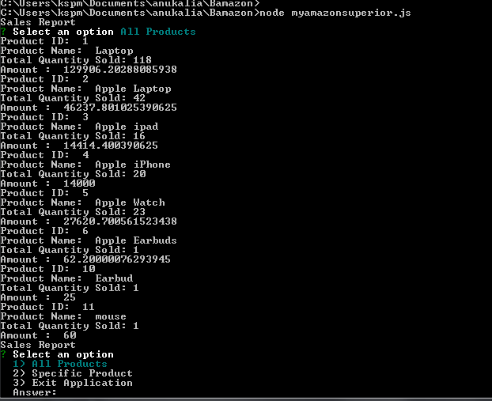

After sales of all products are displayed, the main menu Is displayed.

**Step:3** When Specific Product option is selected.

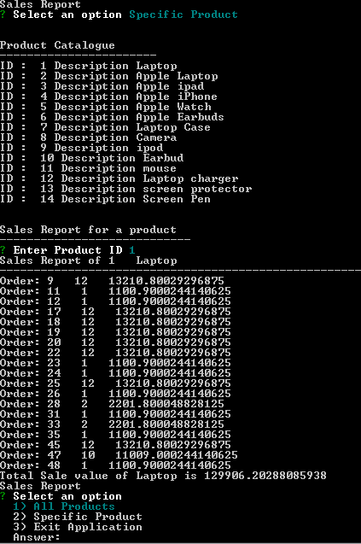

The Specific product all order details are displayed. The total sales for the product is also displayed. The main menu is displayed.

**Step:4** When there no Orders for the specific product,(no records in Order_products table, but the Product exist in master_product table)

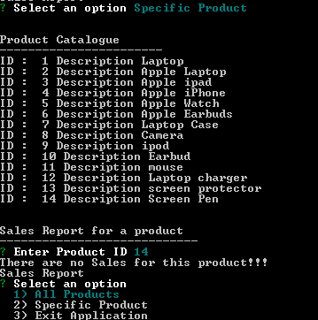

Message that there are not sales for the product is displayed, and Main menu appears

**Step:5** When Invalid Product Id is displayed.

Recursive function call concept.

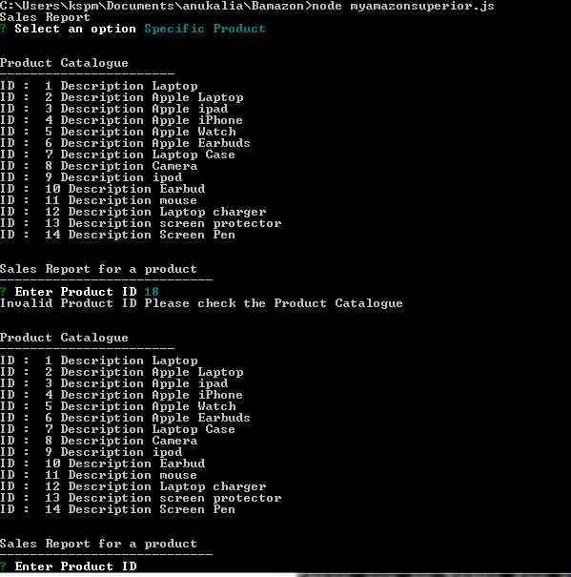

**Step:6** Exit Application

