1 : Run the file (for the condition to check in stock)

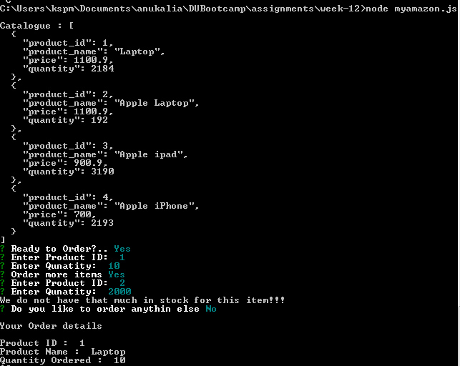

2.The Catalog is displayed and ask the user whether they are ready to place order.

3. Then User selects 1, and enters the quantity. As 10 .(The original quantity of Product 1, 2184)

4. The User selects 2, and 2000 is entered which is more than the stock. Error message displayed, And prompt to do you wish to order anything else...user enters no...

5. A details of all the orders places is displayed

-----------------------------------------------------------------

2. Second Run - to check the stock is updated in database.

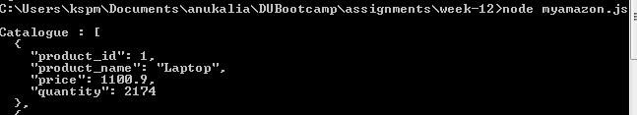

3. Normal Run (less stock)

