**Output: Screenshots of Fine Restaurant – running**

**Back end – Initial Screen**

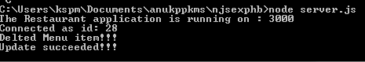

**Front-End Page:**

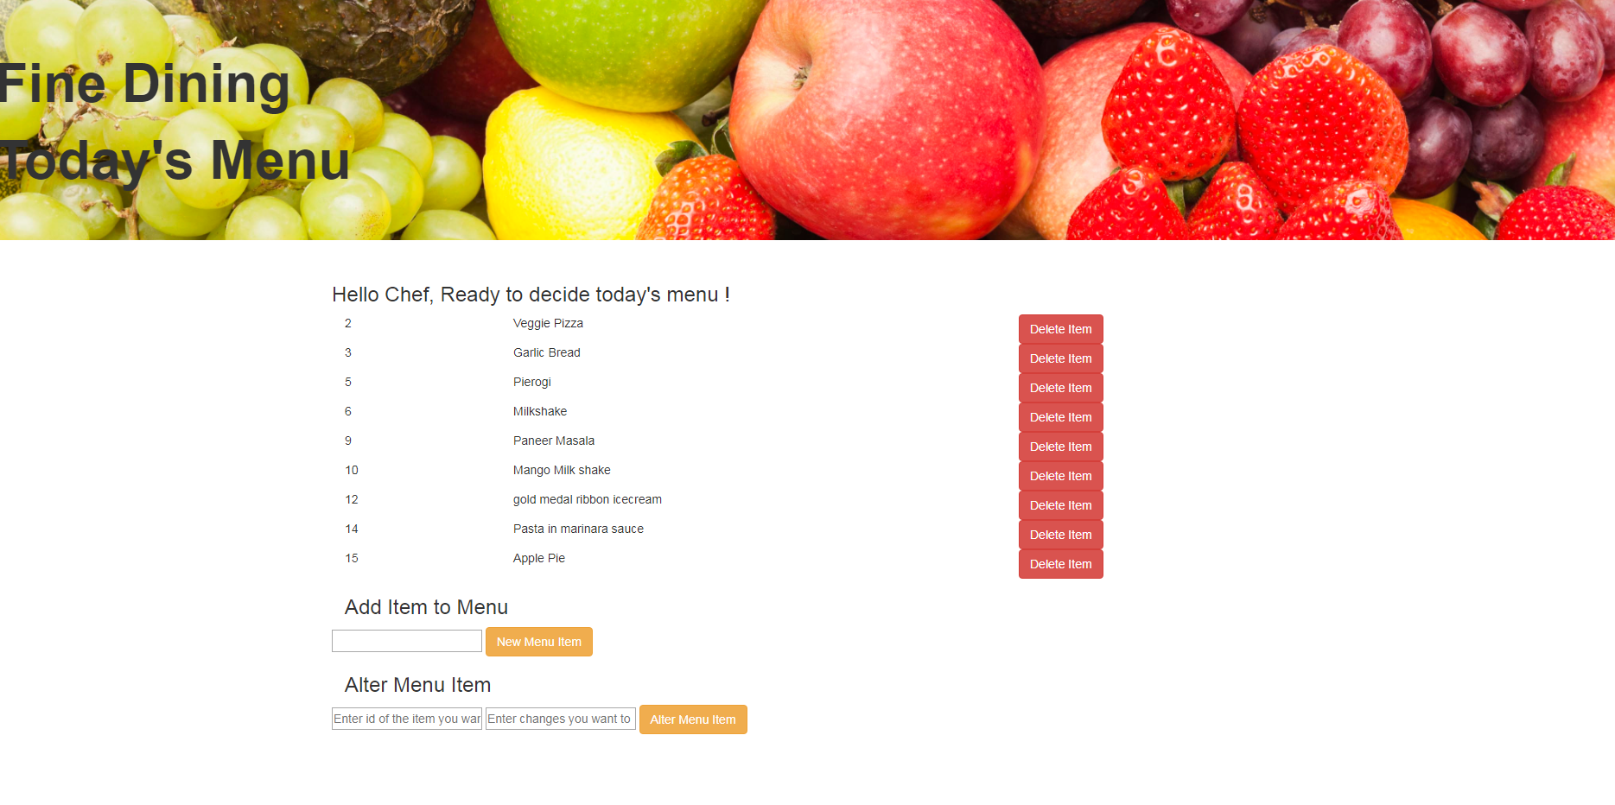

**Add New Menu**

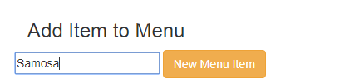

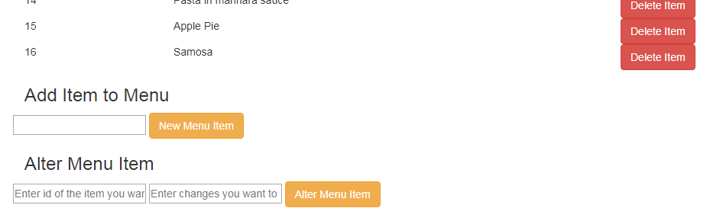

**Alter Item:**

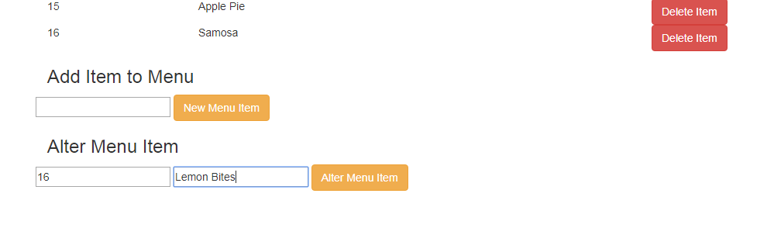

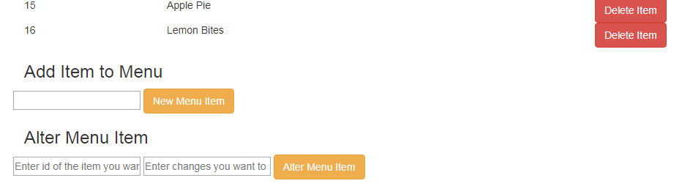

**Delete Item**



