# **INSTALLATION AND EXECUTION GUIDE**

Open your console and navigate into the folder containing the website

Run browser sync to run the webpage on localhost

**browser-sync start --server --directory –files**

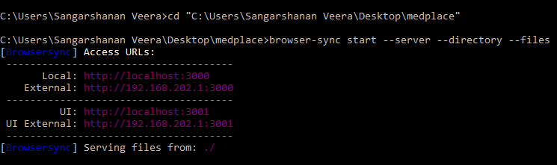

Check if nodejs and npm is installed in your system

**npm –v**

**node –v**

Initialise the node_modules and install the web3 js on ethereum

**npm init**

**npm install ethereum/web3.js –save**

Run testrpc to create 10 test accounts to play with automatically. These accounts come preloaded with 100 fake ethers.

**Testrpc**

I have used solidity programming language to write our contract.

Go to the ethereum remix engine (<http://remix.ethereum.org>)

Change the https to http in order to run in web3 provider environment

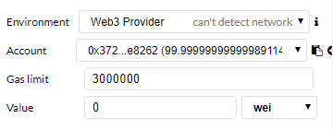

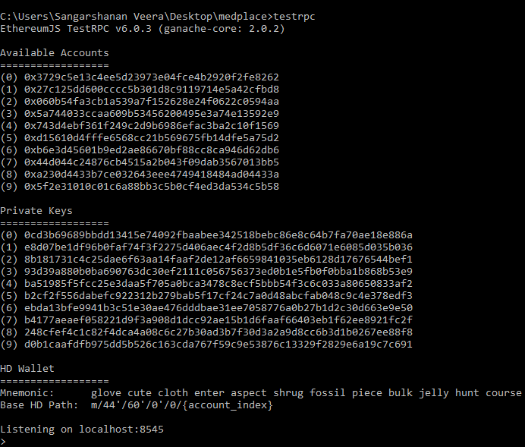

Paste the smart contract code in experience/med place.sol

Now add items to the cart in our website and checkout

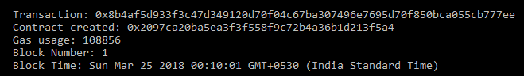

The total amount purchased is transferred to the ethereum blockchain

