Windowed Latent Matching for Granular Audio Resynthesis
Sangarshanan Veeraraghavan. Music Technology Group, Universitat Pompeu Fabra
sangarshanan.veeraraghavan01@estudiant.upf.edu

Introduction
Neural audio codecs compress audio into compact latent sequences, but their potential as a medium for synthesis and creative manipulation remains largely unexplored. Tokui (2024) introduced latent granular resynthesis: encoding a target and a source pool into Encodec latents, replacing each target frame with the nearest pool frame via cosine similarity, and decoding the result but there are different ways to fetch the closest latents and the parameter space of the algorithms used is still quite unexplored and there is no systematic evaluation.

We present a system for granular resynthesis in the 128-dimensional continuous latent space of Encodec (24 kHz). A target signal is encoded into a sequence of latent vectors; a source pool forms a latent codebook. Each target frame is matched to the most similar pool frame using windowed cosine similarity over a configurable local context window, and the matched sequence is decoded back to audio, preserving the target's temporal envelope while transplanting timbral character from the pool. The system introduces four controllable parameters: window size, hop, stride, and grain size; and evaluates pedalboard-based pool augmentation as a method of expanding codebook coverage without additional recordings.

We run a full parameter sweep across 10,800 configurations on both percussive and instrumental material, measuring Fréchet Audio Distance (FAD) and MFCC-L2 against the pool. Results show that grain size and stride are the dominant parameters in both categories. For percussion, stride = 1 and moderate window size minimize FAD. For instruments, large grains (4–5 frames) and stride = 1 are optimal. Pool augmentation reduces FAD for percussion but worsens both metrics for instruments, a finding that diverges from informal perceptual observation, pointing to known limitations of FAD and MFCC-L2 as proxies for perceived quality.
Website with Audio examples: https://latent-granular-resynthesis.vercel.app/
Github Code: https://github.com/Sangarshanan/latent-granular-resynthesis

Motivation
Tokui (2024) introduced latent granular resynthesis with a novel idea: treat a pre-trained codec's latent space as the medium for granular synthesis rather than the waveform domain. This eliminates the need for corpus-specific training, works immediately with any source material, and gains access to the codec's implicit interpolation during decoding to smooth grain boundaries. We explore windowed similarity along with a naive frame level matching and explore how each parameter affect the output for percussive and harmonic sounds

This work is relevant to three groups:
- Musicians and live coders who want training-free timbre transfer with clear parameter intuitions and real-time potential.
- Audio ML researchers interested in what codec latent geometry looks like from the inside, the percussion vs. instruments split in FAD is a concrete probe of latent space structure.
- Instrument and interface designers exploring the multi-pool morphing and alpha blending extensions as new handles for expressive timbral control in codec-native synthesis tools.

Related Work
Granular synthesis has been used in electroacoustic composition since Xenakis (1971) and Roads (2001). By fragmenting audio into sub-second grains and recombining them, composers can stretch, freeze, and retexture sound in ways that spectral methods cannot. The technique remains popular in commercial synthesisers (Ableton Granulator, Output Portal) and research tools alike.
Corpus-based concatenative synthesis (Schwarz, 2006; 2013) extended this paradigm by selecting grains from a large audio corpus. Matching is typically performed on handcrafted descriptors: MFCCs, spectral centroid, zero-crossing rate: with nearest-neighbour search.
The emergence of neural audio codecs: Encodec (Défossez et al., 2022), DAC (Kumar et al., 2023), Music2Latent (Pasini & Schlüter, 2024) — provides a learned, compact representation in which a single 128-dimensional vector captures both spectral and temporal information at each frame.
Tokui (2024) encodes source and target into Encodec latent sequences, replacing each target frame with the best-matching source frame via similarity metrics, and decodes the hybrid. The result preserves the target's macro-temporal structure while transplanting the source's timbre.
Tatar et al. (2021) proposed Latent Timbre Synthesis, encoding audio into a low-dimensional latent space and performing timbre morphing by interpolating between latent trajectories. Their work demonstrated that smooth, perceptually meaningful morphs are achievable in learned spaces when the decoder is sufficiently expressive.
Our work takes direct inspiration from Tokui and Tatar et al. The key distinction is that we operate in a training-free setting using a pre-trained codec, require no corpus-specific model, and provide the first systematic parameter evaluation of this approach. Our implementation with Encodec can also be run in realtime, a demo is available to run locally on the Github link attached for the codebase.

Implementation
Audio files are loaded at 24 kHz and encoded into sequences of 128-dimensional latent vectors at roughly 75 frames per second. The target and pool take slightly different paths through the encoder: target latents are taken directly from the continuous encoder output, while pool latents are passed through the full quantization pipeline and then projected back to the same 128-d space. This keeps the target's fine-grained temporal detail intact while ensuring the pool's vocabulary stays close to what the decoder was trained to expect.

Baseline: Cosine Similarity Matching
The simplest approach matches each target frame to the nearest pool frame independently using cosine similarity. This is computationally efficient and preserves temporal structure, but produces abrupt timbral changes and audible discontinuities — each frame is selected without any temporal context, leading to frame-level jitter and incoherent grain sequences, especially on percussive material.

Windowed Cosine Matching
The problem with frame-level matching is that each grain is selected with no knowledge of what came before or after it. A single latent frame is a very thin slice of information, roughly 13 milliseconds, and two frames that look similar in isolation can produce completely different audio when decoded in context. The result is a sequence of grain selections that are individually plausible but collectively incoherent, manifesting as timbral flicker and discontinuities at grain boundaries.
Windowed matching addresses this by widening the lens of each comparison. Rather than asking "which pool frame looks most like this target frame?", it asks "which pool region looks most like this stretch of target audio?" Concretely, each target position is represented not by a single latent vector but by a short sequence of consecutive vectors, a window, that captures the local shape of the sound as it evolves over several frames. Pool candidates are represented the same way. Matching then finds the pool region whose temporal shape best aligns with the target's local trajectory, rather than its instantaneous value.
This has a smoothing effect: a pool grain that fits well only at a single instant but diverges in context will score lower than one whose neighborhood is consistently similar to the target's neighborhood.

Pool Augmentation
To expand the pool's timbral vocabulary without additional recordings, seven pedalboard effect chains are applied to the pool audio before encoding: pitch shifts of ±2, ±4, and +7 semitones, gain adjustments of ±6 dB, and combinations thereof. Each augmented copy is encoded independently and its latents concatenated with the original pool, effectively multiplying the codebook size by up to 8×.
Limitation: The quality of matching is fundamentally bounded by pool coverage. A small pool with limited timbral diversity will produce poor matches regardless of window or grain settings. Augmentation addresses this partially, but is not a substitute for richer source material. This is discussed further in the results.

Additional Transfer Modes
Beyond the core windowed matching, the system implements two additional transfer modes that are available for interactive use but are not part of the systematic evaluation:
- Alpha blending: matched pool latents are linearly interpolated with the original target latents — α = 1 gives full style transfer, α = 0 is the identity. This functions as a dry/wet knob for timbre transfer.

- Multi-pool morphing: N pools are matched independently against the same target and combined with weights (fixed or per-frame). With two pools this traces a line; with three, a triangle. Per-frame weights enable time-varying crossfades across the pool space.

We perform a systematic evaluation by asking the question
How do window size, grain size, stride, hop, and augmentation affect objective similarity (FAD, MFCC-L2) and subjective audio quality, and how does the answer differ between percussion and instruments?
We evaluate on two categories: percussive material and instrumental material all at 24 kHz mono. Each loop is paired with every other loop in its category (target ≠ pool), yielding pairwise permutations per configuration. All audio is normalized to [−1, 1] peak amplitude.

Parameter Grid

Parameter | Grid Values
Grain size | 1, 2, 3, 4, 5
Window size | 1, 2, 3, 4, 5
Stride | 1, 2, 3
Hop | 1, 2, 3

With pairwise target→pool permutations within each category, the full sweep totals 10,800 individual runs (5,400 per category).

Metrics
- MFCC-L2: L2 distance between the mean 13-coefficient MFCC vector of the output and that of the pool. Measures spectral envelope proximity to the source timbre. Lower is better.
- Fréchet Audio Distance (FAD): Distributional similarity between output and pool audio embeddings using the Encodec backbone at 24 kHz. Measures how statistically close the output distribution is to the pool. Lower is better.

Note on metrics: FAD and MFCC-L2 are imperfect proxies for perceived audio quality. As discussed in the augmentation results below, cases where perceptual quality improves while objective metrics worsen are possible and observed. Results should be interpreted alongside the audio examples at the companion website linked in the introduction.

Results
The full parameter sweep reveals clearly differentiated behavior between percussion and instruments. The two categories have substantially different baseline FAD scores: Instruments average around 95, percussion around 182, So harmonic material tolerates small frame-level mismatches better than transient-dominated percussion, where timing and onset alignment is brittle under nearest-neighbor matching.

Grain Size
Grain size is the strongest single parameter across both categories. Copying longer consecutive latent segments per match reduces frame-to-frame selection jitter and creates more coherent latent trajectories, which Encodec's decoder renders more smoothly. The drop is sharpest between grain sizes 2 and 4.

Grain | Perc MFCC | Perc FAD | Inst MFCC | Inst FAD
1 | 158.2 | 272.6 | 110.5 | 147.7
2 | 133.3 | 242.7 | 111.4 | 146.7
3 | 91.9 | 156.2 | 100.9 | 75.8
4 | 74.1 | 123.4 | 83.6 | 53.2
5 | 67.8 | 118.0 | 80.4 | 54.3

For percussion, larger grains carry a perceptual trade-off: lower FAD does not necessarily mean better transients. Long grains attack envelopes, reducing the rhythmic snap that defines percussive material.
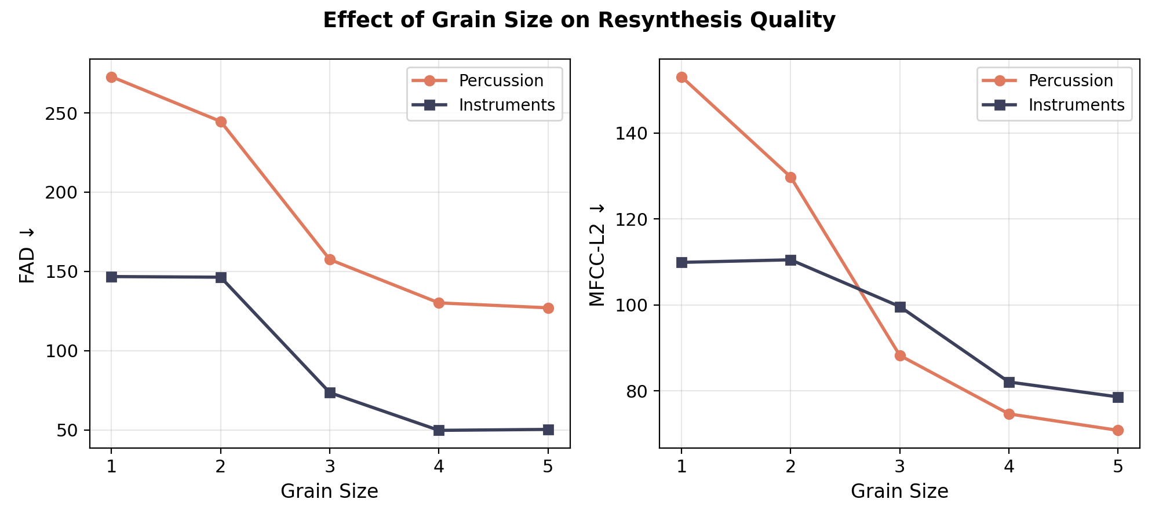

Stride
Stride is the second-strongest parameter. Smaller stride refreshes matches more frequently, keeping the output close to the target's structure. Larger stride extends grains over longer spans, increasing timbral consistency at the cost of onset alignment artifacts.

Stride | Percussion FAD | Instrument FAD
1 | 154.6 | 57.1
2 | 181.6 | 99.0
3 | 211.6 | 130.6

Stride = 1 is consistently optimal for both categories. The effect is larger for instruments, where stride = 3 more than doubles FAD relative to stride = 1.

Window Size
Window size has a mild, non-monotonic effect on FAD. For percussion, FAD is lowest at window = 1; for instruments, the same holds. Larger windows add local temporal context but reduce sensitivity to sharp transient events, which can hurt percussion matching. The non-monotonic shape, FAD dipping at window=4 for percussion before rising again, this suggests that the optimal window size is likely pair-specific rather than a universal setting.

Window | Percussion FAD | Instrument FAD
1 | 165.3 | 87.5
3 | 189.2 | 97.0
5 | 203.1 | 99.5

Pool Augmentation
Augmentation expands the pool with pitch- and gain-shifted variants, multiplying codebook size by up to 8×. The aggregate results show a clear category split:
For percussion, augmentation reduces FAD (186.4 → 178.8) while slightly increasing MFCC-L2 (103.3 → 106.7). This is inconsistent with the Tokui paper which could mean the latent space of Encodec does not really meaningfully encode these transformed characteristics compared to music2latent which was used in the original implementation.
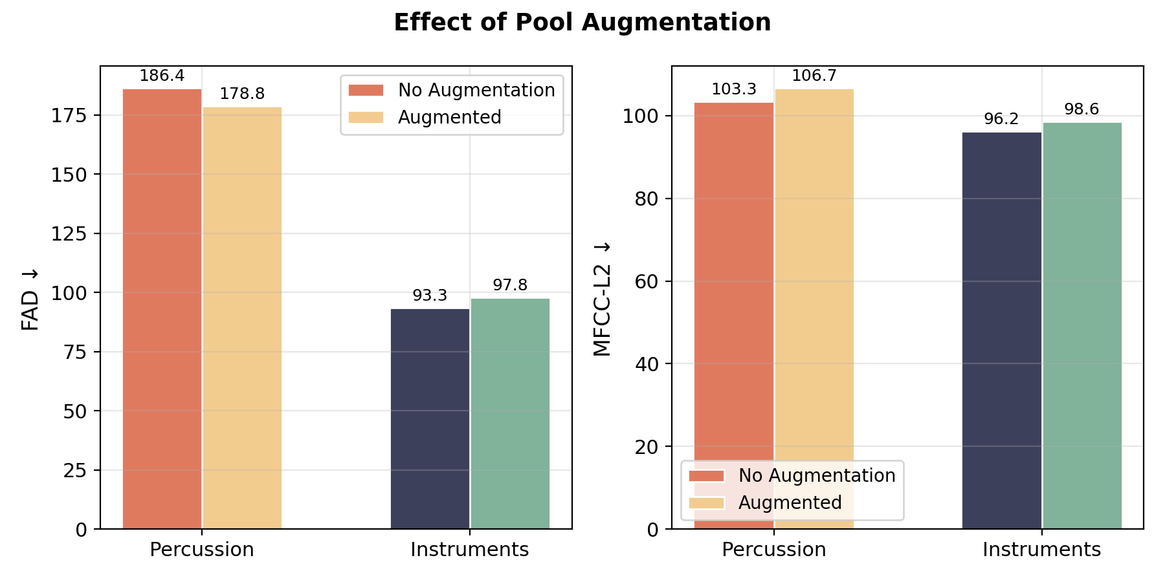
For instruments, augmentation worsens both metrics on average. A plausible cause is that harmonic material is sensitive to the harmonic distortions introduced by pitch shifting, the augmented candidates are acoustically plausible but harmonically incorrect.

Metrics vs. perception: informal listening on violin → saxophone transfer suggests that augmented outputs sound more pitch-coherent to the ear, even as FAD and MFCC-L2 worsen in aggregate. Both observations can be simultaneously true: augmentation may produce more pitch-consistent grain selection on specific pairs while worsening average distributional statistics across the full dataset. This discrepancy is consistent with known limitations of FAD and MFCC-L2 as perceptual proxies, and motivates CLAP-based evaluation as future work.

Latent Space Analysis
PCA visualisation of the amen → tabla transfer reveals a geometrically meaningful picture: target and pool latents occupy clearly distinct regions of the 128-d space. After windowed matching, the assembled hybrid latents concentrate near the pool region rather than interpolating between the two, consistent with the interpretation that nearest-neighbour replacement is a projection onto the pool's latent vocabulary rather than a smooth interpolation through the space.
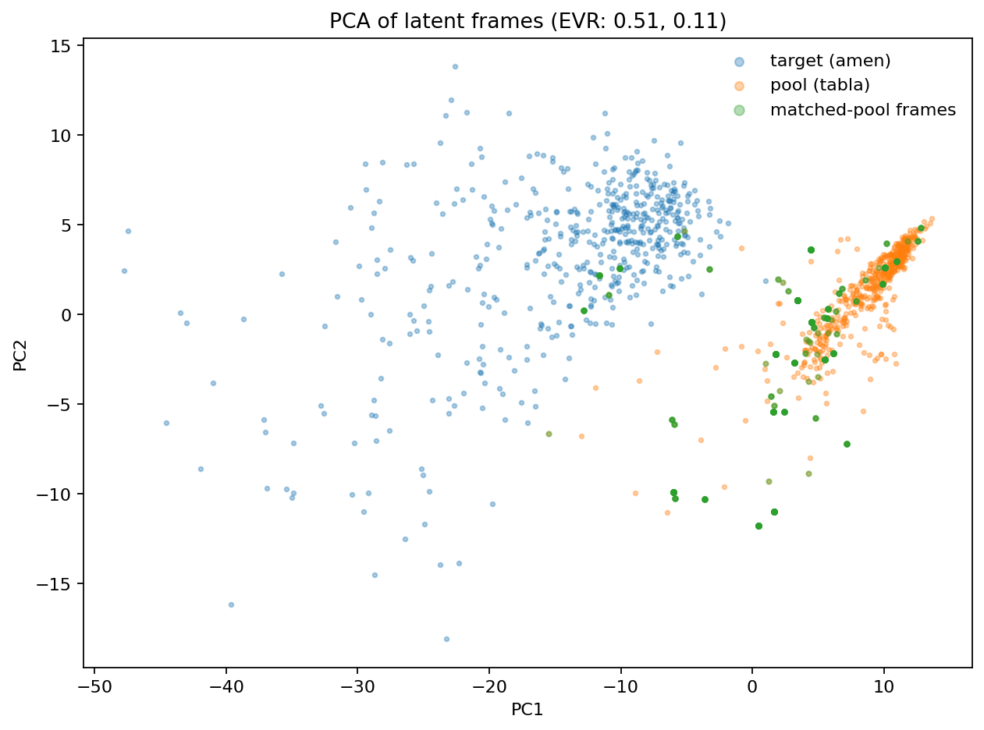

Conclusion
We have presented a windowed latent matching system for granular audio resynthesis in the 128-dimensional latent space of Encodec, evaluated across 10,800 parameter configurations on percussive and instrumental material.
The main findings are:
- Grain size and stride dominate. Both categories are most sensitive to these two parameters. Large grains (4–5) and stride = 1 are optimal for instruments. For percussion, stride = 1 is essential but grain size involves a perceptual trade-off with transient sharpness.
- Window size and hop are secondary. Both show mild, non-monotonic effects. They should be treated as per-pair tuning parameters rather than global settings.
- Augmentation is category-specific. It reduces percussion FAD slightly but worsens both metrics for instruments in aggregate, while informal listening suggests it can improve pitch coherence perceptually, a disconnect that motivates more perceptually grounded evaluation metric.

Future Work
- Semantic matching via CLAP: replacing cosine similarity with CLAP embeddings would enable matching by perceptual similarity rather than geometric proximity in codec space, and would provide a more perceptually grounded evaluation metric.
- Perceptual & Sample Evaluation: the evaluation done is not very perceptual as seen in several examples where the metrics disagree with human assessment, We also see that the audio used to make the pool greatly impacts the output, it would be interesting to evaluate both perceptual metrics and the effects of using different audio samples.
- RVQ layer crossover: taking structural RVQ layers (capturing pitch and rhythm) from one source and textural layers from another could decouple temporal structure from timbre more surgically than full-latent replacement.
- Broader sound categories: extending to voice, environmental sound, and noise textures would test the generality of the percussion/instruments findings.

References
1. Tokui, N. (2024). Latent Granular Resynthesis with Neural Audio Codecs. arXiv:2507.19202.
2. Schwarz, D. (2006). Concatenative Sound Synthesis: The Early Years. Journal of New Music Research, 35(1), 3–22.
3. Schwarz, D. (2013). Corpus-based concatenative synthesis: current state of the art. Proceedings of the DAFx Conference.
4. Bitton, A., Esling, P., & Chemla-Romeu-Santos, A. (2020). Neural Granular Sound Synthesis. arXiv:2008.01393.
5. Tatar, K., Bisig, D., & Pasquier, P. (2021). Latent Timbre Synthesis. Neural Computing and Applications, 33, 67–84.
6. Défossez, A., Copet, J., Synnaeve, G., & Adi, Y. (2022). High Fidelity Neural Audio Compression. arXiv:2210.13438.
7. Kumar, R. et al. (2023). High-Fidelity Audio Compression with Improved RVQGAN. NeurIPS.
8. Pasini, M. & Schlüter, J. (2024). Music2Latent: Consistency Autoencoders for Latent Audio Compression. arXiv:2408.06500.

