PUNE INSTITUTE OF COMPUTER TECHNOLOGY
DHANKAWADI, PUNE – 43.

List OF LAB EXPERIMENTS

ACADEMIC YEAR: 2016-2017

Date: 15/12/2016

DEPARTMENT: COMPUTER ENGINEERING

CLASS: S.E. SEMESTER: II

SUBJECT: Computer Graphics Laboratory

LAB EXPT.NO | PROBLEM STATEMENT
Group A
A1 | Write C++ program to draw the following pattern using Line drawing algorithms. Use Bresenham’s line drawing algorithms for square and DDA line drawing algorithm for diamond.  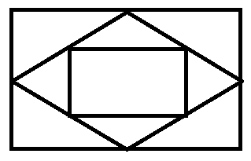
A2 | Write C++ program to draw inscribed and Circumscribed circles in the triangle as shown in an example below. Use Bresenham’s Circle drawing algorithm for outer circle and DDA circle for inner circle. Use any Line drawing algorithm for drawing triangle  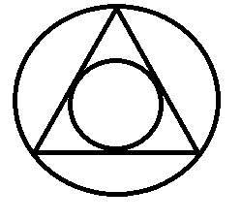
A3 | A Mandelbrot Set is a set of complex number z that does not diverge under the transformation with .Where, both X and z represent the complex numbers. Write Java program to  a) Plot the Mandelbrot set for the threshold |x|= 2.  b) Plot Julia set choosing z ≠ 0. Use 254 colors for plotting in both cases.
A4 | Write Java program to draw 2-D object and perform following basic transformations,  a) Scaling  b) Translation  c) Rotation  Use operator overloading.
A5 | Write C++ program to draw the polygons by using the mouse. Choose colors by clicking on the designed color pane. Use window port to draw. Use DDA algorithm for line drawing.
Group B
B1 | Write C++/ Java program for line drawing using DDA or Bresenham’s algorithm with patterns such as solid, dotted, dashed, dash dot and thick.
B2 | Write C++/Java program to draw a convex polygon and fill it with desired color using Seed fill algorithm. Use mouse interfacing to draw polygon.
B3 | Write C++/Java program to implement Cohen-Sutherland line clipping algorithm for given window. Draw line using mouse interfacing to draw polygon
B4 | Write C++/Java program to implement reflection of 2-D object about X axis, Y axis and about X=Y axis. Also rotate object about arbitrary point given by user.
B5 | Write Java program to generate Hilbert curve using concept of fractals.
Group C
C1 | Write C++/Java program to draw 3-D cube and perform following transformations on it using OpenGL. a) Scaling b) Translation c) Rotation about one axis.
C2 | Write C++/Java program to simulate any one of or similar scene-  - Clock with pendulum  - National Flag hoisting  - Vehicle/boat locomotion  - Water drop falling into the water and generated waves after impact  - Kaleidoscope views generation (at least 3 colorful patterns)

Head of Department Subject Coordinator
(Computer Engineering) (Ms. Geetanjali V Kale)

