Verified-at-Target Moving Target Defense for Hospital IoMT-to-Cloud Infrastructure: An Attacker-Side Evaluation and the Silent Failure Modes of Learned Defenses
Sangavi S, N Suha, N Meghana, Dr Mithun D Souza, Dr Kavitha S Department of Computer Science, CHRIST (Deemed to be University), Bengaluru, India
Abstract—Hospital IoMT-to-cloud pipelines run on fixed IP addresses, ports, API paths and MQTT topics, so an attacker can map them once and exploit them weeks later. Moving Target Defense (MTD) keeps these properties changing, and recent work drives the changes with reinforcement learning (RL). We present GhostNet, an MTD system in which a single learned policy mutates both the cloud and the medical-IoT attack surface of a hospital pipeline, executes each mutation against real infrastructure (AWS security groups and a live MQTT broker), and confirms it at the target rather than trusting an API return code. Our central finding is methodological: a learned MTD can appear to work while providing no defense, and the only reliable guard is end-to-end verification. We evaluate against a simulated reconnaissance-and-exploit attacker that invalidates its own progress when a surface it has mapped is moved, which lets us measure the outcome a defender cares about — attacker break-ins and dwell time — instead of agreement with a hand-labeled action. Across ten training seeds per method, a learned policy stops break-ins no better than a one-line greedy heuristic (0.69 vs 0.88 break-ins per episode; difference not significant) but disrupts the hospital 13% less, a gap that holds under every environment perturbation we tested. We document three ways a learned MTD fails silently: a collapsed policy indistinguishable from no defense yet still logging actions (also reproduced in 5 of 10 A2C seeds); over-reliance on a single action whose modeled effect, if optimistic, triples break-ins with no external symptom; and a relocated rendezvous point that strands the device it protects. For the last we give GMCP, a signed, two-phase coordination protocol that eliminates stranding under message loss and rejects forged, replayed and tampered control commands. We argue that verification at the target, the device and the attacker's side — not the choice of RL algorithm — is what makes such a system credible.
Keywords—Moving Target Defense; Reinforcement Learning; Healthcare IoT Security; Verified Execution; Adversary Emulation; MQTT

I. Introduction
Medical IoT devices sit at the center of clinical workflows: infusion pumps, monitors and imaging systems stream telemetry to cloud-connected platforms. This connectivity improves care but widens the attack surface into a setting where an intrusion threatens patient safety, not only finances. Recent healthcare incidents have followed the same pattern of ransomware and data theft against static, mappable infrastructure.
The clinical environment stays static largely because it is safety-critical and hard to change: cloud instances keep fixed public addresses, security groups keep long-lived ports open, REST endpoints keep stable paths, and MQTT brokers keep unchanging topics. Because none of this moves, an attacker can scan, fingerprint and map the environment at leisure, and reconnaissance gathered weeks ahead stays valid until exploitation. The exposure is compounded by unsupported software: an industry census of connected medical devices found 14% running an unsupported or end-of-life operating system [1].
Moving Target Defense (MTD) counters this by continuously reconfiguring system properties so an attacker's map expires before it can be used. A growing line of work selects MTD actions with reinforcement learning rather than a fixed schedule [2], [3], [4], [5]. Most of it, however, is evaluated in simulation or on one domain, and reports how often the learned policy takes a "correct" action rather than whether an attacker was actually slowed. That gap motivates this paper.
We present GhostNet, an MTD system for the hospital IoMT-to-cloud pipeline. A single policy mutates both cloud infrastructure and IoT messaging, executes each mutation against live AWS and a live MQTT broker, and verifies it at the target. Building and stress-testing it surfaced a set of results that we believe matter more than the system itself. Our contributions are:
1. An attacker-side evaluation of learned MTD. We place a reconnaissance-and-exploit attacker inside the environment, so a mutation genuinely invalidates the attacker's knowledge, and report break-ins, dwell time and forced rescans. Under this measure, across ten training seeds per method with paired confidence intervals, a learned policy does not stop more break-ins than a greedy heuristic, but consistently disrupts the hospital less.
2. Three silent failure modes of learned MTD, each measured. (i) Policy collapse yields a defense statistically indistinguishable from none yet still selecting actions and logging mutations; we reproduce it both from a reward defect and, independently, in 5 of 10 A2C seeds. (ii) Over-reliance on a single high-value action: if that action's real effect is weaker than modeled, break-ins rise from 0.69 to 4.04 per episode with no external symptom, and training under uncertainty about the action's effect cuts this to 1.29. (iii) A relocated rendezvous point strands the device it protects.
3. GMCP, a mutation-coordination protocol for the IoT domain. Signed, sequence-numbered, two-phase and make-before-break, it removes device stranding under control-message loss and rejects forged, replayed and tampered commands, addressing the availability and authentication gaps of the naive scheme.
4. A verified dual-domain execution layer. Every mutation is re-read at the target — a security-group query, a host-firewall membership check, or live telemetry on a rotated topic — and recorded in a ledger separating intent from confirmed effect, with automatic rollback of anything unconfirmed.
We also report honestly what is not yet real: two of six mutation actions change only a tag or a local file, broker relocation is gated off by default, and the adversary-emulation integration drives the attack sequence by reproducible replay rather than live execution. We argue this precision is what makes the rest credible.
II. Related Work
A. Reinforcement Learning for Moving Target Defense
Yoon et al. proposed DESOLATER, a deep-RL framework that jointly learns resource allocation and MTD deployment, weighing security benefit against cost [2]. Huertas Celdrán et al. used RL with behavioral fingerprinting to select MTD mechanisms against zero-day attacks on single-board IoT devices [3], and Feng et al. extended this to a federated setting [6]. Eghtesad et al. framed adaptive MTD as a two-player game solved with adversarial deep RL [4], and Zhang et al. applied deep RL to host-address mutation that disrupts reconnaissance while preserving live connections [5]. These works establish that a learned policy can outperform a fixed schedule. GhostNet differs in three respects: it spans cloud and IoT in one policy, it executes against live infrastructure with verification at the target, and — most relevant to our findings — it is evaluated by attacker outcome rather than action-label agreement, which is what exposes the failure modes of Section VI.
B. Healthcare Cyber-Physical System Security
Healthcare environments combine medical devices, imaging systems and connected services that must stay available for clinical use. Industry analyses document the difficulty of inventorying and securing these devices and the prevalence of unsupported operating systems [7], [1]. Conventional patching is constrained because device changes require clinical testing and coordination, which motivates defenses that change exposed network properties without depending on patching.
C. Cloud Moving Target Defense
Torquato and Vieira surveyed cloud MTD and identified VM migration and IP shuffling as common mechanisms, noting that multi-layer MTD and standard evaluation methods remain open problems [8] — gaps this paper speaks to with a dual-domain system and an outcome-based evaluation. Park et al. proposed Ghost-MTD, mutating the application protocol with a pre-shared one-time bit sequence and redirecting non-conforming traffic to a decoy, at 3.28–4.97% overhead [9]; GMCP (Section V) likewise authenticates a mutating control channel but targets device coordination and availability rather than deception. Alavizadeh et al. evaluated combined shuffle/diversity/redundancy MTD on cloud models including an e-health context, under both security and economic metrics [10].
D. Adversary Emulation for Security Evaluation
MITRE ATT&CK provides a shared taxonomy of adversary techniques [11], and CALDERA, from MITRE's work on automated red-team emulation [12], applies it for automated assessment; structured ATT&CK-aligned red-teaming has been argued to make assessment more realistic [13]. Emulators cover an environment unevenly in practice, however: a 1,700-hour cyber-range study found CALDERA discovered 27% of machines and compromised 7% [14]. GhostNet therefore uses CALDERA to define and drive the adversary but compares defense policies on a deterministic replay of an ATT&CK sequence, so every policy faces an identical, reproducible attack (Section V-C, VI-A).
E. Research Gap
Prior work addresses RL-driven MTD, healthcare device exposure, and adversary emulation largely in isolation, and evaluates learned MTD by how often it selects a labeled action. We are not aware of a system that unifies dual-domain mutation, verified-at-target execution, and an attacker-outcome evaluation on a hospital IoMT-to-cloud pipeline, nor of a study that characterizes how such a learned defense fails silently. GhostNet addresses that combination.
III. Threat Model and System Architecture
A. Threat Model
We consider an external, unauthenticated adversary seeking to disrupt or manipulate the infusion-pump-to-cloud pharmacy pipeline, proceeding through reconnaissance, initial access, lateral movement, command-and-control and impact, consistent with ATT&CK tactic ordering. The adversary continuously scans to map surfaces; a surface becomes exploitable once sufficiently mapped, an exploit takes non-zero time to land, and relocating a surface after the adversary has mapped it invalidates that knowledge and forces a rescan. The defender does not observe the attacker directly; it sees a noisy intrusion-detection estimate of per-surface exposure. The defender's objective is not to prevent every technique but to invalidate reconnaissance so that later stages fail or cost more. Insider threats, supply-chain compromise and physical tampering are out of scope. We note that the unauthenticated control channel of the deployed broker is itself within this model: anyone able to publish on it could redirect the pump — the motivation for GMCP.
B. System Architecture
Fig. 1 shows the architecture. A simulated ESP32-class infusion pump streams telemetry over MQTT to a Mosquitto broker on an AWS EC2 instance. A threat-state engine combines live threat intelligence and IDS-estimated exposure into a 12-dimensional state vector. A single learned policy maps the state to one of seven actions (six mutations and hold) and dispatches it to a cloud executor (AWS SDK) or an IoT executor (an authenticated SSH session and an MQTT control channel that, in the deployed broker, is unauthenticated until GMCP secures it at the message layer, Section V-C). Each executor applies the mutation to live infrastructure and re-reads the target to confirm it; a mutation ledger records old value, new value and confirmation, supplies the current live configuration back to the executors, and rolls back anything unconfirmed. A separate evaluation path drives a MITRE CALDERA operation and a replayed ATT&CK kill chain.
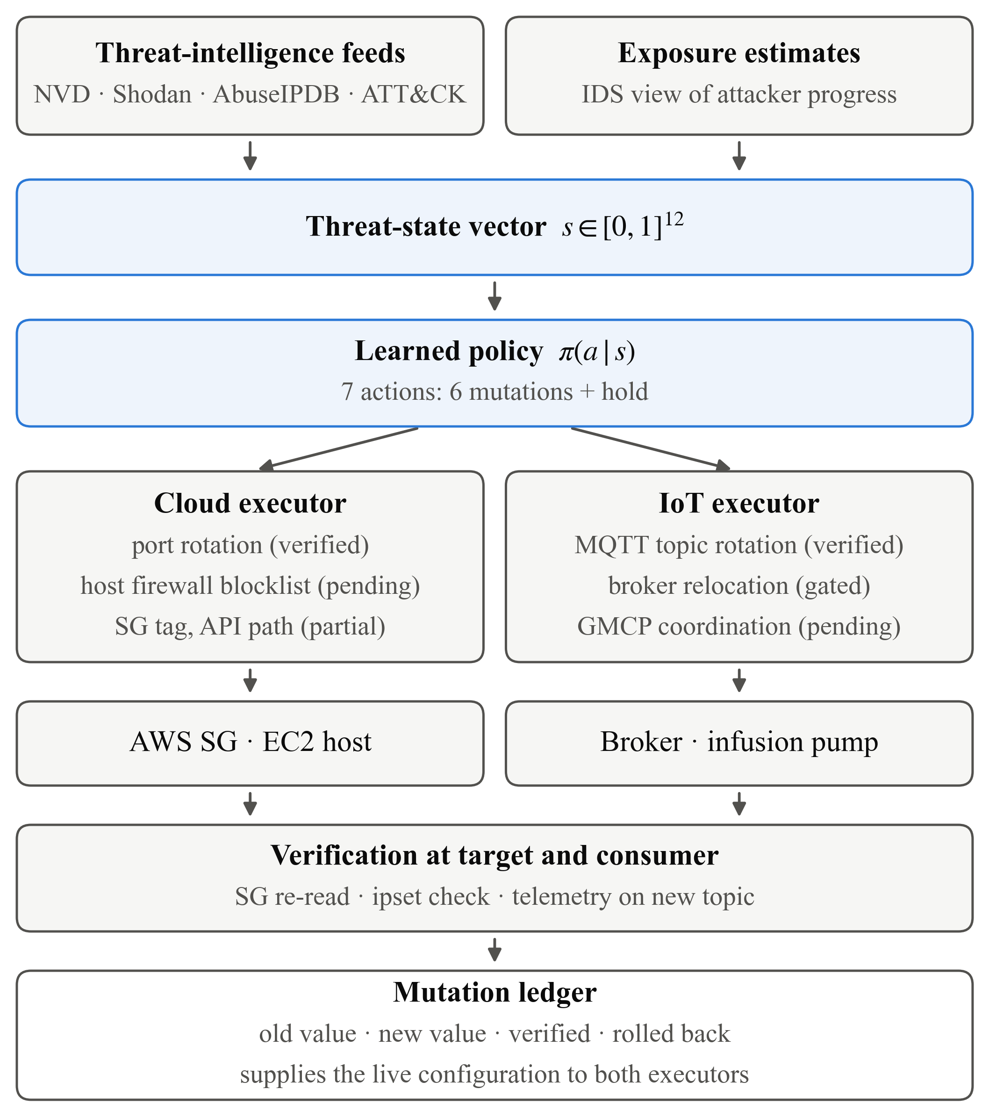
Fig. 1 GhostNet architecture
IV. Methodology
A. Problem Formulation
We model defense as a Markov Decision Process (S, A, P, R, γ). The state S ⊆ [0,1]¹² encodes attack-surface exposure and threat conditions; the action set A = {0,…,6} is six surface mutations plus a hold action; γ = 0.99. The policy π(a|s) maximizes the expected discounted return E[Σₜ γᵗ R(sₜ,aₜ)]. Actions are chosen from the current state rather than on a fixed schedule.
B. Threat-State Representation
The 12-dimensional state (Table I) comprises five surface-exposure dimensions (0–4), four live threat-intelligence dimensions (5, 6, 10, 11) from NIST NVD, Shodan, AbuseIPDB and MITRE ATT&CK, and three network/timing dimensions (7–9). All values are normalized to [0,1]. Threat-intelligence values are sampled per episode so the policy learns to read them rather than memorize one constant.
TABLE I
Threat-State Vector Dimensions
Idx | State dimension | Source
0 | Cloud IP exposure | Derived
1 | Open ports | Derived
2 | API exposure | Derived
3 | IoT gateway IP exposure | Derived
4 | MQTT exposure | Derived
5 | CVE severity | NIST NVD (live)
6 | Exposed services | Shodan (live)
7 | Traffic load | Network
8 | Recon attempts | Network
9 | Time since mutation | Internal
10 | IP reputation | AbuseIPDB (live)
11 | ATT&CK relevance | MITRE (live)

C. The Evaluation Environment
A defense that is only scored on whether it picks a "correct" action can score well without slowing an attacker. We therefore evaluate in an environment where the attack is part of the dynamics (contributions 1–2 depend on this):
• In-world attack. During each kill-chain stage, the active technique raises the exposure of the surfaces it targets; a mutation resets the chosen surface's exposure, genuinely setting the attacker back.
• Reconnaissance that regrows. Exposure rises again from continued scanning, so mutation timing matters and a moved surface does not stay safe for free.
• An attacker with memory. When a surface's exposure reaches a launch threshold the attacker begins an exploit that lands after a fixed delay; moving that surface first makes the attempt fail (recon invalidated). A foothold persists until the surface is moved. These states are hidden from the defender.
• Partial observability. The defender sees exposure through Gaussian IDS noise.
• Outcome reward. Reward is the negative of a weighted sum of mean exposure, hot surfaces, compromised surfaces, and the clinical disruption each action causes — no term rewards matching a label.
Environment constants (attacker speed, exploit delay, IDS noise, the firewall action's modeled effect) were frozen using only the rule-based baselines of Section VI-A, before any agent was trained, and never retuned afterward; Section VI-D reports sensitivity to them.
D. Dual-Domain Action Space and the Reality of Each Action
The six mutations and their execution status are listed in Table II. We state plainly that only two change live infrastructure today: port rotation (cloud) and MQTT topic rotation (IoT). The host-firewall blocklist (action 5) is implemented against the live host but its end-to-end validation is pending; broker relocation (action 3) is gated off by default because it affects every device on the segment; cloud-IP identity (action 0) writes a security-group tag and API-path rotation (action 2) writes a local mapping file. This distribution is itself a subject of Section VI.
TABLE II
Dual-Domain Action Space and Execution Status
# | Mutation | Domain | Status
0 | Rotate cloud IP identity | Cloud | Partial (SG tag)
1 | Rotate open port | Cloud | Verified (live)
2 | Rotate API path | Cloud | Partial (local file)
3 | Rotate IoT gateway / broker | IoT | Gated (off by default)
4 | Rotate MQTT topic | IoT | Verified (live)
5 | Update firewall (blocklist) | Cloud | Pending live test
6 | Hold (no mutation) | - | n/a

E. Reward Design and Two Collapse Modes
Early reward formulations caused policy collapse, and the diagnosis is a result in its own right (Section VI-B). A first version scored an action by exposure after mutation; because the post-mutation value was effectively random, every action earned the same expected reward and the policy collapsed to a single action. A second version valued the broad firewall action by maximum rather than mean surface exposure, giving it a standing advantage and again collapsing the policy onto it. The present environment (Section IV-C) scores by pre-mutation exposure and outcome, removing both degeneracies.
F. Training Configuration
Policies are trained with PPO [15] in Stable-Baselines3 [16] on a Gymnasium environment [17] (Table III). To separate real effects from seed luck we train ten independent seeds per method and report the mean and a 95% confidence interval across seeds; the policy kept is the one at the end of training, with no best-checkpoint selection, so the test set cannot leak into model choice. The same protocol trains two rival algorithms, DQN [18] and A2C [19], and two ablations (threat feeds hidden; hold action removed). Training uses randomly ordered technique sequences; the fixed AIIMS-style chain used for testing is never seen in training.
TABLE III
PPO Training Hyperparameters
Parameter | Value
Learning rate | 3 x 10^-4
Rollout length | 2048 steps
Mini-batch size | 64
Discount factor | 0.99
Entropy coefficient | 0.02
Seeds per method | 10
Timesteps per seed | 300,000
Rivals | DQN, A2C (SB3 defaults)

V. Implementation
A. Cloud Mutation and Verification
Cloud mutations run through the AWS SDK against a live EC2 security group. Success is never inferred from the API response: after each mutation the security group is re-read and compared against intent. This is a requirement, not a diagnostic — an earlier implementation reported success for operations that only wrote local files. Port rotation opens the new port, verifies it, closes the old one and verifies again, holding the open-port count constant. The host-firewall action loads the current AbuseIPDB high-confidence blocklist into a host ipset matched by one iptables rule, swaps it atomically, and verifies entry count and sample membership on the host; an unchanged blocklist is reported as no-change rather than as a mutation. A mutation ledger records, per mutation, the previous value, the new value and whether an independent re-read confirmed it; it supplies the live configuration so a rotation acts on the port actually in use, and flags unconfirmed mutations for rollback.
B. IoT Mutation
IoT mutations use two channels. Topic rotation publishes a control message to the device's command topic; the device switches its publication topic at runtime, and rotation is confirmed only when telemetry appears on the new topic on an independent subscription — publishing alone is not treated as evidence. Broker-port migration rewrites the listener configuration over SSH and restarts the service. Because the control channel runs on the broker, the broker cannot announce its own relocation after moving; the naive scheme publishes one relocation notice on the old listener before moving. Section VI-E measures the failure of this scheme and Section V-C gives the protocol that fixes it. Because a relocation affects every device on the segment, the action is gated off by default; the policy may select it, and the executor declines it unless explicitly enabled.
C. GMCP: Mutation-Coordination Protocol
GMCP replaces the single unacknowledged notice with four rules. (1) Authenticated — every control message carries an HMAC-SHA256 tag [20] under a per-device key; unauthenticated messages are dropped. (2) Fresh — a monotonic sequence number and a timestamp defeat replay and stale messages. (3) Two-phase — a prepare/commit exchange with bounded retries; if prepare is never acknowledged the change is aborted and nothing moves, and retries are idempotent. (4) Make-before-break — the new rendezvous is opened before the device moves and the old one is closed only after telemetry is confirmed on the new one, so a device that fails to move falls back to the still-open old listener. The same signed, sequenced exchange is applied to topic rotation.
D. Adversary-Emulation Bridge
The bridge connects to a CALDERA 5.0.0 server over its REST API, creates an operation, and maps each executed ATT&CK technique to the state dimensions it affects — e.g. network service discovery (T1046) raises open-port and reconnaissance exposure, application-layer C2 (T1071) raises MQTT exposure, and data-encrypted-for-impact (T1486) raises all five surfaces. This technique-to-state table is an author-defined modeling choice, published in full and used identically by every component. What is live and what is replay is stated in Section VI-A.
VI. Results and Evaluation
Unless noted, results are on the nine-stage chain (T1046, T1190, T1078, T1021, T1071, T1041, T1565, T1486, T1489; ten steps per stage), over 50 seeded games; learned methods are averaged over ten training seeds with a 95% CI across seeds, and rules over a 95% CI across games. Per-game paired differences between methods use a 10,000-sample bootstrap; "significant" means the 95% interval excludes zero.
A. Live Feeds and the CALDERA Integration
All four feeds returned live data: NVD 15–20 CVEs per query with peak CVSS 8.8–9.8 (normalized 0.88–0.98, varying across cycles); Shodan 0.003–0.004; AbuseIPDB saturating at 1.000; ATT&CK 0.033. The bridge drove a real CALDERA operation through the API (created and closed; operation id in the run log). Because the adversary profile carries no executable abilities, CALDERA executed no techniques in this run; the integration path is validated, not live execution, and all policy comparisons use the deterministic replay described above. We make no claim of live execution of the full chain.
B. Policy Collapse as a Silent Security Failure
Under the defective reward, mean episode reward stayed flat and explained variance never left zero; action sampling showed a single action chosen on 30 of 30 sampled states. The resulting policy leaves the network critically exposed on essentially every step — indistinguishable from no defense — while still selecting actions, executing mutations and returning rewards. Nothing external distinguishes it from a working defense. We observe the same pattern independently in a rival algorithm: 5 of 10 A2C seeds exceed a 90%-single-action collapse threshold (Section VI-C), confirming collapse is a property of learned MTD under these conditions, not of one run.
C. Attacker-Outcome Comparison
Table IV reports the main comparison. A no-defense control is breached on 5.0 of 5 attacker attempts and the attacker holds a foothold 94.9% of the time. Among non-learning policies, round-robin rotation (classical fixed-schedule MTD) reduces break-ins to 3.00 per game but still allows them, while a greedy "move the most-exposed surface" rule reduces them to 0.88. The learned PPO policy reaches 0.69 break-ins; the paired difference from greedy is not significant (−0.19, 95% CI [−0.44, +0.05]), so we do not claim the learned policy stops more break-ins than a one-line rule. What it does do significantly is act less often on a hot surface (attacker-launch opportunities 2.33 vs 4.48, significant) and disrupt the hospital less (3.61 vs 4.15, significant). DQN matches PPO (0.72 break-ins). The original single-run model from the pre-registration evaluation, run in this environment, allows 4.12 break-ins and 37.1% dwell — worse than round-robin — which is why an attacker-side evaluation matters.
TABLE IV
Attacker-Outcome Comparison on the Nine-Stage Chain
Policy | Attacks | Breaches | Inside % | Disrupt. | Reward
Static (no defence) | 5.0 | 5.00 | 94.9 | 0.00 | -453.6
Round-robin MTD | 13.9 | 3.00 | 3.4 | 4.09 | -20.5
Greedy (most exposed) | 4.5 | 0.88 | 1.2 | 4.15 | -13.5
PPO (ours) | 2.3 | 0.69 | 1.3 | 3.61 | -9.8
DQN | 2.7 | 0.72 | 1.1 | 3.45 | -9.6
A2C | 1.1 | 0.87 | 10.1 | 3.61 | -20.1
PPO, robust (ours) | 4.1 | 0.92 | 1.4 | 3.80 | -11.5
PPO v2 (prior model) | 5.7 | 4.12 | 37.1 | 4.62 | -67.7
Learned policies: mean over 10 training seeds. Lower is better except Reward. The PPO-vs-Greedy breach difference is not significant.
D. Robustness and Over-Reliance on One Action
The learned policies place 51–68% of their decisions on the firewall action (ablations and rivals similarly), so their security depends on that action's modeled effect. Fig. 2 re-tests the same trained policies as that effect is weakened. When the firewall action is made ineffective, PPO break-ins rise from 0.69 to 4.04 per game — worse than round-robin — while the greedy rule, which never uses it, is unchanged at 0.88. This is a silent failure: in the nominal environment the policy looks excellent. Training under uncertainty about the action's effect (domain randomization over its strength [21]) reduces the worst case to 1.29 break-ins at a small nominal cost (0.92 vs 0.69). The robustness sweep also surfaced one regime where learning helps on security: under the highest IDS noise (observation noise 0.20) the learned policies allowed significantly fewer break-ins than greedy (PPO 1.11 vs 1.44 per game, −0.33, 95% CI [−0.63, −0.05]; DQN 1.04), plausibly because a greedy rule chases the noisiest apparent surface while the policy has learned to discount the noise. Across all nine perturbations we tested — attacker speed, exploit delay, IDS noise, firewall effect — one property held without exception: every learned policy disrupted the hospital less than greedy.
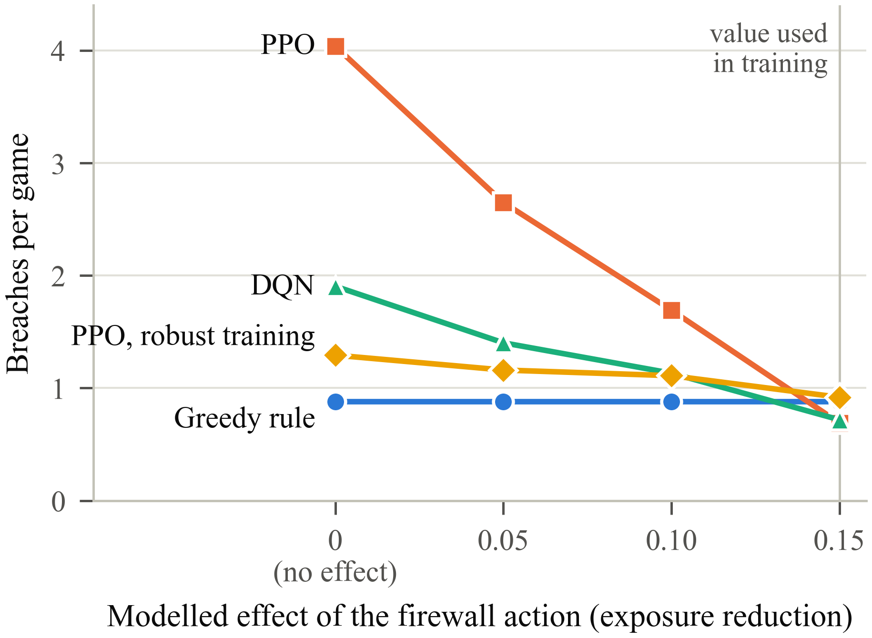
Fig. 2 breaches vs firewall effect
E. The Threat-Feed Ablation
Hiding the four threat-intelligence dimensions from the policy did not significantly change break-ins (0.62 vs 0.69, CI includes zero). We therefore do not claim that conditioning the policy on the live feeds improves security in this environment; the feeds' operational value is elsewhere — the firewall action blocks real AbuseIPDB-reported addresses. This is a negative result we report rather than omit.
F. Verified Infrastructure Mutation
In an integrated run against live infrastructure, independent re-reads confirmed every cloud and IoT mutation attempted. Port rotation moved the open mutable port across {8545→8202→8737→8288} while the protected ports (SSH, HTTPS, the MQTT listener and its websocket) and the total open-port count were held constant, confirming that repeated rotation does not expand the surface. Of the mutations in the representative run, those that changed live infrastructure were the port and topic rotations; the remainder exercised partial or gated actions, consistent with Table II.
G. Device Availability and GMCP
The naive broker relocation exposes the availability problem: in a measured run the broker moved and was verified on the new port, yet the pump, told nothing it could act on, did not reconnect within the 30-second window. Fig. 3 quantifies this over a lossy control channel in simulation. The no-notice scheme strands the device on essentially every relocation; the single-notice scheme (as deployed) strands it on 5–51% of relocations as message loss rises from 5% to 50%; GMCP strands it on none, at the cost of a few extra control messages, falling back to the old listener whenever the move is not confirmed. Against an adversary able to publish on the broker, the deployed scheme accepts forged, replayed, cancelled-then-replayed, tampered and stranding-port commands, whereas GMCP rejects all five.
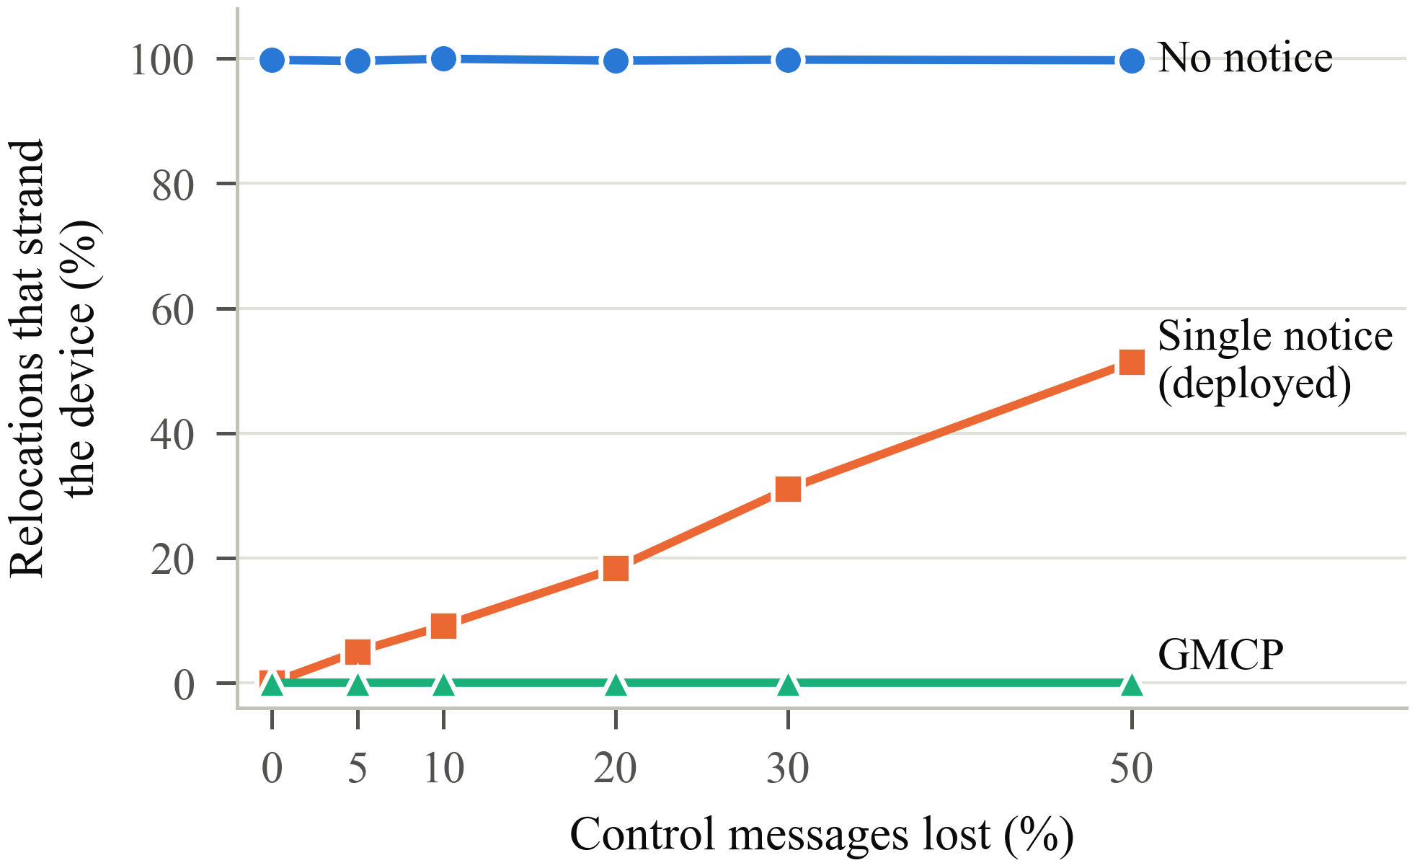
Fig. 3 device stranding vs message loss
VII. Discussion and Limitations
GhostNet shows that cloud and IoT surface mutation can be coordinated in one verified loop, and that an attacker-side evaluation changes the conclusions one draws about it. The system's honest limitations are substantial and we state them so results are not over-read.
• Two of six actions are not yet live (cloud-IP tag, API-path file); two more (host firewall, GMCP coordination) are implemented but their end-to-end live validation on EC2 is pending.
• The evaluation attacker is a model, not a live red team; the CALDERA path validates integration, and the kill chain is replay, not concurrent live execution.
• The learned policy does not beat a greedy heuristic on break-ins; its measured advantage is reduced clinical disruption and, under high IDS noise, fewer break-ins.
• Scope is one segment, one device, one cloud instance, with a simulated pump.
• The firewall action's modeled effect is an assumption; Section VI-D is the sensitivity analysis, and over-reliance on it is a documented risk.
• Three state dimensions carry little signal under current normalization (Shodan, saturated AbuseIPDB, reset timing), so the effective state is smaller than twelve.
VIII. Conclusion and Future Work
We presented GhostNet, a verified-at-target, dual-domain moving target defense for hospital IoMT-to-cloud infrastructure, and used it to argue a methodological point: a learned MTD can look like a working defense while providing none, and only end-to-end verification — at the target, the device and the attacker's side — distinguishes the two. Evaluated by attacker outcome across ten seeds per method, a learned policy did not stop more break-ins than a one-line heuristic but disrupted the hospital less; and we characterized three silent failure modes, giving a signed two-phase protocol that removes the availability failure. Future work will complete live validation of the partial actions and the host-firewall and GMCP paths on the deployment, replace the modeled attacker with a live adaptive red team, add a restore action (the environment already models exposure regrowth and a hold action) so the full mutation lifecycle is learnable, and scale beyond a single segment and device. We also intend to make cloud-IP and API-path rotation live (Elastic IP and a reverse proxy) so that every action the policy can select is executed and confirmed on real infrastructure.
Acknowledgment
The authors thank Dr Mithun D Souza and Dr Kavitha S for their guidance, and CHRIST (Deemed to be University) for supporting this work.
References
[1] Claroty Team82, "State of CPS security report: Healthcare 2023," Claroty, 2023.
[2] S. Yoon, J.-H. Cho, D. S. Kim, T. J. Moore, F. Free-Nelson, and H. Lim, "DESOLATER: Deep reinforcement learning-based resource allocation and moving target defense deployment framework," IEEE Access, vol. 9, pp. 70700-70714, 2021.
[3] A. Huertas Celdran, P. M. Sanchez Sanchez, J. von der Assen, T. Schenk, G. Bovet, G. Martinez Perez, and B. Stiller, "RL and fingerprinting to select moving target defense mechanisms for zero-day attacks in IoT," IEEE Trans. Inf. Forensics Security, vol. 19, pp. 5520-5529, 2024.
[4] T. Eghtesad, Y. Vorobeychik, and A. Laszka, "Adversarial deep reinforcement learning based adaptive moving target defense," in Decision and Game Theory for Security (GameSec), LNCS. Springer, 2020, pp. 58-79.
[5] T. Zhang, C. Xu, J. Shen, X. Kuang, and L. A. Grieco, "How to disturb network reconnaissance: A moving target defense approach based on deep reinforcement learning," IEEE Trans. Inf. Forensics Security, vol. 18, pp. 5735-5748, 2023.
[6] C. Feng, A. Huertas Celdran, P. M. Sanchez Sanchez, J. Kreischer, J. von der Assen, G. Bovet, G. Martinez Perez, and B. Stiller, "CyberForce: A federated reinforcement learning framework for malware mitigation," IEEE Trans. Dependable Secure Comput., vol. 22, no. 4, pp. 4398-4411, 2025.
[7] Armis, "Medical and IoT device security for healthcare," White Paper, Armis Inc., 2024.
[8] M. Torquato and M. Vieira, "Moving target defense in cloud computing: A systematic mapping study," Computers & Security, vol. 92, art. 101742, 2020.
[9] J.-G. Park, Y. Lee, K.-W. Kang, S.-H. Lee, and K.-W. Park, "Ghost-MTD: Moving target defense via protocol mutation for mission-critical cloud systems," Energies, vol. 13, no. 8, art. 1883, 2020.
[10] H. Alavizadeh, S. Aref, D. S. Kim, and J. Jang-Jaccard, "Evaluating the security and economic effects of moving target defense techniques on the cloud," IEEE Trans. Emerg. Topics Comput., vol. 10, no. 4, pp. 1772-1788, 2022.
[11] B. E. Strom, A. Applebaum, D. P. Miller, K. C. Nickels, A. G. Pennington, and C. B. Thomas, "MITRE ATT&CK: Design and philosophy," The MITRE Corporation, Tech. Rep., 2020.
[12] A. Applebaum, D. Miller, B. Strom, C. Korban, and R. Wolf, "Intelligent, automated red team emulation," in Proc. 32nd Annu. Computer Security Applications Conf. (ACSAC), 2016, pp. 363-373.
[13] S. Yulianto, B. Soewito, F. L. Gaol, and A. Kurniawan, "Enhancing cybersecurity resilience through advanced red-teaming exercises and MITRE ATT&CK framework integration," Cyber Security and Applications, vol. 3, art. 100077, 2025.
[14] H. Holm and L. Helgeson, "An empirical study of automated adversary emulators," in Proc. 59th Hawaii Int. Conf. System Sciences (HICSS), 2026.
[15] J. Schulman, F. Wolski, P. Dhariwal, A. Radford, and O. Klimov, "Proximal policy optimization algorithms," arXiv:1707.06347, 2017.
[16] A. Raffin, A. Hill, A. Gleave, A. Kanervisto, M. Ernestus, and N. Dormann, "Stable-Baselines3: Reliable reinforcement learning implementations," J. Mach. Learn. Res., vol. 22, no. 268, pp. 1-8, 2021.
[17] M. Towers et al., "Gymnasium: A standard interface for reinforcement learning environments," in Adv. Neural Inf. Process. Syst. 38, 2025, pp. 163114-163129.
[18] V. Mnih, K. Kavukcuoglu, D. Silver, A. A. Rusu, J. Veness, M. G. Bellemare et al., "Human-level control through deep reinforcement learning," Nature, vol. 518, no. 7540, pp. 529-533, 2015.
[19] V. Mnih, A. P. Badia, M. Mirza, A. Graves, T. Lillicrap, T. Harley, D. Silver, and K. Kavukcuoglu, "Asynchronous methods for deep reinforcement learning," in Proc. 33rd Int. Conf. Machine Learning (ICML), PMLR 48, 2016, pp. 1928-1937.
[20] H. Krawczyk, M. Bellare, and R. Canetti, "HMAC: Keyed-hashing for message authentication," RFC 2104, 1997.
[21] J. Tobin, R. Fong, A. Ray, J. Schneider, W. Zaremba, and P. Abbeel, "Domain randomization for transferring deep neural networks from simulation to the real world," in Proc. IEEE/RSJ Int. Conf. Intelligent Robots and Systems (IROS), 2017, pp. 23-30.

