**CAD_Phase5**

**Objective of the project:**

Cloud computing has been one of the most popular topics on information technology, since it was proposed by Google in 2007. In the past years, cloud computing has become from a theoretical concept into the real applications in different industries such as telecommunication and healthcare. Inevitably, its influences on different industries have also attracted much attention. Based on the literature review, this paper discussed how the traditional E-commerce businesses and industry were influenced by cloud computing in technical architecture, service modes and the industrial chain. Besides, it analyzed the driving-forces which led to the changes of E-commerce in cloud era. Finally, it concluded that only when the E-commerce enterprises involved cloud computing in the business strategy and established the core competencies, could they realize the sustainable development in the cloud era.

**Elements Of Design Thinking Applied To E-Commerce Apps**

**1. Empathize**

The first phase of design thinking is to empathize with the end-user. To succeed, designers have to understand what users want, what motivates them to use e-commerce apps and what bothers them about other e-commerce apps, along with what features are loved and what features are missing.

Many designers or businesses assume they know what customers want, but assumptions often fall short of customers' actual expectations.

Empathizing with users is the foundation of design thinking because it's what allows designers to question the norm and break traditional thought patterns.

**2. Define**

The define stage is all about organizing the information gained during the empathize stage. The point is to take the information, identify problems and define your plan from a user-centered perspective.

So many companies define the purpose of their app through business goals rather than through the user's needs. With the goal defined, designers can start to define additional problems that users want to be solved.

**3. Ideate**

Now it's time to start thinking of specific ideas that can solve users' problems. The ideate stage often includes brainstorming sessions meant to inspire creative solutions.

Designers might start by creating a list of the worst possible solutions and work to define the opposite - the best possible solutions. There are many out-of-the-box brainstorming ideas that can spark innovation, but the hope is that designers create a way to solve identified pain points.

**4. Prototype**

It's time to turn ideas into action. Designers create a prototype that addresses all of the solutions generated in the ideate stage. The prototype is typically tested on the in-house team first and may include a small subset of users as well.

With feedback from users, the design team can make adjustments before going into full testing mode.

**5. Test**

The new app design goes through rigorous testing. Testing should explore not just what users think of the app, but how they use it, when they use it, how they behave while using it. It should also explore the most popular features and glitches that are found by users.

## Top ecommerce app and online store features

Let’s dig into the **top e-commerce app features** you can implement in your app to make it **effective** and **attractive for your target audience**! These bullet points mostly can also relate to **online stores**, so if you don’t have an app for your business yet, don’t worry. Hints will be valuable for you too.

#### Sign-up and login

First of all, **every ecommerce app should enable a one-step registration process and login with their external accounts like Apple, Google, Facebook or others**. Right at the start, users should be able to enter all the necessary data to avoid doing it with each purchase. On the other hand, you shouldn’t force users to enter e.g. preferred payment method and the shipping address needed for purchase. **Let users browse products and enter data once they decide to buy something.** The app should remember the data for future purchases though!

Alternatively, you can add an “**enter as a guest**” option for those who haven’t decided to make a purchase yet.

**Remember: long registration forms might discourage customers from buying in your store**, especially mobile users. To avoid this, you should also let your customers use the email address as a login. One way or another, a trouble-free registration process is a must!

**Shopping cart**

Of course, in every ecommerce mobile app and every online store there has to be a shopping cart. **It’s a place where users can put the products they’d like to buy or compare.** In the shopping cart all the products should be visible with **photos**, **prices** and **short descriptions**. There should also be a **call to action button enabling purchase** (moving on to payment). You can also add a **progress bar**so that the user knows how many steps are ahead and can **estimate how much time the purchase will take**.

#### Easy browsing

Every e-commerce mobile app should enable really easy products browsing, without issues including **reloading errors** etc. It’s recommended to put **product pictures** and **short descriptions** on this page. On this screen users should have the**possibility to enter the product page**, **add the product to the shopping cart**, as well as to**find the search bar**, **go to the menu**with categories and **filter the results**

Platform‘s User interface

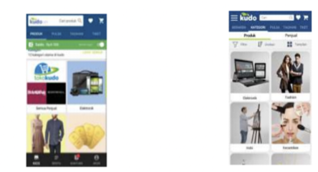

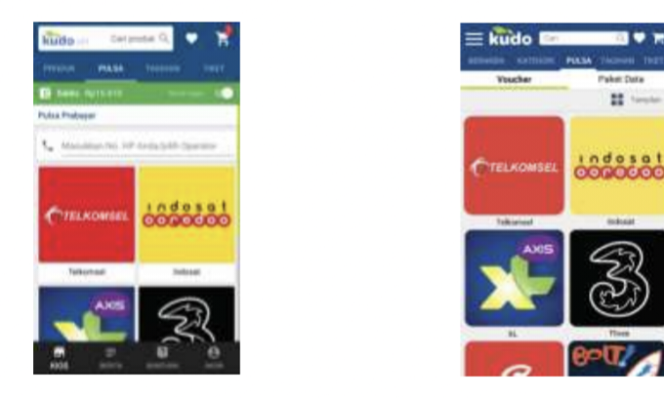

Screenshots are attached