NATIONAL UNIVERSITY OF SINGAPORE
Institute of Systems Science

PRACTICE MODULE · PROJECT REPORT
From Pixels to Provenance
Automated Galaxy Morphology Classification in HST Archival Imaging
with Cross-Catalogue Robustness Validation and Instrument-Aware Calibration
Student name | SANGEETA BAHRANI
Student ID | A0339780R
Team members | NA (individual project)
Programme | Graduate Certificate in Pattern Recognition Systems
Module | Practice Module (ISY5002)
Supervisor | Zhu Fangming
Report date | 25 October 2026
Pipeline release | 24 October 2026 (second release), 27 of 27 stages verified on real data

Hubble Space Telescope · ACS/WFC · GOODS-South · F475W · F606W · F814W
Table of Contents
Executive Summary 4
1. Introduction 5
1.1 Background 5
1.2 Why archival HST imaging is hard 5
1.3 Problem statement 5
1.4 Scope of this report 5
2. Project Objectives 6
3. Data Sources 7
3.1 HST imaging 7
3.2 Reference catalogues 7
3.3 Data governance 7
4. System Architecture 8
4.1 Software stack 8
5. Project Flow 10
6. Pipeline Stages and Outputs 12
6.1 Phase 0 — Data governance 12
Stage 0 — Sky-region partition 12
6.2 Phase 1 — Ingestion and instrument-aware preprocessing 12
Stage 1a — Archive acquisition 12
Stage 1b — Frame quality control 12
Stage 1c — Detection, deblending, registration and cosmic rays 13
Stage 1d — Cross-filter PSF matching 15
Stage 1e — Pass-1 photometry and morphology 15
6.3 Phase 2 — Unsupervised object segregation 15
Stage 2a — Representation learning and feature fusion 15
Stage 2b — Unsupervised clustering 16
Stage 2c — Baseline segregation 16
Stage 2d — Semantic audit 16
Stage 2e — Continuum handling and physical gate 17
6.4 Phase 3 — Label anchoring and three-way routing 18
Stage 3a — Galaxies: GZH label anchoring 18
Stage 3b — Stars: calibration routing 18
Stage 3c — Noise: false-positive modelling 18
6.5 Phase 5 — Optical calibration feedback 19
Stage 5a — Empirical PSF construction 19
Stage 5b — Deterministic Pass-2 refinement 19
6.6 Phase 4 — Supervised multi-task learning and ensemble 19
Stage 4c — Probability calibration 19
Stage 4d — Controlled ablation 20
6.7 Phase 6 — In-domain evaluation and explainability 20
Stage 6a — One-time test evaluation 20
Stage 6b — Uncertainty audit 21
Stage 6c — Explainability 21
6.8 Phase 7 — Cross-catalogue robustness 22
Stage 7a — Taxonomy alignment 22
Stage 7b — Cross-catalogue test 22
Stage 7c — Generalisation gap 23
6.9 Phase 8 — Unified catalogue assembly 23
7. Ensemble Architecture 24
7.1 Member 1 — Dual-branch multi-task network 24
7.2 Members 2 and 3 24
7.3 Combination and calibration 24
7.4 What the ablation says about the ensemble 24
8. Results Against the Success Criteria 26
8.1 Improvement from the review fixes 26
9. Project Challenges and Solutions 27
10. Major Components Implemented 28
11. Comparison with Existing Work 29
11.1 Source-classification literature 29
11.2 Galaxy-morphology literature 29
11.3 Where this project differs 30
11.4 Our results in the light of the literature 30
12. Limitations and Future Work 31
12.1 Limitations 31
12.2 Future work 31
13. Conclusion 32
References 33
Appendix A. Catalogue Columns 34
Appendix B. Reproducing the Run 35

Executive Summary
This report documents the complete, end-to-end implementation of From Pixels to Provenance, an instrument-aware pipeline that turns science-ready Hubble Space Telescope (HST) images into a calibrated, provenance-tracked catalogue of galaxy morphologies. The pipeline was run on real archival data: three ACS/WFC drizzled images of one GOODS-South pointing in the F475W, F606W and F814W filters, together with the Galaxy Zoo: Hubble (GZH) labels, the Gaia DR3 star catalogue and the CANDELS expert catalogue of Kartaltepe et al. (2015).
The system has 27 stages in nine phases. It governs the data before any model sees it (a spatial sky split that prevents leakage), cleans and aligns the images, separates stars, galaxies and spurious detections without labels (convolutional autoencoder + Gaussian mixture + HDBSCAN, then a physics-based gate), builds an empirical PSF from the stars it finds, trains a hybrid multi-task ensemble (ResNet-18 + physical features, EfficientNet-B0 and XGBoost) on the galaxies, calibrates its probabilities, tests it once on a held-out sky region and against an independent expert catalogue, and finally writes one catalogue of 7,516 sources × 91 columns in which every value carries its provenance.
Key results on the real GOODS-South run (24 Oct 2026)
- All 27 of 27 stages ran without manual steps; all 7 of 7 delivery checks passed; zero leakage between the train, dev and test sky regions.
- 47,448 detections in F814W, of which 40,932 were identified as cosmic-ray candidates. The final catalogue holds 3,061 galaxies, 21 stars and 4,434 noise/artefact rows, each with the reason for its class.
- A hidden 0.88″ misregistration of the F475W image was measured from 97 galaxies and removed (residual 0.000″). This raised the median F475W S/N of bright galaxies from 3 to 19.8.
- Empirical PSF from 18 stars: FWHM 0.130″, within 6 % of the PSF-matched resolution (0.139″).
- Morphology on the held-out test region (n = 38): Macro-F1 0.32 (95 % CI 0.17–0.46) against a majority-class baseline of 0.08, meeting the Minimum tier. Temperature scaling (T = 0.52) reduced dev ECE from 0.169 to 0.150; Platt scaling reduced merger ECE from 0.180 to 0.016.
- Controlled ablation: the classical-feature branch alone (dev Macro-F1 0.56) beat the hybrid (0.37) — the outcome the literature predicts when labels are scarce (only 284 GZH-labelled galaxies in one field).
- Cross-catalogue test against CANDELS: taxonomy ceiling 0.43 (κ = 0.27), cross-catalogue Macro-F1 0.05, true degradation 0.385 — separated from the labelling-scheme effect as the proposal required.

The most important engineering lesson is that single-exposure drizzled products (NDRIZIM = 2, one exposure per filter) contain no cosmic-ray rejection. About 85 % of all detections were cosmic rays, which at first corrupted registration, PSF estimation, clustering and morphology. The pipeline now detects them with a two-band confirmation test and a pixel-level sharpness test, and the report shows how each downstream stage improved as a result. The supervised scores are limited by the number of labels, not by the architecture; the clearest route to the Target tiers is more fields (more GZH labels) and multi-exposure imaging.

1. Introduction

1.1 Background
The shape of a galaxy records its history. Smooth, centrally concentrated spheroids are usually old and quiescent; discs with spiral arms are still forming stars; irregular and disturbed systems are often the result of interactions and mergers, which drive much of galaxy evolution. Morphology is therefore one of the first quantities astronomers measure for a new galaxy sample, and the Hubble Space Telescope, free of atmospheric blurring, resolves this structure out to large distances.
The difficulty is scale. Modern surveys detect millions to billions of sources, far more than experts can inspect. Citizen-science projects such as Galaxy Zoo: Hubble (Willett et al. 2017) classified about 120,000 HST galaxies by volunteer votes, but every new field still needs either human effort or a trained model. Deep-learning classifiers have since reproduced crowd votes on ground-based surveys (Dieleman et al. 2015; Walmsley et al. 2022) and expert classes on HST data (Huertas-Company et al. 2015). Most of this work, however, starts from a clean, pre-selected galaxy catalogue. An archival HST image contains stars, detector artefacts, cosmic rays and galaxies together, observed in several filters that are not perfectly aligned and that have different point-spread functions (PSFs).

1.2 Why archival HST imaging is hard
- Mixed populations. A detection list contains galaxies, foreground stars and spurious detections (cosmic rays, diffraction spikes, edge effects). A morphology classifier trained only on galaxies will still assign a morphology to a cosmic ray.
- Cosmic rays. The drizzled _drc product removes cosmic rays only when several exposures are combined. The files used here were each made from one exposure (two ACS chips, NDRIZIM = 2), so every cosmic-ray hit remains in the image.
- Multi-filter registration. The three filters were observed in different programmes (F475W in 2003; F606W and F814W in 2010). Their world-coordinate solutions can disagree by a fraction of an arcsecond, which corrupts colours.
- Wavelength-dependent PSF. The PSF is broader in red filters. Without PSF matching, colours and sizes are biased; without an empirical PSF, a compact galaxy cannot be told apart from a star.
- Few labels. Only galaxies brighter than about magnitude 23.5 have GZH votes, and only a few hundred fall in a single pointing.
- Different label schemes. CANDELS experts and GZH volunteers use different class definitions, so an external test mixes model error with taxonomy disagreement.

1.3 Problem statement
“How can we build an automated, instrument-aware pipeline that classifies galaxy morphology directly from science-ready archival HST imaging — performing its own source triage (star/galaxy/artefact) without supervision, refining morphology against an empirical instrument PSF, attaching calibrated per-object uncertainty and full data provenance, and reporting honest cross-survey generalisation by explicitly separating true model degradation from differences in human labeling schemes?”

1.4 Scope of this report
The report covers the full pipeline as implemented and verified on 24 October 2026: design, architecture, every stage with its real outputs and figures, the ensemble, results against the success criteria in the proposal, the challenges met and how they were solved, and a comparison with published work. All numbers come from the run logs and JSON summaries of that run (run_log.json, pipeline.log and the per-stage outputs).

2. Project Objectives
The proposal set five verifiable objectives. Table 1 restates them with the metric used to judge each one.
Table 1. Project objectives and how each is measured.
# | Objective | How it is measured
O1 | Reproducible, instrument-aware ingestion and preprocessing: registered, PSF-homogenised cutouts and a physical feature table, under a frozen sky partition that prevents leakage | Runs end-to-end with no manual steps; zero cross-region leakage
O2 | Unsupervised segregation of galaxies, stars and spurious detections, validated against Gaia DR3 and compared with a size–magnitude / stellarity baseline | Star precision / recall vs Gaia; galaxy recall vs GZH; comparison with Stage 2c
O3 | Supervised multi-task classifier: five morphology classes plus a merger flag; ablation shows whether the hybrid beats either representation alone | Macro-F1, merger PR-AUC, ablation Δ Macro-F1
O4 | Cross-catalogue generalisation on the CANDELS expert catalogue, separating true degradation from labelling differences | Taxonomy ceiling, cross-catalogue Macro-F1, true degradation
O5 | One provenance-tracked catalogue with calibrated probabilities and heritage flags | ECE after calibration; delivery checks

The five morphology classes follow the GZH decision tree: Smooth, FaceOnSpiral, EdgeOn, Irregular and Ambiguous (no majority path). The merger flag is a separate binary output.

3. Data Sources

3.1 HST imaging
All imaging is from the Advanced Camera for Surveys / Wide Field Channel (ACS/WFC) in the GOODS-South field (RA 53.18°, Dec −27.76°), retrieved from MAST. The pipeline uses the _drc products: drizzled onto a sky-aligned 0.05″ grid, corrected for geometric distortion and charge-transfer efficiency, with a reliable world coordinate system. Each file is a multi-extension FITS with science (SCI), weight (WHT) and context (CTX) arrays.
Table 2. The three input images (Stage 1a manifest).
Filter | Programme | Date | Exposure | NDRIZIM | AB zero-point | Size (px)
F475W (g) | 9488 | 2003-02-11 | 600 s | 2 | 26.07 | 5,079 × 5,086
F606W (V) | 11563 | 2010-11-12 | 1,231 s | 2 | 26.49 | 4,435 × 4,453
F814W (I), detection band | 11563 | 2010-11-11 | 1,225 s | 2 | 25.94 | 4,434 × 4,454

NDRIZIM = 2 with a single exposure means the two ACS chips were drizzled together but no cosmic-ray rejection was possible. This single fact drove most of the engineering in Stage 1c (Section 9).

3.2 Reference catalogues
Table 3. External catalogues and their role.
Catalogue | Reference | Role in the pipeline | Used in | Matched in this field
Galaxy Zoo: Hubble | Willett et al. 2017 | Morphology labels (vote fractions → 5 classes + merger) | 2d, 3a, 4, 6 | 284 galaxies (train 195, dev 24, test 40, buffer 25)
Gaia DR3 | Gaia Collaboration 2023 | Independent star ground truth (parallax, proper motion) | 2c, 2d, 2e, 3b | 3 stars
CANDELS visual (K15) | Kartaltepe et al. 2015 | Independent expert labels for the cross-catalogue test | 7a–7c, 8 | 428 galaxies; 68 in the test region

Positions were matched with measured catalogue offsets: GZH (+0.080″, −0.290″), CANDELS (+0.061″, −0.264″), both within a 0.5″ match radius.

3.3 Data governance
Neighbouring galaxies share pixels and sky background, so a random train/test split of objects would leak information. Stage 0 therefore splits the sky, not the objects: three stripes in RA for train / dev / test, with a 6″ collar (buffer) between them. The split rule is written once, before any model is trained, and every later stage reads it. The test region is opened exactly once, in Stage 6a.

4. System Architecture
Figure 1 (next page) shows the system architecture. The architecture is layered so that each phase consumes only frozen outputs of earlier phases. This is what makes the pipeline reproducible and leakage-free: a stage cannot change data that an earlier evaluation depended on.
Layer | Phases / stages | Responsibility
Governance | Phase 0 (Stage 0) | Sky-region partition and buffer collar, written before any model is trained
Ingestion & preprocessing | Phase 1 (1a–1e) | Read FITS, frame QC, detection and deblending, cosmic-ray identification, multi-band registration, PSF matching, Pass-1 morphology
Unsupervised segregation | Phase 2 (2a–2e) | Representation learning, clustering, baseline, semantic naming of clusters, physical gate → Star / Galaxy / Noise
Routing & optical calibration | Phases 3 and 5 | Galaxy labels, star routing to the empirical PSF, noise model; ePSF and Pass-2 morphology
Supervised learning | Phase 4 (4a–4d) | Dual-branch multi-task network, ensemble, calibration, ablation
Evaluation | Phases 6–7 | One-time test evaluation, uncertainty audit, explainability, taxonomy ceiling and cross-catalogue test
Delivery | Phase 8 | Unified catalogue (7,516 × 91), column dictionary, delivery checks
Cross-cutting | all | config.yaml (213 lines of parameters), run_log.json provenance, stage logs, frozen splits, version tag

4.1 Software stack
Area | Libraries
FITS, WCS, photometry | astropy, photutils (detection, deblending, EPSFBuilder), astroquery (MAST, Gaia, VizieR downloads)
Morphology | statmorph (Gini, M20, CAS, Sérsic, shape asymmetry), SciPy (Gaussian PSF fits, filters)
Deep learning | PyTorch, torchvision (ResNet-18, EfficientNet-B0); convolutional autoencoders written for this project
Classical ML | scikit-learn (PCA, GMM, scalers, metrics), hdbscan, XGBoost (with built-in TreeSHAP for attributions)
Data and plots | NumPy, pandas, matplotlib, PyYAML, joblib

The code base has about 6,000 lines of Python in 47 modules: a package p2p with shared modules (FITS I/O, detection, multi-band tools, morphology, catalogue matching, networks, inference) and one module per stage, a runner run_pipeline.py (with --from and --only options), and command-line tools for download and inspection.

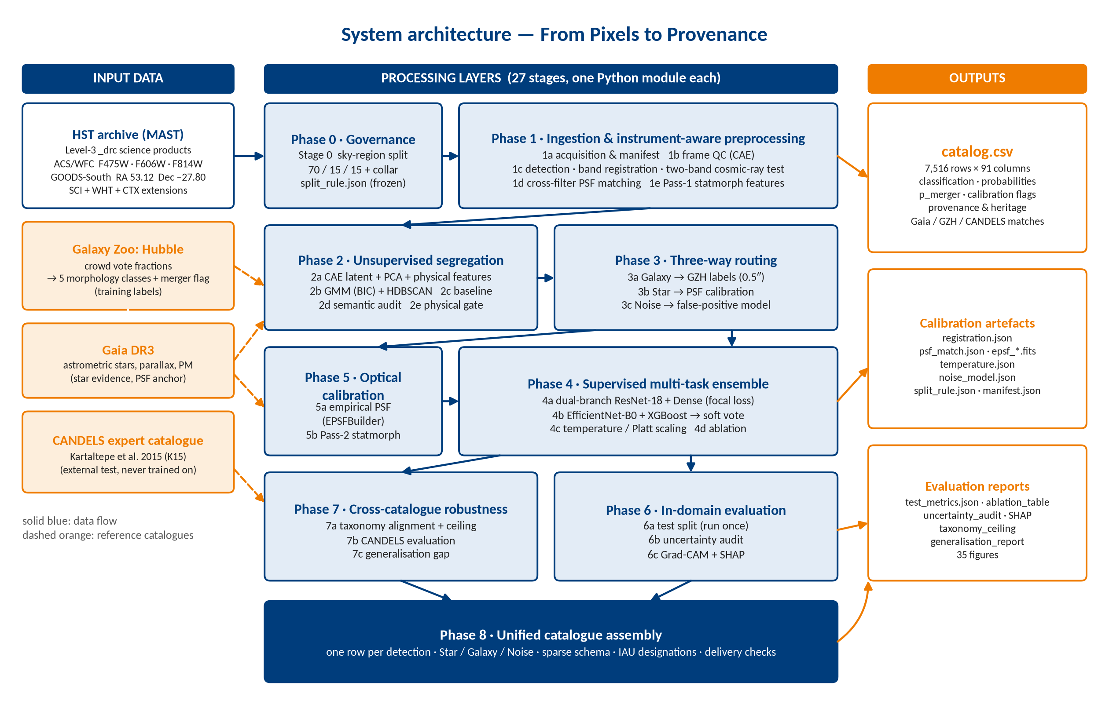
Figure 1. System architecture. External inputs (left) feed nine phases; Phases 4–7 depend on the frozen outputs of earlier phases; the outputs (right) are the catalogue, the calibration artefacts and the evaluation reports.

5. Project Flow
Figure 2 (next page) shows the execution order with the key numbers of the real run. The flow is linear and deterministic: python run_pipeline.py runs every stage in order, and --from <stage> resumes from any stage using the saved outputs of the earlier ones. Three design decisions are visible in the figure:
- Unsupervised before supervised. Stage 2 decides which detections are galaxies before any galaxy label is used, so the classifier never sees stars or artefacts.
- Stage 5 before Stage 4. The empirical PSF (5a) is built from the stars found in Stage 3b, and Pass-2 morphology (5b) is computed before training, so the models train on the same PSF-refined features they are deployed on. The splits are frozen in 5b.
- One-time test. Stages 6a–7c read the test region once; nothing is tuned after it.

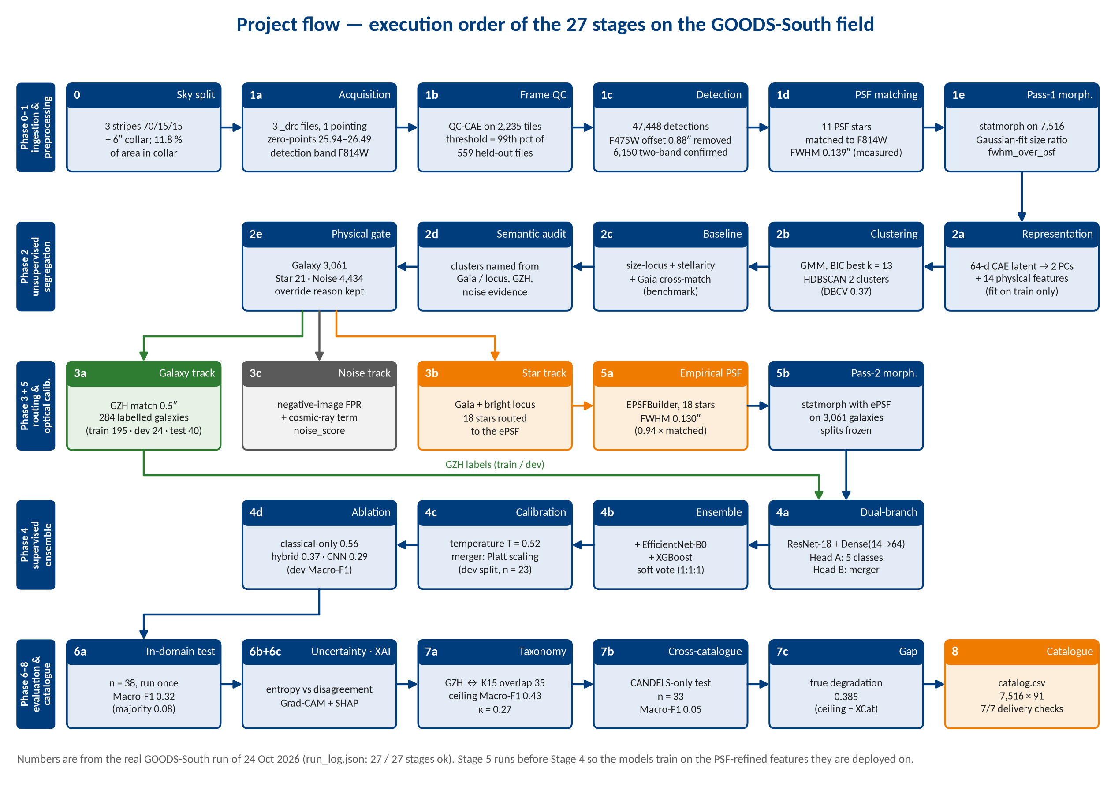
Figure 2. Execution order of the 27 stages with the key numbers from the real run. Coloured tracks show how the three populations are routed after Stage 2e.

6. Pipeline Stages and Outputs
Each subsection gives the purpose of a stage, the method, and the real output of the 24 October run, followed by the figures that stage writes.

6.1 Phase 0 — Data governance

Stage 0 — Sky-region partition
Purpose. Prevent spatial leakage between training and evaluation. Method. The union of the file footprints is divided into three RA stripes with target area fractions 70 / 15 / 15 and a 6″ collar around every boundary. Objects inside a collar are tagged buffer and are never used for training or testing. Output. Usable data area: train 0.67, test 0.12, dev 0.09, collar 0.12 (split_rule.json). Objects: train 4,204, buffer 1,303, test 1,295, dev 714.
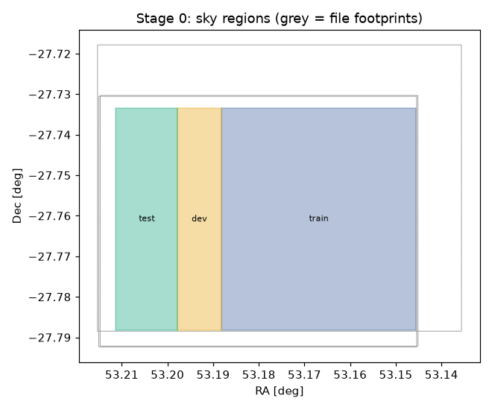
Figure 3. Stage 0 sky regions. Grey outlines are the file footprints; the coloured stripes are the test, dev and train regions.

6.2 Phase 1 — Ingestion and instrument-aware preprocessing

Stage 1a — Archive acquisition
Reads every FITS file, checks that SCI, WHT and CTX extensions and a valid WCS exist, computes AB zero-points from PHOTFLAM/PHOTPLAM, the pixel scale, footprint and epoch, and groups files into pointings. Output. One pointing (P01), three valid files, detection band F814W, zero-points 25.94–26.49 (Table 2).

Stage 1b — Frame quality control
A small convolutional autoencoder (QC-CAE) is trained on 2,235 image tiles from the training region. Tiles that it reconstructs poorly contain unusual structure: saturated stars, chip gaps, edges or strong artefacts. The threshold is the 99th percentile of the reconstruction error on 559 held-out tiles (MSE 0.0031), so it is set without looking at the tiles being judged. Flagged tiles are recorded in qc_flagged_bands and frame_quality_flag.
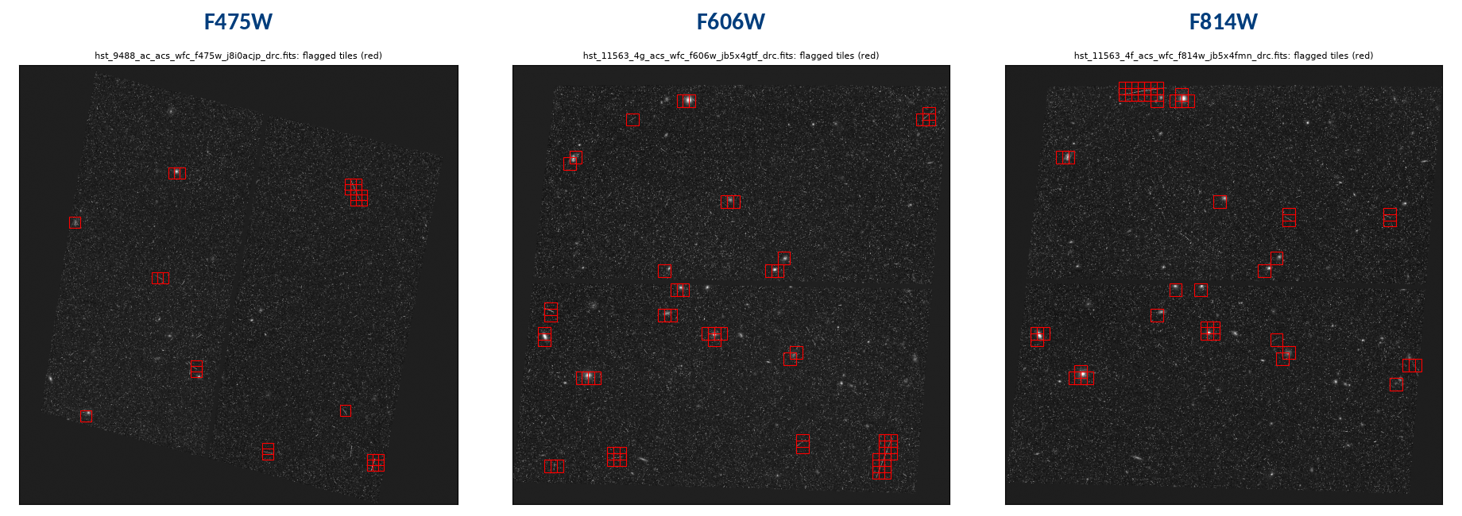
Figure 4. Stage 1b: tiles flagged by the QC autoencoder (red boxes) in each filter. Most flags fall on bright stars, large galaxies and the chip gap.
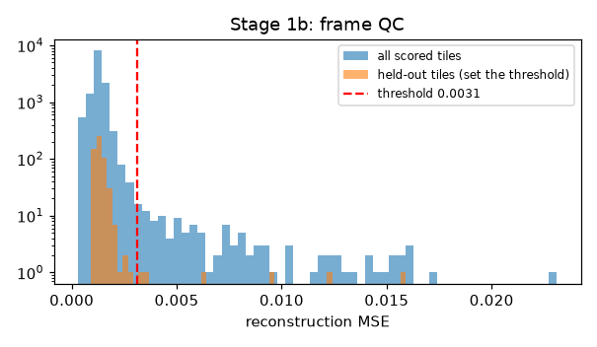
Figure 5. Stage 1b: reconstruction-error distribution of all scored tiles and the held-out tiles that set the threshold (dashed line, MSE 0.0031).

Stage 1c — Detection, deblending, registration and cosmic rays
This is the stage that had to change most for real data. Sources are detected and deblended on F814W with photutils. Because each filter is a single exposure, most detections are cosmic rays, so the stage does four things in order:
- Registration. Matching sources are taken from 5 × 5 median-filtered images, which removes cosmic rays but keeps galaxies. The offset between bands is accepted only if its peak stands at least 5× above the random-pair level. F475W vs F814W: 97 pairs, 7.7×, offset (0.162″, 0.868″), removed by shifting the F475W WCS (residual 0.0001″). F606W: 306 pairs, 18.4×, offset (−0.002″, 0.007″), below threshold, not corrected.
- Two-band confirmation. A second band confirms a source only if it has S/N ≥ 3 and its light is centred within 1.5 px (or 0.5 × the source radius) of the detection. Without the position test, chance cosmic rays in the other band "confirmed" 15,881 sources; with it, 6,150, and none of 290 GZH galaxies is lost.
- Pixel-level cosmic-ray mask. A pixel is a cosmic ray if it is > 5σ and > 4× what the other bands predict from the source's median pixel colour, and sharp: > 5σ and > 2× the median of its 8 neighbours. Such pixels are replaced by the prediction and flagged. The sharpness test keeps the smooth red halo of bright stars in F814W.
- Caps and photometry. Confirmed sources and cosmic-ray candidates are capped separately (8,000 and 1,000) so cosmic rays cannot crowd out galaxies. Per-band magnitudes, errors, n_exposures (from CTX) and saturation are written.
Output. 47,448 detections; 6,150 confirmed in a second band; 40,932 cosmic-ray candidates; 7,516 sources kept for the catalogue. Median F475W S/N of galaxies brighter than mag 23.7 rose from 3 (before registration) to 19.8.
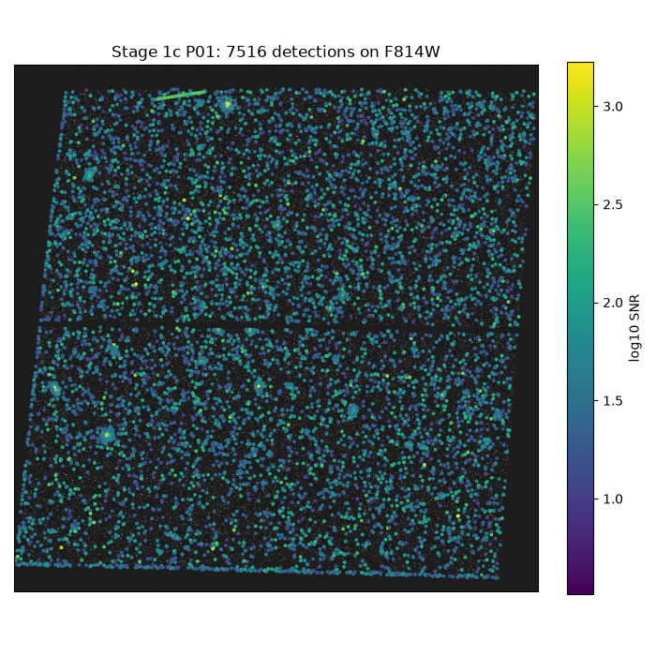
Figure 6. Stage 1c: the 7,516 catalogue sources on the F814W image, coloured by log₁₀ S/N.
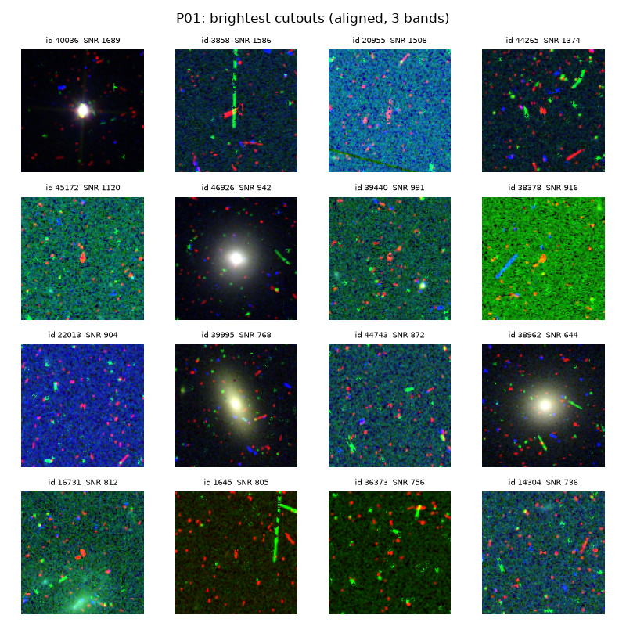
Figure 7. Stage 1c: the brightest aligned three-band cutouts (F475W, F606W, F814W as blue, green, red). The single-colour streaks are cosmic rays that appear in only one band.

Stage 1d — Cross-filter PSF matching
Stars are selected as bright, round (ellipticity < 0.3), confirmed, unsaturated and isolated (5 px), with a size within 15 % of the Gaia stars' size. Each band's FWHM is the median of individual bounded Gaussian fits; a band needs stars with S/N ≥ 30 to shape its own PSF. All bands are then convolved to the broadest one. Output. 11 PSF stars; FWHM F606W 2.741 px, F814W 2.778 px; F475W uses the Gaussian fallback (2.0 px) because only 4 stars reach S/N 30 in it; target F814W; measured matched FWHM 0.139″ (it was a configured 0.10″ before).
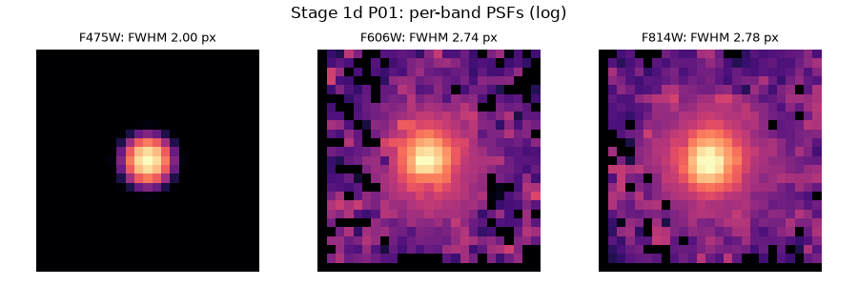
Figure 8. Stage 1d: per-band PSFs on a log scale. F475W is the Gaussian fallback; F606W and F814W are stacks of the selected stars.

Stage 1e — Pass-1 photometry and morphology
statmorph measures Gini, M20, concentration, asymmetry, smoothness (CAS), Sérsic index and half-light radius, ellipticity, shape asymmetry and related indices on every source, with cosmic-ray pixels masked. The size ratio fwhm_over_psf uses the same Gaussian-fit estimator for the source and the PSF, so a star sits at 1.0 (Gaia stars: 0.91–1.00). Failed fits are left empty instead of −99, and Sérsic fits stuck at a bound get flag 1.
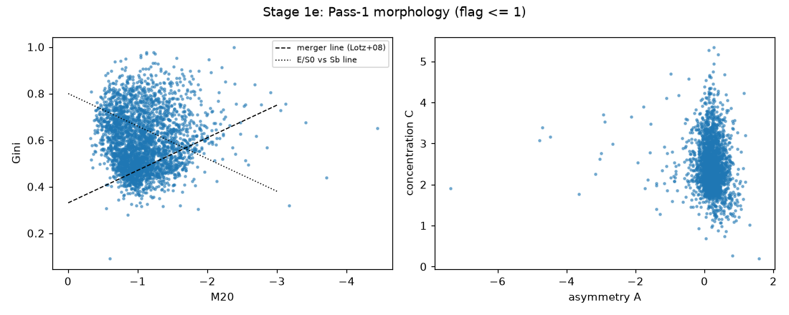
Figure 9. Stage 1e: Gini–M20 plane (left, with the merger and E/S0–Sb dividing lines) and concentration–asymmetry plane (right) for sources with flag ≤ 1.

6.3 Phase 2 — Unsupervised object segregation

Stage 2a — Representation learning and feature fusion
A convolutional autoencoder learns a 64-dimensional latent code from the PSF-matched cutouts. PCA on the training region keeps the components that explain most of the variance: PC1 and PC2 together explain ≈ 90 %, so two are kept. They are fused with 14 robust-scaled physical features (fwhm_over_psf, band_consistency, Gini, M20, C, A, S, Sérsic n, r½, ellipticity, mag, S/N and two colours) into a 16-dimensional hybrid vector. All scalers and the PCA are fitted on the training region only.
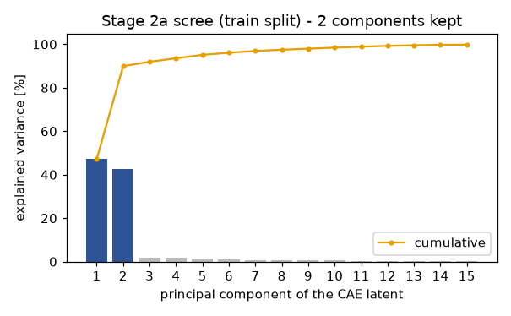
Figure 10. Stage 2a: scree plot of the CAE latent (train split). Two components explain ≈ 90 % of the variance.

Stage 2b — Unsupervised clustering
A Gaussian mixture model is fitted for k = 2–14 and the Bayesian information criterion picks k = 13. HDBSCAN is run in parallel over a grid of minimum cluster sizes scored by density-based cluster validity (DBCV); it finds 2 clusters (DBCV 0.37) and labels most objects as noise points, which is expected for a continuum of faint sources. Both labelings are kept in the catalogue (cluster_id_gmm, cluster_id_hdbscan).
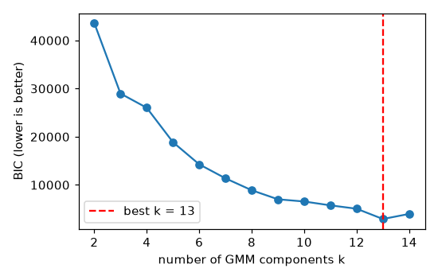
Figure 11. Stage 2b: BIC of the Gaussian mixture against the number of components; the minimum is at k = 13.

Stage 2c — Baseline segregation
The benchmark that the learned method must beat: a size–magnitude locus plus a stellarity cut, with a Gaia cross-match. Its result is stored as baseline_semantic. On all objects it finds the 3 Gaia stars (recall 1.0, precision 0.5); its galaxy recall against GZH is 0.926.

Stage 2d — Semantic audit
Clusters have no names. Stage 2d names each one from independent evidence, never from the labels used later for training: star evidence is a Gaia match, or a point-like source confirmed in two bands with S/N ≥ 150 (about mag 22.3 here); galaxy evidence is a GZH position or a resolved, confirmed source with S/N ≥ 5; noise evidence comes from cosmic-ray candidates and sources sharper than the PSF. Each cluster takes the class with the highest evidence fraction. Output. Evidence from 3 Gaia stars + 19 locus stars, 290 GZH galaxies + 1,055 resolved sources; 4 clusters named Galaxy, 1 Star, 8 Noise. Learned galaxy recall vs GZH 0.905 (baseline 0.926).
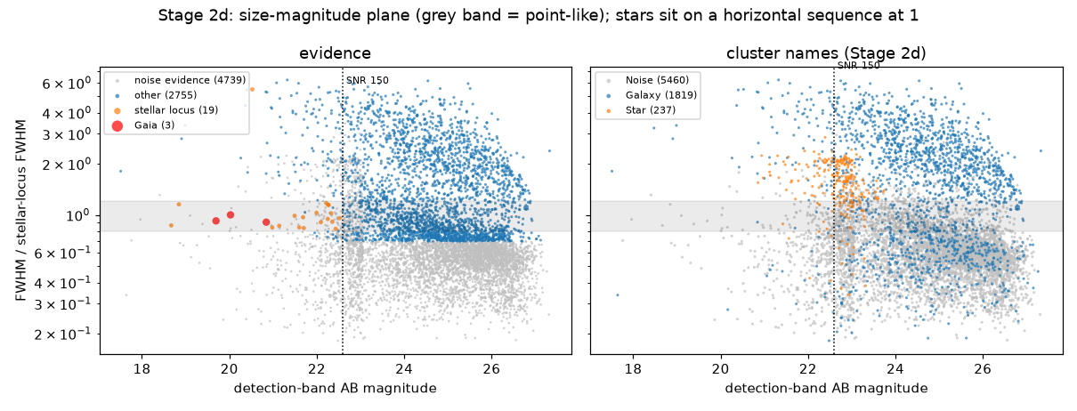
Figure 12. Stage 2d: size–magnitude plane. Left: the evidence used for naming (Gaia stars, locus stars, GZH galaxies, noise). Right: the cluster names. The grey band is the point-source locus.
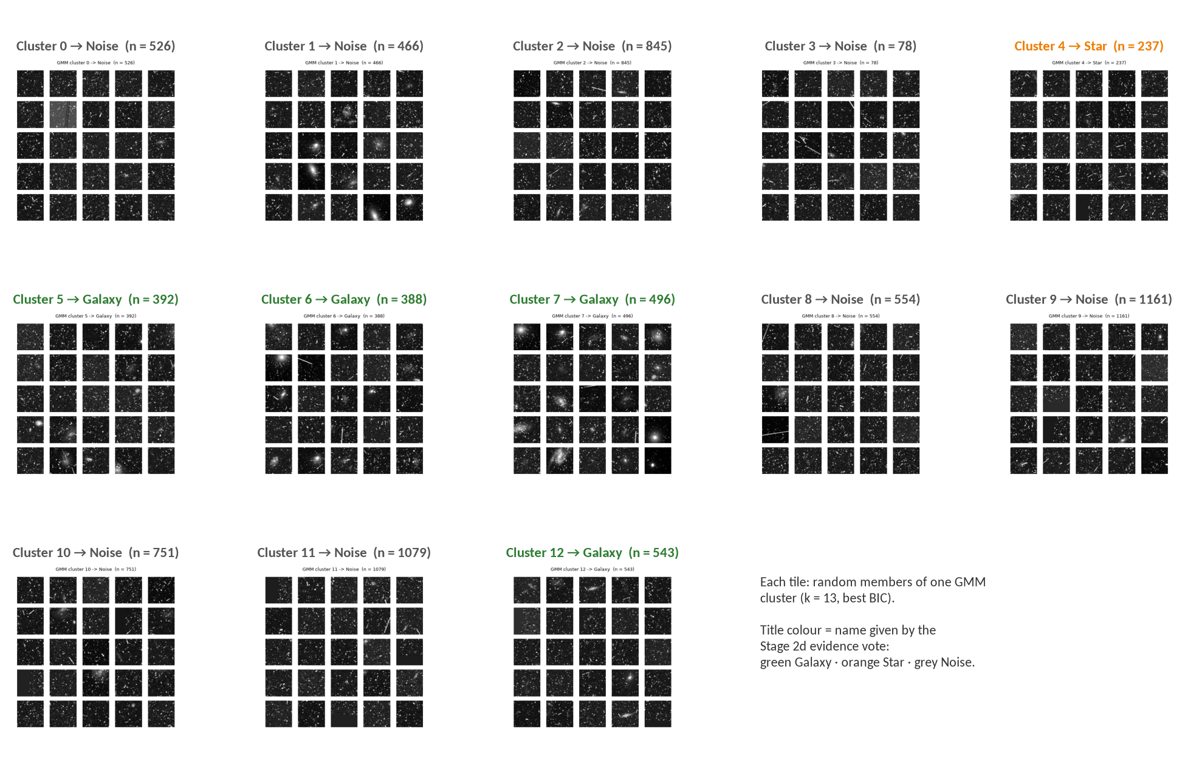
Figure 13. Stage 2d: random members of the 13 GMM clusters with the name each received. Noise clusters are dominated by cosmic-ray tracks; galaxy clusters show extended sources. Cluster 4 was named Star, but the physical gate (Stage 2e) moved most of its members to Galaxy or Noise.

Stage 2e — Continuum handling and physical gate
A GMM cluster is a statistical group, and one cluster can mix stars with compact galaxies. Stage 2e therefore applies physical rules to every object and records the reason for every change in classification_override. Objects with a high autoencoder reconstruction error are logged as anomalies. Table 4 shows the overrides in the real run.
Table 4. Physical-gate overrides in Stage 2e (real run).
Rule | Objects
Noise cluster, but a real source (confirmed in 2 bands, S/N ≥ 5, not sharper than the PSF) → Galaxy | 1,224
Cosmic-ray candidate (no second band confirms it) → Noise | 201
Star cluster, but broader than a point source → Galaxy | 65
Noise cluster, but confirmed in 2 bands on the stellar locus → Star | 15
Star cluster, but too faint for size to separate a star from a compact galaxy → Galaxy | 13
Star cluster, but sharper than the PSF → Noise | 12
Galaxy cluster, but on the stellar locus → Star | 2
Final populations | Galaxy 3,061 · Star 21 · Noise 4,434

6.4 Phase 3 — Label anchoring and three-way routing

Stage 3a — Galaxies: GZH label anchoring
Galaxies are matched to GZH within 0.5″ after removing the measured offset. Vote fractions are turned into one of the five classes by following the GZH decision tree; galaxies with no majority path are Ambiguous, and the merger flag comes from the merger question. Output. 284 labelled galaxies; a boundary set of 10 galaxies with high human disagreement; merger prevalence in train 3.6 % (7 galaxies).
Table 5. GZH-labelled galaxies by class and split.
Class | Train | Dev | Test | Buffer
Smooth | 11 | 1 | 8 | 2
FaceOnSpiral | 46 | 9 | 10 | 1
EdgeOn | 36 | 5 | 5 | 6
Irregular | 52 | 4 | 7 | 8
Ambiguous | 50 | 5 | 10 | 8
Total | 195 | 24 | 40 | 25

Stage 3b — Stars: calibration routing
Stars are not classified further; they are routed to the optical calibration. Only Gaia stars and bright stellar-locus stars are trusted for the empirical PSF. Output. 21 stars, 18 routed to Stage 5a (before the fix, 456 "stars" — mostly compact galaxies — were routed).

Stage 3c — Noise: false-positive modelling
The detector is run on the negative image, where every detection is false by construction. The false-positive rate is measured as a function of the peak-significance threshold, and combined with a cosmic-ray term and a resolution floor into a per-object noise_score. Output. FPR 0.036 at 2σ; median noise_score 0.83 for Noise, 0.21 for Galaxy and 0.08 for Star rows.
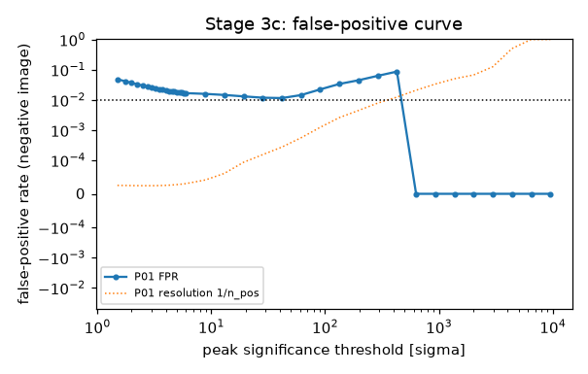
Figure 14. Stage 3c: false-positive rate measured on the negative image against the peak-significance threshold. The dotted line is the resolution floor 1/n.

6.5 Phase 5 — Optical calibration feedback

Stage 5a — Empirical PSF construction
photutils EPSFBuilder stacks the 18 routed stars, each centred on its core, with neighbours given zero weight. Output. ePSF FWHM 2.602 px = 0.130″, 0.94 × the matched PSF of Stage 1d. Before the fixes the ePSF was built from 47 objects (16 cosmic rays, 39 extended) and was 0.24″ wide.
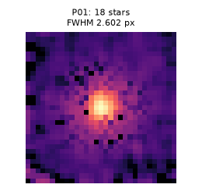
Figure 15. Stage 5a: empirical PSF of pointing P01 from 18 stars (log scale).

Stage 5b — Deterministic Pass-2 refinement
Morphology of the 3,061 galaxies is re-measured with the empirical PSF (Sérsic fits are PSF-convolved). The non-parametric indices do not use the PSF, so their median change is 0; the Sérsic half-light radius shrinks by a median 0.14 px, as expected once the PSF is deconvolved. The train/dev/test splits are frozen here and verified unchanged (frozen_columns_unchanged = true).

6.6 Phase 4 — Supervised multi-task learning and ensemble
Section 7 describes the ensemble in detail. In brief: 4a trains the dual-branch multi-task network (ResNet-18 image branch + dense branch on 14 physical features, a softmax head for five classes and a sigmoid merger head); 4b trains EfficientNet-B0 on pixels and XGBoost on the feature table, and combines the three by soft voting; 4c calibrates the ensemble on the dev split; 4d runs the controlled ablation.

Stage 4c — Probability calibration
Temperature scaling, p = softmax(log P / T), is fitted on the dev split: T = 0.523 (T < 1 sharpens: the averaged ensemble was under-confident). Dev ECE for morphology fell from 0.169 to 0.150. The merger probability is calibrated with Platt scaling (a = 0.226, b = −2.870): dev ECE 0.180 → 0.016. With only 23 dev galaxies and one merger, these values are indicative.
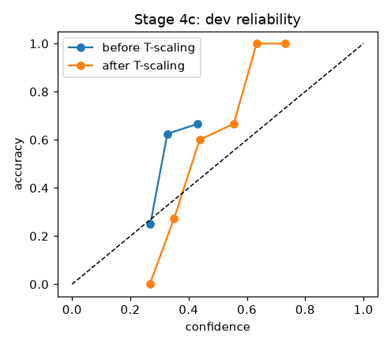
Figure 16. Stage 4c: reliability diagram on the dev split before and after temperature scaling.

Stage 4d — Controlled ablation
Each representation is trained and scored on the same dev split. Output (dev Macro-F1): classical-only (dense branch) 0.563, XGBoost 0.465, full ensemble 0.366, hybrid fusion 0.365, CNN-only 0.294, EfficientNet 0.071. With 195 training galaxies, models that start from physical features learn more than models that must learn from pixels; Section 11 shows that the literature predicts this.
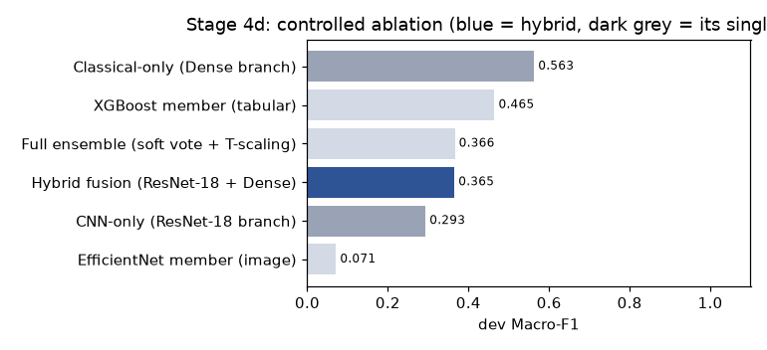
Figure 17. Stage 4d: controlled ablation on the dev split (blue = hybrid).

6.7 Phase 6 — In-domain evaluation and explainability

Stage 6a — One-time test evaluation
The test region is scored once. Output (n = 38): Macro-F1 0.324 (bootstrap 95 % CI 0.168–0.461), balanced accuracy 0.348, majority-class Macro-F1 0.077, one-vs-rest PR-AUC 0.353, ECE 0.318. FaceOnSpiral (F1 0.40) and Irregular (0.38) are recognised best; EdgeOn (0.22) is often predicted as Irregular. Tier: Macro-F1 meets the Minimum; ECE is below the Minimum, because calibration fitted on 23 dev galaxies does not transfer to 38 test galaxies.
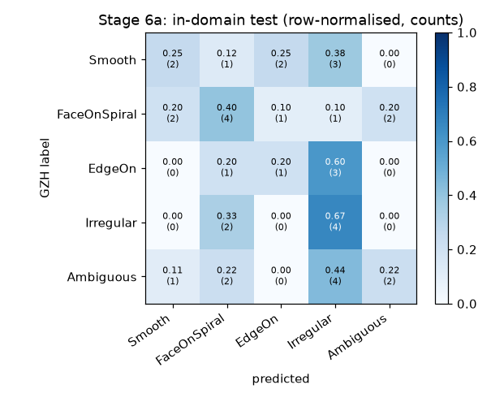
Figure 18. Stage 6a: row-normalised confusion matrix on the held-out test region (counts in brackets).

Stage 6b — Uncertainty audit
Does the model know when humans disagree? The Spearman correlation between predictive entropy and GZH disagreement is −0.01 (p = 0.95): not yet. Only one boundary-set galaxy fell in the test region, so the planned Mann–Whitney test was not run (the stage records this rather than reporting a meaningless p-value).
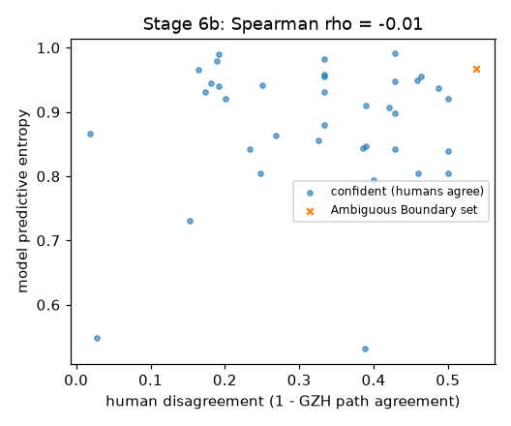
Figure 19. Stage 6b: model predictive entropy against human disagreement for the test galaxies.

Stage 6c — Explainability
Grad-CAM on the last ResNet-18 block shows where the image branch looks; XGBoost's built-in TreeSHAP gives the contribution of each physical feature per class. EdgeOn relies on ellipticity, Smooth on colour and concentration, FaceOnSpiral on fwhm_over_psf (size) and magnitude — physically sensible drivers.
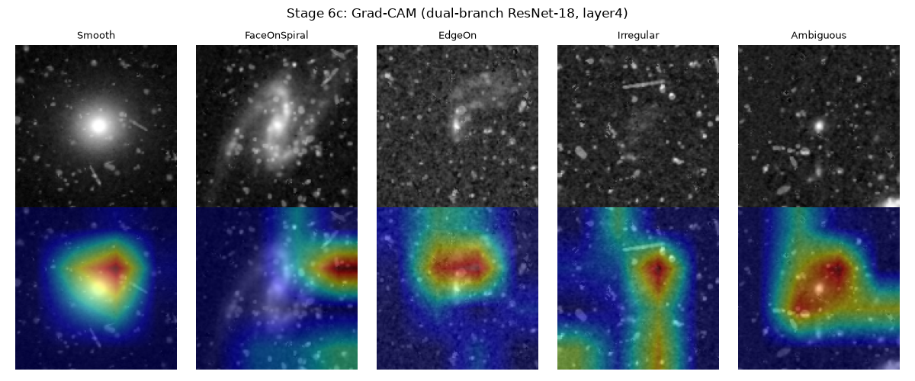
Figure 20. Stage 6c: Grad-CAM heat maps of the dual-branch network for one example per class.
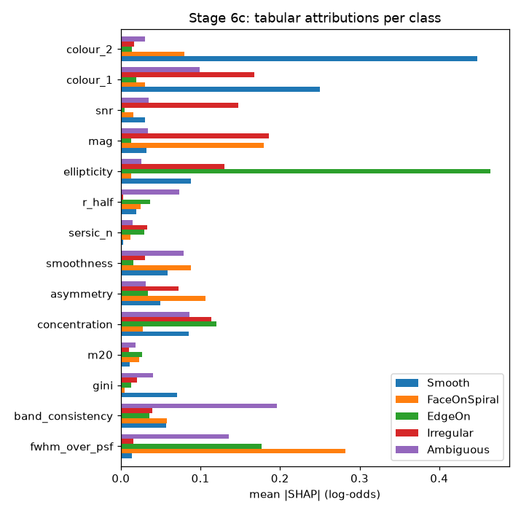
Figure 21. Stage 6c: mean |SHAP| per feature and class for the XGBoost member.

6.8 Phase 7 — Cross-catalogue robustness

Stage 7a — Taxonomy alignment
GZH and CANDELS use different classes. Both are mapped to a shared coarse scheme (Disk, Spheroid, Irregular, Unclassifiable), and the agreement between the two human catalogues on the 35 galaxies they share is the ceiling a model trained on one can reach on the other: Macro-F1 0.432, Cohen's κ 0.274.

Stage 7b — Cross-catalogue test
The model, trained on GZH labels, is scored on 33 test-region galaxies that only CANDELS labels (overlap and point sources excluded): Macro-F1 0.047 (CI 0.0–0.11).

Stage 7c — Generalisation gap
True degradation = ceiling − cross-catalogue = 0.385; the in-domain coarse Macro-F1 is 0.370. The CANDELS-only galaxies are fainter (median S/N 23 vs 46 for GZH training galaxies; mag 24.9 vs 23.8), so part of the drop is covariate shift towards faint, small galaxies where morphology is hardest. Because this is a single field, Phase 7 used the held-out test region: the gap measures the label-scheme change and the fainter population, not a new field.
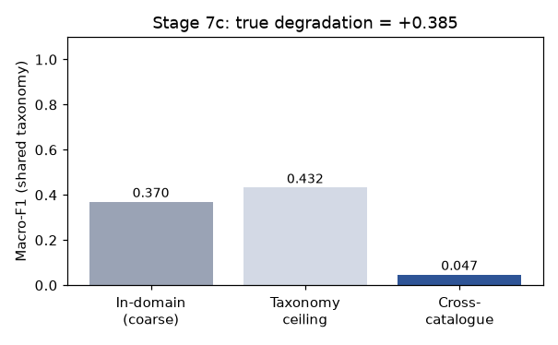
Figure 22. Stage 7c: in-domain coarse Macro-F1, taxonomy ceiling and cross-catalogue Macro-F1.

6.9 Phase 8 — Unified catalogue assembly
Stage 8 joins all stage outputs on object_id into catalog.csv (7,516 rows × 91 columns) and writes catalog_columns.csv (group, rows filled, description for each column) and delivery_checks.json. Columns A–BW keep the order agreed in the catalogue review; 16 new columns follow from BX. Appendix A lists all columns by group.
Table 6. Stage 8 delivery checks (all True in the real run).
Check | Result
Every galaxy has calibrated morphology probabilities | True
Every galaxy has a merger probability | True
Every galaxy has a heritage flag (is_pseudo_label: catalogue label vs model inference) | True
Every measured galaxy is at Pass 2 | True
Class columns are empty for Star and Noise rows | True
Designations are unique | True
Column order as specified | True
Note written by the stage | p_merger spans only 0.022–0.117: the merger head is effectively constant — not trainable with 7 training mergers

7. Ensemble Architecture
The supervised part of the pipeline is a committee of three models with different views of each galaxy. Figure 3, at the end of this section, shows the full inference path.

7.1 Member 1 — Dual-branch multi-task network
- Image branch: ResNet-18, trained from scratch in the reported run (supervised.pretrained: false; ImageNet weights are an option), on 3 × 128 × 128 PSF-matched cutouts, asinh-scaled per band, with 90° rotations and flips (morphology does not depend on orientation). Output 512-d, LayerNorm.
- Tabular branch: Dense 14 → 64 with ReLU and LayerNorm on the Pass-2 features (median-imputed, log-transformed where skewed, RobustScaler fitted on train).
- Fusion: concatenation, 512 + 64 = 576-d.
- Head A: softmax over 5 morphology classes. Head B: sigmoid merger probability.
- Loss: focal loss (γ = 2) with class weights for Head A — it down-weights easy examples and counters class imbalance (Smooth has only 11 training galaxies) — plus 0.5 × binary cross-entropy for Head B.

7.2 Members 2 and 3
EfficientNet-B0 sees pixels only and gives a second, architecturally different image view. XGBoost sees the feature table only, with balanced class weights and early stopping on dev. XGBoost runs in a separate process (xgb_worker.py) because its OpenMP runtime conflicts with PyTorch's on macOS.

7.3 Combination and calibration
The members' class probabilities are averaged with weights 1 : 1 : 1 (configurable in supervised.ensemble_weights). Averaging probabilities, rather than votes, keeps the uncertainty of each member. Temperature scaling then fixes the confidence of the average without changing its ranking (a single parameter T, so it cannot over-fit 23 dev galaxies). Only member 1 has a merger head, so the merger branch is calibrated separately with Platt scaling. The outputs in the catalogue are p_smooth … p_ambiguous, pred_class, pred_entropy and p_merger.

7.4 What the ablation says about the ensemble
On this field the best single model (classical-only, 0.56) is better than the ensemble (0.37), because EfficientNet (0.07) — trained from scratch on 195 galaxies — pulls the average down. Equal weights were fixed in the proposal before seeing results, and the report keeps them for honesty. Learning the weights on dev, dropping EfficientNet, or starting the image members from ImageNet weights (supervised.pretrained: true) are direct improvements, the last one testable without new labels (Section 12).

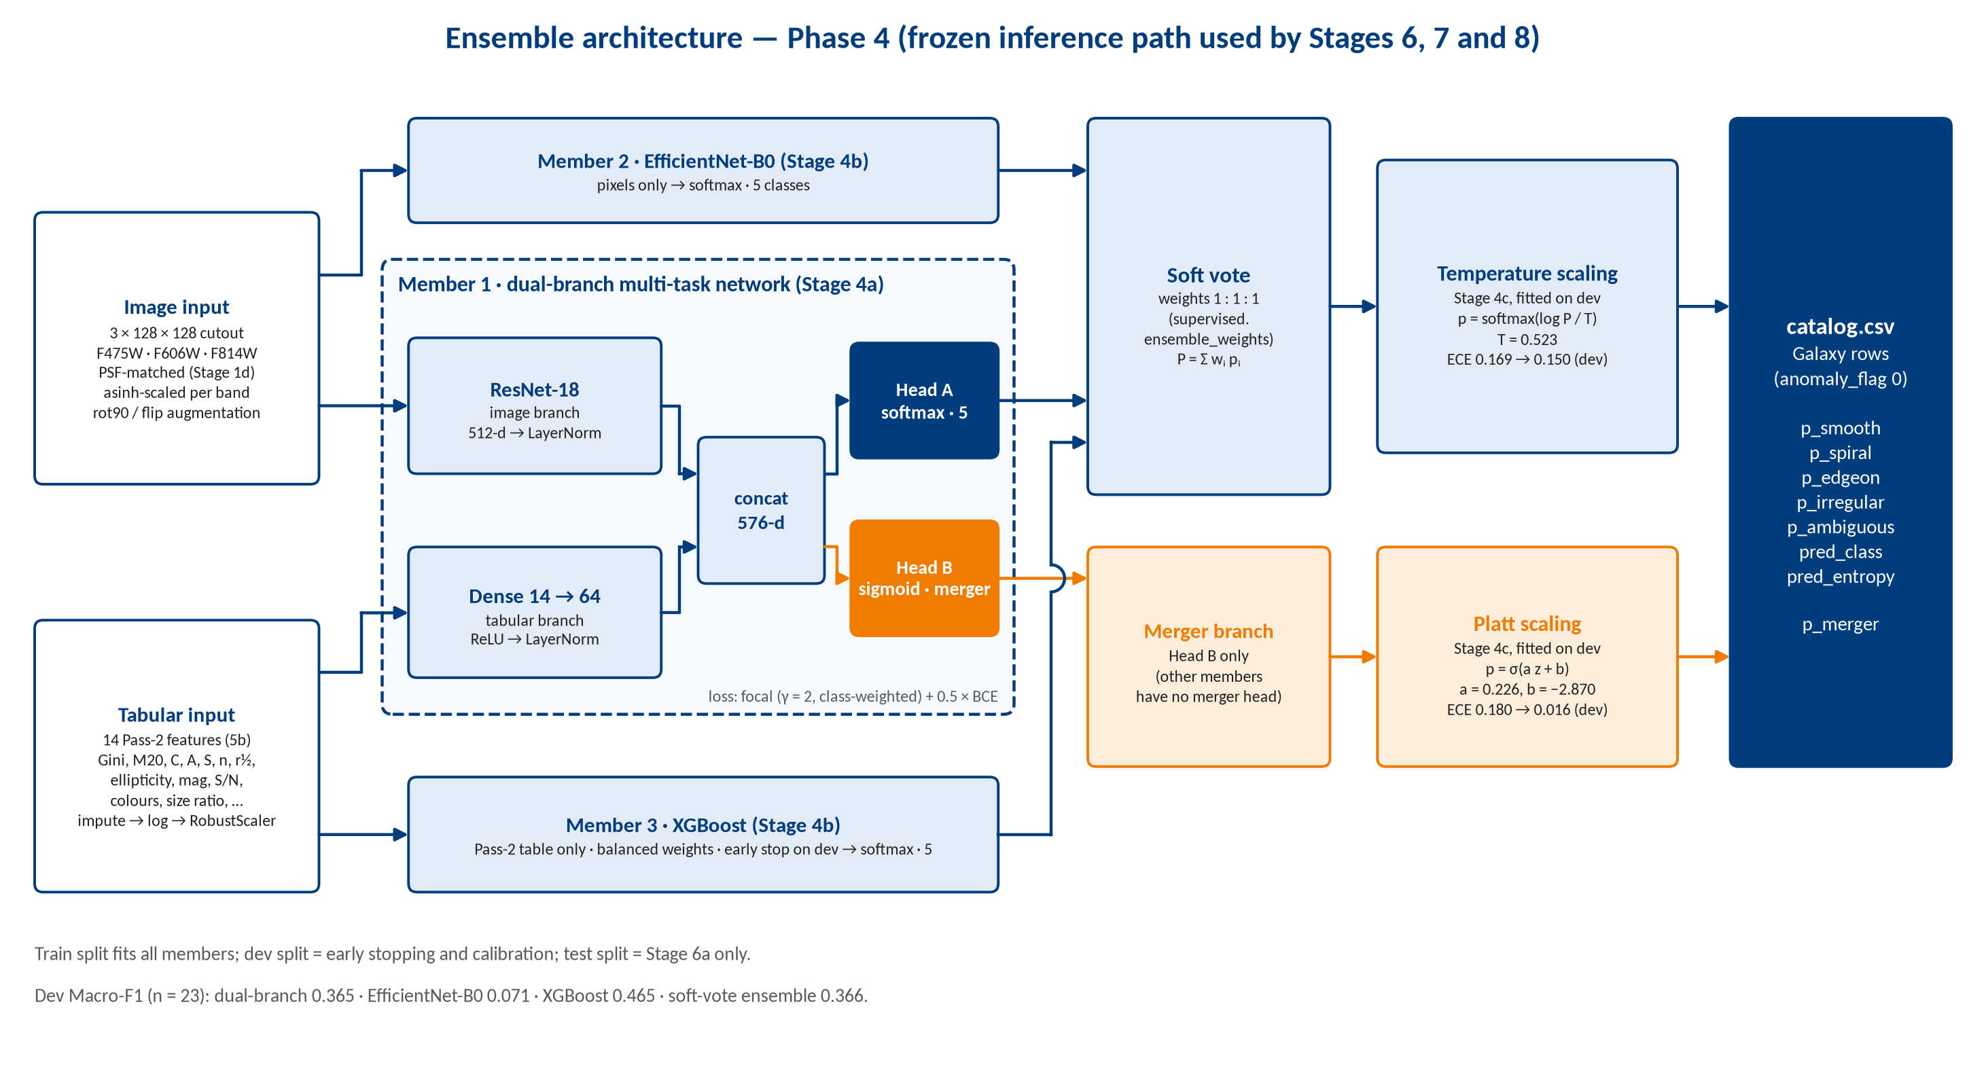
Figure 23. Ensemble used for inference: three members, soft voting, temperature scaling for morphology and Platt scaling for the merger head.

8. Results Against the Success Criteria
The proposal defined three tiers per objective: Minimum (the objective did not fail), Target and Stretch. Table 7 reports the real run against them.
Table 7. Results of the real run against the proposal's tiered targets.
Objective | Metric | Minimum / Target | Result | Status
Pipeline end-to-end (O1) | Completeness + leakage | No manual steps; zero leakage | 27/27 stages; 0 leakage; 7/7 checks | Met
Segregation (O2) | Star P / R vs Gaia | Beat Stage 2c / ≥ 0.90 | Gaia stars all in train region: held-out P = R = 0 for both methods. All 3 Gaia stars end as Star after the gate | Not measurable in this field
Segregation (O2) | Galaxy recall vs GZH | — | 0.905 learned vs 0.926 baseline | Close to baseline
Morphology (O3) | Test Macro-F1 | > majority (0.08) / ≥ 0.65 | 0.324 (CI 0.17–0.46) | Minimum met
Hybrid value (O3) | Ablation Δ Macro-F1 | Hybrid ≥ best single branch | Hybrid 0.365 vs classical 0.563 | Not met (as literature predicts)
Merger flag (O3) | PR-AUC | > prevalence | n/a: 1 dev merger; head constant | Not trainable
Cross-catalogue (O4) | Ceiling, XCat, degradation | Gap quantified and disentangled | 0.432 / 0.047 / 0.385 | Met
Calibration (O5) | ECE | < 0.10 / < 0.05 | Dev: 0.150 (morph), 0.016 (merger); test 0.318 | Merger dev met; morphology not
Catalogue (O5) | Delivery checks | All pass | 7/7, 7,516 × 91 | Met

8.1 Improvement from the review fixes
The catalogue review of the first real run found 16 problems. Table 8 shows the effect of the fixes on the same data, and the regression test on a simulated GOODS-S-like field with known truth. The largest single gain came from Stage 1c: once cosmic rays and the F475W offset were handled, every later stage — PSF, segregation, labels and morphology — improved without any change to its own model.
Table 8. Before and after the fixes (real data and simulated field).
Quantity | Before | After
F475W S/N at catalogue positions (bright galaxies) | 3 (0.88″ offset) | 19.8
Star class | 170 (65 cosmic rays, 68 galaxies) | 21, incl. all 3 Gaia stars
Gaia stars' fwhm_over_psf | 1.9–2.9 | 0.91–1.00
GZH-labelled galaxies | 43 | 284
ePSF | 47 objects (16 cosmic rays), 0.24″ | 18 stars, 0.130″
PSF-matching stars / matched FWHM | 0 / 0.10″ (configured) | 11 / 0.139″ (measured)
Median Gini / M20 of galaxies | 0.80 / −0.70 | 0.61 / −1.07
Simulated field: real galaxies classified Galaxy | 299 of 597 | 594 of 597
Simulated field: colour rank correlation with truth | 0.21 | 0.84
Simulated field: ePSF stars that are real stars | 43 of 134 | 42 of 49

9. Project Challenges and Solutions
Table 9 lists the main challenges, what revealed each one, and how it was solved. Most were found only when the pipeline met real data; the synthetic test field had hidden them.
Table 9. Challenges met during the project.
Challenge | Evidence | Solution | Result
Cosmic rays in single-exposure _drc files | ~85 % of 47,448 detections were cosmic rays; they filled the 4,000-source cap | Two-band confirmation with a position test; pixel-level mask (colour + sharpness); separate caps | 6,150 confirmed sources; 0 of 290 GZH galaxies lost
Registration broken by cosmic rays | Stage 1c stopped: "F475W is offset by 2.064″" (random pairing of cosmic rays) | Match on 5 × 5 median-filtered images; significance ≥ 5× random pairs; residual check | Offset (0.162″, 0.868″) from 97 galaxies; residual 0.000″
False two-band confirmations | 15,881 "confirmed" sources | Require the second band's light centred within 1.5 px | 6,150 confirmed
Masking real light | F814W red halo of bright stars masked as cosmic rays | Pixel must also be sharp vs its 8 neighbours | Halo kept; colours of stars correct
No PSF stars; failed Gaussian fits | 0 PSF stars; one axis of the fit collapsed to 0 | Bounded, normalised Gaussian fit; star selection by Gaia-star size; median of single-star fits | 11 stars; matched FWHM 0.139″
Star class contaminated | Star 170: 65 cosmic rays, 68 galaxies | Stellar locus only above S/N 150; physical gate with recorded reasons | Star 21, all Gaia stars included
Faint galaxies named Noise | GZH stops at mag ~23.5, so faint clusters had no galaxy evidence | Galaxy evidence also from resolved, confirmed sources with S/N ≥ 5 | Galaxy 177 → 3,061
Few labels | 284 GZH galaxies; 7 training mergers; 23 dev, 38 test | Focal loss, class weights, augmentation; bootstrap CIs; honest tier reporting | Minimum tier met; merger head reported as not trainable
Different label schemes | GZH vs CANDELS classes disagree | Taxonomy alignment matrix and human–human ceiling | Degradation 0.385 separated from scheme effect
Spatial leakage | Neighbouring cutouts share pixels | Sky-stripe split with 6″ collar, frozen before training | Zero leakage
Platform issues | XGBoost and PyTorch OpenMP clash on macOS | XGBoost in a separate worker process | Runs on the student's Mac

Two further lessons are worth stating. First, every stage now fails loudly (for example, it stops if registration is not significant or if no PSF stars are found) instead of silently using a configured default; the original 0.10″ matched FWHM was such a default. Second, the synthetic field was useful for regression testing but could not reveal problems that only real detectors produce.

10. Major Components Implemented
- Instrument-aware ingestion (Stages 1a–1e). FITS reader for SCI/WHT/CTX, AB zero-points, frame-QC autoencoder with a held-out threshold, detection and deblending, significance-tested multi-band registration, two-band confirmation, pixel-level cosmic-ray masking, star selection and cross-filter PSF matching, statmorph morphology with quality flags.
- Unsupervised segregation (Stages 2a–2e). Convolutional autoencoder, PCA, physical-feature fusion, GMM with BIC, HDBSCAN with DBCV, a baseline segregator, evidence-based semantic naming and a physical gate with an audit trail.
- Routing and optical calibration (Stages 3a–3c, 5a–5b). GZH decision-tree labels with offset-corrected matching, star routing, negative-image false-positive model, empirical PSF, PSF-aware Pass-2 morphology with frozen splits.
- Hybrid multi-task ensemble (Stages 4a–4d). Dual-branch ResNet-18 + dense network with focal + BCE loss, EfficientNet-B0, XGBoost worker, soft voting, temperature and Platt calibration, controlled ablation.
- Honest evaluation (Stages 6a–7c). One-time test with bootstrap CIs and tier report, uncertainty audit, Grad-CAM and TreeSHAP, taxonomy ceiling, cross-catalogue test and generalisation-gap decomposition with covariate-shift statistics.
- Provenance-tracked catalogue (Stage 8). 91 columns in the agreed order, column dictionary, delivery checks, heritage flags and override reasons.
- Engineering. A configurable runner with resume (--from), per-stage logs and timing in run_log.json, 213 documented configuration keys, download and inspection tools, a simulated test field for regression testing, and a change log for every release.

11. Comparison with Existing Work
Previous work on automated source classification has largely addressed binary star–galaxy separation on ground-based surveys, using either convolutional networks on pixels (Kim & Brunner 2017; Kennamer et al. 2018; Stoppa et al. 2023) or tree ensembles and other learners on catalogue features (Machado et al. 2016; Zeraatgari et al. 2024; Jeakel et al. 2025). A recurring result is that feature-based trees remain competitive with CNNs, and that adding morphological parameters to photometry improves separation. This project extends that line in three directions: it separates stars, galaxies and spurious detections without labels on space-based HST imaging; it fuses pixel and physical-feature representations in one dual-branch model whose value is measured by ablation; and it delivers calibrated, provenance-tracked morphology and merger probabilities evaluated both in-domain and against an independent expert catalogue.

11.1 Source-classification literature
Table 10. Published work compared with this project (details checked against the papers).
Work | Task | Data and labels | Method | Calibration | Relation to this project
Kim & Brunner 2017, MNRAS 464, 4463 | Star vs galaxy | SDSS, CFHTLenS; 5 bands; spectroscopic labels | ConvNet on pixels vs random-forest trees on photometry (+ morphology) | Well calibrated | Same question as our ablation: the CNN wins AUC on CFHTLenS; trees with morphology win on SDSS
Kennamer et al. 2018, ICML (ContextNet) | Star vs galaxy | LSST simulations | Per-object net + context net over the exposure | Not the focus | Uses exposure context for seeing; we use a per-pointing stellar locus and PSF matching
Stoppa et al. 2023, A&A 680, A109 (ASID-C) | Star vs galaxy | MeerLICHT, 32 × 32 single band; DECaLS labels | Dual-branch CNN + position branch; focal loss | Logit Platt scaling | Closest design to ours; XGBoost on features was competitive
Machado et al. 2016, IJCNN | Faint star vs galaxy | COSMOS features | NN, kNN, SVM, RF, naive Bayes | — | Tabular learners remain strong baselines
Jeakel et al. 2025, arXiv:2511.20524 | Extended vs point-like | miniJPAS, J-NEP; 14,594 labels | XGBoost; photometry ± morphology | ROC | Morphology features significantly help — supports our physical branch
Zeraatgari et al. 2024, MNRAS 527, 4677 | 3 to 7 source classes | SDSS + ALLWISE, ~1.25 M labels | RF, kNN, XGBoost, voting, ANN | — | F1 drops 98.9 % → 73.6 % from 3 to 7 classes — fine classes are harder
Muyskens et al. 2022 (arXiv:2105.01106) | Star vs galaxy | HSC COSMOS; HST labels | PCA embedding + Gaussian process | Posterior variance | Like our PCA embedding and uncertainty audit; works with few labels
Koblischke et al., arXiv:2512.11982 | Morphology search | 100 M+ Legacy Survey galaxies | Foundation-model embeddings aligned with text | Retrieval | Future direction for our autoencoder

11.2 Galaxy-morphology literature
Work | Relevance
Dieleman, Willett & Dambre 2015, MNRAS | First CNN trained on Galaxy Zoo vote fractions; motivates our rotation / flip augmentation
Huertas-Company et al. 2015, ApJS | CNN trained on CANDELS visual classes on HST imaging — the closest prior work to our Phase 7
Walmsley et al. 2022, MNRAS 509, 3966 | Bayesian CNNs on Galaxy Zoo DECaLS votes with uncertainty — state of the art for crowd-labelled morphology (314,000 galaxies)
Rodriguez-Gomez et al. 2019, MNRAS 483, 4140 | statmorph: the source of our Gini, M20, CAS and Sérsic features and their quality flags
Willett et al. 2017; Kartaltepe et al. 2015 | Our label source (GZH) and external benchmark (CANDELS)

11.3 Where this project differs
Table 11. Distinguishing features of this project.
Aspect | The cited works | This project
Task | Mostly binary star vs galaxy (or source type) | Three-way Star / Galaxy / Noise, then 5-class morphology and a merger flag
Labels for separation | Supervised, from spectroscopy or a deeper survey | Unsupervised: clusters named afterwards from independent evidence (Gaia, GZH positions, noise physics)
Imaging | Ground-based (SDSS, CFHT, HSC, MeerLICHT, J-PAS) or simulated | Space-based HST drizzled products with drizzle-specific QC, registration, cosmic-ray handling and PSF matching
Features | Pixels or catalogue features; a few combine them | Hybrid by design, with an ablation that measures what each part adds
Output | Class labels or probabilities | Calibrated, provenance-tracked catalogue; cross-catalogue test with a taxonomy ceiling

11.4 Our results in the light of the literature
- The hybrid did not beat the tabular model (0.37 vs 0.56). Kim & Brunner (2017) and Stoppa et al. (2023) found feature-based trees matching or beating CNNs; with 195 training galaxies this is the expected outcome, and it is reported under Objective 3 rather than hidden.
- Calibration needs its own step. Like Stoppa et al., we calibrate on a held-out split; the merger ECE fell from 0.180 to 0.016 on dev.
- Fine-grained classes score lower. Zeraatgari et al. drop from 98.9 % to 73.6 % F1 going from 3 to 7 classes with ~1.25 M labels. Our 5 overlapping morphology classes from 284 labels should be compared with that, not with star–galaxy accuracies near 99 %.
- Label quantity matters. The cited works train on 10⁴–10⁷ labelled objects. Our single field gives 284; Muyskens et al. show that low-dimensional embeddings (like our PCA space) work with few labels, which supports the unsupervised first stage.

12. Limitations and Future Work

12.1 Limitations
- One field, one pointing. Train, dev and test regions come from one 3.7′ × 3.7′ image; test n = 38 gives wide confidence intervals, and only 3 Gaia stars exist, all in the train region.
- Single exposures. Cosmic rays remain the main source of error; 158 of 295 flag-0 galaxies still have Gini > 0.75 or M20 > −1, mostly deblended fragments of large galaxies and long cosmic-ray tracks.
- Merger head. Seven training mergers are not enough; p_merger is effectively constant (0.022–0.117).
- Test calibration. Temperature fitted on 23 dev galaxies does not transfer (test ECE 0.318).
- F475W PSF. Too few bright stars, so a Gaussian fallback is used for that band.

12.2 Future work
- Use multi-exposure products (AstroDrizzle with ≥ 3 exposures) or the deep, cleaned GOODS-S mosaics, which remove cosmic rays at the source.
- Process several CANDELS/GOODS fields so that train, dev and test come from different fields and GZH labels number in the thousands; this is the main route to the Target tiers.
- Start the image members from ImageNet weights, learn ensemble weights on dev (or drop weak members) and fit calibration on a larger dev set; consider a Bayesian / Dirichlet output as in Walmsley et al. (2022).
- Add a minor-axis test for cosmic-ray tracks and a deblending check for fragments.
- Replace the task-specific autoencoder with foundation-model embeddings (Koblischke et al.) and test the pipeline on JWST imaging.

13. Conclusion
The project delivered what the proposal set out to build: a reproducible, 27-stage pipeline that takes archival HST images to a calibrated, provenance-tracked morphology catalogue, triages its own sources without labels, refines morphology against an empirical PSF, and reports generalisation honestly by separating model degradation from label-scheme disagreement. On real GOODS-South data it runs end-to-end, passes every delivery check, and meets the Minimum tier for morphology while reporting where the Target tiers were not reached and why.
The work also showed that the hardest part of applying machine learning to astronomical archives is not the classifier but the data: one unrejected cosmic-ray population disturbed every stage downstream. Solving that problem — with registration, confirmation and masking methods that can be verified with independent evidence — produced larger gains than any change to the model. With multi-exposure data and more fields, the same pipeline can be scaled without changes to its design.

References
- Dieleman, S., Willett, K. W. & Dambre, J. (2015). Rotation-invariant convolutional neural networks for galaxy morphology prediction. MNRAS, 450, 1441. arXiv:1503.07077.
- Gaia Collaboration, Vallenari, A., et al. (2023). Gaia Data Release 3: Summary of the content and survey properties. A&A, 674, A1.
- Huertas-Company, M., et al. (2015). A catalog of visual-like morphologies in the 5 CANDELS fields using deep learning. ApJS, 221, 8. arXiv:1509.05429.
- Jeakel, et al. (2025). arXiv:2511.20524 (miniJPAS / J-NEP extended vs point-like classification with XGBoost).
- Kartaltepe, J. S., et al. (2015). CANDELS visual classifications: scheme, data release, and first results. ApJS, 221(1), 11.
- Kennamer, N., Kirkby, D., Ihler, A. & Sanchez-Lopez, F. J. (2018). ContextNet: Deep learning for star galaxy classification. Proc. ICML, PMLR 80.
- Kim, E. J. & Brunner, R. J. (2017). Star–galaxy classification using deep convolutional neural networks. MNRAS, 464(4), 4463.
- Koblischke, N., et al. (2025). Semantic search for 100M+ galaxy images using AI-generated captions. arXiv:2512.11982.
- Machado, et al. (2016). Exploring machine learning methods for the star/galaxy separation problem. Proc. IJCNN 2016.
- Muyskens, A., et al. (2022). Star–galaxy image separation with computationally efficient Gaussian process classification. AJ. arXiv:2105.01106.
- Rodriguez-Gomez, V., et al. (2019). The optical morphologies of galaxies in the IllustrisTNG simulation: a comparison to Pan-STARRS observations. MNRAS, 483, 4140. arXiv:1809.08239.
- Simmons, B. D., et al. (2017). Galaxy Zoo: quantitative visual morphological classifications for 48,000 galaxies from CANDELS. MNRAS, 464(4), 4420.
- Stoppa, F., et al. (2023). AutoSourceID-Classifier (ASID-C): star–galaxy classification using a convolutional neural network with spatial information. A&A, 680, A109.
- Walmsley, M., et al. (2022). Galaxy Zoo DECaLS: detailed visual morphology measurements from volunteers and deep learning for 314,000 galaxies. MNRAS, 509, 3966. arXiv:2102.08414.
- Willett, K. W., et al. (2017). Galaxy Zoo: morphological classifications for 120,000 galaxies in HST legacy imaging. MNRAS, 464(4), 4176.
- Zeraatgari, et al. (2024). Machine learning-based photometric classification of galaxies, quasars, emission-line galaxies, and stars. MNRAS, 527(3), 4677.
- Space Telescope Science Institute. Barbara A. Mikulski Archive for Space Telescopes (MAST). https://archive.stsci.edu/
- STScI. DrizzlePac / AstroDrizzle documentation. https://www.stsci.edu/scientific-community/software/drizzlepac
- Software: Astropy, photutils, statmorph, PyTorch, torchvision, scikit-learn, hdbscan, XGBoost, NumPy, pandas, matplotlib.
- AI assistive tools: Anthropic's Claude (claude.ai); Google AI Mode.

Appendix A. Catalogue Columns
catalog.csv has 91 columns. Columns A–BW (C1–C75) follow the order agreed in the catalogue review; BX–CM (16 columns) were added in the 24 October release. Every column is described in catalog_columns.csv.
Col | Name | Col | Name | Col | Name
A | object_id | AF | pointing_epsf_fwhm_arcsec | BK | gaia_teff
B | designation | AG | pointing_matched_fwhm_arcsec | BL | noise_score
C | product_type | AH | is_pseudo_label | BM | fpr_at_threshold
D | ra | AI | gz_label | BN | qc_flagged_bands
E | dec | AJ | gz_vote_frac | BO | pipeline_version
F | pointing | AK | gz_merger_flag | BP | snr
G | detection_band | AL | gaia_source_id | BQ | ndrizim
H | tile_id | AM | gaia_sep_arcsec | BR | flux
I | frame_quality_flag | AN | mag | BS | flux_err
J | edge_flag | AO | colour_1 | BT | fwhm_over_psf
K | anomaly_flag | AP | colour_2 | BU | band_consistency
L | cluster_id_gmm | AQ | gini | BV | reconstruction_error
M | cluster_id_hdbscan | AR | m20 | BW | baseline_semantic
N | gmm_p_star | AS | concentration | BX | ra_err
O | gmm_p_galaxy | AT | asymmetry | BY | dec_err
P | gmm_p_noise | AU | smoothness | BZ | mag_F475W
Q | split_tag | AV | is_transitional | CA | mag_F606W
R | classification | AW | psf_pass | CB | mag_F814W
S | morph_flag | AX | morph_flag_sersic | CC | magerr_F475W
T | pred_class | AY | sersic_n | CD | magerr_F606W
U | p_smooth | AZ | sersic_rhalf | CE | magerr_F814W
V | p_spiral | BA | r_half | CF | n_exposures
W | p_edgeon | BB | ellipticity | CG | cr_candidate
X | p_irregular | BC | shape_asymmetry | CH | cr_pixels_masked
Y | p_ambiguous | BD | multimode | CI | gaia_match
Z | pred_entropy | BE | intensity | CJ | classification_override
AA | p_merger | BF | deviation | CK | k15_class
AB | star_fwhm_arcsec | BG | parallax | CL | k15_merger_frac
AC | used_in_psf_match | BH | pmra | CM | k15_sep_arcsec
AD | used_in_epsf | BI | pmdec
AE | epsf_isolated | BJ | gaia_g

Appendix B. Reproducing the Run
- Place the three _drc FITS files in data/raw/ (or download them with tools/download_mast.py), and the GZH, Gaia and CANDELS tables in data/catalogs/ (tools/download_catalogs.py).
- Run all stages: python run_pipeline.py. Resume from a stage with python run_pipeline.py --from 1c.
- Inspect a stage with python tools/show_stage.py <stage>; check the catalogue with python tools/check_catalog_columns.py.
- Check the log lines: Stage 1c "F475W vs F814W: 97 matched sources (peak 7.7x the random-pair level)" and "47448 detections | confirmed by another band 6150 | cosmic-ray candidates 40932"; Stage 1d "stars=11"; Stage 8 "{'Noise': 4434, 'Galaxy': 3061, 'Star': 21}". Small differences are normal: the autoencoder and clustering depend on hardware.

