NATIONAL UNIVERSITY OF SINGAPORE
Institute of Systems Science

PRACTICE MODULE · PROJECT REPORT
Pixels to Provenance
Automated Galaxy Morphology Classification in HST Archival Imaging
with Cross-Catalogue Robustness Validation and Instrument-Aware Calibration
Student name | SANGEETA BAHRANI
Student ID | A0339780R
Group ID | Group 46
Team members | NA (individual project)
Programme | Graduate Certificate in Pattern Recognition Systems
Module | Practice Module (ISY5002)
Supervisor | Zhu Fangming
Report date | 31-October-2026
Gitlab repo

Hubble Space Telescope · ACS/WFC · GOODS-South + GOODS-North · F435W · F606W · F775W
Table of Contents
1. Introduction –
2. Problem Statement –
2.1 Background –
2.2 Why archival HST imaging is hard –
3. System Context & Architectural Premise –
4. Project Objectives –
5. System Architecture –
6. Data Sources –
6.1 Why fourteen GOODS pointings –
6.2 How I chose the images –
6.3 Reference catalogues –
6.4 Why Galaxy Zoo: Hubble –
6.5 Why CANDELS, and what it adds –
7. Data Segregation, Split Rule and Sealing –
7.1 Splitting the sky, not the objects –
7.2 Split plan updates –
7.3 How the held-out data stayed sealed –
8. Generalized Project –
9. Morphology Classification Rules and Scoring –
9.1 From GZH votes to morphology classes: the rules –
9.2 How the Macro-F1 and shape scores are calculated –
9.3 Why the Macro-F1 is low –
10. Project Flow –
11. Pipeline Stages and Outputs –
11.1 Phase 0 — Data governance –
Stage 0 — Sky-region partition –
11.2 Phase 1 — Ingestion and instrument-aware preprocessing –
Stage 1a — Archive acquisition –
Stage 1b — Frame quality control –
Stage 1c — Detection, deblending, registration and cosmic rays –
Stage 1d — Cross-filter PSF matching –
Stage 1e — Pass-1 photometry and morphology –
11.3 Phase 2 — Unsupervised object segregation –
Stage 2a — Representation learning and feature fusion –
Stage 2b — Unsupervised clustering –
Stage 2c — Baseline segregation –
Stage 2d — Semantic audit –
Stage 2e — Continuum handling and physical gate –
11.4 Phase 3 — Label anchoring and three-way routing –
Stage 3a — Galaxies: GZH label anchoring –
Stage 3b — Stars: calibration routing –
Stage 3c — Noise: false-positive modelling –
11.5 Phase 5 — Optical calibration feedback –
Stage 5a — Empirical PSF construction –
Stage 5b — Deterministic Pass-2 refinement –
11.6 Phase 4 — Supervised learning: the morphology ensemble –
Stage 4a — Galaxy stamps and frozen CNN features –
Stage 4b — Ensemble: fine-tuned CNNs and XGBoost models –
Stage 4c — Probability calibration –
Stage 4d — Controlled ablation –
11.7 Phase 6 — In-domain evaluation and explainability –
Stage 6a — In-domain test –
Stage 6b — Uncertainty audit –
Stage 6c — Explainability –
11.8 Phase 7 — External robustness –
Stage 7a — Taxonomy alignment –
Stage 7b — External evaluation –
Stage 7c — Generalisation gap –
11.9 Phase 8 — Unified catalogue assembly –
11.10 Phase 9 — Galaxy image atlas –
Stage 9 — Galaxy image atlas –
12. Ensemble Architecture –
12.1 Input: a stamp of the galaxy, not of the sky –
12.2 Members 1 and 2: fine-tuned ResNet-18 and EfficientNet-B0 –
12.3 Training, and the loss and accuracy curves –
12.4 Members 3 and 4: XGBoost models –
12.5 Combining the members and calibrating –
12.6 The CNN training techniques in this model –
12.7 Model selection –
13. The Catalogue: How the Columns Were Decided –
13.1 How the names and the order were decided –
13.2 Where each column comes from –
14. Results –
15. Tech Stack –
16. Project Challenges and Solutions –
16.1 Why the Macro-F1 was low, and what changed it –
16.2 Cropping the galaxy before the networks –
16.3 A 224 × 224 input for ResNet-18 and EfficientNet-B0 –
16.4 Making ResNet-18 and EfficientNet-B0 more accurate –
16.5 Too little data at first –
16.6 Other challenges –
16.7 Cosmic rays that passed as galaxies –
16.8 A leakage audit –
16.9 The last attempts to raise the score –
17. Novelty of the Project –
18. Changes from the Proposal and Why They Are Better –
19. Core Implementations –
20. Market Research –
20.1 Source-classification literature –
20.2 Galaxy-morphology literature –
20.3 Comparison of the work to date with this project –
21. Future Work –
22. Report Executive Summary –
References –
Appendix. Reproducing the Run –

1. Introduction
Pixels to Provenance is an end-to-end, instrument-aware pipeline for extragalactic imaging. It ingests multi-band Hubble Space Telescope (HST) images in FITS (Flexible Image Transport System) format, retrieved from the MAST archive, and produces a calibrated, provenance-tracked morphology catalogue.
Before any model sees the data, the sky is partitioned into frozen train / dev / test / external regions separated by a buffer collar, which prevents spatial data leakage. A convolutional-autoencoder quality check screens each frame, the filters are registered to one another through their World Coordinate System (WCS), cosmic rays are rejected with a two-band and pixel-level test, and every detection is cut into a source-centered, PSF-matched 128×128-pixel cutout.
Detections are triaged without labels: a self-supervised convolutional autoencoder’s latent space, fused with fourteen physical features, is clustered by a Gaussian Mixture Model (with HDBSCAN alongside). The clusters are named from independent evidence (Gaia DR3, Galaxy Zoo positions, noise tests) and refined by a physics-based gate into stars, galaxies and spurious detections.
Stars bypass the morphology classifier and build an empirical Point Spread Function (PSF) for each field. This PSF then drives a single, deterministic Pass-2 refinement in which galaxy Sérsic fits are corrected for PSF blurring.
The galaxies, anchored to Galaxy Zoo Hubble labels, are classified by an ensemble of four members: two ImageNet networks, ResNet-18 and EfficientNet-B0, whose last stages are fine-tuned on the labelled galaxy images, an XGBoost model on eighteen physical features, and a fusion XGBoost that adds frozen CNN features.
Their probabilities for five morphology classes (Smooth, Face-On Spiral, Edge-On, Irregular, Ambiguous) are averaged with equal weights and calibrated with temperature scaling; a separate XGBoost gives a Platt-calibrated merger probability, and the Expected Calibration Error is reported. For fields without Galaxy Zoo labels, a frozen model bundle is applied instead.
Generalisation is tested against the independent CANDELS expert catalogue: a Taxonomy Alignment Matrix separates true model degradation from differences between the two human labelling schemes. Where CANDELS does not cover a field, only this test is skipped; the morphological classification and the catalogue are produced as usual.
The output is a single, deliberately sparse catalog.csv in which each row fills only the columns that apply to its class (stellar and Gaia fields for stars, morphology and merger probabilities for galaxies, noise scores for spurious detections), with every class decision and label source recorded. It comes with a colour PNG image atlas of every classified galaxy.
The pipeline is generic: it runs on any set of calibrated HST images, and a download tool chooses the images for a sky position. It was developed on 42 archival ACS/WFC images of fourteen GOODS-South and GOODS-North pointings in the F435W, F606W and F775W filters, chosen so that all three filters cover the same sky.
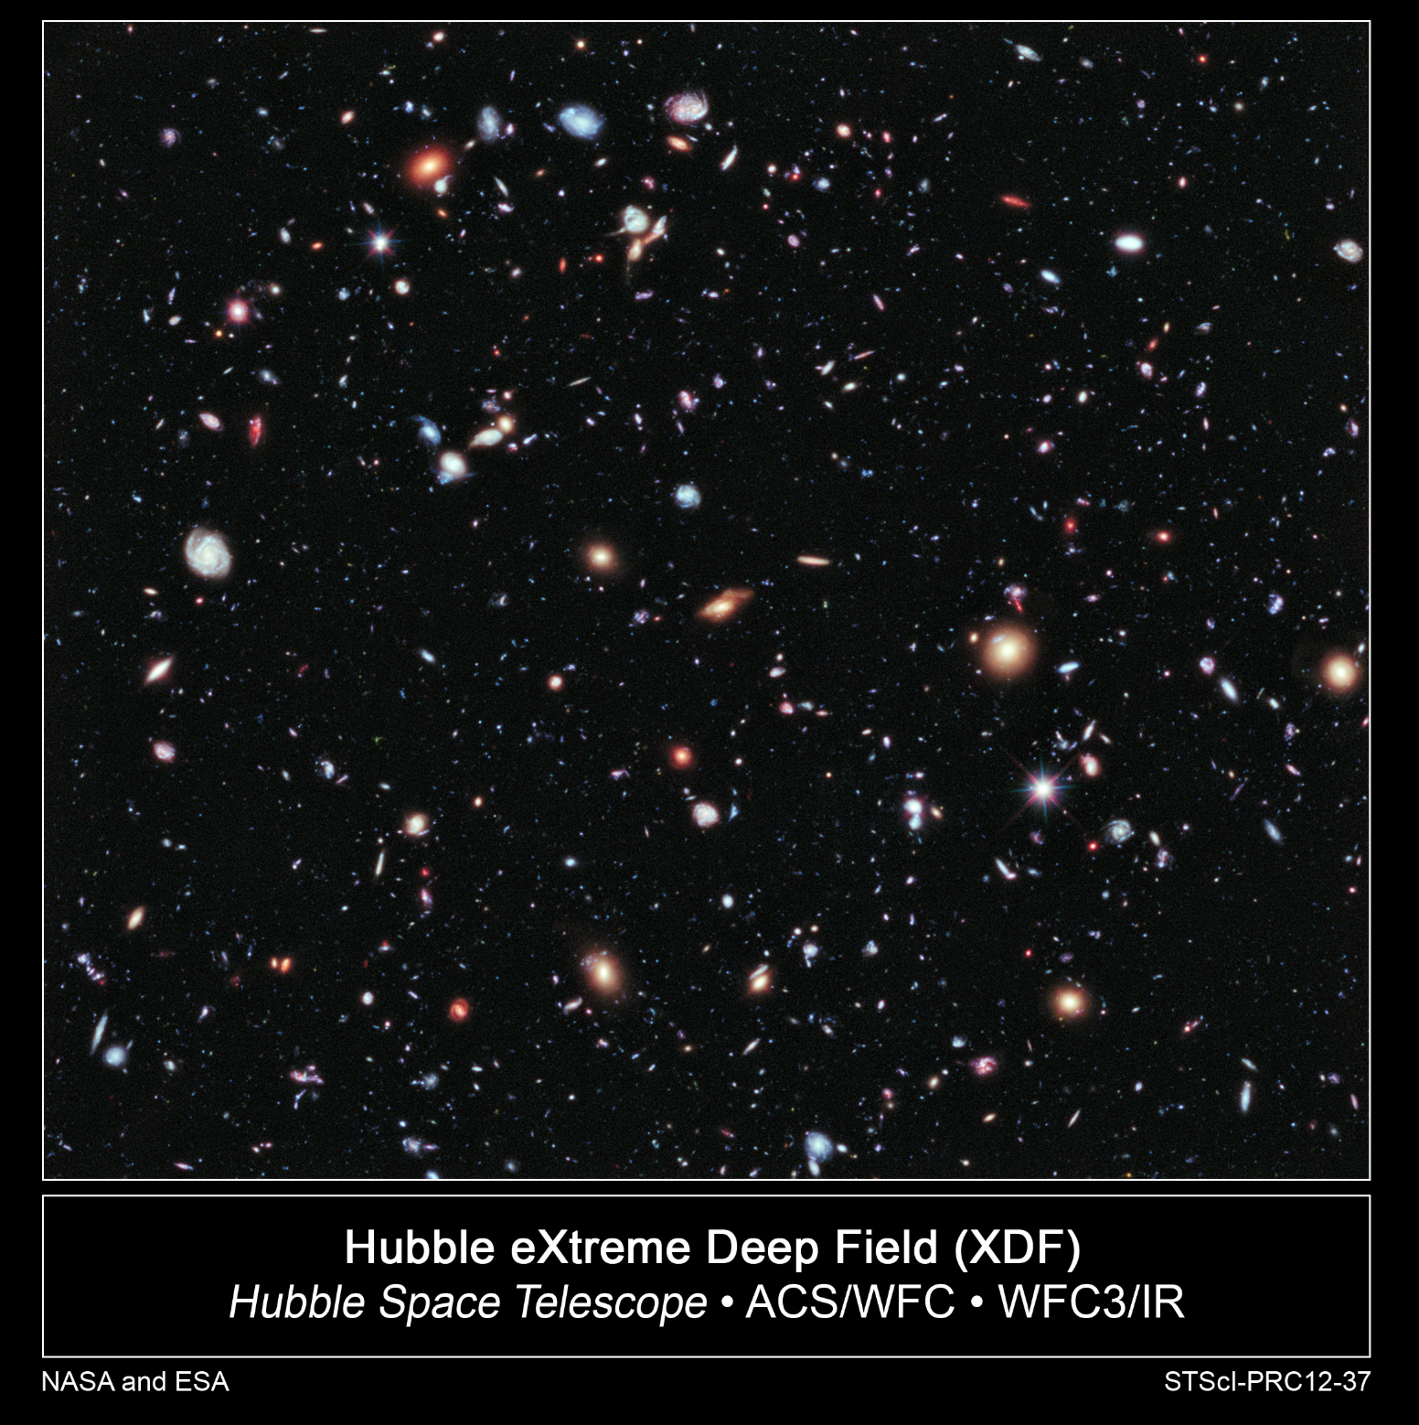
Example of a Hubble Space Telescope image, shown as a PNG for illustration; it is not raw FITS data.

2. Problem Statement

“How can we build an automated, instrument-aware pipeline that categorizes and classifies galaxy morphology directly from science-ready archival HST imaging — performing its own source triage (star/galaxy/artefact) without supervision, refining morphology against an empirical instrument PSF, attaching calibrated per-object uncertainty and full data provenance, and reporting honest cross-survey generalization by explicitly separating true model degradation from differences in human labeling schemes?”

2.1 Background
The shape of a galaxy records its history. Smooth, centrally concentrated spheroids are usually old and quiescent; discs with spiral arms are still forming stars; irregular and disturbed systems are often the result of interactions and mergers, which drive much of galaxy evolution.
Morphology is therefore one of the first quantities astronomers measure for a new galaxy sample, and the Hubble Space Telescope, free of atmospheric blurring, resolves this structure out to large distances.
Telescopic sky surveys generate high-volume, multi-band image data that outpaces manual cataloguing and public crowdsourcing. Automated approaches often treat source categorization as an isolated computer-vision problem, ignoring localized optical variations, structural contaminants and spatial data leakage.
An archival HST image contains stars, detector artefacts, cosmic rays and galaxies together, observed in several filters that are not perfectly aligned and that have different point-spread functions (PSFs).

2.2 Why archival HST imaging is hard
- Mixed populations: A detection list mixes galaxies, foreground stars and spurious detections such as cosmic rays, diffraction spikes and edge effects.
- Cosmic rays: Drizzling rejects cosmic rays only when several exposures are combined. Single-exposure products keep every hit, and these look like real, sharp sources.
- Multi-filter registration: Filters and instruments are often observed in different programs, years and orientations, with different pixel scales. Their coordinate solutions can disagree by a fraction of an arcsecond, which corrupts colors unless the bands are registered.
- Wavelength-dependent PSF: The point-spread function changes with filter, instrument and position. Without PSF matching, colors and sizes are biased, and without an empirical PSF a compact galaxy cannot be told apart from a star.
- Few labels: Crowd-sourced morphology labels cover only some surveys and only the brighter galaxies, so most fields have few labels or none.
- Different label schemes: Expert and volunteer catalogues define their classes differently, so an external test mixes model error with disagreement between the label schemes.
Hence, this project presents Pixels to Provenance, an end-to-end machine learning system that ingests calibrated, drizzled 32-bit floating-point science extensions directly from the Mikulski Archive for Space Telescopes (MAST) and converts them into a science-ready, provenance-tracked physical catalogue.

3. System Context & Architectural Premise
System pipeline implements a Hierarchical Two-Tier Processing Framework.
Tier 1: Unsupervised Object Segregation: The first tier separates detections into physical categories without any training labels. A convolutional autoencoder’s latent space, fused with up to fourteen physical features, is clustered by a Gaussian Mixture Model, with HDBSCAN alongside. The clusters are then named from independent evidence that was not used for clustering (Gaia DR3, Galaxy Zoo positions, noise tests), and each object is checked by a physics-based gate.
- Point sources (stellar tracers): sources matched to Gaia DR3, or point-like (size ≈ the PSF, fwhm_over_psf ≈ 1), bright and seen in two bands are clustered as Stars.
- Spurious detections: cosmic rays, hot pixels and artefacts, identified because no second band shows light at the same position, because they are sharper than the PSF, or because their S/N is very low. They are kept in the catalogue as Noise, not deleted.
- Extended sources: Galaxy candidates, typically resolved (larger than the PSF) and confirmed in a second band. They form the input stream for morphological profiling.
Tier 2: Supervised Classification & Morphological Profiling: Only galaxies are classified; the stellar and spurious streams provide the calibration making galaxy results trustworthy.
- Point sources → Empirical PSF: stars bypass morphology. The cleanest ones (isolated, unsaturated) are stacked with photutils.EPSFBuilder to measure each field’s optical blur.
- Spurious detections → False-positive model: a negative-image test measures the false-positive rate of the detection threshold. Together with the two-band and sharpness tests, it gives every object a noise_score.
- Extended sources → Morphological profiling: the empirical PSF first drives a single Pass-2 refinement, in which the galaxies’ Sérsic fits are corrected for PSF blurring. The galaxies are then classified by an ensemble of two fine-tuned ImageNet CNNs and two XGBoost models.
  - Morphological class: temperature-calibrated probabilities for Smooth, Face-On Spiral, Edge-On, Irregular and Ambiguous.
  - Interaction signature: a Platt-calibrated merger probability from a separate merger XGBoost (frozen CNN features of the galaxy stamp plus the physical features), alongside the measured asymmetry and shape-asymmetry indices in the catalogue.
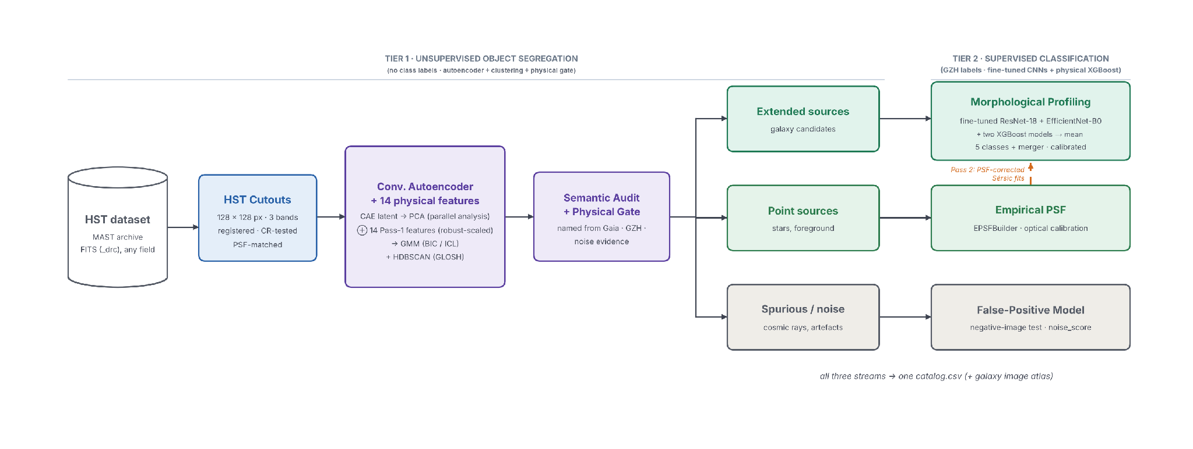
Hierarchical two-tier processing framework: unsupervised segregation (Tier 1) feeds the stellar, spurious and galaxy streams of Tier 2 (supervised classification).

4. Project Objectives
The proposal set five verifiable objectives. During the project they were sharpened to the final design (more fields, an ensemble of fine-tuned CNNs and two XGBoost models, model selection by cross-validation, sealed external data), and a sixth was added: the pipeline must work on any HST field, not only on the one it was developed on. The table below lists the six objectives with the metric used to judge each one.
Project objectives and how each is measured.
# | Objective | How it is measured
O1 | Reproducible, instrument-aware ingestion and preprocessing of multi-pointing HST imaging: registered, PSF-homogenised cutouts and a physical feature table, under a frozen sky partition that prevents leakage | Runs end-to-end with no manual steps; no pixels shared between splits (at least 7.2″ apart) and no GZH entry used twice; registration residuals; a PSF for every band and pointing, measured or borrowed from another pointing
O2 | Unsupervised segregation of galaxies, stars and spurious detections, including cosmic-ray rejection, validated against Gaia DR3 and compared with a size–magnitude / stellarity baseline | Star precision / recall vs Gaia; galaxy recall vs GZH; cluster purity and NMI vs independent evidence; comparison with Stage 2c; objects removed by the cosmic-ray gate
O3 | Supervised morphology ensemble: five morphology classes, with labels derived from GZH vote fractions by stated rules, predicted by two fine-tuned ImageNet CNNs (ResNet-18, EfficientNet-B0) and two XGBoost models (18 physical features; frozen CNN + physical features), averaged and calibrated; a merger probability from a separate XGBoost; an ablation shows what each member adds | Out-of-fold Macro-F1 (5-fold CV on train + dev); test 5-class Macro-F1 (target 0.65); coverage, accuracy and 4-class Macro-F1 on galaxies given a shape; merger PR-AUC; ablation Δ Macro-F1 of the ensemble over the best single source
O4 | Generalisation beyond the training conditions: (a) the same derived labels on held-out external sky; (b) the independent CANDELS expert catalogue, separating model disagreement from differences between labelling schemes | (a) External GZH score, overall and per pointing, with and without GOODS-N-4; (b) taxonomy ceiling, cross-catalogue Macro-F1 and their difference, per split (CANDELS part skipped, not failed, where CANDELS does not cover the field)
O5 | One provenance-tracked catalog.csv with calibrated probabilities, confidence and heritage flags, plus a .png image of every classified galaxy, with its class and confidence, and low-confidence predictions filed as Uncertain | Test ECE after calibration; delivery checks; atlas index; cosmic-ray suspect flags
O6 | Generic, reusable pipeline (added): any HST field, with a data-acquisition tool; train mode where GZH labels exist, apply mode (frozen model bundle) where they do not | Runs on a new field without code changes; a missing optional catalogue (Gaia, CANDELS) skips stages instead of failing

5. System Architecture
The architecture is layered so that each phase consumes only frozen outputs of earlier phases. This is what makes the pipeline reproducible and leakage-free: a stage cannot change data that an earlier evaluation depended on. The table below lists the layers and the figure below shows the data flow.
Architecture layers and their responsibilities.
Layer | Phases / stages | Responsibility
Governance | Phase 0 (Stage 0) | Data acquisition (tools/get_fits.py); sky-region partition by pointing with a buffer collar; a seal for the external data and a ledger for the test — fixed before any model is trained
Ingestion & preprocessing | Phase 1 (1a–1e) | Read FITS, frame QC, detection and deblending, cosmic-ray identification, multi-band registration, PSF matching, Pass-1 morphology
Unsupervised segregation | Phase 2 (2a–2e) | Representation learning, clustering, baseline, semantic naming of clusters, physical gate → Star / Galaxy / Noise
Routing & optical calibration | Phases 3 and 5 | Galaxy labels, star routing to the empirical PSF, noise model; ePSF and Pass-2 morphology
Supervised learning | Phase 4 (4a–4d) | Galaxy stamps and frozen ImageNet features; ensemble of fine-tuned ResNet-18, fine-tuned EfficientNet-B0, a physical-feature XGBoost and a fusion XGBoost (averaged); merger XGBoost; calibration; ablation — every member cross-validated on the same 5 folds
Evaluation | Phases 6–7 | In-domain test (Stages 6a–6c, every evaluation logged), uncertainty audit, SHAP of the XGBoost models, Grad-CAM of the CNNs; taxonomy ceiling and cross-catalogue test on every split; external GZH score once the model is final
Delivery | Phases 8–9 (Stages 8, 9) | Unified catalogue (one row per source × 95 columns), column dictionary, delivery checks; colour image atlas of every catalogue galaxy
Cross-cutting | all | config.yaml (about 270 documented parameters), run_log.json provenance, stage logs, frozen splits, version tag; train / apply mode

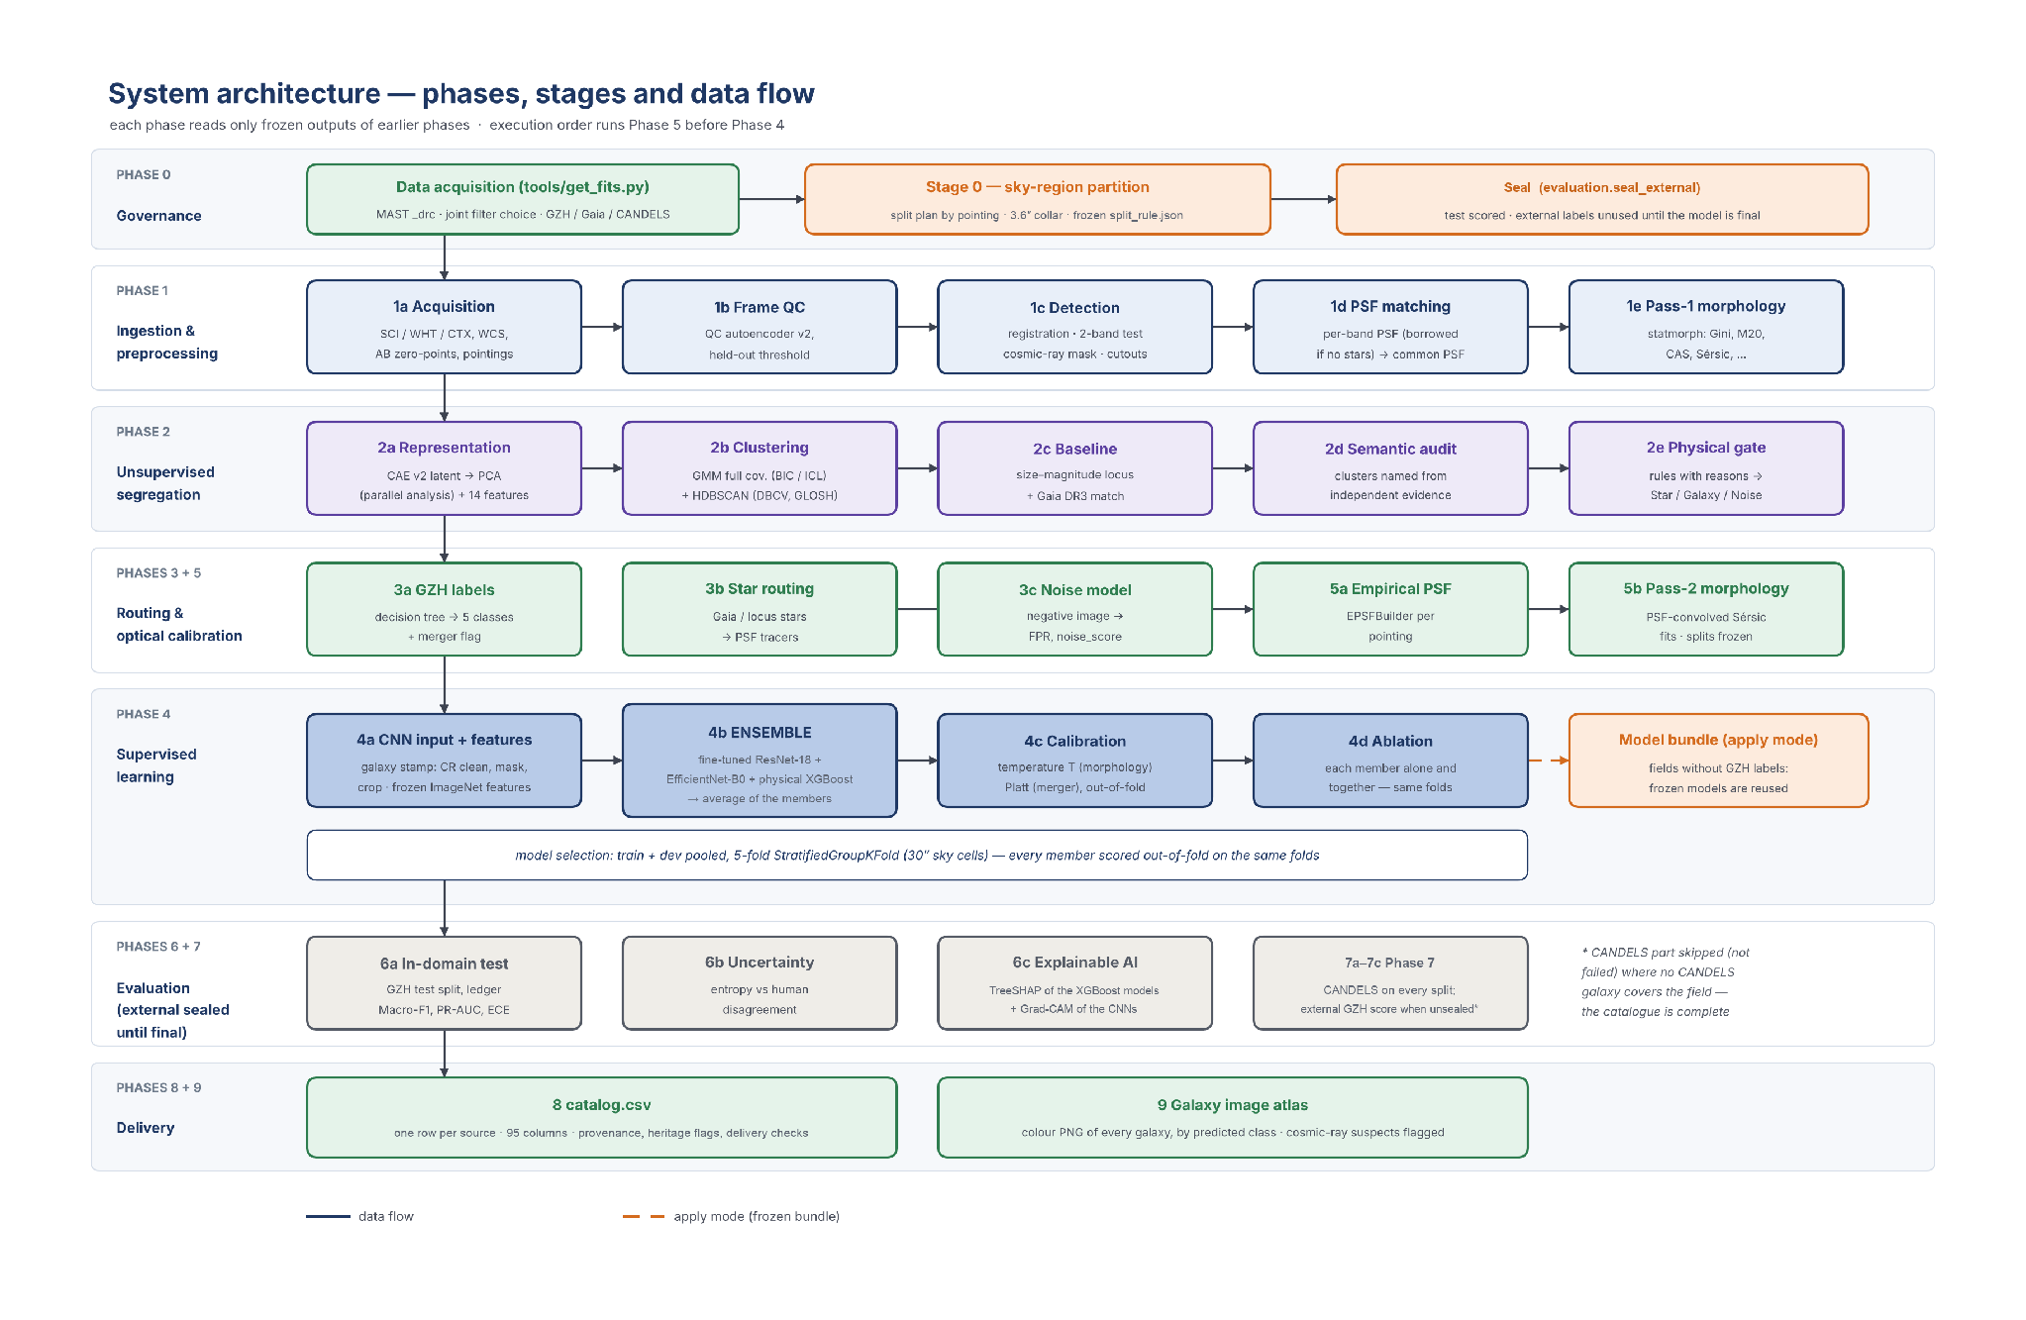
System architecture: phases, stages and the data passed between them.

6. Data Sources
Everything in this project starts with the data, so this section explains, in plain words, what I used and why. I worked only with real archival observations: Hubble images from the MAST archive, the Galaxy Zoo: Hubble (GZH) volunteer labels, the Gaia DR3 star catalogue and the CANDELS expert catalogue. There is no simulated or demo data anywhere in the final pipeline.

6.1 Why fourteen GOODS pointings
I started with a single GOODS-South pointing of three files. It held only 280 GZH-labelled galaxies, of which about 216 could be used for training and model selection and 40 for testing. Five classes cannot be learned, or tested honestly, from so few examples, so I extended the data first to eight and finally to fourteen pointings in the two GOODS fields (Giavalisco et al. 2004).
All images are ACS/WFC _drc products: drizzled onto a sky-aligned 0.05″ grid, corrected for geometric distortion and charge-transfer efficiency, with a reliable world coordinate system.
Every pointing has the same three filters, F435W (B), F606W (V) and F775W (i), and the reddest, F775W, is the detection band.
Colour slot | ACS broad-band filters
blue | F435W, F475W
green | F555W, F606W, F625W
red | F775W, F814W, F850LP

The fourteen pointings: files, programme, exposure and NDRIZIM per filter F435W / F606W / F775W, sky area covered by all three filters, and GZH and CANDELS catalogue entries in that area.
Pointing | Files (F435W, F606W, F775W) | Programme; date | Exposure (s) | NDRIZIM | Area (arcmin²) | GZH / CANDELS
GOODS-S | jb5x4k010, hst_11563_4i, hst_11563_34 | 11563; 2009-11 – 2010-11 | 5,105 / 1,231 / 1,230 | 8 / 2 / 2 | 11.4 | 299 / 476
GOODS-S-2 | hst_9803_39, hst_9803_33, hst_9803_41 | 9803; 2003-11 | 1,150 / 1,150 / 1,150 | 2 / 2 / 2 | 7.4 | 173 / 133
GOODS-S-3 | j8e606010, j8e621010, j8e621030 | 9425; 2002-08 | 7,200 / 1,040 / 1,040 | 12 / 4 / 4 | 11.5 | 367 / 570
GOODS-S-4 | hst_9425_11, j8e688010, j8e688030 | 9425; 2002-08 – 2003-02 | 1,200 / 1,040 / 1,040 | 2 / 4 / 4 | 11.3 | 353 / 603
GOODS-S-5 | j8e607010, j8e622010, j8e622030 | 9425; 2002-08 | 7,200 / 1,040 / 1,040 | 12 / 4 / 4 | 11.4 | 295 / 429
GOODS-S-8 | j8e613010, j8e628010, j8e628030 | 9425; 2002-08 | 7,200 / 1,040 / 1,040 | 12 / 4 / 4 | 11.5 | 330 / 344
GOODS-S-9 | j8e609010, j8e624010, j8e624030 | 9425; 2002-08 | 7,200 / 1,040 / 1,040 | 12 / 4 / 4 | 11.5 | 269 / 488
GOODS-N-1 | hst_9583_a1, hst_9583_h8, hst_9583_h8 | 9583; 2002-11 – 2003-05 | 1,200 / 480 / 480 | 2 / 2 / 2 | 11.2 | 408 / –
GOODS-N-2 | j8dna3010, j8dnb8010, j8dnb8030 | 9583; 2002-11 | 7,200 / 1,120 / 1,120 | 12 / 4 / 4 | 11.3 | 349 / –
GOODS-N-3 | j8dna0010, j8dnb5010, j8dnb5030 | 9583; 2002-11 – 2002-12 | 7,200 / 1,120 / 1,120 | 12 / 4 / 4 | 11.4 | 424 / –
GOODS-N-4 | j8dna4010, j8dnb9010, j8dnb9030 | 9583; 2002-11 | 7,200 / 1,120 / 1,120 | 12 / 4 / 4 | 11.5 | 321 / –
GOODS-N-6 | j8dn99010, j8dnb4010, j8dnb4030 | 9583; 2002-11 | 7,200 / 1,120 / 1,120 | 12 / 4 / 4 | 11.4 | 373 / –
GOODS-N-7 | j8dna6010, j8dnc1010, j8dnf2030 | 9583; 2002-11 – 2003-02 | 7,200 / 1,120 / 960 | 12 / 4 / 4 | 11.0 | 322 / –
GOODS-N-9 | j8dna9010, j8dnc4010, j8dnc4030 | 9583; 2002-11 – 2002-12 | 7,200 / 1,120 / 1,120 | 12 / 4 / 4 | 11.5 | 355 / –
Total | 42 files |  |  |  |  | 4,638 / 3,043 entries

6.2 How I chose the images
Choosing the images was harder than I expected. A position in GOODS is covered by dozens of HST products from different programs, depths, orientations and years, and a source only counts where all three filters see it, because two-band confirmation, colors and PSF matching all need every band. I wrote tools/get_fits.py for this and it needed three versions before the final download (figure below). I took the target positions from the GZH catalogue itself — the 3.3′ boxes with the most labelled galaxies (413, 336, 364 and 302 in the four GOODS-North boxes), so that every pointing adds training labels.
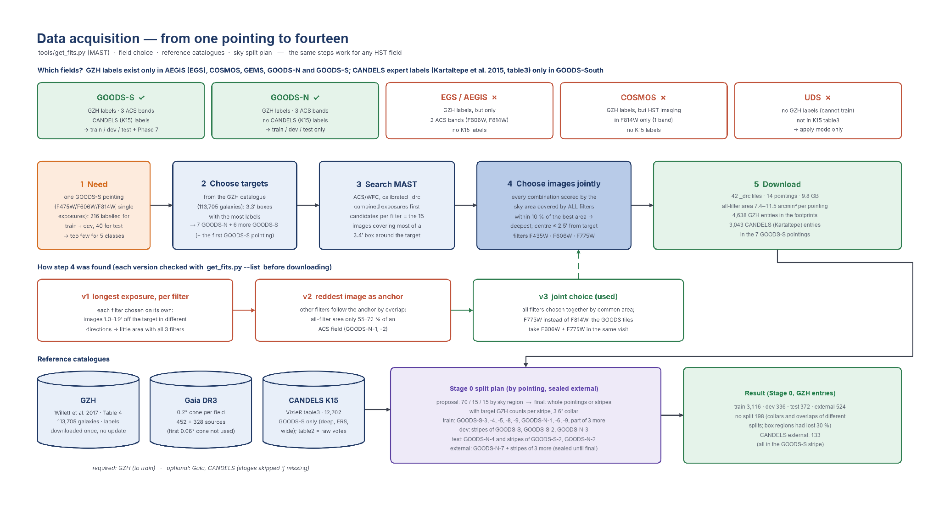
Data acquisition: from one pointing to fourteen. Top: steps of tools/get_fits.py; middle: the three versions of the image choice; bottom: reference catalogues and Stage 0 split plan.

Before downloading any file, I checked every choice with get_fits.py --list, which prints the chosen file per filter, its exposure, its offset and the common area. The result is 42 files (9.8 GB) with 7.4–11.5 arcmin² covered by all three filters per pointing.

6.3 Reference catalogues
Three catalogues give the pipeline its independent evidence . Only GZH is required, and only for training; Gaia and CANDELS are optional. Every catalogue is matched within 0.5″ after removing the astrometric offset of each pointing, measured in every run. For GZH the offsets range from (+0.03″, −0.39″) to (+0.49″, +0.76″) in GOODS-N-4 — which is why one offset for the whole data set was not enough (Section 16.1).
Catalogue | Reference | Role in the pipeline | Used in | In the 14 pointings
Galaxy Zoo: Hubble (GZH) | Willett et al. 2017; Table 4, 113,705 galaxies | Morphology labels (vote fractions → 5 classes + merger); position evidence for naming clusters | 2d, 3a, 4, 6 | 4,638 entries in the footprints of the 14 pointings; matched to catalogue galaxies: final run
Gaia DR3 | Gaia Collaboration 2023 | Independent star ground truth (parallax, proper motion) | 2c, 2d, 2e, 3b | matched to sources: final run
CANDELS visual (K15) | Kartaltepe et al. 2015; VizieR J/ApJS/221/11 table3, 12,702 galaxies  Url: https://archive.stsci.edu/hlsp/candels | Independent expert labels for the cross-catalogue test | 7a–7c, 8 | 3,043 entries in the seven GOODS-South pointings; none in GOODS-North

6.4 Why Galaxy Zoo: Hubble
A supervised classifier needs morphology labels for galaxies in the same images. Galaxy Zoo: Hubble (Willett et al. 2017) is the natural source: 113,705 galaxies in HST legacy imaging, classified by volunteers through a fixed decision tree. It is public, it is dense in GOODS, it uses the same telescope, and its vote fractions record how much people agreed. Its limits matter too: it covers only some surveys and the brighter galaxies, volunteers often disagree, and its FULLDEPTH images are deeper than the _drc files used here. GZH holds vote fractions, not morphology classes; Section 9.1 explains how the classes are derived.

6.5 Why CANDELS, and what it adds
Scoring a model only against the labels it learned from cannot show whether those labels are meaningful. The CANDELS visual classifications (Kartaltepe et al. 2015; 12,702 galaxies in table 3) are made by expert astronomers, independently of GZH, under a different scheme: spheroid, disk, irregular, point source and unclassifiable. In this project CANDELS never trains a model and does not enter the GZH Macro-F1.
It has three roles:
- the k15_* reference columns of catalog.csv;
- the taxonomy ceiling, which measures how far the two human catalogues agree;
- and the cross-catalogue score, which measures how far the model agrees with experts.
Together these separate model error from differences between labelling schemes. Face-on spirals and edge-on galaxies both map to Disk, because they are usually the same kind of galaxy seen at different angles; CANDELS therefore supports "disk" but cannot confirm "spiral". It covers only GOODS-South here, so no GOODS-North galaxy gets this check.

7. Data Segregation, Split Rule and Sealing
How the labelled galaxies are divided decides whether the scores in this report can be trusted. This section explains how the data were segregated, how the split rule was decided, and how the held-out data were kept sealed.

7.1 Splitting the sky, not the objects
Neighbouring galaxies share pixels and sky background, and overlapping pointings can detect the same galaxy twice. A random split of objects would therefore put near-copies of a test galaxy into training. Stage 0 splits the sky instead: each pointing, or a stripe of it, belongs to exactly one bucket, and a 3.6″ collar (buffer) on each side separates neighbouring regions, so two splits stay at least 7.2″ apart, more than the 6.4″ width of one cutout. They therefore share no pixels. A region is the real data footprint of the pointing (the area with data in every band). Objects in a collar, or in the overlap of two regions of different buckets, get no split and are never used for training or scoring. The rule is written once to split_rule.json, before any model is trained, and every later stage only reads it.

7.2 Split plan updates
The proposal planned a 70 / 15 / 15 split of one field by sky stripes. With eight pointings the split became a plan that I set pointing by pointing in config.yaml (partition.pointing_splits).
It went through five versions, each tested by simulating Stage 0 on the real files before any run:
- Automatic split (first 8-pointing attempt). Whole pointings, with GOODS-S-3 and GOODS-S-4 held out. The simulation showed that the regions were RA/Dec boxes around tilted ACS frames, about twice the real data area; neighbouring boxes overlapped and 778 of 2,581 GZH galaxies (30 %) got no split. Regions are now the real data footprints.
- Planned split (28 Oct, 16:36). Every pointing assigned by me, with stripes of equal data area. The simulation showed that the 20 % dev stripe of GOODS-S-2 fell on its western edge, outside the GZH coverage, and would have held no labelled galaxy.
- Plan by GZH share (28 Oct, 16:44). Stripes are sized by their share of the pointing's GZH galaxies — positions only, never classes so that every bucket receives labels; 219 of 2,581 GZH galaxies (8.5 %) were left without a split.
- More training data (30 Oct evening). Too many GZH galaxies were parked in external, where they are scored only at the very end, so I moved stripes of GOODS-S-4 and GOODS-N-2 into train and test, with the target counts 1,423 / 319 / 373 / 318. Stage 0 then gave 1,454 / 319 / 325 / 279, because collars and overlaps removed galaxies after the stripes had been sized.
- Final plan (31 Oct). Stripes now have target counts, and Stage 0 moves their cuts until the counts hold after collars and overlaps (positions only). The collar went from 6″ to 3.6″, because GOODS-N-2 could not reach its targets otherwise. Six deep pointings were added: GOODS-N-6, GOODS-N-9, GOODS-S-5, GOODS-S-8 and GOODS-S-9 for training, and GOODS-N-7 wholly as external. GOODS-N-6 and GOODS-N-9 overlap held-out stripes and yield there, so adding them does not shrink the test or external data. GOODS-S-4 then moved wholly into train, and labelled buffer galaxies at least 7.2″ from every test and external galaxy joined the training pool.
The final split plan: what each bucket contains and what it is used for (GZH galaxies as assigned by Stage 0).
Bucket | Pointings | GZH galaxies | Used for | When
Train | GOODS-S-3, -4, -5, -8, -9; GOODS-N-1, -6, -9; stripes of GOODS-S, GOODS-N-2, GOODS-N-3; plus labelled buffer galaxies ≥ 7.2″ from held-out galaxies | 3,116 | fitting every model: autoencoders, scalers, PCA, clustering, ensemble members | continuously
Dev | stripes of GOODS-S, GOODS-S-2, GOODS-N-3 | 336 | validation of the autoencoders; pooled with train for 5-fold cross-validation (model choices, calibration, ablation) | continuously
Test | GOODS-N-4 (66 %), GOODS-S-2 (80 %), GOODS-N-2 (15.5 %) | 372 | in-domain score of the final ensemble (Stages 6a–6c) | every evaluation logged
External | GOODS-N-7; stripes of GOODS-S, GOODS-N-2, GOODS-N-4 | 524 | out-of-field GZH score and the external part of Phase 7 | once, when the model is final
No split | 3.6″ collars and overlaps of different buckets | 198 | buffer galaxies far from held-out sky can train; never scored in Stage 6a; catalogue rows and Phase 7 (CANDELS) | –

GZH catalogue entries per pointing and split, as Stage 0 assigns them in the 14-pointing plan (detection, label matching and edge cuts later leave fewer galaxies in each split). "No split": inside a collar or in an overlap of two regions of different splits.
Pointing (stripes by share of GZH galaxies) | train | dev | test | external | no split
GOODS-S (train / dev / external) | 62 | 127 | – | 72 | 34
GOODS-S-2 (test / dev) | – | 33 | 133 | – | 7
GOODS-S-3 | 354 | – | – | – | 0
GOODS-S-4 | 353 | – | – | – | 0
GOODS-S-5 | 295 | – | – | – | 0
GOODS-S-8 | 330 | – | – | – | 0
GOODS-S-9 | 268 | – | – | – | 0
GOODS-N-1 | 372 | – | – | – | 13
GOODS-N-2 (train / test / external) | 212 | – | 48 | 47 | 42
GOODS-N-3 (train / dev) | 206 | 176 | – | – | 42
GOODS-N-4 (test / external) | – | – | 191 | 97 | 17
GOODS-N-6 (yields to held-out stripes) | 340 | – | – | – | 10
GOODS-N-7 (external) | – | – | – | 308 | 14
GOODS-N-9 (yields to held-out stripes) | 324 | – | – | – | 19
Total | 3,116 | 336 | 372 | 524 | 198

7.3 How the held-out data stayed sealed
Nothing is tuned on held-out data: no test or external label is used for training, model selection or calibration. evaluation.seal_external kept the external galaxies out of scoring until the final run, and test_split_ledger.json records every test evaluation. The test split was scored four times (Macro-F1 0.526, 0.511, 0.540 and 0.548) with no tuning on those scores, and an audit exposed an external score once, which no decision used. GOODS-N-7 was added as untouched external data, and the external score is also reported without GOODS-N-4, because 80 of its galaxies had earlier been scored as test. The label rule changed after the first three evaluations, using train and dev galaxies only, so those three scores are not comparable with the final one.

8. Generalized Project
Nothing in the code is specific to GOODS. User only needs calibrated HST images: get_fits.py --target RA,Dec,name downloads one _drc image per filter with the joint-coverage rule, Stage 1a groups the files into pointings, and with an empty split plan Stage 0 assigns whole pointings (three or more) or 70 / 15 / 15 stripes automatically. A field with at least 150 GZH galaxies is trained directly; otherwise it runs in apply mode, where a saved model bundle (the fine-tuned networks, the XGBoost models and the calibration) classifies every galaxy. Table below lists what happens when an input is missing — in every case the galaxies are classified and the catalogue and atlas are written.
Input | Needed by | If it is missing
HST _drc images (1–3 filters) | all stages | required
Galaxy Zoo: Hubble | 3a, 4a–4d (training), 6a–6c | apply mode with a saved model bundle; Stages 6a–6c skipped when the field has no GZH galaxy
Gaia DR3 | 2c, 2d, 3b | star evidence from the stellar locus; star precision / recall vs Gaia not reported
CANDELS (Kartaltepe et al. 2015) | 7a–7c, k15_* columns | CANDELS part of Phase 7 skipped (no cross-catalogue score); morphology, catalogue and atlas unchanged; k15_* columns empty

9. Morphology Classification Rules and Scoring

9.1 From GZH votes to morphology classes: the rules
Stage 3a converts the vote fractions into classes. The GZH dataset was kept intact, untouched. The rules are checked in the order of the table below, and a galaxy takes the first class it passes, so a galaxy with edge-on 0.45 and spiral 0.43 becomes EdgeOn. Ambiguous means the galaxy passed no shape rule; it is not a value in GZH and usually not an unclassifiable image. smooth and features are debiased fractions; the others are weighted fractions. The first rule used limits of 0.5 and 0.6 and left 782 of 2,852 train and dev galaxies Ambiguous. I relaxed the limits after comparing rules on train and dev only (Ambiguous 391). A 0.4 vote is weaker evidence than 0.5, and the rule was chosen after seeing those results, so it is reported as a design decision, not as a discovery about galaxies.
Rules that derive the five classes from GZH vote fractions (checked in this order).
Class | Rule | Meaning
1 Smooth | smooth ≥ 0.6, or smooth ≥ 0.4 and smooth ≥ features | volunteers saw no features
2 EdgeOn | features ≥ 0.4 and edge-on ≥ 0.4 | a featured disk seen from the side
3 FaceOnSpiral | features ≥ 0.4 and spiral ≥ 0.4 | a featured disk with spiral arms voted
4 Irregular | features ≥ 0.4, and clumpy ≥ 0.5, or odd ≥ 0.4 and the larger of irregular, disturbed ≥ 0.4 | clumpy or disturbed structure
5 Ambiguous | everything else | no shape rule passed

The model does not use these rules. They create the training labels; the networks and trees then learn from examples, and for any new galaxy the class with the highest averaged, calibrated probability becomes pred_class. A top probability below 0.4 also sends the galaxy to the Uncertain folder of the atlas.

9.2 How the Macro-F1 and shape scores are calculated
Every score compares pred_class with the derived label. For one class, precision = TP / (TP + FP), recall = TP / (TP + FN) and F1 = 2 × precision × recall / (precision + recall). Macro-F1 is the plain average of the class F1 scores, so each class counts equally however many galaxies it has; this matters because the classes are unbalanced.
Accuracy = correct predictions / all galaxies, so each galaxy counts equally. Because Ambiguous means no rule passed, two further numbers are reported.
Coverage is the share of galaxies the model gives a shape (any class except Ambiguous). On those galaxies, accuracy and 4-class Macro-F1 are measured against the derived label, and a derived label of Ambiguous counts as wrong. Nothing is removed from GZH. Coverage is always stated with these scores, because a model could raise them by calling hard galaxies Ambiguous. The proposal's 0.65 target remains a 5-class target.
The next two tables show the calculation for the final test run.
Confusion matrix: final test run (328 galaxies; rows: derived label, columns: prediction).
Label / predicted | Smooth | FaceOnSpiral | EdgeOn | Irregular | Ambiguous | F1
Smooth | 28 | 5 | 4 | 2 | 4 | 0.675
FaceOnSpiral | 2 | 47 | 8 | 19 | 4 | 0.566
EdgeOn | 3 | 6 | 44 | 16 | 2 | 0.595
Irregular | 4 | 21 | 12 | 40 | 10 | 0.462
Ambiguous | 3 | 7 | 9 | 9 | 19 | 0.442

Worked example for each class (Macro-F1 = (0.675 + 0.566 + 0.595 + 0.462 + 0.442) / 5 = 0.548; accuracy = 178 / 328 = 0.543).
Class | TP | FP | FN | Precision | Recall | F1
Smooth | 28 | 12 | 15 | 0.700 | 0.651 | 0.675
FaceOnSpiral | 47 | 39 | 33 | 0.547 | 0.588 | 0.566
EdgeOn | 44 | 33 | 27 | 0.571 | 0.620 | 0.595
Irregular | 40 | 46 | 47 | 0.465 | 0.460 | 0.462
Ambiguous | 19 | 20 | 28 | 0.487 | 0.404 | 0.442

9.3 Why the Macro-F1 is low
The final test Macro-F1 is 0.548 (95 % CI 0.494–0.599), against 0.084 for always predicting the majority class and the proposal target of 0.65. Section 16.1 shows how the score was raised during the project. Six things limit it:
- Noisy labels. GZH provides volunteer votes, not classes, and the classes are derived by the rules above. Galaxies that appear twice in GZH agree on their class only 41 % of the time, which limits the score any model can reach.
- The Ambiguous class. It means that no shape rule passed, so it is not a real shape, yet it counts for one fifth of the Macro-F1. Its test F1 is 0.442.
- Very small galaxies. The median galaxy covers about 10 × 10 pixels of its 128 × 128 cutout, so spiral arms and clumps are hard to see.
- Similar classes. FaceOnSpiral and Irregular are confused most often, in 40 of the 150 test errors.
- Few labels. Only 3,185 labelled galaxies were available for training and model selection.
- Image quality. The three single-exposure pointings contain many cosmic rays. GOODS-S-2 reaches an accuracy of 0.44 on test (107 galaxies) and GOODS-S 0.39 on external (44 galaxies), although these samples are small.
The GZH data were not changed; only the rules that turn its votes into classes were. Editing the labels themselves would raise the score, but it would change the answer key and make the result meaningless. The table below shows how strongly the score depends on label clarity.
Macro-F1 on all galaxies and on galaxies with clearer labels.
Scored on | Test | External
All galaxies, 5 classes | 0.548 | 0.562
Galaxies where the label and the prediction are both shapes | 0.626 | 0.688
Galaxies where at least 70 % of volunteers agree | 0.700 | 0.698

The last row is above 0.65, but this does not mean that the model reached the target, because those galaxies are easier and were selected after the fact. The subsets show that clearer labels go with much higher scores; they do not show what Macro-F1 a better version of GZH would give, because that was not tested.

10. Project Flow
The figure below shows the execution order of the stages. The flow is linear and deterministic: python run_pipeline.py runs every stage in order, and --from <stage> resumes from any stage using the saved outputs of the earlier ones. Three design decisions are visible in the figure:
- Unsupervised before supervised. Stage 2 decides which detections are galaxies before any galaxy label is used, so the classifier never sees stars or artefacts.
- Stage 5 before Stage 4. The empirical PSF (5a) is built from the stars found in Stage 3b, and Pass-2 morphology (5b) is computed before training, so the models train on the same PSF-refined features they are deployed on. The splits are frozen in 5b.
- Test scored, external sealed. All model choices (fine-tuning settings, number of trees, calibration, ablation) use 5-fold cross-validation on the pooled train + dev galaxies. The test galaxies are scored in Stages 6a–6c, and Phase 7 runs on train, dev, test and buffer galaxies. The external galaxies stay sealed until the model is final, when they are scored once.
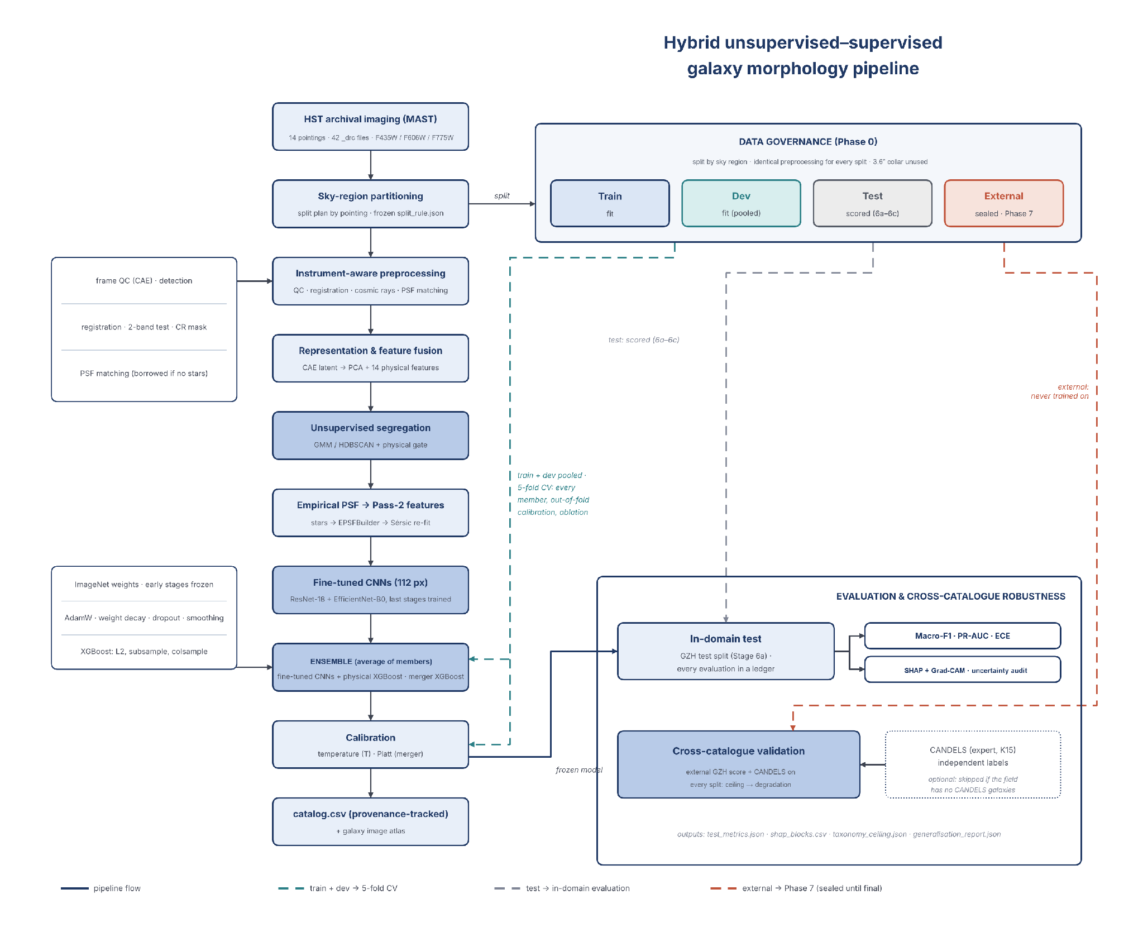
Project flow: execution order of the stages and the use of the train, dev, test and external splits.

11. Pipeline Stages and Outputs
Where the numbers in this section come from
Every value in this section comes from the final 14-pointing run of 31 October 2026 (12:30–16:29; run_final.log and outputs/), unless the text names an earlier run.

11.1 Phase 0 — Data governance

Stage 0 — Sky-region partition
Purpose. Prevent spatial leakage between training and evaluation. Method. The split plan of Section 7: each pointing or stripe is one region (its data footprint), stripes have target GZH counts, and a 3.6″ collar surrounds every boundary. Output. 21 regions in split_rule.json (figure below); GZH entries train 3,116, dev 336, test 372, external 524, no split 198.
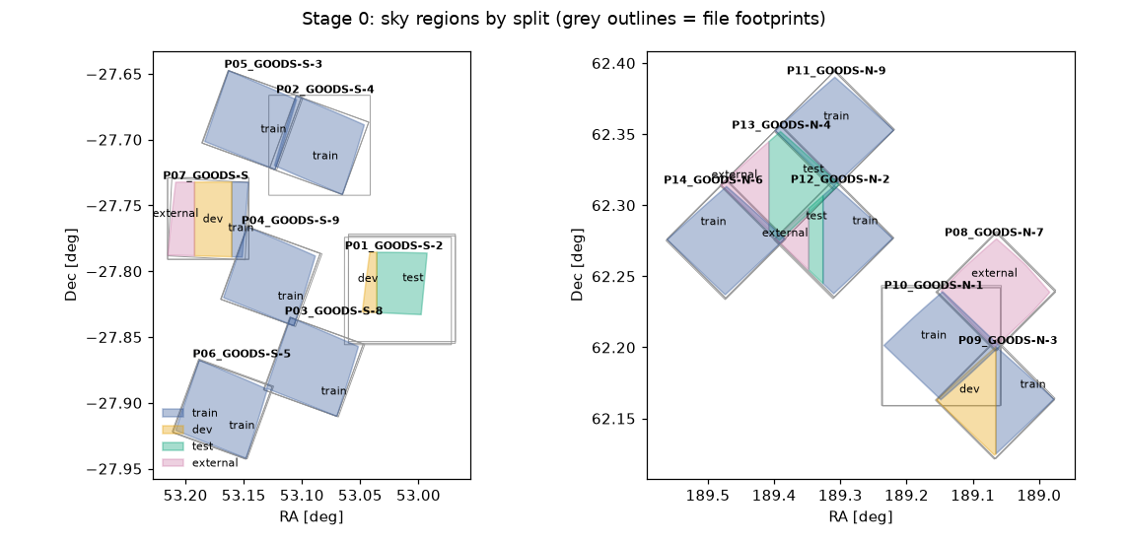
Stage 0 sky regions of the 14-pointing plan (left GOODS-South, right GOODS-North). Grey outlines are the file footprints; colours are the train, dev, test and external regions.

11.2 Phase 1 — Ingestion and instrument-aware preprocessing

Stage 1a — Archive acquisition
Reads every FITS file, checks that SCI, WHT and CTX extensions and a valid WCS exist, computes AB zero-points from PHOTFLAM/PHOTPLAM, the pixel scale, footprint and epoch, and groups the files into pointings by sky overlap. Each pointing gets its name, its splits from Stage 0 and a detection band (the reddest). Output. 42 verified files, 0 rejected → 14 pointings with F435W, F606W and F775W each, detection band F775W.

Stage 1b — Frame quality control
A small convolutional autoencoder (QC-CAE v2, 653,969 weights) learns what ordinary sky tiles look like; tiles it reconstructs poorly contain unusual structure: saturated stars, chip gaps, edges or strong artefacts. Only train and dev sky is used: 4,000 tiles of 128 px in 606 sky cells of 30″, and whole cells go to one role — 2,793 training, 407 validation and 800 calibration tiles. The threshold is the 99th percentile of the reconstruction error on the calibration tiles, with a bootstrap interval, so it is set without looking at the tiles being judged.
How early stopping works. After every epoch the autoencoder is scored on the validation tiles, which it never trains on. If the validation loss beats the best value so far by at least 0.5 %, the weights are saved as the new best (marked * in the log); otherwise a counter rises ("no gain k/10"). After 4 epochs without gain the learning rate is halved, and after 10 the training stops and the best weights are restored. A plateau guard keeps training while the model is less than 2 % better than a flat tile (each tile replaced by its mean), so it cannot stop on the initial "mean image" plateau — visible in the figure below up to about epoch 15. The cap is 120 epochs.
Output. Training stopped at epoch 63 (best epoch 61); validation loss 7.4 % below the flat-tile baseline; threshold MSE 0.00255 (95 % CI 0.00200–0.00291); on average 0.6 % of the tiles of a file are flagged. Flags are recorded in qc_flagged_bands (1,157 catalogue rows) and frame_quality_flag.
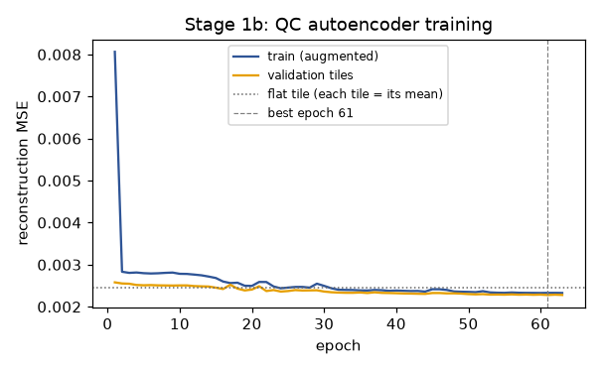
Stage 1b: QC autoencoder training. Validation loss of held-out sky cells against the flat-tile baseline (dotted); best epoch 61, early stop at 63.
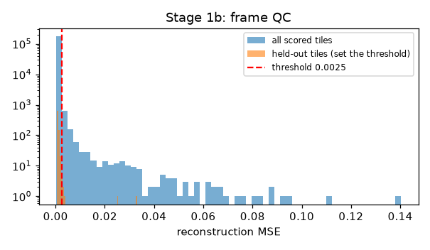
Stage 1b: reconstruction error of all scored tiles; the threshold (MSE 0.00255) is the 99th percentile of the calibration tiles.

Stage 1c — Detection, deblending, registration and cosmic rays
This is the stage that had to change most for real data. Sources are detected and deblended on F775W with photutils (deblend contrast 0.005, the SExtractor default; 0.001 split spiral arms and clumps into separate sources). Where a filter is a single exposure most detections are cosmic rays, so the stage does four things in order:
- Registration. Matching sources are taken from 5 × 5 median-filtered images, which removes cosmic rays but keeps galaxies; an offset is accepted only if its peak stands at least 5× above the random-pair level. The F435W images of GOODS-N-3 and GOODS-N-1 were offset by (0.97″, 1.81″) and (1.22″, 1.95″) and the F606W image of GOODS-N-2 by (−0.98″, 2.40″) (442, 145 and 459 matched sources; 184×, 12× and 240× the random level); all were corrected to a residual below 0.001″. The largest offset of the fourteen pointings is the F435W image of GOODS-S-5, (0.24″, 2.70″). Offsets of a few milliarcseconds are left as they are.
- Two-band confirmation. A second band confirms a source only if it has S/N ≥ 3 and its light is centred within 1.5 px (or 0.5 × the source radius) of the detection.
- Pixel-level cosmic-ray mask. A pixel is a cosmic ray if it is > 5σ and > 4× what the other bands predict from the source's median colour, and sharp: > 5σ and > 2× the median of its 8 neighbours. Such pixels are replaced by the prediction and flagged.
- Caps and photometry. Confirmed sources and cosmic-ray candidates are capped separately (8,000 and 1,000 per pointing), so cosmic rays cannot crowd out galaxies; per-band magnitudes, errors, n_exposures (from CTX) and saturation are written.
Output. 150,728 detections → 43,015 catalogue sources with aligned 128 × 128 × 3 cutouts. The table below shows how strongly the detections depend on the number of exposures: the three single-exposure pointings (GOODS-S-2, GOODS-S and GOODS-N-1) give 7–29 times more detections than the multi-exposure GOODS tiles, almost all of them cosmic rays.
Stage 1c per pointing.
Pointing | NDRIZIM F606W / F775W | Detections | Confirmed in a 2nd band | Cosmic-ray candidates | Catalogue sources | Median S/N
P01 GOODS-S-2 | 2 / 2 | 49,686 | 6,287 | 40,290 | 9,000 | 39.4
P02 GOODS-S-4 | 4 / 4 | 1,922 | 1,082 | 835 | 1,922 | 17.3
P03 GOODS-S-8 | 4 / 4 | 2,475 | 991 | 1,484 | 1,991 | 21.5
P04 GOODS-S-9 | 4 / 4 | 1,803 | 880 | 923 | 1,803 | 17.9
P05 GOODS-S-3 | 4 / 4 | 2,155 | 1,034 | 1,121 | 2,034 | 18.5
P06 GOODS-S-5 | 4 / 4 | 2,197 | 863 | 1,334 | 1,863 | 20.1
P07 GOODS-S | 2 / 2 | 52,779 | 6,392 | 46,172 | 7,607 | 30.2
P08 GOODS-N-7 | 4 / 4 | 1,935 | 927 | 951 | 1,935 | 17.9
P09 GOODS-N-3 | 4 / 4 | 3,011 | 1,387 | 1,624 | 2,387 | 21.3
P10 GOODS-N-1 | 2 / 2 | 22,540 | 3,056 | 19,483 | 4,057 | 40.5
P11 GOODS-N-9 | 4 / 4 | 2,225 | 1,087 | 1,137 | 2,088 | 17.8
P12 GOODS-N-2 | 4 / 4 | 3,093 | 1,172 | 1,921 | 2,172 | 22.4
P13 GOODS-N-4 | 4 / 4 | 2,691 | 1,132 | 1,559 | 2,132 | 21.3
P14 GOODS-N-6 | 4 / 4 | 2,216 | 1,024 | 1,192 | 2,024 | 18.7
Total |  | 150,728 | 27,314 | 120,026 | 43,015

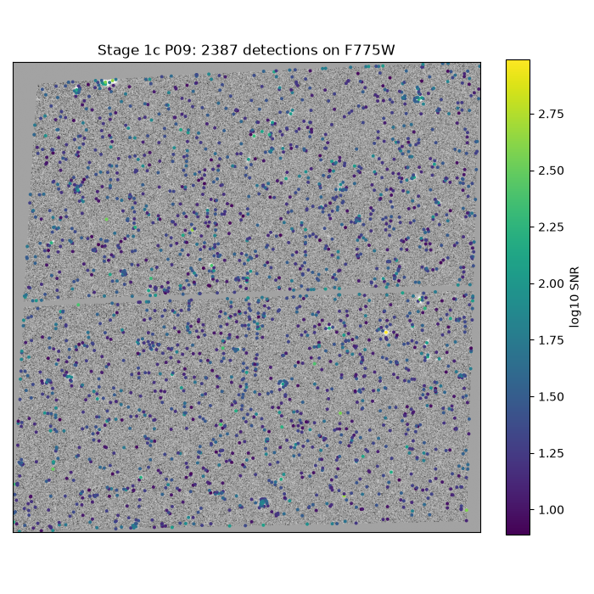
Stage 1c: the 2,387 catalogue sources of GOODS-N-3 (P09) on the F775W image, coloured by log₁₀ S/N.
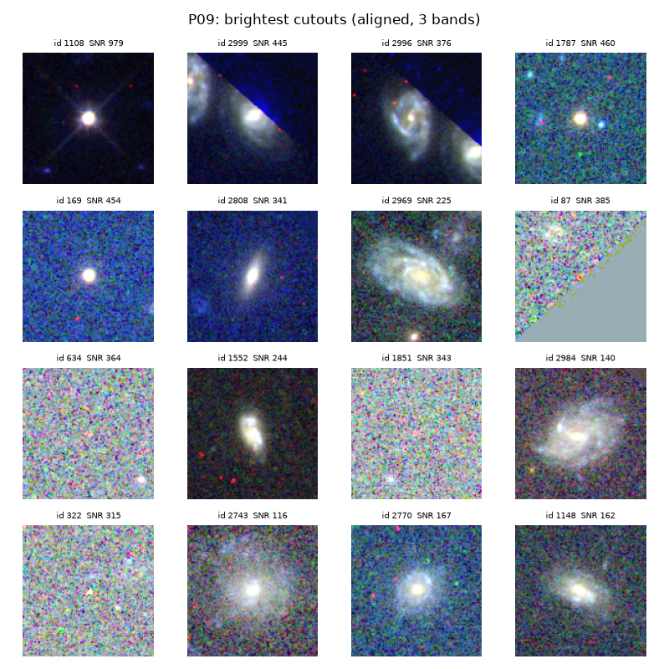
Stage 1c: the brightest aligned three-band cutouts of GOODS-N-3 (F435W, F606W, F775W as blue, green, red).

Stage 1d — Cross-filter PSF matching
Stars are selected as bright, round (ellipticity < 0.3), confirmed, unsaturated and isolated, with a size within 15 % of the Gaia stars' size; each band's FWHM is the median of individual Gaussian fits. The stage first measures every pointing; a band with too few stars borrows the stacked PSF of the pointing with the most stars in that band (same camera, filter and pixel scale). All bands are then convolved to the broadest one. Output. 0–22 PSF stars per pointing; GOODS-S-4 and GOODS-S-9 have none and borrow all three bands, and six other pointings borrow some or all bands; band FWHMs 2.34–2.79 px; after matching every pointing has one PSF of 2.52–2.79 px (0.126–0.139″).
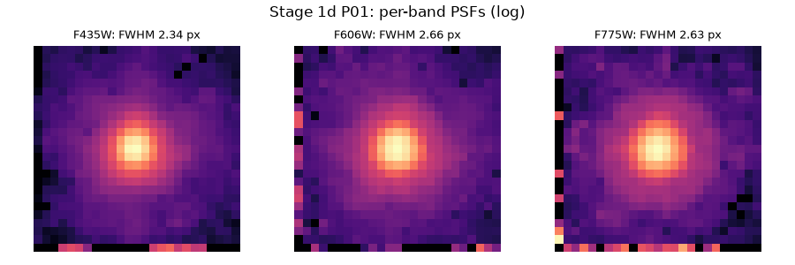
Stage 1d: per-band PSFs of GOODS-S-2 (P01, 22 stars) on a log scale; F435W and F775W are matched to F606W (2.66 px).

Stage 1e — Pass-1 photometry and morphology
statmorph measures Gini, M20, concentration, asymmetry, smoothness (CAS), Sérsic index and half-light radius, ellipticity, shape asymmetry and related indices on every source, with cosmic-ray pixels masked; failed fits are left empty instead of −99. The size ratio fwhm_over_psf uses the same Gaussian-fit estimator for the source and the PSF, so a star sits at 1.0. Output. 43,008 of 43,015 sources measured (S/N ≥ 3) on 8 workers; statmorph flags 0 (good) 10,254, 1 (suspect) 18,409, 2 (bad) 13,640, 4 (too faint) 712; median Gini 0.497, C 2.27, A 0.107; median fwhm_over_psf 0.81, 17.6 % point-like.
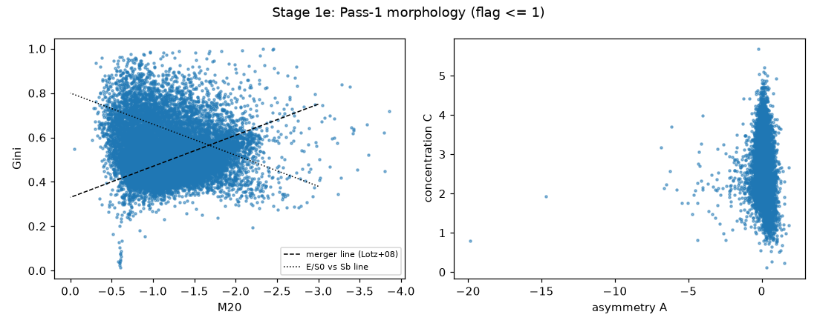
Stage 1e: Gini–M20 plane (with the merger and E/S0–Sb dividing lines) and concentration–asymmetry plane for sources with flag ≤ 1.

11.3 Phase 2 — Unsupervised object segregation

Stage 2a — Representation learning and feature fusion
A convolutional autoencoder (representation CAE v2, 261,667 weights) learns a 32-dimensional code from the PSF-matched cutouts. Its input puts every band on one noise scale per pointing (local background subtracted, divided by the band's background σ, asinh above 3σ) with a 0/1 "data present" channel per band — 9.0 % of the cutouts have no F435W and 4.1 % no F606W — so that a missing band is not read as a dark source. The loss weights the source footprint and ignores cosmic-ray pixels; rotations and flips augment the training cutouts.
Early stopping. The CAE trains on the 20,592 train-region cutouts and is validated after every epoch on 5,265 dev-region cutouts it never trains on. The rule is the same as in Stage 1b: a new best needs a 0.5 % improvement of the validation loss, the learning rate is halved on a plateau, and after 10 epochs without gain training stops and the best weights are restored (cap 100 epochs). The figure below shows why this matters: the training loss keeps falling, while the validation loss is flat after about epoch 18 — more epochs would only memorise the training cutouts.
Output. Best epoch 18, stopped at 28; reconstruction better than a flat per-band image for 99.5 % of train and 96.5 % of dev cutouts (median gain 16.6 % and 6.5 %). PCA on the train region keeps the components chosen by Horn's parallel analysis (eigenvalue above the 95th percentile of the same latent with every column shuffled): 5 components, 52.3 % of the latent variance. A linear probe on them separates point-like from extended sources with balanced accuracy 0.852 and flags cosmic-ray candidates with 0.715; their largest correlation with a band background level is 0.45 (the original CAE: 0.98). The 5 components and 14 robust-scaled physical features (fwhm_over_psf, band_consistency, Gini, M20, C, A, S, Sérsic n, r½, ellipticity, mag, S/N and two colours) form the 19-value hybrid vector; all scalers and the PCA are fitted on the train region only.
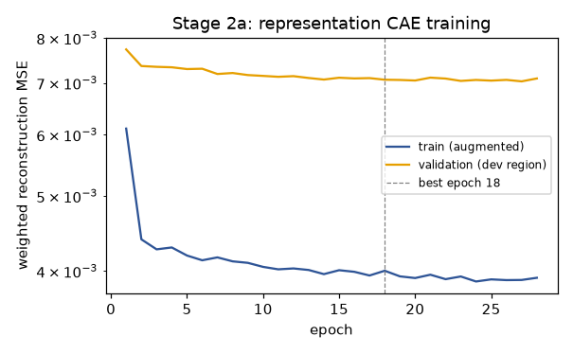
Stage 2a: representation CAE training — training loss (augmented) and validation loss on the dev region; best epoch 18, early stop at 28.

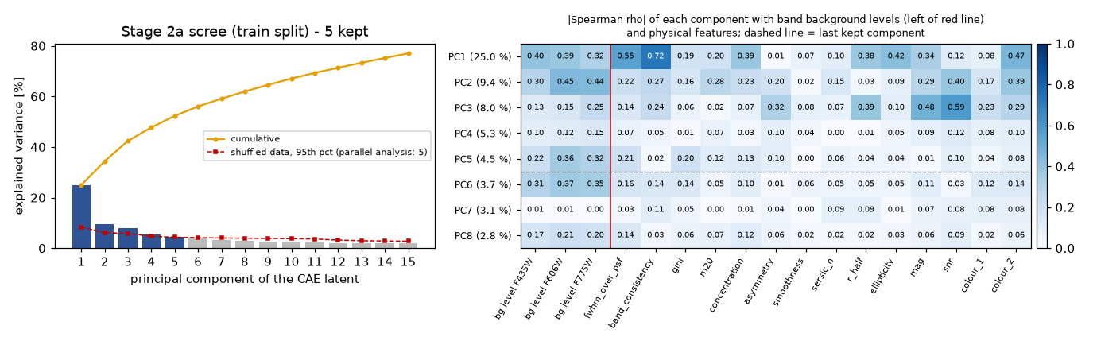
Stage 2a: Scree plot of the CAE latent with the parallel-analysis threshold (5 components kept) and |Spearman ρ| of each component with the band background levels and the physical features.

Stage 2b — Unsupervised clustering
A Gaussian mixture model with full covariance is fitted for k = 2–20 on the train region; k is the minimum of the Bayesian information criterion if it has one inside the range, otherwise the knee of the curve, checked against the integrated completed likelihood (ICL), the dev-region log-likelihood, other random seeds and bootstrap stability (adjusted Rand index). HDBSCAN runs alongside. Output. BIC never reached a minimum (it was still falling at k = 20), so k = 5 was taken from the knee. ICL also keeps falling to k = 20, the dev log-likelihood keeps rising, and other seeds put their BIC minimum at 7; bootstrap ARI 0.39–0.97 (mean 0.61, moderately stable). The exact k matters little, because Stage 2d names clusters by evidence and several clusters can share a name. HDBSCAN puts 100 % of the train sources in one cluster, so the sources form one density continuum; HDBSCAN is used only for its GLOSH outlier score (11.5 % density outliers, Stage 2e).
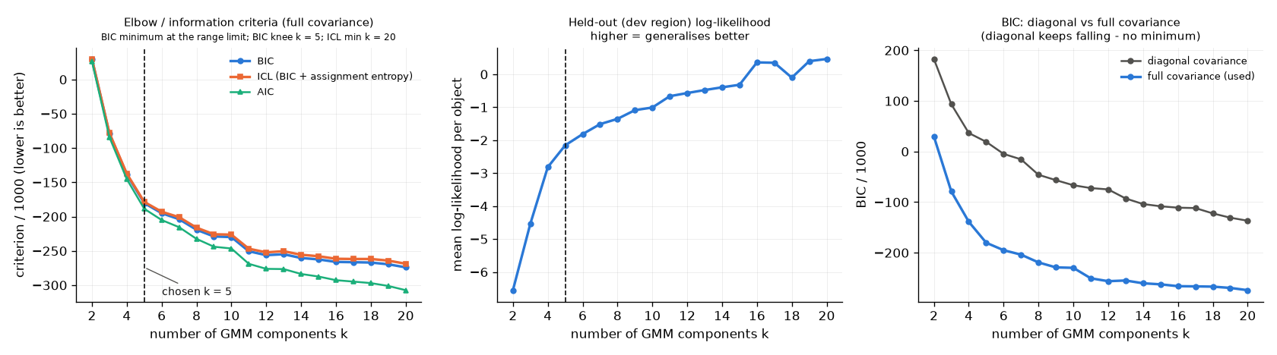
Stage 2b: GMM model selection BIC, ICL and AIC (k = 5 chosen at the BIC knee), dev-region log-likelihood, and diagonal vs full covariance.

Stage 2c — Baseline segregation
The benchmark the learned method must beat: a size–magnitude locus plus a stellarity cut, with a Gaia cross-match (baseline_semantic). The nearest source within 3″ of a bright, moving Gaia star counts as that star, because a saturated star's bleed column can move its centroid beyond the 0.5″ match. Output. Galaxy 16,200, Star 3,041, Noise 23,774; 722 Gaia DR3 sources in the footprints, 118 matched after removing each pointing's offset.

Stage 2d — Semantic audit
Clusters have no names. Stage 2d names each one from independent evidence, never from the labels used later for training: star evidence is a Gaia match or a bright point-like source confirmed in two bands; galaxy evidence is a GZH position or a resolved, confirmed source with S/N ≥ 5; noise evidence comes from cosmic-ray candidates and sources sharper than the PSF. Output. Evidence from 118 Gaia + 137 locus stars and 4,403 GZH positions + 8,831 resolved sources; 1 cluster named Galaxy, 3 Noise and 1 Star. Against held-out objects with one evidence signal, the GMM is informative (purity 0.902 vs a majority-class share of 0.712, NMI 0.321) while HDBSCAN is not (purity gain 0.000). The cluster named Star is impure: of its 6,906 objects, 1.5 % have star evidence and 83 % galaxy evidence, so most are compact galaxies, which Stage 2e moves back by physical rules. Stars vs Gaia on held-out objects (n = 40): learned precision 0.347, recall 0.650, F1 0.452; baseline 0.615 / 0.600 / 0.608. The Objective-2 minimum (beat the baseline) is not met on F1.
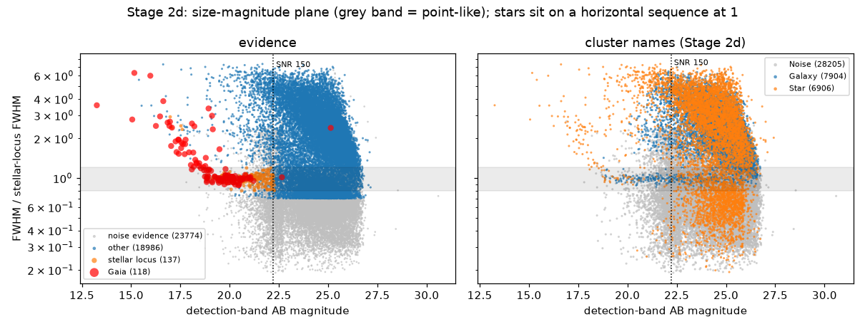
Stage 2d: size–magnitude plane left, the evidence used for naming (Gaia stars, locus stars, GZH galaxies, noise); right, the cluster names. The grey band is the point-source locus.

Stage 2e — Continuum handling and physical gate
A GMM cluster is a statistical group, and one cluster can mix stars with compact galaxies. Stage 2e applies physical rules to every object and records the reason for every change in classification_override. Objects with low density (HDBSCAN noise or a high GLOSH score, 4,946) are kept as transitional galaxies when the GMM galaxy posterior is high; objects that fit no population are logged as anomalies (none in this run).
Three later rules came from looking at the Stage 9 atlas. (1) Artefact rules: a Gaia star brighter than G = 17 that really moves masks its surroundings (spikes, halo and bleed column → Noise), and a galaxy sharper than 0.8 × the PSF that misses a band or is baseline Noise → Noise. (2) Cosmic-ray gate: a galaxy that loses more than 70 % of its central light to the Stage 9 cleaner (single-band, sharp pixels) → Noise. The cutoff was chosen on train and dev only, where it removed 27 % of the unlabelled galaxies and 0.9 % of the GZH-labelled ones. (3) Fragment rule: a galaxy inside the half-light radius of a brighter galaxy with a trusted radius (statmorph flag ≤ 1, r½ ≤ 2″) is a piece of it; it stays in the catalogue with fragment_of set, but receives no label, prediction or image.
Physical-gate and later rules in Stage 2e.
Rule | Objects
Noise cluster, but a real source (confirmed in 2 bands, S/N ≥ 5, not sharper than the PSF) → Galaxy | 4,697
Star cluster, but broader than a point source → Galaxy | 4,663
Star cluster, but sharper than the PSF → Noise | 1,156
Star cluster, but too faint for size to separate a star from a compact galaxy → Galaxy | 777
Cosmic-ray candidate (no second band confirms it) → Noise | 258
Galaxy cluster, but on the stellar locus → Star | 98
Noise cluster, but confirmed in 2 bands on the stellar locus → Star | 78
Low density in HDBSCAN, GMM galaxy posterior ≥ 0.8 → kept as transitional Galaxy | 16
Gaia star → Star | 2
Artefact rule: objects around bright moving Gaia stars → Noise | 380
Artefact rule: galaxy sharper than 0.8 × the PSF, missing a band or baseline Noise → Noise | 1,423
Cosmic-ray gate: more than 70 % of the central light is single-band, sharp pixels → Noise | 2,698 of 16,114 galaxies
Fragment rule: inside a brighter galaxy's half-light radius → fragment_of, stays Galaxy without a prediction | 860
Final populations | Galaxy 13,416 · Noise 29,345 · Star 254

11.4 Phase 3 — Label anchoring and three-way routing

Stage 3a — Galaxies: GZH label anchoring
Galaxies are matched to GZH within 0.5″ after removing each pointing's offset. Vote fractions are turned into one of the five classes by the rules of Section 9.1; galaxies that pass none of the shape rules are Ambiguous, and the merger flag comes from the merger question. While a split is sealed, Stage 3a reports only how many of its galaxies are labelled, not their classes. Output. 4,254 of 12,556 galaxies in the galaxy track matched (247–389 per pointing); merger prevalence in the scored train + dev galaxies 6.6 %.
GZH-labelled galaxies by class and split, before edge-truncated galaxies are removed:
Class | Train | Dev | Buffer | Test | External
Smooth | 335 | 43 | 30 | 47 | 68
FaceOnSpiral | 633 | 80 | 56 | 82 | 121
EdgeOn | 667 | 76 | 83 | 72 | 101
Irregular | 796 | 72 | 100 | 89 | 123
Ambiguous | 391 | 39 | 48 | 47 | 55
Total | 2,822 | 310 | 317 | 337 | 468

Smooth is the rarest class (523 of 4,254 galaxies, 12 %). Under the earlier rule it was far rarer; Section 16.1 explains why, and why it matters for the Macro-F1.

Stage 3b — Stars: calibration routing
Stars are not classified further; they are routed to the optical calibration. Only Gaia stars and bright stellar-locus stars are trusted for the empirical PSF; where a pointing has fewer than four clean Gaia stars, all clean stars of the star track are used. Output. 254 stars (118 Gaia, 209 point-like, all confirmed in two bands); 127 clean, isolated, unsaturated stars routed to Stage 5a (6–20 per pointing).

Stage 3c — Noise: false-positive modelling
The detector is run on the negative image, where every detection is false by construction; the false-positive rate (FPR) is measured as a function of the peak-significance threshold and combined with a cosmic-ray term and a resolution floor into a per-object noise_score. Output. FPR at the 2σ detection threshold: 0 in the eleven multi-exposure pointings, 0.017 in GOODS-S-2 and 0.054 in GOODS-N-1; in the single-exposure GOODS-S image negative residuals appear at every threshold (FPR 1.0), so there the cosmic-ray term carries the score. Mean noise_score on held-out objects: Noise 0.634, Star 0.174, Galaxy 0.073 (the catalogue stores it for Noise rows only). Noise sources have a median S/N of 29.9: cosmic rays are bright, which is why S/N alone cannot separate them.
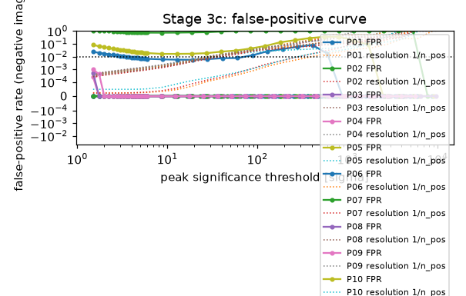
Stage 3c: false-positive rate measured on the negative image against the peak-significance threshold, per pointing

11.5 Phase 5 — Optical calibration feedback

Stage 5a — Empirical PSF construction
photutils EPSFBuilder stacks the routed stars of each pointing, centred on their cores, with neighbours given zero weight. Output. One ePSF per pointing from 6–20 stars; FWHM 2.41–3.56 px (0.12–0.18″), 0.88–1.34 times the matched PSF of Stage 1d. GOODS-S (P07) has the broadest ePSF (3.56 px from 6 stars), consistent with its single-exposure images.
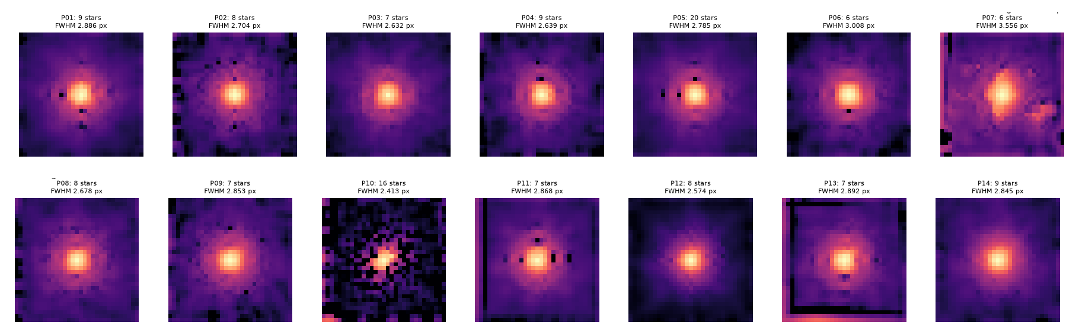
Stage 5a: the empirical PSF of every pointing (log scale).

Stage 5b — Deterministic Pass-2 refinement
The morphology of the 12,552 measurable galaxies is re-measured once with the empirical PSF (Sérsic fits are PSF-convolved). The non-parametric indices do not use the PSF, so their median change is 0; the Sérsic half-light radius shrinks by a median 0.368 px, as expected once the PSF is deconvolved. The train / dev / test / external splits are frozen here and verified unchanged (frozen_columns_unchanged = true).

11.6 Phase 4 — Supervised learning: the morphology ensemble
Section 12 describes the model in detail. In brief: 4a prepares a clean stamp of every galaxy and extracts frozen ImageNet features; 4b cross-validates and trains the four ensemble members — fine-tuned ResNet-18, fine-tuned EfficientNet-B0, a physical-feature XGBoost and a fusion XGBoost — and averages them, and trains the merger XGBoost; 4c calibrates the probabilities; 4d runs the ablation. All four use only the train + dev galaxies.

Stage 4a — Galaxy stamps and frozen CNN features
Every galaxy cutout becomes a stamp: cosmic rays are cleaned, pixels of other sources (Stage 1c segmentation) are replaced by the sky, the galaxy is cropped to about 4 Petrosian radii (at least 32 px), and the three bands are stretched together (asinh, R, G, B = F775W, F606W, F435W) and normalised with the ImageNet mean and standard deviation. The fine-tuned networks of Stage 4b read these stamps at 112 × 112 px. Stage 4a also passes every stamp, resized to 224 × 224, through frozen ResNet-18 (512 features) and EfficientNet-B0 (1,280 features), averaged over 4 rotations; these frozen features feed the fusion XGBoost, the merger XGBoost, the SHAP analysis and the ablation. Output. 12,556 galaxies × 1,792 features in 12.5 minutes on the Mac GPU, and the layer-by-layer model summaries (both networks take 224 × 224 × 3 and end in a 7 × 7 map before global average pooling).

Stage 4b — Ensemble: fine-tuned CNNs and XGBoost models
The train + dev galaxies are split into 5 folds (StratifiedGroupKFold: stratified by class, grouped by 30″ sky cells, and galaxies closer than one cutout, 6.4″, always share a fold). Each member is trained on four folds and predicts the fifth, so every galaxy gets an out-of-fold prediction from a model that never saw it; the members are then retrained on all of them. The ensemble probability is the average of the four members (Section 12.5). Output. ensemble_members.csv (every member and every combination, out-of-fold), training_history_resnet18.png and training_history_efficientnet_b0.png (loss and accuracy per epoch, Section 12.3), finetuned_*.pt, xgb_physical.joblib, the merger XGBoost and the out-of-fold predictions used by 4c and 4d.
Result (final run, cross-validated, 3,185 galaxies, same folds). Fine-tuned ResNet-18 0.513, fine-tuned EfficientNet-B0 0.514, physical XGBoost 0.516, fusion XGBoost 0.532; the equal-weight ensemble 0.551 (95 % CI 0.533–0.569), accuracy 0.556, log-loss 1.134, fold range 0.529–0.595. Without the 220 buffer galaxies the out-of-fold score is 0.554 (n = 2,965). On the 295 dev galaxies alone it is 0.482.

Stage 4c — Probability calibration
Temperature scaling, p = softmax(log P / T) (Guo et al. 2017), is fitted on the out-of-fold predictions of Stage 4b — every train + dev galaxy, each predicted by a model that did not see it. The merger probability is calibrated with Platt scaling (Platt 1999) in the same way and falls back to the base rate if the fitted slope is negative. Accuracy, log-loss and ECE are logged before and after. In the final run (T = 0.84) the out-of-fold ECE fell from 0.045 to 0.014. That value is measured on the same predictions that fit T, so it is optimistic: the test ECE is 0.074 (Minimum tier), and the test value is the one reported with the results.

Stage 4d — Controlled ablation
Every row is scored on the same five folds: each ensemble member alone, the two fine-tuned CNNs together, the final ensemble with and without calibration, and XGBoost on each frozen feature source (ResNet-18, EfficientNet-B0, both, physical, all fused). The tier is the gain of the ensemble over the best single source: ≥ 0 Minimum, ≥ 0.03 Target, ≥ 0.05 Stretch. The table below gives the results.
Ablation: out-of-fold Macro-F1 on the 3,185 train + dev galaxies of the final run (5-fold CV).
Configuration | Macro-F1 (95 % CI) | Accuracy | Type
XGBoost on frozen ResNet-18 features | 0.379 (0.362–0.395) | 0.405 | frozen source
XGBoost on frozen EfficientNet-B0 features | 0.422 (0.405–0.439) | 0.441 | frozen source
XGBoost on both frozen CNN feature sets | 0.437 (0.419–0.454) | 0.455 | frozen source
XGBoost on the 18 physical features | 0.518 (0.501–0.536) | 0.520 | physical source
Fine-tuned ResNet-18 | 0.513 (0.495–0.529) | 0.517 | member
Fine-tuned EfficientNet-B0 | 0.514 (0.495–0.530) | 0.515 | member
Physical XGBoost | 0.516 (0.499–0.535) | 0.517 | member
Fusion XGBoost (frozen CNN + physical features) | 0.532 (0.513–0.550) | 0.536 | member
Both fine-tuned CNNs, averaged | 0.528 (0.509–0.544) | 0.532 | combination
Final ensemble: all four members, averaged and calibrated | 0.551 (0.533–0.569) | 0.556 | final model
Fusion without CNN PCA (all 1,810 raw columns) | 0.524 (0.506–0.543) | 0.530 | variant
Fusion without label-confidence weights | 0.526 (0.509–0.543) | 0.530 | variant
Fusion, whole 128 px cutout (no crop, mask, cleaning or rotations) | 0.527 (0.509–0.544) | 0.532 | variant
Fusion, stamps at 128 px CNN input | 0.535 (0.514–0.552) | 0.540 | variant

Three results stand out. Frozen ImageNet features add a small gain on top of the physical features (fusion 0.532 vs physical alone 0.518, overlapping intervals). Fine-tuned networks reach about the level of the physical model on their own. Averaging all four gives +0.023 over the best single source (the two fine-tuned CNNs), below the +0.03 Target tier, so the result is the Minimum tier. Every variant lies inside the interval of the full fusion model, so these settings matter less than the labels.

11.7 Phase 6 — In-domain evaluation and explainability

Stage 6a — In-domain test
The calibrated ensemble is scored on the test galaxies (stripes of GOODS-N-4, GOODS-S-2 and GOODS-N-2); test_split_ledger.json counts every evaluation (four, Section 7.3). Metrics: Macro-F1 with a bootstrap 95 % CI, balanced accuracy, the majority-class baseline, one-vs-rest PR-AUC, merger PR-AUC, ECE and the confusion matrix. Output. Test Macro-F1 0.548 (95 % CI 0.494–0.599) on 328 galaxies, accuracy 0.543, balanced accuracy 0.545, against 0.084 for always predicting the majority class; one-vs-rest PR-AUC 0.613; merger PR-AUC 0.131 (95 % CI 0.027–0.409, 10 mergers, prevalence 0.030); ECE 0.074 (95 % CI 0.060–0.134). The model gives a shape to 289 galaxies (88.1 %), with accuracy 0.550 and 4-class Macro-F1 0.596; where the label is a shape too (261 galaxies), accuracy 0.609 and Macro-F1 0.626. The figure below shows the confusion matrix: FaceOnSpiral and Irregular are confused most (40 of the 150 errors).
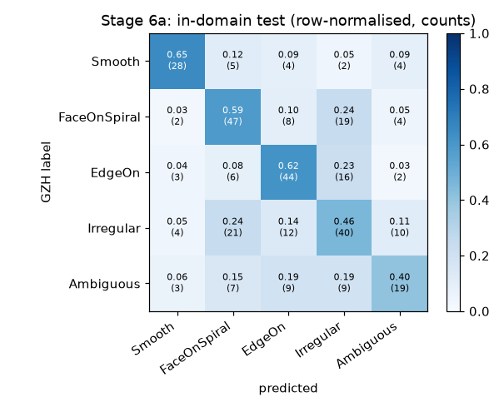
Stage 6a: confusion matrix of the final ensemble on the test galaxies (row-normalised, with counts).

Stage 6b — Uncertainty audit
Does the model know when humans disagree? The Spearman correlation between the predictive entropy and the GZH disagreement is computed on the test galaxies, and the boundary set is compared with confident galaxies. Output. Spearman ρ = 0.227 (p = 3.3 × 10⁻⁵), a weak but real link. The 45 boundary galaxies have a higher mean entropy than the 283 confident ones (0.769 vs 0.662; Mann–Whitney p = 0.0004) and a lower accuracy (0.356 vs 0.572).

Stage 6c — Explainability
XGBoost's exact TreeSHAP gives the contribution of every input to every test prediction. For the fusion XGBoost the contributions are summed per feature block (ResNet-18, EfficientNet-B0, physical); for the physical XGBoost member of the ensemble they are listed per physical feature (shap_physical_member.csv). TreeSHAP does not cover the fine-tuned CNNs, so Grad-CAM shows where each network looks in the stamp (gradcam_resnet18.png, gradcam_efficientnet_b0.png; 7 × 7 maps from ResNet-18 layer 3 and EfficientNet-B0 stage 5). Output. Over the test galaxies, the physical block carries 50 % of the fusion XGBoost's mean |SHAP|, EfficientNet-B0 27 % and ResNet-18 23 % (first figure below). In the physical member the strongest features are ellipticity, colour_1 and colour_2, which is physically sensible: ellipticity drives EdgeOn and colour drives Smooth. Grad-CAM puts 48 % (ResNet-18) and 36 % (EfficientNet-B0) of its heat in the central quarter of the stamp area, against 25 % for a uniform map (Grad-CAM figures below), so the networks do look at the galaxy, though not only there.
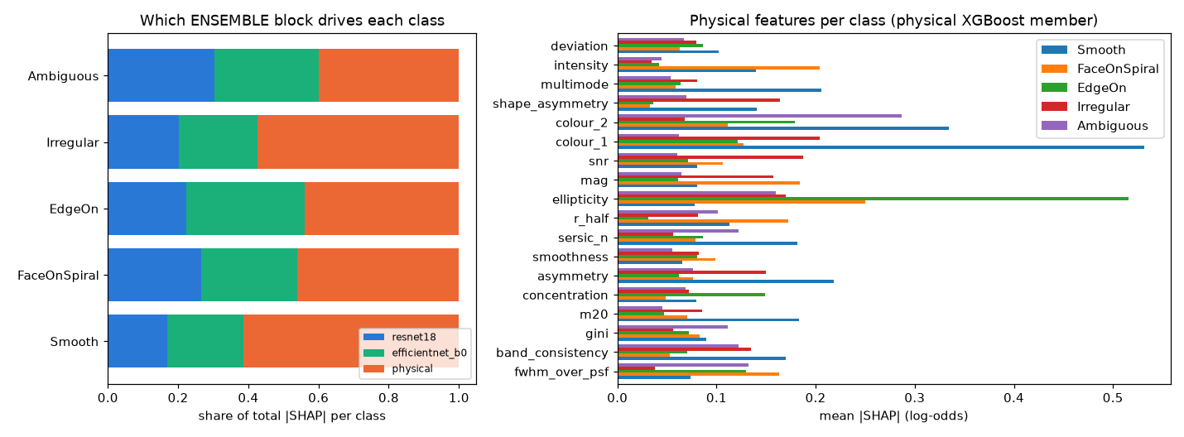
Stage 6c: share of |SHAP| per feature block in the fusion XGBoost (left) and mean |SHAP| of the physical features per class in the physical XGBoost member (right).
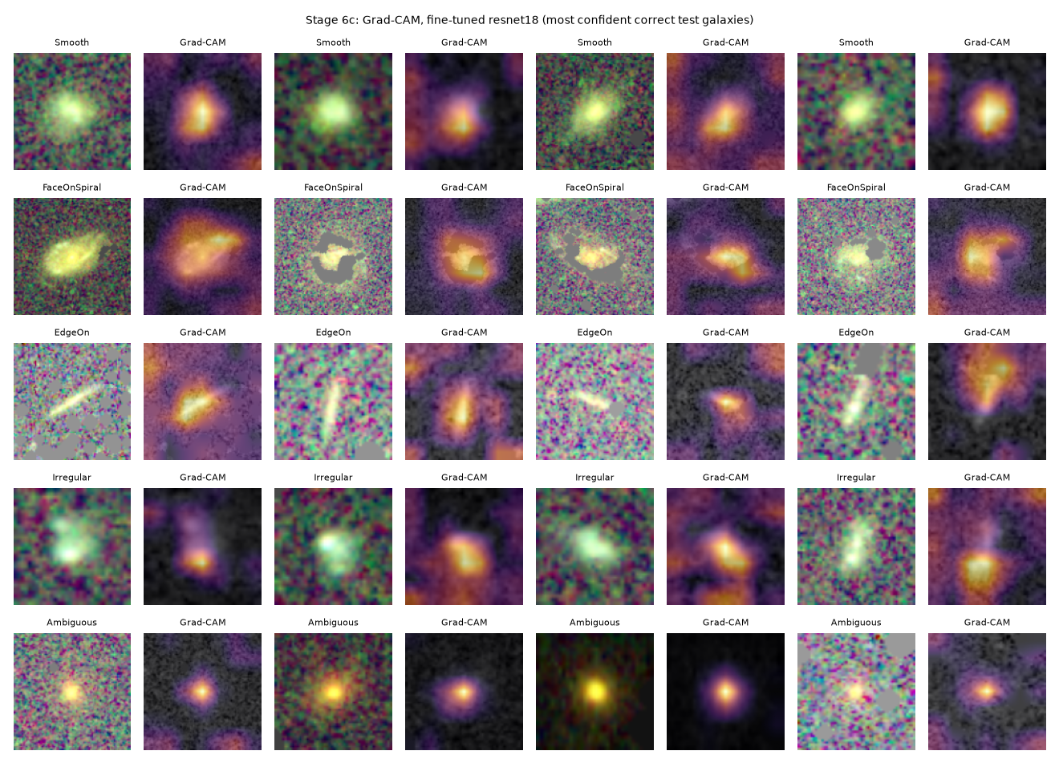
Stage 6c: Grad-CAM of the fine-tuned ResNet-18 on test stamps.
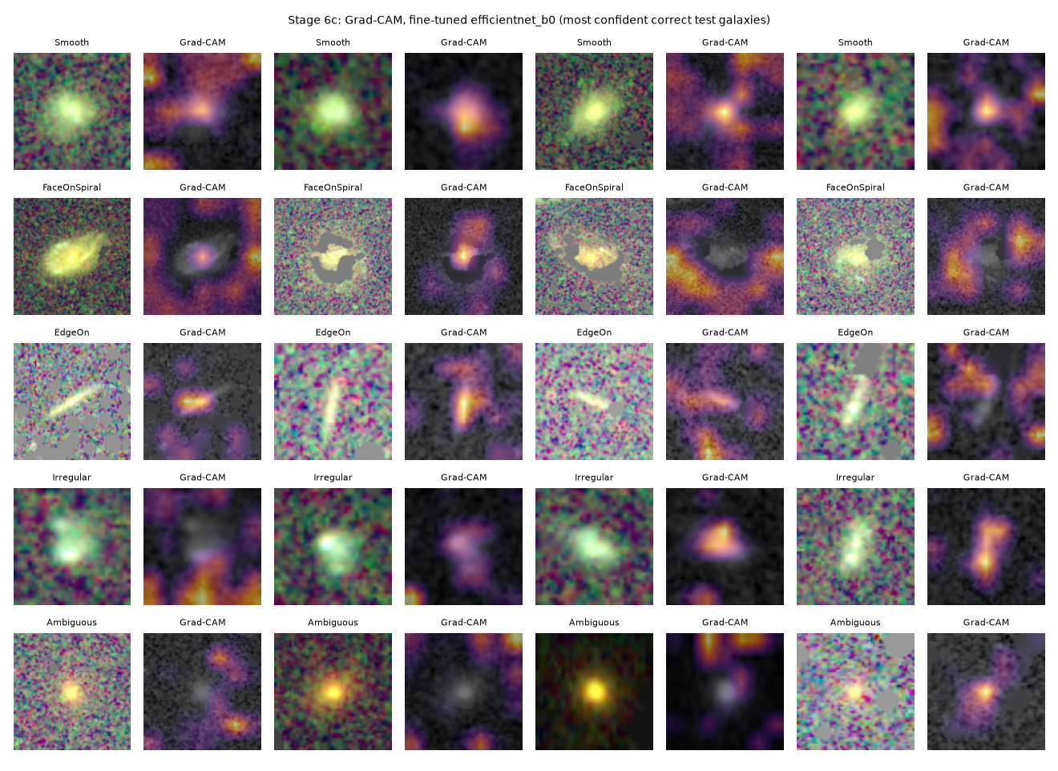
Stage 6c: Grad-CAM of the fine-tuned EfficientNet-B0 on test stamps.

11.8 Phase 7 — External robustness

Stage 7a — Taxonomy alignment
GZH and CANDELS use different classes. Both are mapped to a shared coarse scheme (Disk, Spheroid, Irregular, Unclassifiable), and the agreement between the two human catalogues on the galaxies they share is the ceiling a model trained on one can reach on the other. Phase 7 uses the galaxies of every scored split, overall and per split. CANDELS covers GOODS-South only, so these scores come from GOODS-South galaxies. Output. The ceiling is Macro-F1 0.276 (Cohen's κ 0.135) on 1,633 shared galaxies: the two human catalogues agree only weakly.

Stage 7b — External evaluation
The frozen, calibrated ensemble is scored on the CANDELS-only galaxies, which never had a training label, mapped to the shared scheme (cross_catalogue_metrics.json), overall and per split: Macro-F1 0.227 (95 % CI 0.202–0.252) on 729 galaxies. Most expert Spheroids (191 of 318) are predicted Irregular. Stage 7b also scores the external GZH galaxies exactly like Stage 6a and per pointing (external_gzh_metrics.json; figure below): Macro-F1 0.562 (95 % CI 0.515–0.606) on 434 galaxies, accuracy 0.576, ECE 0.074; without GOODS-N-4 0.552 (366 galaxies). Per pointing: GOODS-N-7 0.601 (276), GOODS-N-4 0.610 (68), GOODS-N-2 0.453 (40), GOODS-S 0.330 (44); GOODS-N-6 has only 6 galaxies, too few to read. The model gives a shape to 372 galaxies (85.7 %), with accuracy 0.621 and 4-class Macro-F1 0.656.
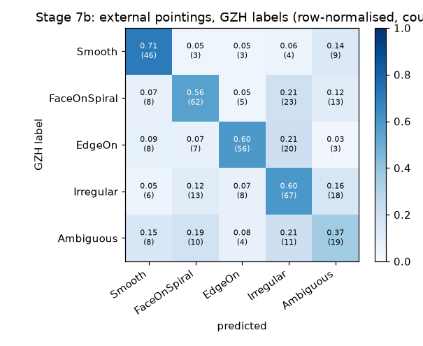
Stage 7b: confusion matrix of the final ensemble on the external GZH galaxies.

Stage 7c — Generalisation gap
True degradation = taxonomy ceiling − cross-catalogue Macro-F1, reported with the covariate shift (S/N, magnitude, size, Gini, asymmetry, concentration). The coarse in-domain score is 0.562, the ceiling 0.276 and the cross-catalogue score 0.227 (figure below): of the naive drop of 0.335, 0.286 comes from the change of label scheme and 0.049 is true degradation. The ceiling and the cross-catalogue score use different galaxies, because the second set excludes the GZH overlap, so this split is an estimate. The scored galaxies are also fainter than the GZH training galaxies (median S/N 14.5 vs 27.7, magnitude 25.1 vs 23.9), and the score rises with S/N (0.187, 0.233 and 0.242 by tertile). They share depth and PSF with training, so the value does not measure generalisation to a new field.
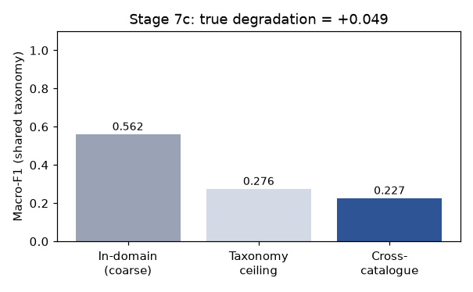
Stage 7c: in-domain score on the shared classes, the human-human ceiling and the cross-catalogue score.

11.9 Phase 8 — Unified catalogue assembly
Stage 8 joins all stage outputs on object_id into catalog.csv and writes catalog_columns.csv (group, rows filled and description of every column) and delivery_checks.json; Section 13 explains the columns. Output. 42,827 rows × 95 columns (188 sources detected twice in overlapping pointings merged): Galaxy 13,242 (12,453 classified, 789 fragments), Noise 29,331, Star 254. 4,254 galaxies carry a GZH label and 8,199 a model prediction only; 2,415 galaxies are matched to CANDELS and 118 stars to Gaia. All seven delivery checks pass.
Stage 8 delivery checks (final run).
Check | Result
Every galaxy has calibrated morphology probabilities | True
Every galaxy has a merger probability | True
Every galaxy has a heritage flag (is_pseudo_label: catalogue label vs model inference) | True
Every measured galaxy is at Pass 2 | True
Class columns are empty for Star and Noise rows | True
Designations are unique | True
Column order as specified | True
Merger probability (from the stage notes) | Test merger PR-AUC 0.131 against a prevalence of 0.030 (10 test mergers); p_merger range 0.003–0.712

11.10 Phase 9 — Galaxy image atlas

Stage 9 — Galaxy image atlas
Purpose. Show every catalogue galaxy as a picture, so that its class can be checked by eye and the catalogue can be handed on with images. Method. The three PSF-matched bands of each galaxy are background-subtracted, put on one flux scale with the AB zero-points and combined into a colour image (F775W, F606W, F435W as red, green, blue) with an asinh stretch that keeps the colours. Cosmic rays left outside the source footprints are removed from the images only (sharp, single-band pixels → 5 × 5 median); the catalogue values are not changed. Output. 12,453 PNG images of 128 × 128 pixels (154.4 MB; galaxy_images.zip 158.0 MB), one folder per predicted class, an index galaxy_images_index.csv that links each image to its catalogue row, and galleries of the most confident galaxies of each class (figure below). Per class: Smooth 844, FaceOnSpiral 1,970, EdgeOn 2,426, Irregular 5,048, Ambiguous 2,165.
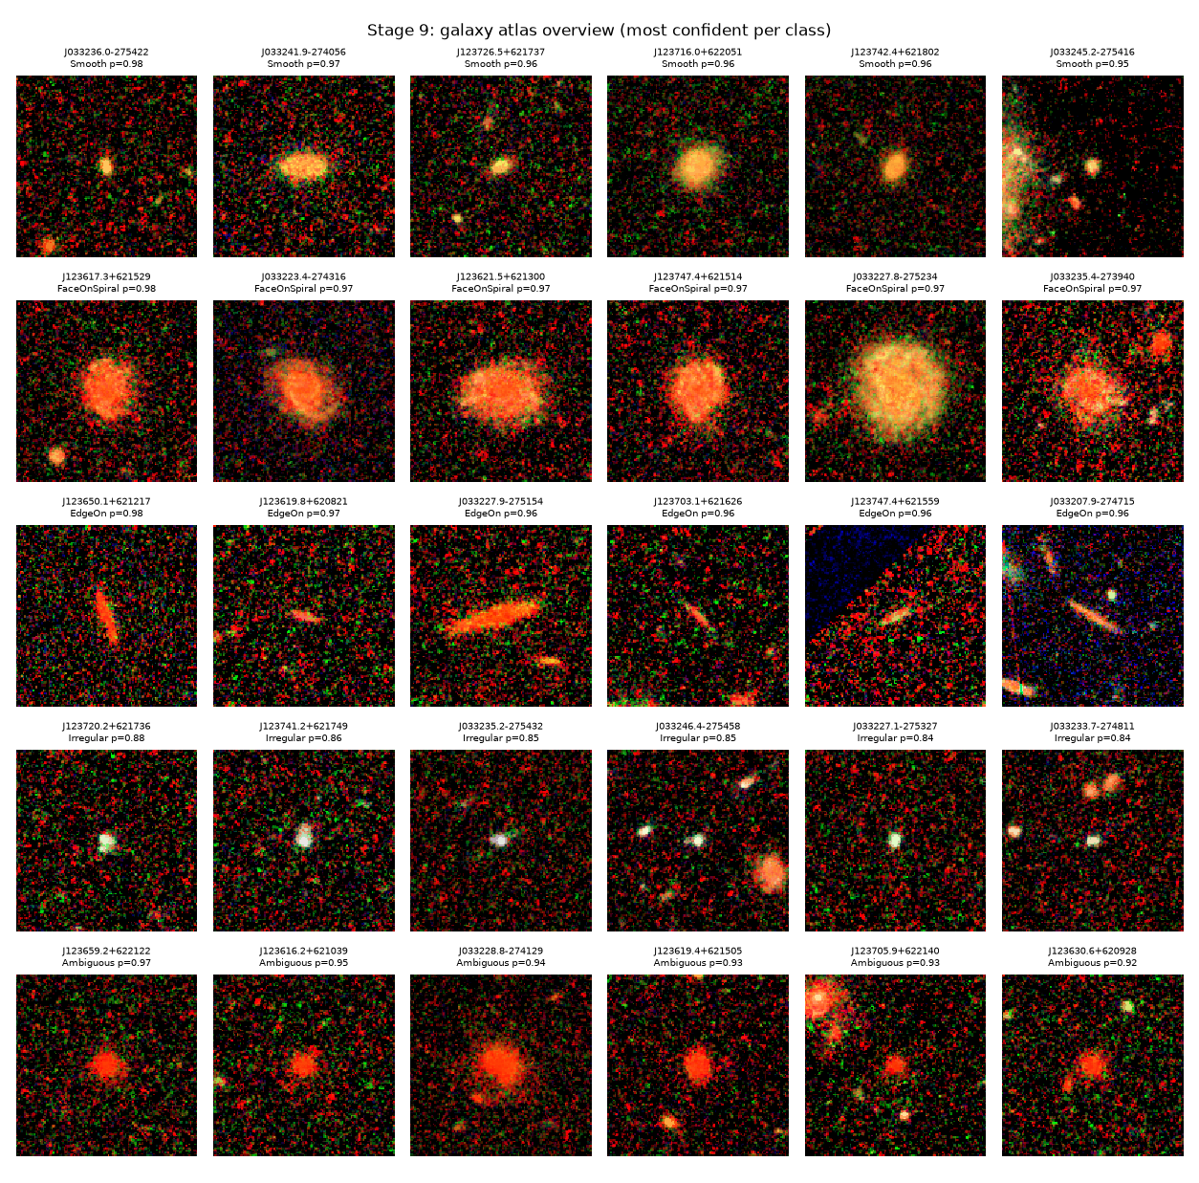
Stage 9: the most confident galaxies of each predicted class (rows: Smooth, FaceOnSpiral, EdgeOn, Irregular, Ambiguous), F775W, F606W and F435W as red, green and blue.
Cosmic-ray suspects. For each galaxy the stage measures how much of the significant central light the cleaner removes; above half, the galaxy is flagged cr_suspect in the catalogue and index (figure below). Before the gate this applied to 3,197 of 10,934 galaxies (29 %), most of them in single-exposure pointings. Stage 2e now moves those above 70 % to Noise, so the flag marks only the less certain cases: 518 galaxies in the final run (4.2 %), of which 489 have a model prediction only. Predictions with a top probability below 0.4 are filed under images/Uncertain/ with the class in the file name, and galaxies in QC-flagged tiles carry _QC in theirs.
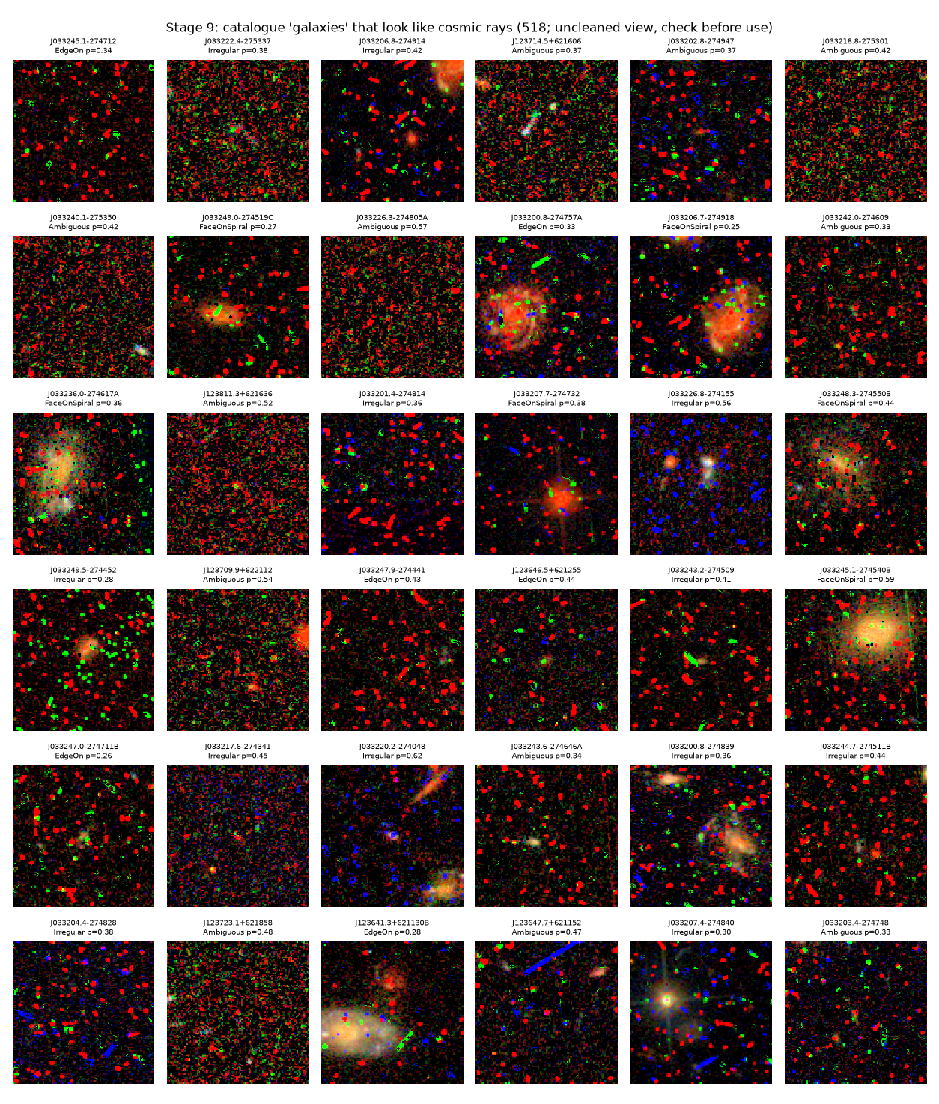
Stage 9: catalogue galaxies flagged as cosmic-ray suspects, shown without cleaning; the single-colour dots and streaks are cosmic rays that appear in one band only.

12. Ensemble Architecture
The supervised part has to learn five classes from 3,185 labelled train + dev galaxies, most of them only 10–20 pixels across. No single type of model suits this well: networks can read the image but have few labels to learn from, while trees on measured quantities need few labels but cannot see structure that was not measured.
The final model is therefore an ensemble of four members that look at a galaxy in different ways: two convolutional networks pre-trained on ImageNet and fine-tuned on the galaxy images, gradient-boosted trees on eighteen measured physical features, and a fusion XGBoost on frozen CNN features plus the same physical features. Their class probabilities are averaged with equal weight and calibrated, and a separate XGBoost gives the merger probability. The figure below shows the full path, from the labelled data to the final prediction.
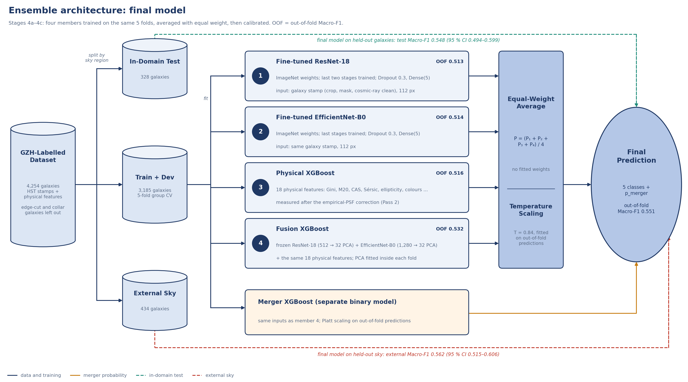
Ensemble architecture: four members are trained on the same 5 folds, averaged with equal weight and calibrated. A separate XGBoost gives the merger probability.

12.1 Input: a stamp of the galaxy, not of the sky
The median galaxy covers about 10 × 10 pixels of its 128 × 128 cutout, so a network looking at the whole cutout mostly sees sky and neighbours. Every galaxy is therefore turned into a stamp first (Stage 4a): cosmic rays are cleaned, the pixels of other sources are replaced by the sky, the image is cropped to about four Petrosian radii (at least 32 px), and the three bands are stretched together with one asinh curve so the colours survive (R, G, B = F775W, F606W, F435W). The stamp is normalised with the ImageNet mean and standard deviation, because the pre-trained filters expect inputs on that scale.

12.2 Members 1 and 2: fine-tuned ResNet-18 and EfficientNet-B0
Both networks start from ImageNet weights (Deng et al. 2009). Their early stages stay frozen: edges, blobs and textures are generic and this many galaxies are too few to relearn them. Their last stages (layer3–4 of ResNet-18, features.5–8 of EfficientNet-B0) are retrained on the galaxies, because those layers encode ImageNet objects (dogs, cars), not spiral arms or bulges. The 1,000-class ImageNet classifier is replaced by Dropout(0.3) → Dense(5). Batch-normalisation layers of the frozen stages keep their ImageNet statistics; only those of the trained stages adapt. The table below gives the split.
The two fine-tuned networks (input 3 × 112 × 112).
 | ResNet-18 (He et al. 2016) | EfficientNet-B0 (Tan & Le 2019)
Building block | residual blocks: 3 × 3 convolutions, batch normalisation, ReLU, identity shortcut | mobile inverted-bottleneck (MBConv) blocks with squeeze-and-excitation, SiLU
Frozen (ImageNet) | conv1, layer1, layer2 — 683,072 weights | features.0 … features.4 — 308,660 weights
Trained on the galaxies | layer3, layer4 — 10,493,440 weights | features.5 … features.8 — 3,698,888 weights
Head (new) | global average pooling → 512 → Dropout 0.3 → Dense(5): 2,565 weights | global average pooling → 1,280 → Dropout 0.3 → Dense(5): 6,405 weights
Output | 5 class probabilities (softmax), averaged over 4 rotations of the stamp | 5 class probabilities (softmax), averaged over 4 rotations of the stamp

The stamp is resized to 112 × 112 for fine-tuning. Both networks accept any size, because global average pooling removes the spatial dimensions; the fixed 224 × 224 of ImageNet matters only for frozen filters, and the trained stages adapt to the new scale. 112 px has a quarter of the pixels of 224 px, which keeps the run practical on a laptop: the whole of Stage 4b took 84 minutes in the final run. The frozen features of Stage 4a are still extracted at 224 × 224.

12.3 Training, and the loss and accuracy curves
Both networks are trained with the same recipe: cross-entropy with balanced class weights (every class counts equally, so the rare Smooth galaxies are not ignored) and label smoothing 0.1 because the GZH labels are noisy; AdamW with decoupled weight decay 1e-4; a one-cycle learning rate peaking at 3e-4; batch 32; random 90° rotations and flips, since a galaxy's class does not depend on its orientation. To choose the number of epochs, both networks were trained for 20 epochs on each of the five folds, and training and validation loss and accuracy were recorded after every epoch (figures below).
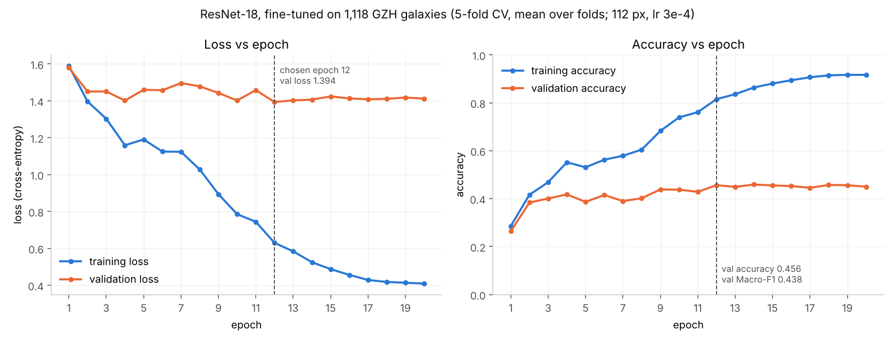
Fine-tuned ResNet-18: loss vs epoch and accuracy vs epoch, training and validation, from the earlier 20-epoch test that fixed the number of epochs (mean over the 5 cross-validation folds; 112 px, peak learning rate 3e-4).
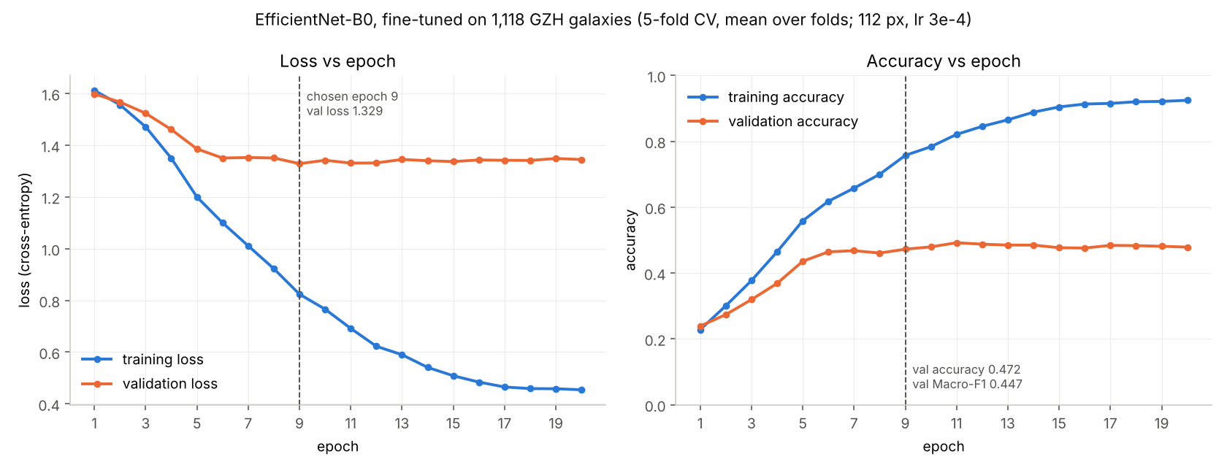
Fine-tuned EfficientNet-B0: loss vs epoch and accuracy vs epoch, training and validation, from the earlier 20-epoch test that fixed the number of epochs (mean over the 5 cross-validation folds; 112 px, peak learning rate 3e-4).
The curves show three things. (1) The networks learn: validation loss drops from 1.58–1.60 to its minimum and validation accuracy rises from about 0.25 to 0.46–0.49. (2) The useful learning ends early: the validation loss reaches its minimum at epoch 12 for ResNet-18 (1.394) and epoch 9 for EfficientNet-B0 (1.329) and stays flat afterwards. (3) After that the networks memorise: training accuracy keeps climbing to 0.92 at epoch 20 while validation accuracy stays at 0.46–0.49 — the gap is overfitting, not progress. The pipeline therefore trains for a fixed 12 epochs, where the one-cycle schedule has annealed the learning rate to almost zero; the plateau of the validation accuracy around 0.47 also reflects how noisy the labels are (Section 16.1). On the larger final data at 12 epochs, validation accuracy reaches 0.517 for ResNet-18 and 0.515 for EfficientNet-B0, with training accuracy 0.788 and 0.772.

12.4 Members 3 and 4: XGBoost models
The third member is XGBoost (Chen & Guestrin 2016) with a softmax objective on 18 Pass-2 physical features: fwhm_over_psf, band_consistency, Gini, M20, concentration, asymmetry, smoothness, Sérsic n, r½, ellipticity, magnitude, S/N, two colours, shape asymmetry, multimode, intensity and deviation. The clustering of Phase 2 still uses the first fourteen. These are the quantities astronomers use to describe morphology, measured after the PSF correction of Stage 5b. Trees need no input scaling and learn a default direction for missing values, so the features enter as measured. Balanced sample weights give every class the same total weight, and the number of trees is chosen by the out-of-fold log-loss (learning rate 0.05, max depth 4, subsample 0.8, colsample 0.3, L2 penalty 1; 200 trees in the final run). XGBoost runs in a separate worker process, because the OpenMP runtimes of XGBoost and PyTorch conflict on macOS.
Member 4 is the fusion XGBoost, and it is where the three kinds of input meet. Each frozen CNN feature block (512 from ResNet-18 and 1,280 from EfficientNet-B0) is reduced to 32 principal components inside every fold, so that the PCA never sees the validation galaxies, and is joined with the 18 physical features, giving 82 inputs. Sample weights are balanced classes × GZH label confidence. Block weights and tree settings are chosen together by out-of-fold log-loss from a small grid; the final run chose equal block weights, max depth 6, colsample 0.3 and 175 trees. The member adds a different view of the galaxy without any further network training.

12.5 Combining the members and calibrating
The ensemble probability is the plain average of the four members, P = (P₁ + P₂ + P₃ + P₄) / 4. No weight is fitted. On the final out-of-fold predictions, weights of 0.25 / 0.25 / 0.5 / 0 changed Macro-F1 by −0.001 (95 % CI −0.009 to +0.007), weights fitted on log-loss in nested folds gave 0.547 against 0.551, and leaving out the fusion XGBoost gave −0.005 (95 % CI −0.013 to +0.003) with a worse log-loss. The fourth member was kept for its log-loss and because the gains are small either way. The averaged probabilities are then calibrated by temperature scaling fitted on the out-of-fold predictions (Stage 4c). The catalogue reports p_smooth … p_ambiguous, pred_class and pred_entropy. A galaxy is called FaceOnSpiral because it resembles the training galaxies that volunteers voted as spiral, not because arms were found: no step of the model measures spiral arms directly.
After cross-validation, every member is retrained on all 3,185 galaxies, and this frozen model scores the test and external galaxies and every unlabelled galaxy. Train and dev galaxies keep their out-of-fold prediction in the catalogue, so no catalogue prediction comes from a model that saw that galaxy. The table below shows what each member contributes: alone they reach 0.51–0.53, and the average reaches 0.551 with the lowest log-loss. After temperature scaling (T = 0.84) the log-loss falls to 1.126.
Out-of-fold scores of each member and of the ensemble (final run, same 5 folds, 3,185 galaxies).
Member | Input | Macro-F1 (95 % CI) | Accuracy | Log-loss
1 Fine-tuned ResNet-18 | galaxy stamp | 0.513 (0.495–0.529) | 0.517 | 1.217
2 Fine-tuned EfficientNet-B0 | galaxy stamp | 0.514 (0.495–0.530) | 0.515 | 1.213
3 Physical XGBoost | 18 physical features | 0.516 (0.499–0.535) | 0.517 | 1.213
4 Fusion XGBoost | frozen CNN features + 18 physical features | 0.532 (0.513–0.550) | 0.536 | 1.165
Equal-weight average | all four members | 0.551 (0.533–0.569) | 0.556 | 1.134

Merger flag. GZH mergers are too few to fine-tune a network (71 of 1,118 galaxies when this was decided). The merger probability therefore comes from a separate binary XGBoost on the frozen CNN features of the stamp (each network's features reduced to 32 principal components inside every fold) and the 18 physical features, calibrated with Platt scaling. Its out-of-fold PR-AUC is 0.224 (prevalence 0.066). On the test galaxies it is 0.131 against a prevalence of 0.030, from only 10 test mergers (95 % CI 0.027–0.409), and on external galaxies 0.203 against 0.058. That is above chance (the Minimum tier), but p_merger is a ranking at best, not a merger detector.

12.6 The CNN training techniques in this model
The table below shows how the standard techniques for training a CNN accurately are applied in the ensemble.
CNN training techniques and their settings in the final ensemble.
Technique | In this model | Setting
Activation function | ReLU (ResNet-18) and SiLU (EfficientNet-B0) inside the networks; softmax output | fixed by the architectures
Weight initialisation | ImageNet pre-trained weights (transfer learning); the new Dense(5) head starts from PyTorch's default (Kaiming-uniform) initialisation | supervised.pretrained: true
L2 weight regularisation | decoupled weight decay in AdamW; L2 penalty on the XGBoost leaf weights | weight_decay 1e-4; reg_lambda 1
Dropout | before the new head; random rows and columns per tree in XGBoost | dropout 0.3; subsample 0.8, colsample 0.3
Batch normalisation | kept with ImageNet statistics in the frozen stages, adapted in the trained stages | frozen-stage BN in evaluation mode
Number of epochs / trees | fixed from the cross-validated loss curves in Section 12.3; trees by out-of-fold log-loss | 12 epochs; ≤ 400 trees
Against noisy and few labels | label smoothing, balanced class weights, rotation / flip augmentation, 4-rotation averaging at prediction | label_smoothing 0.1

12.7 Model selection
All choices use 5-fold StratifiedGroupKFold on the pooled train + dev galaxies: folds are stratified by class and grouped by 30″ sky cells (measured with the cos δ factor, so a cell is 30″ wide at GOODS-North too), and galaxies closer than one cutout (6.4″) across a cell border join one group, so close neighbours, which share pixels and background, never sit in the training and the validation fold together. The leakage audit found 201 of 877 such pairs split across folds before this rule, and none after it. The same folds are used for every member, every combination and every ablation row, so their scores are directly comparable. Log-loss rather than Macro-F1 picks settings such as the number of trees, because it uses the whole probability and is far less noisy on a few hundred galaxies per fold.

13. The Catalogue: How the Columns Were Decided
catalog.csv is the main deliverable: one row per physical source and 95 columns. This section explains how the column names and their order were decided, and where the values of each column come from — the pipeline's own measurements, the model, or one of the three reference catalogues.

13.1 How the names and the order were decided
The proposal defined the column groups (identity, provenance, classical morphology, unsupervised segregation, supervised morphology, stellar / Gaia, spurious) and the rule that the catalogue is sparse: a column is filled only where it applies. In the catalogue review of 24 October I fixed the names and their order in a column sheet (columns A–BW, 75 columns), and the pipeline writes them in exactly that order — a delivery check verifies it. Four rules came out of that review:
- One row per physical source. Detection runs once per pointing on the detection band; the three filters become columns (mag_F435W, mag_F606W, mag_F775W), named after the bands of the run. Sources detected twice in overlapping pointings are merged, keeping the detection that holds the GZH label.
- One class column decides which groups are filled. classification (Star / Galaxy / Noise; renamed from cluster_semantic) is the switch: galaxies get morphology and class probabilities, stars get PSF and Gaia columns, noise rows get noise_score and fpr_at_threshold. Repeated columns such as pred_merger were removed (the merger probability is p_merger).
- Names say what the value is. Probabilities start with p_, catalogue values with their source (gz_, gaia_, k15_), flags end in _flag, and units are in the column dictionary catalog_columns.csv.
- New columns go at the end. The 20 columns added after the review (ra_err … k15_sep_arcsec, with fragment_of, morph_confidence, cr_removed_frac and cr_suspect) follow BW, so the agreed order never changes; every column is described, with the number of rows it fills, in catalog_columns.csv.

13.2 Where each column comes from
The table below groups the columns by their source. Three sources are external: GZH gives the training labels, Gaia DR3 confirms stars, and CANDELS provides the expert labels for the cross-catalogue validation. Everything else is measured or predicted by the pipeline itself.
Sources of the catalog.csv columns and the rows they fill (final run, 42,827 rows).
Source | Columns | Filled for | Rows filled
Pipeline: identity, detection (1a, 1c) | object_id, designation, ra, dec, ra_err, dec_err, pointing, detection_band, tile_id, product_type, ndrizim, n_exposures, snr, flux, flux_err, pipeline_version | all rows | 42,827
Pipeline: photometry (1c) | mag, mag_<band>, magerr_<band>, colour_1, colour_2 | stars and galaxies | 13,496 (mag); 11,765–13,148 per band or colour (empty where a band has no data)
Pipeline: quality, cosmic rays (1b, 1c) | frame_quality_flag, qc_flagged_bands, edge_flag, cr_candidate, cr_pixels_masked | all rows | 42,827 (qc_flagged_bands 1,157)
Pipeline: unsupervised segregation (2a–2e) | cluster_id_gmm, cluster_id_hdbscan, gmm_p_star, gmm_p_galaxy, gmm_p_noise, reconstruction_error, fwhm_over_psf, band_consistency, baseline_semantic, classification, classification_override, anomaly_flag, is_transitional, split_tag | all rows (is_transitional: galaxies) | 42,827 (override 11,792)
Pipeline: morphology (1e, 5b) | gini, m20, concentration, asymmetry, smoothness, sersic_n, sersic_rhalf, r_half, ellipticity, shape_asymmetry, multimode, intensity, deviation, morph_flag, morph_flag_sersic, psf_pass | galaxies | 8,271–13,242
Pipeline: PSF calibration (1d, 3b, 5a) | star_fwhm_arcsec, used_in_psf_match, used_in_epsf, epsf_isolated, pointing_epsf_fwhm_arcsec, pointing_matched_fwhm_arcsec | stars | 254
Pipeline: noise model (3c) | noise_score, fpr_at_threshold | noise | 29,331
Model: ensemble and merger XGBoost (4b, 4c) | pred_class, p_smooth, p_spiral, p_edgeon, p_irregular, p_ambiguous, pred_entropy, p_merger | galaxies | 12,453
Galaxy Zoo: Hubble (3a) | gz_label, gz_vote_frac, gz_merger_flag; is_pseudo_label (GZH label or model only) | GZH-matched galaxies (is_pseudo_label: all classified galaxies) | 4,254 (is_pseudo_label 12,453)
Gaia DR3 (2c, 3b) | gaia_source_id, gaia_sep_arcsec, gaia_g, parallax, pmra, pmdec, gaia_teff; gaia_match | Gaia-matched stars (gaia_match: all rows) | 118 (parallax, proper motion 99; Teff 38)
CANDELS, Kartaltepe et al. 2015 (8) | k15_class, k15_merger_frac, k15_sep_arcsec | CANDELS-matched galaxies (GOODS-South only) | 2,415

The CANDELS columns are the only ones used for the cross-catalogue validation (Phase 7). They are filled for every GOODS-South galaxy that CANDELS classified, except that external rows stay empty while sealed. In GOODS-North they are empty by design, while every other applicable column is filled (Section 6.5). A galaxy row therefore always says where its label comes from: gz_label (volunteers, used for training), pred_class with calibrated probabilities (the model, for every galaxy; train and dev galaxies carry their out-of-fold prediction, so the catalogue does not repeat their labels) and k15_class (experts, only for validation).

14. Results
The proposal defined three tiers per objective: Minimum (the objective did not fail), Target and Stretch. The table below reports where each objective stands. FaceOnSpiral means the model predicts that volunteers would describe the galaxy as a spiral, not that arms were measured.
Status of every objective against the proposal's tiered targets.
Objective | Metric | Result
O1 Pipeline end-to-end | Completeness + leakage | 28 stages on 14 pointings in about 4 hours, no manual steps, no stage failed; split frozen before training, regions at least 7.2″ apart
O2 Segregation | Star P / R vs Gaia | Learned P 0.347, R 0.650, F1 0.452; baseline 0.615, 0.600, 0.608 (n = 40)
O2 Segregation | Galaxies vs GZH; cluster purity | 4,254 of the 4,403 sources at a GZH position are in the galaxy track (96.6 %); GMM purity 0.902 vs majority 0.712; 2,698 objects removed by the cosmic-ray gate
O3 Morphology | Macro-F1 | Test 0.548 (95 % CI 0.494–0.599) vs majority 0.084; coverage 88.1 %; shape accuracy 0.550, 4-class Macro-F1 0.596; out-of-fold 0.551
O3 Ensemble value | Ablation Δ Macro-F1 | +0.023 over the best single source
O3 Merger flag | PR-AUC | Test 0.131 vs prevalence 0.030 (10 mergers; 95 % CI 0.027–0.409); out-of-fold 0.224
O4 External | GZH score, ceiling, XCat, degradation | External GZH 0.562 (95 % CI 0.515–0.606, n = 434); GOODS-N-7 0.601; without GOODS-N-4 0.552; ceiling 0.276, cross-catalogue 0.227, degradation 0.049
O5 Calibration | ECE | Test 0.074 (95 % CI 0.060–0.134); external 0.074
O5 Catalogue | Delivery checks | 42,827 rows, 95 columns, 12,453 images; all seven checks pass; 518 cosmic-ray suspects flagged
O6 Generic pipeline | New field, missing inputs | Same code on 1, 8 and 14 pointings; Gaia and CANDELS optional; apply mode implemented, not re-tested on the final model

The test, external and out-of-fold scores agree within their intervals, so there is no sign of overfitting and the model holds up on sky it never saw. The score reaches the Minimum tier, far above the majority-class baseline, but stays below the 0.65 Target.
Final-run scores on the three evaluations.
Evaluation | Galaxies | Macro-F1 (95 % CI) | Accuracy | Coverage | 4-class Macro-F1, shape galaxies | Where label is a shape too
Out-of-fold (train + dev) | 3,185 | 0.551 (0.533–0.569) | 0.556 | 85.2 % | 0.619 | 0.653 (n = 2,455)
Test | 328 | 0.548 (0.494–0.599) | 0.543 | 88.1 % | 0.596 | 0.626 (n = 261)
External | 434 | 0.562 (0.515–0.606) | 0.576 | 85.7 % | 0.656 | 0.688 (n = 339)

Final-run F1 per class.
Class | Out-of-fold | Test | External
Smooth | 0.623 | 0.675 | 0.652
FaceOnSpiral | 0.567 | 0.566 | 0.602
EdgeOn | 0.613 | 0.595 | 0.659
Irregular | 0.546 | 0.462 | 0.565
Ambiguous | 0.408 | 0.442 | 0.333

Confidence is useful. On test galaxies whose top probability is at least 0.7 (90 galaxies, 27 %), accuracy is 0.800 and Macro-F1 0.766; on external galaxies (118, 27 %), 0.737 and 0.658. Clear labels also score higher: where at least 70 % of the volunteers agree, Macro-F1 is 0.700 on test (116 galaxies) and 0.698 on external (134). These subsets are reported as findings and do not replace the 5-class score.
The limits of these results are stated plainly:
- Faint galaxies are not directly scored. The 8,199 model-only galaxies are fainter than the labelled ones (median S/N 14 vs 28). The model calls 46 % of them Irregular against 30 % of the labelled galaxies, and the share rises with magnitude, from 10 % brighter than mag 24 to 57 % at mag 25–26. Together with the expert Spheroids predicted Irregular (Stage 7b), this suggests that these predictions partly reflect low S/N rather than shape.
- Cosmic-ray suspects remain. 518 classified galaxies (4.2 %) are still flagged cr_suspect, 489 of them model-only.
- Single-exposure pointings score lower. GOODS-S-2 reaches accuracy 0.44 on test (107 galaxies) against 0.59 for GOODS-N-4 (172), and GOODS-S 0.39 on external (44). These are small samples, but the pattern matches the cosmic-ray load of those images.
- The external score leans on one pointing. 276 of its 434 galaxies come from GOODS-N-7.
- Few mergers. With 10 test mergers the merger PR-AUC interval is too wide for a firm statement.
- The test set is not a first look. It was evaluated four times, and the labels and splits changed between runs (Section 7.3). No result in this section was used to tune anything.
- Labels are the limit. All scores are against labels derived from volunteer votes, so they measure agreement with those labels, not physical truth.

15. Tech Stack
Libraries used by the pipeline.
Area | Libraries
FITS, WCS, photometry | astropy, photutils (detection, deblending, EPSFBuilder), astroquery (MAST, Gaia, VizieR downloads)
Morphology | statmorph (Gini, M20, CAS, Sérsic, shape asymmetry), SciPy (Gaussian PSF fits, filters)
Deep learning | PyTorch, torchvision (ResNet-18 and EfficientNet-B0 with ImageNet weights, fine-tuned); convolutional autoencoders written for this project
Classical ML | scikit-learn (PCA, GMM, scalers, StratifiedGroupKFold, metrics), hdbscan, XGBoost (with built-in TreeSHAP for attributions)
Data and plots | NumPy, pandas, matplotlib, PyYAML, joblib

The code base has about 10,500 lines of Python in 61 modules: a package p2p with shared modules (FITS I/O, detection, multi-band tools, morphology, catalogue matching, networks, fine-tuning, inference) and one module per stage, a runner run_pipeline.py (with --from, --to and --only) and command-line tools for download, inspection and exporting a trained model bundle.

16. Project Challenges and Solutions
Most challenges appeared only when the pipeline met real data. The five that shaped the supervised model are described first, in the order I met them; Section 16.6 lists the others.

16.1 Why the Macro-F1 was low, and what changed it
The first full run on eight pointings gave an out-of-fold Macro-F1 of only 0.415. Before touching the model I examined the labels the score is computed on, and found four problems:
- Not every galaxy has a GZH label. Of the 15,675 galaxies the pipeline finds, only 2,586 (16.5 %) match a GZH entry: GZH classified only the brighter galaxies (to about mag 23.5). The other 84 % are classified by the model alone (is_pseudo_label = True), and the training and scoring set is small — 1,118 train + dev galaxies after edge-truncated cutouts are removed.
- The catalogue matching was wrong for one pointing. One astrometric offset was removed for all eight pointings, but GOODS-N-4 is shifted by (+0.49″, +0.76″) relative to GZH, against about 0.3″ elsewhere — only 11 of its galaxies matched. I changed the matching to measure the offset of each pointing (the peak of the 2-D histogram of image-minus-catalogue offsets within 3″). GZH matches rose from 2,312 to 2,586 and the GOODS-N-4 test galaxies from 11 to 289; the same per-pointing offsets are now used for Gaia and CANDELS.
- The labels are unbalanced and noisy. Smooth has only 42 of 1,118 galaxies (F1 0.14 at first): the GZH debiased vote fraction, which corrects for the fading of features in faint, distant galaxies, lowers "smooth" by a median 0.34. Ambiguous means the volunteers had no majority, which is not a shape. And galaxies that appear twice in GZH agree on their class only 41 % of the time — a ceiling that no model can pass.
- The networks saw mostly sky. With the galaxy covering about 10 × 10 px of a 128 × 128 cutout, the pooled CNN features described the background: CNN features alone scored 0.33 against 0.43 for the physical features.

The table below lists what I changed and how the out-of-fold Macro-F1 moved. One step lowered the number on purpose: the code review found that the 30″ sky cells that keep neighbours in the same fold ignored the cos δ factor, so at GOODS-North (Dec +62°) a cell was only 14″ wide and close neighbours could fall into different folds. Correcting it made the folds harder and the score more honest.
How the out-of-fold Macro-F1 developed (5-fold CV, train + dev; data and labels changed between steps, so steps are not strictly comparable).
Step | Change | Macro-F1 (95 % CI)
1 | First 8-pointing run: frozen ImageNet features (224 px) + 14 physical → XGBoost | 0.415 (0.380–0.450)
2 | Per-pointing catalogue offsets; galaxy stamps (crop, neighbour mask, cosmic-ray cleaning, 4 rotations); PCA of the CNN features inside each fold; label-confidence weights; XGBoost grid | 0.466 (0.429–0.505)
3 | Corrected cross-validation folds (sky cells with cos δ) — harder, honest folds | 0.440 (0.404–0.476)
4 | Fine-tuned ResNet-18 + fine-tuned EfficientNet-B0 + physical XGBoost, equal-weight mean (folds of step 2) | 0.507 (0.473–0.540)
5 | New split, cosmic-ray gate not yet in place: 8-pointing run of 31 Oct, 1,535 galaxies | 0.511 (0.484–0.537)
6 | 14 pointings, earlier labels, three members | 0.543 (0.524–0.564)
7 | Fourth member (fusion XGBoost), earlier labels | 0.550
8 | Final label rule, labelled buffer galaxies: final run, 3,185 galaxies | 0.551 (0.533–0.569)

16.2 Cropping the galaxy before the networks
Looking at the cutouts made the cause of the weak CNN features obvious: most of every 128 × 128 cutout is empty sky, neighbours and, in single-exposure pointings, cosmic rays. I added a stamp step before the networks (features.cnn_stamp): the Stage 9 cosmic-ray cleaner is applied, pixels belonging to other sources in the Stage 1c segmentation map are replaced by the sky median, and the image is cropped to four times the galaxy's Petrosian radius (at least 32 px). The features are averaged over four 90° rotations, because the class does not depend on orientation. CNN-only Macro-F1 rose from 0.334 to 0.361 and EfficientNet-only from 0.330 to 0.387; in the latest run the full model with the old whole-cutout input scores 0.424 against 0.440 with stamps (Stage 4d).

16.3 A 224 × 224 input for ResNet-18 and EfficientNet-B0
Both networks were trained on ImageNet at 224 × 224 × 3: three channels for red, green and blue, and a size at which their filters learned the scale of everyday objects. Our cutouts are 128 × 128, and the first version fed them unchanged. Stage 4a now resizes every stamp bilinearly to 224 × 224 (the model summaries show the 224 × 224 input reduced to a 7 × 7 map before pooling), and the three HST bands fill the three colour channels as R = F775W, G = F606W, B = F435W. The ablation measured the effect directly: with frozen features, 128 px input scored 0.454 and 224 px 0.440 — within each other's confidence interval, so the input size was not what limited the frozen networks. For fine-tuning, where the trained stages adapt to the scale, I chose 112 px to keep the training time to about an hour.

16.4 Making ResNet-18 and EfficientNet-B0 more accurate
As frozen feature extractors the two networks were weak on their own: Macro-F1 0.322 (ResNet-18) and 0.357 (EfficientNet-B0) with an XGBoost head. I tried three ways to improve them on the same folds:
- Other layers and pooling of the frozen networks (average and max pooling, XGBoost or logistic-regression head): best EfficientNet block 6 + logistic regression 0.454, ResNet layer3 0.396.
- Small CNNs trained from scratch at 64 px (Conv3×3–BN–ReLU ×2 + MaxPool per block, He initialisation, Dropout 0.5): 3 blocks 0.391, 4 blocks 0.395 — too few labels to learn the filters.
- Fine-tuning the last two stages of the ImageNet networks on the galaxy stamps (Section 12): ResNet-18 0.448 and EfficientNet-B0 0.460 — about +0.10 over their frozen versions.
Fine-tuning won clearly, and averaging the two fine-tuned networks with the physical XGBoost gave 0.507. The loss and accuracy curves (Section 12.3) fixed the number of epochs at 12 and showed where training would only memorise.

16.5 Too little data at first
The project began with three files of one GOODS-South pointing: 280 GZH-labelled galaxies, 206 for training and model selection, 38 for the test. With so few labels every choice was unstable: the dev Macro-F1 was 0.509 while the test gave 0.232, and the test interval spanned ±0.12. I therefore added the 12 files of four GOODS-North pointings and completed GOODS-South to four pointings — 24 files in total, chosen by common three-filter coverage (Section 6.2). The labelled set grew to 1,118 train + dev, 387 test and 659 external galaxies, and the split revisions and six further pointings of Section 7.2 then raised the training share again. That made 5-fold cross-validation meaningful and gave the test and external evaluations narrow enough intervals to be useful.

16.6 Other challenges
Other challenges met during the project.
Challenge | Evidence | Solution | Result
Cosmic rays in single-exposure _drc files | ~85 % of 47,448 detections were cosmic rays; they filled the 4,000-source cap | Two-band confirmation with a position test; pixel-level mask (colour + sharpness); separate caps | 6,151 confirmed sources; 0 of 290 GZH galaxies lost
Registration broken by cosmic rays | Stage 1c stopped: "F475W is offset by 2.064″" (random pairing of cosmic rays) | Match on 5 × 5 median-filtered images; significance ≥ 5× random pairs; residual check | Offset (0.162″, 0.868″) from 97 galaxies; residual 0.000″
False two-band confirmations | 15,881 "confirmed" sources | Require the second band's light centred within 1.5 px | 6,151 confirmed
Masking real light | F814W red halo of bright stars masked as cosmic rays | Pixel must also be sharp vs its 8 neighbours | Halo kept; colours of stars correct
No PSF stars; failed Gaussian fits | 0 PSF stars; one axis of the fit collapsed to 0 | Bounded, normalised Gaussian fit; star selection by Gaia-star size; median of single-star fits | 11 stars; matched FWHM 0.139″
Star class contaminated | Star 170: 65 cosmic rays, 68 galaxies | Stellar locus only above S/N 150; physical gate with recorded reasons | Star 22, all Gaia stars included
Faint galaxies named Noise | GZH stops at mag ~23.5, so faint clusters had no galaxy evidence | Galaxy evidence also from resolved, confirmed sources with S/N ≥ 5 | Galaxy 177 → 2,663
Different label schemes | GZH vs CANDELS classes disagree | Taxonomy alignment matrix and human–human ceiling | Degradation 0.345 separated from scheme effect
Spatial leakage | Neighbouring cutouts share pixels | Sky-stripe split with 6″ collar, frozen before training | Zero leakage
Platform issues | XGBoost and PyTorch OpenMP clash on macOS | XGBoost in a separate worker process | Runs on the student's Mac
Too few labels in one pointing | 206 train + dev and 38 test galaxies; dev selection unreliable (dev 0.509 vs test 0.232) | Eight GOODS pointings; 5-fold CV on pooled train + dev for every model choice | About 1,300 train + dev GZH galaxies
Images of different filters did not overlap | Per-filter choice: images 1.0–1.9′ apart; anchor rule: 55–72 % common area | Joint choice of all filters by common area in get_fits.py; F775W instead of F814W | 7.0–11.3 arcmin² with all three filters per pointing
Overlapping split regions | Box regions of tilted frames overlapped: 778 of 2,581 GZH galaxies (30 %) without a split | Regions = real data footprints; stripes sized by GZH share | 219 without a split (collars, overlaps)
No PSF star in a pointing | Run stopped: “P02 (GOODS-S-4): no PSF star passed the cuts” | Borrow the stacked PSF of the pointing with most stars (same camera and pixel scale) | Every pointing gets a measured PSF
Large F435W offsets in GOODS-North | F435W images 2.1–2.3″ off the F775W WCS | Significance-tested registration (Stage 1c) | Residual < 0.001″
CNN over-fitting | ResNet-18 from scratch: 11.2 M weights for 184 galaxies; out-of-fold Macro-F1 0.333 | Fine-tune only the last two stages of ImageNet networks, with dropout, weight decay, label smoothing and augmentation | ResNet-18 0.448, EfficientNet-B0 0.460; ensemble 0.507
Test re-scored during development | The test region had been scored in every run | One seal (evaluation.seal_external) and a project-level ledger of test evaluations | Test scored with every evaluation logged; external data kept for the final model (see Section 7.3)
Stage 1b never stopped early | Validation loss still falling ~1 % per 15 epochs; best epoch 146 of 150 | 120-epoch cap, patience 10, learning-rate patience 4 | Stops at epoch 96 (best 95); 17.7 % better than a flat tile
Cross-validation folds too narrow at GOODS-North | 30″ sky cells measured in RA without cos δ: 14″ wide at Dec +62° | Cells measured with cos δ | Neighbours share a fold; Macro-F1 0.466 → 0.440 (honest)
Apply mode used different CNN inputs | A new field's features were made with the current settings, not those the bundle was trained with | Stage 4a reads the stamp settings from the bundle | Features match the saved models

16.7 Cosmic rays that passed as galaxies
Looking through the Stage 9 folders I found images that were not galaxies: J033200.3-274820 and J033202.4-274925 filed as FaceOnSpiral, J033236.4-274400 and J033237.3-274718 as Smooth. All four are single-exposure cosmic rays: 96–99 % of their central light is sharp, single-band pixels. Two different hits in two bands can land on one segment and pass the two-band confirmation of Stage 1c, and three of the four then moved from a Noise cluster to Galaxy through the "real source" rule. Stage 9 had flagged them, but nothing acted on the flag. The cosmic-ray gate of Stage 2e now removes such objects. A stricter median-filtered confirmation in Stage 1c was tested and rejected: keeping 99 % of the GZH galaxies, it rejected only 27–42 % of these objects. The gate barely changes the Macro-F1, because almost all these objects are unlabelled; what it changes is the catalogue.

16.8 A leakage audit
A review of the whole pipeline on 31 October checked for leakage. The test split was clean: the nearest labelled train or dev galaxy is 13.9″ away, and no GZH entry is used twice. Three leaks of a smaller kind were fixed: close pairs split across cross-validation folds (Section 12.7); train and dev predictions in the catalogue that came from a model fitted on them, with accuracy against GZH of 0.84 against 0.51 on test, so they now carry out-of-fold predictions; and sealed external labels written into the catalogue (Section 7.3). Comparing the same galaxies across two runs also gave a useful warning: on 1,106 shared galaxies the out-of-fold Macro-F1 rose from 0.469 to 0.510, while on 265 shared test galaxies it stayed at 0.506 and 0.505. Only the test score confirms a gain.

16.9 The last attempts to raise the score
On the 14-pointing data I compared the remaining ideas on cross-validation only, so the test and external galaxies played no part. Training the CNNs on GZH vote fractions instead of hard classes lowered ResNet-18 from 0.504 to 0.474 and EfficientNet-B0 from 0.514 to 0.482, so it was rejected. Four further morphology statistics raised the physical XGBoost from 0.501 to 0.509 and were kept. Weighted instead of debiased smooth / features fractions raised accuracy but left almost no EdgeOn labels (105), so they were rejected. Adding labelled buffer galaxies gave no gain in a quick test on the physical model; they were still added to training, at my decision, because they are extra labels that share no pixels with held-out galaxies. The label rule of Section 9.1 raised the share of galaxies given a shape from 73 % to 86 % on train and dev.

17. Novelty of the Project
Several parts of the pipeline exist separately in the literature (Section 20). What is new is how they are combined, and what the user receives at the end:
- One provenance-tracked catalogue for every detection. Stars, galaxies and spurious detections live in the same catalog.csv, one row per physical source. A star row carries the stellar specification — its FWHM, whether it shaped the PSF, its Gaia ID, parallax, proper motion, G magnitude and temperature. A galaxy row carries the galaxy specification — photometry and colours, Gini, M20, CAS and Sérsic fit after PSF correction, calibrated class and merger probabilities, its GZH or CANDELS label where one exists, and its image. A noise row carries its false-positive score. Columns that do not apply stay empty, and every value says where it came from. The published classifiers I compared deliver either a star / galaxy flag or a morphology label, not one catalogue that does both with full provenance.
- Source triage without labels, named by independent evidence. Stars, galaxies and artefacts are separated by clustering an autoencoder's latent space with physical features; the clusters are named afterwards from evidence never used for clustering (Gaia, GZH positions, noise physics), and every change by the physical gate records its reason.
- Stars calibrate the galaxies. The stars the pipeline finds build an empirical PSF for each pointing, which then corrects the galaxies' Sérsic fits (Pass 2) before any model is trained.
- Two kinds of honest external test. The same labels on new sky (the external GZH galaxies, including a whole GOODS-North pointing, GOODS-N-7) and a different label scheme (CANDELS experts) with a human-agreement ceiling, so model degradation is separated from disagreement between labelling schemes.
- A picture of every galaxy. Every catalogue galaxy is also delivered as a colour PNG, sorted by predicted class, with likely cosmic rays flagged.
- Generic and reusable. A download tool chooses the images for any sky position, the pipeline runs on any HST field, applies a saved model where no labels exist, and skips — rather than fails — when an optional catalogue is missing.

18. Changes from the Proposal and Why They Are Better
The proposal of 15 September fixed the problem, the objectives, the phases and the success criteria, and all of them were kept. How several stages work changed once the pipeline met real data. The points below describe the main changes and why each one is better.
The galaxy PNG images. The proposal delivered only the table. I added Phase 9 because a morphology class is something a person wants to see: every catalogue galaxy is now also written as a 128 × 128 colour PNG (12,453 images), one folder per predicted class and packed as galaxy_images.zip, with an index that links each image to its catalogue row and flags likely cosmic rays (Section 11.10). The images made two problems visible that the numbers had hidden — the cosmic rays that reached the galaxy class, and how small most galaxies are in their cutouts — and both led to the fixes in Section 16.
Sealing the data. The proposal used the test set once, at the very end. In practice the test split had to be scored during development, so I sealed the external data instead and recorded every test evaluation in a project-level ledger (test_split_ledger.json). The model could then be checked during development while the external sky stayed out of every score until the final run, and the record of how often the test was seen is open (Section 7.3).
More varied test data, with a split plan per pointing. The proposal split one field 70 / 15 / 15 by sky region and used CANDELS as its external test. The project now uses 14 GOODS pointings (42 files), with a split plan set per pointing, stripes with target GZH counts and a 3.6″ collar (Section 7.2). Every split receives labels, test and external galaxies come from both GOODS fields, and the external test now covers two things: new sky with the same labels, and a new label scheme with CANDELS.
Catalogue columns and their order (Stage 8). The proposal defined column groups around cluster_semantic. In the catalogue review I fixed the names and order, and the catalogue now has 95 columns: classification replaces cluster_semantic, classification_override records why a rule changed a class, and cosmic-ray and provenance columns were added at the end so the agreed order never changes. A delivery check verifies the order, and a reader can see why every class was given (Section 13).
Update to the ensemble model. The proposal used a dual-branch ResNet-18 trained from scratch with EfficientNet and XGBoost, combined by soft voting. A ResNet-18 has about 11 million weights, which cannot be learned from a few thousand labels. The final model fine-tunes only the last stages of two ImageNet networks and averages them with a physical-feature XGBoost and a fusion XGBoost, with a separate XGBoost for mergers. Model choices use 5-fold group cross-validation rather than a small dev split, so every labelled galaxy is used. Section 12 describes the result.

19. Core Implementations
- Data acquisition (tools/get_fits.py). MAST search by sky position, joint choice of filters and images by common sky area, combined exposures first, Gaia DR3 cones, catalogue download and column check.
- Instrument-aware ingestion (Stages 1a–1e). FITS reader for SCI / WHT / CTX, AB zero-points, frame-QC autoencoder with early stopping and a held-out threshold, detection and deblending, significance-tested multi-band registration, two-band confirmation, pixel-level cosmic-ray masking, star selection and cross-filter PSF matching with PSF borrowing, statmorph morphology with quality flags.
- Unsupervised segregation (Stages 2a–2e). Convolutional autoencoder with noise-scaled input and early stopping, PCA by parallel analysis, physical-feature fusion, full-covariance GMM selected by BIC and ICL, HDBSCAN outlier scores, a baseline segregator, evidence-based semantic naming and a physical gate with an audit trail.
- Routing and optical calibration (Stages 3a–3c, 5a–5b). GZH decision-tree labels with per-pointing offsets, star routing, negative-image false-positive model, empirical PSF, PSF-aware Pass-2 morphology with frozen splits.
- Supervised ensemble (Stages 4a–4d). Galaxy stamps (crop, mask, cosmic-ray cleaning); ResNet-18 and EfficientNet-B0 fine-tuned on the galaxies (frozen early stages, AdamW, label smoothing, augmentation, test-time rotations); physical-feature and fusion XGBoost; averaging; merger XGBoost; 5-fold group cross-validation of every member; out-of-fold temperature and Platt calibration; controlled ablation.
- Honest evaluation (Stages 6a–7c). A seal for external data and a ledger for the test, test with bootstrap intervals and tier report, uncertainty audit, TreeSHAP and Grad-CAM, external GZH score per pointing, taxonomy ceiling, cross-catalogue test and generalisation-gap decomposition with covariate-shift statistics.
- Provenance-tracked catalogue (Stage 8). 95 columns in the agreed order, column dictionary, delivery checks, heritage flags and override reasons.
- Galaxy image atlas (Stage 9). A colour PNG of every catalogue galaxy, sorted by predicted class, with display-only cosmic-ray cleaning and a per-galaxy cosmic-ray suspect flag.
- Engineering. A runner with resume (--from), per-stage logs and timing in run_log.json, about 280 documented configuration keys, train / apply mode with exported model bundles, stages that skip (not fail) without an optional catalogue and tools for download and inspection.

20. Market Research
Previous work on automated source classification has largely addressed binary star–galaxy separation on ground-based surveys, using either convolutional networks on pixels (Kim & Brunner 2017; Kennamer et al. 2018; Stoppa et al. 2023) or tree ensembles and other learners on catalogue features (Machado et al. 2016; Zeraatgari et al. 2024; Jeakel et al. 2025). A recurring result is that feature-based trees remain competitive with CNNs, and that adding morphological parameters to photometry improves separation — which this project confirms: the physical-feature XGBoost alone matches each fine-tuned CNN. This project extends that line in three directions: it separates stars, galaxies and spurious detections without labels on space-based HST imaging; it combines fine-tuned pre-trained CNNs with a physical-feature model and measures what each adds by ablation; and it delivers calibrated, provenance-tracked morphology and merger probabilities evaluated both in-domain and on external data.

20.1 Source-classification literature
Published work compared with this project (details checked against the papers).
Work | Task | Data and labels | Method | Calibration | Relation to this project
Kim & Brunner 2017, MNRAS 464, 4463 | Star vs galaxy | SDSS, CFHTLenS; 5 bands; spectroscopic labels | ConvNet on pixels vs random-forest trees on photometry (+ morphology) | Well calibrated | Same question as our ablation: the CNN wins AUC on CFHTLenS; trees with morphology win on SDSS
Kennamer et al. 2018, ICML (ContextNet) | Star vs galaxy | LSST simulations | Per-object net + context net over the exposure | Not the focus | Uses exposure context for seeing; we use a per-pointing stellar locus and PSF matching
Stoppa et al. 2023, A&A 680, A109 (ASID-C) | Star vs galaxy | MeerLICHT, 32 × 32 single band; DECaLS labels | Dual-branch CNN + position branch; focal loss | Logit Platt scaling | Closest design to ours; XGBoost on features was competitive
Machado et al. 2016, IJCNN | Faint star vs galaxy | COSMOS features | NN, kNN, SVM, RF, naive Bayes | — | Tabular learners remain strong baselines
Jeakel et al. 2025, arXiv:2511.20524 | Extended vs point-like | miniJPAS, J-NEP; 14,594 labels | XGBoost; photometry ± morphology | ROC | Morphology features significantly help — supports our physical branch
Zeraatgari et al. 2024, MNRAS 527, 4677 | 3 to 7 source classes | SDSS + ALLWISE, ~1.25 M labels | RF, kNN, XGBoost, voting, ANN | — | F1 drops 98.9 % → 73.6 % from 3 to 7 classes — fine classes are harder
Muyskens et al. 2022 (arXiv:2105.01106) | Star vs galaxy | HSC COSMOS; HST labels | PCA embedding + Gaussian process | Posterior variance | Like our PCA embedding and uncertainty audit; works with few labels
Koblischke et al., arXiv:2512.11982 | Morphology search | 100 M+ Legacy Survey galaxies | Foundation-model embeddings aligned with text | Retrieval | Future direction for our autoencoder

20.2 Galaxy-morphology literature
Galaxy-morphology work relevant to this project.
Work | Relevance
Dieleman, Willett & Dambre 2015, MNRAS | First CNN trained on Galaxy Zoo vote fractions; motivates the rotation / flip augmentation of our autoencoders
Huertas-Company et al. 2015, ApJS | CNN trained on CANDELS visual classes on HST imaging — the closest prior work to our Phase 7
Walmsley et al. 2022, MNRAS 509, 3966 | Bayesian CNNs on Galaxy Zoo DECaLS votes with uncertainty — state of the art for crowd-labelled morphology (314,000 galaxies)
Rodriguez-Gomez et al. 2019, MNRAS 483, 4140 | statmorph: the source of our Gini, M20, CAS and Sérsic features and their quality flags
Willett et al. 2017; Kartaltepe et al. 2015 | Our label source (GZH) and external benchmark (CANDELS)

20.3 Comparison of the work to date with this project
The table below puts the published work and this project side by side on the same criteria.
Work to date compared with this project.
Work | Imaging | Task | Method | Calibration / uncertainty | External test and output
Kim & Brunner 2017 | SDSS, CFHTLenS (ground) | star vs galaxy | ConvNet on pixels vs random forest on photometry | well calibrated | class probabilities
Kennamer et al. 2018 | LSST simulations | star vs galaxy | per-object + exposure-context networks | not the focus | labels
Stoppa et al. 2023 | MeerLICHT, 32 × 32, one band (ground) | star vs galaxy | dual-branch CNN + position branch, focal loss | logit Platt scaling | probabilities
Machado et al. 2016 | COSMOS catalogue features | faint star vs galaxy | NN, kNN, SVM, RF, naive Bayes | — | labels
Jeakel et al. 2025 | miniJPAS, J-NEP (ground) | extended vs point-like | XGBoost, photometry ± morphology | ROC | labels
Zeraatgari et al. 2024 | SDSS + ALLWISE | 3–7 source classes | RF, kNN, XGBoost, voting, ANN | — | labels
Muyskens et al. 2022 | HSC COSMOS, HST labels | star vs galaxy | PCA embedding + Gaussian process | posterior variance | probabilities
Huertas-Company et al. 2015 | HST CANDELS (WFC3/IR) | visual-like morphology | CNN on CANDELS expert classes | — | applied to the 5 CANDELS fields; catalogue
Walmsley et al. 2022 | DECaLS (ground) | detailed morphology (volunteer votes) | Bayesian CNNs | posteriors per question | catalogue of 314,000 galaxies
This project | HST ACS, 14 GOODS pointings, 3 filters | star / galaxy / noise without labels; 5 morphology classes + merger | CAE + GMM triage; fine-tuned ResNet-18 + EfficientNet-B0 + physical and fusion XGBoost | temperature + Platt, ECE, entropy audit | same-label out-of-field test + CANDELS with taxonomy ceiling; provenance-tracked catalog.csv + PNG atlas

21. Future Work
- A simple UI interface for new fields. The user enters an RA / Dec position and the filters, the matching _drc files are downloaded automatically into data/raw (using the joint-coverage rule of get_fits.py), and the pipeline runs on them without editing any file.
- Full-depth GOODS mosaics. Use the GOODS v2.0 mosaics, built from five epochs and the images the GZH volunteers classified, instead of single-epoch _drc files: fewer cosmic rays, deeper images and a closer match between what the model sees and what the volunteers saw.
- Better use of the labels. Compare the GZH debiased and weighted vote fractions for the smooth / featured question (weighted fractions give 327 Smooth galaxies instead of 42), revisit vote-fraction targets (a first test lowered Macro-F1 by about 0.03), and give the output a Bayesian / Dirichlet form as in Walmsley et al. (2022).

22. Report Executive Summary
The project delivered what the proposal set out to build: a reproducible, 28-stage pipeline that takes archival HST images to a calibrated, provenance-tracked morphology catalogue, triages its own sources without labels, refines morphology against an empirical PSF, and reports generalisation honestly by separating model degradation from label-scheme disagreement. On GOODS pointings it ran end-to-end and passed every delivery check, and it classifies galaxies with an ensemble of two fine-tuned ImageNet CNNs and two XGBoost models (Section 12).
The work also showed that the hardest part of applying machine learning to astronomical archives is not the classifier but the data. One unrejected cosmic-ray population disturbed every stage downstream; one catalogue offset hid most of a test pointing; and the networks first looked at sky instead of galaxies. Fixing these with methods that can be checked against independent evidence, collecting more labels and letting pre-trained networks adapt to galaxies took the out-of-fold Macro-F1 from 0.415 to 0.551. The data and labels changed along the way, so the steps are not strictly comparable.
The system has 28 stages in ten phases. It governs the data before any model sees it (a split of the sky by pointing, a test scored with a ledger and sealed external data), cleans and aligns the images, separates stars, galaxies and spurious detections without labels (convolutional autoencoder + Gaussian mixture + HDBSCAN, then a physics-based gate), builds an empirical PSF from the stars it finds, classifies the galaxies with the fine-tuned CNN ensemble selected by 5-fold cross-validation, calibrates the probabilities, tests the model on held-out sky and against an independent expert catalogue, and writes one catalogue (95 columns) in which every value carries its provenance, together with a colour image of every catalogue galaxy.
Key results
- Data: 42 ACS/WFC files of 14 GOODS pointings chosen by common three-filter coverage. 43,015 sources → 42,827 catalogue rows: 13,242 galaxies, 254 stars and 29,331 noise rows; 4,254 GZH-labelled galaxies, 2,415 matched to CANDELS.
- Splits: 3,116 train, 336 dev, 372 test and 524 external GZH entries (Stage 0); scored after edge cuts: 3,185 train + dev, 328 test and 434 external galaxies.
- Preprocessing: single-exposure pointings give 22,540–52,779 detections against 1,803–3,093 in multi-exposure tiles; band offsets up to 2.7″ removed (residual < 0.001″); a measured PSF for every pointing.
- Segregation: GMM k = 5 (BIC knee); stars vs Gaia learned precision 0.347, recall 0.650, F1 0.452 against F1 0.608 for the baseline, so the Objective-2 minimum is not met; 2,698 objects moved to Noise by the cosmic-ray gate.
- Morphology: of 328 test galaxies, the model assigned a shape to 289 (88.1 %) and classified 39 (11.9 %) as Ambiguous. On those 289, accuracy 0.550 and 4-class Macro-F1 0.596, against labels derived from GZH votes; where the label is a shape too (261 galaxies), 0.609 and 0.626. 5-class Macro-F1 0.548 (95 % CI 0.494–0.599) against the proposal's target of 0.65 and 0.084 for the majority class; cross-validated 0.551; test ECE 0.074.
- External data: 5-class Macro-F1 0.562 (95 % CI 0.515–0.606, n = 434); coverage 85.7 %; shape accuracy 0.621 and 4-class Macro-F1 0.656; GOODS-N-7 0.601; without GOODS-N-4 0.552; CANDELS ceiling 0.276 and cross-catalogue Macro-F1 0.227.

The most important engineering lesson is that single-exposure drizzled products (NDRIZIM = 2) contain no cosmic-ray rejection, and that a model is only as good as the labels and images it is given. The supervised scores are limited mostly by the labels — few faint galaxies are labelled, Smooth is rare, and volunteers agree on a galaxy's class only 41 % of the time — which is why the project collected fourteen pointings, corrected the matching, cleaned and cropped the galaxy images, and fine-tuned the networks: the changes the evidence pointed to.
The result is stated as it is. The pipeline runs end to end and generalises consistently: 0.551 cross-validated, 0.548 on test and 0.562 on external sky, far above the 0.084 baseline. It reaches the Minimum tier for morphology, merger ranking, calibration and ensemble gain, but not the 0.65 Target, and the learned star finder does not beat the baseline.

References
Chen, T. & Guestrin, C. (2016). XGBoost: A scalable tree boosting system. Proc. KDD 2016, 785.
Deng, J., Dong, W., Socher, R., Li, L.-J., Li, K. & Fei-Fei, L. (2009). ImageNet: A large-scale hierarchical image database. Proc. CVPR 2009.
Gaia Collaboration, Vallenari, A., et al. (2023). Gaia Data Release 3: Summary of the content and survey properties. A&A, 674, A1.
Giavalisco, M., et al. (2004). The Great Observatories Origins Deep Survey: initial results from optical and near-infrared imaging. ApJ, 600, L93.
Guo, C., Pleiss, G., Sun, Y. & Weinberger, K. Q. (2017). On calibration of modern neural networks. Proc. ICML, PMLR 70.
He, K., Zhang, X., Ren, S. & Sun, J. (2016). Deep residual learning for image recognition. Proc. CVPR 2016.
Kartaltepe, J. S., et al. (2015). CANDELS visual classifications: scheme, data release, and first results. ApJS, 221(1), 11.
Platt, J. (1999). Probabilistic outputs for support vector machines and comparisons to regularized likelihood methods. Advances in Large Margin Classifiers, MIT Press.
Rodriguez-Gomez, V., et al. (2019). The optical morphologies of galaxies in the IllustrisTNG simulation: a comparison to Pan-STARRS observations. MNRAS, 483, 4140. arXiv:1809.08239.
Tan, M. & Le, Q. V. (2019). EfficientNet: Rethinking model scaling for convolutional neural networks. Proc. ICML, PMLR 97.
Walmsley, M., et al. (2022). Galaxy Zoo DECaLS: detailed visual morphology measurements from volunteers and deep learning for 314,000 galaxies. MNRAS, 509, 3966. arXiv:2102.08414.
Willett, K. W., et al. (2017). Galaxy Zoo: morphological classifications for 120,000 galaxies in HST legacy imaging. MNRAS, 464(4), 4176.
Space Telescope Science Institute. Barbara A. Mikulski Archive for Space Telescopes (MAST). https://archive.stsci.edu/
AI assistive tools: Anthropic's Claude (claude.ai); Google AI Mode.
The works compared in Section 20 are cited in full in its tables.

Appendix. Reproducing the Run
The project README gives the full commands, and catalog_columns.csv describes all 95 catalogue columns (Section 13). In short:
- Install. Run pip install -r requirements.txt.
- Download. Put the 42 FITS files in data/raw/ and the catalogues in data/catalogs/ (commands in the README).
- Run. Use python run_pipeline.py, which takes about 4 hours on an Apple-silicon Mac; resume with --from <stage>.
- Check. Stage 1a reports 42 verified files, and Stage 8 reports catalog.csv: 42827 rows x 95 columns. Small differences between runs are normal, because the networks are retrained on every run.

