# IMPORTANCE OF EDUCATION

**What can be considered good education ?**

T

o put it in simple terms, education is the process of acquiring knowledge and skills, building morals, and values and developing habits. Education does not just consist of these. The process of education can be said to be complete only if you are able to put the knowledge you acquire to good use . So, education is not just gaining knowledge and gathering information but developing the ability to apply what you have learned to daily life scenarios.

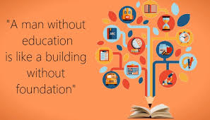

Is there good education and bad education ? This is a question that has been asked for years now. Good education works towards the goal of preparing and empowering individuals to lead a productive life that definitely impacts that economic growth of the society and country they are a part of . Good education is meant to stimulate logical and critical thinking in individuals . Good education does not mean scoring high marks in your assessments . People usually perceive the notion that schooling and scoring good marks in examination is education . Education is beyond all that . Schooling alon does education depands on a lot of factors , including the environment or society you are in , the social and economic background and the ability of the individual to understand analyse and act according to the need of the hour.

It is a fact that quality education and skills development comes from strong education systems .

Having trained and empathetic teachers is one of the prerequisites to availing good education . Education includes learning about different cultures , religions , communities , economic and social standards and grooming oneself to become a socially responsible individual .

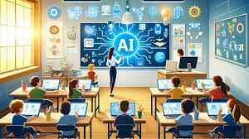

With the advancement of technology , because most children nowadays have their own mobile phones and internet access with which they can be find answer to any questions, sometimes questions their parents , siblings or teachers cannot explain. This is a huge drawback in the process of building a healthy society.

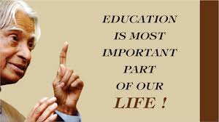

**The power of being educated** imagine you did not know to use a mobile phones , a laptop , a match stick or a bulb . What is the use possessing something that you do not know how found out that hitting two rocks together produces sparks that can start a fire. Every little thing you come across can teach you something or the other. The more you , the more powerful you become.

Knowing how to drive a car would come in handy when you have to go somewhere with more people travelling with you. Knowing how to fix a pipe can help you when someone accidentally breack off a pipe and water keeps flowing .

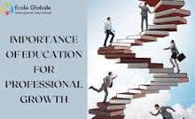

Likewise , everything you learn will help you in one or the other way . Therefore , good education can be defined as the general and specific knowledge people gain by being taught or by experience.

“ Education is not the learning of facts , but the training of the mind to think “ , according to Albert Einstein . Gathering a load of information is easily possible in the present age of the internet and technology . Being able to answer every you for Life where experience and knowledge is accounted for.