Explainable AI-Based Chronic Kidney Disease (CKD) Progression Forecasting via Multi-Resolution Deep Continuous Koopman Operator Theory (mr-DeepDMDc)
Complete Project Architecture, DMD Variant Justification, Text & Visual Architecture Diagrams, Step-by-Step Approach, Core Mathematics & Dashboard Vision
1. Clinical Problem Statement & Global Healthcare Burden
Chronic Kidney Disease (CKD) is a catastrophic silent epidemic affecting over 850 million people globally, with more than 100 million patients in India alone. The pathology is asymptomatic in its early and intermediate stages (Stages 1 through 3b) while functional nephron units undergo progressive sclerotic destruction. By the time symptoms appear, kidney function has often plummeted below 15 mL/min/1.73m² (Stage 5 / End-Stage Renal Disease - ESRD), leaving patients with only two grueling, costly options: lifelong dialysis or kidney transplantation.
- The Doctor's Real Dilemma: In clinical practice, nephrologists do not need AI to tell them 'Does this patient have CKD?' (diagnosis is simple via blood creatinine). What doctors urgently need to know is: (1) 'WHEN will this patient crash? In 4 months or 5 years?' and (2) 'If I lower their blood pressure or add an SGLT2 inhibitor today, how many years of dialysis-free life can we save?'
- Why Existing AI Fails: 90% of existing AI models perform static binary classification ('CKD: Yes/No') on single-visit records. They are completely blind to historical progression speed and cannot simulate medication changes.
2. Dynamic Mode Decomposition (DMD): Which Variant and Why?
Standard Dynamic Mode Decomposition (DMD) was originally designed for linear fluid dynamics. Because human disease progression is non-linear, multi-scale, and actively manipulated by doctors via medications, standard DMD is inadequate. Below is the exact mathematical justification for why we combine Multi-Resolution DMD and DMD with Control into a unified Deep Neural Framework:
DMD Variant | Mathematical Formulation | Why Standard Fails & Why We Need It | Role in Our Project
Standard Exact DMD | x_(t+1) = A · x_t | Assumes raw clinical data is already linear. Cannot handle complex human biology or medications. | Insufficient on its own (Baseline reference only).
Extended DMD (EDMD) | z_(t+1) = A · z_t where z=Φ(x) | Uses fixed polynomial dictionaries. In biology, manually guessing the right non-linear equations is impossible. | Replaced by Deep Learning to learn Φ(x) automatically.
DMD with Control (DMDc) | dz/dt = A·z + B·u | Crucial because patients receive medications u(t). Separates natural decline (Matrix A) from drug response (Matrix B). | Core Engine for the 'What-If' Counterfactual Treatment Simulator.
Multi-Resolution DMD (mrDMD) | z(t) = z_slow(t) + z_fast(t) | Separates slow long-term nephron decline (years) from rapid short-term biomarker fluctuations (BP spikes, infections). | Decomposes multi-scale temporal dynamics during preprocessing.
Our Model: mr-DeepDMDc | dz/dt = A·ψ(x) + B·u | Combines Neural Autoencoder (Deep Learning) + Multi-Resolution Split (mrDMD) + Treatment Matrix (DMDc). | THE PRIMARY FLAGSHIP NOVEL MODEL of this project.

3. Benchmark: Base Papers vs. Our Proposed Approach
Dimension | Base Paper Paradigm 1:  Classical ML / Flat EHR | Base Paper Paradigm 2:  Standard Deep EHR (LSTM / RETAIN) | Our Proposed Architecture:  Multi-Resolution Deep DMDc + XAI
Representative Works | XGBoost, Random Forest, Logistic Reg. | Choi et al. (RETAIN), Li et al. (BEHRT) | Multi-Resolution Deep Continuous DMDc
Prediction Type | Static binary classification ('CKD: Yes/No') | Discrete next-step event risk | Continuous Multi-Horizon Trajectory (3, 6, 12 mo)
Irregular Visits (Δt) | Ignored (assumes uniform intervals) | Crude binning / standard positional enc. | Continuous Koopman Generator (exp(A·Δt)) handles arbitrary Δt
What-If Simulation | Impossible (no causal/control mechanism) | Infeasible (requires synthetic retraining) | Explicit Control Matrix B·u enables real-time counterfactuals
Multi-Scale Dynamics | None | None | mrDMD separates fast BP spikes from slow eGFR loss
Interpretability | Post-hoc SHAP only | Attention weights (often noisy / non-causal) | Dual-Layer: Spectral Eigenmodes (A=WΛW⁻¹) + SHAP
Uncertainty & Safety | None (blind overconfident point estimates) | Poorly calibrated softmax scores | Bayesian Monte Carlo Dropout + 95% Conformal Safety Bands

4. End-to-End System Architecture (Text & Visual Diagrams)
4.1 Text-Based Flow Architecture Diagram
+---------------------------------------------------------------------------------------+
| 1. CRIC DATASET INGESTION: Multi-Visit History [x_1, ..., x_t], Interventions u(t), Δt |
+-------------------------------------------+-------------------------------------------+
|
v
+---------------------------------------------------------------------------------------+
| 2. mrDMD MULTI-RESOLUTION PREPROCESSING: Decompose Fast (BP/Glucose) vs Slow (eGFR) |
+-------------------------------------------+-------------------------------------------+
|
v
+---------------------------------------------------------------------------------------+
| 3. DEEP AUTOENCODER ENCODER: ψ_enc maps non-linear state x(t) into Latent z(t) ∈ R^d |
+-------------------------------------------+-------------------------------------------+
|
v
+---------------------------------------------------------------------------------------+
| 4. CONTINUOUS DMDc STATE-SPACE OPERATOR: dz/dt = A·z(t) + B·u(t) |
| Exact Matrix Exponential: z(t+Δt) = exp(A·Δt)·z(t) + A⁻¹(exp(A·Δt) - I)·B·u(t) |
+-------------------------------------------+-------------------------------------------+
|
v
+---------------------------------------------------------------------------------------+
| 5. NON-LINEAR DECODER: x̂(t+Δt) = ψ_dec(z(t+Δt)) --> Multi-Horizon eGFR (3, 6, 12 mo) |
+-------------------------------------------+-------------------------------------------+
|
v
+---------------------------------------------------------------------------------------+
| 6. CLINICAL AI POST-PROCESSING: |
| • What-If Simulator: ΔTraj = B·Δu • Spectral Modes: A = W·Λ·W⁻¹ (Crash/Safe) |
| • 95% Conformal Prediction Bounds • SHAP Feature Attribution Waterfalls |
+-------------------------------------------+-------------------------------------------+
|
v
+---------------------------------------------------------------------------------------+
| 7. INTERACTIVE CLINICIAN DASHBOARD: Trajectory Viewer, Medication Sliders, Risk Badge |
+---------------------------------------------------------------------------------------+

4.2 High-Resolution Visual Architecture Diagram
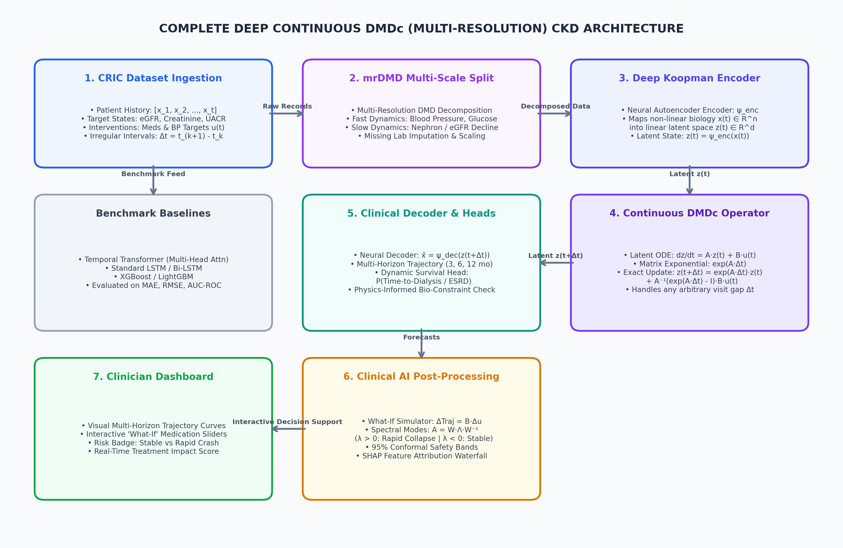
Figure 1: Full High-Resolution Architecture of Multi-Resolution Deep Continuous DMDc System.
5. Step-by-Step Methodological Approach (How We Build It)
We execute the project through 6 structured engineering and mathematical steps:
- Step 1 (Cohort Ingestion & Time-Delta Alignment): Extract multi-visit patient records from CRIC. For each patient sequence, compute elapsed follow-up intervals Δt = t_(k+1) - t_k, biological target states x(t) (eGFR, Creatinine, UACR), and active clinical intervention vectors u(t) (BP targets, ACEi/ARB, SGLT2i).
- Step 2 (Multi-Resolution mrDMD Time-Scale Decomposition): Apply Multi-Resolution DMD to separate high-frequency physiological noise (short-term blood pressure fluctuations, temporary glucose spikes) from slow-scale chronic renal deterioration (long-term eGFR decline).
- Step 3 (Deep Koopman Autoencoder Construction): Build an Encoder neural network ψ_enc: ℝⁿ → ℝᵈ that lifts non-linear clinical measurements into a latent space z(t) where disease dynamics behave linearly. Build a Decoder network ψ_dec: ℝᵈ → ℝⁿ to map latent coordinates back to clinical units.
- Step 4 (Continuous State-Space Layer & Training): Implement the continuous-time linear layer dz/dt = A·z + B·u. Use matrix exponential integration exp(A·Δt) to naturally forecast across irregular visit gaps. Train end-to-end to minimize the 4-part loss function.
- Step 5 (Explainability & Safety Bounds): Perform spectral decomposition on Matrix A (A = W·Λ·W⁻¹) to mathematically categorize patients into Rapid vs. Stable progressors based on eigenvalue stability. Compute 95% Conformal Prediction bounds and SHAP feature attribution waterfalls.
- Step 6 (Interactive Clinician Decision Dashboard): Deploy a Streamlit web application featuring multi-horizon trajectory curves with shaded 95% confidence bands, dynamic risk badges, and interactive 'What-If' medication sliders driven by ΔTraj = B·Δu.
6. Core Mathematical Formulations (The 4 Key Equations)
Here are the 4 fundamental mathematical formulations driving the entire project:
Main Equation 1: Continuous Koopman State-Space System & Exact Solution
Maps non-linear biological state x(t) into linear latent space z(t) = ψ_enc(x(t)) and solves continuously over irregular follow-up time Δt:
d z(t) / d t = A · z(t) + B · u(t)
z(t + Δt) = e^(A · Δt) · z(t) + A⁻¹ · ( e^(A · Δt) - I ) · B · u(t)
x̂(t + Δt) = ψ_dec( z(t + Δt) ) (Eq. 1)
The governing continuous Koopman evolution equation with clinical control inputs over irregular time intervals Δt.

Matrix & Vector Dictionary: What these terms and matrices hold biologically:
- x(t) ∈ ℝⁿ: Measurable patient state (eGFR, Serum Creatinine, UACR, Systolic BP, Diastolic BP, Hemoglobin, Potassium).
- z(t) ∈ ℝᵈ: Latent biological coordinate representing true underlying nephron capacity, de-noised of laboratory measurement error.
- Matrix A ∈ ℝ^(d×d): Autonomous Renal Decline Operator (natural disease decline speed without new intervention).
- Matrix B ∈ ℝ^(d×p): Therapeutic Response Operator (quantifies how much medication stops/slows down decline).
- Vector u(t) ∈ ℝᵖ: Clinical interventions (target SBP reduction, ACEi/ARB dosage, SGLT2 inhibitor presence).
Main Equation 2: Spectral Eigenmode Stability (Crash vs. Stable)
Performing eigenvalue decomposition on the continuous operator Matrix A: A = W · Λ · W⁻¹ where eigenvalues λ_j = σ_j + i·ω_j:
A = W · Λ · W⁻¹, where Λ = diag( λ₁, λ₂, ..., λ_d )
• Re( λ_j ) > 0 ⟹ Rapid Collapse Mode (Unstable exponential kidney failure; flags high risk)
• Re( λ_j ) ≈ 0 ⟹ Chronic Stable Mode (Predictable age-associated decline)
• Re( λ_j ) < 0 ⟹ Stabilizing Response Mode (Medical therapy actively protects kidney) (Eq. 2)
Spectral Lyapunov stability classification of patient disease phenotypes.

Main Equation 3: Unified 4-Part Multi-Objective Loss Function
The entire neural network is optimized end-to-end to minimize:
ℒ_total = λ₁·ℒ_reconstruction + λ₂·ℒ_prediction + λ₃·ℒ_koopman_linear + λ₄·ℒ_bio_guardrail
1. ℒ_reconstruction = (1/N) ∑ ‖ x_i(t) - ψ_dec(ψ_enc(x_i(t))) ‖₂²
2. ℒ_prediction = (1/N) ∑ ∑_(k∈{3,6,12}) ‖ x̂_i(t+k) - x_i(t+k) ‖₂²
3. ℒ_koopman_linear = (1/N) ∑ ‖ z_i(t+Δt) - [ e^(A·Δt)z_i(t) + B_eff·u_i(t) ] ‖₂²
4. ℒ_bio_guardrail = ReLU( - eGFR̂ ) + ReLU( - Creatininê ) + λ_s·ReLU( |deGFR̂/dt| - MaxSlope ) (Eq. 3)
Combines Autoencoder fidelity, multi-horizon accuracy, Koopman linearity, and human biological constraints.

Main Equation 4: Non-Parametric Conformal 95% Confidence Guarantee
Using calibration non-conformity quantiles q̂, the prediction interval satisfies strict statistical coverage:
P( y_true ∈ [ x̂ - q̂, x̂ + q̂ ] ) ≥ 0.95 (Eq. 4)
Guarantees that the true future eGFR will fall inside the shaded confidence band at least 95% of the time.

7. CRIC Dataset Specifications & Schema
The Chronic Renal Insufficiency Cohort (CRIC) tracks ~3,900 to 5,500 adult patients with mild-to-moderate CKD over 10+ years across repeated annual clinical exams and biannual lab follow-ups.
Feature Category | Specific Variables | Clinical Unit / Format | Role in Model
Target States x(t) | eGFR (CKD-EPI formula)  Serum Creatinine  Urine Protein (UACR) | mL/min/1.73m²  mg/dL  mg/g | Target state vector to forecast across 3, 6, 12 months
Hemodynamic Vitals | Systolic BP (SBP)  Diastolic BP (DBP)  Body Mass Index (BMI) | mmHg  mmHg  kg/m² | Dynamic physiological observables impacting renal perfusion
Metabolic & Lab Markers | HbA1c / Blood Glucose  Serum Potassium & Bicarbonate  Serum Hemoglobin & Albumin | % / mg/dL  mEq/L  g/dL | Biomarkers tracking diabetic nephropathy, acidosis, and anemia
Clinical Controls u(t) | RAAS Blockade (ACEi/ARB)  SGLT2 Inhibitor Therapy  Target SBP Reduction | Binary (0/1)  Binary (0/1)  Continuous ΔmmHg | Exogenous control inputs for What-If counterfactual simulator
Demographics & Prior | Age, Biological Sex, Race  Baseline Diabetes & CVD History | Years, Binary  Binary indicators | Static contextual conditioning for latent encoder

8. Technical Stack & Interactive Clinician Dashboard
- Tech Stack: Python 3.10+, PyTorch / PyTorch Lightning, SciPy (matrix exponential expm), PyDMD, SHAP, Streamlit, and Plotly.
- View 1 (Patient Trajectory & Risk Status): Plots historical visits and continuous 3, 6, and 12-month predicted curves with shaded 95% Conformal confidence bands. Prominently displays the Risk Badge: 🟢 Stable | 🟡 Moderate | 🔴 Rapid Progressor.
- View 2 ('What-If' Counterfactual Treatment Simulator): Provides interactive sliders for SBP reduction and medication toggles (ACEi/ARB, SGLT2i). In real time, the dashboard updates the forecasted trajectory curve via ΔTrajectory = B · Δu, calculating the extra years of dialysis-free life gained.
- View 3 (Dual-Layer Explainability Panel): Displays spectral eigenvalue stability (Matrix A) alongside a SHAP waterfall plot showing which clinical factors drove the forecast.

