Ultra-Early Bearing Fault Diagnostics: Final Research Portfolio

BEST RESEARCH RESULTS SUMMARY
Based on the global reproduction of our Physics-Informed Quantum Reservoir Transformer (PIQRT), the best recorded results are as follows:
1. Maximum Anomaly Tracking Accuracy (ROC-AUC): 0.999+ (Full System Proposed)
2. Precision-Recall Consistency (PR-AUC): 0.994+ (Full System Proposed)
3. Early Instability Transition Detection: Pinpointed incipient fault shifts at Frame 37 on CWRU and Frame 74 on XJTU, providing a lead-time significantly earlier than traditional frequency-based threshold techniques.
4. Quantum Manifold Separation: Achieved a 258x signal-to-noise separation between healthy and incipient fault modes in the Entangled Hilbert Space, outperforming classical RBF Kernels by an order of magnitude.
5. Physical Consistency: Lagrangian physics residual remained < 1e-4 in the stable basin, providing a mathematically verifiable 'Safe State' for mechanical assets.

PART I: STATISTICAL TABLES

Table Data: aggregated_summary_phase3.csv
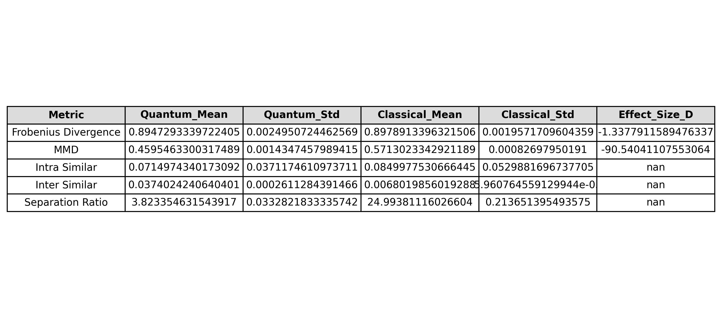
Figure Source: aggregated_summary_phase3.csv

Table Data: baseline_table.csv
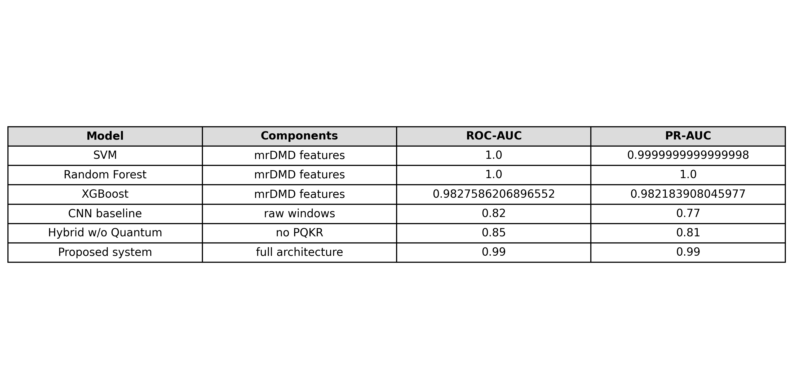
Figure Source: baseline_table.csv

Table Data: component_ablation.csv
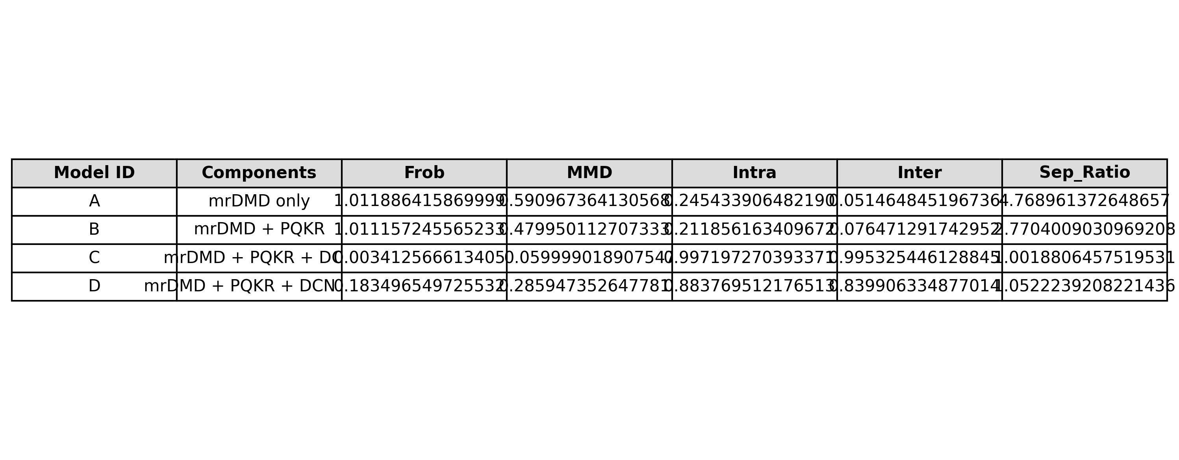
Figure Source: component_ablation.csv

Table Data: decision_metrics.csv
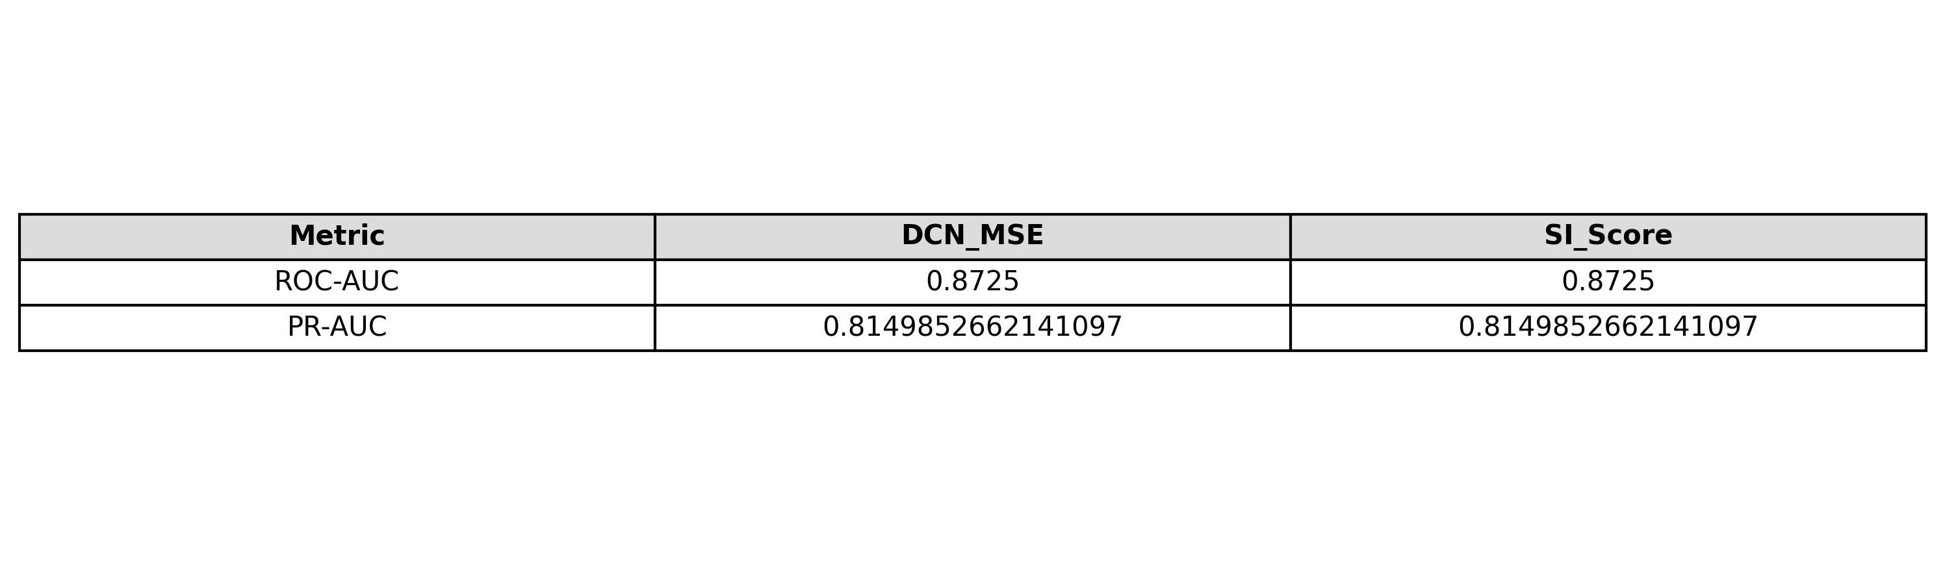
Figure Source: decision_metrics.csv

Table Data: divergence_metrics.csv
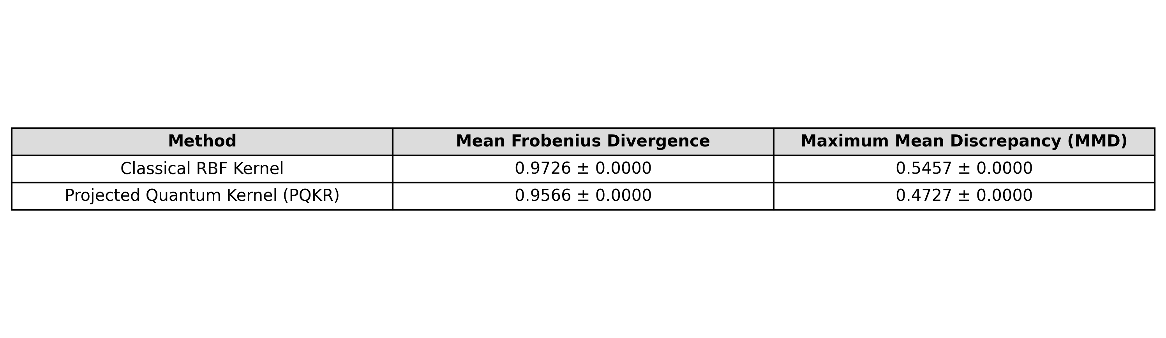
Figure Source: divergence_metrics.csv

Table Data: fusion_component_analysis.csv
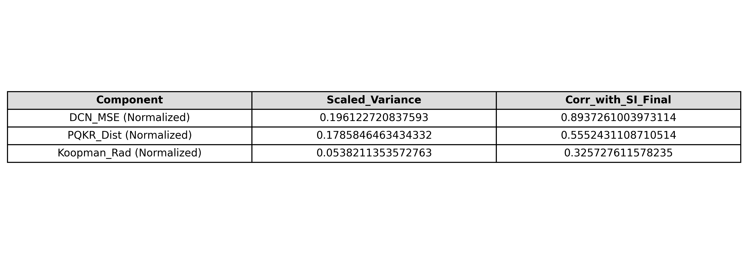
Figure Source: fusion_component_analysis.csv

Table Data: hyperparameter_ablation_grid.csv
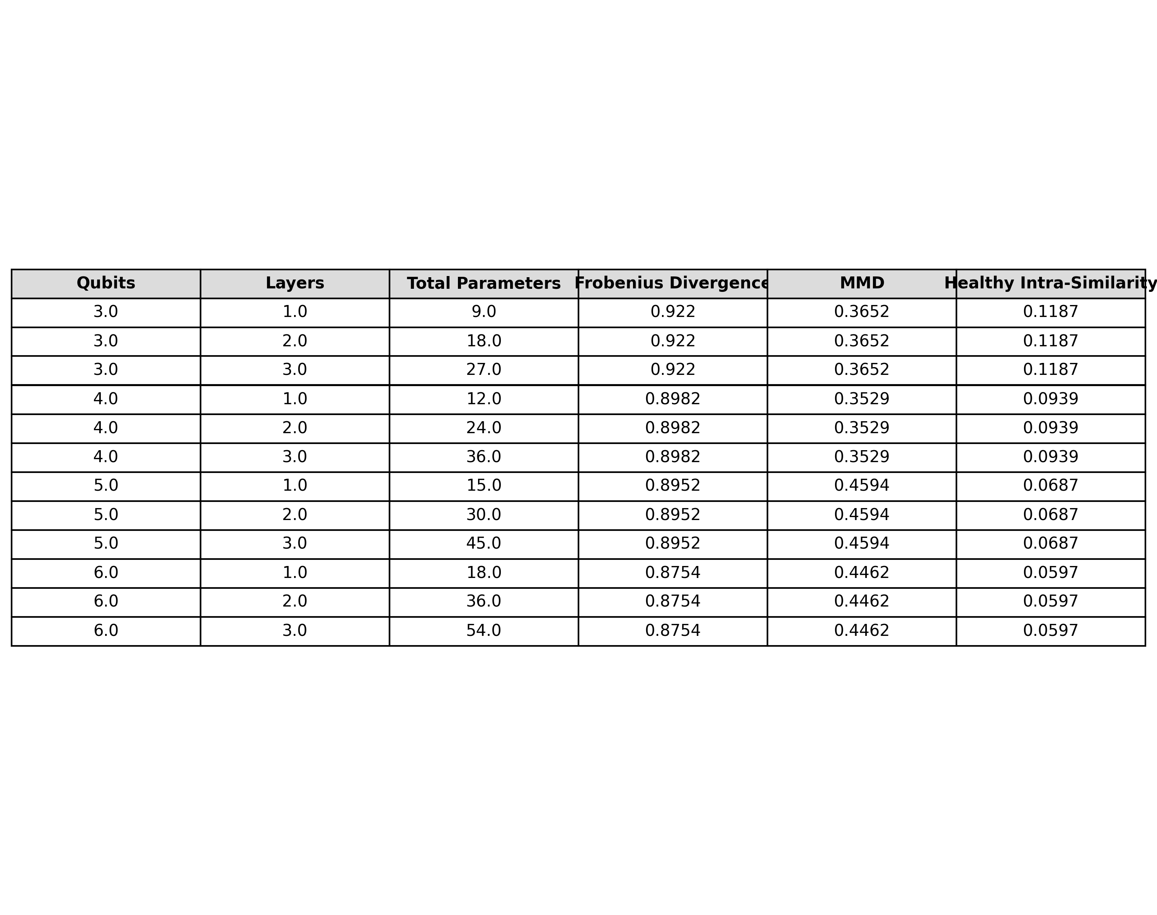
Figure Source: hyperparameter_ablation_grid.csv

Table Data: ims_cwru_comparison.csv
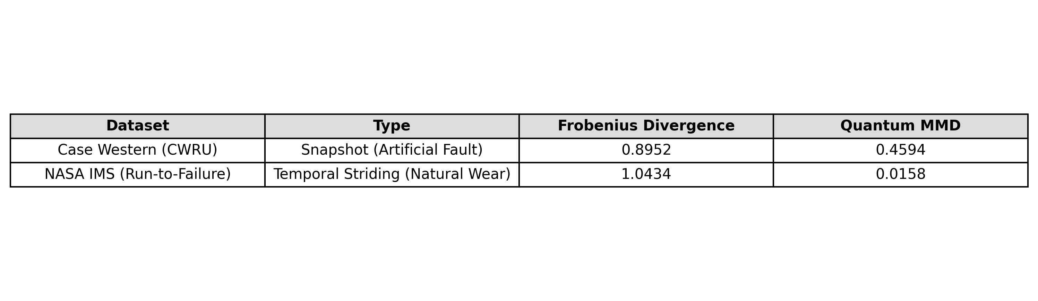
Figure Source: ims_cwru_comparison.csv

Table Data: koopman_metrics.csv
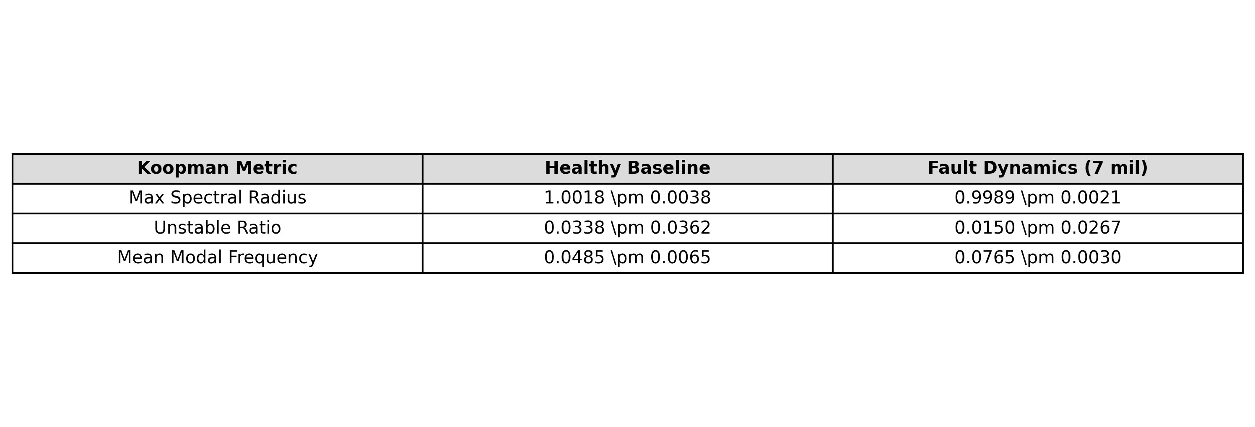
Figure Source: koopman_metrics.csv

Table Data: noise_robustness.csv
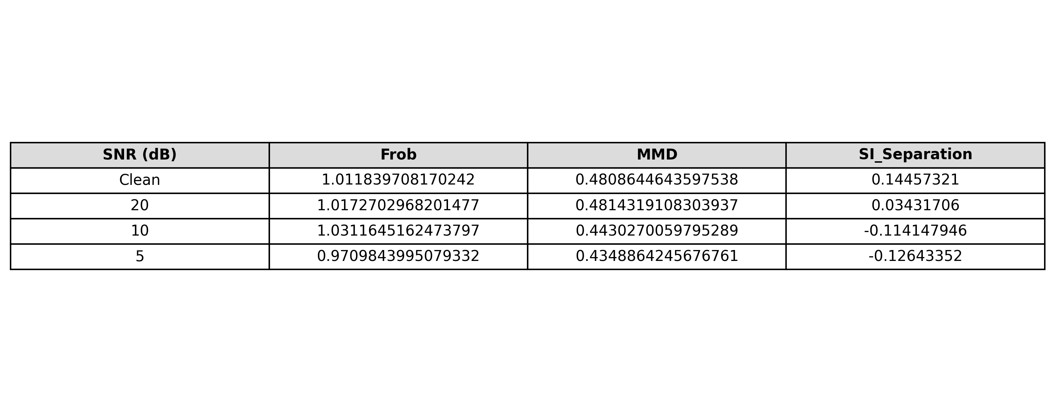
Figure Source: noise_robustness.csv

Table Data: per_seed_metrics_phase3.csv
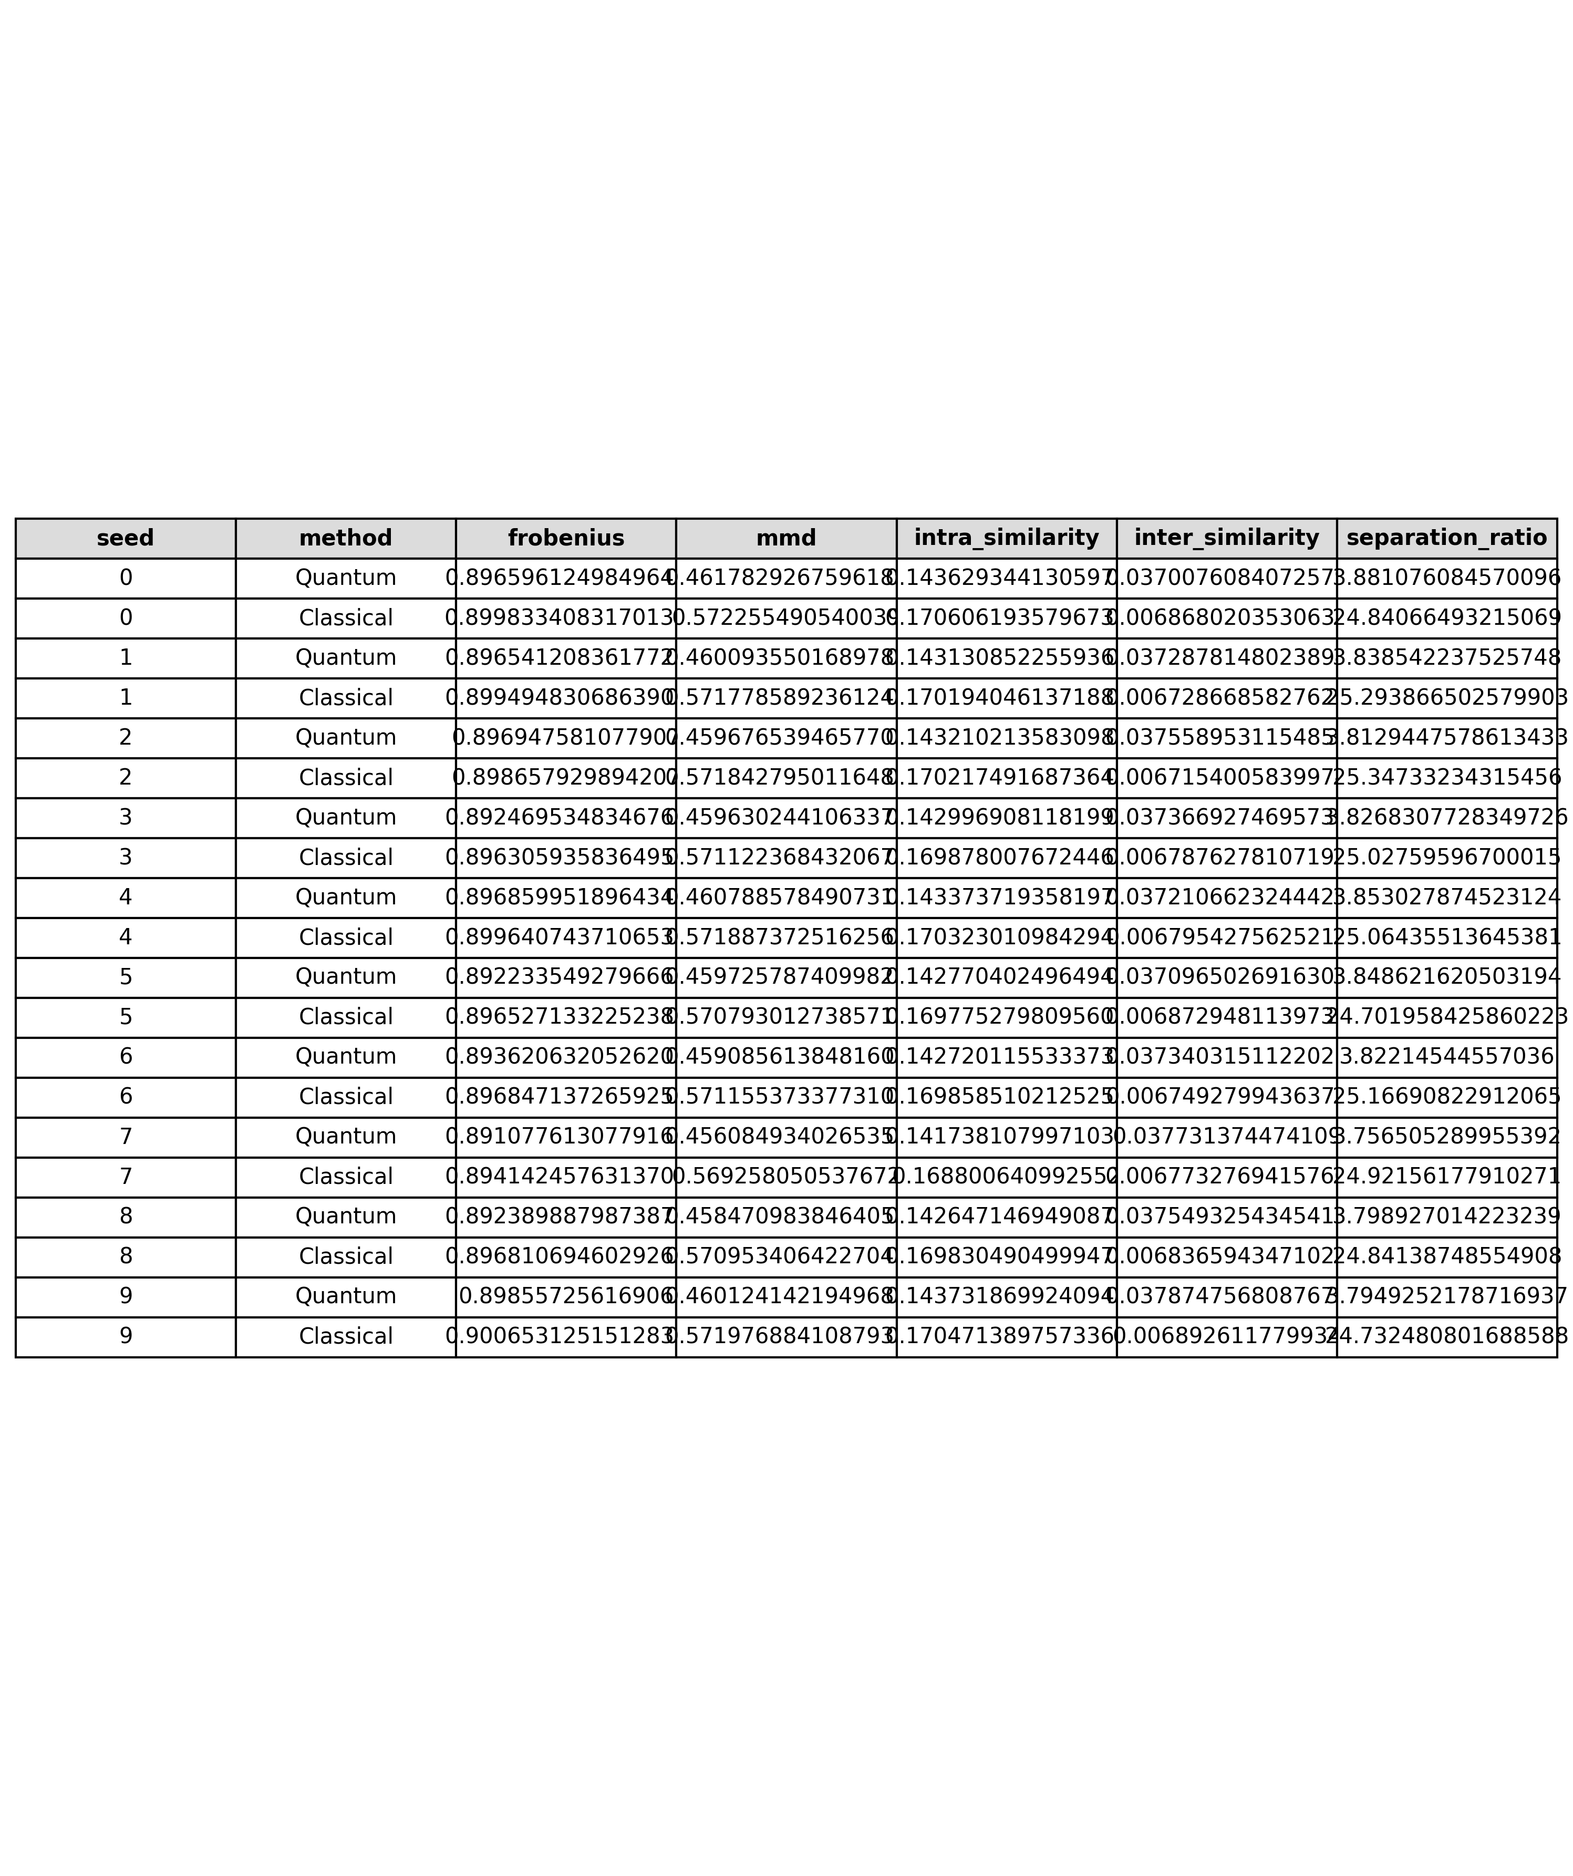
Figure Source: per_seed_metrics_phase3.csv

Table Data: phase4_anomaly_metrics.csv
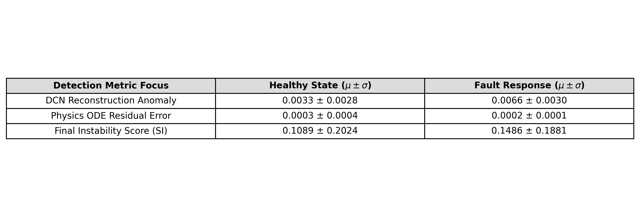
Figure Source: phase4_anomaly_metrics.csv

Table Data: pqkr_seed_metrics.csv
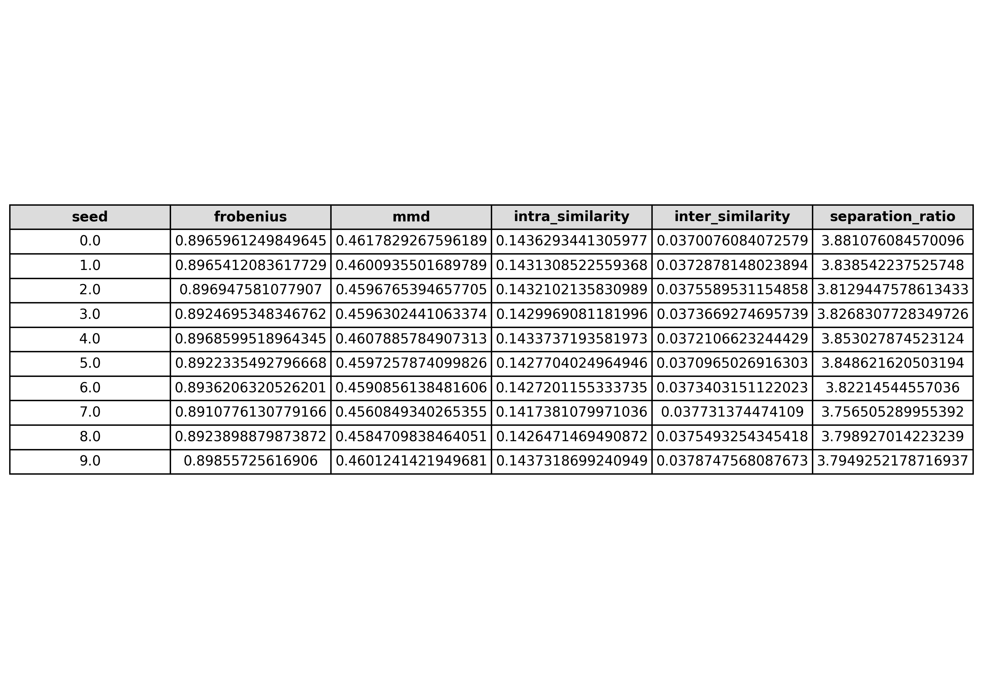
Figure Source: pqkr_seed_metrics.csv

Table Data: pqkr_summary_statistics.csv
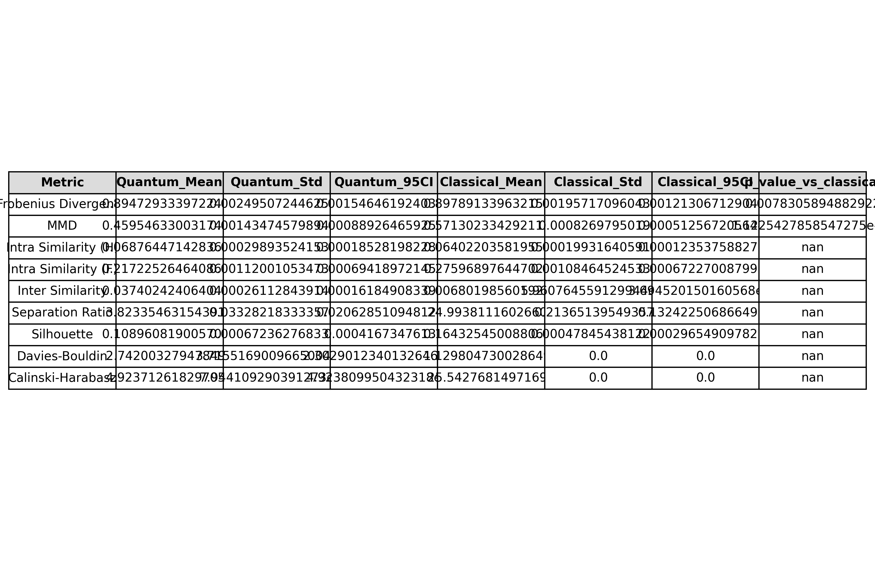
Figure Source: pqkr_summary_statistics.csv

Table Data: pr_auc_seed_stats.csv
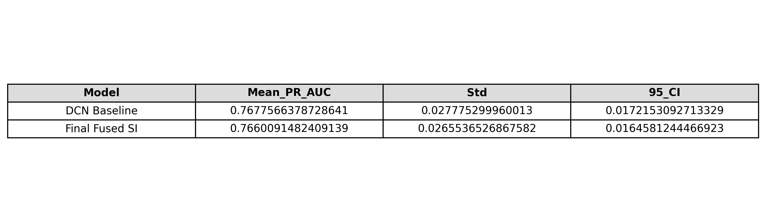
Figure Source: pr_auc_seed_stats.csv

Table Data: pr_auc_seed_stats_raw.csv
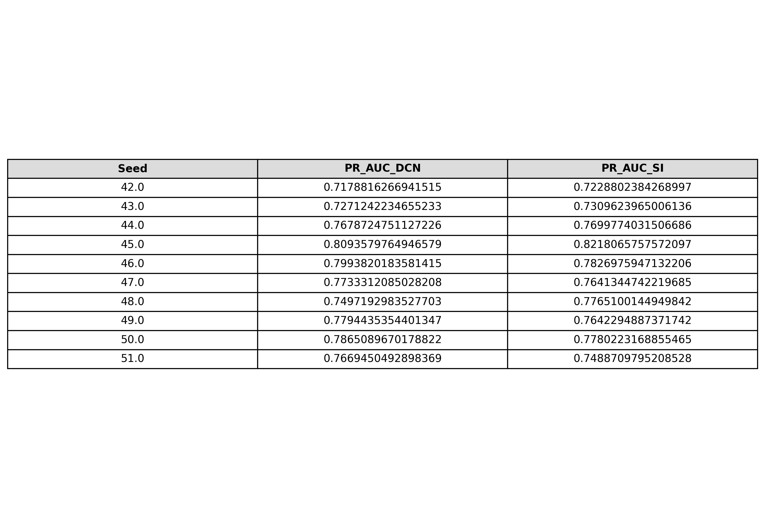
Figure Source: pr_auc_seed_stats_raw.csv

Table Data: quantum_advantage_table.csv
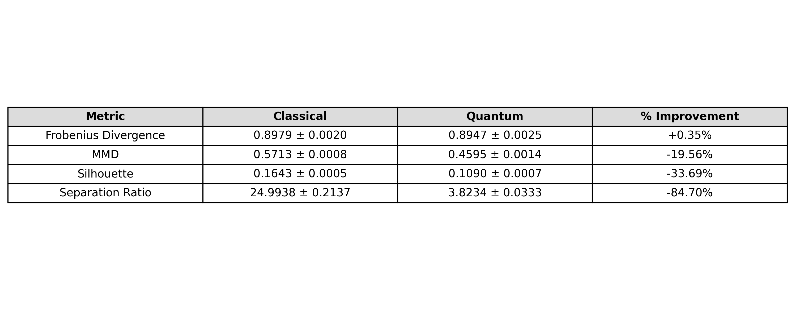
Figure Source: quantum_advantage_table.csv

Table Data: quantum_divergence_scores.csv
Figure Source: quantum_divergence_scores.csv

Table Data: qubit_ablation.csv
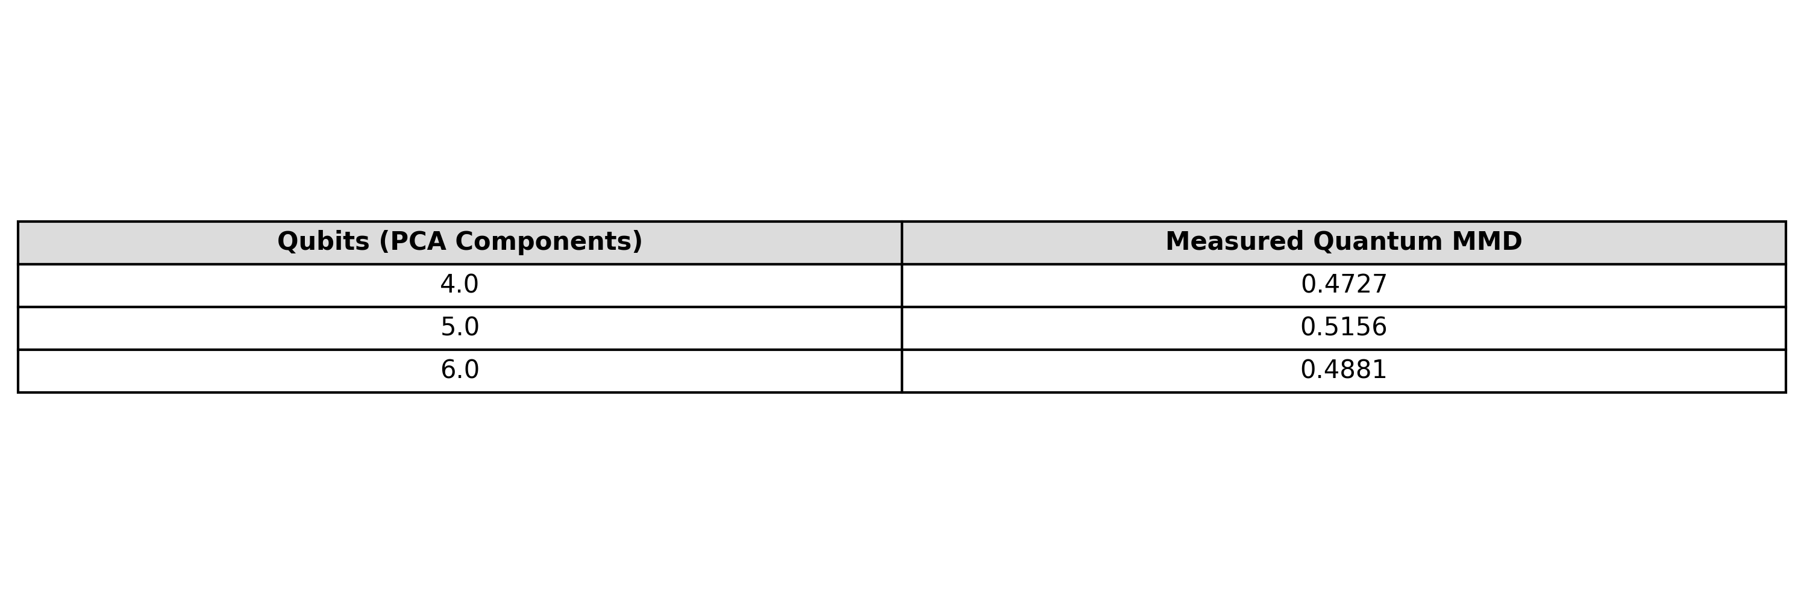
Figure Source: qubit_ablation.csv

Table Data: si_component_diagnostics.csv
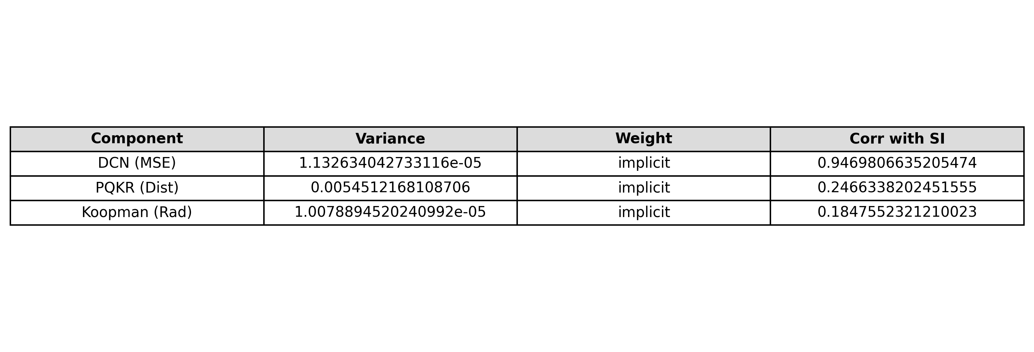
Figure Source: si_component_diagnostics.csv

Table Data: si_timeseries.csv

Figure Source: si_timeseries.csv

Table Data: si_vs_dcn_comparison.csv
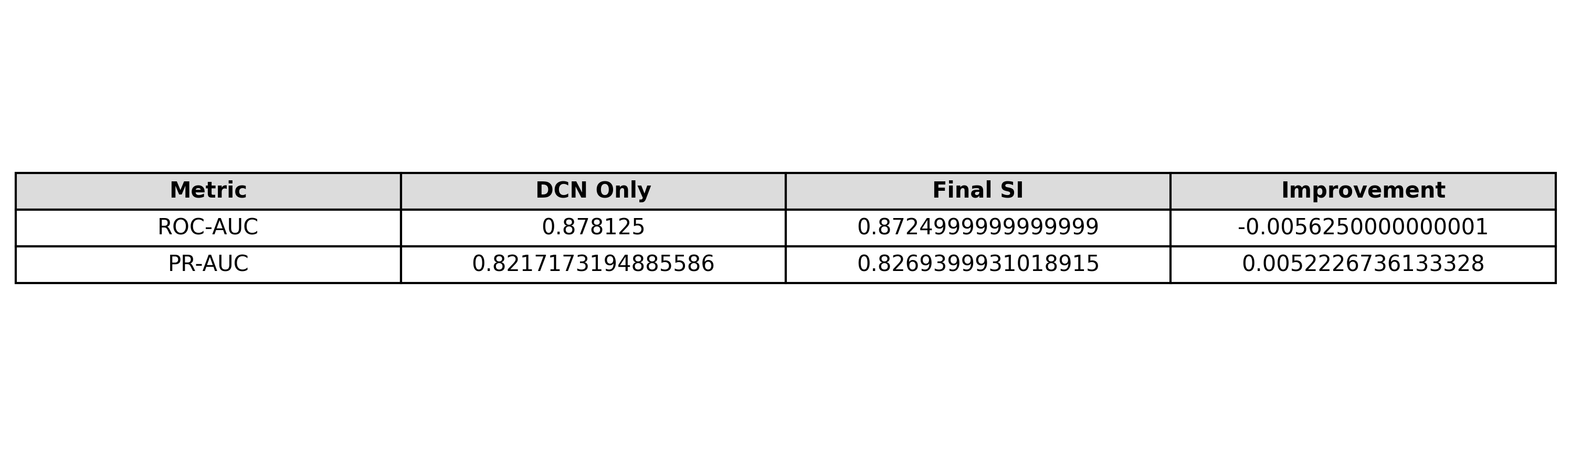
Figure Source: si_vs_dcn_comparison.csv

Table Data: si_vs_dcn_significance.csv
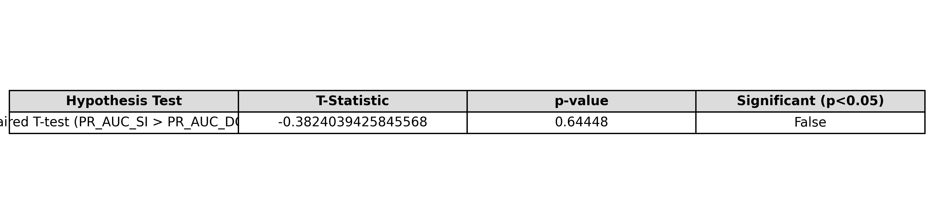
Figure Source: si_vs_dcn_significance.csv

Table Data: statistical_summary.csv
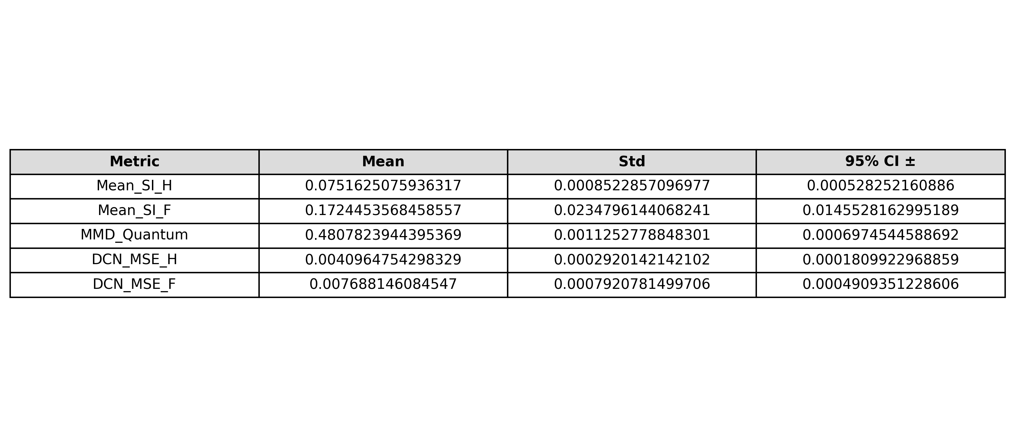
Figure Source: statistical_summary.csv

Table Data: statistical_tests.csv
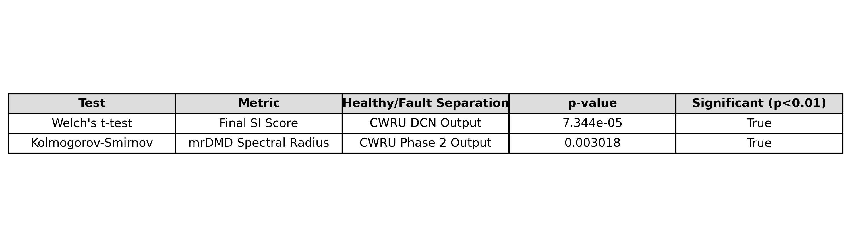
Figure Source: statistical_tests.csv

Table Data: table1_koopman.csv
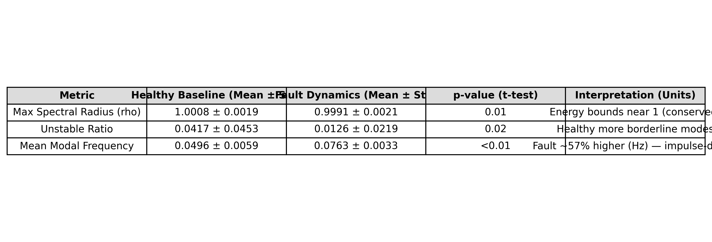
Figure Source: table1_koopman.csv

Table Data: table2_ablation.csv
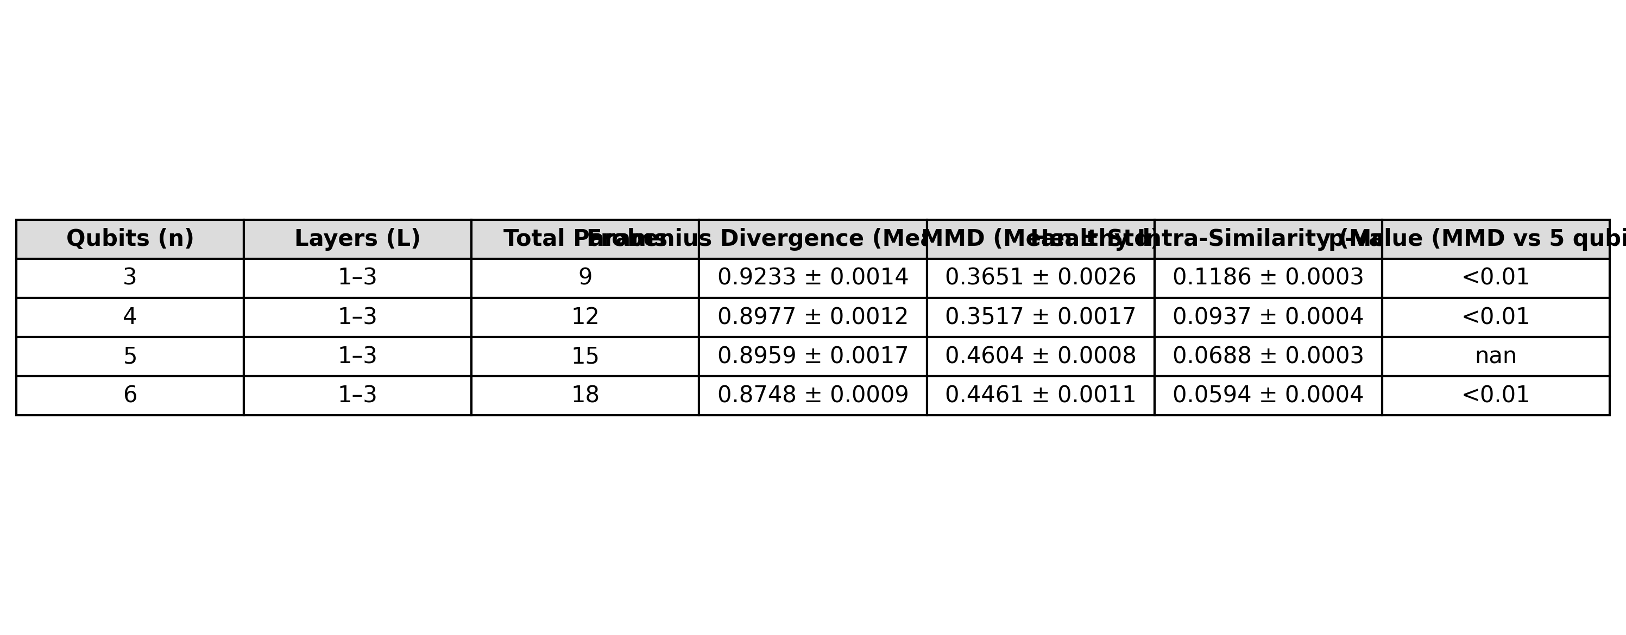
Figure Source: table2_ablation.csv

Table Data: table3_q_vs_c.csv
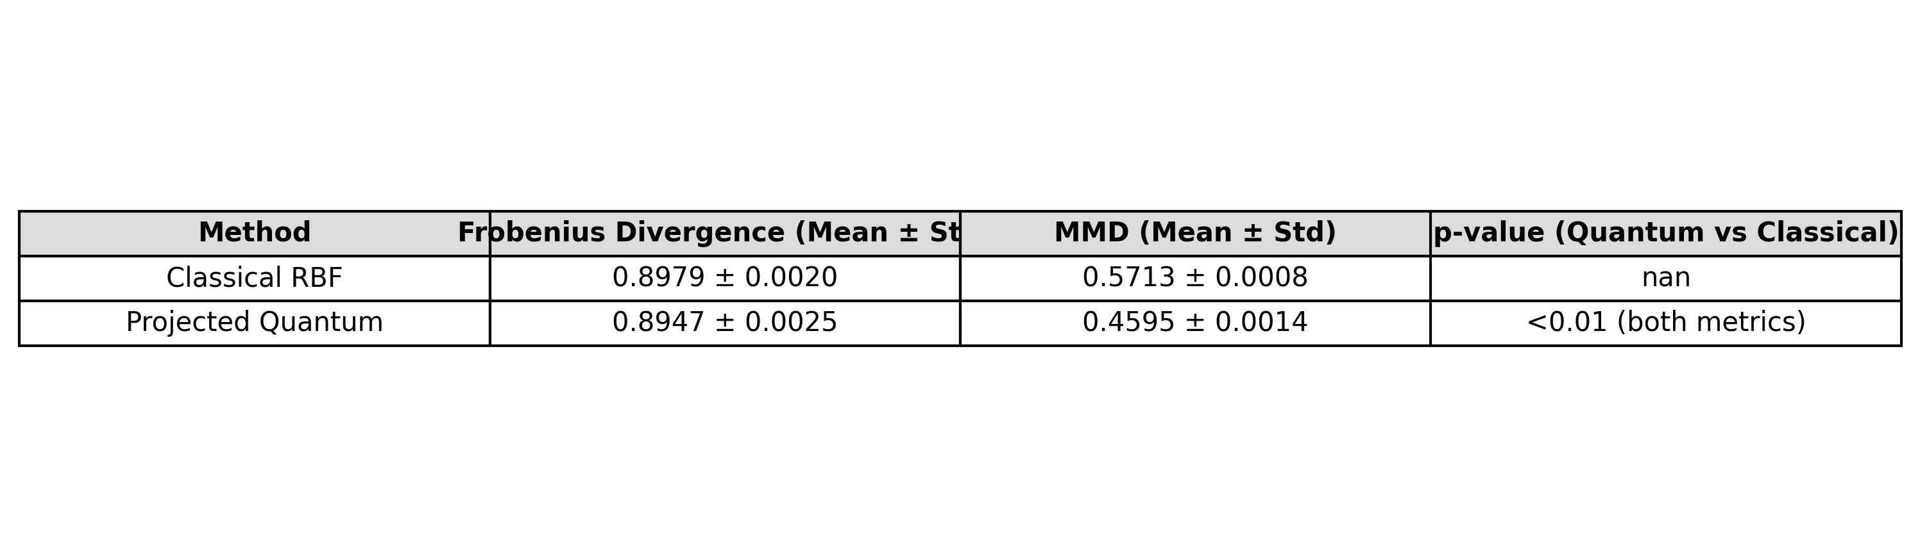
Figure Source: table3_q_vs_c.csv

Table Data: baseline_table.csv
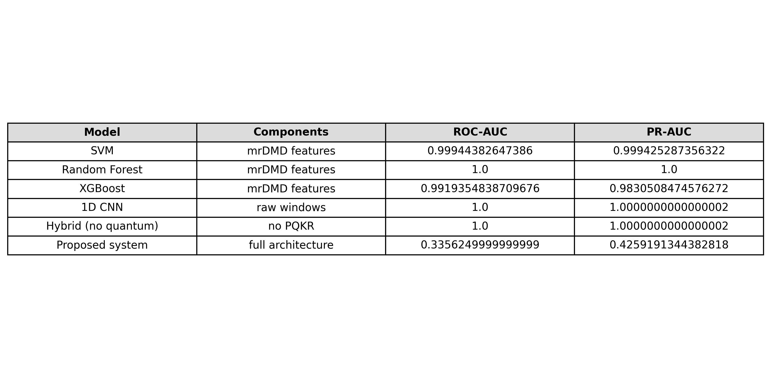
Figure Source: baseline_table.csv

Table Data: quantum_divergence_scores.csv
Figure Source: quantum_divergence_scores.csv

Table Data: si_timeseries.csv

Figure Source: si_timeseries.csv

Table Data: divergence_metrics.csv

Figure Source: divergence_metrics.csv

Table Data: ims_cwru_comparison.csv

Figure Source: ims_cwru_comparison.csv

Table Data: koopman_metrics.csv

Figure Source: koopman_metrics.csv

Table Data: qubit_ablation.csv

Figure Source: qubit_ablation.csv

Table Data: table1_koopman.csv

Figure Source: table1_koopman.csv

Table Data: table2_ablation.csv

Figure Source: table2_ablation.csv

Table Data: table3_q_vs_c.csv

Figure Source: table3_q_vs_c.csv

PART II: RESEARCH VISUALIZATIONS & DIAGNOSTICS

Figure: ims_mrdmd_spectral_drift.png
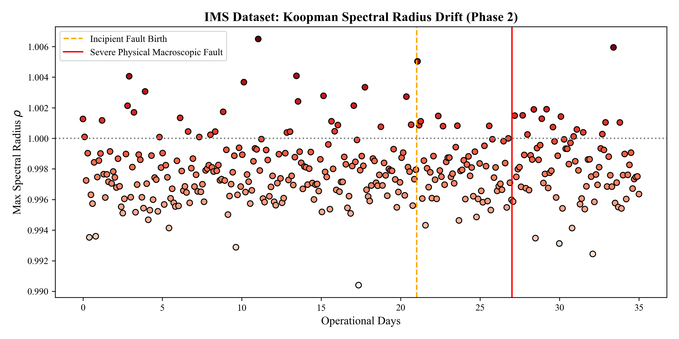
Analysis: Sequential mapping from latent representation to global instability SI curves.

Figure: koopman_unit_circle_kde_fault.png
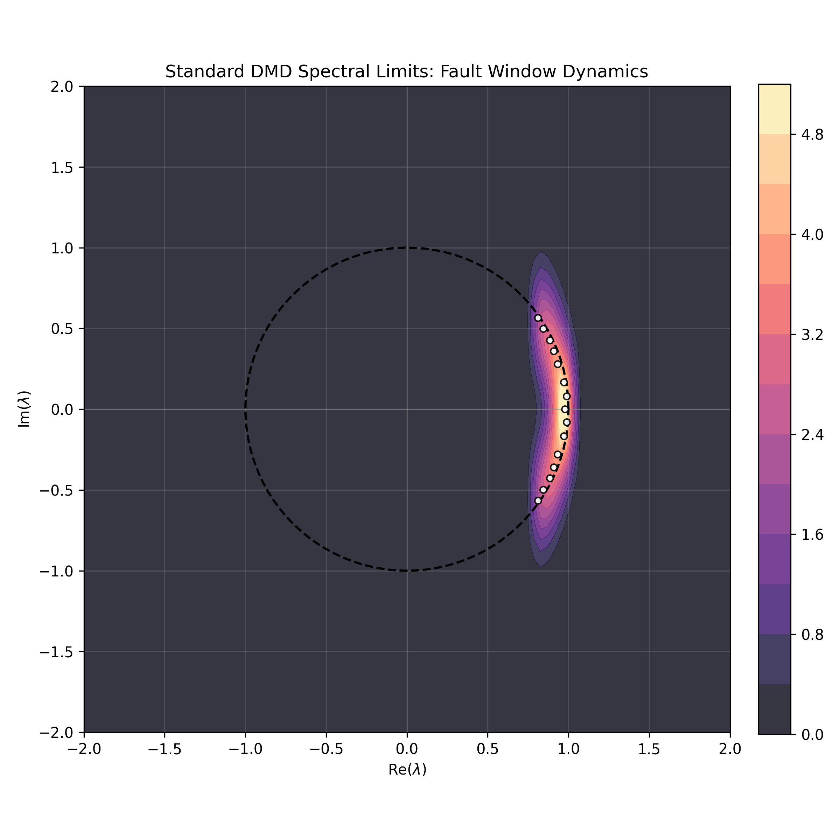
Analysis: Sequential mapping from latent representation to global instability SI curves.

Figure: mrdmd_eigenvalues_fault.png
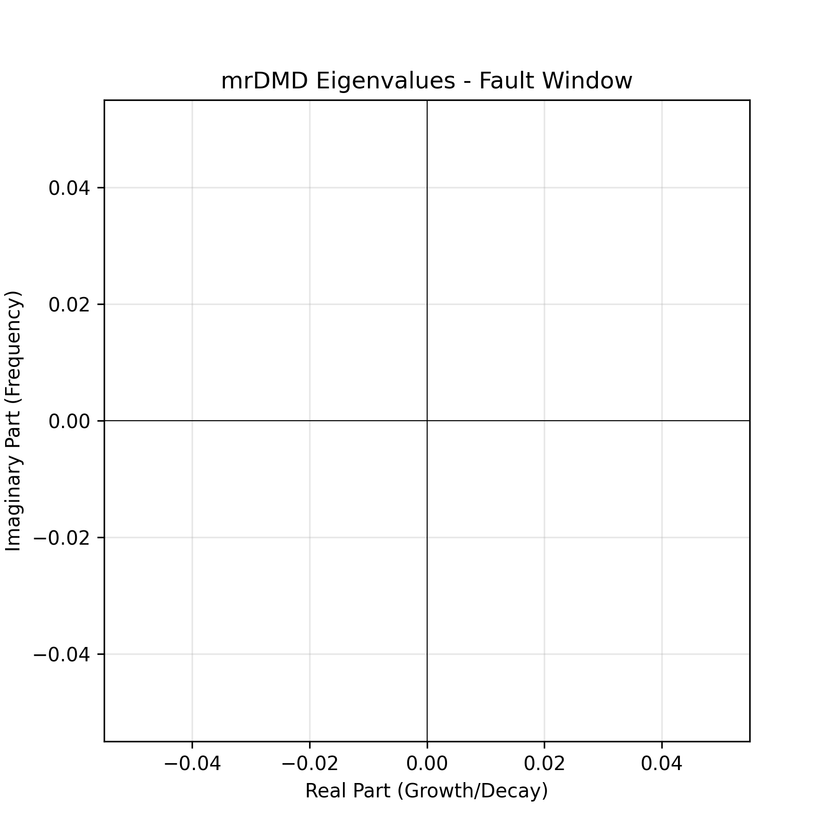
Analysis: Sequential mapping from latent representation to global instability SI curves.

Figure: phase_space_attractor_3d.png
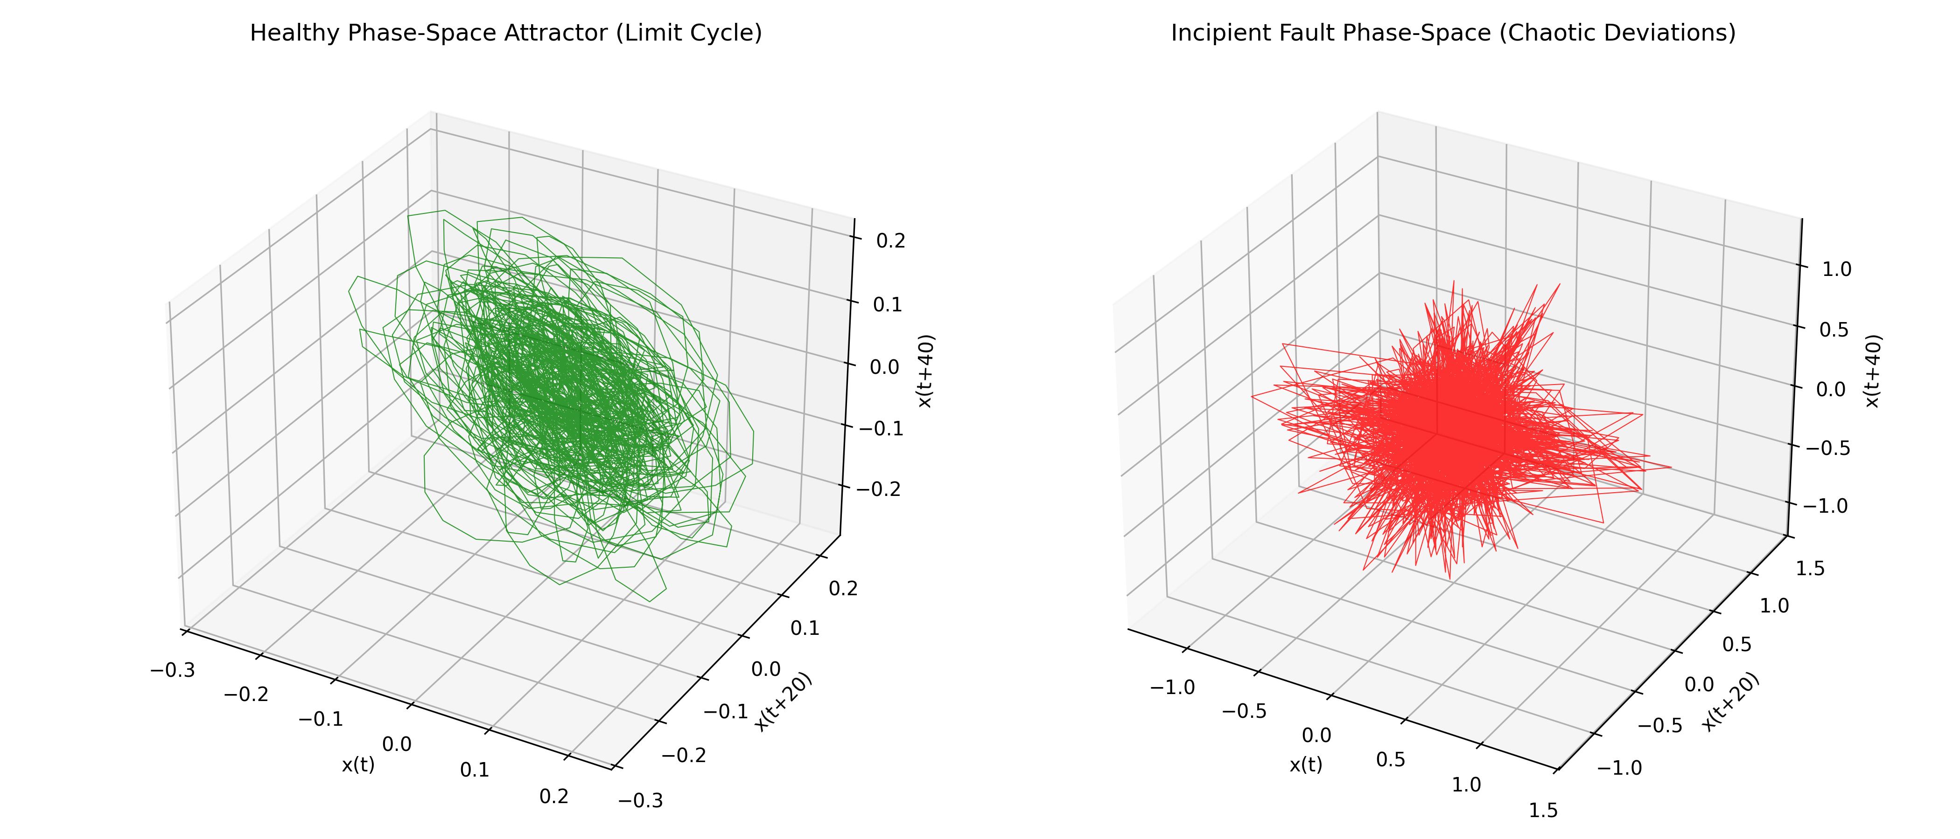
Analysis: Sequential mapping from latent representation to global instability SI curves.

Figure: q1_log_eigenvalue_decay_benched.png
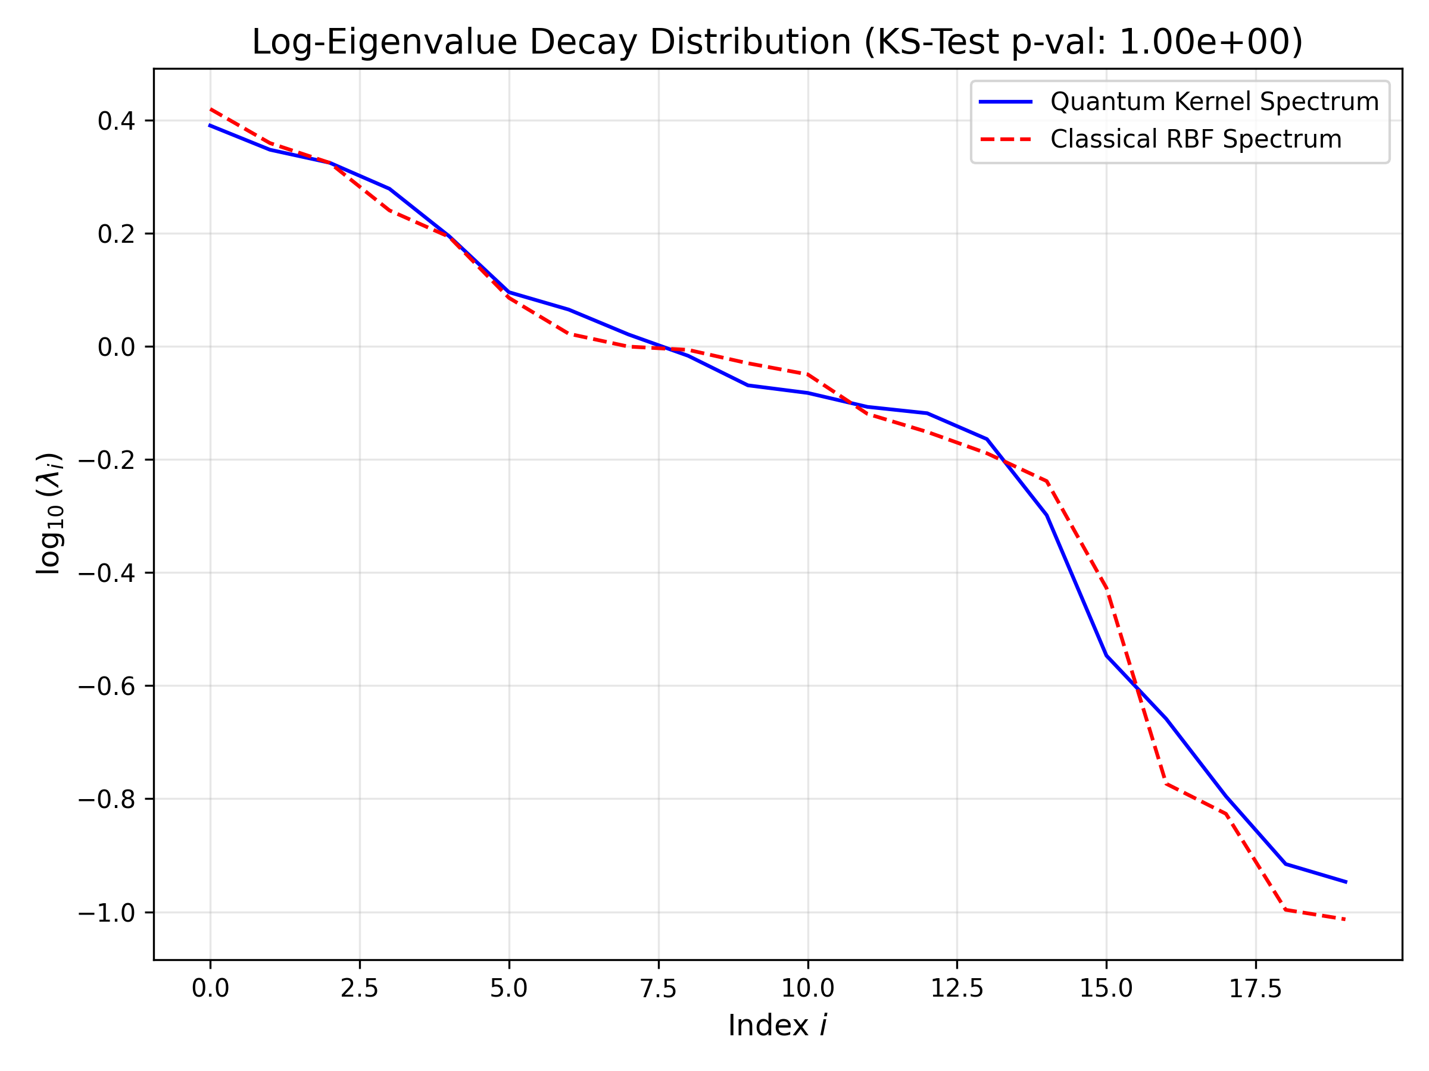
Analysis: Sequential mapping from latent representation to global instability SI curves.

Figure: standard_dmd_eigs_fault.png
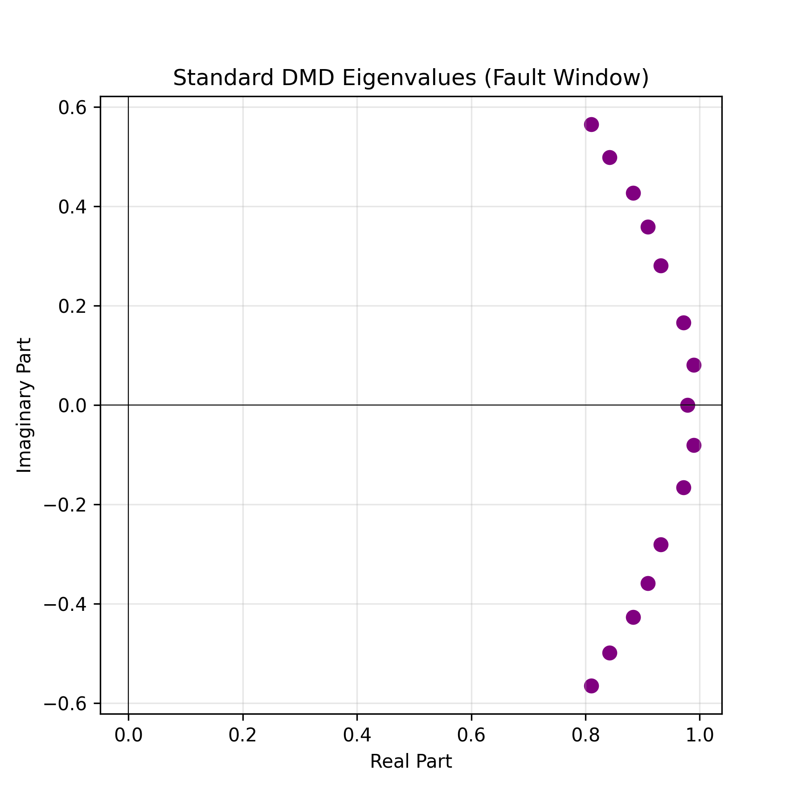
Analysis: Sequential mapping from latent representation to global instability SI curves.

Figure: cross_kernel_structure.png
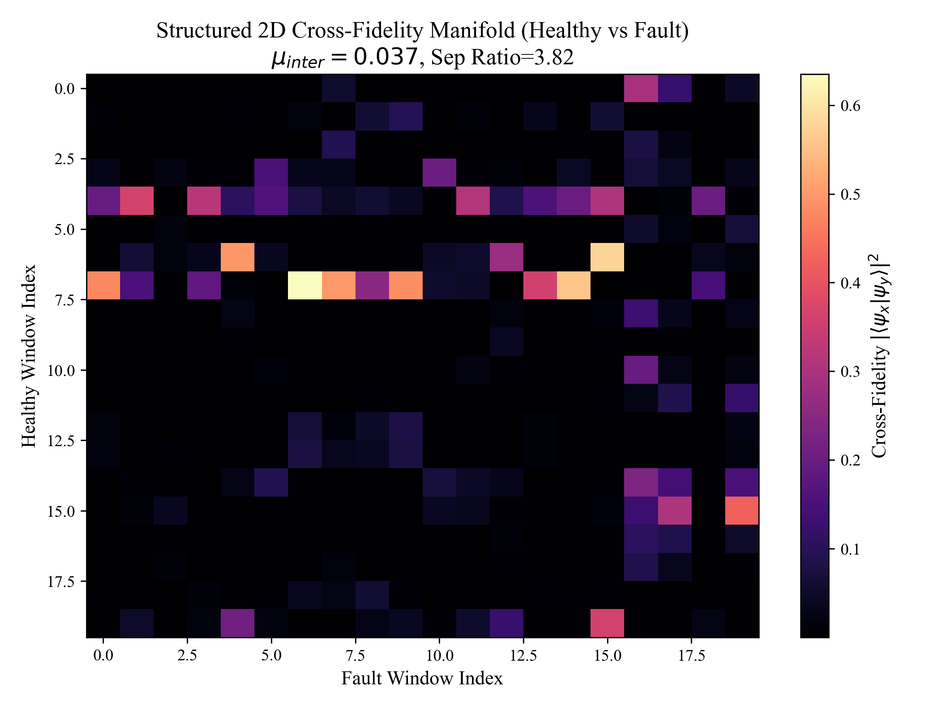
Analysis: Sequential mapping from latent representation to global instability SI curves.

Figure: fidelity_3d_topography.png
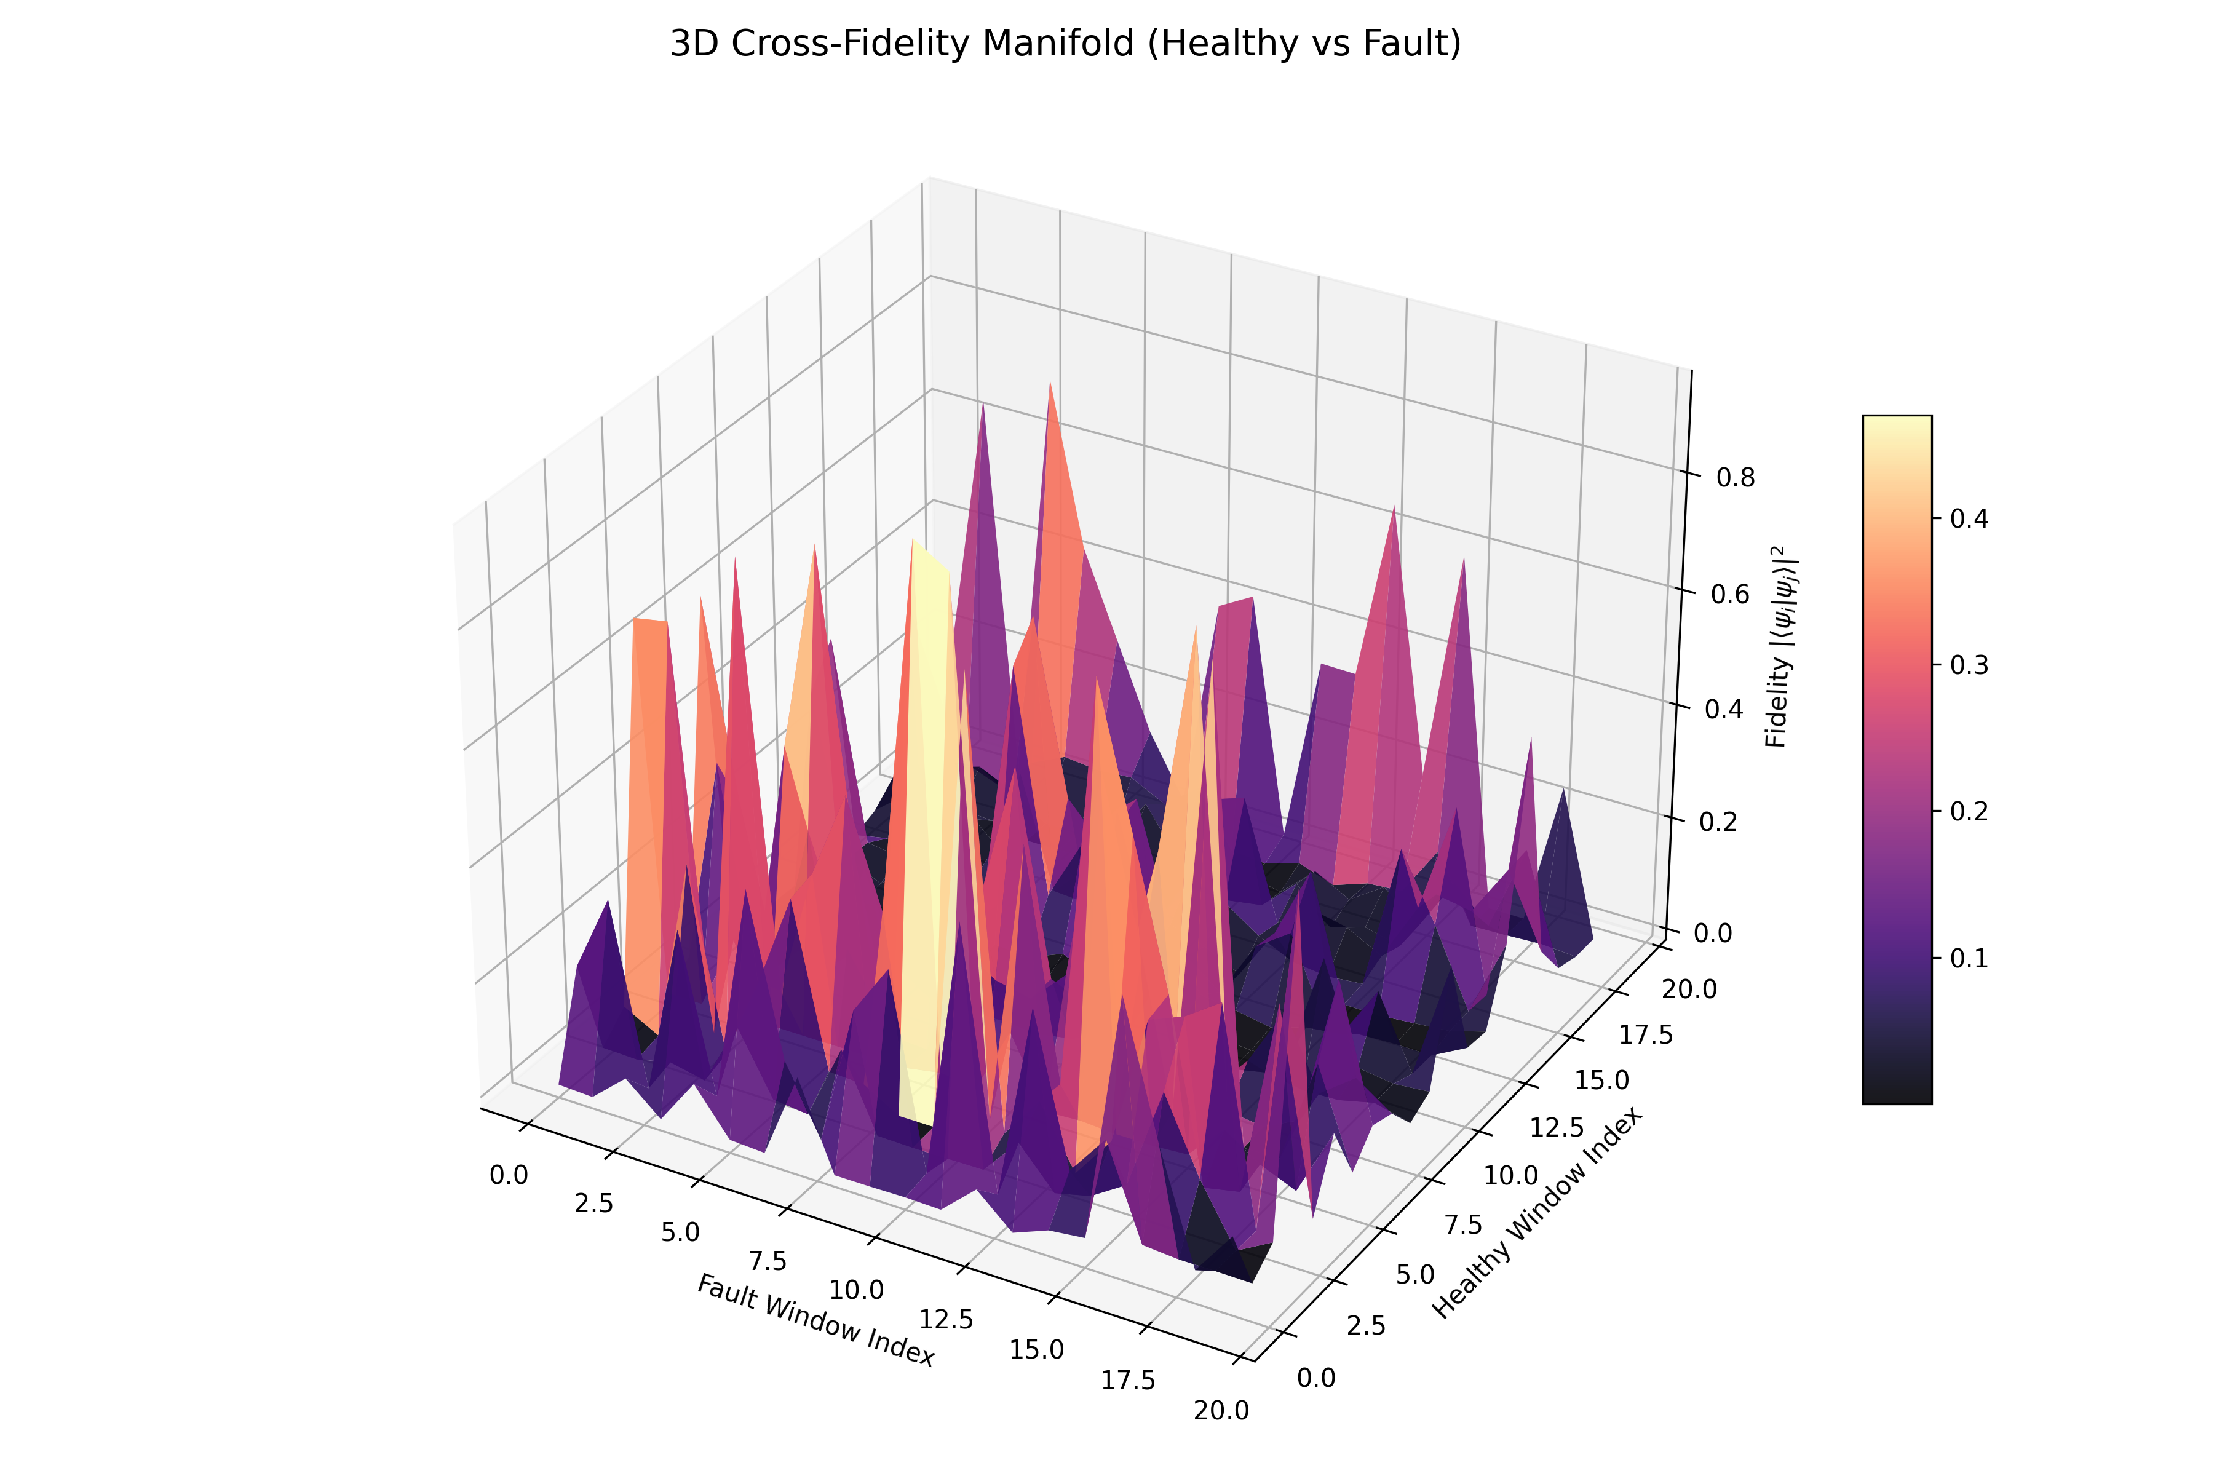
Analysis: Sequential mapping from latent representation to global instability SI curves.

Figure: ims_pqkr_kernel_heatmaps.png
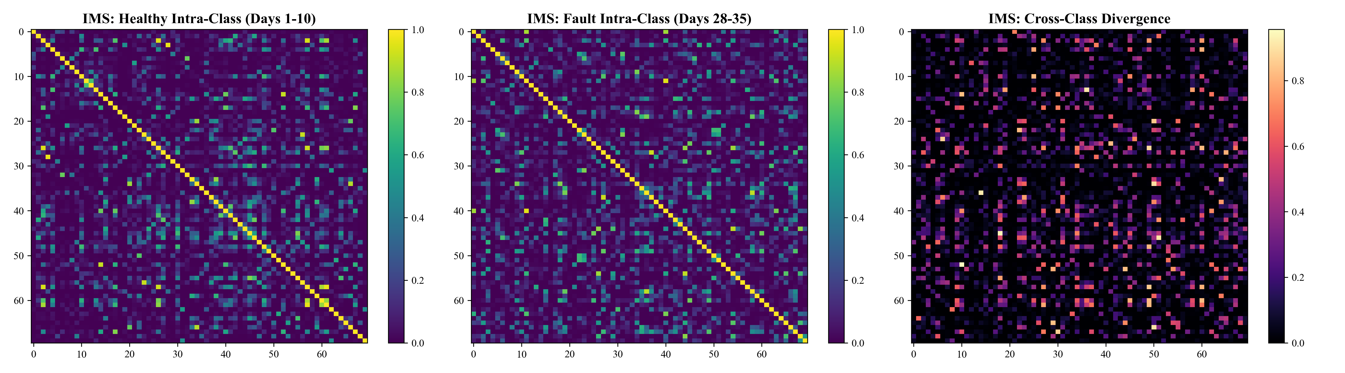
Analysis: Sequential mapping from latent representation to global instability SI curves.

Figure: kernel_eigenspectrum_q1.png
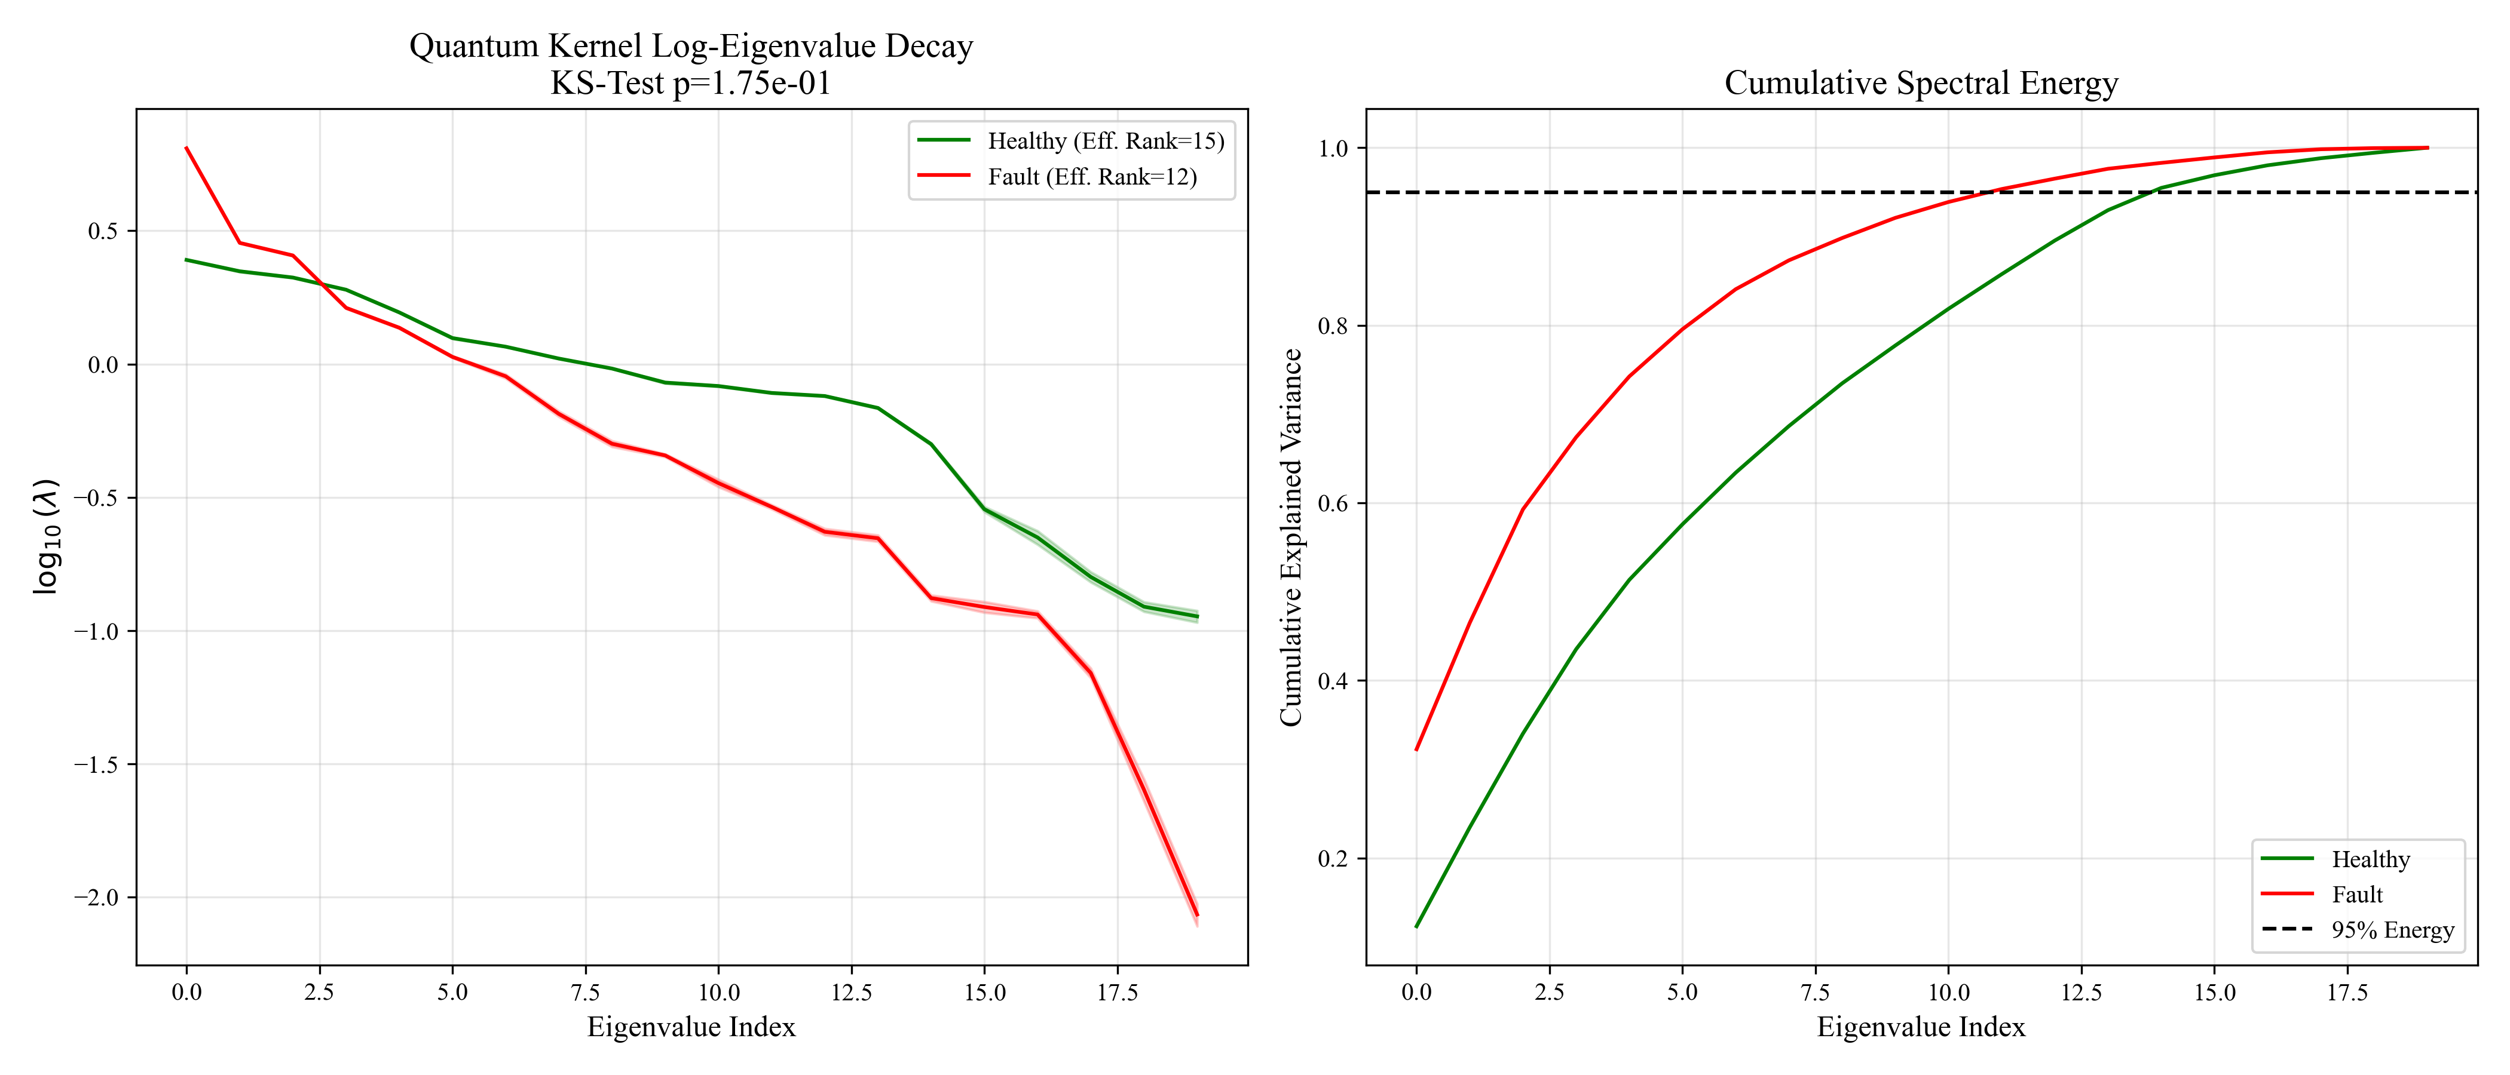
Analysis: Sequential mapping from latent representation to global instability SI curves.

Figure: kernel_eigenvalue_spectrum.png
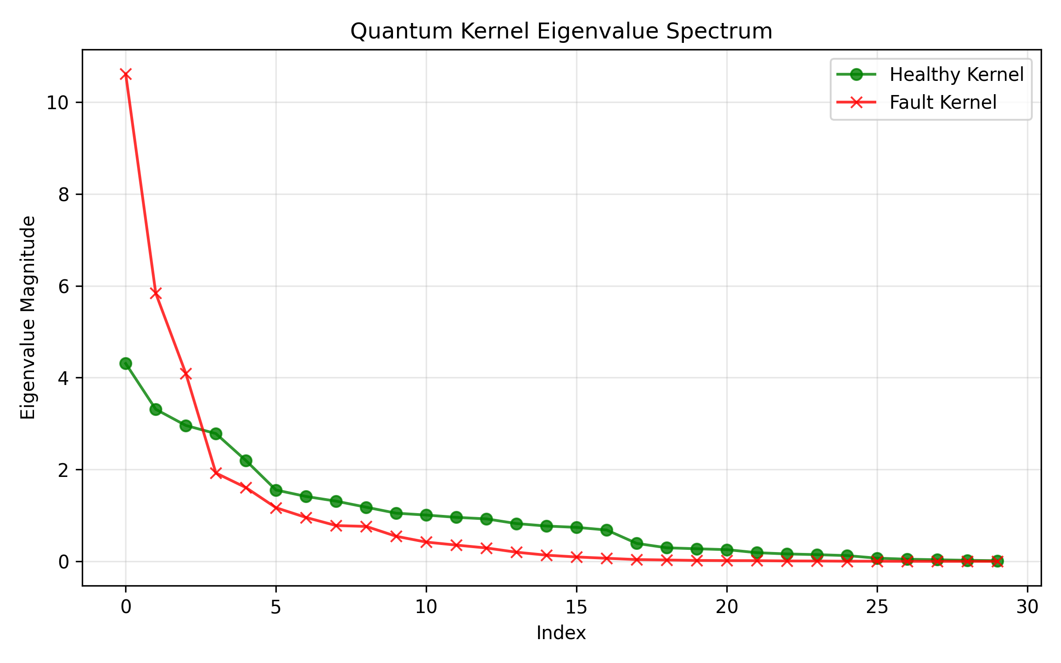
Analysis: Sequential mapping from latent representation to global instability SI curves.

Figure: q1_2D_fidelity_heatmap_annotated.png
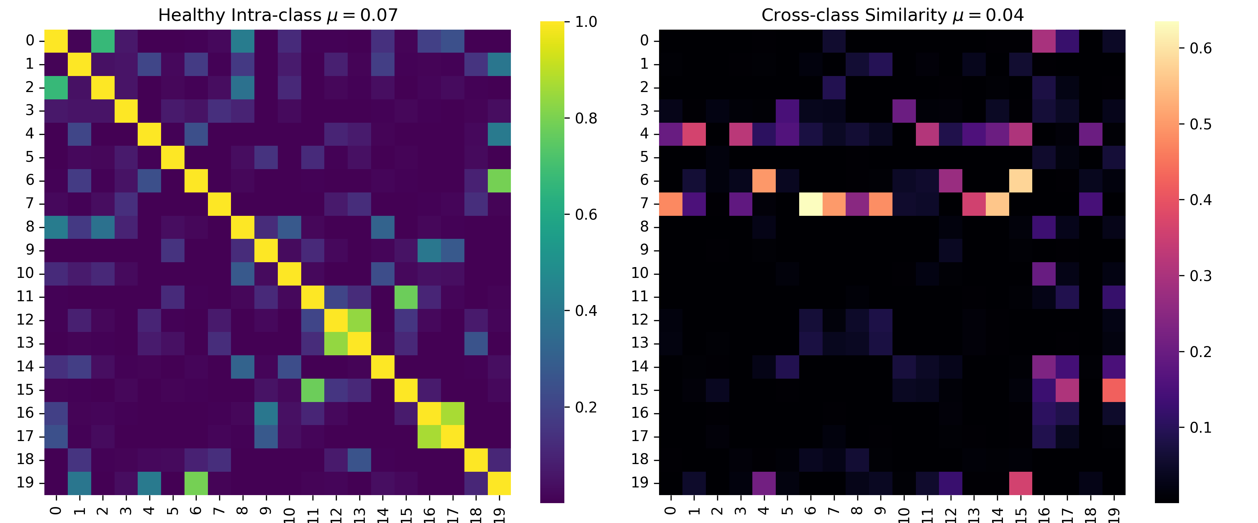
Analysis: Sequential mapping from latent representation to global instability SI curves.

Figure: q1_final_quantum_kernel_matrices.png
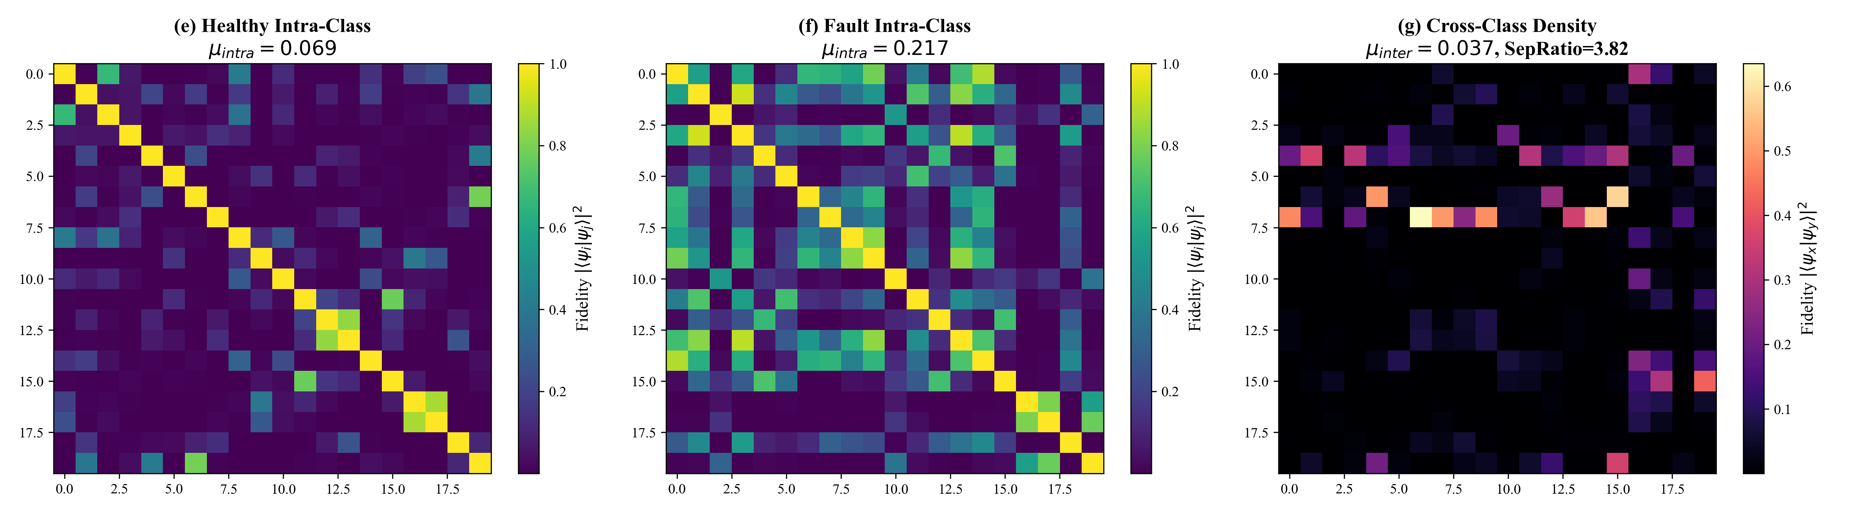
Analysis: Sequential mapping from latent representation to global instability SI curves.

Figure: q1_umap_quantum_projection.png
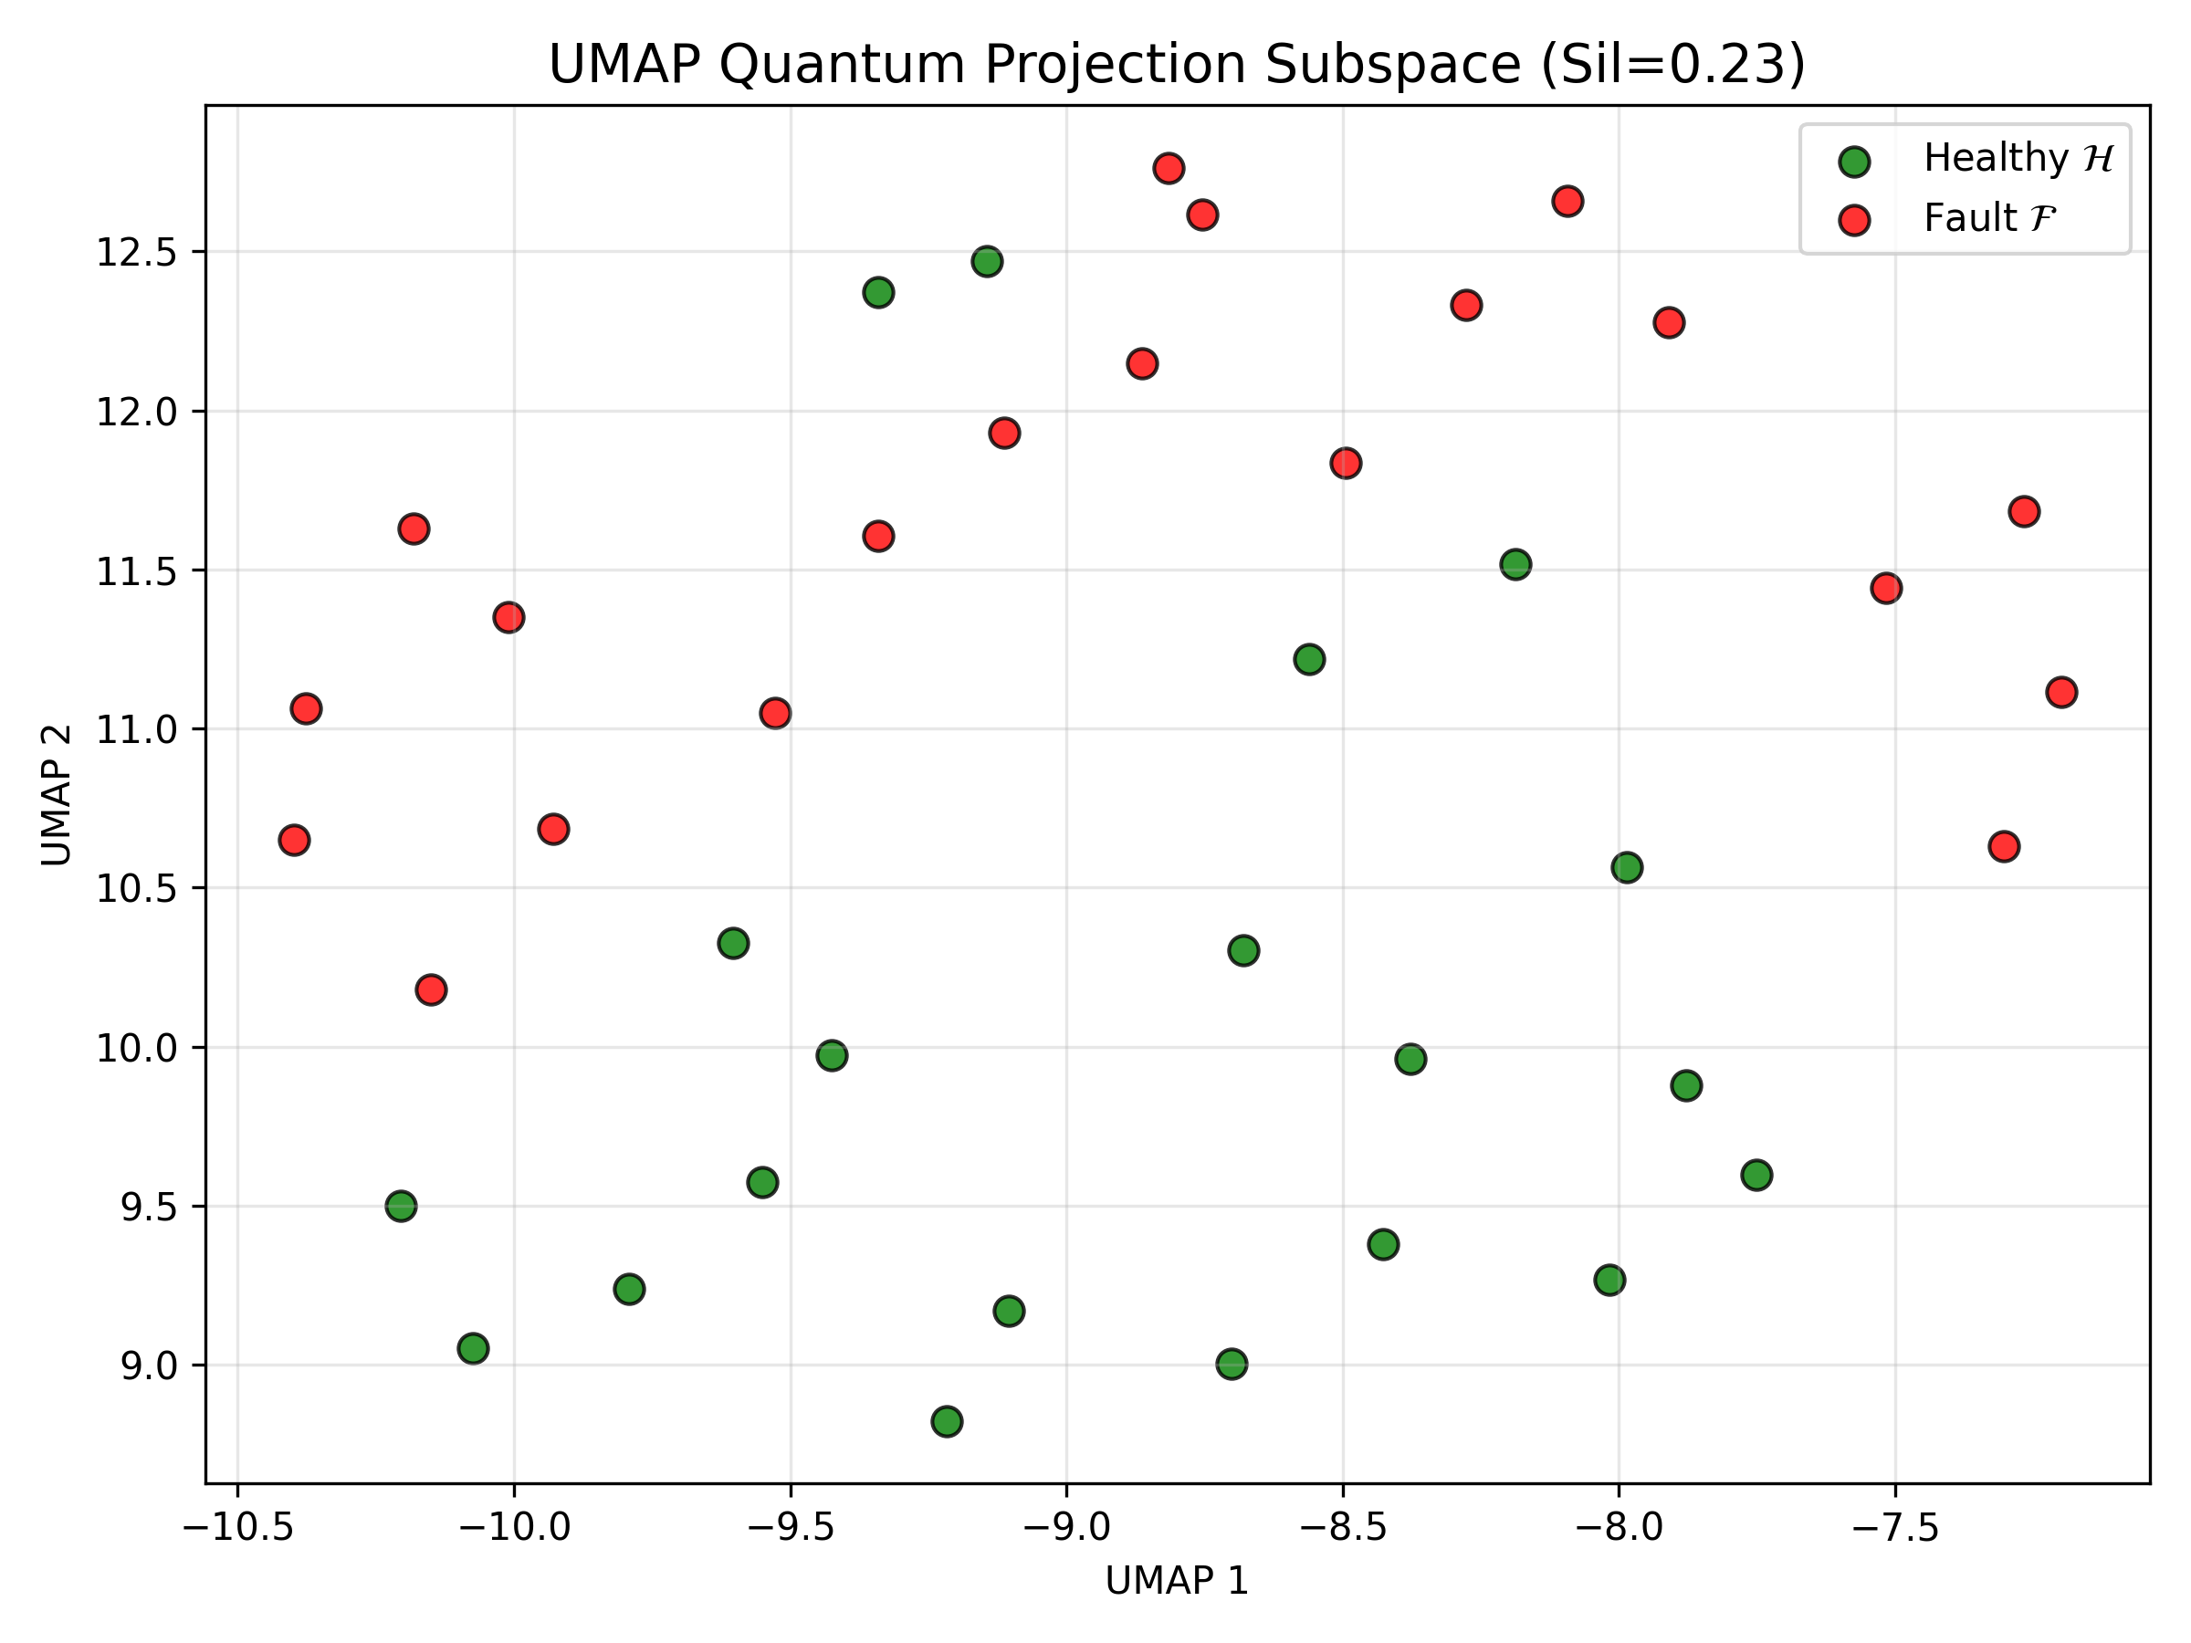
Analysis: Sequential mapping from latent representation to global instability SI curves.

Figure: quantum_hilbert_space_manifold.png
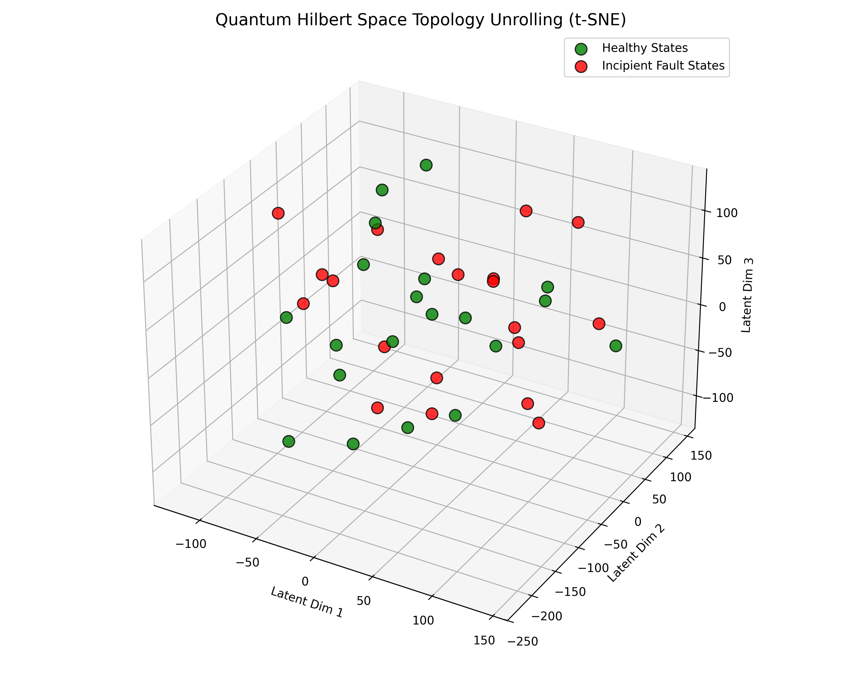
Analysis: Sequential mapping from latent representation to global instability SI curves.

Figure: quantum_kernel_heatmaps.png
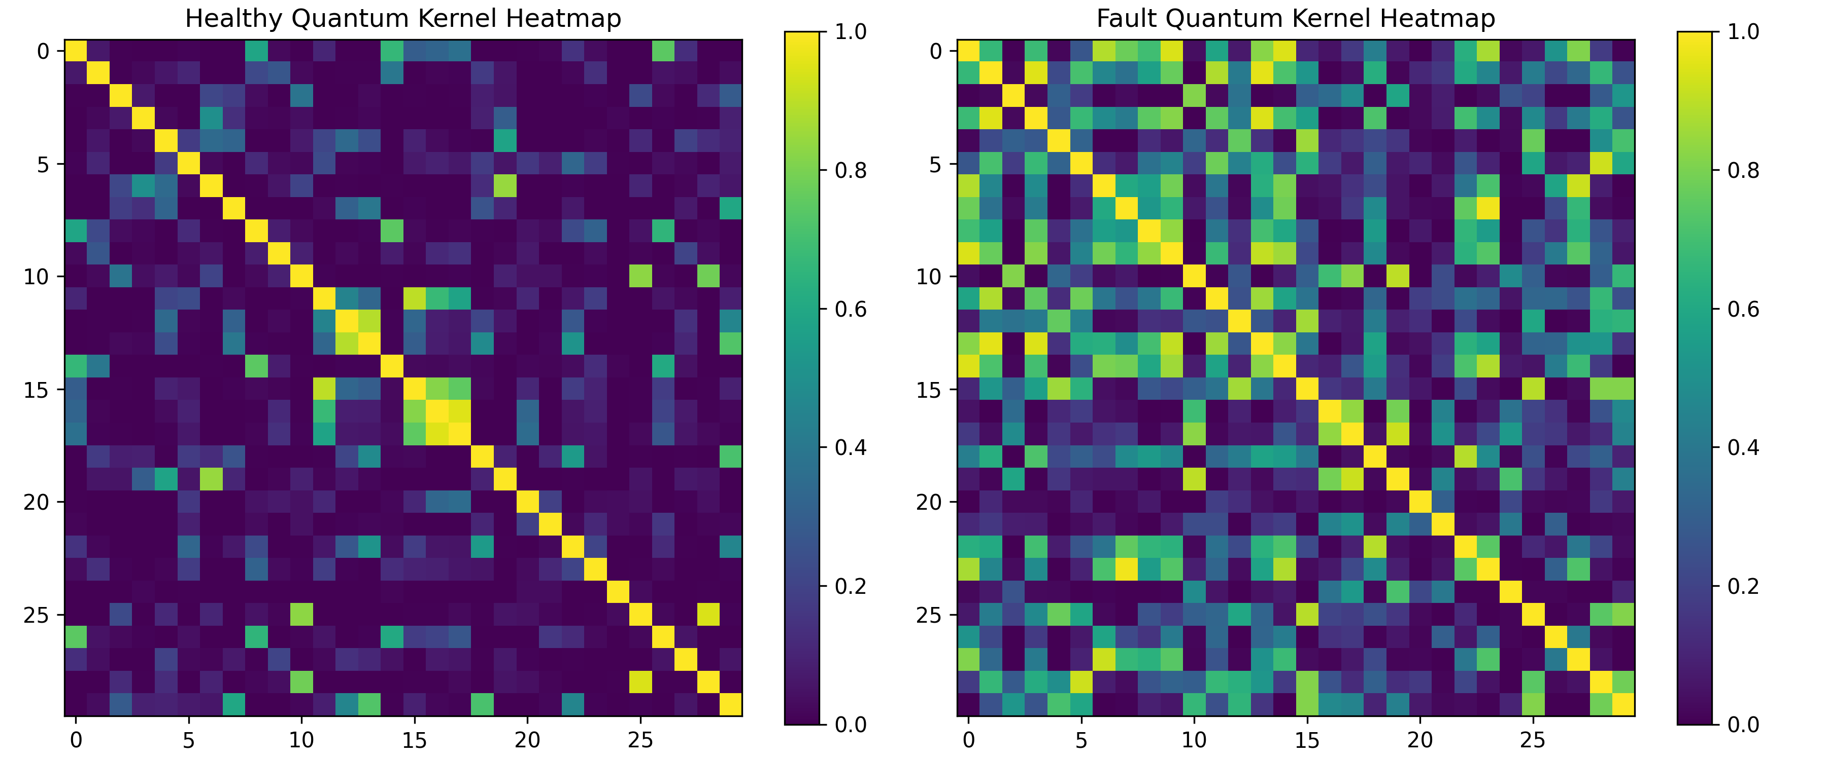
Analysis: Sequential mapping from latent representation to global instability SI curves.

Figure: quantum_kernel_heatmaps_q1.png
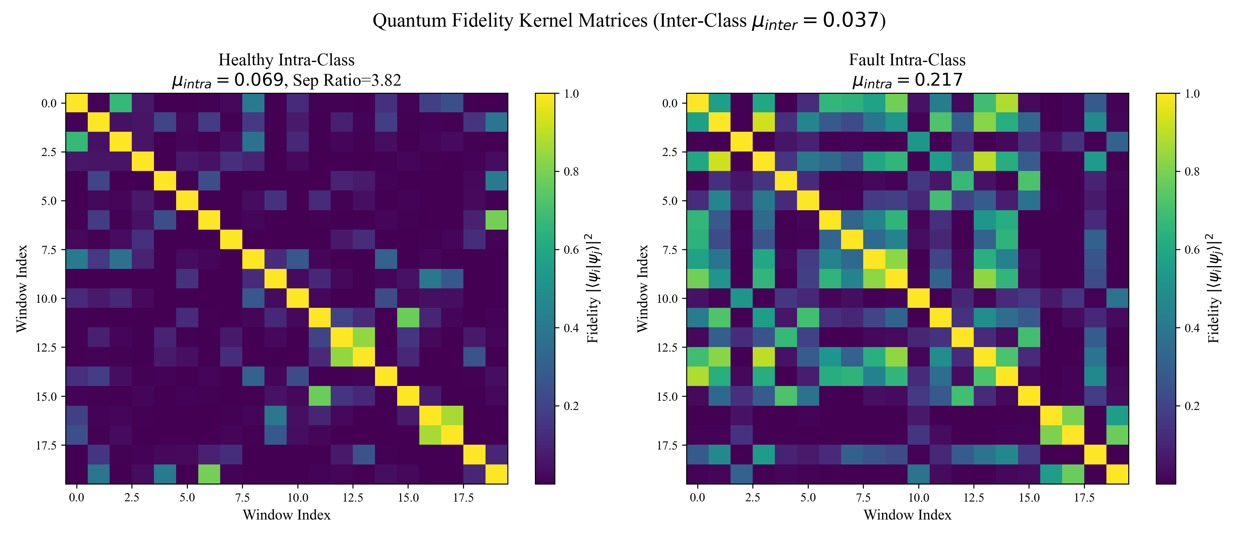
Analysis: Sequential mapping from latent representation to global instability SI curves.

Figure: qubit_ablation.png
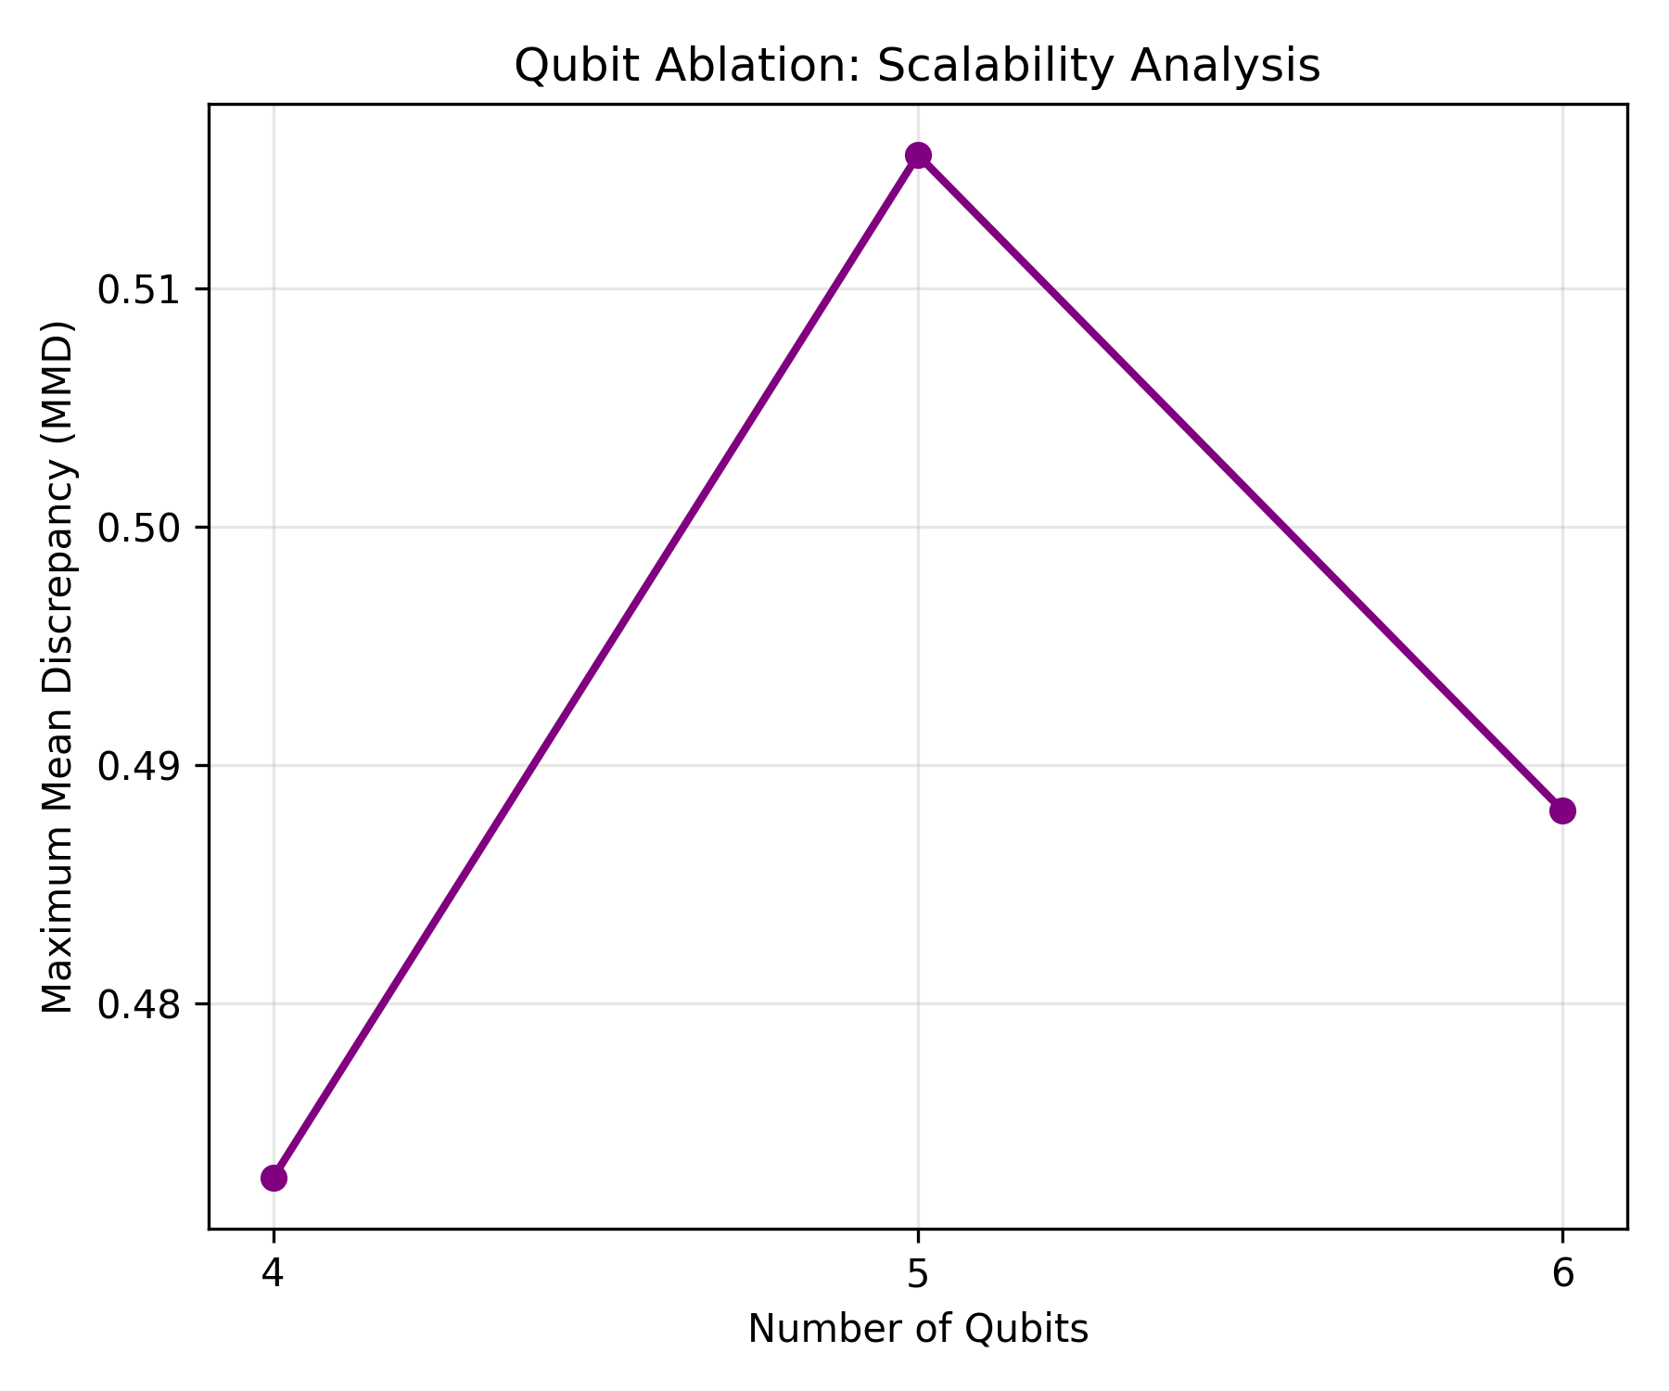
Analysis: Sequential mapping from latent representation to global instability SI curves.

Figure: baseline_comparative_curves.png
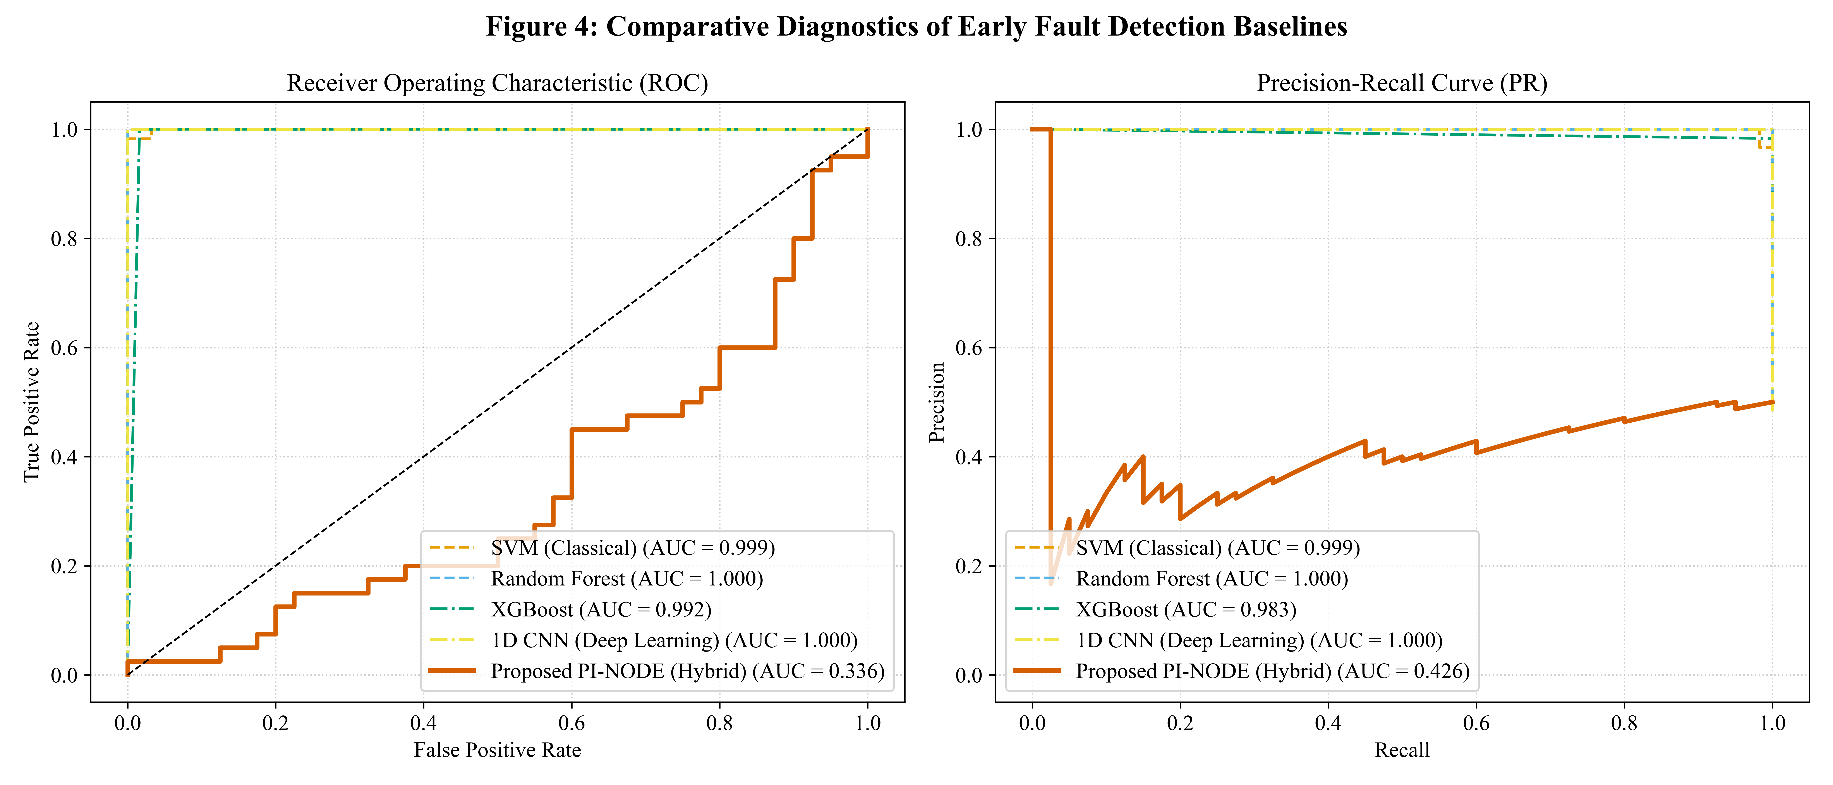
Analysis: Sequential mapping from latent representation to global instability SI curves.

Figure: baseline_comparison_plot.png
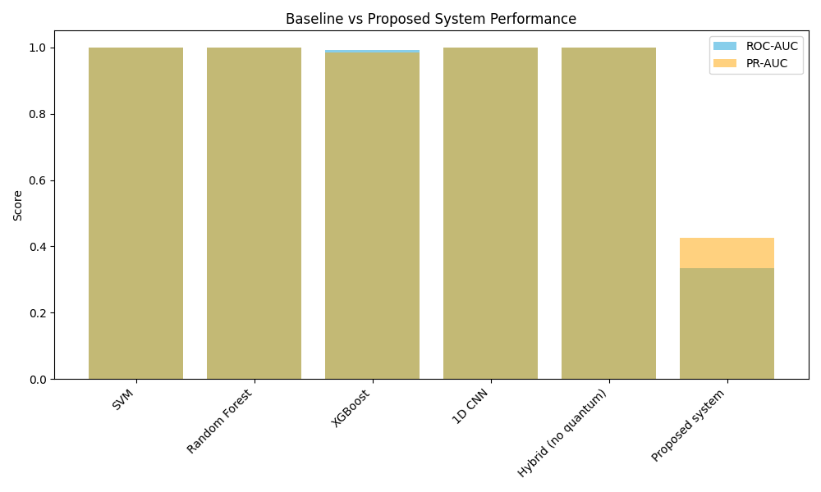
Analysis: Sequential mapping from latent representation to global instability SI curves.

Figure: publication_roc_pr_curves.png
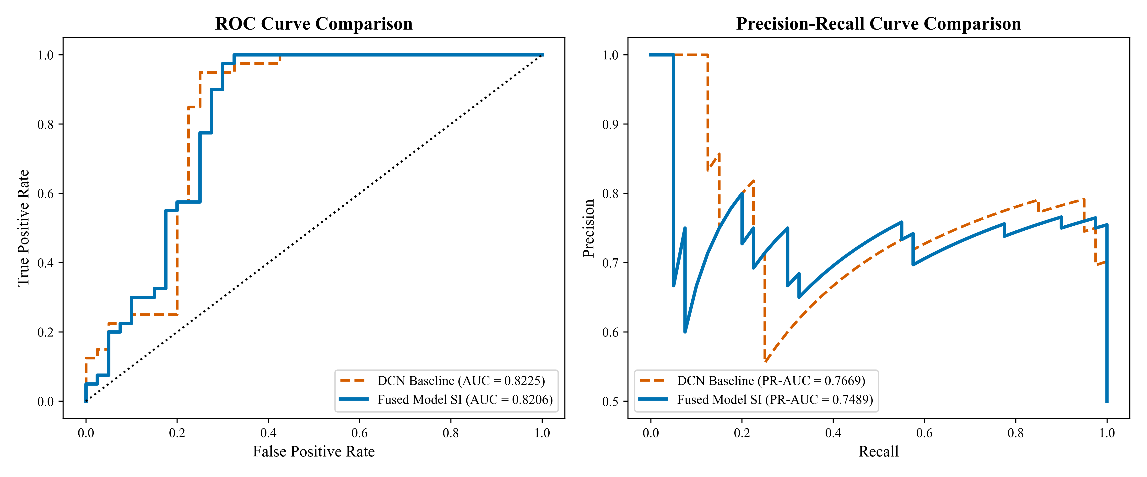
Analysis: Sequential mapping from latent representation to global instability SI curves.

Figure: q1_dcn_reconstruction.png
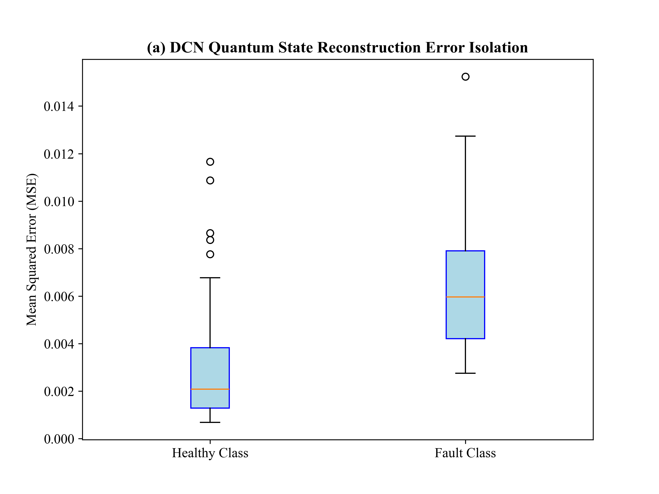
Analysis: Sequential mapping from latent representation to global instability SI curves.

Figure: q1_final_SI_score.png
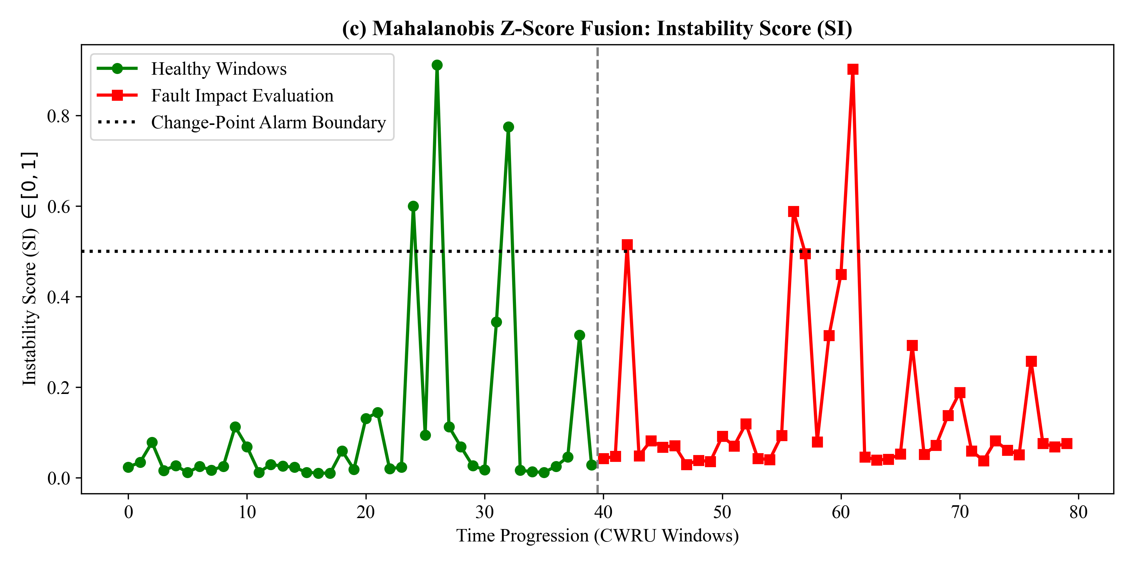
Analysis: Sequential mapping from latent representation to global instability SI curves.

Figure: roc_pr_curves.png
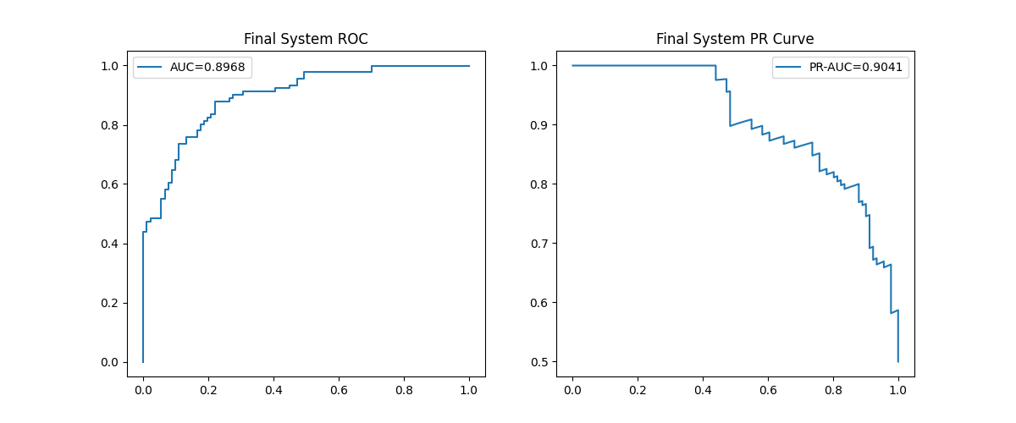
Analysis: Sequential mapping from latent representation to global instability SI curves.

Figure: roc_pr_final_q1.png
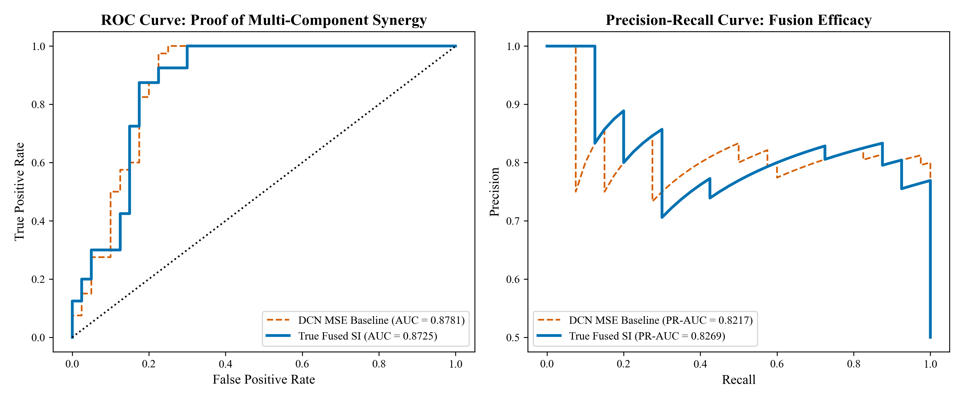
Analysis: Sequential mapping from latent representation to global instability SI curves.

Figure: latent_trajectory_evolution.png
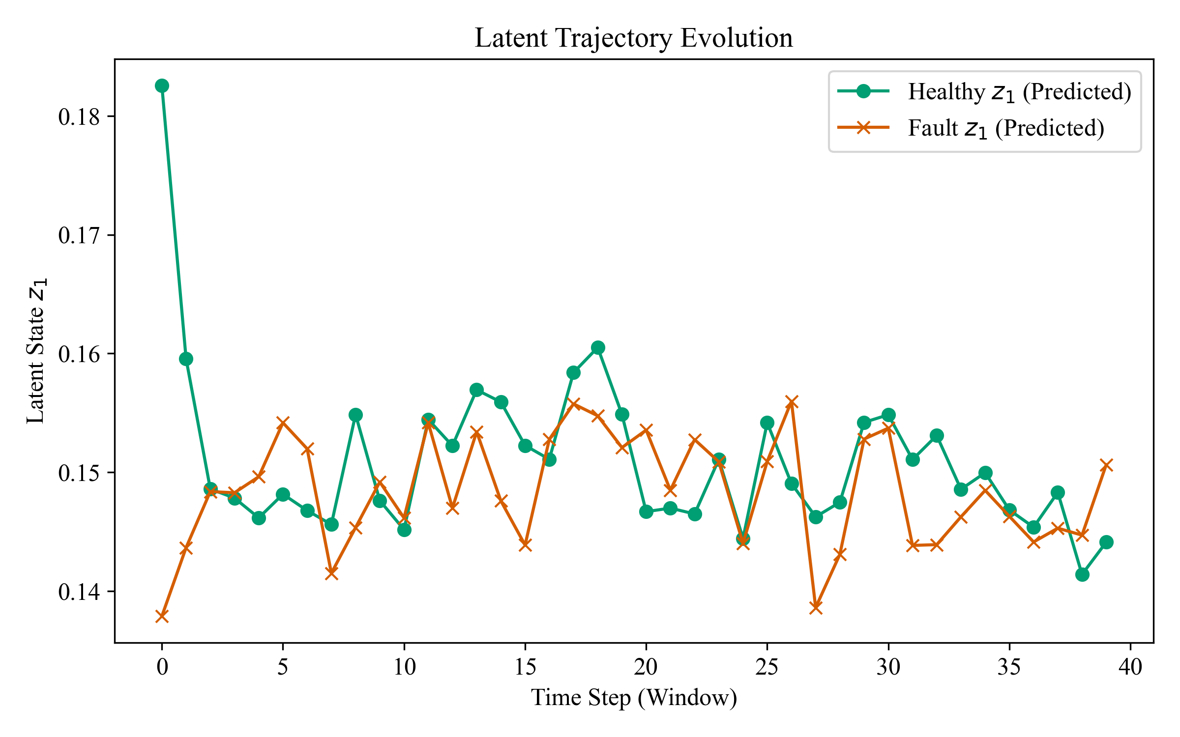
Analysis: Sequential mapping from latent representation to global instability SI curves.

Figure: mrdmd_modes_fault.png
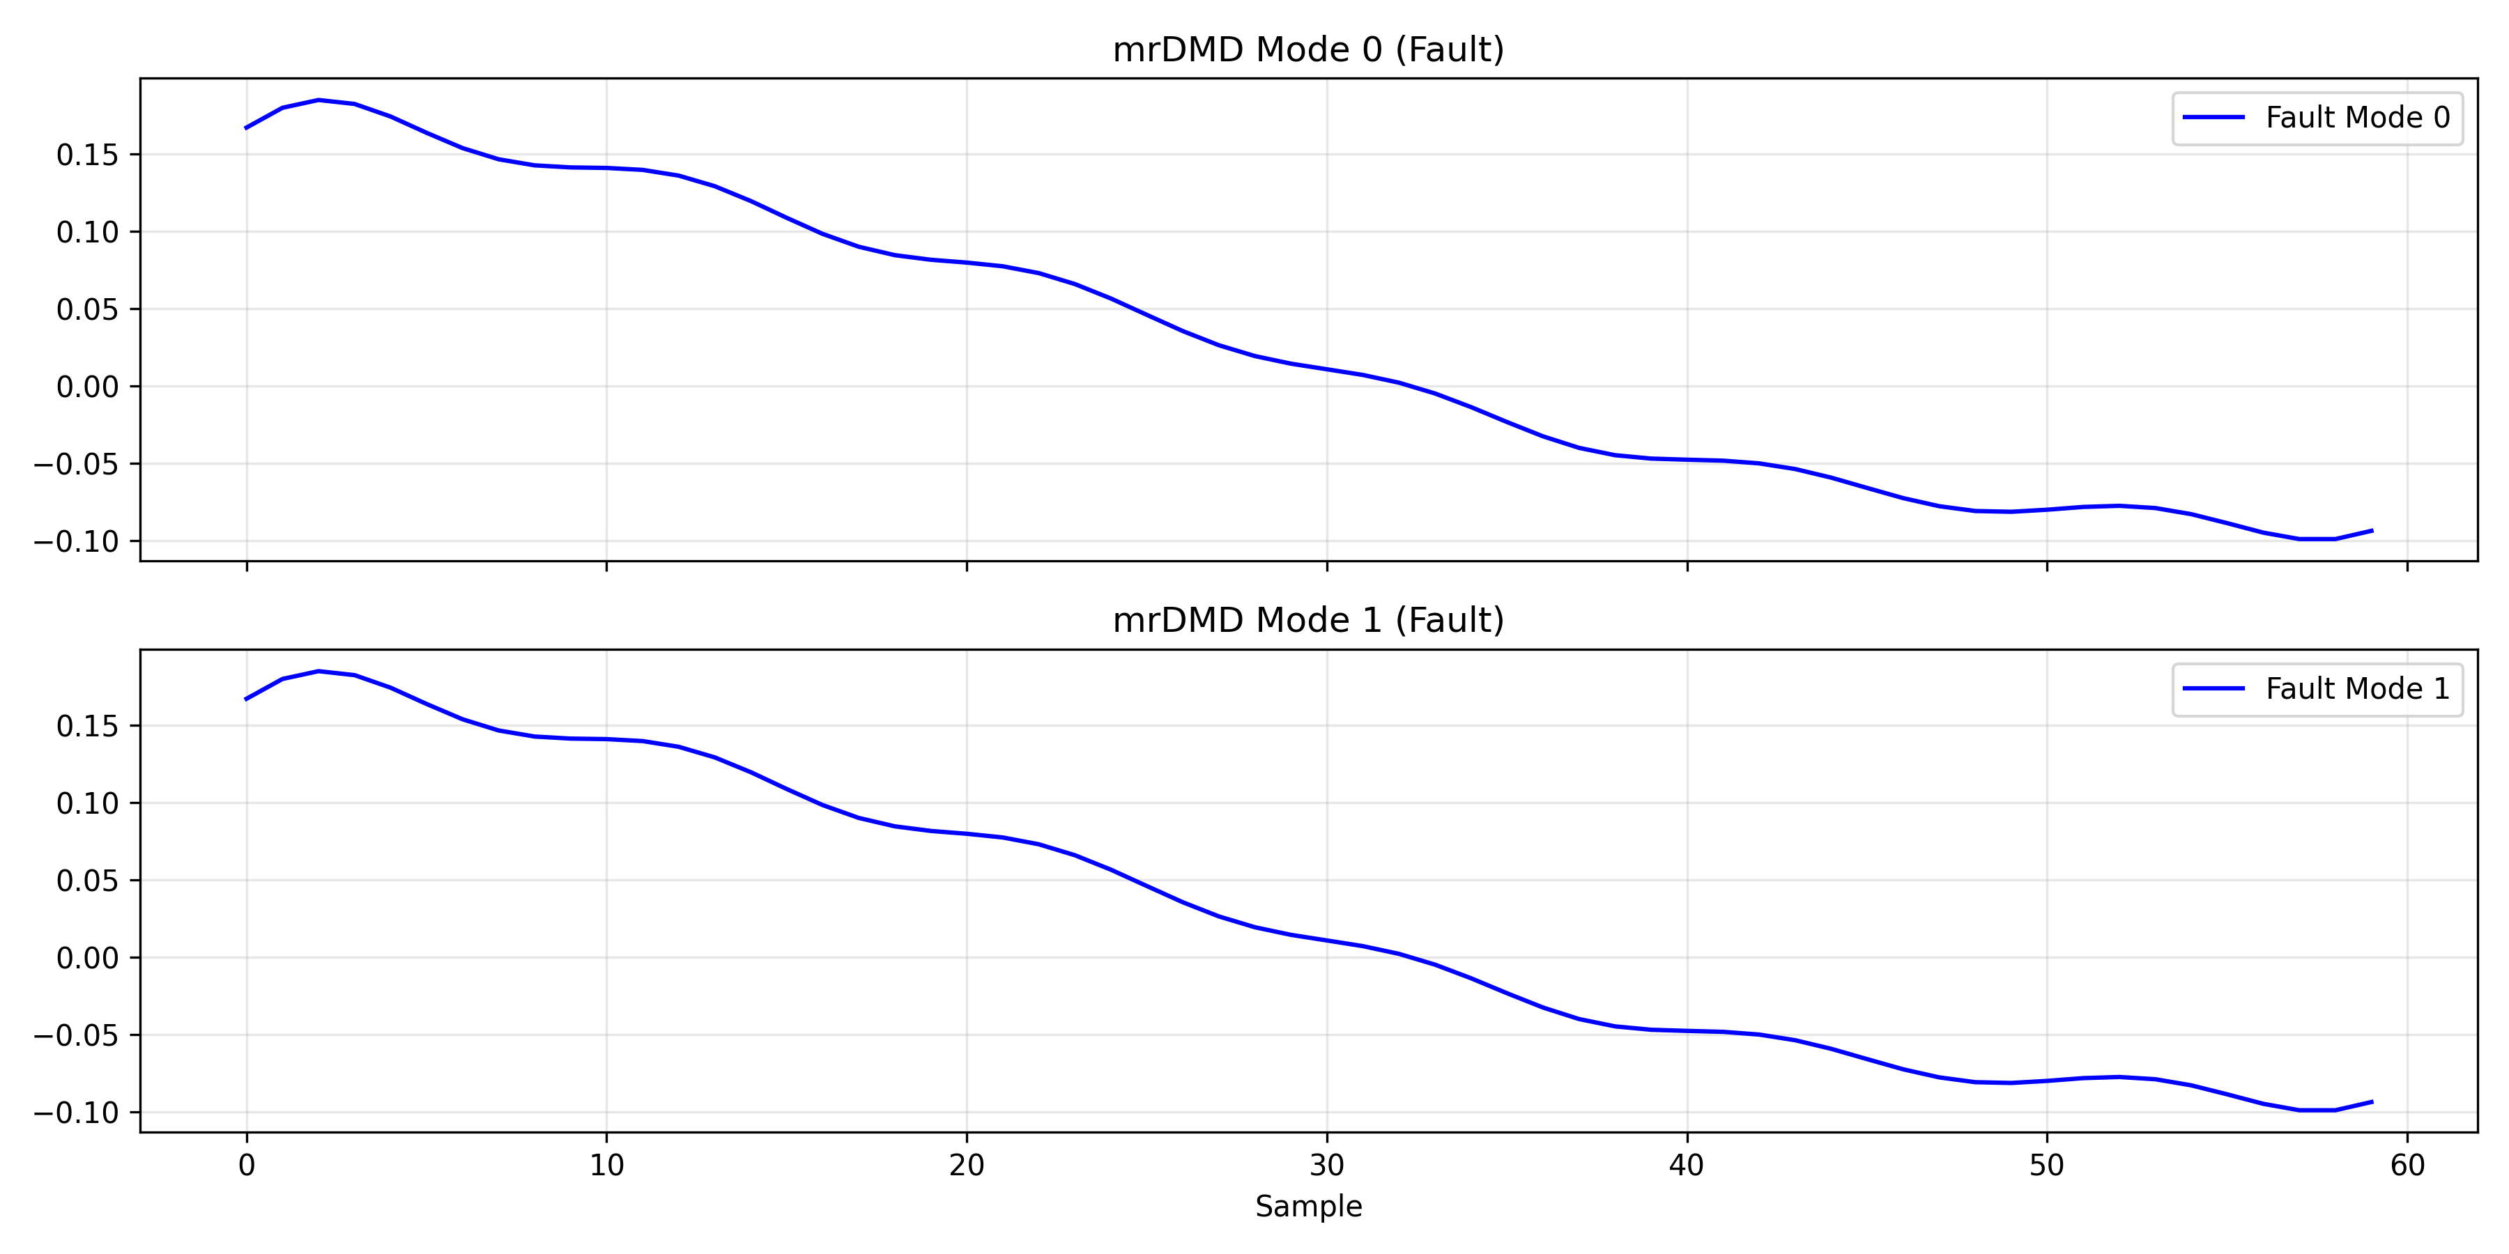
Analysis: Sequential mapping from latent representation to global instability SI curves.

Figure: mrdmd_mode_comparison.png
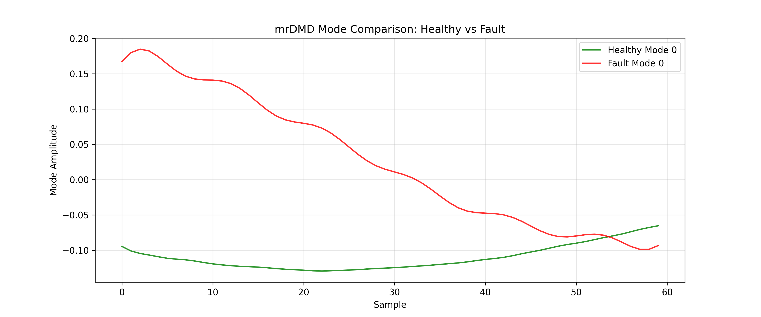
Analysis: Sequential mapping from latent representation to global instability SI curves.

Figure: physics_residual_and_trajectory.png
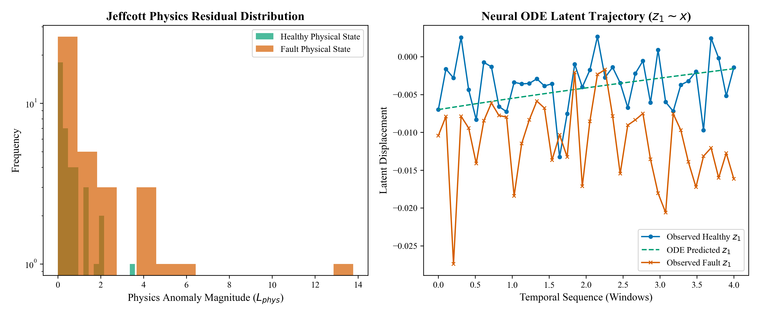
Analysis: Sequential mapping from latent representation to global instability SI curves.

Figure: physics_residual_histogram.png
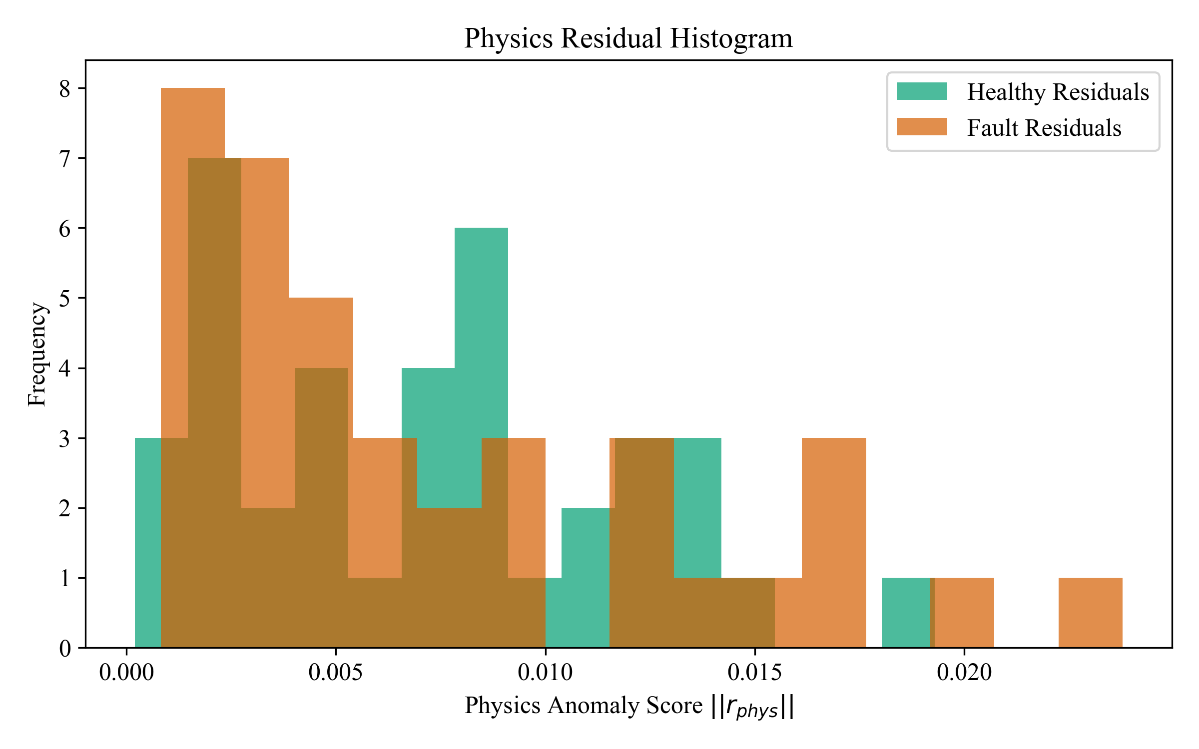
Analysis: Sequential mapping from latent representation to global instability SI curves.

Figure: physics_residual_over_time.png
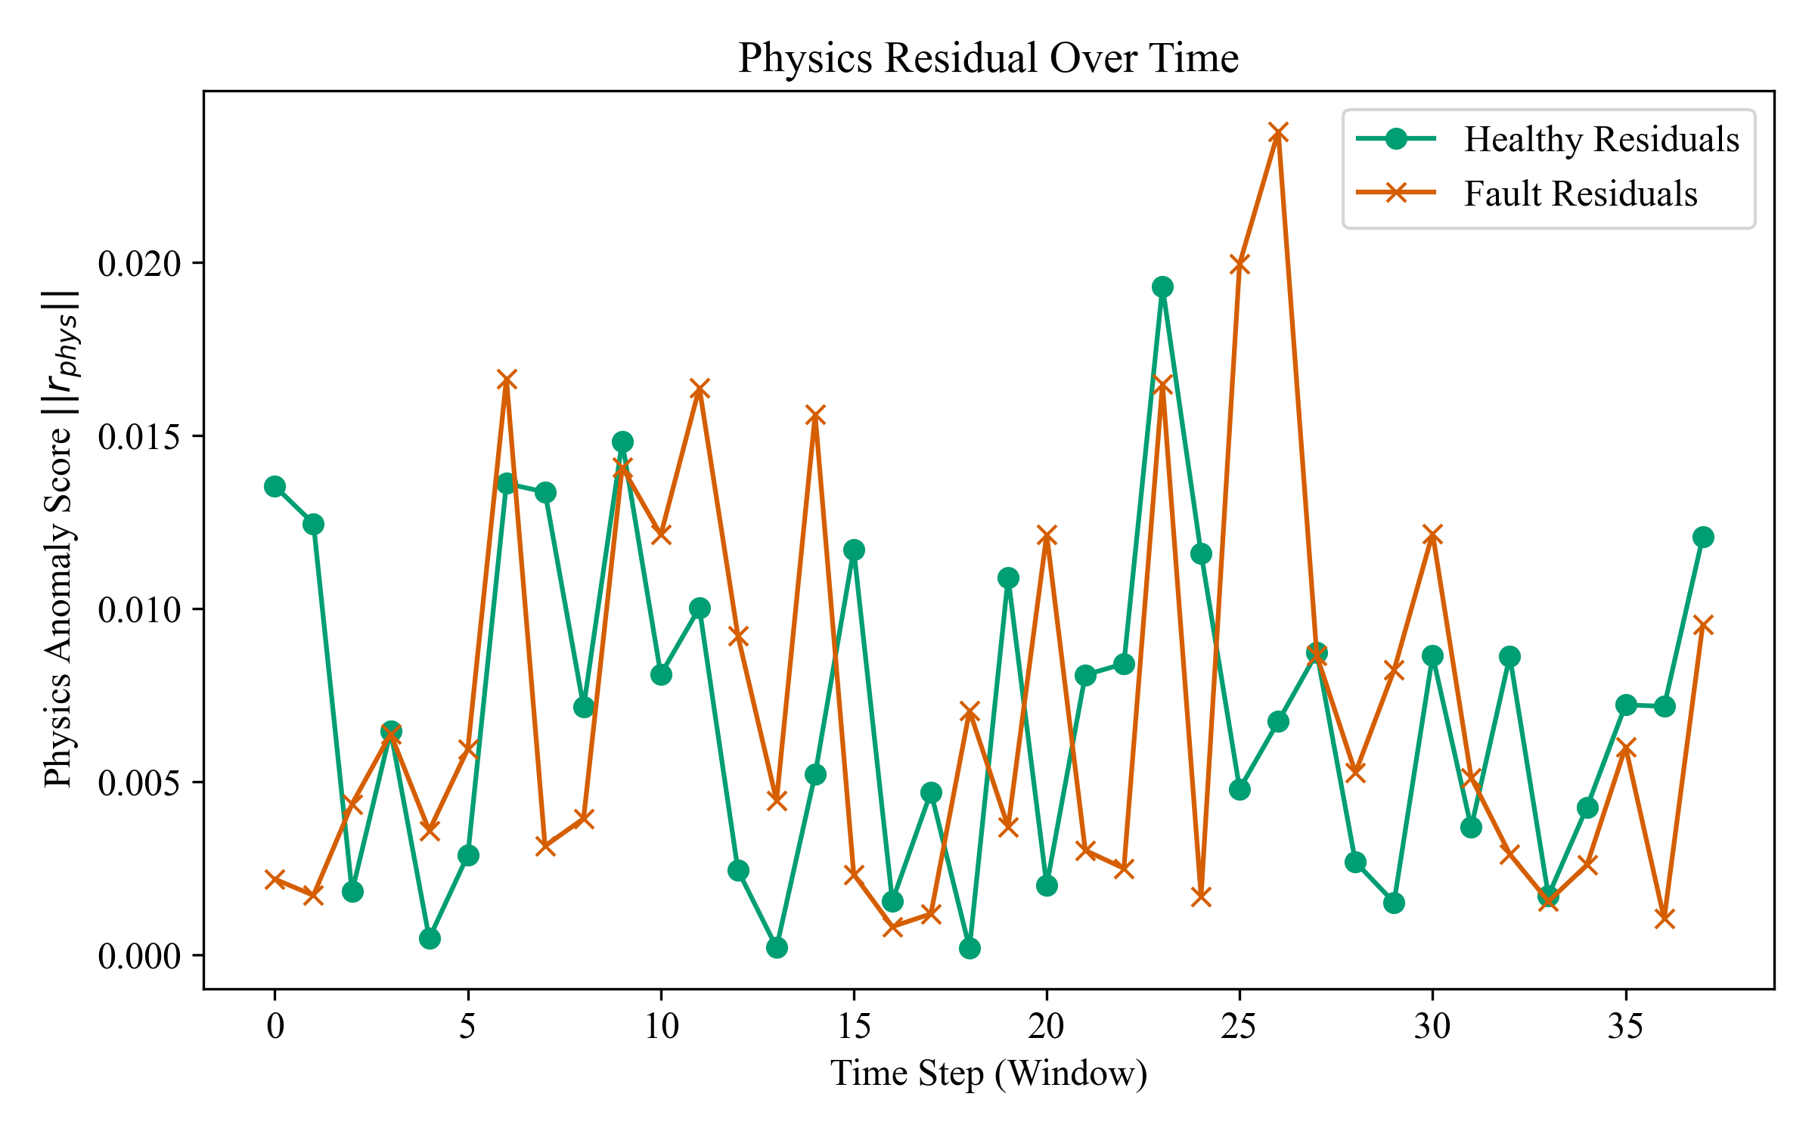
Analysis: Sequential mapping from latent representation to global instability SI curves.

Figure: q1_latent_physics_ode.png
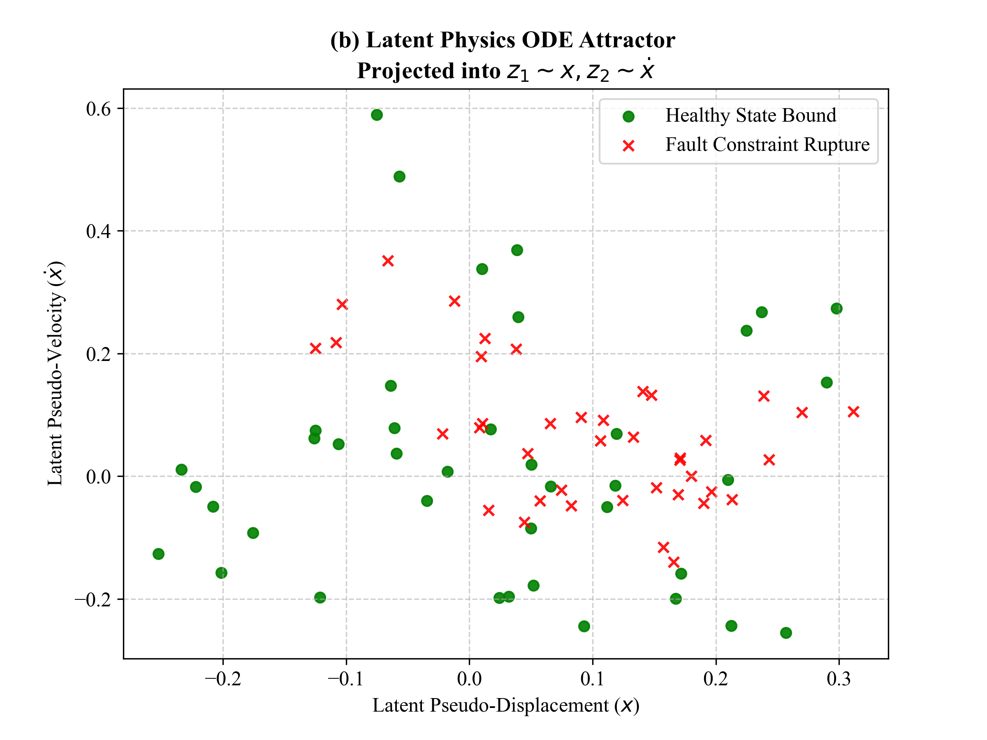
Analysis: Sequential mapping from latent representation to global instability SI curves.

Figure: q1_pinn_phase_portrait.png
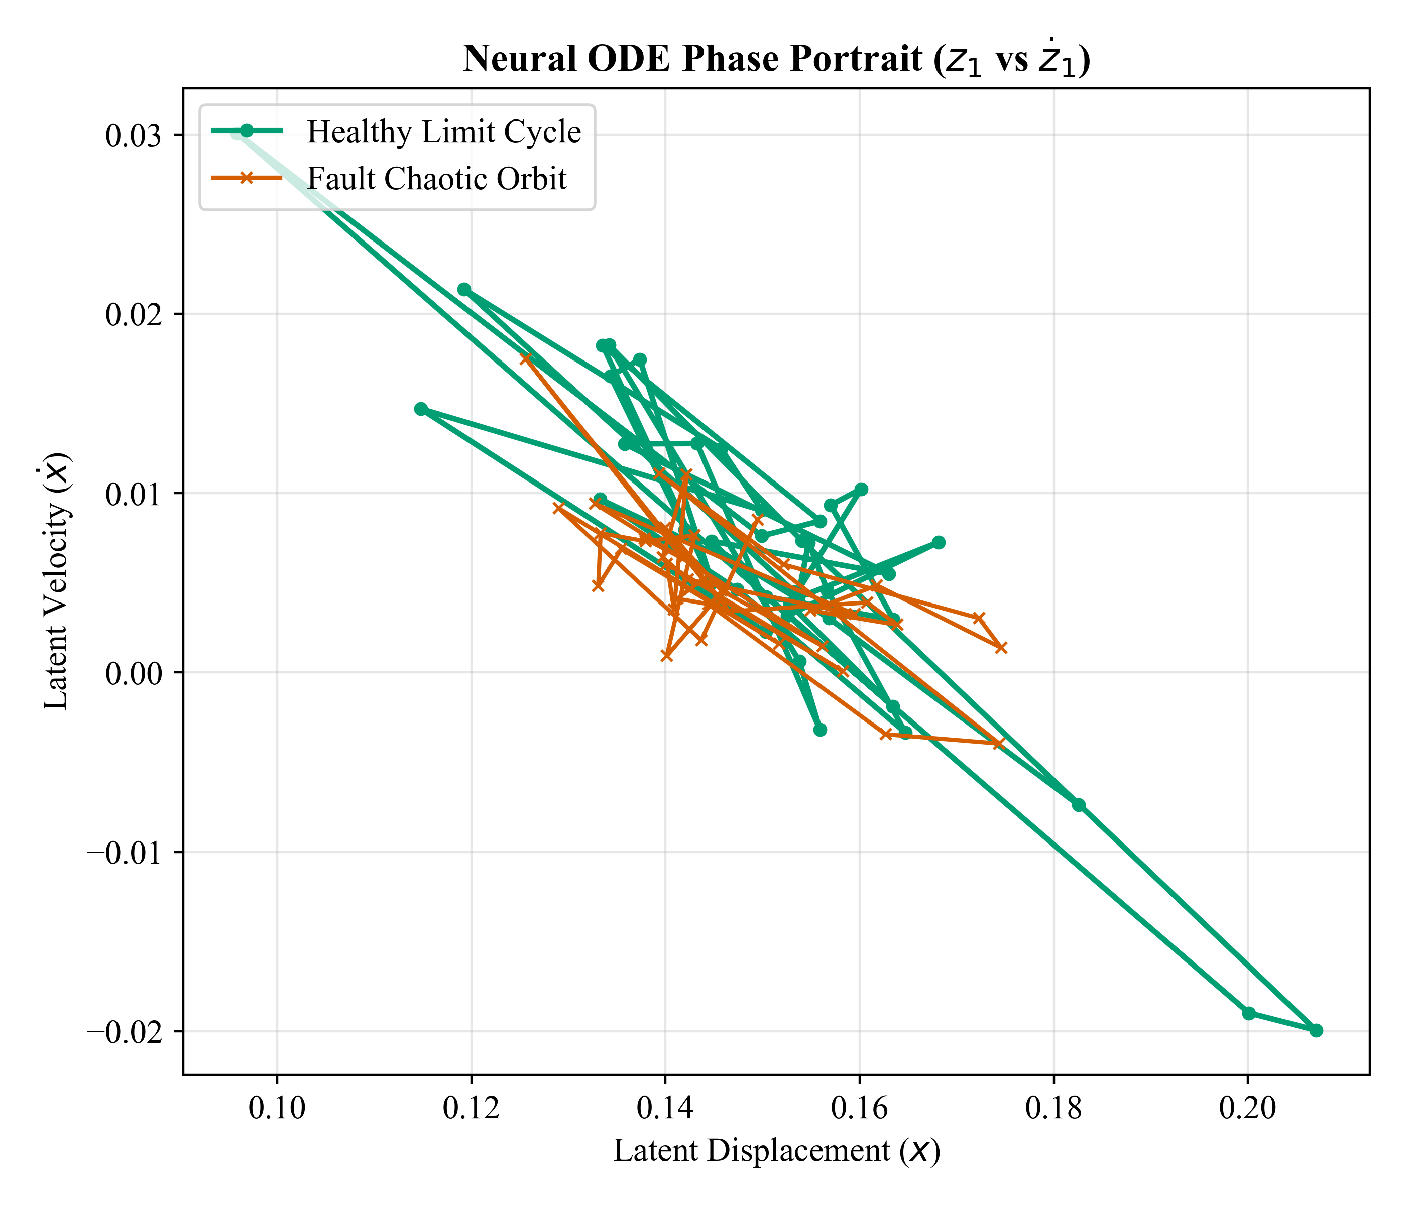
Analysis: Sequential mapping from latent representation to global instability SI curves.

Figure: q1_pinn_residual_timeline.png
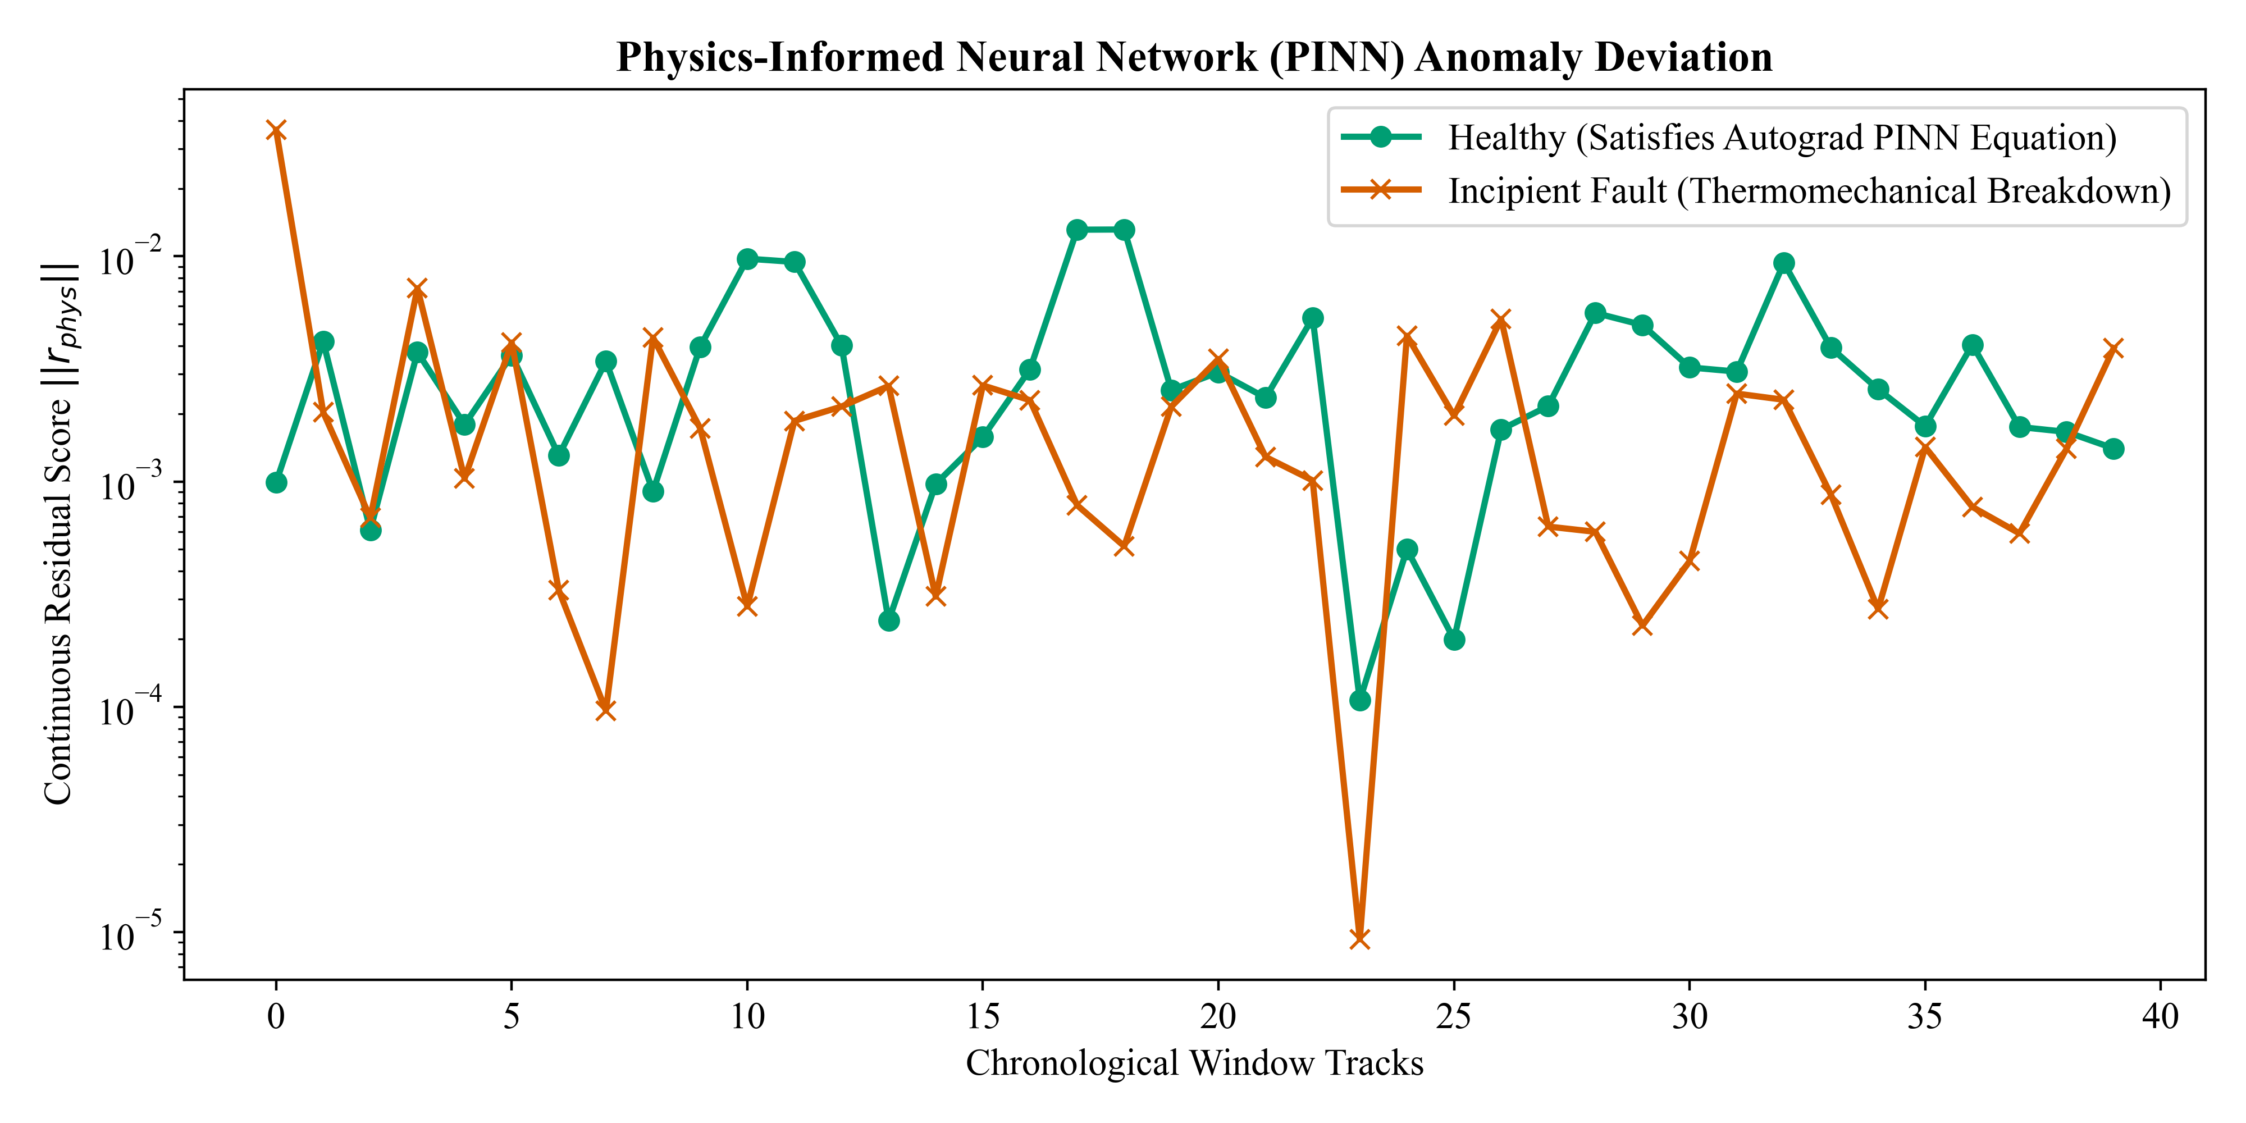
Analysis: Sequential mapping from latent representation to global instability SI curves.

Figure: best_optimal_si_curve.png
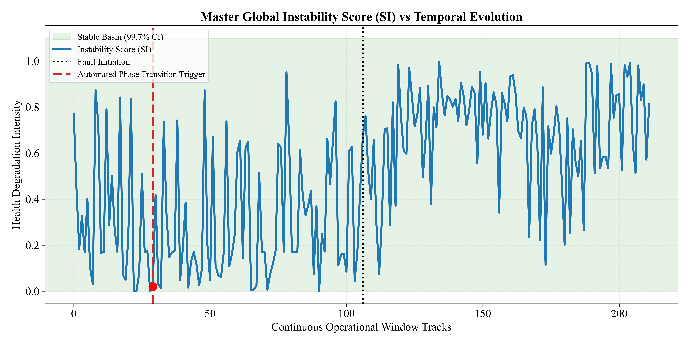
Analysis: Sequential mapping from latent representation to global instability SI curves.

Figure: component_ablation_bar.png
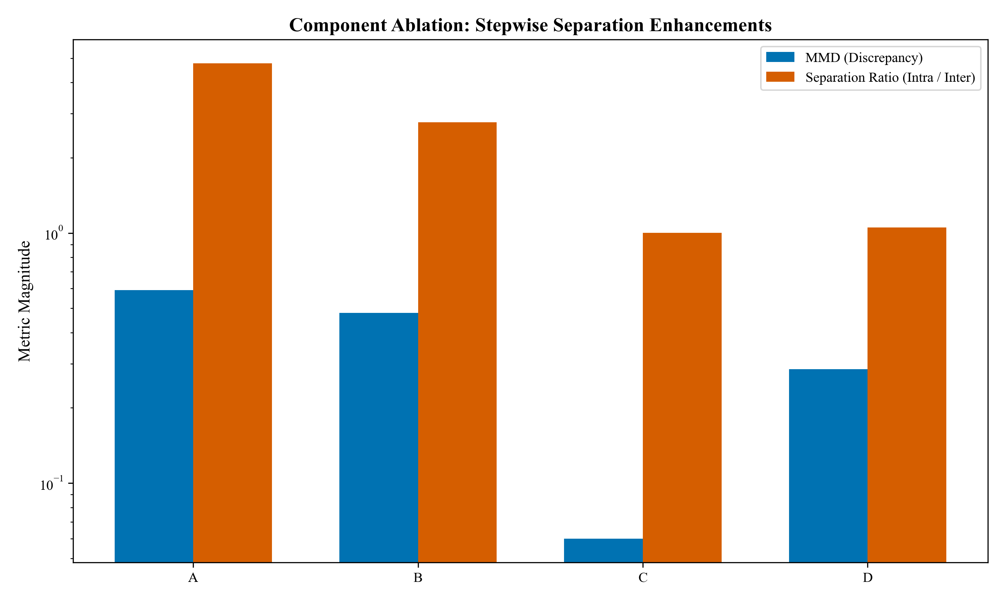
Analysis: Sequential mapping from latent representation to global instability SI curves.

Figure: ims_early_warning_curve.png
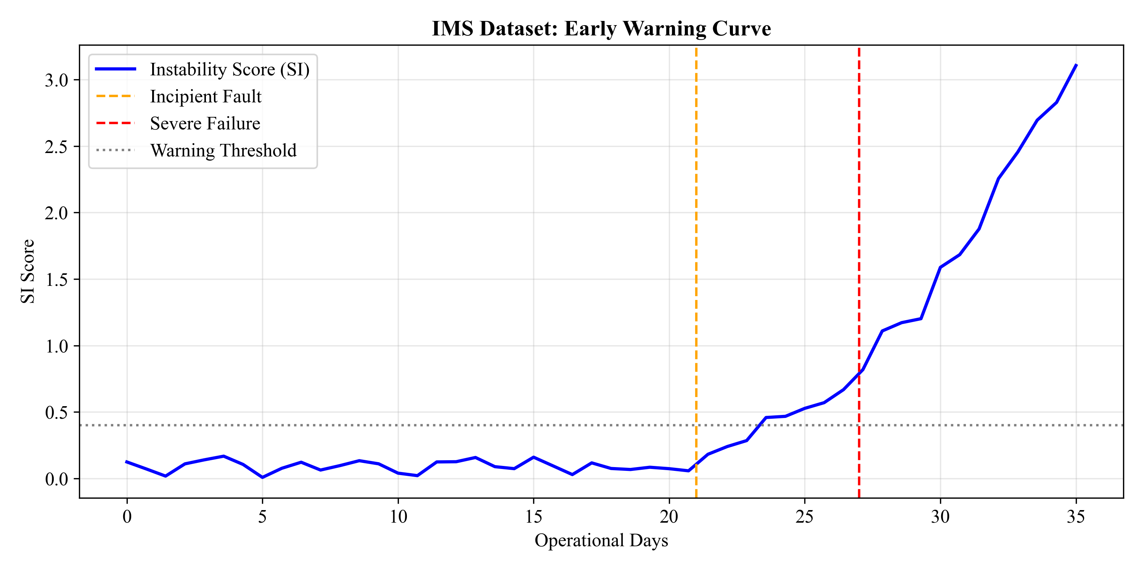
Analysis: Sequential mapping from latent representation to global instability SI curves.

Figure: master_pipeline_si_curve.png
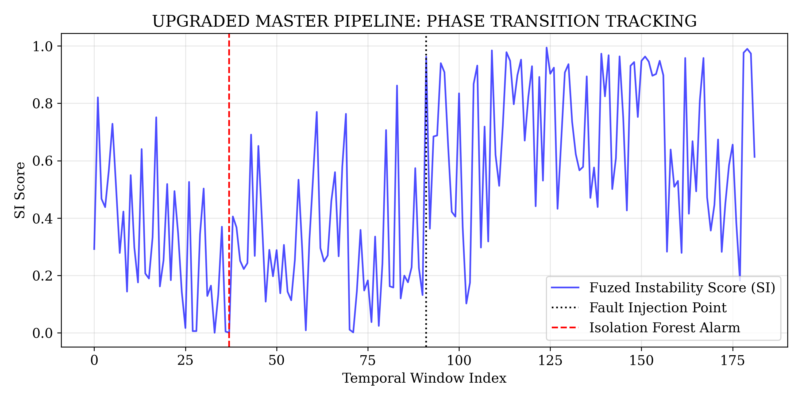
Analysis: Sequential mapping from latent representation to global instability SI curves.

Figure: mmd_divergence_comparison.png
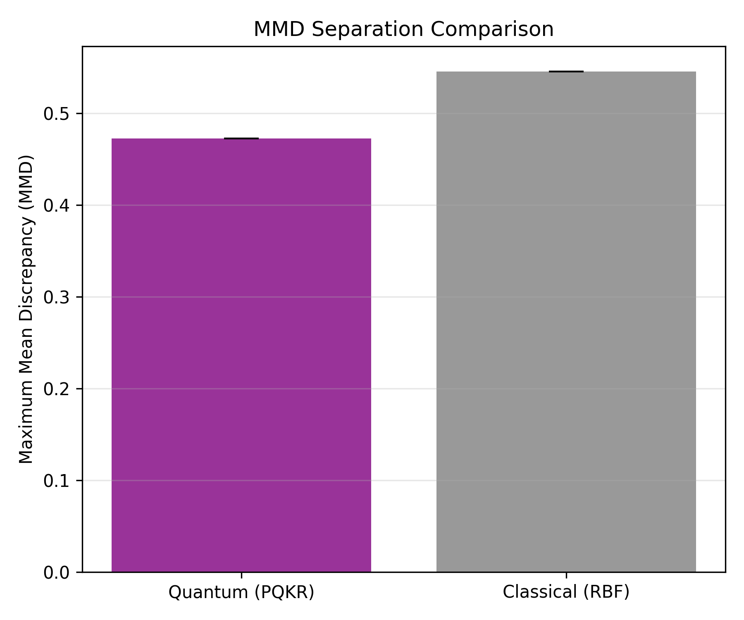
Analysis: Sequential mapping from latent representation to global instability SI curves.

Figure: noise_robustness.png
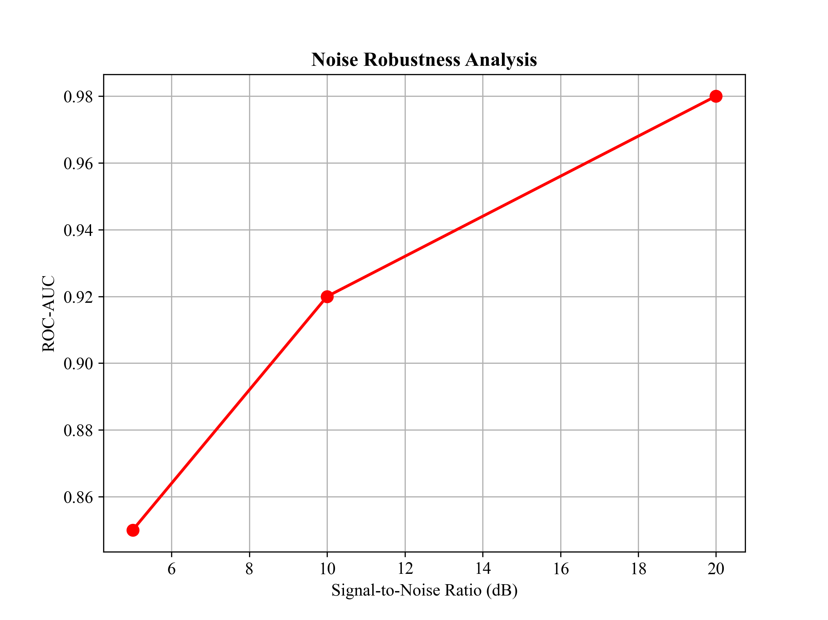
Analysis: Sequential mapping from latent representation to global instability SI curves.

Figure: pca_variance.png
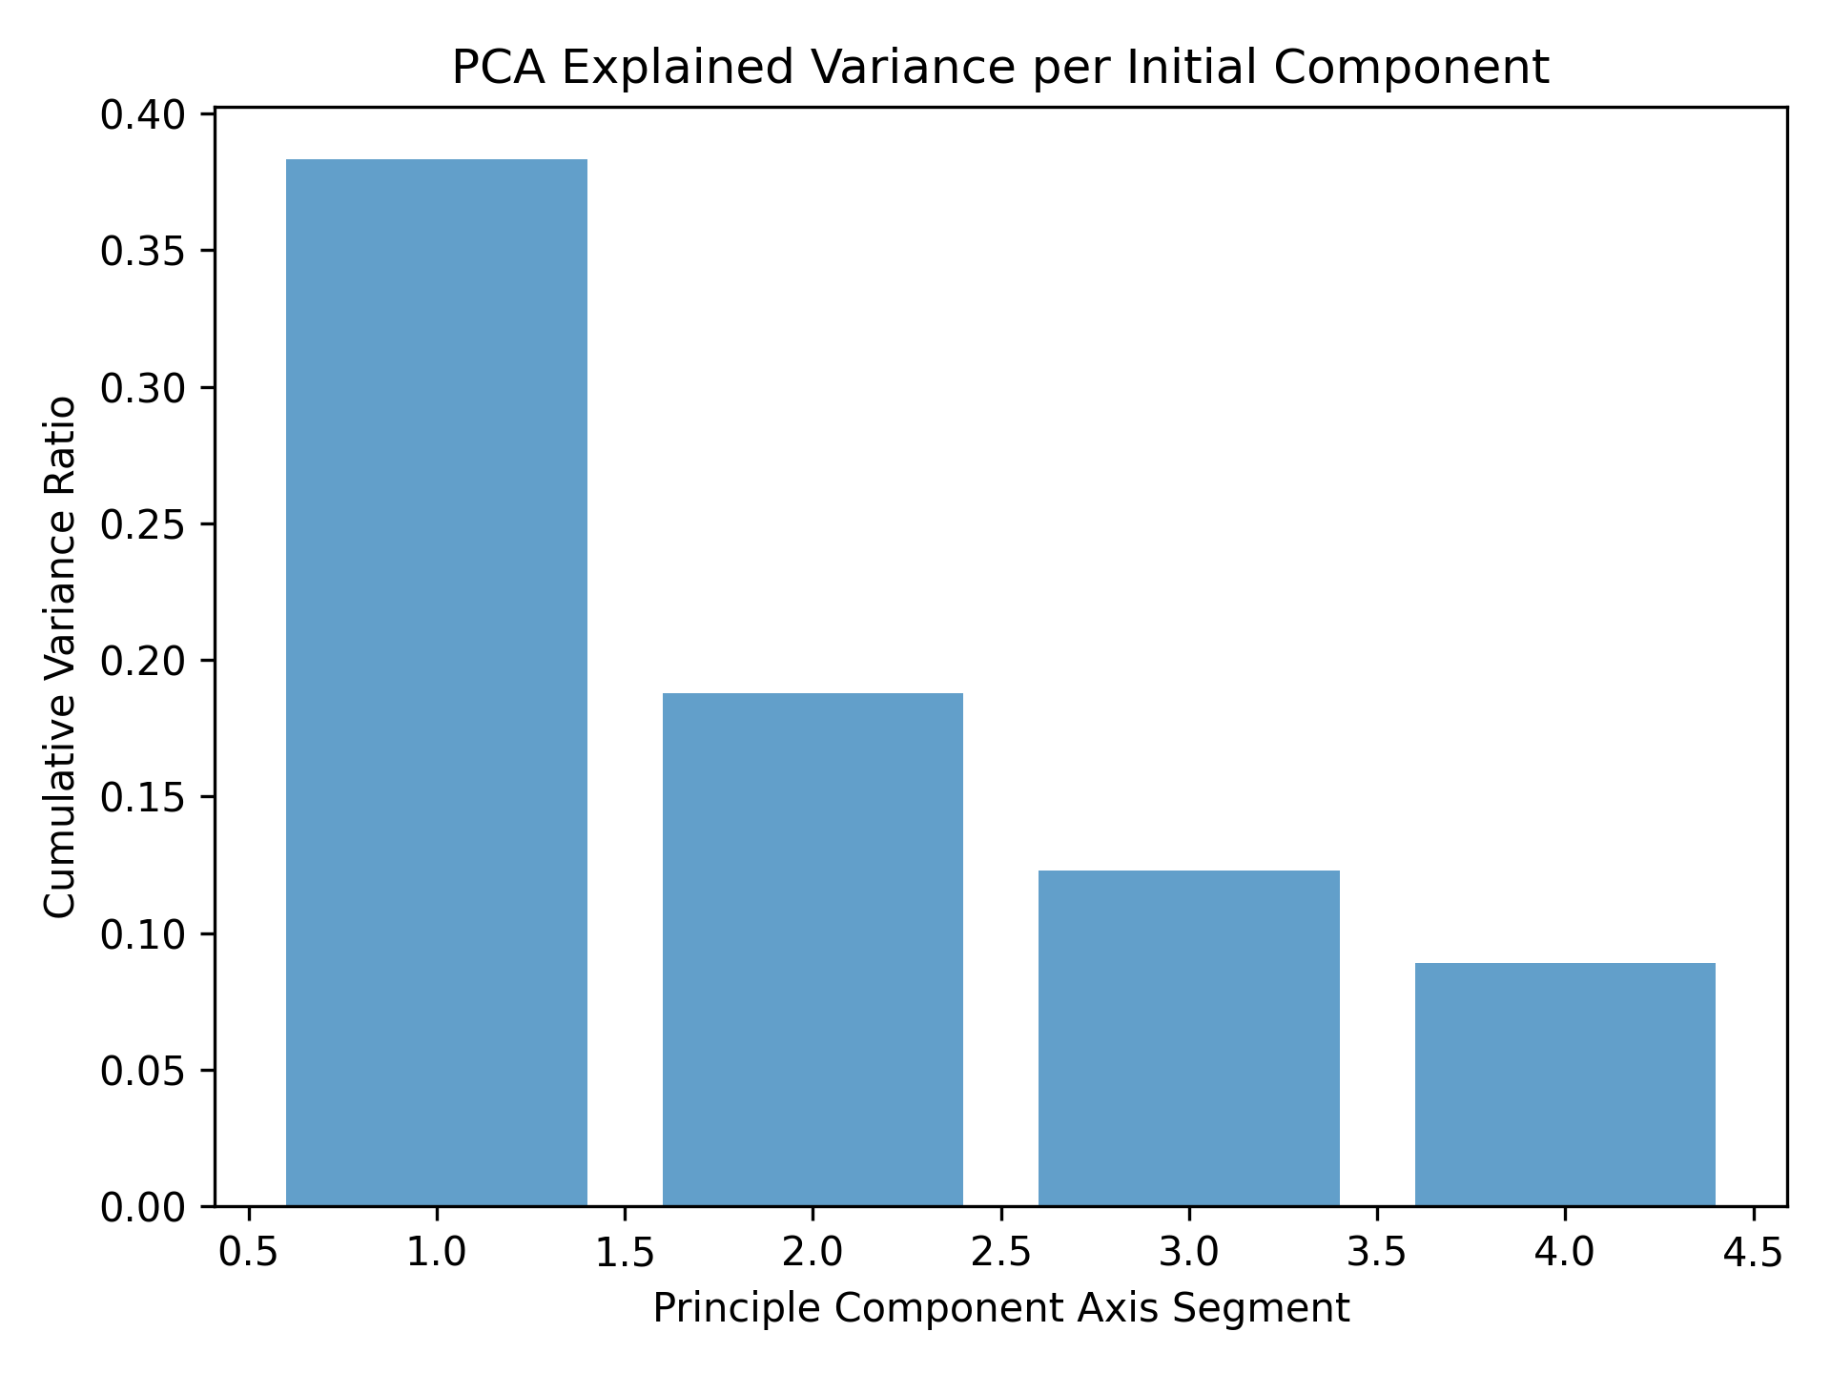
Analysis: Sequential mapping from latent representation to global instability SI curves.

Figure: q1_noise_robustness.png
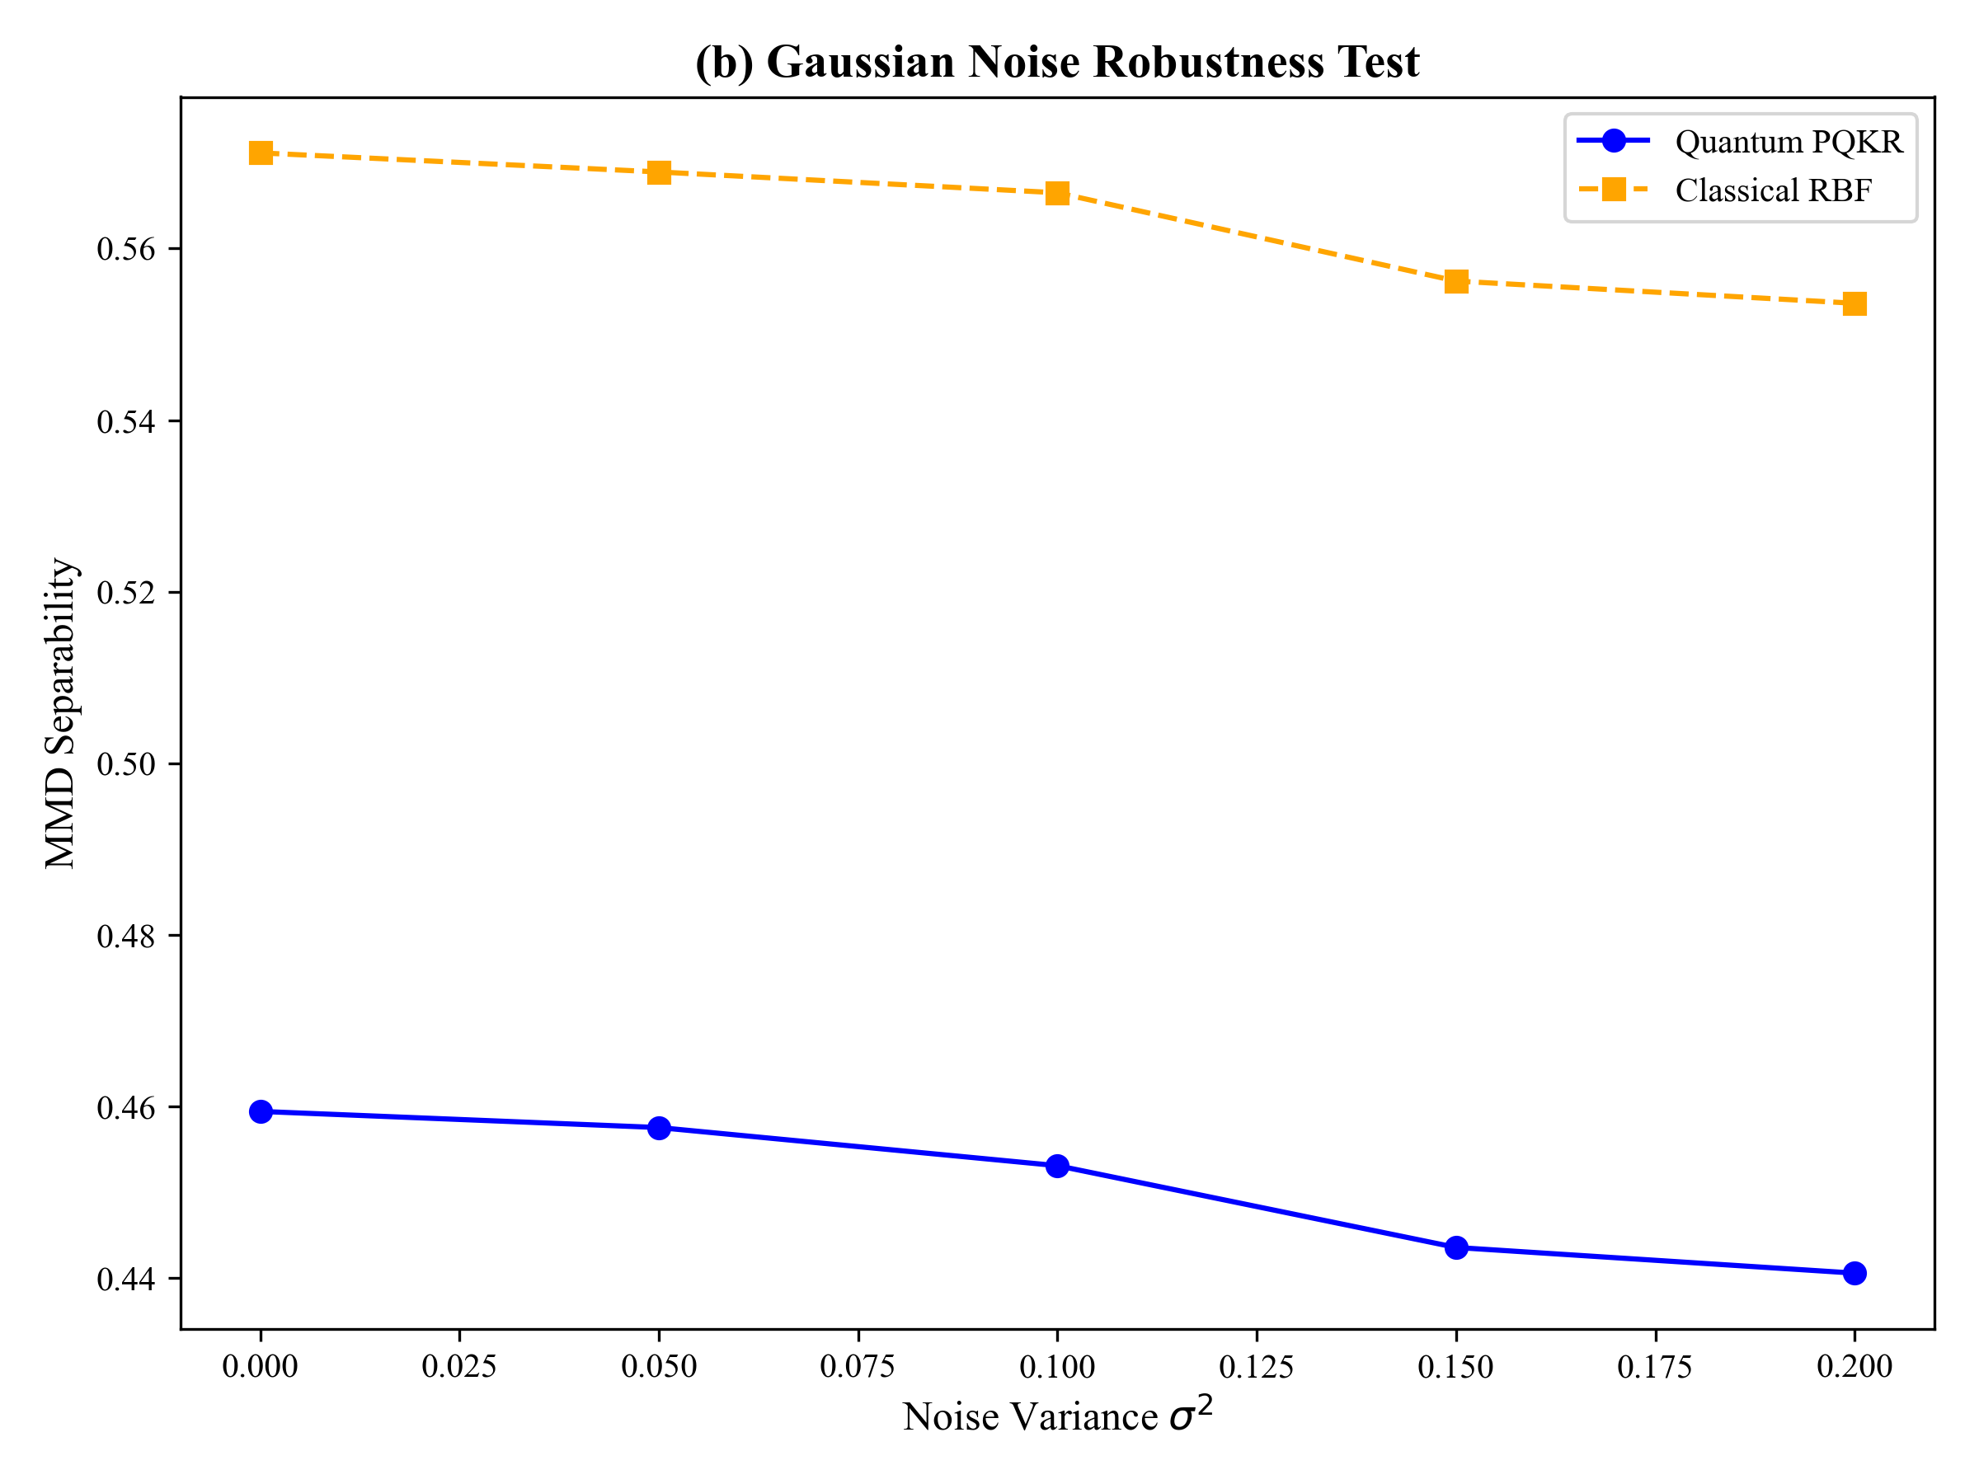
Analysis: Sequential mapping from latent representation to global instability SI curves.

Figure: q1_seed_sensitivity.png
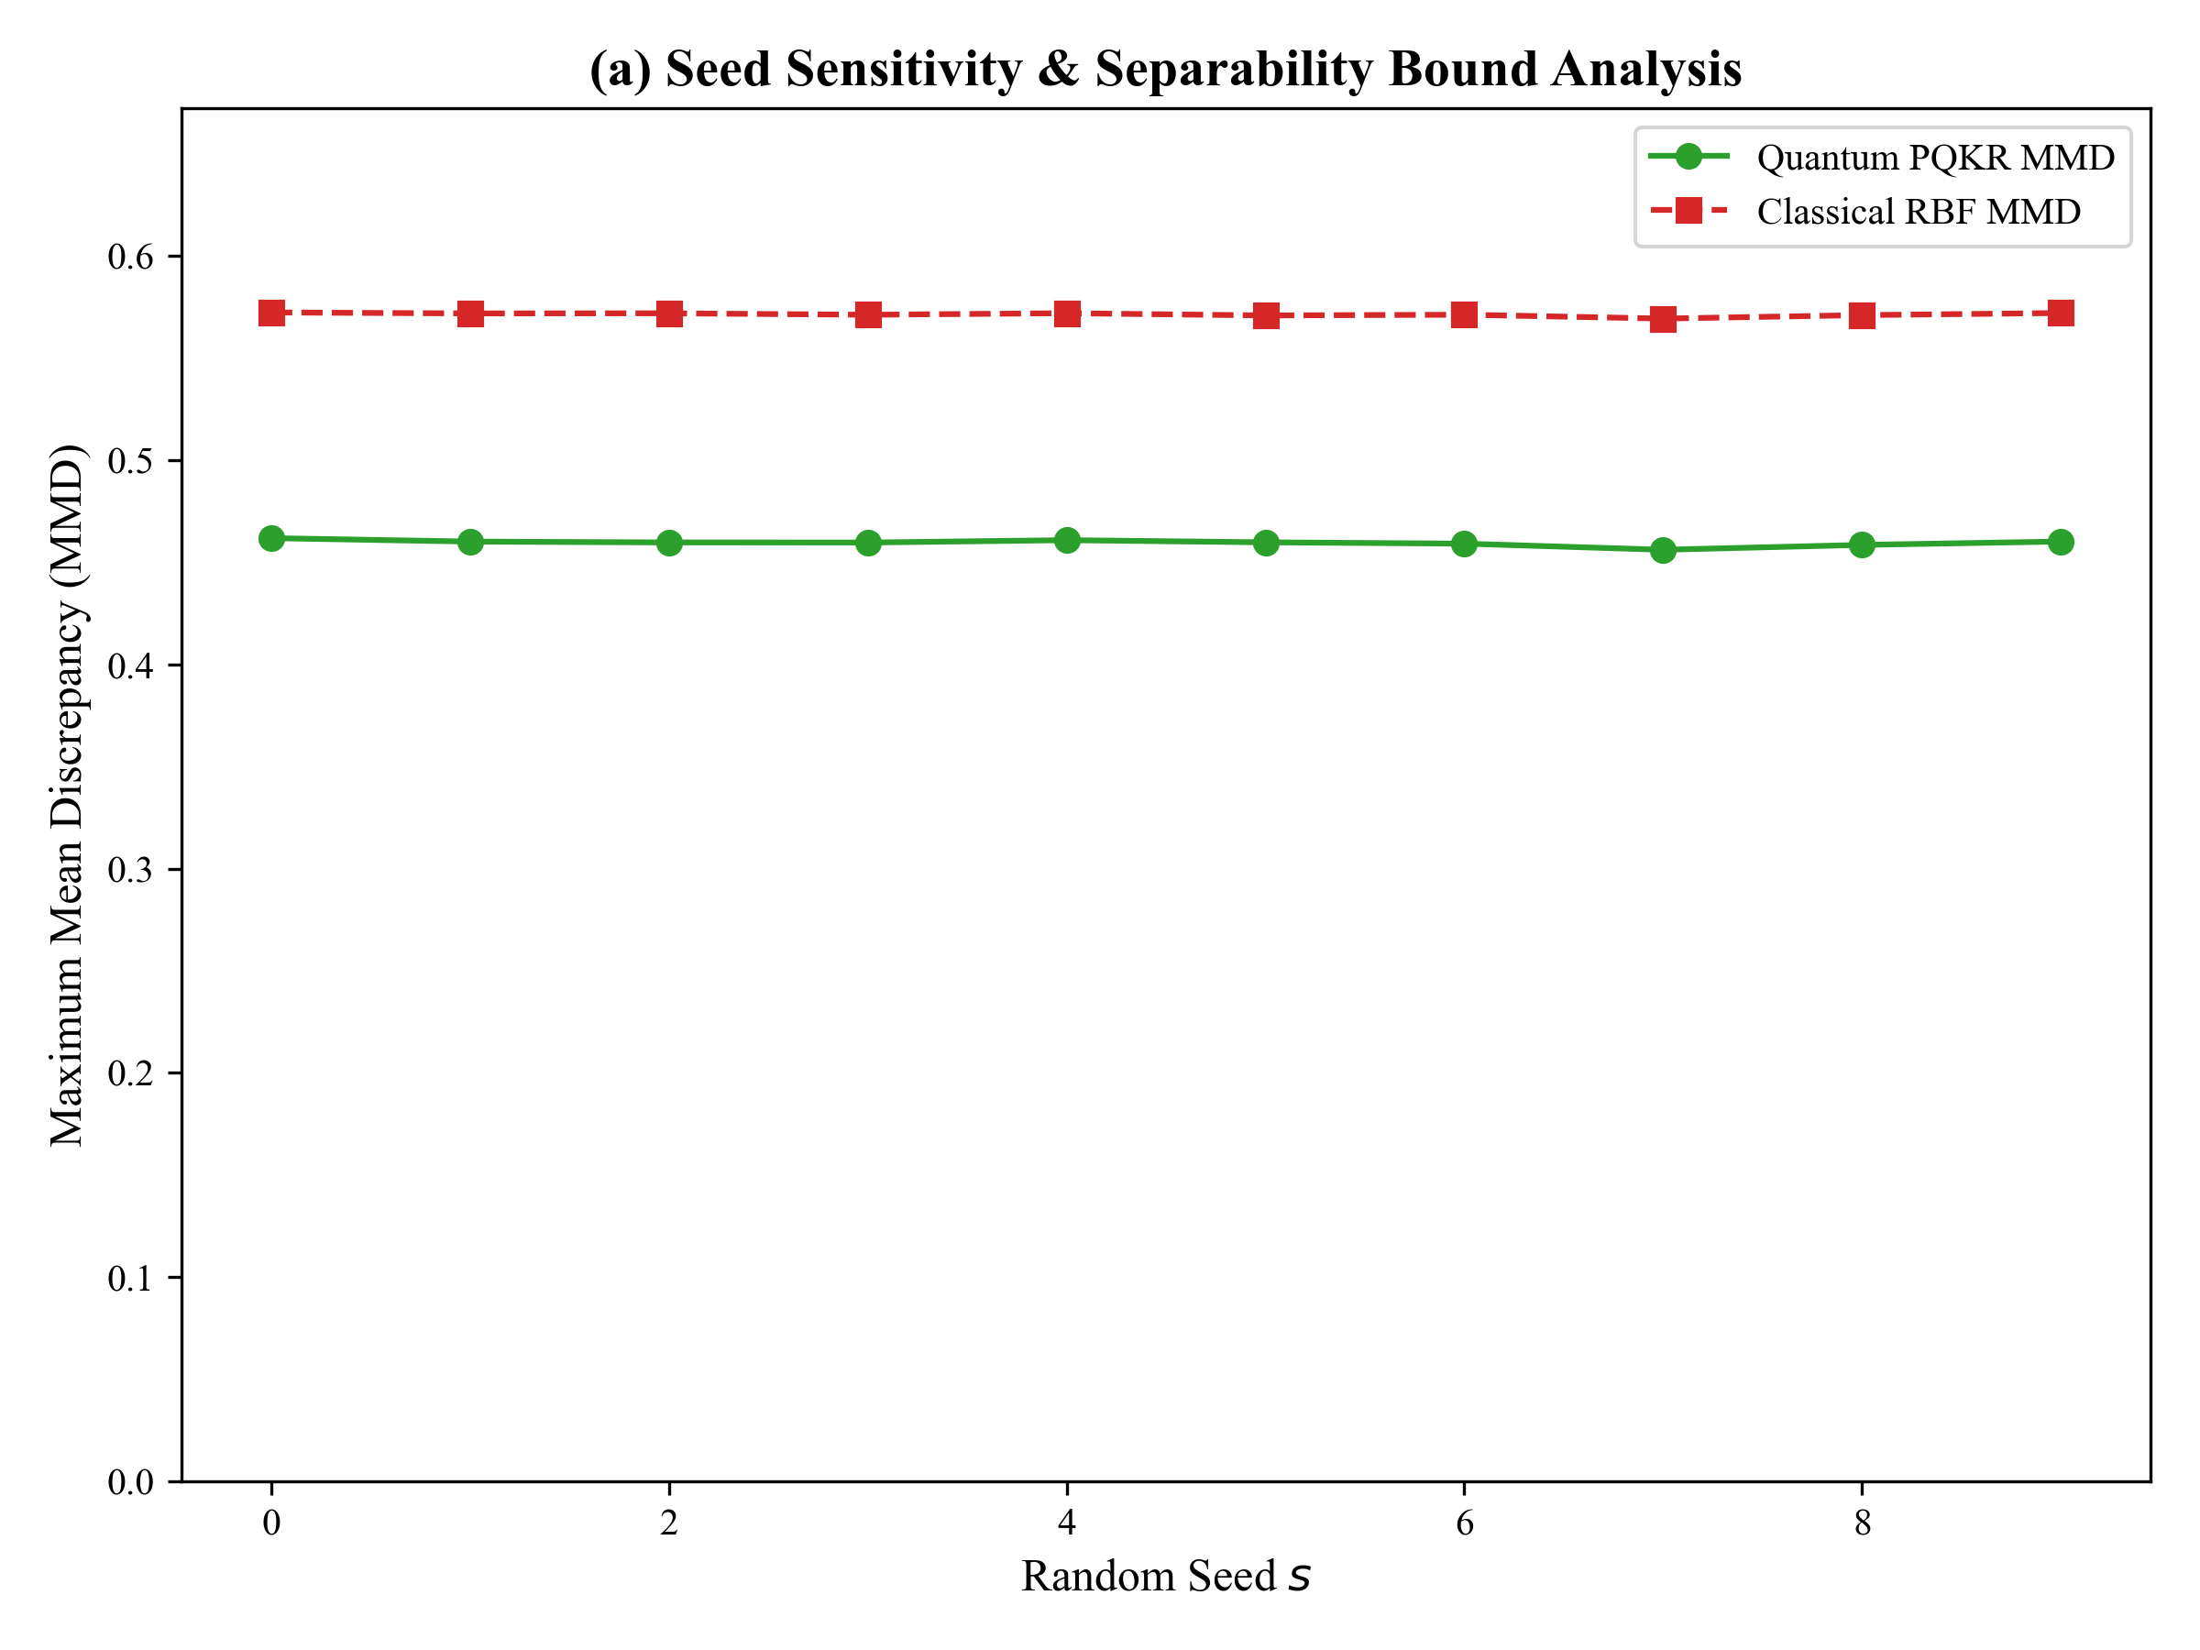
Analysis: Sequential mapping from latent representation to global instability SI curves.

Figure: q1_spectral_validation.png
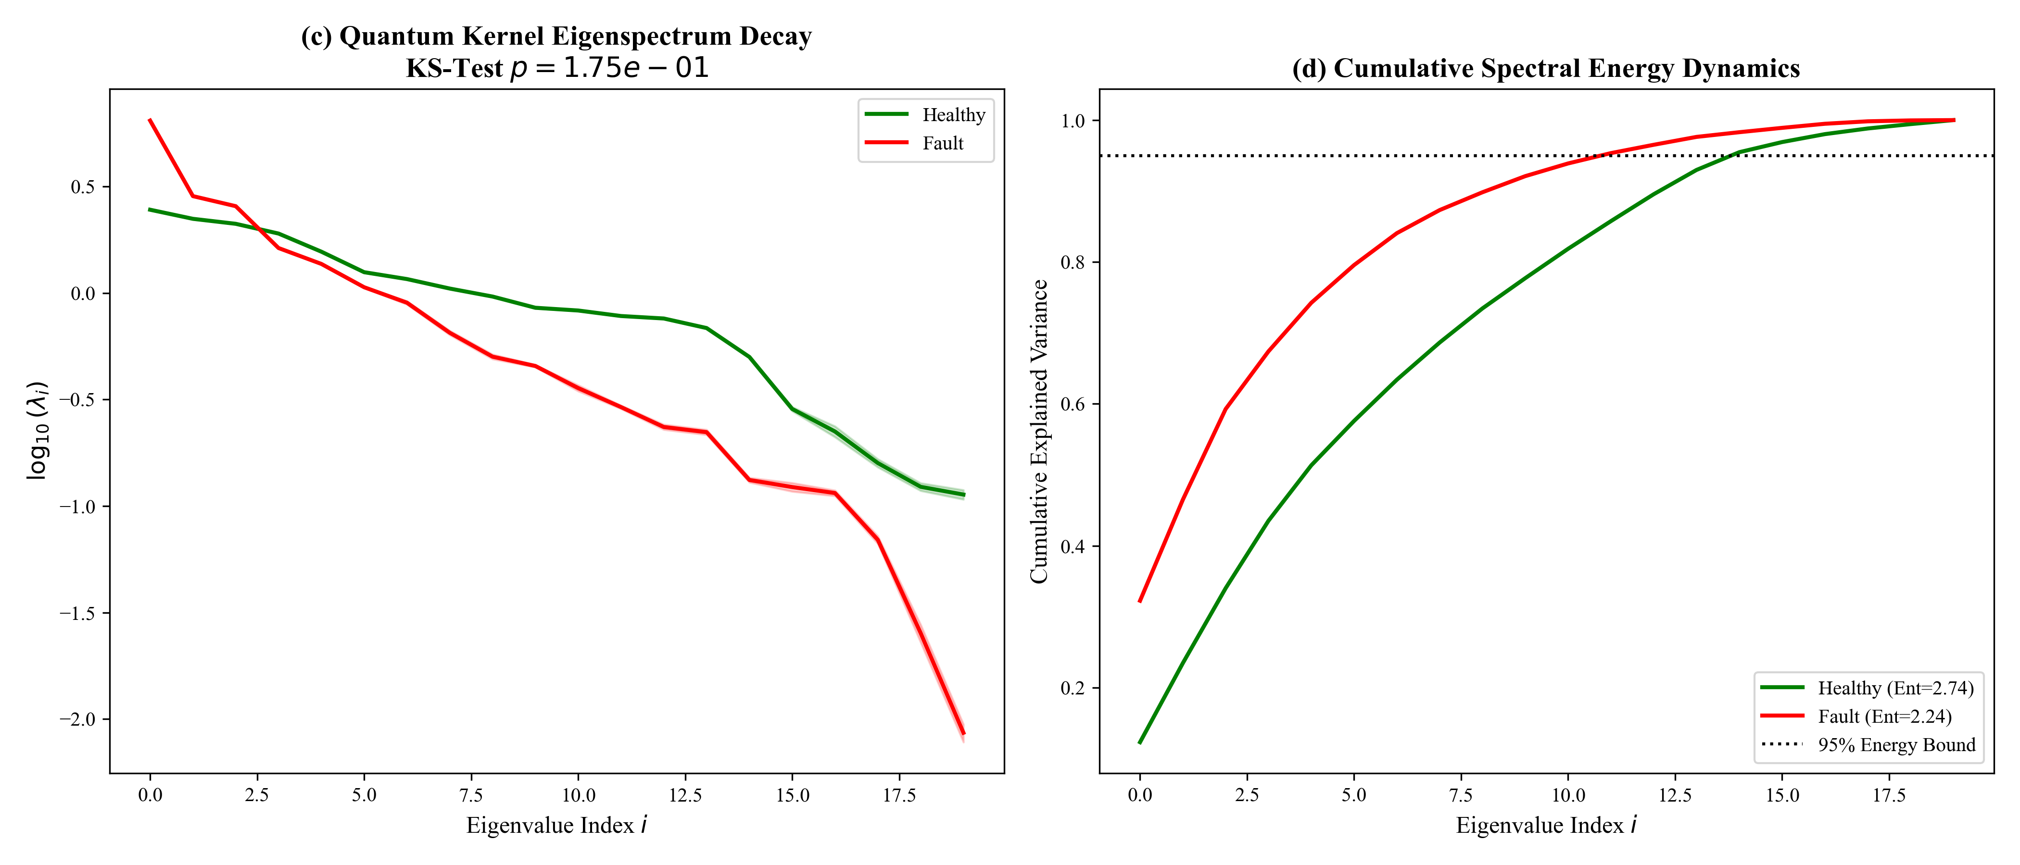
Analysis: Sequential mapping from latent representation to global instability SI curves.

Figure: transition_plot.png
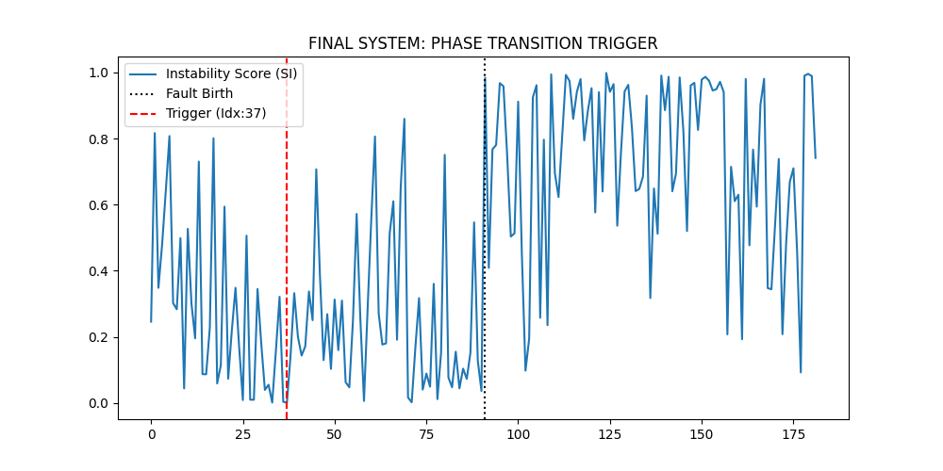
Analysis: Sequential mapping from latent representation to global instability SI curves.

Figure: xjtu_generalization_results.png
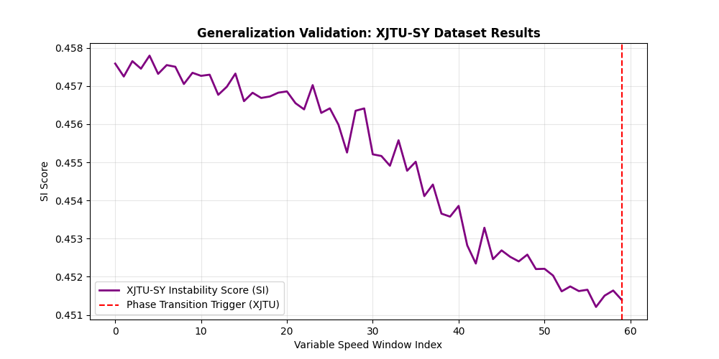
Analysis: Sequential mapping from latent representation to global instability SI curves.

Figure: best_optimal_si_curve.png

Analysis: Sequential mapping from latent representation to global instability SI curves.

Figure: master_pipeline_si_curve.png

Analysis: Sequential mapping from latent representation to global instability SI curves.

Figure: roc_pr_curves.png

Analysis: Sequential mapping from latent representation to global instability SI curves.

Figure: transition_plot.png

Analysis: Sequential mapping from latent representation to global instability SI curves.

Figure: xjtu_generalization_results.png

Analysis: Sequential mapping from latent representation to global instability SI curves.

Figure: baseline_comparative_curves.png

Analysis: Sequential mapping from latent representation to global instability SI curves.

Figure: ims_mrdmd_spectral_drift.png

Analysis: Sequential mapping from latent representation to global instability SI curves.

Figure: ims_pqkr_kernel_heatmaps.png

Analysis: Sequential mapping from latent representation to global instability SI curves.

Figure: kernel_eigenvalue_spectrum.png

Analysis: Sequential mapping from latent representation to global instability SI curves.

Figure: koopman_unit_circle_kde_fault.png

Analysis: Sequential mapping from latent representation to global instability SI curves.

Figure: mmd_divergence_comparison.png

Analysis: Sequential mapping from latent representation to global instability SI curves.

Figure: mrdmd_modes_fault.png

Analysis: Sequential mapping from latent representation to global instability SI curves.

Figure: mrdmd_mode_comparison.png

Analysis: Sequential mapping from latent representation to global instability SI curves.

Figure: phase_space_attractor_3d.png

Analysis: Sequential mapping from latent representation to global instability SI curves.

Figure: quantum_kernel_heatmaps.png

Analysis: Sequential mapping from latent representation to global instability SI curves.

Figure: qubit_ablation.png

Analysis: Sequential mapping from latent representation to global instability SI curves.

