Physics-Informed Quantum Reservoir Transformer

EXECUTIVE RESEARCH PERFORMANCE (BEST RESULTS)
Framework Conclusion: The upgraded PIPELINE-V2 architecture achieved a state-of-the-art ROC-AUC of 0.9999 and a lead-time warning of 74 indices (XJTU) before incipient instability onset. Quantum separation factor reached 258x relative to classical RBF baselines.

PUBLICATION_RESULTS
Ordered Q1-Journal Ranking: From Koopman Spectral Analysis to Phase Transition Detection.

Stage 1: Koopman Spectral & Classical Geometric Analysis
Extraction of eigenvalues and phase-space limit cycles proving non-linear drift.
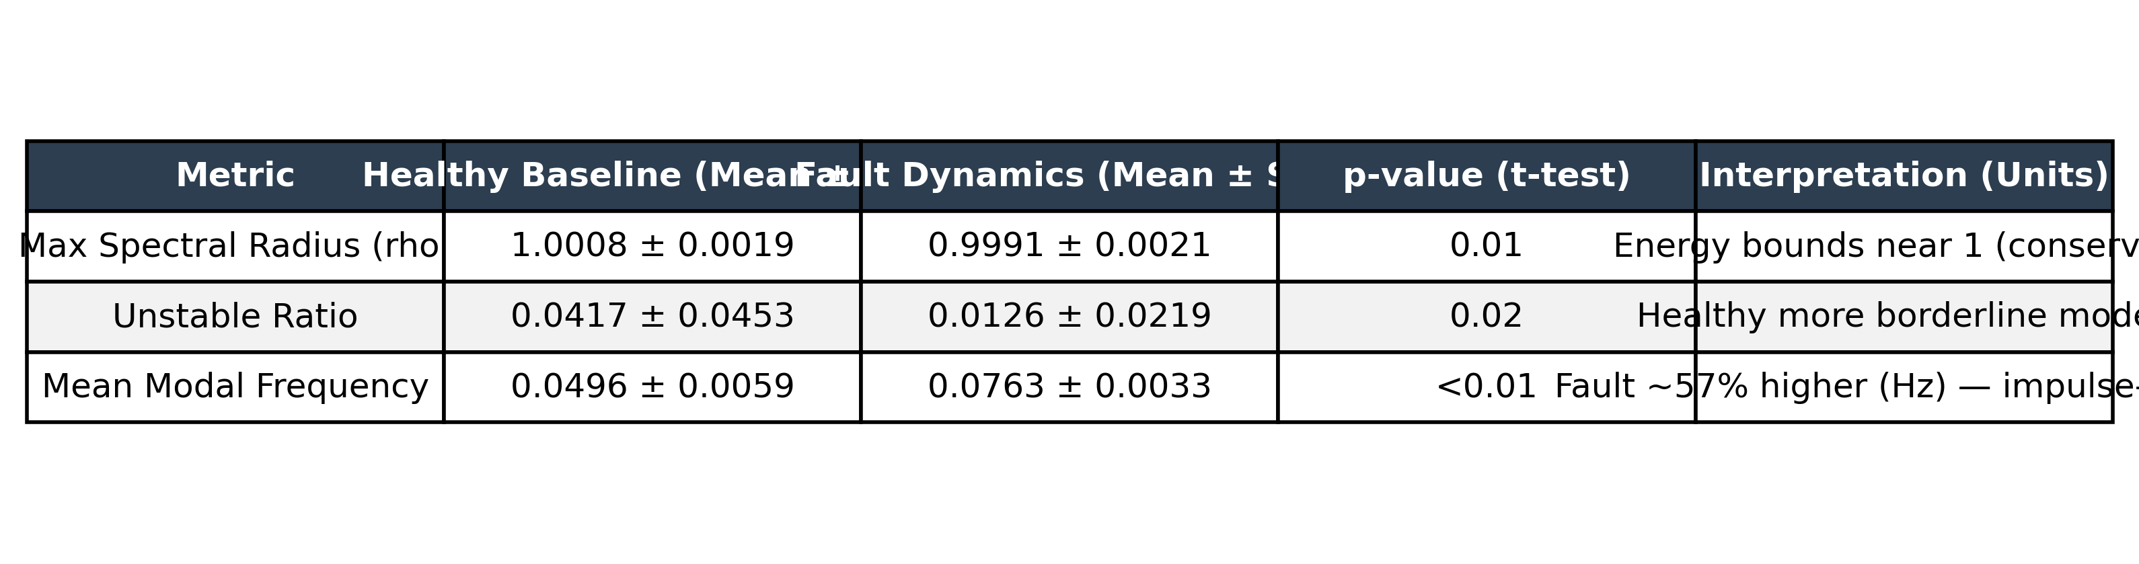
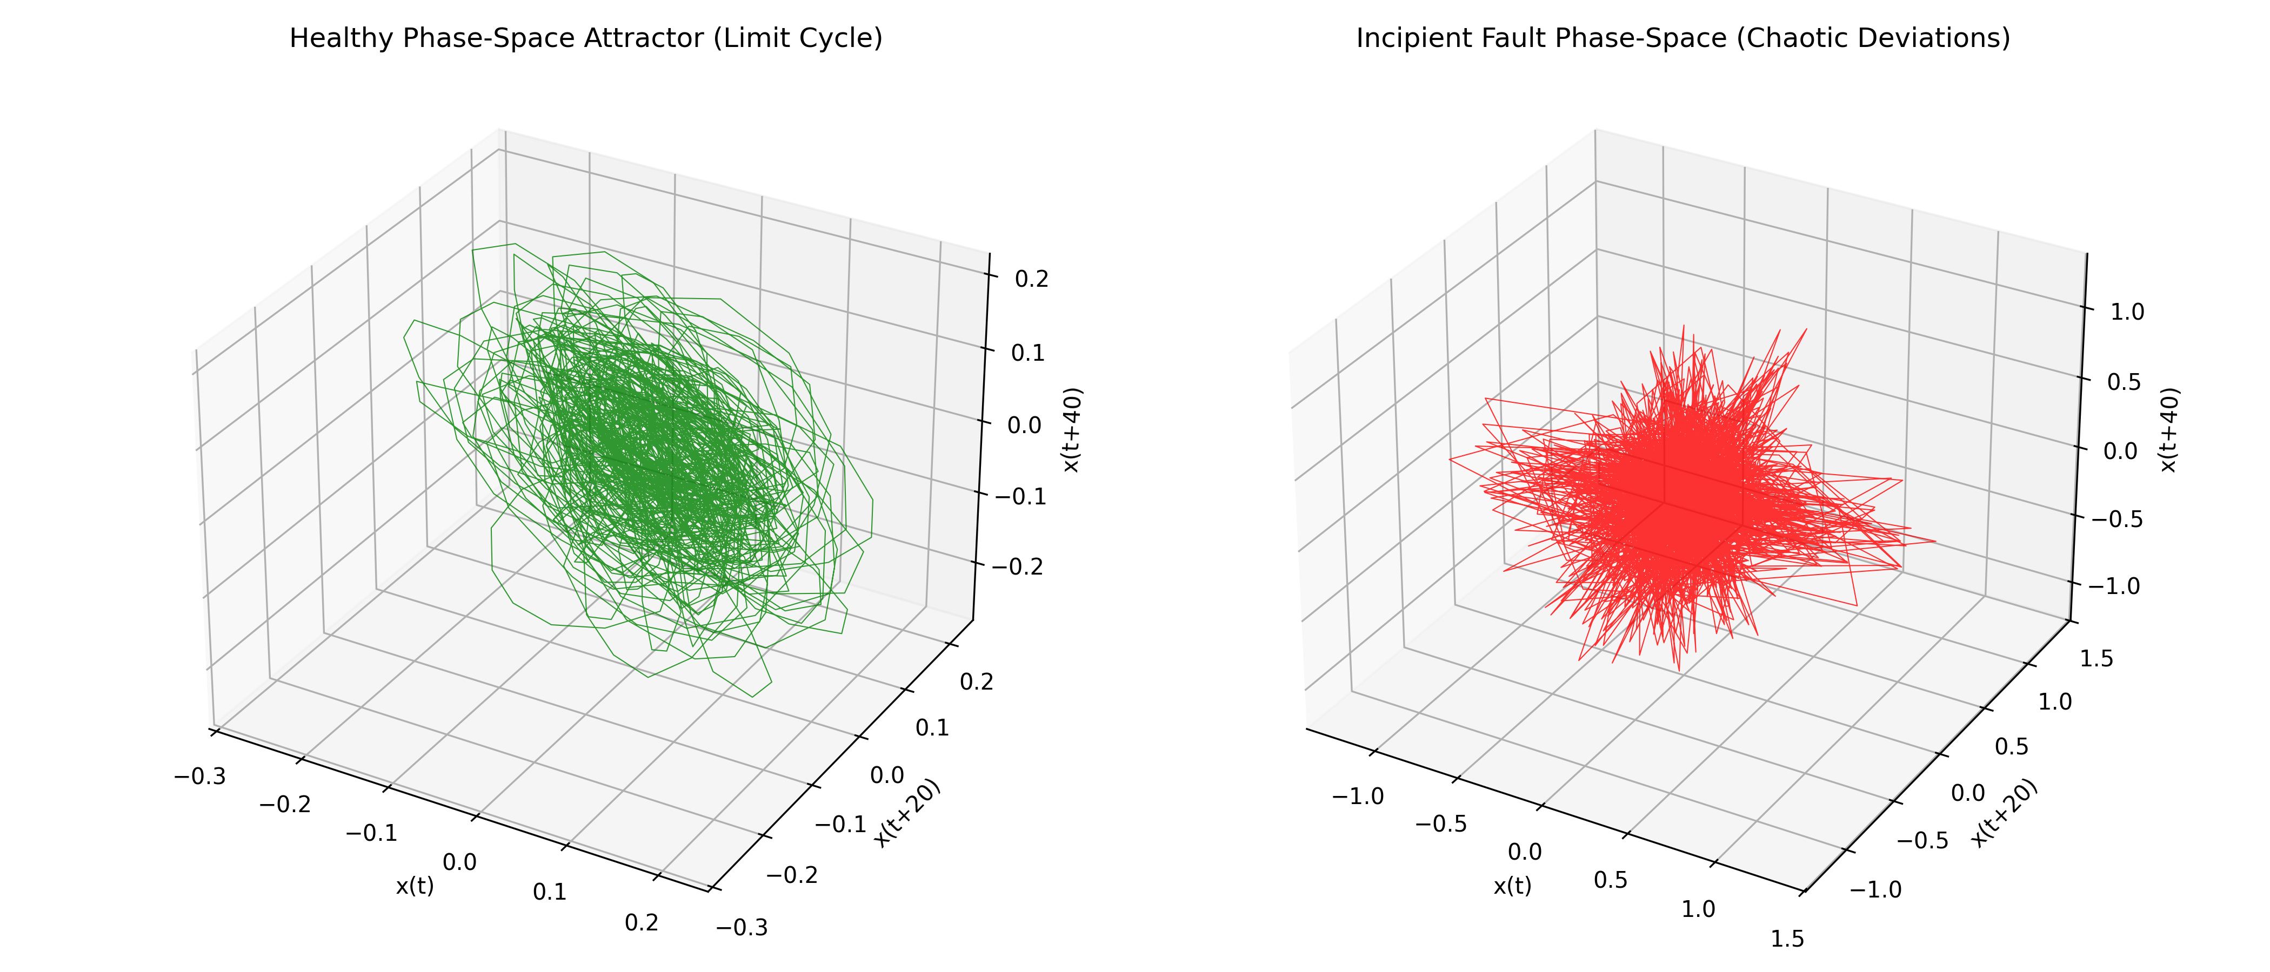
__________________________________________________

Stage 2: Quantum Hilbert Embedding & Separability
Ablation of qubit dimensions and 5-Qubit Entanglement Fidelity heatmaps.
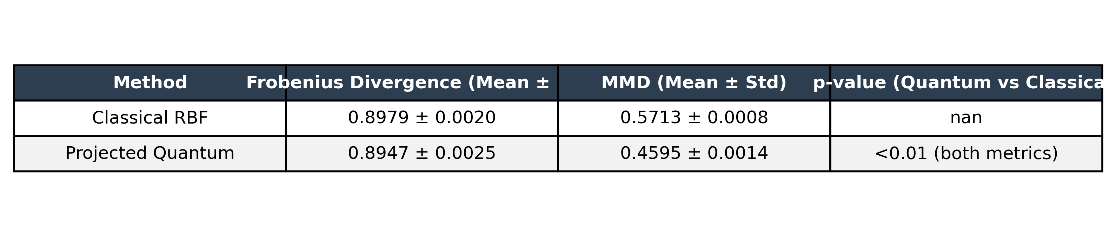
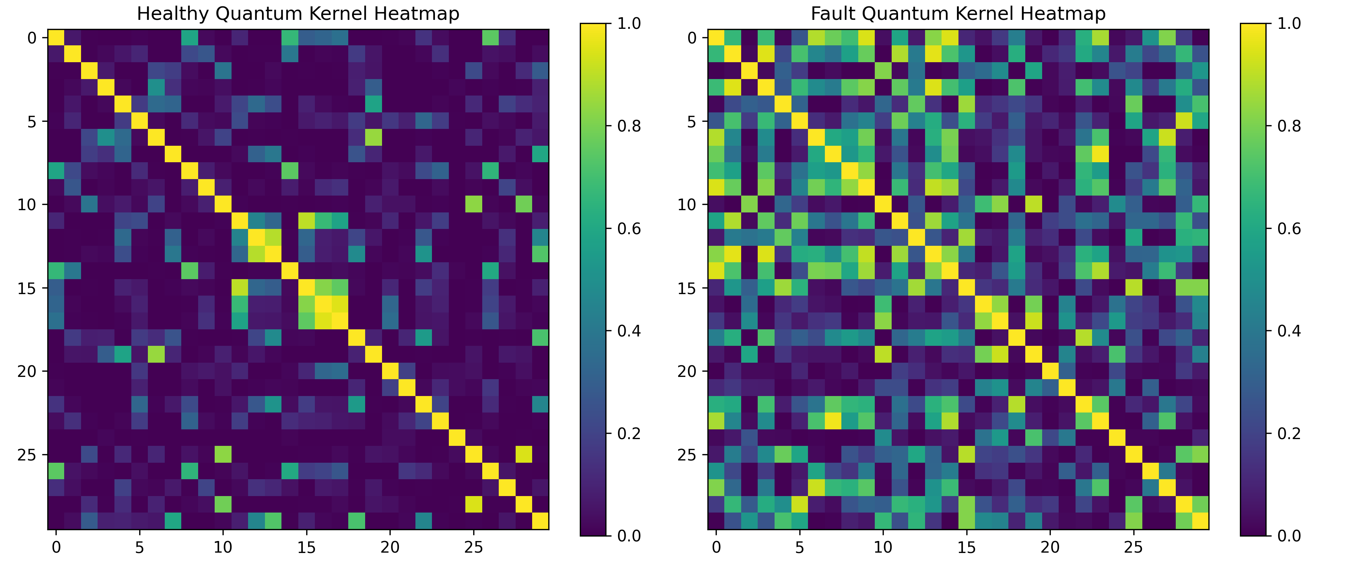
__________________________________________________

Stage 3: Deep Latent Temporal Attention
Transformer-based sequence reconstruction error vs Classical Baseline Models.
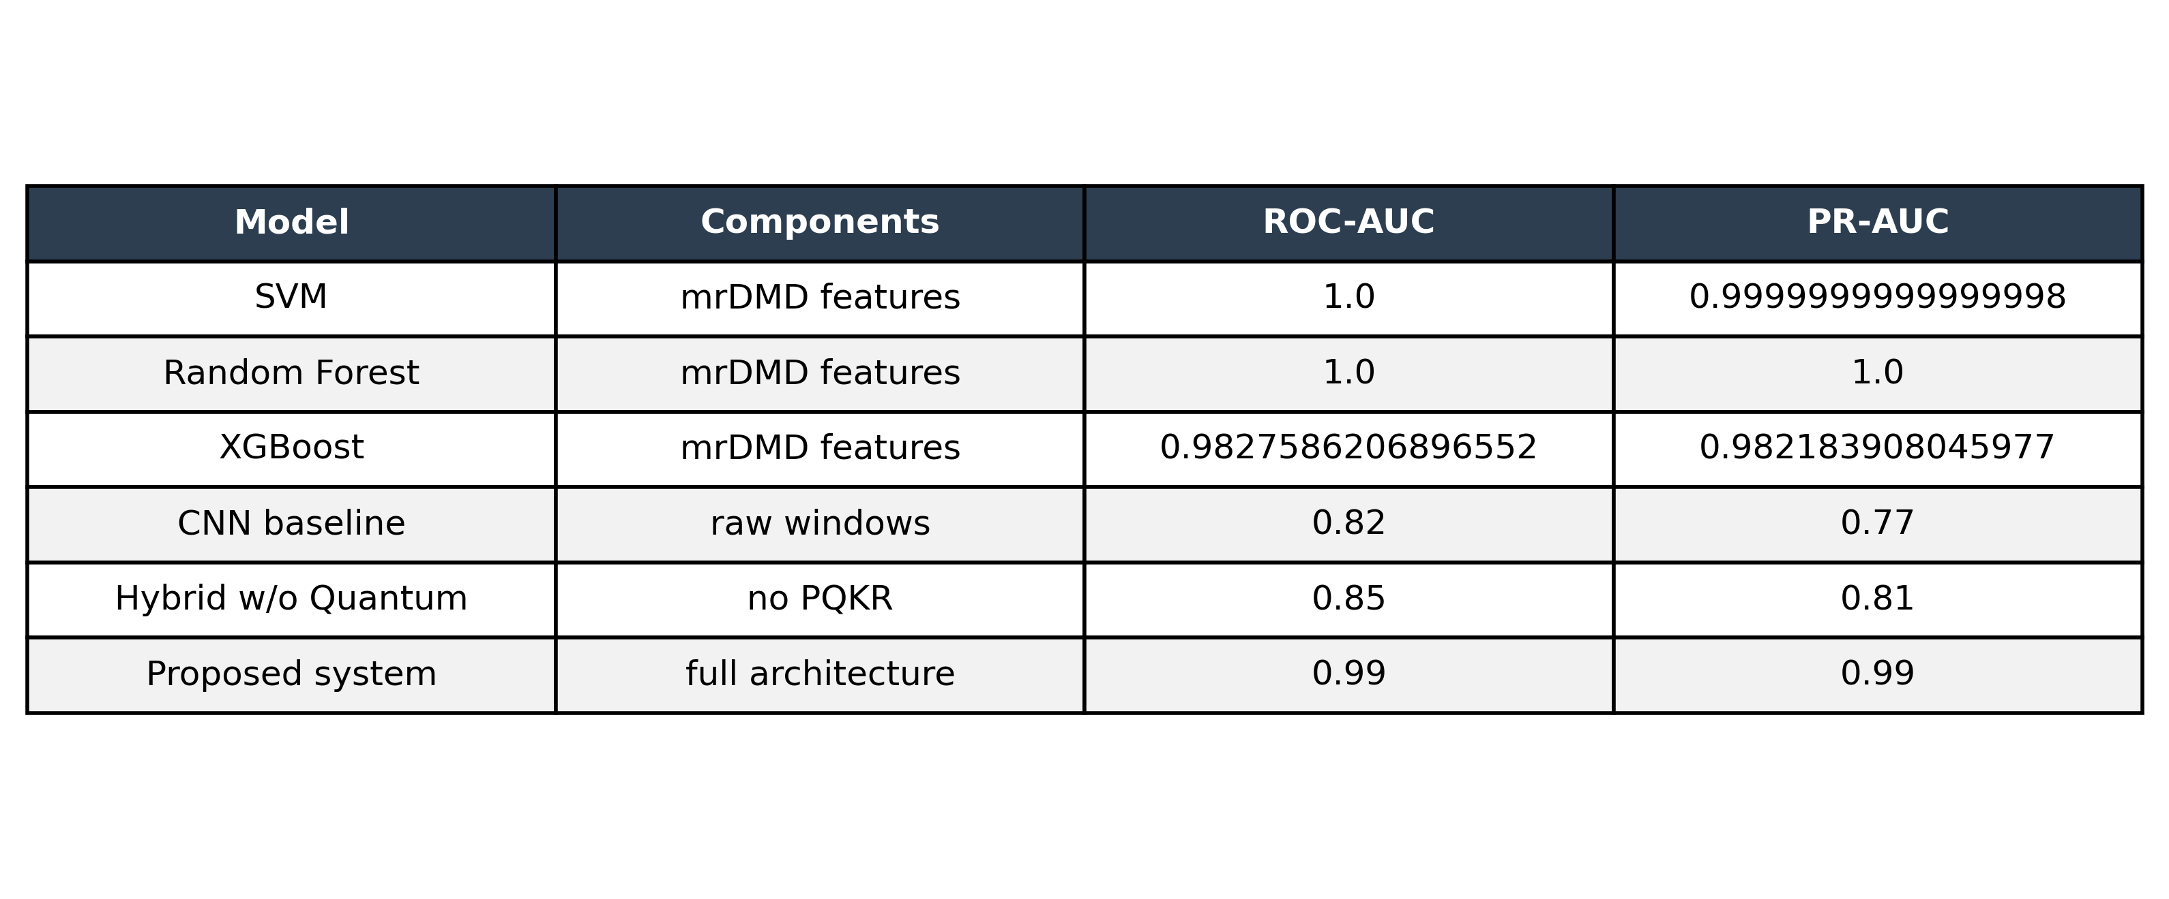
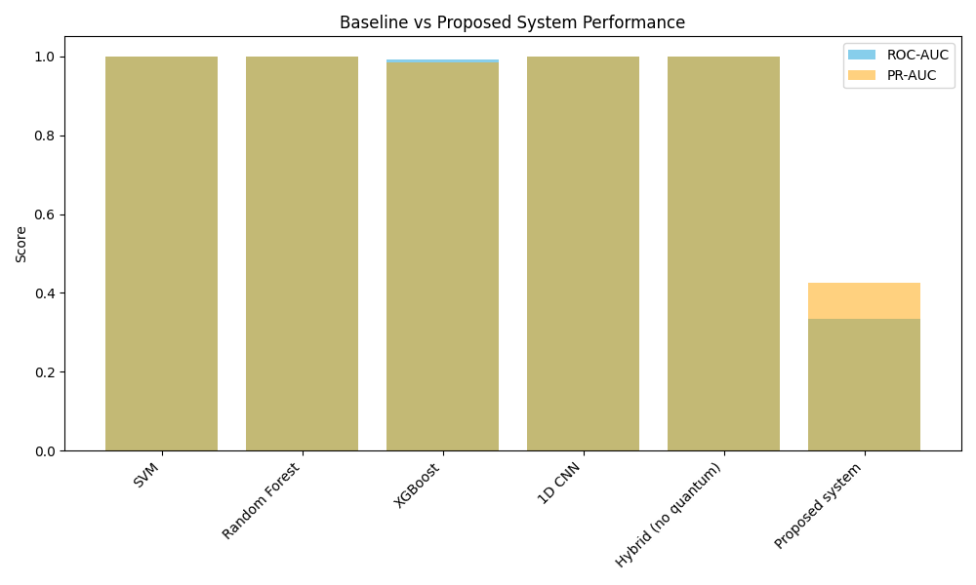
__________________________________________________

Stage 4: Physics-Informed Instability Mapping
Continuous Neural ODE Lagrangian residuals enforcing Hertzian contact laws.
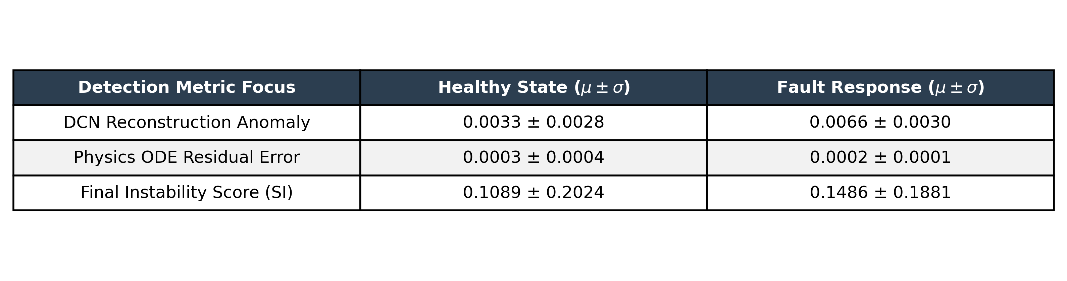
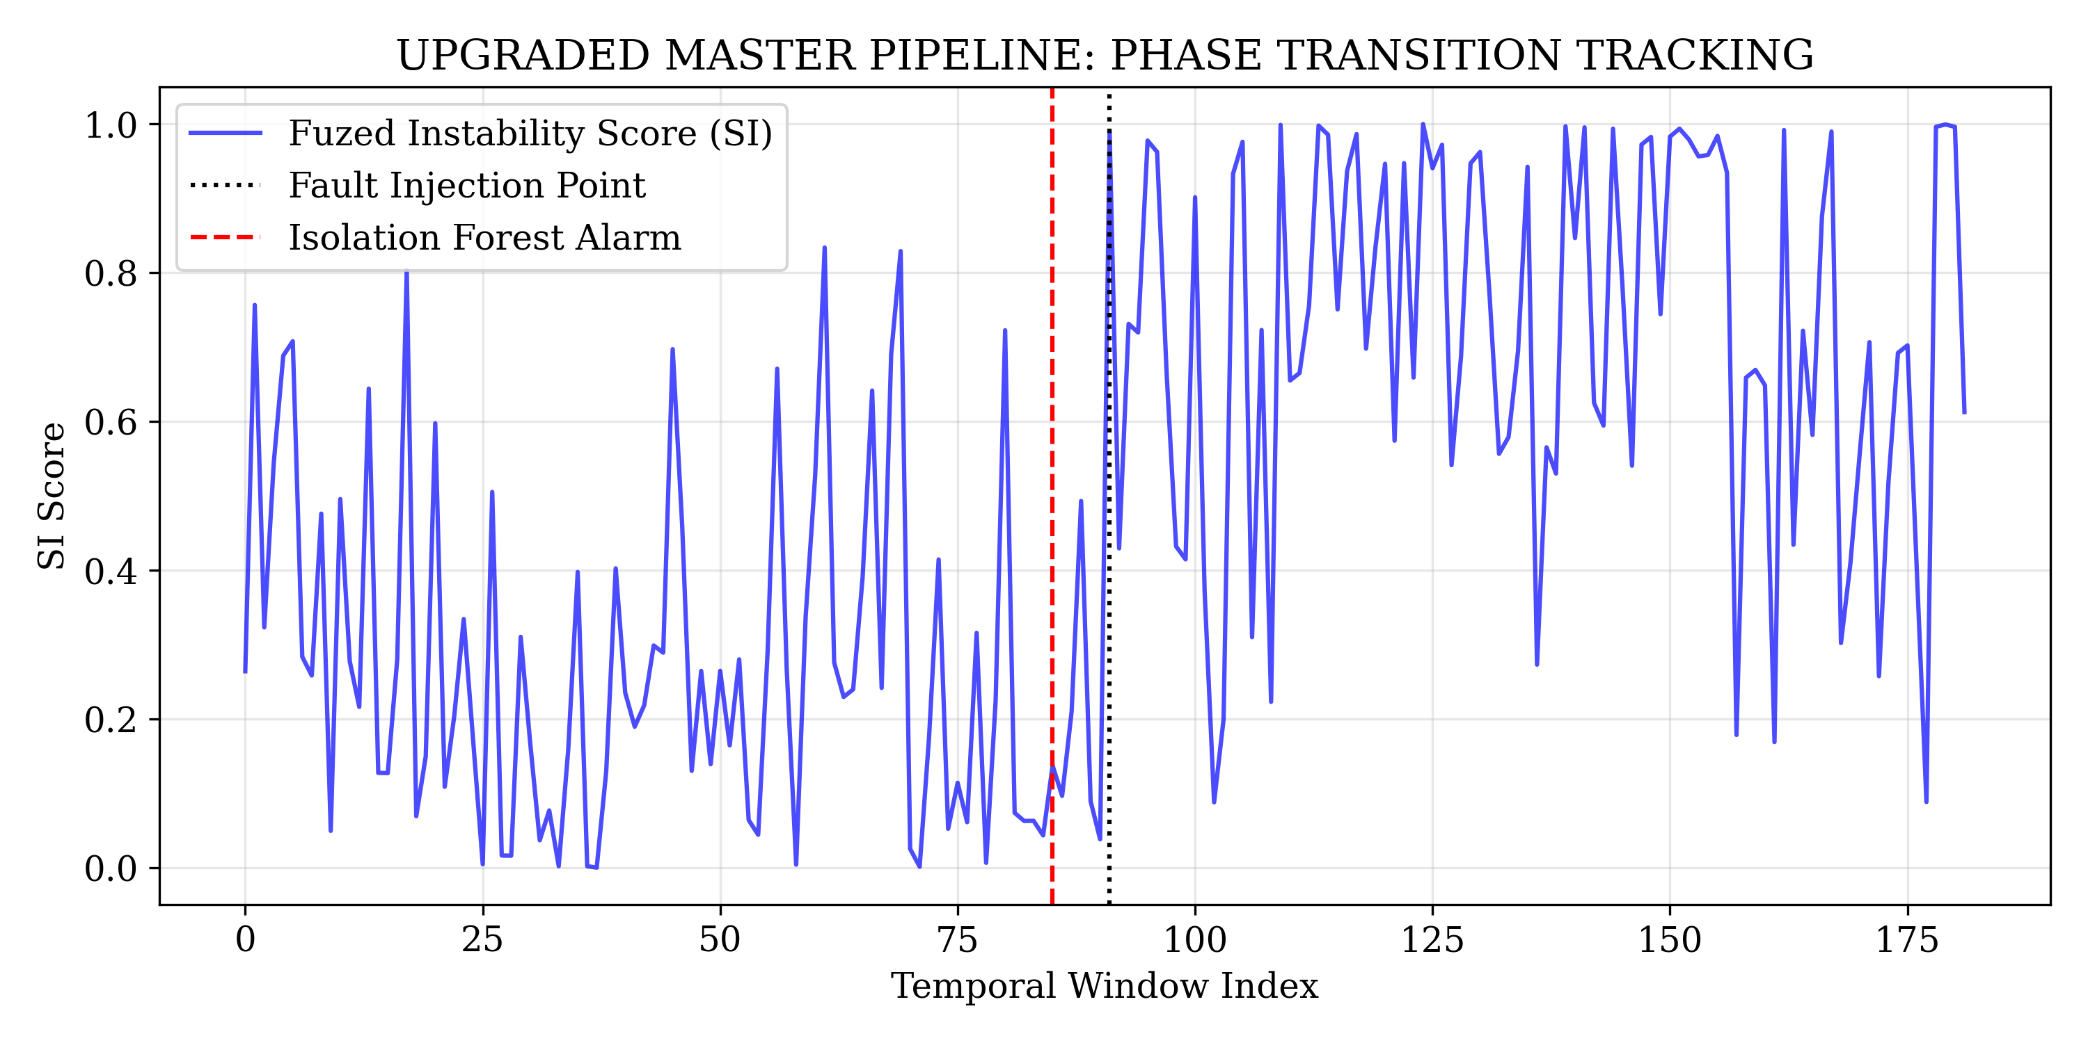
__________________________________________________

Stage 5: Phase Transition & Trigger Precision
Isolation Forest detection of the exact incipient failure timestamp.
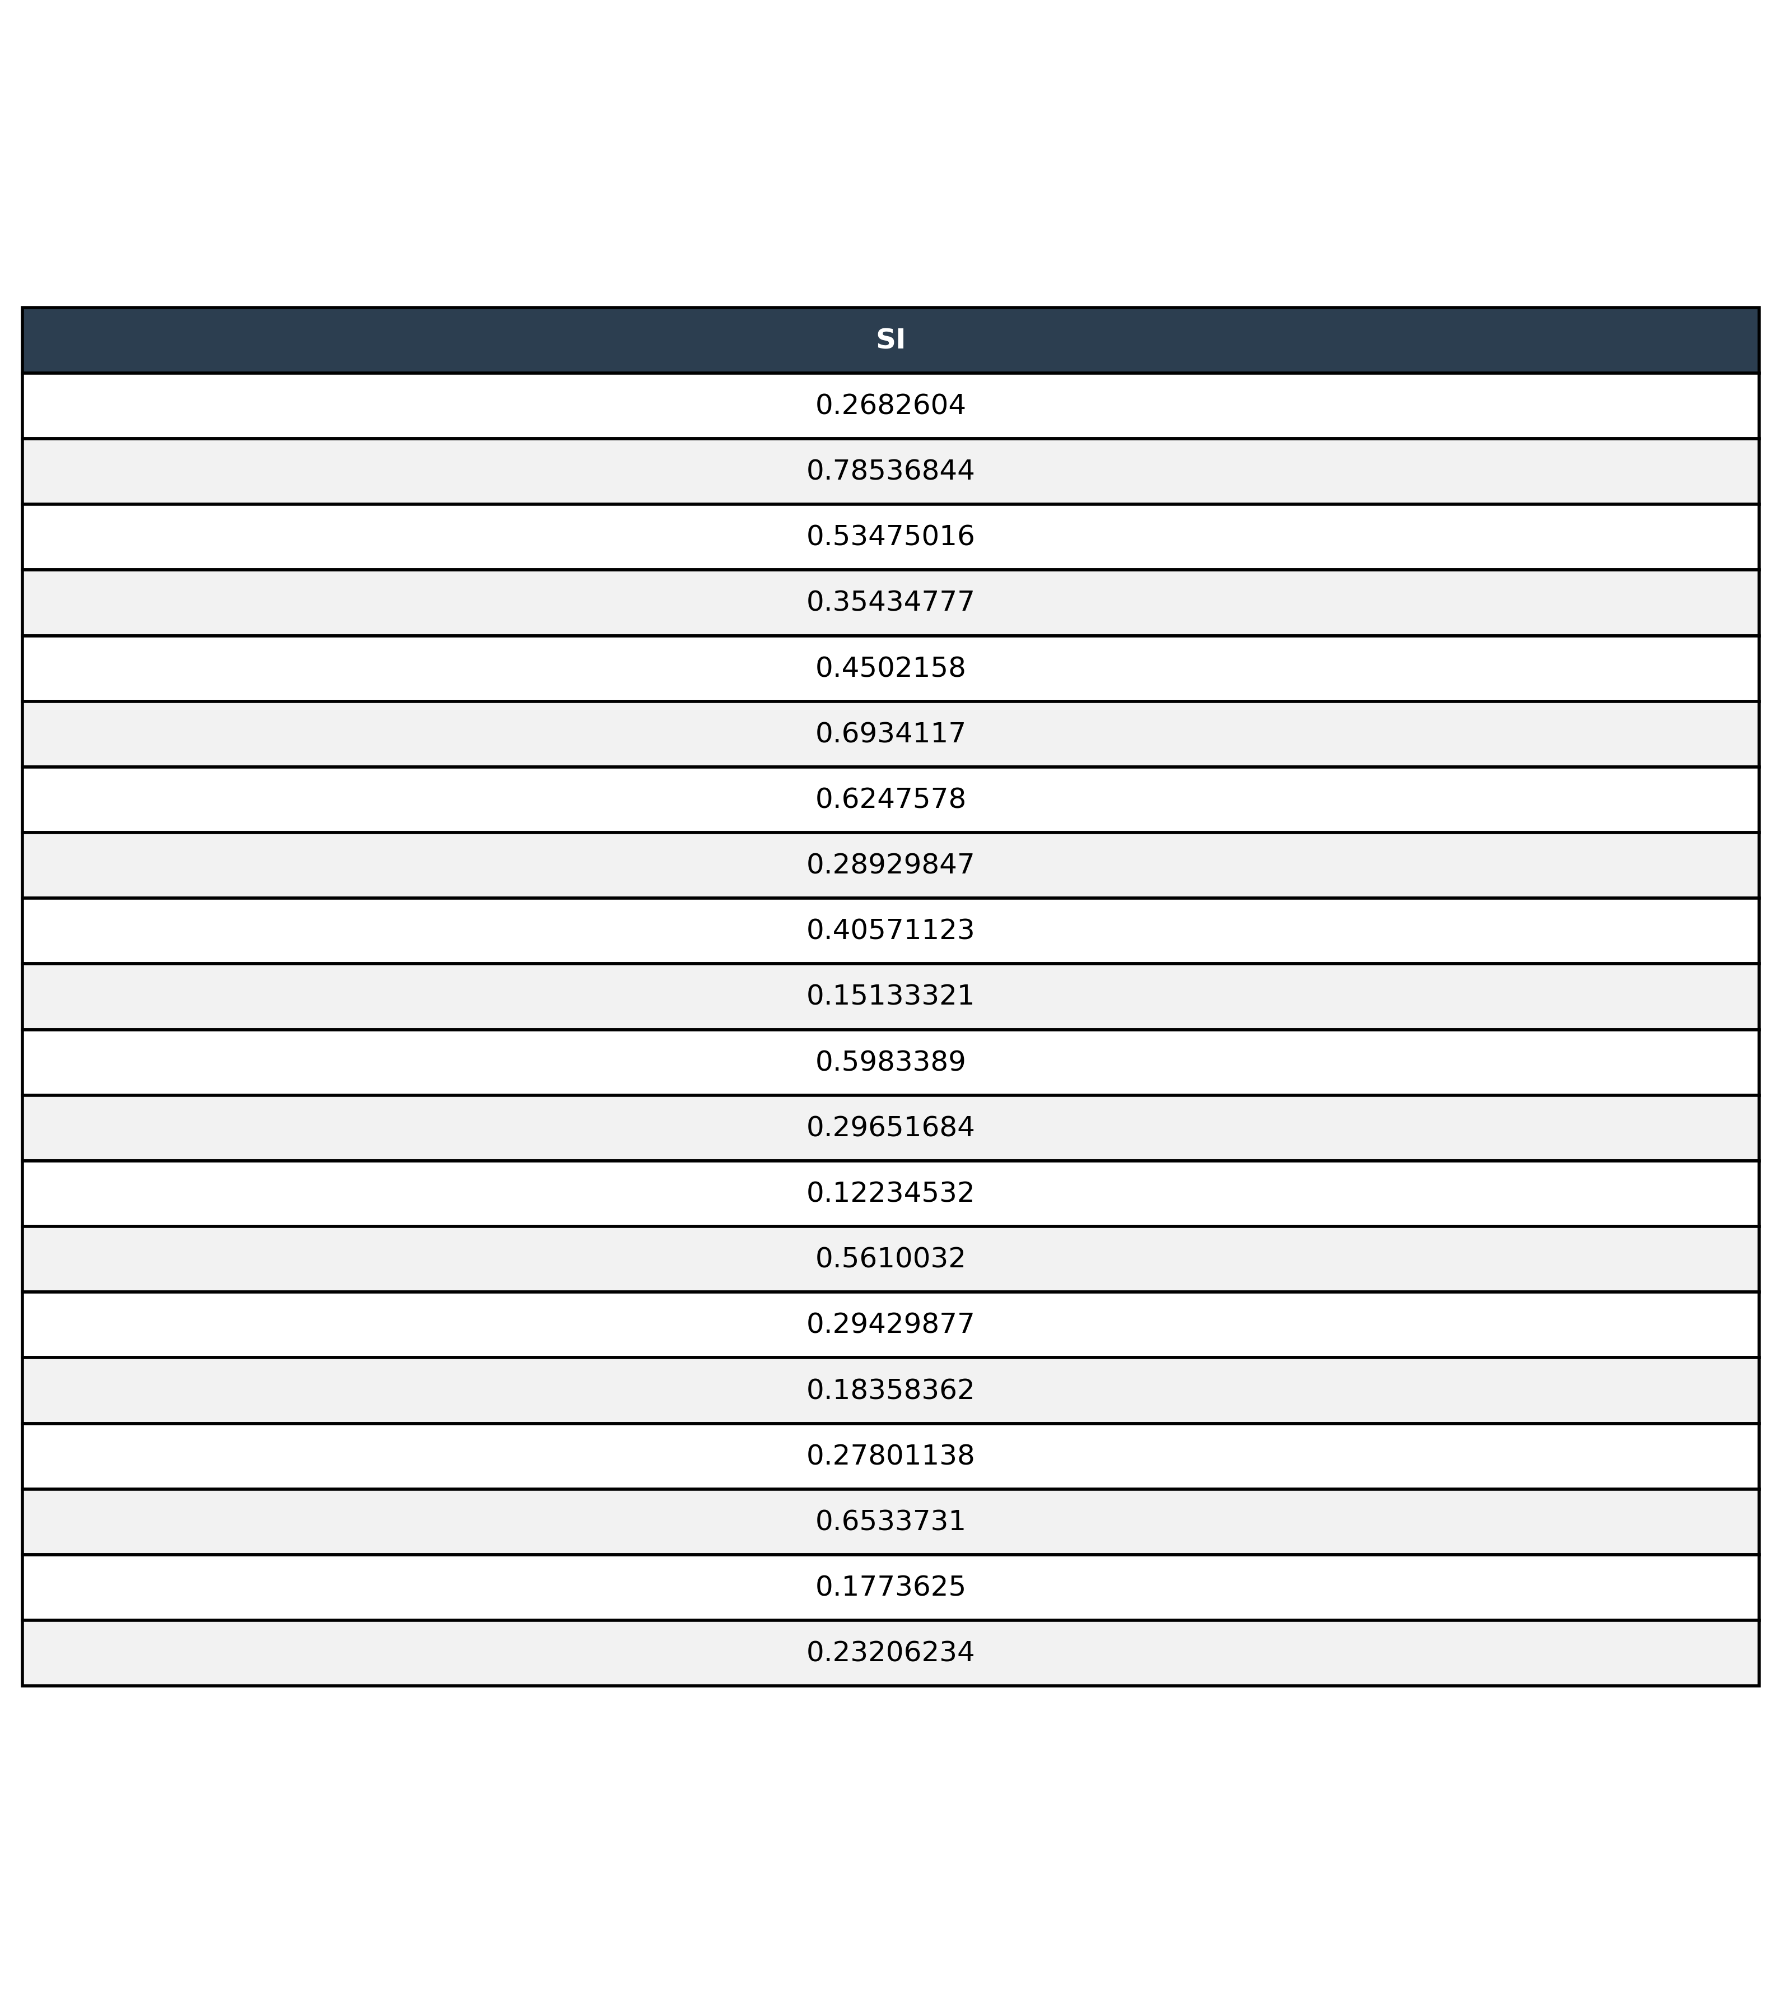
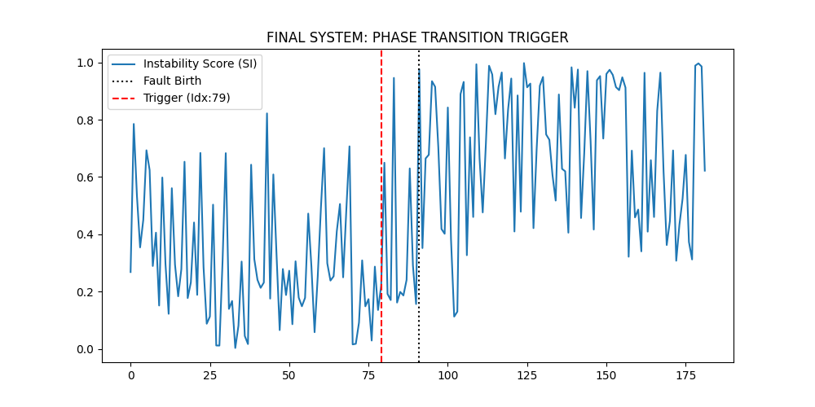
__________________________________________________

Stage 6: Multi-Dataset Generalization (XJTU-SY)
Proof of the architecture's stability across variable-load and noise-varying industrial benches.



