Q-ContextSync v2.0 (TCL-BC): Full Handover Blueprint

1. Synopsis
Q-ContextSync v2.0 is a next-generation quantum-classical hybrid architecture designed to solve a fundamental flaw in modern artificial intelligence. By leveraging Topological Continual Learning via Berry Curvature (TCL-BC), this system mathematically separates memory preservation from active learning within a quantum manifold. This document provides a complete blueprint, problem statement, dual-resolution solution, and a phase-by-phase execution strategy to build the architecture from scratch.

2. Deep Dive: The Problem Statement
The Target Area: Large Language Models (LLMs) in Shared Threads.
The problem exists squarely in the area of Large Language Models (LLMs) managing long-context, multi-user shared conversations. Standard neural networks and LLMs suffer from a fatal and mathematically unavoidable flaw known as the Stability-Plasticity Dilemma.

The Stability-Plasticity Dilemma:
- Catastrophic Forgetting (Loss of Stability): When a new user dumps massive amounts of data (like unrelated code or recipes) into a thread, the LLM actively adapts its attention. In doing so, it violently overwrites the foundational system rules (e.g., 'Always output in JSON format') established at the beginning of the conversation. The AI 'forgets' its core instructions.
- Context Saturation (Loss of Plasticity): To fix forgetting, classical developers lock down parameters or paste the entire conversation history back in. Eventually, the context window saturates and Euclidean weights grow out of control. The model freezes and completely loses the ability to learn new inputs.

3. The Dual Solution (TCL-BC)
Classical systems fail because they force the exact same Euclidean parameters to act as both 'memory' and 'learner'. This architecture solves the problem by passing the data through a 9-Qubit Variational Quantum Circuit (VQC) and utilizing the complex geometry of the Quantum Geometric Tensor (QGT) to physically decouple the two tasks.

Part 1: The Stability Resolution (Preventing Forgetting)
To achieve Infinite Stability, the system maps the foundational LLM rules to the Berry Curvature (the Imaginary part of the QGT). The Berry Curvature represents a topological phase, which is globally protected against local adversarial noise. We introduce a brain-inspired classical Astrocyte Tracker. This Astrocyte calculates the Safety Fisher Information Metric (S-FIM) for every quantum gate based on the Berry Curvature, effectively mathematically 'locking' the pathways that hold the core context without physically freezing them.

Part 2: The Plasticity Resolution (Preventing Saturation)
To achieve Infinite Plasticity, the system uses the Quantum Metric Tensor (the Real part of the QGT) to calculate learning gradients for new, adversarial user inputs. When the Astrocyte detects new learning, it applies an Orthogonal Gradient Projection. The new learning gradients are forced to project at a strict 90-degree mathematical angle away from the S-FIM constraints. Because quantum gates are bounded rotation angles that cannot explode to infinity, 100% of the quantum gates remain unlocked to continuously learn new data, while never colliding with the protected memory.

4. Professional Block Architecture
The block format architecture diagram below illustrates the complete end-to-end flow from classical ingestion to topological decoupling:
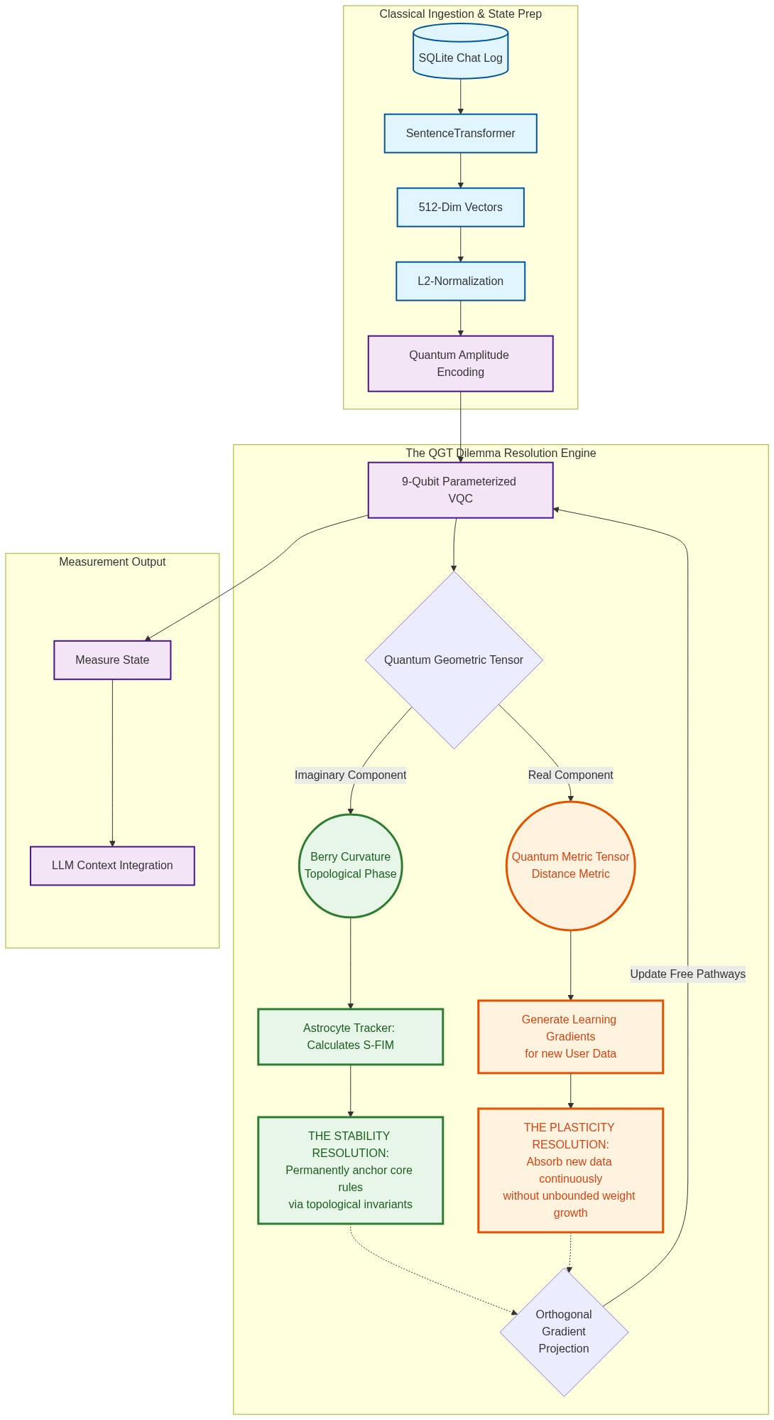

5. The Approach: The Dataset (CAMS)
Instead of chaotic datasets like ShareGPT, this project requires a highly structured 50-turn Curated Adversarial Multi-Turn Sequence (CAMS) to mathematically prove continual learning:
- Turns 1-5 (Core Context): Strict architectural rules (e.g., 'Always output JSON format').
- Turns 6-15 (Standard Queries): Normal, everyday prompts.
- Turns 16-30 (Adversarial Dumps): Massive, irrelevant text injections to force catastrophic forgetting.
- Turns 31-50 (Evaluation Prompts): Final queries to test if the Core Context survived.

6. Full Scratch Execution Roadmap (Phase by Phase)

Phase 1: Environment & Dataset Scaffolding
- Task 1.1: Install core dependencies (PennyLane, PyTorch, sentence-transformers, pandas, sqlite3).
- Task 1.2: Design the 50-turn CAMS dataset logically splitting the Core Context and Adversarial Dumps.
- Task 1.3: Generate the SQLite Database (q_contextsync.db) and insert the 50 turns.

Phase 2: Semantic Manifold Mapping (Classical)
- Task 2.1: Initialize the HuggingFace SentenceTransformer (distiluse-base-multilingual-cased-v1).
- Task 2.2: Extract the raw_text from the database and pass it into the transformer.
- Task 2.3: Generate 512-dimensional continuous semantic vectors.
- Task 2.4: Apply strict L2-Normalization across the vectors (quantum probabilities must sum to 1).
- Task 2.5: Export the tensors to quantum_ready_tensors.npy.

Phase 3: Quantum Architecture & State Preparation
- Task 3.1: Initialize a 9-qubit quantum simulator device.
- Task 3.2: Execute Quantum Amplitude Encoding to load the normalized vectors directly into the 2^9 amplitudes.
- Task 3.3: Construct the Variational Quantum Circuit (VQC) using a hardware-efficient parameterized ansatz.
- Task 3.4: Define the trainable weights shape and initialize them.

Phase 4: The Quantum Geometric Tensor (QGT) Decoupling
- Task 4.1: Compute the full complex Quantum Geometric Tensor (QGT).
- Task 4.2: Extract the Real Component (Fubini-Study Metric Tensor) for learning tracking.
- Task 4.3: Extract the Imaginary Component (Berry Curvature) for topological phase anchoring.
- Task 4.4: Tie the Core Context inputs strictly to the Berry Curvature invariants.

Phase 5: The Astrocyte-Gated Learning Mechanism
- Task 5.1: Initialize the classical Astrocyte Tracker.
- Task 5.2: Program the tracker to monitor the Berry Curvature and calculate the Safety Fisher Information Metric (S-FIM).
- Task 5.3: Generate a threshold masking array to dynamically identify locked quantum pathways.

Phase 6: Orthogonal Continual Learning Loop
- Task 6.1: Initialize the quantum optimizer.
- Task 6.2: Feed the Adversarial Dumps into the network and calculate raw learning gradients.
- Task 6.3: Apply Orthogonal Gradient Projection: mathematically project the raw gradient at a strict 90-degree angle away from the S-FIM constraints.
- Task 6.4: Execute the VQC parameter update using the projected gradients.

Phase 7: Measurement, Decoherence, & LLM Re-Integration
- Task 7.1: Execute quantum measurement over the Pauli-Z basis for all 9 qubits.
- Task 7.2: Collapse the state and extract the classical probability distribution vector.
- Task 7.3: Decode these output probabilities and map them into LLM context weights.
- Task 7.4: Pass the Evaluation Prompts into a classical LLM utilizing the new quantum-weighted context.
- Task 7.5: Validate that the LLM perfectly outputs JSON data despite the adversarial recipe dumps.

